CS 3873: Net-Centric Computing

Lab 2: Examining HTTP with Wireshark

Student Name: ____Adrian Freeman_____ Student Number: __3661616__

[Mandatory] Declaration: “I warrant that this is my own work.”
Signed by _Adrian Freeman___

[Optional] “I hereby give my permission for this work to be used (with my name and identifying information removed) for UNB Faculty of Computer Science program accreditation purposes.”
Signed by _Adrian Freeman__

Report for Lab Exercise 2:

Examining HTTP with Wireshark
LAB ACTIVITIES:
In this lab, we used Wireshark to examine the details of the hypertext transfer protocol (HTTP).
ANSWERS TO LAB QUESTIONS:
Remember to include annotated screenshot to justify your answer.
3. Examine your trace captured above and answer the following questions:
- Inspect the contents of the first HTTP GET request for the Webpage “lab_http1.html” from your browser to the server. Do you see an “If-Modified-Since” line in the HTTP GET?
As shown in the screenshot below, The first HTTP GET message did not contain an “If-Modified-Since” line.
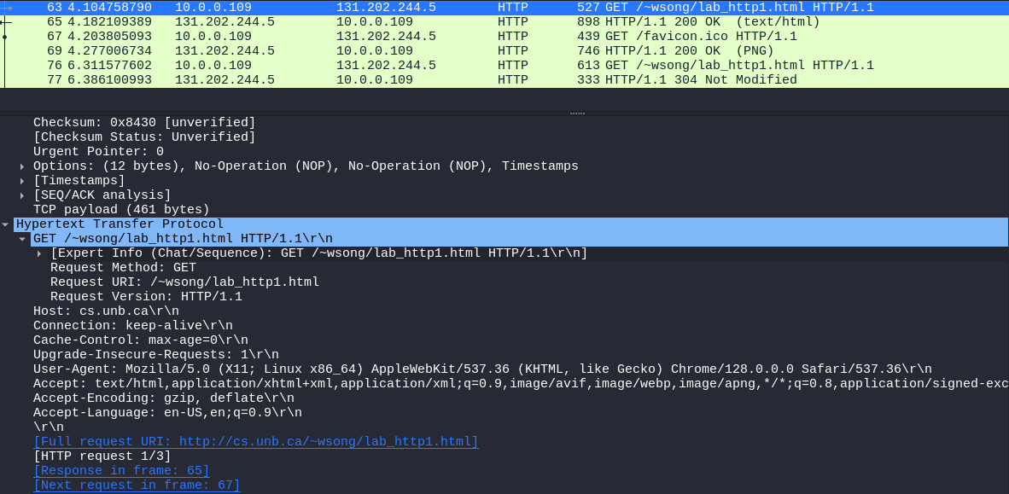
b. Inspect the contents of the server response to the first HTTP GET request. Did the server explicitly return the contents of the file? How can you tell?
The server did explicitly return the contents of the file, as shown in the screenshot below. The 200 OK message contains the raw text data from the webpage’s html.
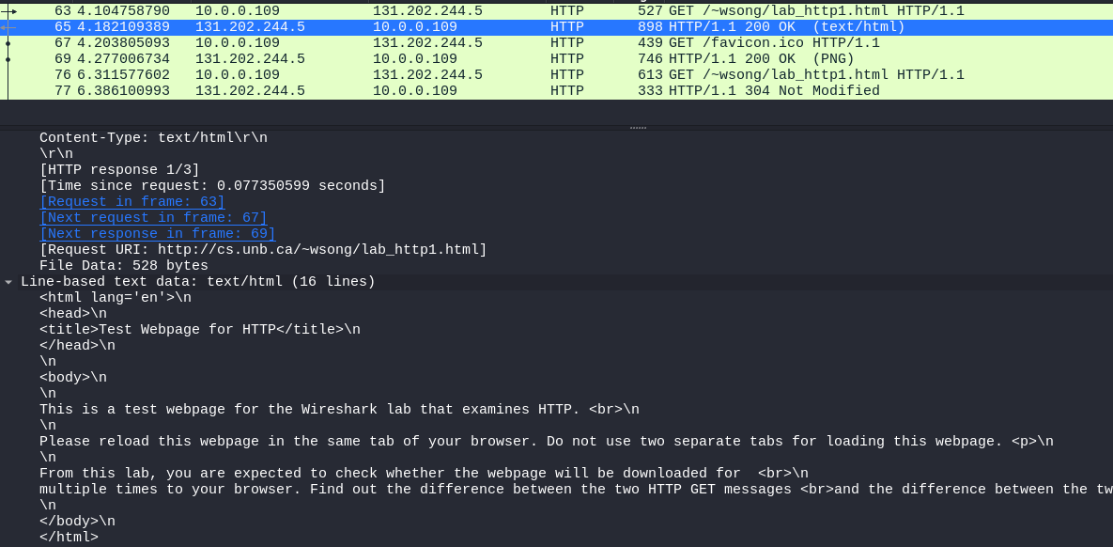

c. Now inspect the contents of the next HTTP GET request for the Webpage “lab_http1.html” from your browser to the server. Do you see an “If-Modified-Since:” line in the HTTP GET? If so, what information follows the “If-Modified-Since:” header?
There is an “If-Modified-Since” line, and within that line, there is a time, representing the last time the client accessed this data, the most recent cached time.
After the header, there are other lines, including the request URI, the # of HTTP requests in the current capture, a reference to the previous GET request, and a reference to the response request for this GET.
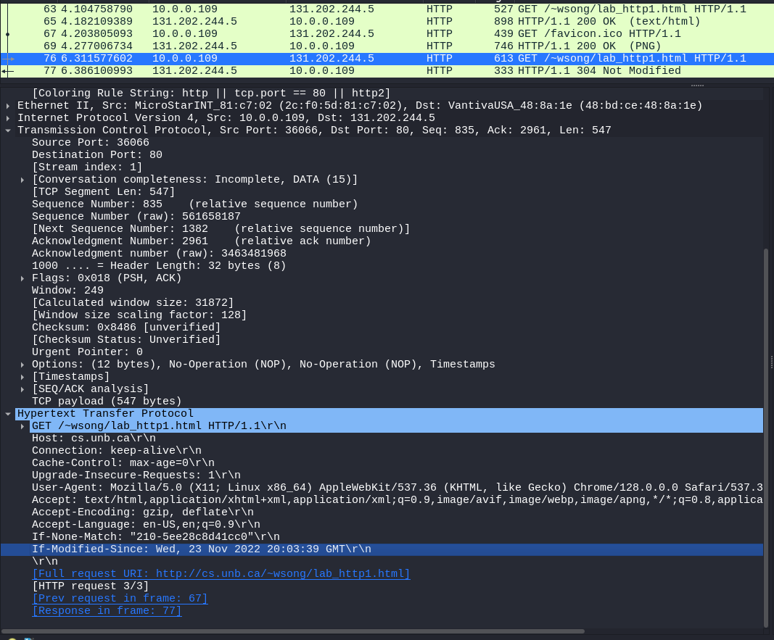

d. What is the HTTP status code and phrase returned from the server in response to this second HTTP GET for “lab_http1.html”? Did the server explicitly return the contents of the file? Explain
The status code for the HTTP response is “304 Not Modified” which means that the “If-Modified- Since” returned that the page was not modified. Because of this, the server did not need to return the contents of the file as the client already had an up-to-date version of it.
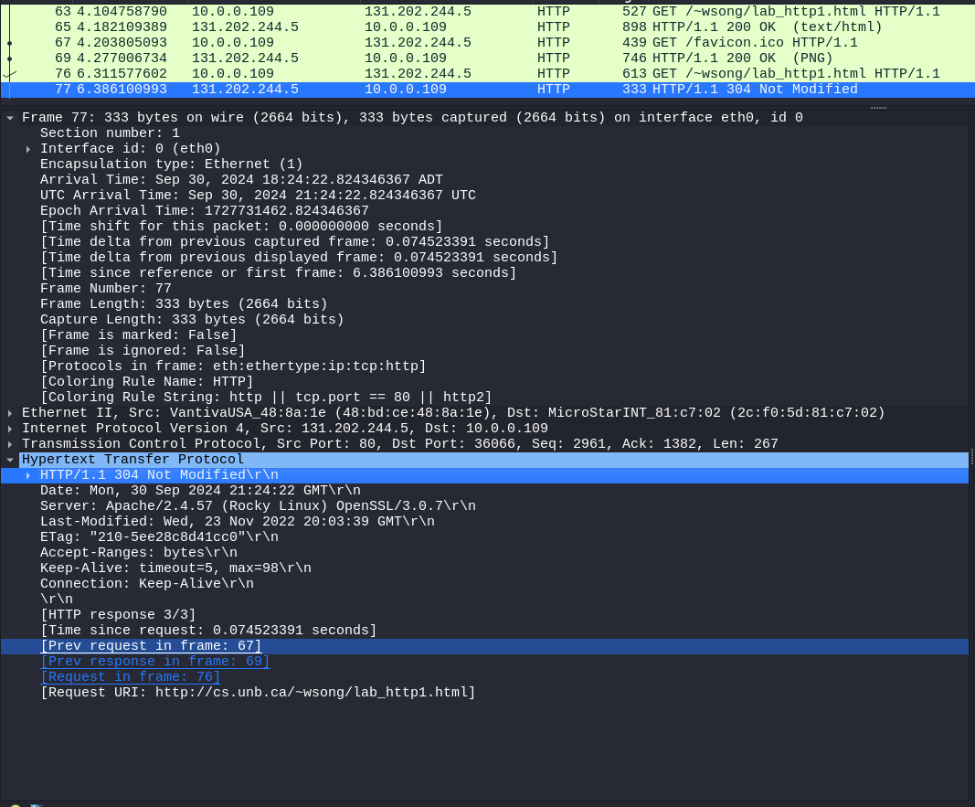

5. Examine your trace captured above and answer the following questions:
a. How many HTTP GET request messages did your browser send? Were these request messages sent toward the same or different Web servers? How can you tell?
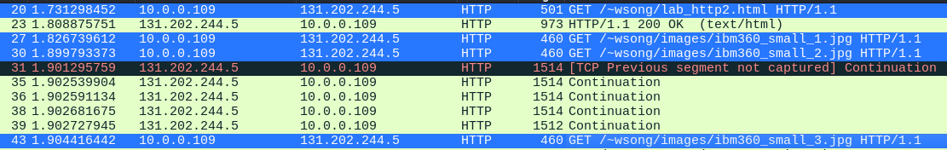
The browser sent 4 HTTP GET requests, all towards the same web server, which I can tell because the destination IP address is the same for all 4.
b. Was persistent or non-persistent HTTP used between your browser and the Web server? How can you tell?
Persistent HTTP was used, which I can tell by looking in the Http section of the GET message, where it says “Connection: keep-alive\r\n”

c. According to the order of the HTTP messages for the embedded images, do you find the browser waits for the response for an earlier request before it sends the HTTP GET request for another image?
The browser does not wait for the response for the GET message. Which can be seen as there are 2 HTTP get messages next to each other, before a response is received. (My response ended up being an error, unsure as of why.)
