CS 3873: Net-Centric Computing
Assignment 4: IP and Network Routing
Student Name: _Adrian Freeman__ Student Number: _3661616_

[Mandatory] Declaration: “I warrant that this is my own work.”
Signed by _Adrian Freeman_
(You can type in your name as your signature.)

From the UNB Undergraduate Calendar, available at the website: http://www.unb.ca/academics/calendar/undergraduate/current/regulations/universitywideacademicregulations/viii-academicoffences/index.html.
“Plagiarism includes:
- quoting verbatim or almost verbatim from any source, regardless of format, without acknowledgement;
- adopting someone else's line of thought, argument, arrangement, or supporting evidence (such as, statistics, bibliographies, etc.) without indicating such dependence;
- submitting someone else's work, in whatever form (essay, film, workbook, artwork, computer materials, etc.) without acknowledgement;
- knowingly representing as one's own work any idea of another.”
Penalties for plagiarism and other academic offences can be found at the above website.

- Suppose IPv4 datagrams are limited to 1,500 bytes (including header) between source Host A and destination Host B. Host A needs to send an MP3 consisting of 5 million bytes over TCP. Assuming only mandatory TCP and IPv4 headers are used and no fragmentation is allowed for IPv4, how many datagrams would be required to send the entire file? Explain how you computed your answer.

IPv4 mandatory header size and TCP mandatory header size are both 20 bytes, so 40 bytes total. 1500 bytes – 40 bytes = 1460 bytes.
5000000Bytes/1460 bytes per datagram = 3424.66 datagrams
You would need 3425 datagrams to send the entire file.

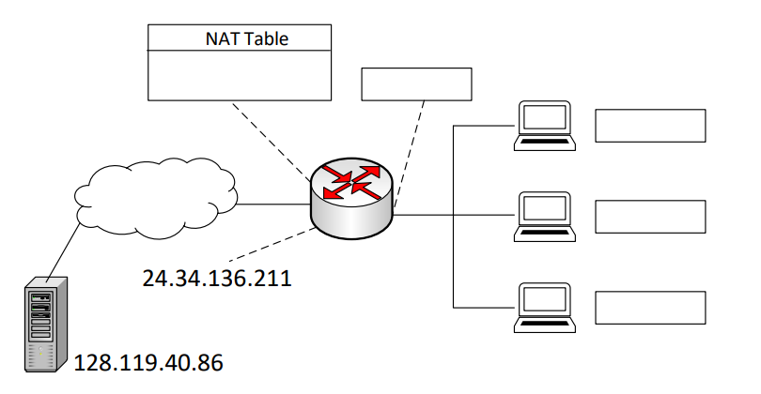
- Consider the network setup in the following figure. Suppose that the ISP assigns the router the address 24.34.136.211 and that the network prefix of the home network is 192.168.1.0/24. `
  - Assign addresses to all 3 interfaces in the home network and the network interface of the router connected to the home network.
192.168.1.1
192.168.1.2
192.168.1.3
192.168.1.4
Router Network Interface: 192.168.1.1
Home Network Interface A: 192.168.1.2
Home Network Interface B: 192.168.1.3
Home Network Interface C: 192.168.1.4

  - Suppose each host has 2 ongoing TCP connections, all to port 80 at host 128.119.40.86. Provide the 6 corresponding entries in the NAT translation table. You can make reasonable assumptions on the port numbers allocated by the local hosts. Note that there can be different correct answers.
NAT Translation Table
WAN Side | LAN Side
24.34.136.211/5000 | 192.168.1.2/5500
24.34.136.211/5001 | 192.168.1.2/5501
24.34.136.211/5002 | 192.168.1.3/5500
24.34.136.211/5003 | 192.168.1.3/5501
24.34.136.211/5004 | 192.168.1.4/5500
24.34.136.211/5005 | 192.168.1.4/5501

- We made a distinction between the forwarding function and the routing function performed in the network layer. What are the key differences between routing and forwarding?
Routing is where routers determine the optimal path for data packets to travel from source to destination, involving creating and updating routing tables based on the network’s layout.
Forwarding is the action of moving the packets through the routers within a network.

- Consider a datagram network using 32-bit host addresses. Suppose a router has five links, numbered 0 through 4, and packets are to be forwarded to the link interfaces as follows:
Destination Address Range | Destination Address Range | Link Interface
11100000 00000000 00000000 00000000 through  11100000 00111111 11111111 11111111 | 224.0.0.0  through  224.63.255.255 | 0
11100000 01000000 00000000 00000000 through  11100000 01000000 11111111 11111111 | 224.64.0.0  through  224.64.255.255 | 1
11100000 01110000 00000000 00000000 through  11100000 01111111 11111111 11111111 | 224.112.0.0  through  224.127.255.255 | 2
11100001 10110000 00000000 00000000 through  11100001 10111111 11111111 11111111 | 225.176.0.0  through  225.191.255.255 | 3
11100010 10000000 00000000 00000000 through  11100010 11111111 11111111 11111111 | 226.128.0.0  through  226.255.255.255 | 4
  - Complete the following forwarding table according to the above setting, assuming longest prefix matching is used to decide where to forward a packet to the correct link interface. Note that the column of network prefix should be presented in the decimal form of a.b.c.d/x.
Network Prefix (Decimal) | Output Link Interface
224.0.0.0/10 | 0
224.64.0.0/16 | 1
224.112.0.0/12 | 2
225.176.0.0/12 | 3
226.128.0.0/9 | 4
  - According to the above forwarding table, give the output link interface for each datagram with the following destination addresses:
225.180.128.1: Output Link Interface 3
224.125.1.2: Output Link Interface 2
224.64.120.1: Output Link Interface 1

- Consider a router that interconnects three subnets: Subnet 1, Subnet 2, and Subnet 3. Suppose all of the interfaces in each of these three subnets should use addresses in a large block defined by prefix 128.16.0.0/12. You need to further divide this large address block into three smaller non-overlapping address blocks for these three subnets. They need to further meet the following conditions:
  - Subnet 1 is required to support at least 300 interfaces, and the last address for this subnet is 128.31.255.255.
300 interfaces, round to 512, subnet mask of /23 because 32-9 (2^9 = 512) = 23
subnet is 128.31.254.0/23
  - Subnet 2 is to support at least 120 interfaces, and the last address for this subnet is 128.16.1.127.
120 interfaces, round to 128, subnet mask is /25 because 32-7 (2^7 = 128) – 25
subnet is 128.16.1.0/25
  - Subnet 3 is to support at least 400 interfaces, and the last address for this subnet is 128.17.7.255.
400 interfaces round to 512, subnet mask is /23, subnet is 128.17.6.0/23
Provide three network prefixes (of the form a.b.c.d/x) for the three subnets that satisfy the above constraints and also minimize the numbers of addresses for these subnets.

