CS 3873: Net-Centric Computing

Lab 5: Examining DHCP and NAT with Wireshark

Student Name: _Adrian Freeman__ Student Number: __3661616___

[Mandatory] Declaration: “I warrant that this is my own work.”
Signed by _Adrian Freeman__

[Optional] “I hereby give my permission for this work to be used (with my name and identifying information removed) for UNB Faculty of Computer Science program accreditation purposes.”
Signed by _Adrian Freeman__

Report for Lab Exercise 5:

Examining DHCP and NAT with Wireshark
ANSWERS TO LAB QUESTIONS:
- The following questions are answered by referring to file dhcp-ethereal-trace-1.pcap I downloaded from D2L:
- A host uses DHCP to obtain an IP address, among other things. But a host’s IP address is not confirmed until the DHCP ACK is exchanged between the client and server! For the first four DHCP messages (DHCP Discover/Offer/Request/ACK), indicate the source and destination IP addresses that are carried in the encapsulating IP datagram, also indicate the source and destination port numbers that can be found in the UDP segment header. What is the IP address of the DHCP server?
Referring to the following figures, I have the answer in the following table. The IP address of the DHCP server is _192.168.1.1_.
Message | Source Address | Destination Address | Source Port | Destination Port
DHCP Discover | 0.0.0.0 | 255.255.255.255 | 68 | 67
DHCP Offer | 192.168.1.1 | 255.255.255.255 | 67 | 68
DHCP Request | 0.0.0.0 | 255.255.255.255 | 68 | 67
DHCP ACK | 192.168.1.1 | 255.255.255.255 | 67 | 68
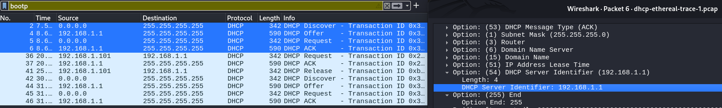
- What is the value of the Transaction-ID in the first four DHCP messages (DHCP Discover/Offer/Request/ACK)? What are the values of the Transaction-ID in the second set of messages (DHCP Request/ACK)? What is the purpose of the Transaction-ID field?
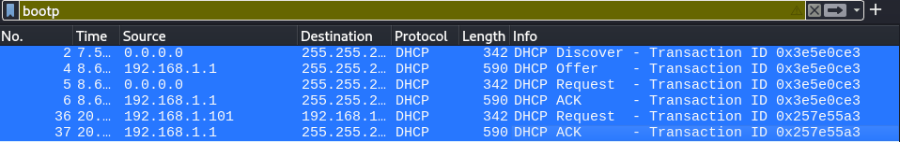
The transaction ID for the first four DHCP messages is 0x3e5e0ce3. The ID for the second set is 0x257e55a3. The purpose of the ID is to help identify and match requests and responses, so that we know, for example, which ACK belongs to which Request.

- The DHCP server offers a specific IP address to the client with the DHCP Offer message. What IP address is the DHCP server offering to the host in the first DHCP Offer message? In addition, what are the router address, subnet mask, domain name, and Domain Name Server given in the DHCP Offer message?
IP Address Offered | Router Address | Subnet Mask | Domain Name | Domain Name Server
192.168.1.101 | 192.168.1.1 | 255.255.255.0 | ne2.client2.attbi.com | 63.240.76.19 and 204.127.198.19

- In the client’s response (DHCP Request) to the server’s first DHCP Offer message, does the client accept the offered IP address? How can you tell?
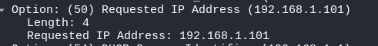
Yes, because the client is now requesting the offered IP address. 192.168.1.101

- To release an allocated IP address, a client sends a DHCP Release message to the DHCP server. Does the DHCP server issue an acknowledgment of receipt of the client’s DHCP request? What would happen if the client’s DHCP Release message is lost?
The DHCP server does not send an ACK in response to a Release. If the release message is lost, the DHCP server will retain the lease until it is expired. Until then it will be marked as in use.
- Use Wireshark to examine the trace file NAT_home_side.pcap and answer the following questions in your lab report. In order to display only those frames containing HTTP messages that are sent to/from this Google server, enter the expression “http && ip.addr == 64.233.169.104” (without quotes) into the Filter in Wireshark .
  - Consider now the HTTP GET sent from the client to the Google server (whose IP address is 64.233.169.104) at time 7.109267. What are the source and destination IP addresses and TCP source and destination ports on the IP datagram carrying this HTTP GET?
Source IP | Destination IP | Source Port | Destination Port
192.168.1.100 | 64.233.169.104 | 4335 | 80
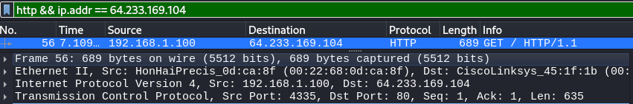
  - At what time is the corresponding HTTP 200 OK message for the above HTTP GET message received from the HTTP server? What are the source and destination IP addresses and TCP source and destination ports on the IP datagram carrying this HTTP 200 OK message?
Time Received | Source IP | Destination IP | Source Port | Destination Port
7.158797 | 64.233.169.104 | 192.168.1.100 | 80 | 4335
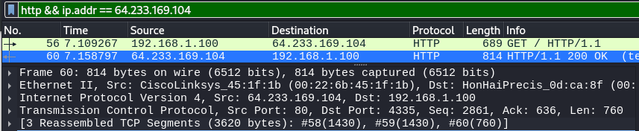
  - Recall that before an HTTP GET command can be sent to an HTTP server, TCP must first set up a connection using the three-way handshake. (Note: To find these segments you will need to clear the Filter expression you entered above and enter the filter “tcp” in the Filter.)
    - At what time is the client-to-server TCP SYN segment sent that sets up the connection used by the HTTP GET sent at time 7.109267? What are the source and destination IP addresses and source and destination ports for the TCP SYN segment?
Time Received | Source IP | Destination IP | Source Port | Destination Port
7.075657 | 192.168.1.100 | 64.233.169.104 | 4335 | 80
    - What are the source and destination IP addresses and source and destination ports of the TCP SYN/ACK sent in response to the TCP SYN? At what time is this TCP SYN/ACK sent from the server?
Time Received | Source IP | Destination IP | Source Port | Destination Port
7.108986 | 64.233.169.104 | 192.168.1.100 | 80 | 4335
    - What are the source and destination IP addresses and source and destination ports of the TCP ACK segment sent at the end of the three-way handshake. At what time is this TCP ACK sent from the client?
Time Received | Source IP | Destination IP | Source Port | Destination Port
7.109053 | 192.168.1.100 | 64.233.169.104 | 4335 | 80

- Use Wireshark to examine the trace file NAT_ISP_side.pcap and answer the following questions in your lab report. In order to display only those frames containing HTTP messages that are sent to/from this Google server, enter the expression “http && ip.addr == 64.233.169.104” (without quotes) into the Filter in Wireshark.
  - In the trace file NAT_ISP_side.pcap, find the HTTP GET message was sent from the client to the Google server (whose IP address is 64.233.169.104) at time 7.109267 (where t=7.109267 is time at which this was sent as recorded in the trace file NAT_home_side.pcap). At what time does this message appear in the trace file NAT_ISP_side.pcap? What are the source and destination IP addresses and TCP source and destination ports on the IP datagram carrying this HTTP GET (as recording in the trace file NAT_ISP_side.pcap)? Which of these fields are the same as, and which are different from, your answer to question 4.a) above?
Time Received | Source IP | Destination IP | Source Port | Destination Port
6.069168 | 71.192.34.104 | 64.233.169.104 | 4335 | 80
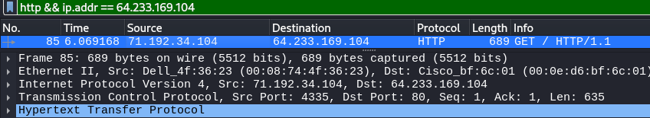
The only differences from 4.a) are the time received, and the source IP. As the source IP on the home side was the local IP address. The rest, Destination IP, and the Source and Destination Ports, are the
  - In the trace file NAT_ISP_side.pcap, at what time is the first HTTP 200 OK message received from the Google server? What are the source and destination IP addresses and TCP source and destination ports on the IP datagram carrying this HTTP 200 OK message? Which of these fields are the same as, and which are different from, your answer to question 4.b) above?
Time Received | Source IP | Destination IP | Source Port | Destination Port
6.117570 | 64.233.169.104 | 71.192.34.104 | 80 | 4335
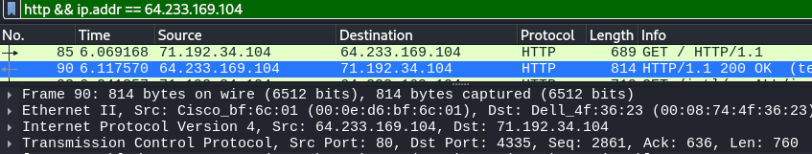
The only differences were the time received as well as the destination IP. The rest is the same.
  - In the trace file NAT_ISP_side.pcap, answer the same question as in 4.c)? Which of these fields are the same as, and which are different from, your answer to question 4.c) above?
Recall that before an HTTP GET command can be sent to an HTTP server, TCP must first set up a connection using the three-way handshake. (Note: To find these segments you will need to clear the Filter expression you entered above and enter the filter “tcp” in the Filter.)
    - At what time is the client-to-server TCP SYN segment sent that sets up the connection used by the HTTP GET sent at time 7.109267? What are the source and destination IP addresses and source and destination ports for the TCP SYN segment?
Time Received | Source IP | Destination IP | Source Port | Destination Port
6.035475 | 71.192.34.104 | 64.233.169.104 | 4335 | 80
The only differences are the time and the source IP. The rest is the same
    - What are the source and destination IP addresses and source and destination ports of the TCP SYN/ACK sent in response to the TCP SYN? At what time is this TCP SYN/ACK sent from the server?
Time Received | Source IP | Destination IP | Source Port | Destination Port
6.067775 | 64.233.169.104 | 71.192.34.104 | 80 | 4335
The only differences are the time and destination IP. The rest is the same.
    - What are the source and destination IP addresses and source and destination ports of the TCP ACK segment sent at the end of the three-way handshake. At what time is this TCP ACK sent from the client?
Time Received | Source IP | Destination IP | Source Port | Destination Port
6.068754 | 71.192.34.104 | 64.233.169.104 | 4335 | 80
The only differences are the time received and the source IP. The rest is the same.
  - Using your answers to the above questions, fill in the NAT translation table entries for the HTTP connection considered above.
NAT Translation Table
WAN Side | LAN Side
71.192.34.104:4335 | 192.168.1.100:4335

