CS 3873: Net-Centric Computing

Lab 6: Monitor with UDP Socket

Student Name: _Adrian Freeman__ Student Number: _3661616_

[Mandatory] Declaration: “I warrant that this is my own work.”
Signed by __Adrian Freeman___

[Optional] “I hereby give my permission for this work to be used (with my name and identifying information removed) for UNB Faculty of Computer Science program accreditation purposes.”
Signed by __Adrian Freeman__

Report for Lab Exercise 6: Monitor with UDP Socket
LAB ACTIVITIES:
In this lab, a client and a server are written in Java to implement a simple application that monitors network conditions with UDP sockets.
PROGRAM SOLUTION:
Please submit all your Java files to the D2L dropbox. It will be 0 points without the Java source files.
PROGRAM RUNNING INSTRUCTIONS:
Please compile and run the uploaded Java programs using the following commands:
(give the commands to compile and run your programs, and other instructions if any)
javac -cp .:jfreechart-2.0.0-SNAPSHOT.jar MonitorClient.java plotRTT.java
java -cp .:jfreechart-2.0.0-SNAPSHOT.jar:. MonitorClient <Server Address> <Server Port>
RESULT PLOTS:
The following is the plots required for this lab:
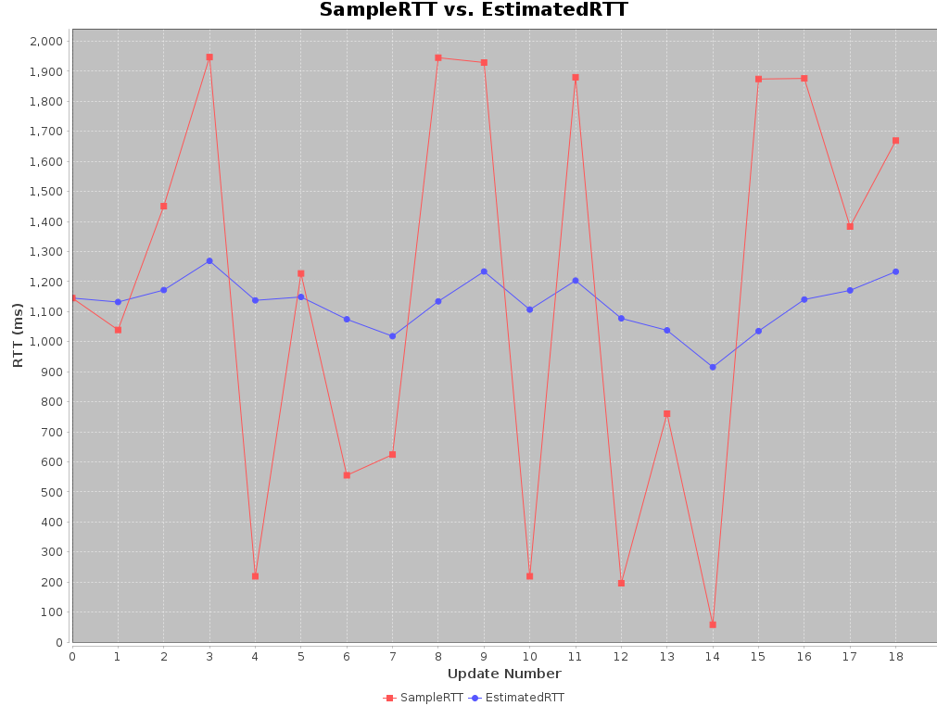

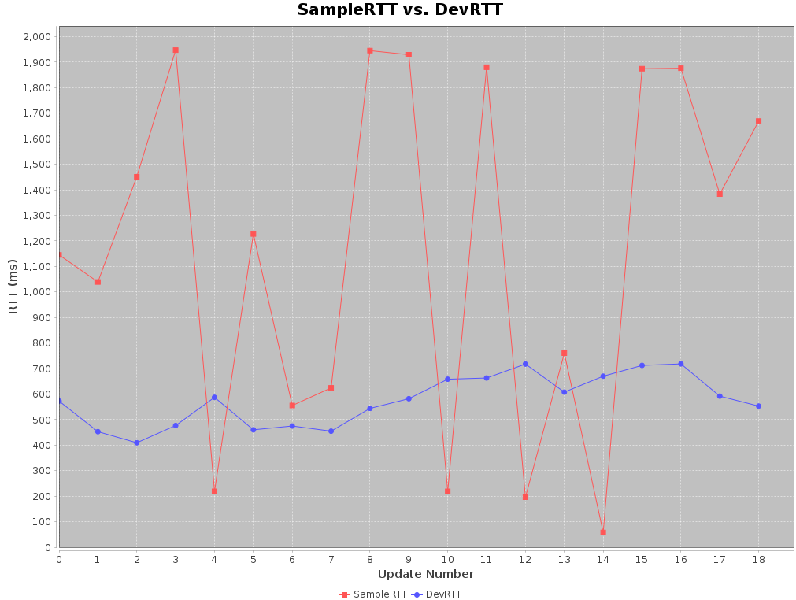
MARKING FEEDBACK:
Please leave this section blank for marking feedback to your code.

