A Math: What to Remember
Accuracy
$$α=36.86990° \text{← keep 5 d.p. while working}$$
$$α=36.9° \text{← round only the final answer: angles 1 d.p., others 3 s.f.}$$
$$\sqrt{8}=2\sqrt{2} \text{← "exact" means no decimals}$$

★ Never leave a part blank
Write the first step even if you are stuck, e.g. $\frac{dy}{dx}=3x^{2}-12=0$. A method line can still earn a mark.
Check the calculator: degrees or radians, before every trig question.

Quadratics

★ Range of $k$ for real roots
The equation $kx^{2}+6x+3=0$ has real roots. Find the range of $k$.
$$b^{2}-4ac≥0 \text{← “real” means }≥0\text{, not }>0 \\ 6^{2}-4(k)(3)≥0 \text{← }a=k, b=6, c=3 \\ 36-12k≥0 \\ -12k≥-36 \\ k≤3 \text{← divide by a negative: flip the sign}$$
Since $k=0$ makes it not a quadratic, the answer is $k≤3$, $k≠0$.

★ Quadratic inequality: read the answer off the graph
Solve $x^{2}-5x+4>0$.
✗ Common mistake  $$(x-1)(x-4)>0$$  $$x>1 \text{or} x>4 \text{← treated each bracket alone}$$  $$x>4$$ | ✓ Correct  $$(x-1)(x-4)>0$$  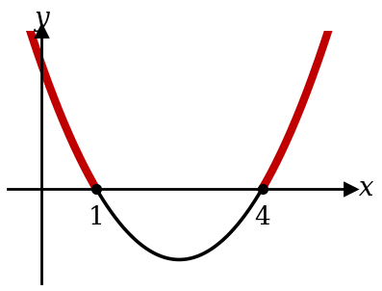  $$x<1\text{ or }x>4 \text{← }>0\text{ is ABOVE the axis}$$

Always positive needs TWO conditions
Find the range of $p$ for which $px^{2}+4x+p$ is positive for all real $x$.
$$p>0 \text{← condition 1: the curve opens upwards}$$
$$b^{2}-4ac<0 \text{← condition 2: never meets the }x\text{-axi}\text{s}$$

Min value by completing the square
Find the minimum value of $2x^{2}-8x+5$ and the value of $x$ where it occurs.
$$2x^{2}-8x+5=2(x^{2}-4x)+5 \text{← take out the 2 first} \\ =2\left[(x-2)^{2}-4\right]+5 \text{← half of }-4\text{, squared} \\ =2(x-2)^{2}-3 \text{← the 2 multiplies BOTH terms}$$
$$\text{Min value}=-3\text{ when }x=2 \text{← the }\text{MIN }\text{VALUE is }y\text{, not }x$$

Surds

Squared both sides? Check every answer
Solve $\sqrt{x+8}=x+2$.
$$x+8=(x+2)^{2} \text{← square the WHOLE right side} \\ x+8=x^{2}+4x+4 \\ x^{2}+3x-4=0 \\ (x+4)(x-1)=0$$
$$x=1 \text{or} x=-4\text{ (rej)} \text{← }x=-4\text{: }\sqrt{4}=2\text{, but }-4+2=-2$$

Equal surd forms: compare the two kinds
Given $(2+\sqrt{3})(a-\sqrt{3})=5+b\sqrt{3}$, find $a$ and $b$.
$$2a-2\sqrt{3}+a\sqrt{3}-3=5+b\sqrt{3} \\ (2a-3)+(a-2)\sqrt{3}=5+b\sqrt{3} \text{← group whole numbers, then surds}$$
$$2a-3=5⇒a=4 a-2=b⇒b=2$$

Indices

★ A number in front stays out of the base
Solve $2×3^{x}=54$.
✗ Common mistake  $$6^{x}=54 \text{← multiplied the 2 into the base}$$ | ✓ Correct  $$3^{x}=27 \text{← divide by 2 first}$$  $$3^{x}=3^{3}$$  $$x=3$$

Same base, then equate the powers
Solve $8^{x+1}=4^{x}$.
$$2^{3(x+1)}=2^{2x} \text{← write 8 and 4 as powers of 2} \\ 3x+3=2x \\ x=-3$$

★ Substitution $→$ quadratic/cubic equation
Solve $9^{x}-2(3^{x})-3=0$.
$$\text{Let }u=3^{x} \text{← }9^{x}=(3^{x})^{2}=u^{2}$$
$$u^{2}-2u-3=0 \\ (u-3)(u+1)=0$$
$$3^{x}=3⇒x=1 3^{x}=-1\text{ (no solution)} \text{← }3^{x}>0\text{ always}$$

Polynomials
★ Solve a cubic: find one root, then factorise
Solve $x^{3}-7x+6=0$.
$$f(1)=1-7+6=0 \text{← try factors of 6: }±1,±2,±3$$
$$(x-1)(x^{2}+x-6)=0 \text{← divide, or compare coefficients} \\ (x-1)(x-2)(x+3)=0$$
$$x=1, 2\text{ or }-3 \text{← a cubic can have three roots}$$

Sum and difference of cubes (not on the formula sheet)
Factorise $8x^{3}-27$.
$$8x^{3}-27=(2x)^{3}-3^{3} \text{← write each as a cube first} \\ =(2x-3)(4x^{2}+6x+9) \text{← }a^{3}-b^{3}=(a-b)(a^{2}+ab+b^{2})$$

Partial fractions

Top degree $≥$ bottom degree: do long division first
Express $\frac{x^{2}+1}{x^{2}-1}$ in partial fractions.
$$\frac{x^{2}+1}{x^{2}-1}=1+\frac{2}{(x-1)(x+1)} \text{← same degree: divide first}$$
$$2=A(x+1)+B(x-1) \\ x=1: A=1 \text{← pick }x\text{ to make a bracket 0} \\ x=-1: B=-1$$
$$\frac{x^{2}+1}{x^{2}-1}=1+\frac{1}{x-1}-\frac{1}{x+1} \text{← do not drop the 1}$$

Choose the right form
$$\frac{3x+1}{(x+2)(x-1)^{2}}=\frac{A}{x+2}+\frac{B}{x-1}+\frac{C}{(x-1)^{2}} \text{← repeated factor: BOTH powers}$$
$$\frac{x+5}{(x-1)(x^{2}+2)}=\frac{A}{x-1}+\frac{Bx+C}{x^{2}+2} \text{← }x^{2}+2\text{ will not factorise: }Bx+C\text{ on top}$$

★ Integrating partial fractions: $+ c$
Find $∫\left(\frac{1}{x-1}-\frac{1}{x+1}\right)dx$.
✗ Common mistake  $$ln(x-1)-ln(x+1)$$ | ✓ Correct  $$ln(x-1)-ln(x+1)+c$$

Binomial theorem

Term independent of $x$: power of $x$ is 0
Find the term independent of $x$ in ${\left(x^{2}+\frac{3}{x}\right)}^{6}$.
$$T_{r+1}=\left({6 \atop r}\right)(x^{2})^{6-r}{\left(\frac{3}{x}\right)}^{r}=\left({6 \atop r}\right)3^{r}x^{12-3r} \text{← power the whole bracket}$$
$$12-3r=0⇒r=4$$
$$\text{Term}=\left({6 \atop 4}\right)3^{4}=15×81=1215$$

Bracket times an expansion: collect every pair
Find the coefficient of $x^{2}$ in $(1+3x)(1-2x)^{5}$.
$$(1+3x)(1-10x+40x^{2}+…)$$
$$x^{2}: 1(40)+3(-10)=10 \text{← }1×x^{2}\text{ AND }3x×x$$

Exponentials and logarithms

★ Reject answers that make a log undefined
Solve $lgx+lg(x-3)=1$.
✗ Common mistake  $$x(x-3)=10$$  $$x=5\text{ or }x=-2 \text{← kept }-2$$ | ✓ Correct  $$lgx(x-3)=lg10 \text{← }1=lg10$$  $$x^{2}-3x-10=0$$  $$x=5 \text{or} x=-2\text{ (rej)} \text{← }lg(-2)\text{ is undefined}$$

★ Log laws: the number in front becomes a power
Solve $2lgx-lg4=lg9$.
$$lgx^{2}-lg4=lg9 \text{← }2lgx=lgx^{2}\text{, not }lg2x \\ lg\frac{x^{2}}{4}=lg9 \\ x^{2}=36$$
$$x=6 \text{or} x=-6\text{ (rej)}$$

Bases will not match: take lg of both sides
Solve $3^{2x}=5$.
$$2xlg3=lg5 \text{← the power comes down} \\ x=\frac{lg5}{2lg3}=0.732$$

Different bases: change to one base
Solve $\log_{2}x+\log_{4}x=6$.
$$\log_{4}x=\frac{\log_{2}x}{\log_{2}4}=\frac{\log_{2}x}{2} \text{← change to base 2}$$
$$\frac{3}{2}\log_{2}x=6 \\ \log_{2}x=4 \\ x=2^{4}=16$$

Graphs: the asymptote and the long run
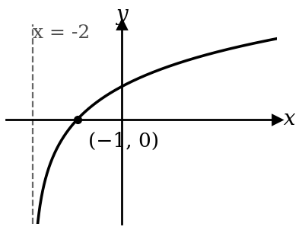  $$y=ln(x+2)$$  Asymptote: inside $=0$, so $x=-2$.  $x$-intercept: inside $=1$, so $x=-1$. | 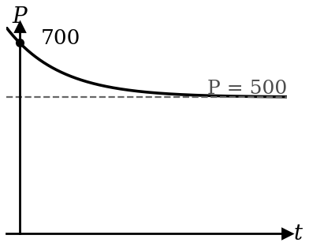  $$P=500+200e^{-kt}$$  Initial value: $t=0$, so $P=700$.  Long run: $e^{-kt}→0$, so $P→500$.

Trigonometry: equations and identities

★ Find EVERY angle in the range
Solve $sin x=-0.5$ for $0°≤x≤360°$.
✗ Common mistake  $$x=\sin^{-1}(-0.5)=-30° \text{← outside the range}$$ | ✓ Correct  $$\text{basic angle}=30° \text{← from }+0.5$$  $$sin x<0\text{: 3rd and 4th quadrants}$$  $$x=180°+30°=210°$$  $$x=360°-30°=330°$$

★ Never divide by $sin x$: factorise
Solve $2 sin x cos x=sin x$ for $0°≤x≤360°$.
✗ Common mistake  $$2 cos x=1 \text{← divided by } sin x$$  $$x=60°, 300° \text{← lost three answers}$$ | ✓ Correct  $$sin x(2 cos x-1)=0$$  $$sin x=0\text{: }x=0°, 180°, 360°$$  $$cos x=\frac{1}{2}\text{: }x=60°, 300°$$

R-formula

★ Find $R$ and $α$; give the max AND where it happens
Express $3 sin x+4 cos x$ as $R sin(x+α)$. Hence find its maximum value.
$$R=\sqrt{3^{2}+4^{2}}=5 tan α=\frac{4}{3} \text{← }R cos α=3, R sin α=4$$
$$α=53.13° \text{← keep full accuracy}$$
$$3 sin x+4 cos x=5 sin(x+53.13°)$$
$$\text{Max}=5\text{ when }x+53.13°=90°\text{, so }x=36.9° \text{← state the }x\text{ too}$$

★ Shift the range before listing angles
Solve $5 sin(x+53.13°)=2.5$ for $0°≤x≤360°$.
✗ Common mistake  $$x+53.13°=30°, 150°$$  $$x=-23.1° \text{← out of range}$$  $$x=96.9°$$ | ✓ Correct  $$53.13°≤x+53.13°≤413.13°$$  $$x+53.13°=150°, 390° \text{← 30° is below the range}$$  $$x=96.9°, 336.9°$$

Trigonometric graphs

Find $a$, $b$, $c$ from the graph
The graph shows $y=a cos bx+c$. Find $a$, $b$ and $c$.
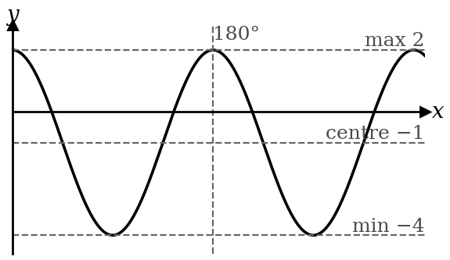 | $$c=\frac{2+(-4)}{2}=-1 \text{← centre line}$$  $$a=\frac{2-(-4)}{2}=3 \text{← half the height}$$  $$\text{period}=180° \text{← gap between two maxima}$$  $$b=\frac{360°}{180°}=2$$  Starts at its max, so $cos$ with $a>0$: $y=3 cos 2x-1$.

★ Count solutions with the drawn curve
Using the graph of $y=2 sin 2x$, find the number of solutions of $4 sin 2x=1$ for $0°≤x≤360°$.
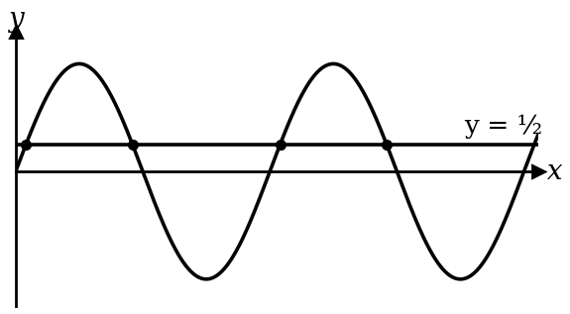 | $$2 sin 2x=\frac{1}{2} \text{← make one side the drawn curve}$$  $$\text{Draw }y=\frac{1}{2}$$  4 crossings, so 4 solutions.

Amplitude and period
$$y=-2 sin 3x\text{: amplitude }2\text{ (never negative), period }\frac{360°}{3}=120°$$
$$y=tan 2x\text{: no amplitude, period }\frac{180°}{2}=90° \text{← tan uses 180°}$$

Coordinate geometry

Perpendicular bisector: midpoint + flipped gradient
Find the perpendicular bisector of $A(1,2)$ and $B(5,6)$.
$$\text{Midpoint}=(3, 4) \text{← the bisector passes through the MIDPOINT}$$
$$m_{AB}=\frac{6-2}{5-1}=1 m_{⟂}=-1 \text{← flip and change sign}$$
$$y-4=-(x-3) \\ y=-x+7$$

Area: go anticlockwise and repeat the first point
Find the area of the triangle $(0,0)$, $(4,1)$, $(1,3)$.
$$\text{Area}=\frac{1}{2}\left|\begin{matrix}0 & 4 & 1 & 0 \\ 0 & 1 & 3 & 0\end{matrix}\right| \text{← first point again at the end}$$
$$=\frac{1}{2}\left|(0+12+0)-(0+1+0)\right|=5.5{\text{ units}}^{2}$$

Linear law

★ $y=ax^{n}$: take lg, then un-log the intercept
A graph of $lgy$ against $lgx$ is a straight line with gradient 1.5 and intercept 0.48. Find $a$ and $n$.
$$lgy=nlgx+lga \text{← take lg of both sides}$$
$$Y=lgy, X=lgx \text{← say what each axis is}$$
$$n=1.5 lga=0.48⇒a={10}^{0.48}=3.02 \text{← not }a=0.48$$

No logs needed: multiply to get a constant term
Express $y=ax+\frac{b}{x}$ in a form to draw a straight line.
$$xy=ax^{2}+b \text{← times }x\text{: }b\text{ is now on its own}$$
$$Y=xy, X=x^{2}, \text{gradient}=a, \text{intercept}=b$$

★ Every step of the graph question carries marks
Table of $X$ and $Y$ (3 s.f.) → plot → rule ONE straight line → gradient from two points ON your line, far apart → intercept → the constants.
Use the scale printed on the grid. "Use your graph" means draw a line and read the crossing.

Circles

Centre and radius: make $x^{2}$ and $y^{2}$ coefficients 1 first
Find the centre and radius of $2x^{2}+2y^{2}-8x+4y-10=0$.
$$x^{2}+y^{2}-4x+2y-5=0 \text{← divide by 2}$$
$$(x-2)^{2}+(y+1)^{2}=5+4+1 \text{← complete the square}$$
$$\text{centre }(2, -1), r=\sqrt{10} \text{← the signs flip}$$

★ Tangent: state the reason
The circle has centre $C(1,1)$ and passes through $P(3,2)$. Find the tangent at $P$.
$$m_{CP}=\frac{2-1}{3-1}=\frac{1}{2}$$
$$m_{\text{tangent}}=-2 \text{← tangent}⟂\text{radius: write this reason}$$
$$y-2=-2(x-3) \\ y=-2x+8$$

Proofs in plane geometry

★ Every statement needs its reason
$AT$ is a tangent at $A$. Show that $∠TAB=∠ACB$.
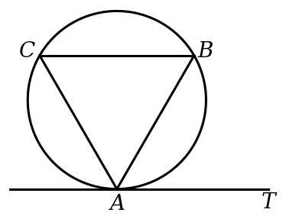
✗ Common mistake  $$∠TAB=∠ACB \text{← no reason: no mark}$$ | ✓ Correct  $$∠TAB=∠ACB$$  (angles in alternate segment)

Similar triangles: read the sides in the same order
$$△ABC\text{ is similar to }△PQR ⇒ \frac{AB}{PQ}=\frac{BC}{QR}=\frac{AC}{PR} \text{← 1st with 1st, 2nd with 2nd}$$
Congruence tests: SSS, SAS, ASA, AAS, RHS. There is no ASS.

Differentiation: rules

★ Chain rule: times the derivative of the inside
Differentiate $(3x^{2}-1)^{5}$.
✗ Common mistake  $$5(3x^{2}-1)^{4} \text{← stopped before the inside}$$ | ✓ Correct  $$5(3x^{2}-1)^{4}×6x \text{← derivative of }3x^{2}-1$$  $$=30x(3x^{2}-1)^{4}$$

★ Product rule: two terms
Differentiate $x^{2} sin 2x$.
✗ Common mistake  $$2x×2 cos 2x \text{← differentiated each factor}$$ | ✓ Correct  $$2x sin 2x+x^{2}(2 cos 2x) \text{← diff first, keep second; + keep first, diff second}$$  $$=2x sin 2x+2x^{2} cos 2x$$

Quotient rule: the order matters
Differentiate $\frac{2x+1}{x-3}$.
$$\frac{dy}{dx}=\frac{(x-3)(2)-(2x+1)(1)}{(x-3)^{2}} \text{← bottom × top' MINUS top × bottom'} \\ =\frac{-7}{(x-3)^{2}}$$

ln: split with the log laws first
Differentiate $ln\frac{x^{2}}{x+1}$.
$$ln\frac{x^{2}}{x+1}=2lnx-ln(x+1) \text{← much easier than the quotient rule}$$
$$\frac{dy}{dx}=\frac{2}{x}-\frac{1}{x+1}$$
Calculus with trig is always in radians.

Differentiation: tangents, normals, rates of change

★ Normal: $-1$ over the gradient
Find the normal to $y=x^{2}+1$ at $x=2$.
$$\frac{dy}{dx}=2x=4 \text{← gradient of the TANGENT}$$
$$y=2^{2}+1=5 \text{← }y\text{ from the curve, not from }\frac{dy}{dx}$$
$$m_{\text{normal}}=-\frac{1}{4} \text{← not }-4$$
$$y-5=-\frac{1}{4}(x-2) \\ y=-\frac{1}{4}x+\frac{11}{2}$$

★ Rates: differentiate first, numbers last
The radius of a sphere grows at 0.1 cm/s. Find the rate of change of its volume when $r=5$ cm.
$$V=\frac{4}{3}πr^{3} \frac{dV}{dr}=4πr^{2} \text{← differentiate BEFORE putting }r=5$$
$$\frac{dV}{dt}=\frac{dV}{dr}×\frac{dr}{dt} \text{← the }dr\text{s cancel}$$
$$=4π(5)^{2}(0.1)=10π{\text{ cm}}^{3}\text{/s} {\text{← units: cm}}^{3}\text{ per second}$$

Differentiation: stationary points, max and min

★ Give the max VALUE, and prove it is a max
Find the maximum value of $y=12x-x^{3}$ for $x>0$.
✗ Common mistake  $$12-3x^{2}=0$$  $$x=2 \text{← stopped at }x$$ | ✓ Correct  $$12-3x^{2}=0⇒x=2$$  $$\frac{d^{2}y}{dx^{2}}=-6x=-12<0\text{, so max} \text{← prove it}$$  $$y=24-8=16 \text{← the max VALUE}$$

★ Optimisation: use the condition to get ONE variable
A rectangle has perimeter 20 cm. Find its largest area.
$$x+y=10⇒A=x(10-x) \text{← now only }x$$
$$\frac{dA}{dx}=10-2x=0⇒x=5 \frac{d^{2}A}{dx^{2}}=-2<0\text{, max}$$
$$A=25{\text{ cm}}^{2}$$

Increasing: solve $\frac{dy}{dx}>0$, not $=0$
Find where $y=x^{3}-12x$ is increasing.
$$3x^{2}-12>0 \\ (x-2)(x+2)>0$$
$$x<-2\text{ or }x>2 \text{← read it off the sketch, as for any quadratic}$$

Integration and area

★ Linear bracket: also divide by the $x$ coefficient
Find $∫(2x+1)^{3} dx$.
✗ Common mistake  $$\frac{(2x+1)^{4}}{4} \text{← forgot the 2 inside, and }c$$ | ✓ Correct  $$\frac{(2x+1)^{4}}{4×2}+c=\frac{(2x+1)^{4}}{8}+c$$

★ Divide by the inside number, never multiply
$$∫ cos 3x dx=\frac{1}{3} sin 3x+c \text{← not }3 sin 3x$$
$$∫e^{2x} dx=\frac{1}{2}e^{2x}+c ∫\frac{1}{2x+1} dx=\frac{1}{2}ln(2x+1)+c$$
$$∫ \cos^{2} x dx=∫\frac{1}{2}(1+cos 2x) dx=\frac{1}{2}x+\frac{1}{4} sin 2x+c \text{← identity first}$$

★ Find $c$ from the given point
The gradient is $\frac{dy}{dx}=6x^{2}-2$ and the curve passes through $(1,5)$.
$$y=2x^{3}-2x+c \text{← }+c\text{ every time}$$
$$5=2-2+c⇒c=5 y=2x^{3}-2x+5$$

★ Area below the $x$-axis: split, then add the sizes
Find the area between $y=x^{2}-2x$, the $x$-axis, $x=0$ and $x=3$.
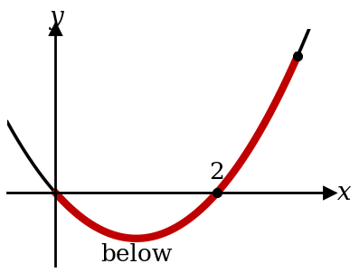 | $$x^{2}-2x=0⇒x=0, 2 \text{← solve }y=0\text{ first}$$  $$\int_{0}^{2}{(}x^{2}-2x) dx=-\frac{4}{3} \text{← negative: below}$$  $$\int_{2}^{3}{(}x^{2}-2x) dx=\frac{4}{3}$$  $$\text{Area}=\frac{4}{3}+\frac{4}{3}=\frac{8}{3}{\text{ units}}^{2}$$

Kinematics

★ Total distance: check if it turns back
$v=t^{2}-4t+3$ m/s. Find the distance travelled in the first 4 s.
✗ Common mistake  $$s=\frac{1}{3}t^{3}-2t^{2}+3t$$  $$s(4)=\frac{4}{3}\text{ m} \text{← this is displacement}$$ | ✓ Correct  $$v=0\text{: }t=1, 3 \text{← it turns here}$$  $$s(0)=0, s(1)=\frac{4}{3}, s(3)=0, s(4)=\frac{4}{3}$$  $$\frac{4}{3}+\frac{4}{3}+\frac{4}{3}=4\text{ m} \text{← add each leg}$$

★ Integrating: find $c$ from the starting values
$a=6t$ ${\text{m/s}}^{2}$ and $v=2$ m/s when $t=0$. Find $v$.
$$v=3t^{2}+c \text{← }+c$$
$$2=0+c⇒c=2 v=3t^{2}+2\text{ m/s}$$

Key words
$$\text{at rest: }v=0 \text{max or min velocity: }a=0 \text{meet or overtake: }s_{A}=s_{B}$$
$$v=5-3e^{-t}\text{: initial }v=2\text{ m/s;} \text{as }t→∞\text{, }e^{-t}→0\text{, so }v→5\text{ m/s}$$
Speed is never negative ($v=-3$ gives speed 3 m/s). Acceleration is in ${\text{m/s}}^{2}$.

