A Math: Quick Checklist
Accuracy
$$α=36.86990° \text{← keep 5 d.p. while working}$$
$$α=36.9° \text{← round only the final answer: angles 1 d.p., others 3 s.f.}$$
$$\sqrt{8}=2\sqrt{2} \text{← "exact" means no decimals}$$

★ Never leave a part blank
Write the first step even if you are stuck, e.g. $\frac{dy}{dx}=3x^{2}-12=0$. A method line can still earn a mark.
Check the calculator: degrees or radians, before every trig question.

Quadratic Functions

Range of $k$ for real roots
The equation $kx^{2}+6x+3=0$ has real roots. Find the range of $k$.
$$b^{2}-4ac≥0 \text{← “real” means }≥0\text{, not }>0 \\ 6^{2}-4(k)(3)≥0 \text{← }a=k, b=6, c=3 \\ 36-12k≥0 \\ -12k≥-36 \\ k≤3 \text{← divide by a negative: flip the sign}$$
Since $k=0$ makes it not a quadratic, the answer is $k≤3$, $k≠0$.

★ Quadratic inequality: read the answer off the graph
Solve $x^{2}-5x+4>0$.
✗ Common mistake  $$(x-1)(x-4)>0$$  $$x>1\text{ or }x>4 \text{← treated each bracket alone}$$  $$x>4$$ | ✓ Correct  $$(x-1)(x-4)>0$$  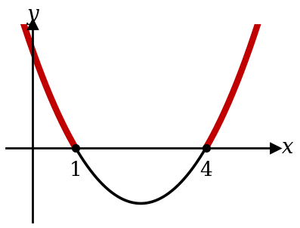  $$x<1\text{ or }x>4 \text{← }>0\text{ is ABOVE the axis}$$

★ Always positive needs TWO conditions
Find the range of $p$ for which $px^{2}+4x+p$ is positive for all real $x$.
$$p>0 \text{← condition 1: the curve opens upwards}$$
$$b^{2}-4ac<0 \text{← condition 2: never meets the }x\text{-axis}$$

★ "$>0$ for all $x$" means NO real roots
Find the range of $p$ for which $2x^{2}+px+8>0$ for all real $x$.
✗ Common mistake  $$b^{2}-4ac>0 \text{← saw "}>0\text{" and copied it}$$  $$p^{2}-64>0$$ | ✓ Correct  $$b^{2}-4ac<0 \text{← never touches the }x\text{-axis}$$  $$p^{2}-64<0$$  $$-8<p<8 \text{← and }a=2>0\text{ already}$$

What the words mean: which $b^{2}-4ac$ to use
The question says | Use
two real distinct roots;  meets the curve at two points;  cuts the $x$-axis twice | $$b^{2}-4ac>0$$
real roots; meets or intersects the curve | $$b^{2}-4ac≥0$$
equal roots (repeated roots); line is a tangent; touches the $x$-axis | $$b^{2}-4ac=0$$
no real roots; does not meet, never cuts the $x$-axis | $$b^{2}-4ac<0$$
graph is always positive for all real $x$  graph is always negative for all real $x$ | $$b^{2}-4ac<0\text{ and }a>0$$  $$b^{2}-4ac<0\text{ and }a<0$$

Basic Idea:
Whenever you meet with a quadratic equation with unknowns in it (besides $x$), and you want
The question says | Use
2 solutions | $$b^{2}-4ac>0$$
1 solution | $$b^{2}-4ac=0$$
0 solutions | $$b^{2}-4ac<0$$

Min value by completing the square
Find the minimum value of $2x^{2}-8x+5$ and the value of $x$ where it occurs.
$$2x^{2}-8x+5=2(x^{2}-4x)+5 \text{← take out the 2 first} \\ =2\left[(x-2)^{2}-4\right]+5 \text{← half of }-4\text{, squared} \\ =2(x-2)^{2}-3 \text{← the 2 multiplies BOTH terms}$$
$$\text{Min value}=-3\text{ when }x=2 \text{← the MIN VALUE is }y\text{, not }x$$
$$\text{Check: }2(x-2)^{2}-3=2x^{2}-8x+8-3 \\ =2x^{2}-8x+5 \text{← expand back to check that completing the square is correct}$$

Surds
★ Squared both sides? Check every answer
Solve $\sqrt{x+8}=x+2$.
$$x+8=(x+2)^{2} \text{← square the WHOLE right side} \\ x+8=x^{2}+4x+4 \\ x^{2}+3x-4=0 \\ (x+4)(x-1)=0$$
$$x=1 \text{or} x=-4\text{ (rej)} \text{← }x=-4\text{: }\sqrt{4}=2\text{, but }-4+2=-2$$

Equal surd forms: compare the two kinds
Given $(2+\sqrt{3})(a-\sqrt{3})=5+b\sqrt{3}$, find $a$ and $b$.
$$2a-2\sqrt{3}+a\sqrt{3}-3=5+b\sqrt{3} \\ (2a-3)+(a-2)\sqrt{3}=5+b\sqrt{3} \text{← group whole numbers, then surds}$$
$$2a-3=5⇒a=4 a-2=b⇒b=2$$

Polynomials
Sum and difference of cubes (not on the formula sheet)
Factorise $8x^{3}-27$.
$$8x^{3}-27=(2x)^{3}-3^{3} \text{← write each as a cube first} \\ =(2x-3)(4x^{2}+6x+9) \text{← }a^{3}-b^{3}=(a-b)(a^{2}+ab+b^{2})$$

★ Using $f(x)=\text{divisor}×\text{quotient}+\text{remainder}$
When $f(x)=x^{3}+ax^{2}+bx-4$ is divided by $x^{2}-x-2$, the remainder is $x+6$. Find $a$ and $b$.
$$f(x)=(x-2)(x+1) Q(x)+x+6 \text{← write the identity first; factorise the divisor}$$
$$x=2\text{: }8+4a+2b-4=8⇒2a+b=2 \text{← }x=2\text{ makes the divisor 0, so }Q(x)\text{ disappears}$$
$$x=-1\text{: }-1+a-b-4=5⇒a-b=10$$
$$3a=12⇒a=4, b=-6 \text{← solve the two equations together}$$
Use this whenever the divisor is a quadratic or the remainder is given as $ax+b$: long division cannot be done while $a$ and $b$ are unknown.

★ Using $f(x)=\text{divisor}×\text{quotient}+\text{remainder}$ (leave quotient as $Q(x)$)
When $x^{3}+ax^{2}+bx+5$ is divided by $x^{2}+1$, the remainder is $2x+3$. Find $a$ and $b$.
$$x^{3}+ax^{2}+bx+5=(x^{2}+1)(x+c)+2x+3 \text{← cubic}÷\text{quadratic: quotient is }x+c$$
$$=x^{3}+cx^{2}+3x+(c+3) \text{← expand the right side}$$
$$\text{constant: }c+3=5⇒c=2 x^{2}\text{: }a=c=2 x\text{: }b=3 \text{← compare coefficients}$$
Case 1 (above): the divisor factorises, so keep the quotient as $Q(x)$ and substitute the roots of the divisor. Case 2: $x^{2}+1=0$ has no real roots, so write the quotient out.

Partial fractions
★ Top degree $≥$ bottom degree: do long division first
Express $\frac{x^{2}+1}{x^{2}-1}$ in partial fractions.
$$\frac{x^{2}+1}{x^{2}-1}=1+\frac{2}{(x-1)(x+1)} \text{← same degree: divide first}$$
$$2=A(x+1)+B(x-1) \\ x=1: A=1 \text{← pick }x\text{ to make a bracket 0} \\ x=-1: B=-1$$
$$\frac{x^{2}+1}{x^{2}-1}=1+\frac{1}{x-1}-\frac{1}{x+1} \text{← do not drop the 1}$$

Choose the right form
$$\frac{x-2}{x^{2}(x+3)}=\frac{A}{x}+\frac{B}{x^{2}}+\frac{C}{x+3}$$

$$\frac{3x+1}{(x+1)(x^{2}-1)}=\frac{3x+1}{(x+1)(x+1)(x-1)} \text{← factorize first} \\ =\frac{3x+1}{{\left(x+1\right)}^{2}(x-1)} \text{← form is actually a repeated linear factor} \\ =\frac{A}{x+1}+\frac{B}{{\left(x+1\right)}^{2}}+\frac{C}{x-1} \text{← repeated factor: BOTH powers}$$

$$\frac{x+5}{(x-1)(x^{2}+2)}=\frac{A}{x-1}+\frac{Bx+C}{x^{2}+2} \text{← }x^{2}+2\text{ will not factorise: }Bx+C\text{ on top}$$

★ Factorise the bottom fully: it may hide a repeated factor
Express $\frac{5x+1}{x^{3}-x^{2}-x+1}$ in partial fractions.

$$x^{3}-x^{2}-x+1=x^{2}\left(x-1\right)-\left(x-1\right) \\ =\left(x-1\right)\left(x^{2}-1\right) \\ =(x-1)^{2}(x+1) \text{← repeated!}$$
$$\frac{5x+1}{(x-1)^{2}(x+1)}=\frac{A}{x+1}+\frac{B}{x-1}+\frac{C}{(x-1)^{2}}$$

★ integrating $\frac{1}{ax+b}$ gives ln, but $\frac{1}{(ax+b)^{2}}$ does not
Find $∫\left(\frac{2}{2x+1}+\frac{3}{(2x+1)^{2}}\right)dx$.
✗ Common mistake  $$∫\frac{3}{(2x+1)^{2}} dx=3ln(2x+1)^{2}$$  A squared bracket does not give ln. | ✓ Correct  $$∫\frac{7}{2x+1} dx=\frac{7 ln(2x+1)}{2} \text{← divide by }a=2$$  $$∫3(2x+1)^{-2} dx=\frac{3(2x+1)^{-1}}{(-1)(2)} \text{← power rule, divide by 2 too}$$  $$=ln(2x+1)-\frac{3}{2(2x+1)}+c$$

Binomial theorem

Term independent of $x$: power of $x$ is 0
Find the term independent of $x$ in ${\left(x^{2}+\frac{3}{x}\right)}^{6}$.
$$T_{r+1}=\left({6 \atop r}\right)(x^{2})^{6-r}{\left(\frac{3}{x}\right)}^{r}=\left({6 \atop r}\right)3^{r}x^{12-3r} \text{← power the whole bracket}$$
$$12-3r=0⇒r=4$$
$$\text{Term}=\left({6 \atop 4}\right)3^{4}=15×81=1215$$

Bracket times an expansion: collect every pair
Find the coefficient of $x^{2}$ in $(1+3x)(1-2x)^{5}$.
$$(1+3x)(1-10x+40x^{2}+…)$$
$$x^{2}: 1(40)+3(-10)=10 \text{← }1×x^{2}\text{ AND }3x×x$$

General term of ${\left(ax^{2}-\frac{b}{x^{2}}\right)}^{n}$: collect the terms correctly
Find the term in $x^{4}$ in the expansion of ${\left(2x^{2}-\frac{3}{2x^{2}}\right)}^{6}$.
$$T_{r+1}=\left({6 \atop r}\right){\left(2x^{2}\right)}^{6-r}{\left(-\frac{3}{{2x}^{2}}\right)}^{r} \text{← keep the minus inside the bracket} \\ =\left({6 \atop r}\right) {\left(2\right)}^{6-r} {\left(x^{2}\right)}^{6-r}{\left(-\frac{3}{2}\right)}^{r} x^{-2r} \text{← split: numbers first, then the }x\text{s} \\ =\left({6 \atop r}\right) 2^{6-r} {\left(-\frac{3}{2}\right)}^{r} x^{12-4r} \text{← add the powers of }x$$
$$12-4r=4⇒r=2 \text{← set the power you want}$$
$$T_{3}=\left({6 \atop 2}\right) 2^{4} (-3)^{2} x^{4} \\ =2160x^{4}$$

Exponential Equations
★ Do not multiply the base if powers are not the same
Solve $2×3^{x}=54$.
✗ Common mistake  $$6^{x}=54 \text{← multiplied the 2 into the base}$$ | ✓ Correct  $$3^{x}=27 \text{← divide by 2 first}$$  $$3^{x}=3^{3}$$  $$x=3$$

Same base, then equate the powers
Solve $8^{x+1}=4^{x}$.
$$2^{3(x+1)}=2^{2x} \text{← write 8 and 4 as powers of 2} \\ 3x+3=2x \\ x=-3$$

★ Substitution $→$ quadratic/cubic equation
Solve $9^{x}-2(3^{x})-3=0$.
$$\text{Let }u=3^{x} \text{← }9^{x}=(3^{x})^{2}=u^{2}$$
$$u^{2}-2u-3=0 \\ (u-3)(u+1)=0$$
$$3^{x}=3⇒x=1 3^{x}=-1\text{ (no solution)} \text{← }3^{x}>0\text{ always}$$

Logarithms
★ Reject answers that make a log undefined
Solve $lgx+lg(x-3)=1$.
✗ Common mistake  $$x(x-3)=10$$  $$x=5\text{ or }x=-2 \text{← kept }-2$$ | ✓ Correct  $$lgx(x-3)=lg10 \text{← }1=lg10$$  $$x^{2}-3x-10=0$$  $$x=5 \text{or} x=-2\text{ (rej)} \text{← }lg(-2)\text{ is undefined}$$

★ Log laws: the number in front becomes a power
Solve $2lgx-lg4=lg9$.
$$lgx^{2}-lg4=lg9 \text{← }2lgx=lgx^{2}\text{, not }lg2x \\ lg\frac{x^{2}}{4}=lg9 \\ x^{2}=36$$
$$x=6 \text{or} x=-6\text{ (rej)}$$

★ Bases will not match: take lg of both sides
Solve $3^{2x}=5$.
$$2xlg3=lg5 \text{← the power comes down} \\ x=\frac{lg5}{2lg3}=0.732$$

Different bases: change to one base
Solve $\log_{2}x+\log_{4}x=6$.
$$\log_{4}x=\frac{\log_{2}x}{\log_{2}4}=\frac{\log_{2}x}{2} \text{← change to base 2}$$
$$\frac{3}{2}\log_{2}x=6 \\ \log_{2}x=4 \\ x=2^{4}=16$$

Log form ↔ index form
Solve $\log_{2}(x+1)=3$.
$$\log_{a}x=y⇔x=a^{y} \text{← the base becomes the base of the power}$$
$$x+1=2^{3}=8⇒x=7$$

★ Log equation that needs a substitution
Solve $\log_{2}x-3\log_{x}2=2$.
$$\log_{x}2=\frac{1}{\log_{2}x} \text{← change of base turns it upside down}$$
$$\text{Let }u=\log_{2}x\text{: }u-\frac{3}{u}=2 \text{← substitution}$$
$$u^{2}-2u-3=0 \text{← multiply through by }u \\ (u-3)(u+1)=0$$
$$\log_{2}x=3⇒x=8 \log_{2}x=-1⇒x=\frac{1}{2} \text{← back to }x$$

Which method? Look at the equation first
Equation | What you see → method | Working
$$2^{x+1}=8^{x}$$ | same base possible → compare powers | $$2^{x+1}=2^{3x}⇒x=\frac{1}{2}$$
$$3^{x}=7$$ | bases will not match → take lg | $$x=\frac{lg7}{lg3}=1.77$$
$$4^{x}-3(2^{x})-4=0$$ | $4^{x}=(2^{x})^{2}$ → let $u=2^{x}$ | $$u=4\text{ or }-1\text{ (rej)}, x=2$$
$$(lgx)^{2}-3lgx+2=0$$ | a log squared → let $u=lgx$ | $$u=1,2⇒x=10,100$$
$$lg(x+1)+lg(x-2)=1$$ | logs added → combine into one log | $$(x+1)(x-2)=10⇒x=4 (-3\text{ rej})$$
Graphs: the asymptote and the long run
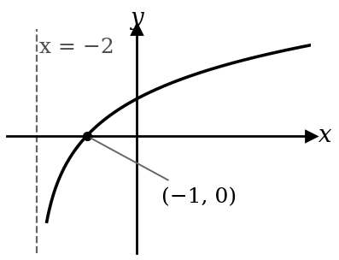  $$y=ln(x+2)$$  Asymptote: inside $=0$, so $x=-2$.  $x$-intercept: inside $=1$, so $x=-1$. | 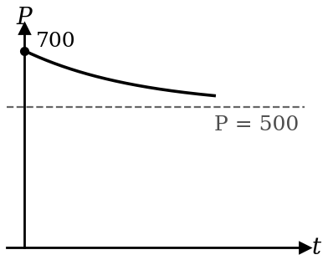  $$P=500+200e^{-kt}$$  Initial value: $t=0$, so $P=700$.  Long run: $e^{-kt}→0$, so $P→500$.

As $t→∞$, $e^{-at}→0$
For $y=6-4e^{-0.5t}$, find the initial value and what $y$ approaches in the long run.
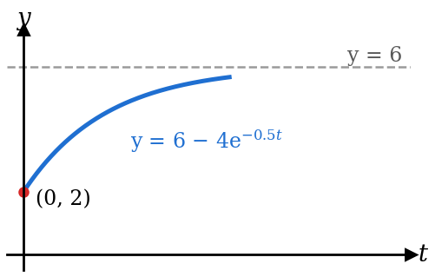 | $$e^{-1}=0.37, e^{-5}=0.0067, e^{-10}=0.000045 \text{← shrinks to 0, never reaches it}$$  $$t=0\text{: }y=6-4(1)=2 \text{← }e^{0}=1$$  $$t→∞\text{: }e^{-0.5t}→0\text{, so }y→6$$  The line $y=6$ is the asymptote: $y$ gets closer to 6 but never equals 6.

Trigonometry: equations and identities
Find EVERY angle in the range
Solve $sin x=-0.5$ for $0°≤x≤360°$.
✗ Common mistake  $$x=\sin^{-1}(-0.5)=-30° \text{← outside the range}$$ | ✓ Correct  $$\text{basic angle}=30° \text{← from }+0.5$$  $$sin x<0\text{: 3rd and 4th quadrants}$$  $$x=180°+30°=210°$$  $$x=360°-30°=330°$$

★ Hidden answers: a negative angle can come back into range
Solve $sin(x-30°)=-0.5$ for $0°≤x≤360°$.
✗ Common mistake  $$x-30°=210°, 330°$$  $$x=240°, 360° \text{← missed one}$$ | ✓ Correct  Subtract $30°$ from both ends of the range:  $$-30°≤x-30°≤330°$$  $$x-30°=-30°, 210°, 330° \text{← }-30°\text{ counts}$$  $$x=0°, 240°, 360°$$

★ Never divide by a variable : factorise
Solve $2 sin x cos x=sin x$ for $0°≤x≤360°$.
✗ Common mistake  $$2 cos x=1 \text{← divided by } sin x$$  $$x=60°, 300° \text{← lost three answers}$$ | ✓ Correct  $$sin x(2 cos x-1)=0$$  $$sin x=0\text{: }x=0°, 180°, 360°$$  $$cos x=\frac{1}{2}\text{: }x=60°, 300°$$

Proving an identity: rough work on the RHS shows where to aim
Prove that $\frac{cos x}{1-sin x}=sec x+tan x$.
Proof (LHS only)  $$\text{LHS}=\frac{cos x}{1-sin x}×\frac{1+sin x}{1+sin x}$$  $$=\frac{cos x(1+sin x)}{1-\sin^{2} x}$$  $$=\frac{cos x(1+sin x)}{\cos^{2} x} \text{← }1-\sin^{2} x=\cos^{2} x$$  $$=\frac{1+sin x}{cos x}=\frac{1}{cos x}+\frac{sin x}{cos x}$$  $$=sec x+tan x=\text{RHS}$$ | Rough work (RHS)  $$sec x+tan x=\frac{1}{cos x}+\frac{sin x}{cos x}$$  $$=\frac{1+sin x}{cos x}$$  So aim for $\frac{1+sin x}{cos x}$: that tells you to multiply by $1+sin x$.

Check every line as you go: one wrong sign and you will never reach the RHS.

R-formula

★ Find $R$ and $α$; give the max AND where it happens
Express $3 sin x+4 cos x$ as $R sin(x+α)$. Hence find its maximum value.
$$R=\sqrt{3^{2}+4^{2}}=5 tan α=\frac{4}{3} \text{← }R cos α=3, R sin α=4$$
$$α=53.13° \text{← keep full accuracy}$$
$$3 sin x+4 cos x=5 sin(x+53.13°)$$
$$\text{Max}=5\text{ when }x+53.13°=90°\text{, so }x=36.9° \text{← state the }x\text{ too}$$
Max and min: $R sin(x+α)$ always stays between $-R$ and $R$
Using $3 sin x+4 cos x=5 sin(x+53.13°)$:
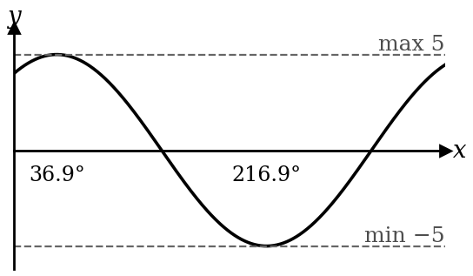 | Since $-1≤ sin(…)≤1$, the curve always stays between $-5$ and $5$.  Max $5$ when $x+53.13°=90°$; min $-5$ when $x+53.13°=270°$.

Expression | Max | Min
$$5 sin(x+α)$$ | $$5$$ | $$-5$$
$$2+5 sin(x+α)$$ | $$2+5=7$$ | $$2+5(-1)=-3$$
$$2-5 sin(x+α)$$ | $$2-5\left(-1\right)=7$$ | $$2-5\left(1\right)=-3$$
$$25 \sin^{2}(x+α)$$ | $$25{\left(1\right)}^{2}=25$$ | $$25{\left(0\right)}^{2}=0$$
$$\frac{1}{7+5 sin(x+α)}$$ | $$\frac{1}{7+5(-1)}=\frac{1}{2}$$  $$\text{make denominator as small as possible}$$ | $$\frac{1}{7+5(1)}=\frac{1}{12}$$  $$\text{make denominator as large as possible}$$

Trigonometric graphs
The three basic graphs
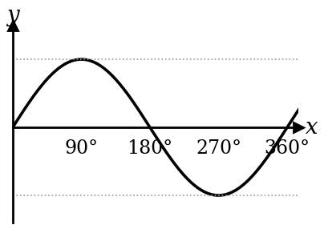  $$y=sin x$$  amplitude 1, centre line $y=0$  period $360°$  max 1 at $90°$, min $-1$ at $270°$ | 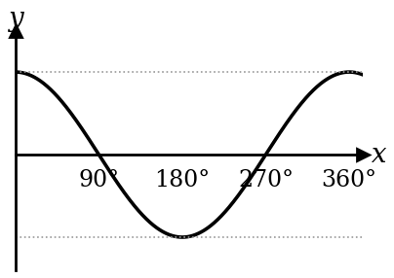  $$y=cos x$$  amplitude 1, centre line $y=0$  period $360°$  max 1 at $0°$, $360°$; min $-1$ at $180°$ | 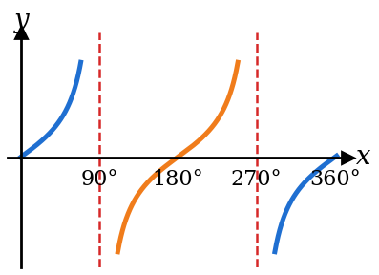  $$y=tan x$$  no amplitude, no max or min  period $180°$  asymptotes $x=90°$, $270°$

For $y=a sin bx+c$ and $y=a cos bx+c$ (with $b>0$)
$$\text{amplitude}=|a| \text{← always positive; a negative }a\text{ turns the curve over}$$
$$\text{period}=\frac{360°}{b} \text{← }b\text{ full curves in }360°\text{ (}\frac{2π}{b}\text{ in radians)}$$
$$\text{centre line }y=c\text{;} max=c+|a|\text{,} min=c-|a| \text{← read from the centre line, not the axis}$$

★ For $y=a tan bx+c$:
$$\text{period}=\frac{180°}{b} \text{← tan repeats every }180°\text{, not }360°$$
$$\text{no amplitude, no max or min;} \text{first asymptote at }x=\frac{90°}{b}$$

Six graphs to compare ($0°≤x≤360°$)
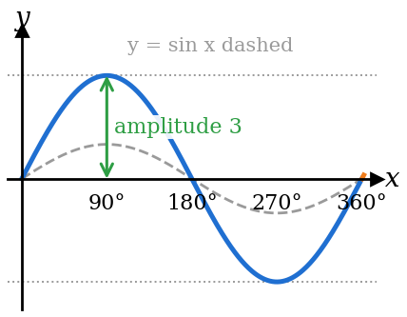  $$y=3 sin x$$  $a=3$: amplitude 3  max 3, min $-3$ | 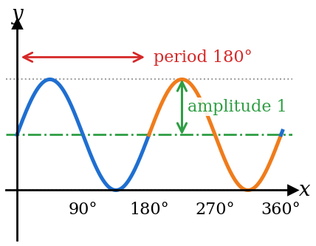  $$y=sin 2x+1$$  $b=2$: 2 curves in $360°$  period $\frac{360°}{2}=180°$  $c=1$: centre line $y=1$  max $1+1=2$, min $1-1=0$ | 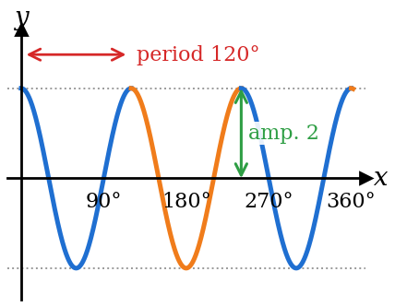  $$y=2 cos 3x$$  $a=2$: amplitude 2  $b=3$: 3 curves in $360°$  period $\frac{360°}{3}=120°$  max 2, min $-2$

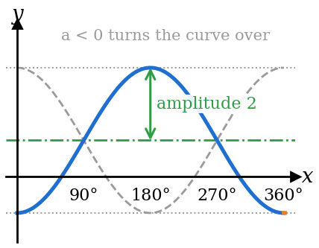  $$y=-2 cos x+1$$  $a=-2$: turned over  amplitude $|-2|=2$  $c=1$: centre line $y=1$  max $1+2=3$, min $1-2=-1$ | 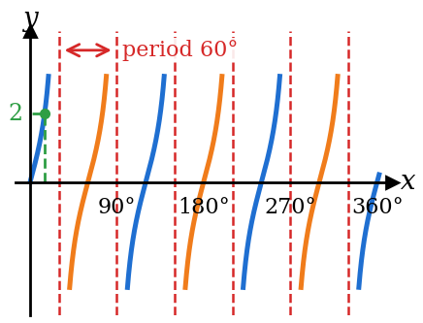  $$y=2 tan 3x$$  $a=2$: at $x=15°$, $tan 45°=1$, so $y=2$  $b=3$: 3 tan curves in $180°$  period $\frac{180°}{3}=60°$ | 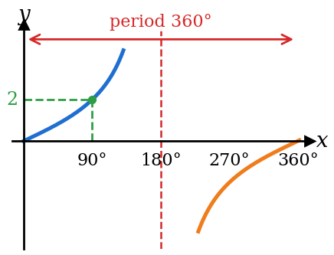  $$y=2 tan\frac{1}{2}x$$  $a=2$: at $x=90°$, $tan 45°=1$, so $y=2$  $b=\frac{1}{2}$: half a tan curve in $180°$  period $\frac{180°}{\frac{1}{2}}=360°$

When you sketch: draw the centre line first, then light dotted lines at the max and the min, then the curve between them. A tan curve never touches its asymptotes.

Find $a$, $b$, $c$ from the graph
The graph shows $y=a cos bx+c$. Find $a$, $b$ and $c$.
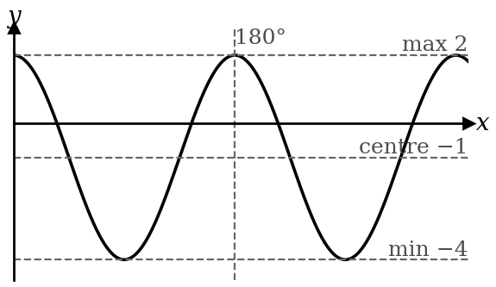 | $$c=\frac{2+(-4)}{2}=-1 \text{← centre line}$$  $$a=\frac{2-(-4)}{2}=3 \text{← half the height}$$  $$\text{period}=180° \text{← gap between two maxima}$$  $$b=\frac{360°}{180°}=2$$  Starts at its max, so $cos$ with $a>0$: $y=3 cos 2x-1$.

★ A negative $a$: the graph starts at its MINIMUM
The graph shows $y=a cos bx+c$. It starts at its minimum $-1$ and its maximum is 5. Find $a$, $b$ and $c$.
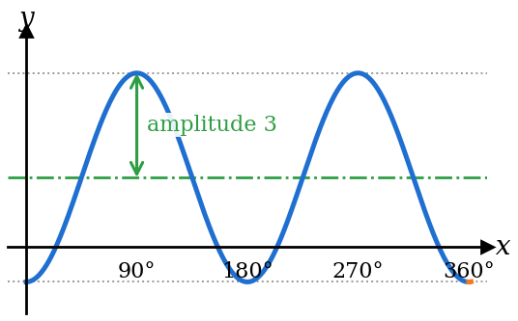 | $$c=\frac{5+(-1)}{2}=2 \text{← centre line}$$  $$|a|=\frac{5-(-1)}{2}=3 \text{← the size of }a$$  $$a=-3 \text{← starts at its MIN, so }a<0$$  A plain cos curve starts at its MAX; this one is turned over.  $$\text{period}=180°⇒b=\frac{360°}{180°}=2$$  $$y=-3 cos 2x+2$$

★ Solve an equation graphically: draw a suitable straight line
The graph of $y=2 sin x$ is drawn for $0°≤x≤360°$. By drawing a suitable straight line, solve $2 sin x+\frac{x}{180}=1$.
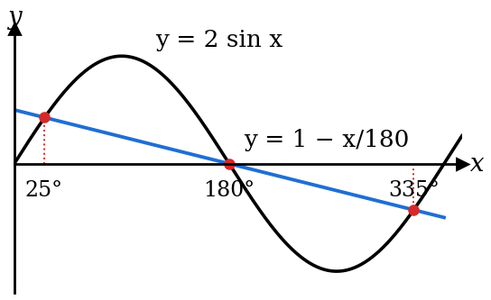 | Make one side EXACTLY the drawn curve:  $$2 sin x=1-\frac{x}{180}$$  $$\text{Draw }y=1-\frac{x}{180} \text{← the other side is the line}$$  $$x=0\text{: }y=1 x=360\text{: }y=-1 \text{← two points to rule it}$$  Read the $x$-values where they cross:  $$x≈25°, 180°, 335°$$

★ Amplitude and period
$$y=-2 sin 3x\text{: amplitude }2\text{ (never negative), } \text{period }\frac{360°}{3}=120°$$
$$y=tan 2x\text{: no amplitude, } \text{period }\frac{180°}{2}=90° \text{← tan uses 180°}$$

Trig inequality: solve the equation, then read the graph
Solve $cos 2x≥0.5$ for $0°≤x≤180°$.
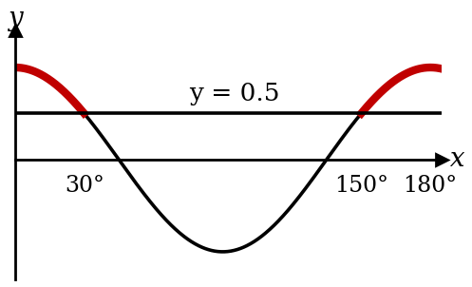 | $$0°≤2x≤360°$$  $$cos 2x=0.5\text{: }2x=60°, 300°⇒x=30°, 150°$$  $$0°≤x≤30° \text{or} 150°≤x≤180°$$  Read the parts of the curve ABOVE the line $y=0.5$ (red).

Application: find $a$, $b$, $c$ from the story
A Ferris wheel of diameter 40 m has its centre 25 m above the ground and turns once every 12 minutes. A rider starts at the lowest point. Their height is $h=a cos bt+c$ ($t$ in minutes). Find $a$, $b$, $c$, and when the rider first reaches 35 m.
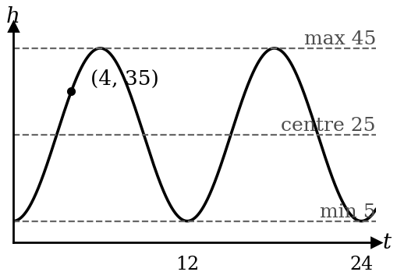 | $$c=25 \text{← height of the centre: the centre line}$$  $$|a|=20 \text{← the radius}$$  $$a=-20 \text{← starts at the LOWEST point}$$  $$b=\frac{360°}{12}=30 \text{← one turn = one period}$$  $$h=25-20 cos 30t$$  $$25-20 cos 30t=35⇒ cos 30t=-0.5$$  $$30t=120°⇒t=4\text{ minutes} \text{← first time: smallest }t$$

Coordinate geometry
Perpendicular bisector: midpoint + flipped gradient (negative reciprocal)
Find the perpendicular bisector of $A(1,2)$ and $B(5,6)$.
$$\text{Midpoint}=(3, 4) \text{← the bisector passes through the MIDPOINT}$$
$$m_{AB}=\frac{6-2}{5-1}=1 m_{⟂}=-1 \text{← flip and change sign}$$
$$y-4=-(x-3) \\ y=-x+7$$

★ Area: go anticlockwise and repeat the first point
Find the area of the triangle $(0,0)$, $(4,1)$, $(1,3)$.
$$\text{Area}=\frac{1}{2}\left|\begin{matrix}0 & 4 & 1 & 0 \\ 0 & 1 & 3 & 0\end{matrix}\right| \text{← first point again at the end} \\ =\frac{1}{2}\left|(0+12+0)-(0+1+0)\right|=5.5{\text{ units}}^{2}$$

Linear law
★ $y=ax^{n}$: take lg, then un-log the intercept
A graph of $lgy$ against $lgx$ is a straight line with gradient 1.5 and intercept 0.48. Find $a$ and $n$.
$$lgy=nlgx+lga \text{← take lg of both sides}$$
$$Y=lgy, X=lgx \text{← say what each axis is}$$
$$n=1.5 lga=0.48⇒a={10}^{0.48}=3.02 \text{← not }a=0.48$$

No logs needed: multiply to get a constant term
Express $y=ax+\frac{b}{x}$ in a form to draw a straight line.
$$xy=ax^{2}+b \text{← times }x\text{: }b\text{ is now on its own}$$
$$Y=xy, X=x^{2}, \text{gradient}=a, \text{intercept}=b$$

★ Every step of the graph question carries marks
Table of $X$ and $Y$ (3 s.f.) → plot → rule ONE straight line → gradient from two points ON your line, far apart → intercept → the constants.
Use the scale printed on the grid. "Use your graph" means draw a line and read the crossing.

★ Choose the scale, and make the line cut the vertical axis
Pick a scale that uses most of the grid and is easy to read (1, 2 or 5 units per square).
If you need the intercept, start the horizontal axis at $X=0$ so the line cuts the vertical axis.
Plan your scale before drawing the graph to avoid redrawing.

★ The straight-line form is not always given: rearrange it yourself
Express $y=\frac{a}{x+b}$ in a form to draw a straight line.
$$\frac{1}{y}=\frac{x+b}{a} \text{← flip both sides}$$
$$\frac{1}{y}=\frac{1}{a}x+\frac{b}{a} \text{← split into }mX+c$$
$$Y=\frac{1}{y}, X=x, \text{gradient}=\frac{1}{a}, vertical \text{intercept}=\frac{b}{a}$$
Rule: make every part with $x$ and $y$ together the $Y$ and $X$, and leave only constants in the gradient and intercept.
Note: there may be more than one way to obtain a straight line, for example, for the above equation, we can
$$\frac{1}{y}=\frac{x+b}{a}$$
$$a=xy+by \text{← cross multiply}$$
$$xy=-by+a \text{← write as }mX+c$$
$$Y=xy, X=y, \text{gradient}=-b, vertical \text{intercept}=a$$

Circles
★ Centre and radius: make $x^{2}$ and $y^{2}$ coefficients 1 first
Find the centre and radius of $2x^{2}+2y^{2}-8x+4y-10=0$.
$$x^{2}+y^{2}-4x+2y-5=0 \text{← divide by 2}$$
$$(x-2)^{2}+(y+1)^{2}=5+4+1 \text{← complete the square}$$
$$\text{centre }(2, -1), r=\sqrt{10} \text{← the signs flip}$$

Lines through the centre: draw a diagram first
The chord $AB$ joins $A(1,5)$ and $B(5,1)$. The centre lies on $y=3x-4$. Find the centre and radius.
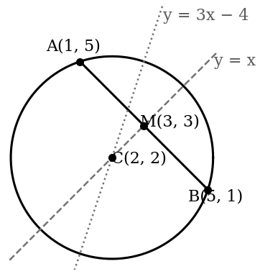 | $$M=(3, 3), m_{AB}=-1⇒m_{⟂}=1$$  $$\text{perpendicular bisector: }y=x \text{← it passes through the centre}$$  $$x=3x-4⇒x=2\text{: centre }C(2, 2)$$  $$r=CA=\sqrt{1^{2}+3^{2}}=\sqrt{10}$$  Also: the normal at any point of a circle passes through the centre.

Tangent lines described in words: draw it, then read the circle off
The lines $y=1$ and $y=7$ are both tangents to a circle whose centre lies on $y=x-1$. Find the equation of the circle.
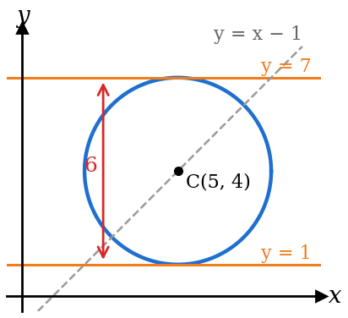 | $$\text{diameter}=7-1=6⇒r=3 \text{← the two tangents are a diameter apart}$$  $$\text{centre is halfway: }y=4 \text{← midway between the tangents}$$  $$4=x-1⇒x=5\text{: centre }(5, 4)$$  $$(x-5)^{2}+(y-4)^{2}=9$$

Reflecting a circle: reflect the centre, keep the radius
The circle $(x-2)^{2}+(y+1)^{2}=9$ is reflected in the line $x=4$. Find the equation of the new circle.
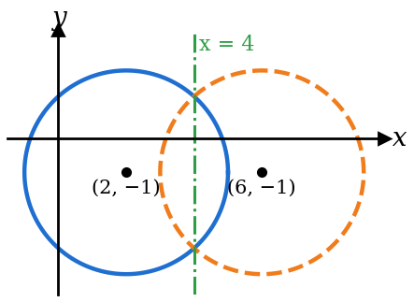 | $$\text{centre }(2, -1), r=3$$  $$2\text{ is }2\text{ units left of }x=4⇒\text{new }x=4+2=6 \text{← same distance, other side}$$  $$\text{new centre }(6, -1), r=3 \text{← the radius never changes}$$  $$(x-6)^{2}+(y+1)^{2}=9$$

Inside, on or outside? Do two circles touch?
$$\text{Circle A: }(x-1)^{2}+(y-2)^{2}=9\text{: centre }(1, 2), r=3$$  $$P(4, 3)\text{: }CP=\sqrt{3^{2}+1^{2}}=\sqrt{10}=3.16>3 \text{← further than }r\text{: OUTSIDE}$$  Distance $=r$: on the circle. Distance $<r$: inside.  $$\text{Circle B: centre }(7, 10), r=7$$  $$AB=\sqrt{6^{2}+8^{2}}=10=3+7 \text{← centres apart = sum of radii}$$  So the circles touch each other (on the outside). If the distance = the difference of the radii, one touches the other from inside. | 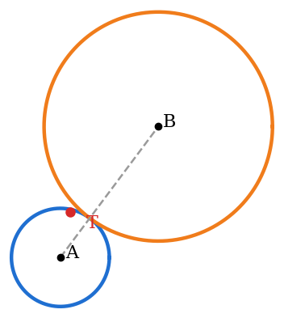

Proofs in plane geometry
Every statement needs its reason
$AT$ is a tangent at $A$. Show that $∠TAB=∠ACB$.
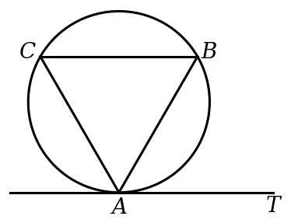
✗ Common mistake  $$∠TAB=∠ACB \text{← no reason: no mark}$$ | ✓ Correct  $$∠TAB=∠ACB$$  (angles in alternate segment)

★ Similar triangles: read the sides in the same order
$$△ABC\text{ is similar to }△PQR ⇒ \frac{AB}{PQ}=\frac{BC}{QR}=\frac{AC}{PR} \text{← 1st with 1st, 2nd with 2nd}$$
Congruence tests: SSS, SAS, ASA, AAS, RHS. There is no ASS.

★ Proving two angles equal: call one angle $a$ and chase it
$PQ$ is the tangent at $A$, and the chord $BC$ is parallel to $PQ$. Prove that $AB=AC$.
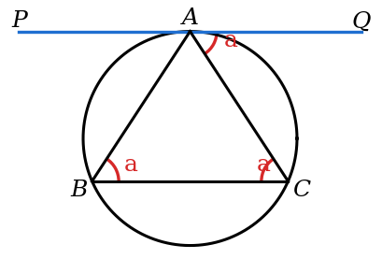 | $$\text{Let }∠QAC=a \text{← give the angle a name}$$  $$∠ACB=a (\text{alt. }∠\text{s}, PQ∥BC)$$  $$∠ABC=a (∠\text{ in alt. segment})$$  $$∴∠ABC=∠ACB=a \text{← link back to what you must prove}$$  $$△ABC\text{ is isosceles, so }AB=AC$$
Mark every angle equal to $a$ on the diagram as you find it. When the angle you need is also $a$, you are done.

Midpoint theorem: parallel AND length is halved
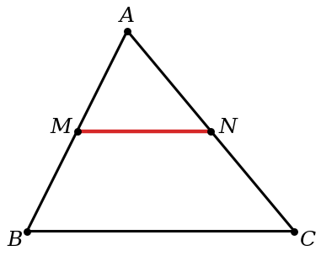 | $$M, N\text{ are the midpoints of }AB, AC$$  $$MN∥BC \text{and} MN=\frac{1}{2}BC \text{← both facts; students forget the half}$$  Converse: a line through one midpoint, parallel to a side, passes through the other midpoint.

Differentiation: rules
Chain rule: times the derivative of the inside
Differentiate $(3x^{2}-1)^{5}$.
✗ Common mistake  $$5(3x^{2}-1)^{4} \text{← stopped before the inside}$$ | ✓ Correct  $$5(3x^{2}-1)^{4}×6x \text{← derivative of }3x^{2}-1$$  $$=30x(3x^{2}-1)^{4}$$

Product rule: two terms
Differentiate $x^{2} sin 2x$.
$$\frac{dy}{dx}=2x\sin{2x}+x^{2}\left(2\cos{2x}\right) \text{← differentiate 1st, keep 2nd PLUS keep 1st, differentiate 2nd} \\ =2x\sin{2x}+2x^{2}\cos{2x}$$

Quotient rule: the order matters
Differentiate $\frac{2x+1}{x-3}$.
$$\frac{dy}{dx}=\frac{(x-3)(2)-(2x+1)(1)}{(x-3)^{2}} \begin{matrix}\text{← differentiate top, keep bottom MINUS keep top} \\ \text{ divide by denominator squared}\end{matrix} \\ =\frac{-7}{(x-3)^{2}}$$

ln: split with the log laws first
Differentiate $ln\frac{x^{2}}{x+1}$.
$$ln\frac{x^{2}}{x+1}=2lnx-ln(x+1) \text{← much easier than the quotient rule}$$
$$\frac{dy}{dx}=\frac{2}{x}-\frac{1}{x+1}$$
Calculus with trig is always in radians.

ln of a power: bring the power down first
Differentiate $ln\sqrt{x^{2}+1}$.
$$ln\sqrt{x^{2}+1}=ln(x^{2}+1)^{\frac{1}{2}}=\frac{1}{2}ln(x^{2}+1) \text{← bring the power down in front}$$
$$\frac{dy}{dx}=\frac{1}{2}×\frac{2x}{x^{2}+1}=\frac{x}{x^{2}+1} \text{← }\frac{f'(x)}{f(x)}$$

Exponentials: copy $e^{f(x)}$, then times $f'(x)$
Differentiate
(a) $e^{3x^{2}-1}$ (b) $xe^{2x}$.
$$\text{(a) }6x e^{3x^{2}-1} \text{← derivative of the power in front}$$ | $$\text{(b) }e^{2x}+x(2e^{2x})=e^{2x}(1+2x)$$

★ For differentiation of trig functions, angles are in radians

Differentiation Applications
What each sign means
$$\frac{dy}{dx}>0$$ | increasing function (curve going up)
$$\frac{dy}{dx}<0$$ | decreasing function (curve going down)
$$\frac{dy}{dx}=0$$ | stationary point: find this FIRST, then its nature

At a stationary point (nature):

$$\frac{d^{2}y}{dx^{2}}>0$$ | minimum point
$$\frac{d^{2}y}{dx^{2}}<0$$ | maximum point
$$\frac{d^{2}y}{dx^{2}}=0$$ | NO conclusion: use the first-derivative (sign) test

Anywhere on the curve (the gradient itself):

$$\frac{d^{2}y}{dx^{2}}>0$$ | the gradient is increasing
$$\frac{d^{2}y}{dx^{2}}<0$$ | the gradient is decreasing

Turning points and their nature: the steps
Find the stationary points of $y=x^{3}-3x^{2}-9x+5$ and their nature.
$$\frac{dy}{dx}=3x^{2}-6x-9=3(x-3)(x+1)=0 \text{← step 1: }\frac{dy}{dx}=0$$
$$x=3\text{: }y=-22 x=-1\text{: }y=10 \text{← step 2: }y\text{ from the curve}$$
$$\frac{d^{2}y}{dx^{2}}=6x-6 \text{← step 3: second derivative}$$
$$x=3\text{: }12>0⇒(3, -22)\text{ is a minimum} x=-1\text{: }-12<0⇒(-1, 10)\text{ is a maximum}$$

★ $\frac{d^{2}y}{dx^{2}}=0$: use the sign test (point of inflexion)
Find the stationary point of $y=x^{3}-3x^{2}+3x+1$ and its nature.

$$\frac{dy}{dx}=3x^{2}-6x+3=3(x-1)^{2}=0⇒x=1, y=2 \text{← stationary point first}$$
$$\frac{d^{2}y}{dx^{2}}=6x-6=0\text{ at }x=1 \text{← no conclusion yet}$$

$$x$$ | $$0.9$$ | $$1$$ | $$1.1$$
$$\frac{dy}{dx}$$ | $$0.03$$ | $$0$$ | $$0.03$$
sign | $$+$$ | $$0$$ | $$+$$

$$\text{Same sign on both sides: }(1, 2)\text{ is a point of inflexion} \text{← }+, 0, +\text{ is neither max nor min}$$

Application: set up ONE variable, then the same steps
Squares of side $x$ cm are cut from the corners of a 12 cm by 12 cm sheet to make an open box. Find the greatest volume.
Find the equation for $V$ first:
$$V=x(12-2x)^{2} \\ =4x^{3}-48x^{2}+144x \text{← volume in terms of }x\text{ only}$$
Differentiate and equate to zero:
$$\frac{dV}{dx}=12x^{2}-96x+144 \\ =12(x-2)(x-6)=0$$
$$x=2 \text{or} x=6\text{ (rej, no box is left)}$$
Prove nature of stationary point:
$$\frac{d^{2}V}{dx^{2}}=24x-96 \\ =-48<0\text{: maximum} \text{← prove it}$$
$$V=2(12-4)^{2} \\ =128{\text{ cm}}^{3} \text{← the max VALUE, with units}$$

Increasing $y$ : solve $\frac{dy}{dx}>0$, not $=0$
Find where $y=x^{3}-12x$ is increasing.
$$3x^{2}-12>0 \\ (x-2)(x+2)>0$$
$$x<-2\text{ or }x>2 \text{← read it off the sketch, as for any quadratic}$$

★ Increasing FUNCTION vs increasing GRADIENT: not the same
For $y=x^{3}-6x^{2}+5$, find where
(a) $y$ is increasing or decreasing, (b) the gradient is increasing or decreasing.
(a) The function: use $\frac{dy}{dx}$  $$\frac{dy}{dx}=3x^{2}-12x=3x(x-4)$$  $$\text{increasing: }3x(x-4)>0⇒x<0\text{ or }x>4$$  $$\text{decreasing: }3x(x-4)<0⇒0<x<4$$ | (b) The gradient: use $\frac{d^{2}y}{dx^{2}}$  $$\frac{d^{2}y}{dx^{2}}=6x-12$$  $$\text{gradient increasing: }6x-12>0⇒x>2$$  $$\text{gradient decreasing: }6x-12<0⇒x<2$$

★ Max or min GRADIENT: set $\frac{d^{2}y}{dx^{2}}=0$, then prove its nature
Find the minimum gradient of the curve $y=x^{3}-3x^{2}-9x+5$.
$$\text{gradient}=\frac{dy}{dx}=3x^{2}-6x-9 \text{← step 1: write the gradient}$$
$$\frac{d}{dx}\left(\frac{dy}{dx}\right)=\frac{d^{2}y}{dx^{2}}=6x-6=0 \text{← step 2: differentiate the GRADIENT, set it to 0}$$
$$x=1 \text{← step 3: solve}$$
$$\frac{d^{3}y}{dx^{3}}=6>0\text{, so the gradient is a minimum} \text{← step 4: prove the nature}$$
$$\text{min gradient}=3(1)^{2}-6(1)-9=-12 \text{← step 5: put }x=1\text{ into the GRADIENT, not into }y$$

★ Rates: differentiate first, numbers last
The radius of a sphere grows at 0.1 cm/s. Find the rate of change of its volume when $r=5$ cm.
$$V=\frac{4}{3}πr^{3} \frac{dV}{dr}=4πr^{2} \text{← differentiate BEFORE putting }r=5$$
$$\frac{dV}{dt}=\frac{dV}{dr}×\frac{dr}{dt} \text{← the }dr\text{s cancel}$$
$$=4π(5)^{2}(0.1)=10π{\text{ cm}}^{3}\text{/s} {\text{← units: cm}}^{3}\text{ per second}$$

Integration and area

★ Linear bracket: also divide by the $x$ coefficient
Find $∫(2x+1)^{3} dx$.
✗ Common mistake  $$\frac{(2x+1)^{4}}{4} \text{← forgot the 2 inside, and }c$$ | ✓ Correct  $$\frac{(2x+1)^{4}}{4×2}+c=\frac{(2x+1)^{4}}{8}+c$$

★ Divide by the inside number, not multiply
$$∫ cos 3x dx=\frac{1}{3} sin 3x+c \text{← not }3 sin 3x$$
$$∫e^{2x} dx=\frac{1}{2}e^{2x}+c ∫\frac{1}{2x+1} dx=\frac{1}{2}ln(2x+1)+c$$
$$∫ \cos^{2} x dx=∫\frac{1}{2}(1+cos 2x) dx=\frac{1}{2}x+\frac{1}{4} sin 2x+c \text{← identity first}$$

★ "Power up 1, divide by the new power" is ONLY for powers of $x$
Find $∫ \cos^{2} x dx$ and $∫e^{2x} dx$.
✗ Common mistake  $$∫ \cos^{2} x dx=\frac{\cos^{3} x}{3} \text{← power rule on trig}$$  $$∫e^{2x} dx=\frac{e^{2x+1}}{2x+1} \text{← power rule on }e$$ | ✓ Correct  $$\cos^{2} x=\frac{1}{2}(1+cos 2x) \text{← double-angle formula first}$$  $$∫ \cos^{2} x dx=\frac{1}{2}x+\frac{1}{4} sin 2x+c$$  $$∫e^{2x} dx=\frac{1}{2}e^{2x}+c \text{← reverse the chain rule}$$  $$\text{Check: }\frac{d}{dx}\left(\frac{1}{2}e^{2x}\right)=e^{2x}✓$$

★ Find $c$ from the given point
The gradient is $\frac{dy}{dx}=6x^{2}-2$ and the curve passes through $(1,5)$.
$$y=2x^{3}-2x+c \text{← }+c\text{ every time}$$
$$5=2-2+c⇒c=5 y=2x^{3}-2x+5$$

★ Area below the $x$-axis: split, then add the sizes
Find the area between $y=x^{2}-2x$, the $x$-axis, $x=0$ and $x=3$.
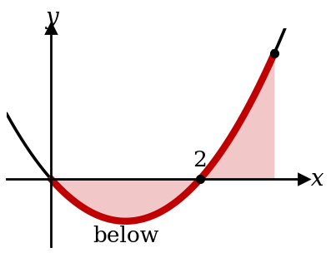 | $$x^{2}-2x=0⇒x=0, 2 \text{← solve }y=0\text{ first}$$  $$\int_{0}^{2}{(}x^{2}-2x) dx=-\frac{4}{3} \text{← negative: below}$$  $$\int_{2}^{3}{(}x^{2}-2x) dx=\frac{4}{3}$$  $$\text{Area}=\frac{4}{3}+\frac{4}{3}=\frac{8}{3}{\text{ units}}^{2}$$

Between two curves: $∫(y_{1}-y_{2}) dx$, top minus bottom
Find the area between $y=4-x^{2}$ and $y=x+2$.
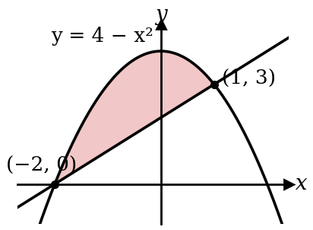 | $$4-x^{2}=x+2⇒x^{2}+x-2=0⇒x=-2, 1 \text{← limits: where they meet}$$  $$\text{Area}=\int_{-2}^{1}{\left[(4-x^{2})-(x+2)\right]}dx \text{← top minus bottom}$$  $$={\left[2x-\frac{x^{2}}{2}-\frac{x^{3}}{3}\right]}_{-2}^{1}=\frac{7}{6}-\left(-\frac{10}{3}\right)=4.5{\text{ units}}^{2}$$

Against the $y$-axis: integrate with respect to $y$
Find the area between $y=\sqrt{x}$, the $y$-axis and the line $y=2$.
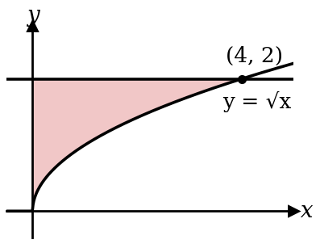 | $$x=y^{2} \text{← make }x\text{ the subject}$$  $$\text{Area}=\int_{0}^{2}{y^{2}} dy={\left[\frac{y^{3}}{3}\right]}_{0}^{2}=\frac{8}{3}{\text{ units}}^{2} \text{← }y\text{-limits}$$  How to choose: region against the $x$-axis → $∫y dx$ with $x$-limits. Region against the $y$-axis → $∫x dy$ with $y$-limits.

Split the region into pieces, find each, then add
Find the area bounded by $y=x^{2}$, the line $y=6-x$ and the $x$-axis, for $x≥0$.
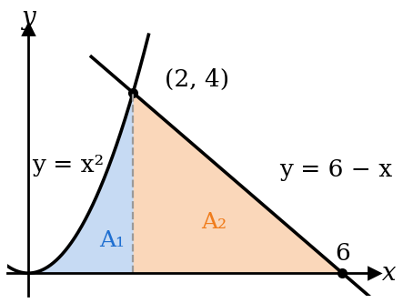 | $$x^{2}=6-x⇒x=2 \text{← where the curve meets the line}$$  $$A_{1}=\int_{0}^{2}{x^{2}} dx=\frac{8}{3} \text{← under the curve}$$  $$A_{2}=\frac{1}{2}×4×4=8 \text{← a triangle: no need to integrate}$$  $$\text{Total}=\frac{8}{3}+8=\frac{32}{3}{\text{ units}}^{2}$$

Kinematics

★ Total distance: check if it turns back
$v=t^{2}-4t+3$ m/s. Find the distance travelled in the first 4 s.
✗ Common mistake  $$s=\frac{1}{3}t^{3}-2t^{2}+3t$$  $$s(4)=\frac{4}{3}\text{ m} \text{← this is displacement}$$ | ✓ Correct  $$v=0\text{: }t=1, 3 \text{← it turns here}$$  $$s(0)=0, s(1)=\frac{4}{3}, s(3)=0, s(4)=\frac{4}{3}$$  $$\frac{4}{3}+\frac{4}{3}+\frac{4}{3}=4\text{ m} \text{← add each leg}$$

Total distance: two ways to see it
Same particle: $v=t^{2}-4t+3$, first 4 seconds.
Method 1: positions on the line  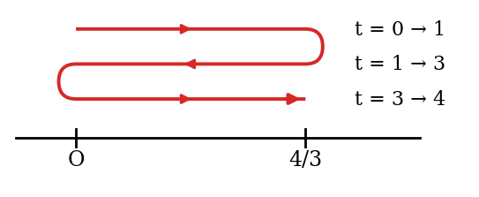  $$\text{distance}=\frac{4}{3}+\frac{4}{3}+\frac{4}{3}=4\text{ m} \text{← out, back, out again}$$ | Method 2: area under the v–t graph  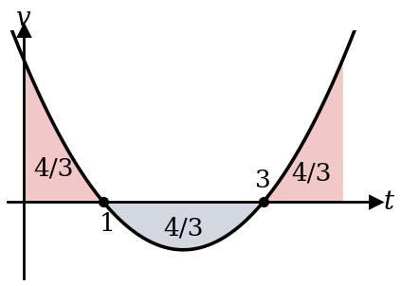  $$\int_{0}^{1}{v} dt=\frac{4}{3}, \int_{1}^{3}{v} dt=-\frac{4}{3}, \int_{3}^{4}{v} dt=\frac{4}{3}$$  Split at the turning points ($v=0$) and add the SIZES: 4 m.

★ Integrating: find $c$ from the starting values
$a=6t$ ${\text{m/s}}^{2}$ and $v=2$ m/s when $t=0$. Find $v$.
$$v=3t^{2}+c \text{← }+c$$
$$2=0+c⇒c=2 v=3t^{2}+2\text{ m/s}$$

Key words
$$\text{at rest: }v=0 \text{max or min velocity: }a=0 \text{meet or overtake: }s_{A}=s_{B}$$
$$v=5-3e^{-t}\text{: initial }v=2\text{ m/s;} \text{as }t→∞\text{, }e^{-t}→0\text{, so }v→5\text{ m/s}$$
Speed is never negative ($v=-3$ gives speed 3 m/s). Acceleration is in ${\text{m/s}}^{2}$.

What the words and signs mean
$$s>0$$ | the particle is to the RIGHT of O
$$s<0$$ | the particle is to the LEFT of O
$$s=0$$ | the particle is AT O (passes through or returns to O)
$$v>0$$ | moving to the right (forwards)
$$v<0$$ | moving to the left (backwards)
$$v=0$$ | instantaneously at rest; it may turn round here
$$a>0$$ | velocity increasing
$$a<0$$ | velocity decreasing
$$a=0$$ | velocity is at its max or min (constant at that instant)
speeding up | $v$ and $a$ have the SAME sign
slowing down | $v$ and $a$ have OPPOSITE signs
initially | $$t=0$$

