MATHEMATICS 4052/01 · WORKED SOLUTIONS
Paper 1 · set 1 · 90 marks
- Solve the equation $\frac{5k−2}{4}=2k−5$. [2]

Solution:
Multiply both sides by 4:
$$5k−2=4(2k−5)$$
$$5k−2=8k−20$$
Collect terms: $20−2=8k−5k$, so $3k=18$.
Hence $k=6$.
✓ Check: LHS $=\frac{5(6)−2}{4}=\frac{28}{4}=7$; RHS $=2(6)−5=7$.

- The diagram shows a sector $OAB$ of a circle, centre $O$ and radius 12 cm.
Angle $AOB={150}^{∘}$.
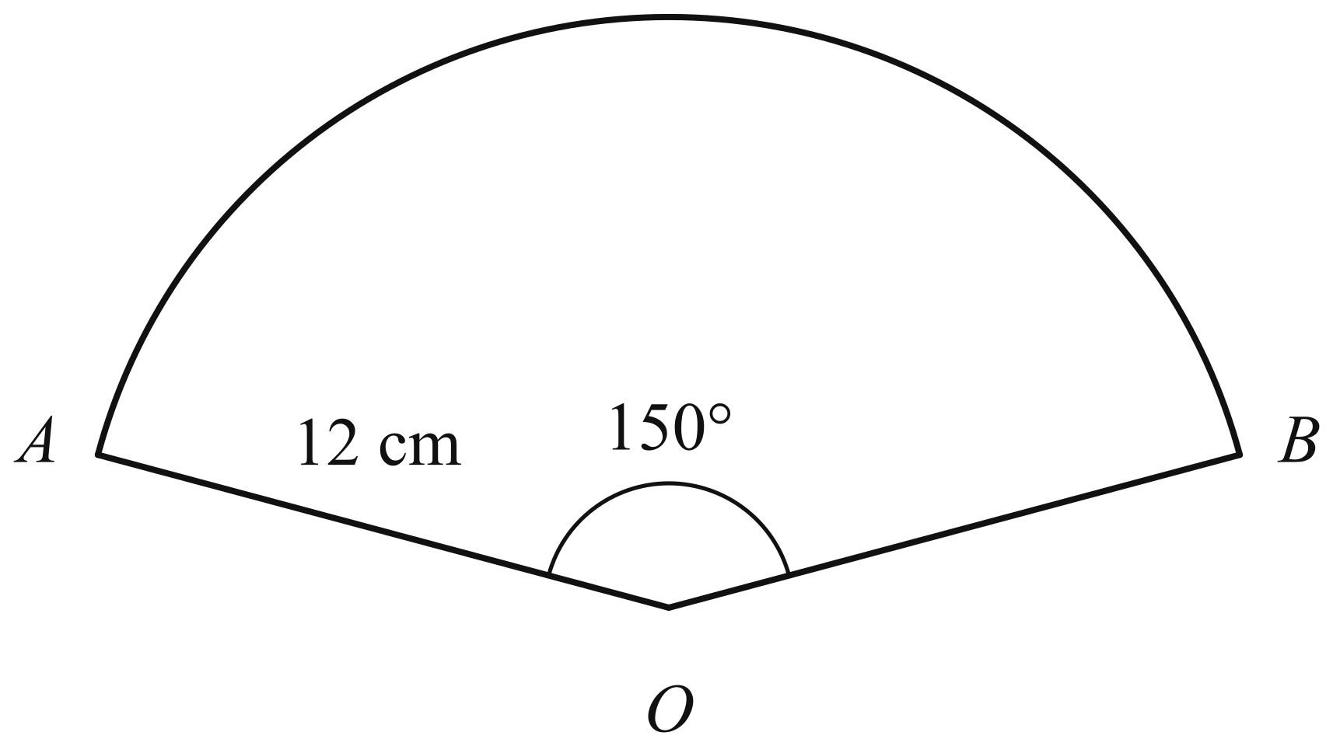
(a) Convert ${150}^{∘}$ to radians. Give your answer in terms of $π$. [1]
(b) Calculate the area of the sector $OAB$. Give your answer in terms of $π$. [1]

Solution:
(a) | ${180}^{∘}=π$ radians, so ${150}^{∘}=\frac{150}{180}×π=\frac{5π}{6}$ radians.
(b) | Area of sector $=\frac{1}{2}r^{2}θ=\frac{1}{2}×{12}^{2}×\frac{5π}{6}=72×\frac{5π}{6}=60π$ cm$​^{2}$.  (Equivalently, area $=\frac{150}{360}×π×{12}^{2}=\frac{5}{12}×144π=60π$ cm$​^{2}$.)

- The cash price of an electric bicycle is \1840$.
Under a hire-purchase scheme, a customer pays a deposit of \400$ followed by 18 equal monthly payments.
The hire-purchase price is $22.5\%$ more than the cash price.
(a) Calculate the hire-purchase price. [1]
(b) Calculate the amount of each monthly payment. [2]

Solution:
(a) | Hire-purchase price = 1840 \times \frac{122.5}{100} = 1840 \times 1.225 = \2254$.
(b) | Total of the monthly payments = 2254 - 400 = \1854$.  Each monthly payment = \frac{1854}{18} = \103$.

- Written as a product of its prime factors, $1176=2^{3}×3×7^{2}$.
(a) Explain why $6×1176$ is a perfect square. [1]
(b) Find the smallest positive integer $n$ such that $\frac{1176}{n}$ is a cube number. [1]

Solution:
(a) | $$\begin{aligned}6×1176&=2×3×2^{3}×3×7^{2} \\ &=2^{4}×3^{2}×7^{2}\end{aligned}$$  Every prime factor now has an even index, so $6×1176=(2^{2}×3×7)^{2}={84}^{2}$, which is a perfect square.
(b) | For $\frac{1176}{n}$ to be a cube number, every prime in its factorisation must have an index that is a multiple of 3.  $1176=2^{3}×3×7^{2}$: the index of 2 is already 3, so the factors $3$ and $7^{2}$ must be divided out.  Smallest $n=3×7^{2}=147$, giving $\frac{1176}{147}=2^{3}=8$, a cube number.

- Priya invests \5600$atarateof$2.5\%$ per year compound interest.
(a) Calculate the interest earned during the second year. [2]
(b) Priya says that the total interest earned in the first 8 years will be \1120$.Explainwhythetotalinterestwillbemorethan$\$1120$. [1]

Solution:
(a) | Amount at the end of the first year = 5600 \times 1.025 = \5740$.  Interest earned during the second year = 5740 \times \frac{2.5}{100} = \143.50$.  (Alternatively: 5600 \times 1.025^2 - 5600 \times 1.025 = 5883.50 - 5740 = \143.50$.)
(b) | 5600 \times \frac{2.5}{100} \times 8 = \1120$istheinterestifitwereSIMPLEinterest,calculatedontheoriginal$\$5600$ in every one of the 8 years.  With compound interest each year's interest is calculated on the growing amount, so the interest in every year after the first is more than \140$(thesecondyearearns$\$143.50$ from part (a)). Hence the total interest is more than \1120$.  (For reference, the actual total is 5600 \times 1.025^8 - 5600 \approx \1223.06$.)

- The curve $y=x^{2}+bx+c$ has line of symmetry $x=1.5$.
One of the points where the curve crosses the $x$-axis is $(−2,0)$.
(a) Write down the coordinates of the other point where the curve crosses the $x$-axis. [1]
(b) Find the value of $b$ and the value of $c$. [2]

Solution:
(a) | The two $x$-intercepts are symmetrical about the line $x=1.5$.  $−2$ is $3.5$ units to the left of $1.5$, so the other intercept is $3.5$ units to the right: $1.5+3.5=5$.  The other point is $(5,0)$.
(b) | The roots of $x^{2}+bx+c=0$ are $x=−2$ and $x=5$, so  $$y=(x+2)(x−5)=x^{2}−5x+2x−10=x^{2}−3x−10$$  Hence $b=−3$ and $c=−10$.  ✓ Check: line of symmetry $x=−\frac{b}{2}=\frac{3}{2}=1.5$.

- The diagram is an accurate scale drawing of a triangular garden $ABC$.
The scale is 1 cm to 5 m.
Angle $ABC={90}^{∘}$ and $BC=35$ m.
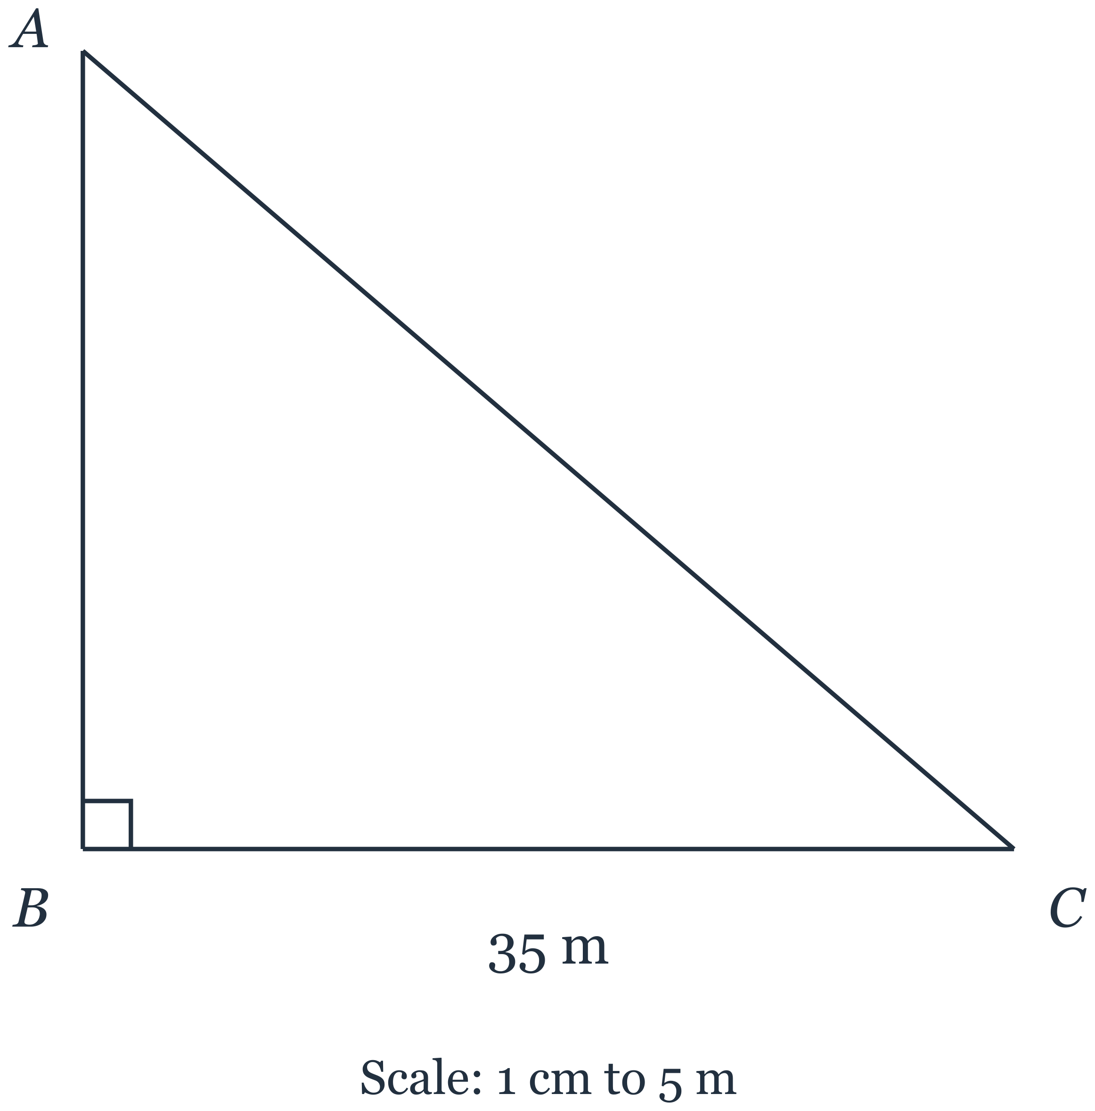
(a) Measure the length of $AB$ on the drawing. Hence find the actual length of $AB$, in metres. [1]
(b) Construct the perpendicular bisector of $AB$. [1]
(c) Construct the bisector of angle $ABC$. [1]
(d) A tap, $T$, is to be placed in the garden so that it is equidistant from $A$ and $B$ and equidistant from $AB$ and $BC$.
Mark the point $T$ on the diagram and measure the length of $TC$. Hence find the actual distance $TC$, in metres. [1]

Solution:
(a) | On the drawing $AB$ measures $6.0$ cm.  Actual length of $AB=6.0×5=30$ m.
(b) | With compasses, arcs of equal radius (more than half of $AB$) centred at $A$ and at $B$ cross on either side of $AB$; the line through the two crossings is the perpendicular bisector of $AB$. Because angle $ABC={90}^{∘}$, it is parallel to $BC$ and 3.0 cm above $BC$ on the drawing.
(c) | With compasses, an arc centred at $B$ cuts $BA$ and $BC$; equal arcs centred at these two points cross inside the angle; the line from $B$ through the crossing is the bisector of angle $ABC$. It makes ${45}^{∘}$ with $BC$.
(d) | $T$ is equidistant from $A$ and $B$, so $T$ lies on the perpendicular bisector of $AB$. $T$ is equidistant from $AB$ and $BC$, so $T$ lies on the bisector of angle $ABC$. $T$ is the point where the two constructed lines meet: on the drawing it is 3.0 cm from $AB$ and 3.0 cm from $BC$.  Measuring, $TC=5.0$ cm.  Actual distance $TC=5.0×5=25$ m.  ✓ Check: in metres $T$ is 15 m from $AB$ and 15 m from $BC$, so with $N$ the foot of the perpendicular from $T$ to $BC$, $BN=15$ m, $TN=15$ m, $NC=35−15=20$ m and $TC=\sqrt{{20}^{2}+{15}^{2}}=\sqrt{625}=25$ m, which agrees with the measurement.

- It is given that $(x+2)(x^{2}+hx+k)=x^{3}−x^{2}−10x−8$ for all values of $x$.
(a) Find the value of $h$ and the value of $k$. [2]
(b) Hence factorise $x^{3}−x^{2}−10x−8$ completely. [1]

Solution:
Expand the left-hand side:
$$\begin{aligned}(x+2)(x^{2}+hx+k)&=x^{3}+hx^{2}+kx+2x^{2}+2hx+2k \\ &=x^{3}+(h+2)x^{2}+(k+2h)x+2k\end{aligned}$$
(a) | Comparing the coefficients of $x^{2}$: $h+2=−1$, so $h=−3$.  Comparing the constant terms: $2k=−8$, so $k=−4$.  (Check with the coefficient of $x$: $k+2h=−4−6=−10$, which agrees.)
(b) | From (a), $x^{3}−x^{2}−10x−8=(x+2)(x^{2}−3x−4)$.  $x^{2}−3x−4=(x+1)(x−4)$, so  $$x^{3}−x^{2}−10x−8=(x+2)(x+1)(x−4)$$

- $P$, $Q$ and $R$ are points on a circle, centre $O$.
Angle $POR={116}^{∘}$.
Find angle $PQR$.
Give a reason for each step of your working. [2]
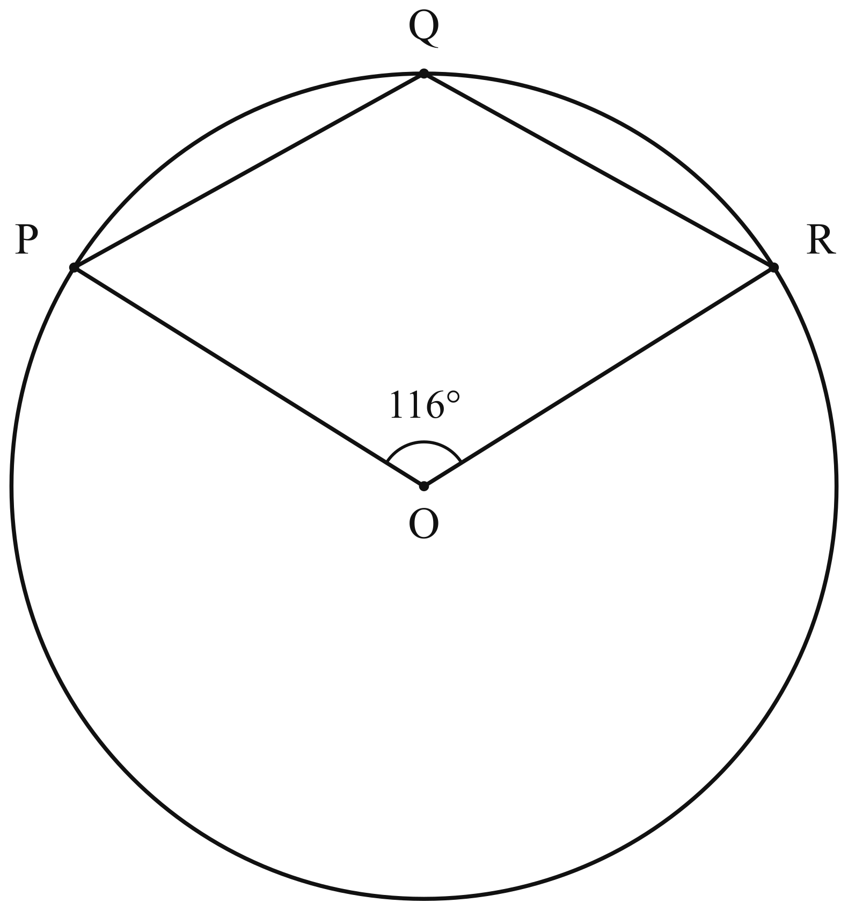

Solution:
Reflex angle $POR={360}^{∘}−{116}^{∘}={244}^{∘}$ (angles at a point).
Angle $PQR=\frac{1}{2}×{244}^{∘}={122}^{∘}$ (the angle at the centre is twice the angle at the circumference standing on the same arc; $Q$ is on the minor arc $PR$, so angle $PQR$ stands on the major arc $PR$, which subtends the reflex angle at $O$).
Alternatively: take any point $S$ on the major arc $PR$. Angle $PSR=\frac{1}{2}×{116}^{∘}={58}^{∘}$ (angle at the centre is twice the angle at the circumference), and angle $PQR={180}^{∘}−{58}^{∘}={122}^{∘}$ (opposite angles of the cyclic quadrilateral $PQRS$ are supplementary).
Angle $PQR={122}^{∘}$.

- A paint shop makes a shade of paint called Sea Mist by mixing blue paint, white paint and grey paint in the ratio $2:9:4$ by volume.
(a) Find the volume of white paint in 7.5 litres of Sea Mist. [1]
(b) Express the ratio volume of grey paint : volume of Sea Mist in the form $1:n$. [1]
(c) A decorator has 1.5 litres of blue paint, 8 litres of white paint and 2.6 litres of grey paint.
Find the greatest volume of Sea Mist she can make. [2]

Solution:
(a) | Total number of parts $=2+9+4=15$.  Volume of white paint $=\frac{9}{15}×7.5=4.5$ litres.
(b) | Grey : Sea Mist $=4:15=1:\frac{15}{4}=1:3.75$.
(c) | Each batch of 15 parts needs 2 parts blue, 9 parts white and 4 parts grey.  Volume of one part allowed by each colour:  blue: $1.5÷2=0.75$ litres,  white: $8÷9=0.888…$ litres,  grey: $2.6÷4=0.65$ litres.  The grey paint runs out first, so one part is at most $0.65$ litres.  Greatest volume of Sea Mist $=15×0.65=9.75$ litres.  ✓ Check: this uses $2×0.65=1.3$ litres of blue and $9×0.65=5.85$ litres of white, both available.

(a) Simplify $\frac{2x^{2}−8}{x^{2}−5x+6}$. [2]
(b) Hence solve $\frac{2x^{2}−8}{x^{2}−5x+6}=4$. [1]

Solution:
(a) | Factorise the numerator: $2x^{2}−8=2(x^{2}−4)=2(x−2)(x+2)$.  Factorise the denominator: $x^{2}−5x+6=(x−2)(x−3)$.  So $\frac{2x^{2}−8}{x^{2}−5x+6}=\frac{2(x−2)(x+2)}{(x−2)(x−3)}=\frac{2(x+2)}{x−3}$.
(b) | Using (a), $\frac{2(x+2)}{x−3}=4$  $$2x+4=4x−12$$  $$16=2x$$  $$x=8$$  ✓ Check: $\frac{2(64)−8}{64−40+6}=\frac{120}{30}=4$.

- $q=\sqrt{\frac{p+2r}{p−r}}$
(a) Rearrange the formula to make $p$ the subject. [3]
(b) Hence find $p$ when $q=3$ and $r=8$. [1]

Solution:
(a) | Square both sides: $q^{2}=\frac{p+2r}{p−r}$.  Multiply by $(p−r)$: $q^{2}(p−r)=p+2r$  $$q^{2}p−q^{2}r=p+2r$$  Collect the terms in $p$ on one side: $q^{2}p−p=2r+q^{2}r$  $$p(q^{2}−1)=r(q^{2}+2)$$  $$p=\frac{r(q^{2}+2)}{q^{2}−1}$$
(b) | $$p=\frac{8(3^{2}+2)}{3^{2}−1}=\frac{8×11}{8}=11$$  ✓ Check: $\sqrt{\frac{11+16}{11−8}}=\sqrt{9}=3$.

- A bakery sells muffins in three flavours: chocolate, banana and lemon.
Each customer buys exactly one muffin.
The probability that a customer buys a chocolate muffin is $0.35$.
The probability that a customer buys a lemon muffin is $0.2$.
(a) Find the probability that a customer buys a banana muffin. [1]
(b) Two customers each buy a muffin. The flavour each customer buys is independent of the other.
Find the probability that the two customers buy muffins of different flavours. [2]

Solution:
(a) | The three probabilities sum to 1.  P(banana) $=1−0.35−0.2=0.45$
(b) | The two customers are independent, so multiply along each pair of choices.  P(both chocolate) $=0.35×0.35=0.1225$  P(both banana) $=0.45×0.45=0.2025$  P(both lemon) $=0.2×0.2=0.04$  P(same flavour) $=0.1225+0.2025+0.04=0.365$  P(different flavours) $=1−0.365=0.635$  Alternative for (b): add the six ordered pairs of different flavours, $2(0.35×0.45)+2(0.35×0.2)+2(0.45×0.2)=0.315+0.14+0.18=0.635$.

- Solve these simultaneous equations.
$3x+2y=17$
$5x−4y=−1$
You must show your working. [2]

Solution:
Multiply the first equation by 2 so that the $y$ terms cancel:
$$6x+4y=34$$
Add this to the second equation:
$$(6x+4y)+(5x−4y)=34+(−1)$$
$$11x=33$$
$$x=3$$
Substitute into the first equation: $3(3)+2y=17$, so $2y=8$ and $y=4$.
Check in the second equation: $5(3)−4(4)=15−16=−1$. Correct.
So $x=3$, $y=4$.

- The diagram shows a parallelogram $ABCD$.
$E$ is the point on $DC$ such that $AE$ bisects angle $DAB$.
Angle $ABC={116}^{∘}$.
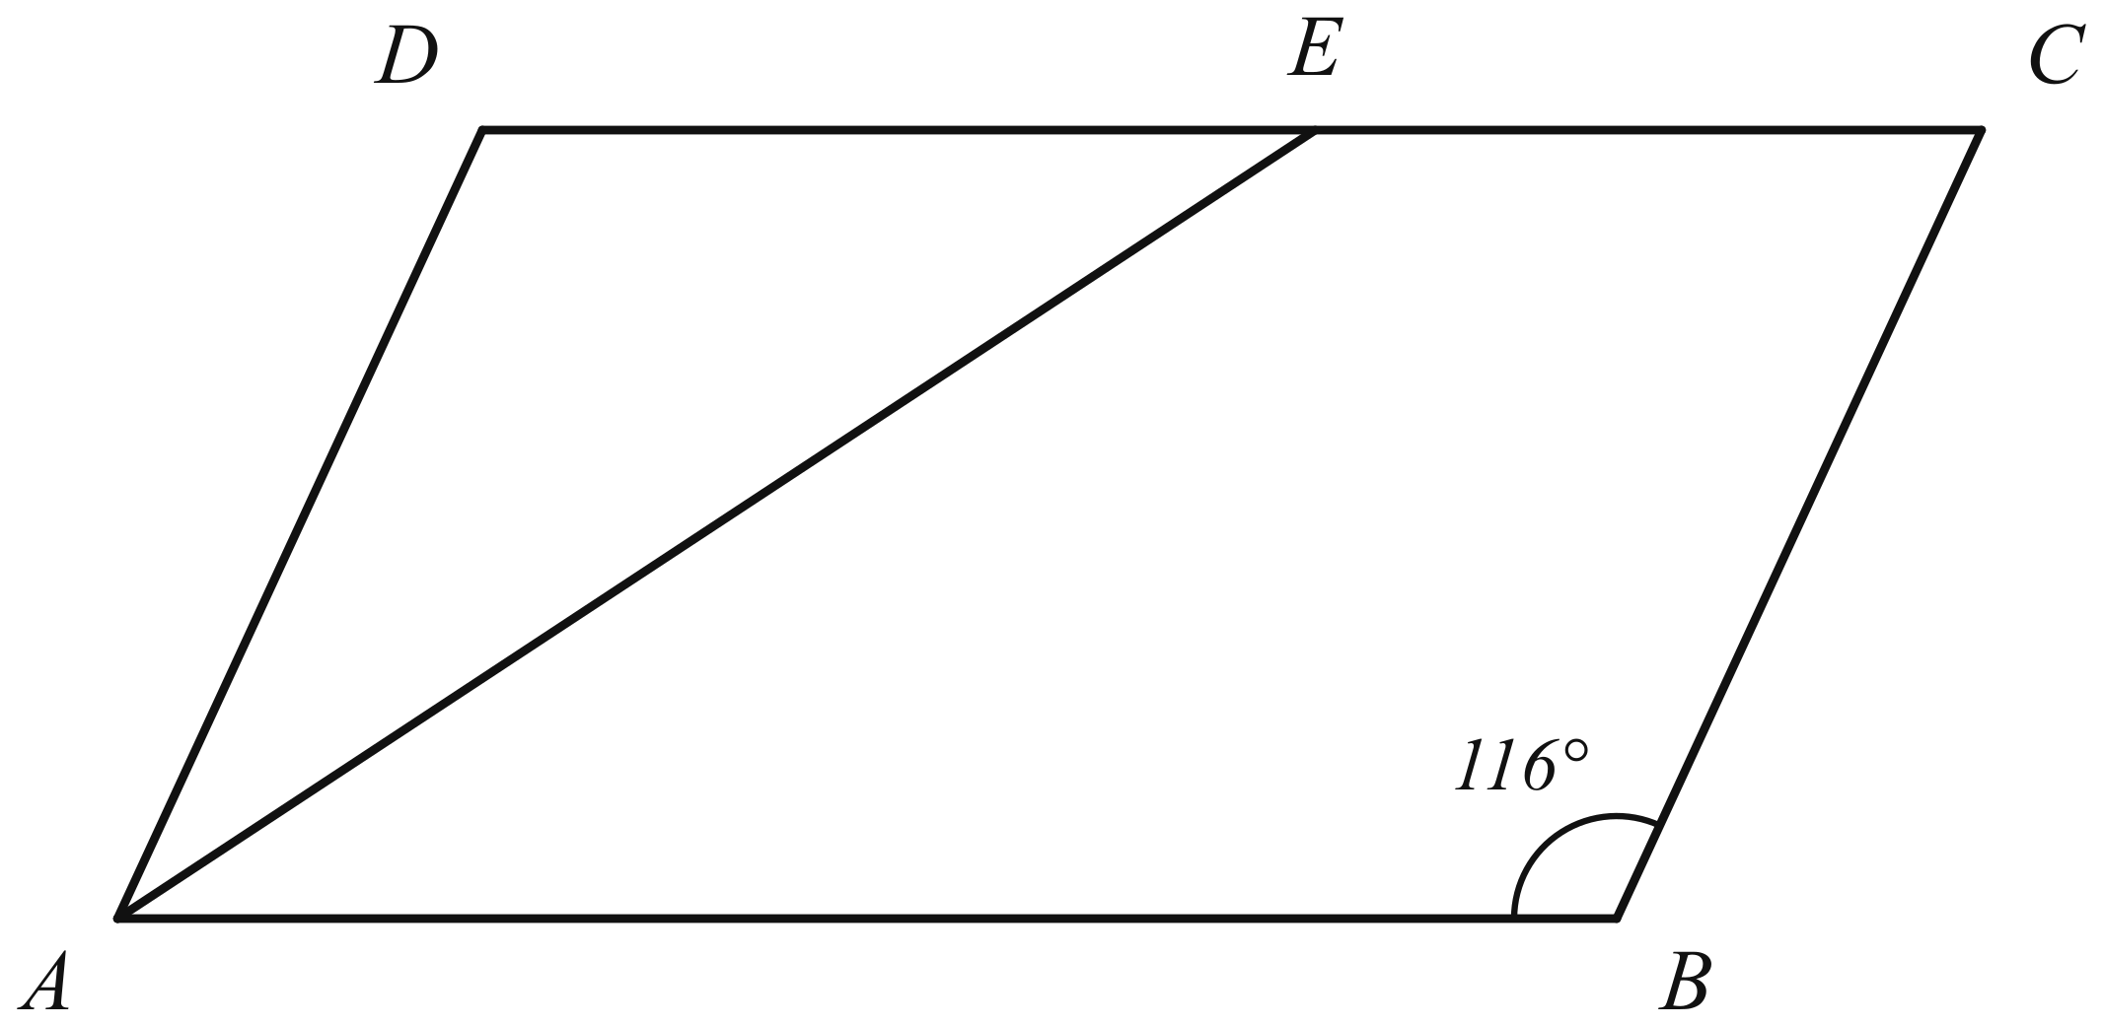
(a) Find angle $DAE$. [1]
(b) Find angle $AEC$. [2]

Solution:
(a) | In a parallelogram, adjacent angles are supplementary (co-interior angles, $AD∥BC$).  Angle $DAB={180}^{∘}−{116}^{∘}={64}^{∘}$  $AE$ bisects angle $DAB$, so angle $DAE=\frac{1}{2}×{64}^{∘}={32}^{∘}$.
(b) | Angle $EAB={32}^{∘}$ (the other half of the bisected angle).  Since $DC∥AB$, angle $DEA=$ angle $EAB={32}^{∘}$ (alternate angles).  Angle $AEC={180}^{∘}−{32}^{∘}={148}^{∘}$ (angles on a straight line, $DEC$).  Alternative for (b): angle $ADE=$ angle $ABC={116}^{∘}$ (opposite angles of a parallelogram), so in triangle $ADE$ angle $AED={180}^{∘}−{116}^{∘}−{32}^{∘}={32}^{∘}$, giving angle $AEC={148}^{∘}$.  (Setter's check of the figure: triangle $ADE$ has angle $DAE=$ angle $DEA={32}^{∘}$, so $DE=DA=5$ units; with $DC=9$ units, $E$ lies strictly between $D$ and $C$, as drawn.)

- Two solid trophies are geometrically similar and are made of the same metal.
The smaller trophy has height $6$ cm and the larger trophy has height $15$ cm.
(a) The surface area of the smaller trophy is $72$ cm$​^{2}$.
Calculate the surface area of the larger trophy. [1]
(b) The mass of the larger trophy is $875$ g.
Calculate the mass of the smaller trophy. [2]

Solution:
 | Scale factor of lengths, smaller to larger: $k=\frac{15}{6}=\frac{5}{2}=2.5$.
(a) | Ratio of surface areas $=k^{2}={\left(\frac{5}{2}\right)}^{2}=\frac{25}{4}$.  Surface area of larger trophy $=72×\frac{25}{4}=450$ cm$​^{2}$.
(b) | Ratio of volumes $=k^{3}={\left(\frac{5}{2}\right)}^{3}=\frac{125}{8}$.  The trophies are made of the same metal, so mass is proportional to volume.  Mass of smaller trophy $=875÷\frac{125}{8}=875×\frac{8}{125}=7×8=56$ g.

- $E=\{x:x\text{ is an integer and }1≤x≤15\}$
$A=\{x:x\text{ is a multiple of }3\}$
$B=\{x:x\text{ is a factor of }30\}$
(a) List the elements of $A∩B$. [1]
(b) Find $n(A^{′}∩B^{′})$. [1]

Solution:
 | $A=\{3,6,9,12,15\}$ and $B=\{1,2,3,5,6,10,15\}$.
(a) | $$A∩B=\{3,6,15\}$$
(b) | $$A^{′}∩B^{′}=(A∪B)^{′}$$  $A∪B=\{1,2,3,5,6,9,10,12,15\}$, so $n(A∪B)=9$.  $n(E)=15$, so $n(A^{′}∩B^{′})=15−9=6$.  (The elements are $\{4,7,8,11,13,14\}$.)

- The mass of one helium atom is $6.64×{10}^{−27}$ kg.
A balloon contains $2.5×{10}^{23}$ helium atoms.
(a) Calculate the mass of the helium in the balloon.
Give your answer in kilograms in standard form. [2]
(b) A second balloon contains $4.15×{10}^{−3}$ kg of helium.
Calculate the total number of helium atoms in the two balloons.
Give your answer in standard form. [2]

Solution:
(a) | Mass $=(6.64×{10}^{−27})×(2.5×{10}^{23})$  $$=(6.64×2.5)×{10}^{−27+23}$$  $$=16.6×{10}^{−4}$$  $=1.66×{10}^{−3}$ kg.
(b) | Number of atoms in the second balloon $=\frac{4.15×{10}^{−3}}{6.64×{10}^{−27}}$  $$=\frac{4.15}{6.64}×{10}^{−3−(−27)}$$  $$=0.625×{10}^{24}$$  $$=6.25×{10}^{23}$$  Total number of atoms $=2.5×{10}^{23}+6.25×{10}^{23}$  $$=8.75×{10}^{23}$$

- A teacher has 216 pens and 288 erasers. She puts them into gift bags so that each bag has the same number of pens and the same number of erasers, with none left over.
(a) Find the greatest number of gift bags she can make. [2]
(b) She also puts stickers into each of the gift bags, with the same number in each bag and none left over. Stickers are sold in packets of 10.
Find the smallest number of packets of stickers she must buy. [1]

Solution:
(a) | The number of bags must divide both 216 and 288 exactly, so the greatest number of bags is the HCF of 216 and 288.  $$216=2^{3}×3^{3}$$  $$288=2^{5}×3^{2}$$  HCF $=2^{3}×3^{2}=72$  Greatest number of gift bags $=72$.  (Each bag then has $216÷72=3$ pens and $288÷72=4$ erasers.)
(b) | The stickers come in packets of 10, so the number bought is a multiple of 10. They are shared equally among 72 bags with none left over, so the number is also a multiple of 72.  Smallest number $=$ LCM of 10 and 72 $=2^{3}×3^{2}×5=360$.  (That is 36 packets, giving $360÷72=5$ stickers in each bag.)  The number of stickers must be a multiple of 72 and of 10. LCM(72, 10) = 360, so she buys 360 stickers = 36 packets.

- Simplify $\frac{6x^{2}−7x−20}{4x^{2}−25}$. [3]

Solution:
Factorise the numerator (a quadratic trinomial): we need two numbers with product $6×(−20)=−120$ and sum $−7$; these are $−15$ and $8$.
$$\begin{aligned}6x^{2}−7x−20&=6x^{2}−15x+8x−20 \\ &=3x(2x−5)+4(2x−5) \\ &=(3x+4)(2x−5)\end{aligned}$$
Factorise the denominator (difference of two squares):
$$4x^{2}−25=(2x)^{2}−5^{2}=(2x−5)(2x+5)$$
Cancel the common factor $(2x−5)$:
$$\begin{aligned}\frac{6x^{2}−7x−20}{4x^{2}−25}&=\frac{(3x+4)(2x−5)}{(2x−5)(2x+5)} \\ &=\frac{3x+4}{2x+5}\end{aligned}$$
Check by expanding: $(3x+4)(2x−5)=6x^{2}−15x+8x−20=6x^{2}−7x−20$ and $(2x−5)(2x+5)=4x^{2}−25$.

- Two shops, Shop A and Shop B, sell bags of rice, trays of eggs and bottles of cooking oil. The matrix $P$ shows the price, in dollars, of each item at each shop. The rows represent Shop A and Shop B, and the columns represent rice, eggs and cooking oil, in that order.
$P=\left(\begin{matrix}12 & 4 & 7 \\ 13 & 3 & 6\end{matrix}\right)$
Mrs Tan needs to buy 2 bags of rice, 5 trays of eggs and 3 bottles of cooking oil.
(a) Represent the numbers of items Mrs Tan needs to buy in a $3×1$ matrix $Q$. [1]
(b) Find the matrix $C=PQ$. [2]
(c) Find the matrix $\left(\begin{matrix}1 & −1\end{matrix}\right)C$ and explain what the element of this matrix represents. [1]

Solution:
(a) | The rows of $Q$ must match the columns of $P$ (rice, eggs, cooking oil).  $$Q=\left(\begin{matrix}2 \\ 5 \\ 3\end{matrix}\right)$$
(b) | $$\begin{aligned}C&=PQ \\ &=\left(\begin{matrix}12 & 4 & 7 \\ 13 & 3 & 6\end{matrix}\right)\left(\begin{matrix}2 \\ 5 \\ 3\end{matrix}\right) \\ &=\left(\begin{matrix}12×2+4×5+7×3 \\ 13×2+3×5+6×3\end{matrix}\right) \\ &=\left(\begin{matrix}24+20+21 \\ 26+15+18\end{matrix}\right) \\ &=\left(\begin{matrix}65 \\ 59\end{matrix}\right)\end{aligned}$$  (The elements are the total cost, in dollars, of all the items at Shop A and at Shop B respectively.)
(c) | $$\begin{aligned}\left(\begin{matrix}1 & −1\end{matrix}\right)\left(\begin{matrix}65 \\ 59\end{matrix}\right)&=\left(\begin{matrix}65−59\end{matrix}\right) \\ &=\left(\begin{matrix}6\end{matrix}\right)\end{aligned}$$  The element is the difference between the two totals: buying all the items at Shop A costs \6$ more than buying all of them at Shop B.

- A square tile has sides of length $(3x+2)$ cm. A square hole with sides of length $(x−1)$ cm is cut from the tile, where $x>1$. The remaining part of the tile is called the frame.
(a) Show that the area of the frame is $(8x^{2}+14x+3)$ cm$​^{2}$. [2]
(b) The area of the frame is $63$ cm$​^{2}$. Find the length of a side of the tile. [2]

Solution:
(a) | Area of frame $=$ area of tile $−$ area of hole  $$=(3x+2)^{2}−(x−1)^{2}$$  $$=(9x^{2}+12x+4)−(x^{2}−2x+1)$$  $$=9x^{2}+12x+4−x^{2}+2x−1$$  $=8x^{2}+14x+3$ (shown).  [Alternative by difference of two squares: $(3x+2−x+1)(3x+2+x−1)=(2x+3)(4x+1)=8x^{2}+14x+3$.]
(b) | $$8x^{2}+14x+3=63$$  $$8x^{2}+14x−60=0$$  $$4x^{2}+7x−30=0$$  $$(4x+15)(x−2)=0$$  $x=2$ or $x=−\frac{15}{4}$ (rejected, since $x>1$).  Length of a side of the tile $=3(2)+2=8$ cm.  ✓ Check: tile $8×8=64$ cm$​^{2}$, hole $1×1=1$ cm$​^{2}$, frame $64−1=63$ cm$​^{2}$.

- The diagram shows a triangular plot of land $LMN$ on horizontal ground.
The side $MN$ runs along a straight road.
$LM=120$ m, $LN=85$ m and angle $MLN={104}^{∘}$.
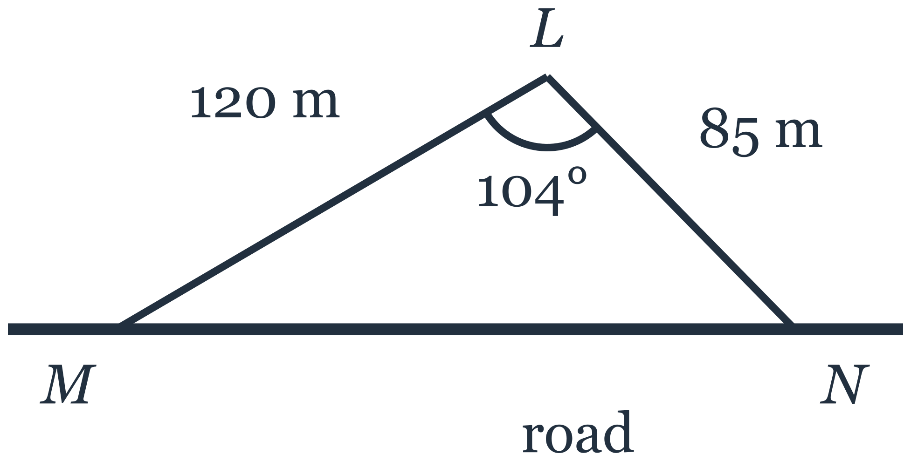
(a) Show that $MN=163$ m, correct to 3 significant figures. [2]
(b) Calculate angle $LMN$. [2]
(c) A straight path is to be built from $L$ to the road so that the path is as short as possible.
Calculate the length of this path. [2]

Solution:
(a) | By the cosine rule in triangle $LMN$,  $$MN^{2}=LM^{2}+LN^{2}−2(LM)(LN)cosMLN$$  $$={120}^{2}+{85}^{2}−2(120)(85)cos{104}^{∘}$$  $$=14400+7225−20400(−0.24192…)$$  $$=21625+4935.2…=26560.2…$$  $MN=\sqrt{26560.2…}=162.97…=163$ m (correct to 3 significant figures).
(b) | By the sine rule,  $$\frac{sinLMN}{LN}=\frac{sinMLN}{MN}$$  $$sinLMN=\frac{85sin{104}^{∘}}{162.97…}=0.50607…$$  Angle $LMN=30.40…^{∘}={30.4}^{∘}$ (1 d.p.).  (Using $MN=163$ gives $sinLMN=0.50598…$ and the same ${30.4}^{∘}$.)
(c) | The shortest path from $L$ to the road is the perpendicular from $L$ to $MN$. Let its foot be $P$; since the angles at $M$ and $N$ are both acute (${30.4}^{∘}$ and ${180}^{∘}−{104}^{∘}−{30.4}^{∘}={45.6}^{∘}$), $P$ lies between $M$ and $N$.  In right-angled triangle $LPM$, $LP=LMsinLMN=120sin30.40…^{∘}=60.73…=60.7$ m.  Alternatively, using the area: area of triangle $LMN=\frac{1}{2}(120)(85)sin{104}^{∘}=4948.5…$ m$​^{2}$, and also $=\frac{1}{2}(MN)(LP)$, so $LP=\frac{2×4948.5…}{162.97…}=60.7$ m.  Length of the path $=60.7$ m.

- The time, $T$ seconds, taken by a pendulum to complete one swing is directly proportional to the square root of its length, $L$ cm.
A pendulum of length $64$ cm takes $1.6$ seconds to complete one swing.
(a) Find an expression for $T$ in terms of $L$. [2]
(b) Find the length of a pendulum that takes $2.5$ seconds to complete one swing. [1]

Solution:
(a) | Since $T$ is directly proportional to $\sqrt{L}$, $T=k\sqrt{L}$ for some constant $k$.  When $L=64$, $T=1.6$: $1.6=k\sqrt{64}=8k$, so $k=0.2$.  Hence $T=0.2\sqrt{L}$, that is $T=\frac{\sqrt{L}}{5}$.
(b) | When $T=2.5$: $2.5=0.2\sqrt{L}$, so $\sqrt{L}=12.5$ and $L={12.5}^{2}=156.25$.  The pendulum is $156.25$ cm long (156 cm to 3 s.f.).

- The box-and-whisker plot shows the distribution of the times, in minutes, taken by 80 runners to complete a race.
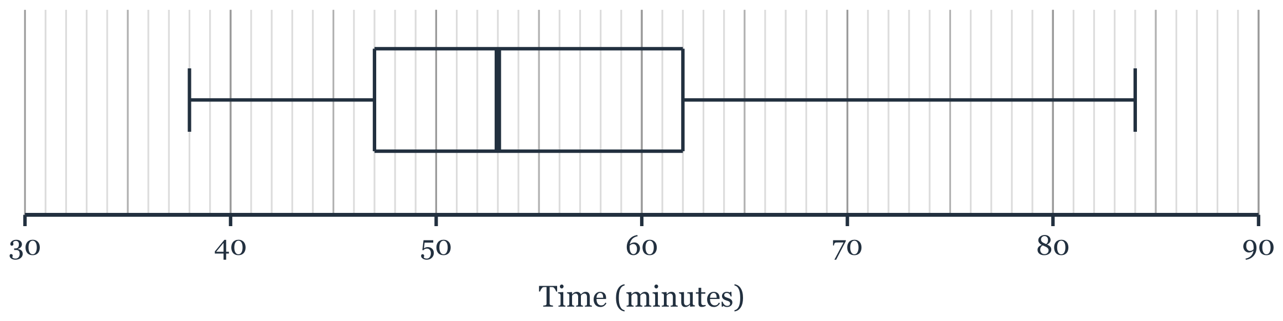
(a)
(i) Find the interquartile range of the times. [1]
(ii) Find how many of the runners took more than 62 minutes to complete the race. [1]
(b) The times taken by 80 runners in a second race had a median of 58 minutes and an interquartile range of 9 minutes.
Make two comments comparing the times taken in the two races. [2]

Solution:
(a)(i) | From the plot, the lower quartile is 47 minutes and the upper quartile is 62 minutes.  Interquartile range $=62−47=15$ minutes.
(a)(ii) | 62 minutes is the upper quartile, so $25\%$ of the runners took more than 62 minutes.  Number of runners $=\frac{25}{100}×80=20$.
(b) | From the plot, the median of the first race is 53 minutes.  Comment on the averages: the median of the first race (53 minutes) is less than the median of the second race (58 minutes), so on average the runners in the first race completed the race more quickly.  Comment on the spread: the interquartile range of the first race (15 minutes) is greater than that of the second race (9 minutes), so the times in the first race were more spread out; the times in the second race were more consistent.

- The diagram shows a solid wooden ornament.
It is made from a cylinder of radius 6 cm and height 10 cm.
A hemisphere of radius 4 cm is removed from the top face of the cylinder, as shown.
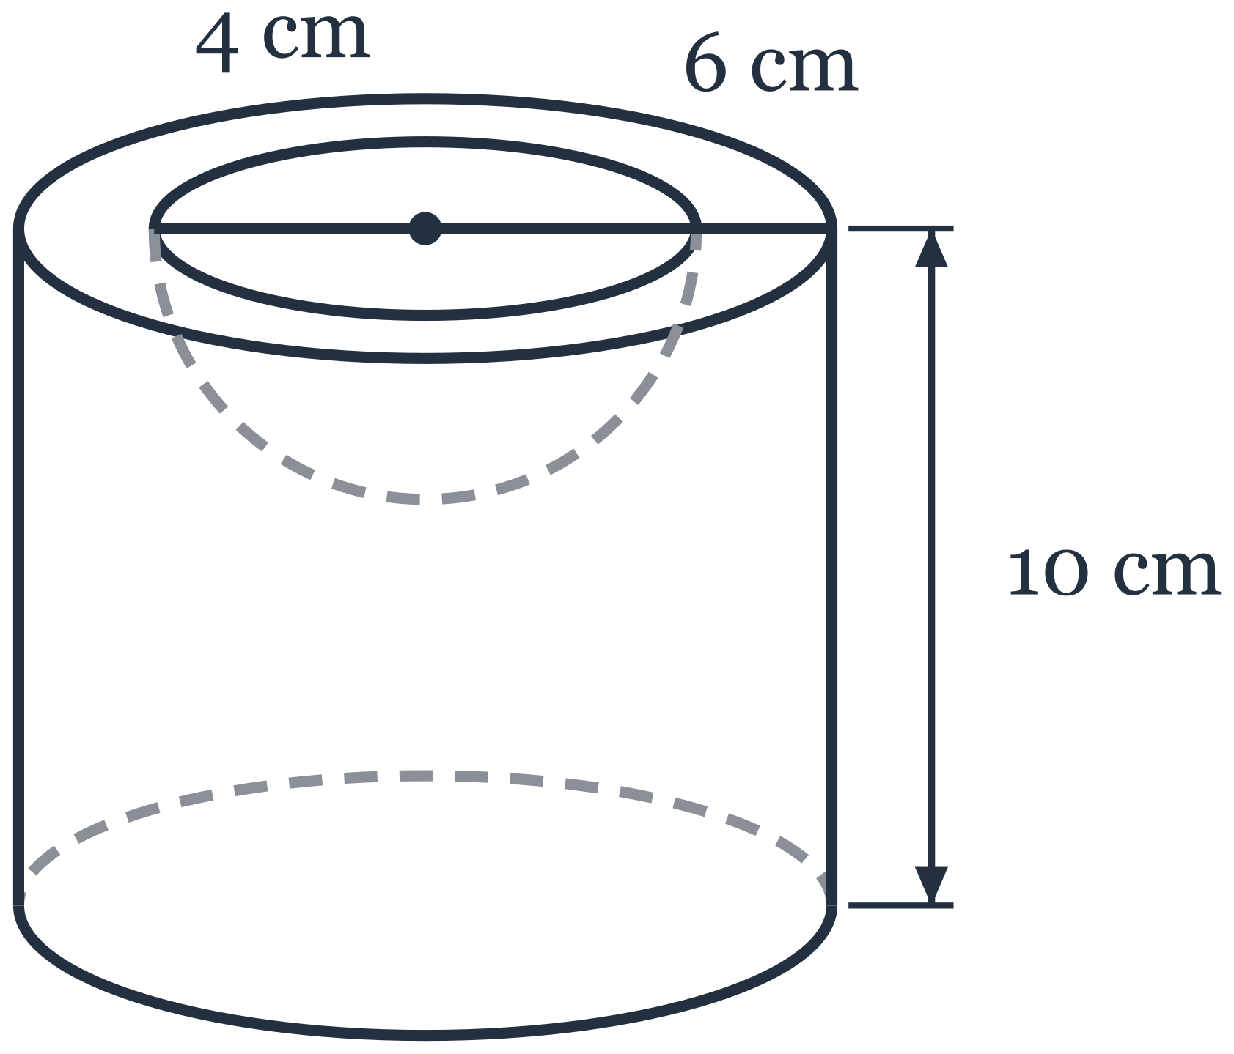
(a) Calculate the volume of the ornament. [2]
(b) Calculate the total surface area of the ornament.
Give your answer in terms of $π$. [3]

Solution:
(a) | Volume of cylinder $=π×6^{2}×10=360π$ cm$​^{3}$.  Volume of hemisphere removed $=\frac{2}{3}π×4^{3}=\frac{128π}{3}$ cm$​^{3}$.  Volume of ornament $=360π−\frac{128π}{3}=\frac{952π}{3}=996.9…≈997$ cm$​^{3}$.
(b) | The surface of the ornament has four pieces.  Curved surface of cylinder $=2π×6×10=120π$ cm$​^{2}$.  Bottom face $=π×6^{2}=36π$ cm$​^{2}$.  Top face, which is a circle of radius 6 cm with a circle of radius 4 cm removed $=π×6^{2}−π×4^{2}=20π$ cm$​^{2}$.  Curved surface of the hollow hemisphere $=2π×4^{2}=32π$ cm$​^{2}$.  Total surface area $=120π+36π+20π+32π=208π$ cm$​^{2}$.

- The first five terms of a sequence are $5$, $12$, $21$, $32$, $45$.
(a) Write down the next term of the sequence. [1]
(b) Find an expression, in terms of $n$, for the $n$th term of the sequence. [2]
(c)
(i) Show that every term of the sequence is 4 less than a square number. [1]
(ii) Hence explain why 500 is not a term of the sequence. [1]
(iii) Hence find the value of $n$ for which the $n$th term of the sequence is 1152. [1]

Solution:
(a) | The differences between consecutive terms are $7,9,11,13$, so the next difference is $15$.  Next term $=45+15=60$.
(b) | The second difference is constant, $2$, so the $n$th term is $n^{2}+bn+c$.  $n=1$: $1+b+c=5$; $n=2$: $4+2b+c=12$.  Subtracting, $3+b=7$, so $b=4$ and $c=0$.  $n$th term $=n^{2}+4n$ (which is $n(n+4)$). Check: $n=5$ gives $25+20=45$.
(c)(i) | $$n^{2}+4n=(n+2)^{2}−4$$  $(n+2)^{2}$ is a square number, so every term is 4 less than a square number.
(c)(ii) | If 500 were a term, then $500+4=504$ would be a square number.  ${22}^{2}=484$ and ${23}^{2}=529$, so $504$ is not a square number. Hence 500 is not a term of the sequence.
(c)(iii) | $$1152+4=1156={34}^{2}$$  So $(n+2)^{2}={34}^{2}$, giving $n+2=34$ and $n=32$.  ✓ Check: ${32}^{2}+4×32=1024+128=1152$.

Answers
1 $k=6$
2
3
4
5
6
7
8
9 Angle $PQR={122}^{∘}$
10
11
12
13
14 $x=3$, $y=4$
15
16
17
18
19
20 $\frac{3x+4}{2x+5}$
21
22
23
24
25
26
27

