MATHEMATICS 4052/01
Paper 1 · 2 hours 15 minutes · 90 marks
Practice paper in the style of the GCE O-Level, set 1. Newly written questions, not a past-year paper.

READ THESE INSTRUCTIONS FIRST
Answer all the questions.
Write your answers in the spaces provided.
If working is needed for any question it must be shown with the answer.
Omission of essential working will result in loss of marks.
The use of an approved scientific calculator is expected, where appropriate.
If the degree of accuracy is not specified in the question, and if the answer is not exact, give the answer to three significant figures. Give answers in degrees to one decimal place.
For $π$, use either your calculator value or 3.142, unless the question requires the answer in terms of $π$.
The number of marks is given in brackets [ ] at the end of each question or part question.
The total number of marks for this paper is 90.

Mathematical Formulae

Compound interest Total amount $=P{\left(1+\frac{r}{100}\right)}^{n}$
Mensuration Curved surface area of a cone $=πrl$
Surface area of a sphere $=4πr^{2}$
Volume of a cone $=\frac{1}{3}πr^{2}h$
Volume of a sphere $=\frac{4}{3}πr^{3}$
Area of triangle $ABC=\frac{1}{2}absinC$
Arc length $=rθ$, where $θ$ is in radians
Sector area $=\frac{1}{2}r^{2}θ$, where $θ$ is in radians
Trigonometry $\frac{a}{sinA}=\frac{b}{sinB}=\frac{c}{sinC}$
$a^{2}=b^{2}+c^{2}−2bccosA$
Statistics Mean $=\frac{∑fx}{∑f}$
Standard deviation $=\sqrt{\frac{∑fx^{2}}{∑f}−{\left(\frac{∑fx}{∑f}\right)}^{2}}$

- Solve the equation $\frac{5k−2}{4}=2k−5$. [2]

- The diagram shows a sector $OAB$ of a circle, centre $O$ and radius 12 cm.
Angle $AOB={150}^{∘}$.
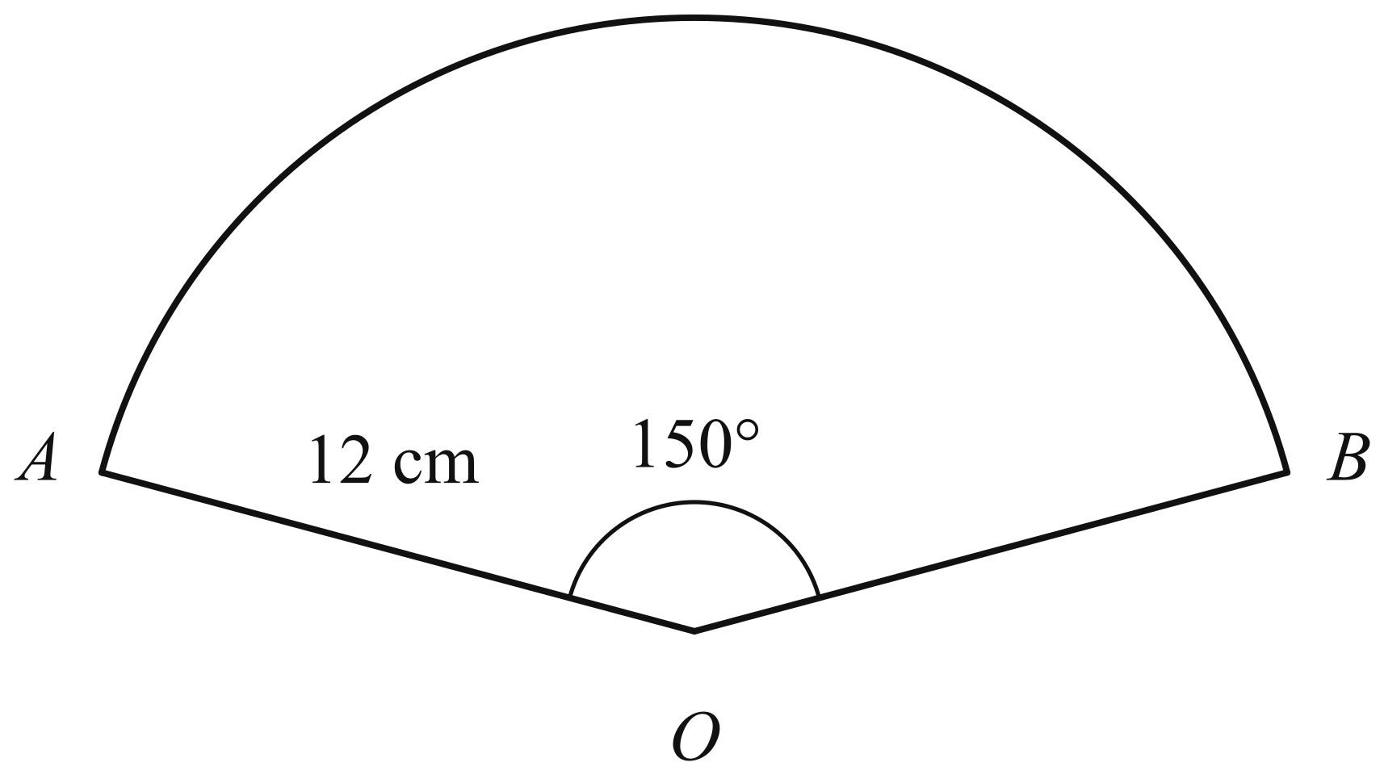
(a) Convert ${150}^{∘}$ to radians. Give your answer in terms of $π$. [1]

(b) Calculate the area of the sector $OAB$. Give your answer in terms of $π$. [1]

- The cash price of an electric bicycle is \1840$.
Under a hire-purchase scheme, a customer pays a deposit of \400$ followed by 18 equal monthly payments.
The hire-purchase price is $22.5\%$ more than the cash price.
(a) Calculate the hire-purchase price. [1]

(b) Calculate the amount of each monthly payment. [2]

- Written as a product of its prime factors, $1176=2^{3}×3×7^{2}$.
(a) Explain why $6×1176$ is a perfect square. [1]

(b) Find the smallest positive integer $n$ such that $\frac{1176}{n}$ is a cube number. [1]

- Priya invests \5600$atarateof$2.5\%$ per year compound interest.
(a) Calculate the interest earned during the second year. [2]

(b) Priya says that the total interest earned in the first 8 years will be \1120$.Explainwhythetotalinterestwillbemorethan$\$1120$. [1]

- The curve $y=x^{2}+bx+c$ has line of symmetry $x=1.5$.
One of the points where the curve crosses the $x$-axis is $(−2,0)$.
(a) Write down the coordinates of the other point where the curve crosses the $x$-axis. [1]

(b) Find the value of $b$ and the value of $c$. [2]

- The diagram is an accurate scale drawing of a triangular garden $ABC$.
The scale is 1 cm to 5 m.
Angle $ABC={90}^{∘}$ and $BC=35$ m.
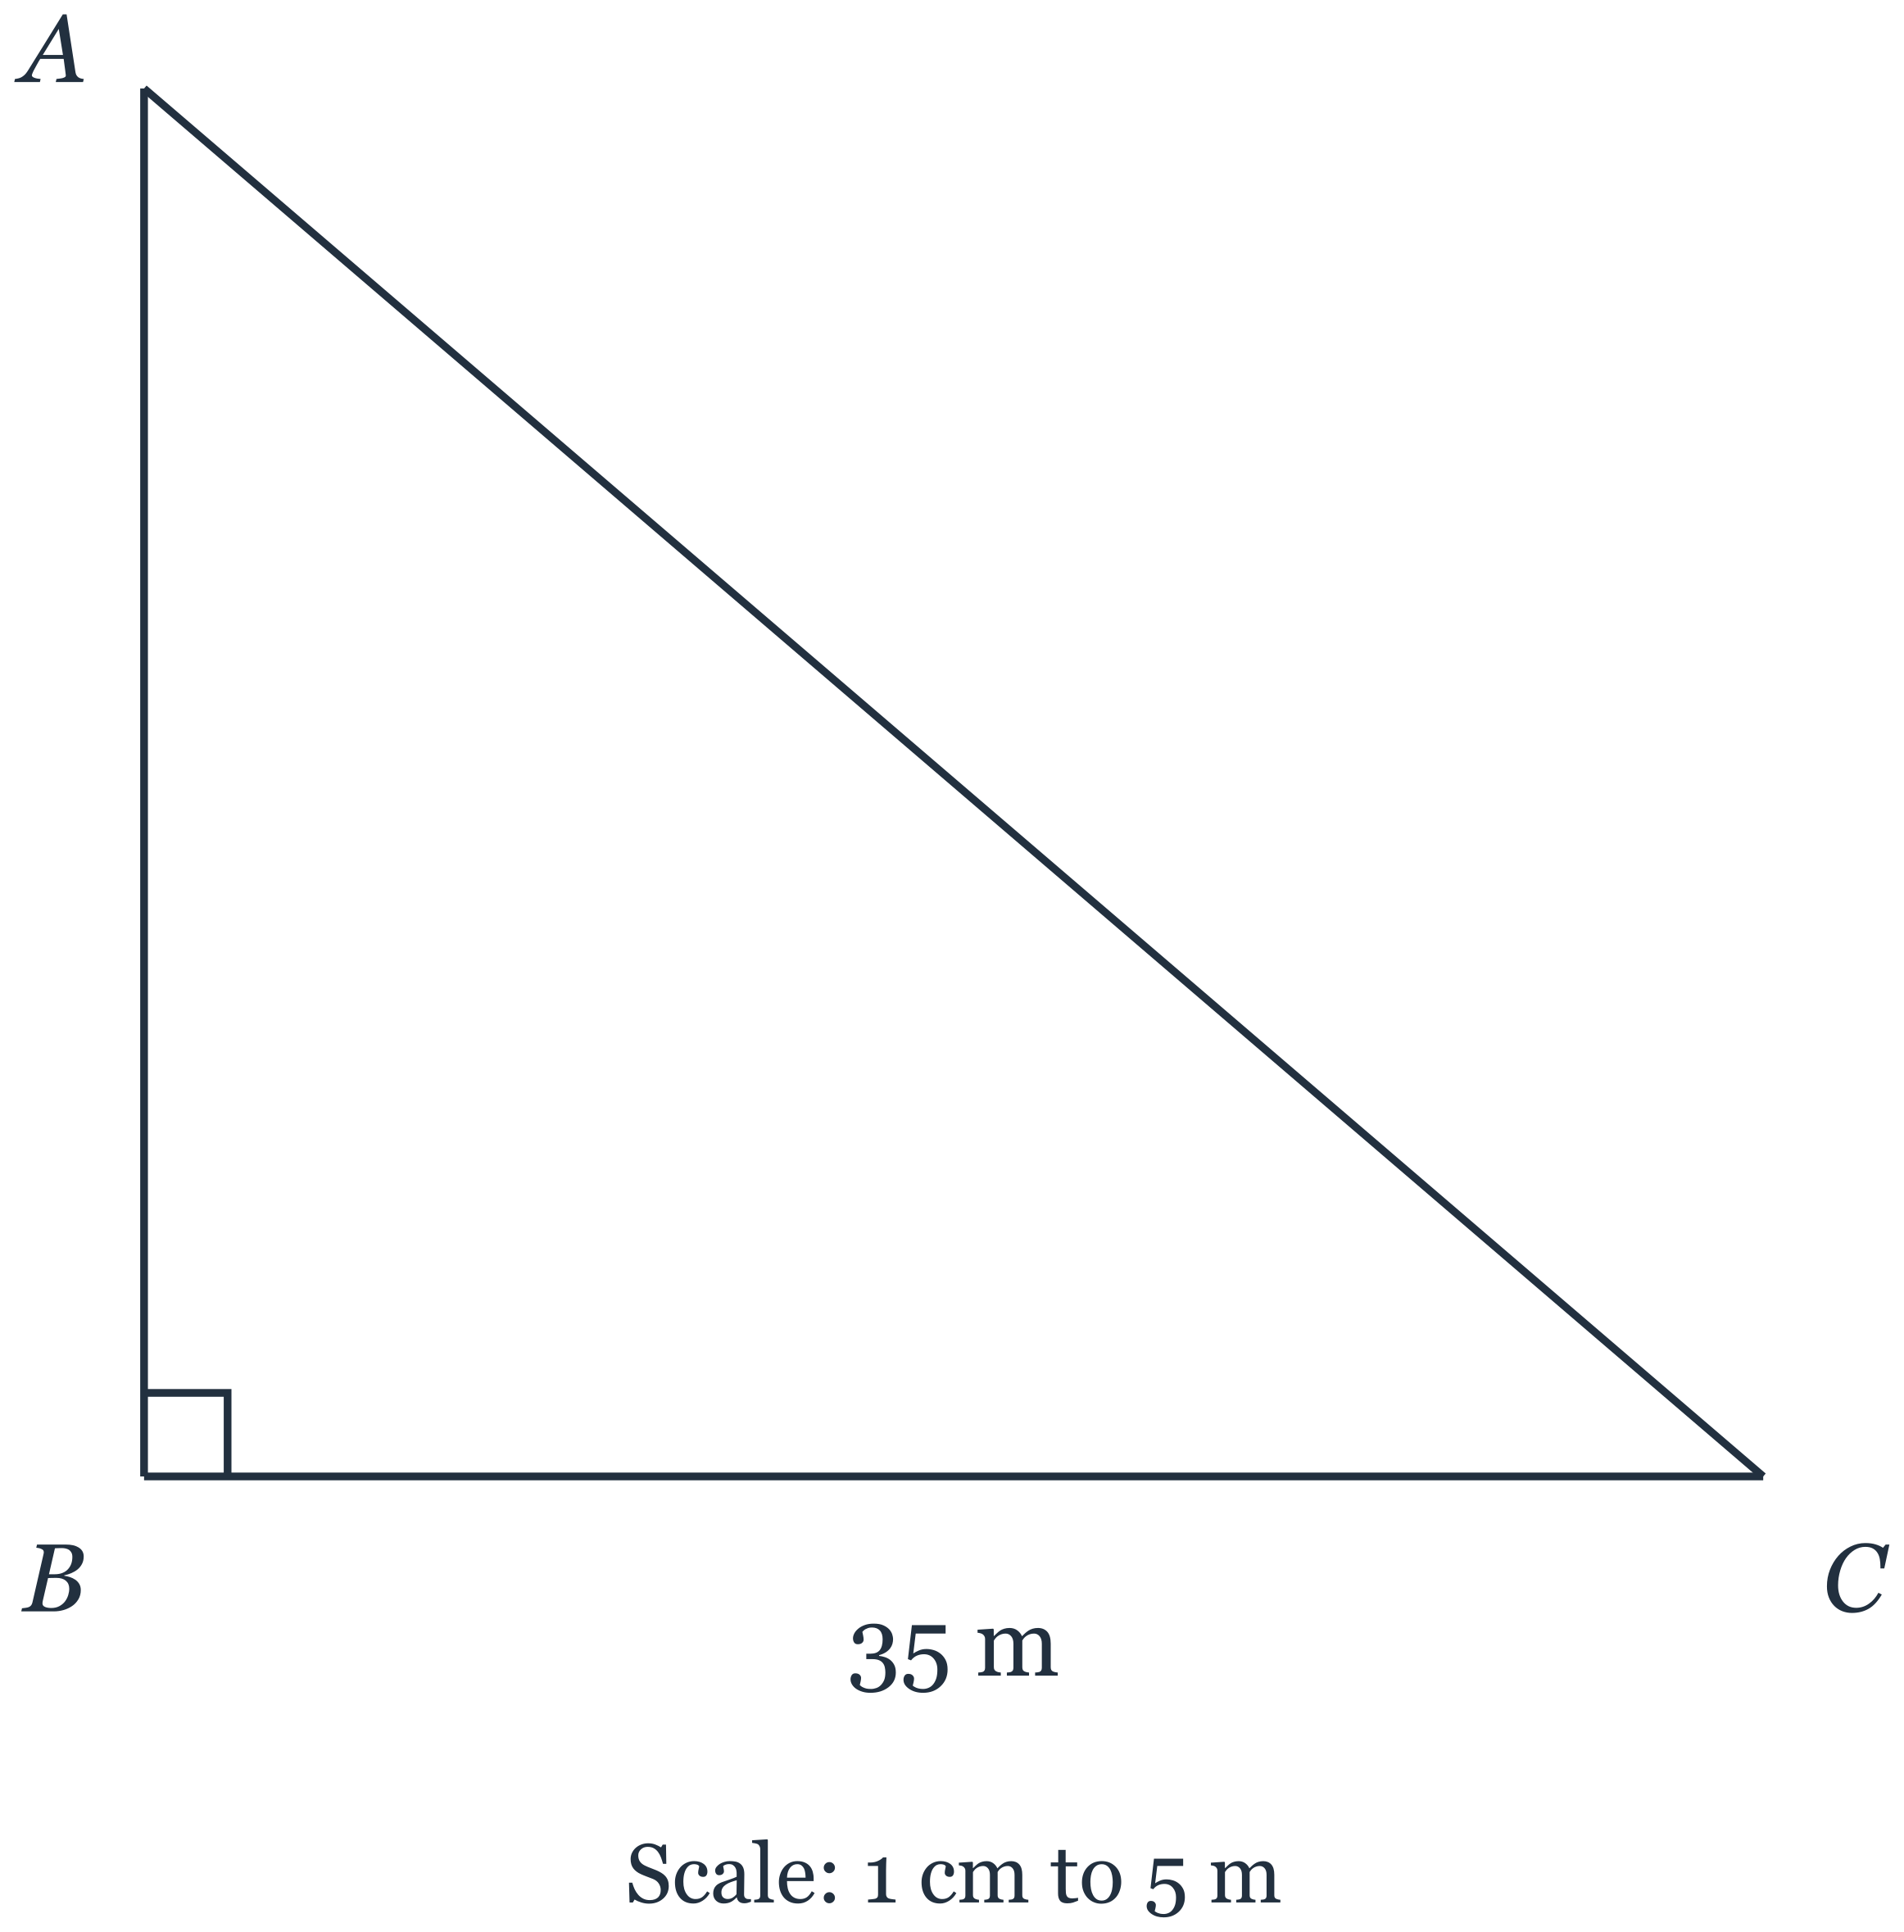
(a) Measure the length of $AB$ on the drawing. Hence find the actual length of $AB$, in metres. [1]

(b) Construct the perpendicular bisector of $AB$. [1]

(c) Construct the bisector of angle $ABC$. [1]

(d) A tap, $T$, is to be placed in the garden so that it is equidistant from $A$ and $B$ and equidistant from $AB$ and $BC$.
Mark the point $T$ on the diagram and measure the length of $TC$. Hence find the actual distance $TC$, in metres. [1]

- It is given that $(x+2)(x^{2}+hx+k)=x^{3}−x^{2}−10x−8$ for all values of $x$.
(a) Find the value of $h$ and the value of $k$. [2]

(b) Hence factorise $x^{3}−x^{2}−10x−8$ completely. [1]

- $P$, $Q$ and $R$ are points on a circle, centre $O$.
Angle $POR={116}^{∘}$.
Find angle $PQR$.
Give a reason for each step of your working. [2]

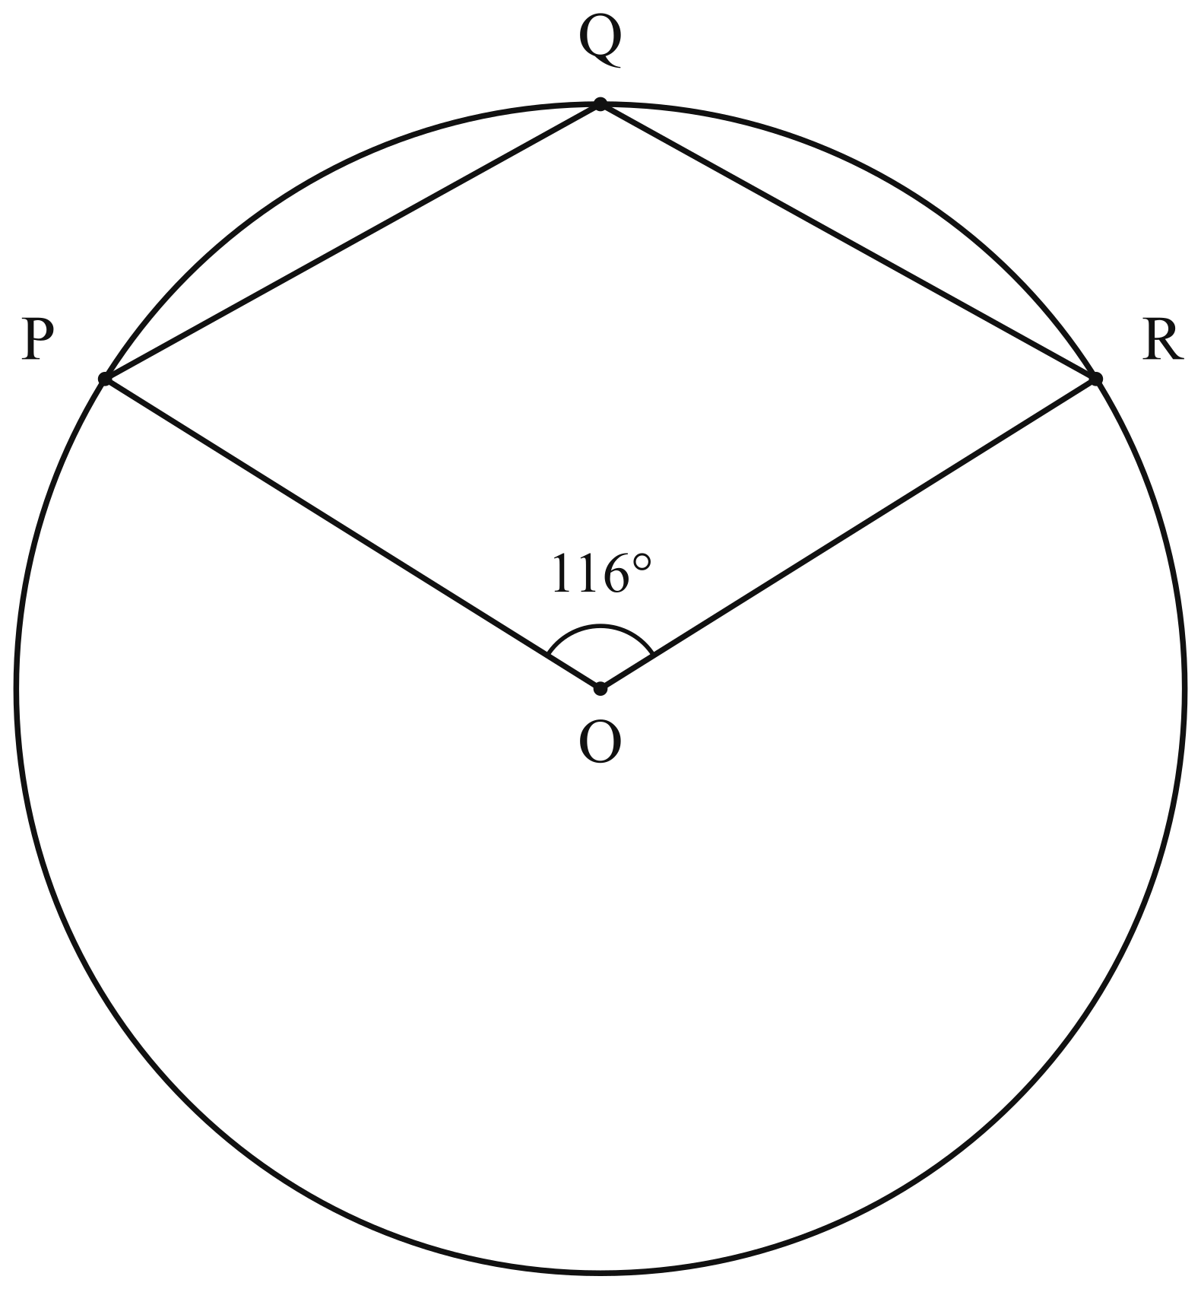
- A paint shop makes a shade of paint called Sea Mist by mixing blue paint, white paint and grey paint in the ratio $2:9:4$ by volume.
(a) Find the volume of white paint in 7.5 litres of Sea Mist. [1]

(b) Express the ratio volume of grey paint : volume of Sea Mist in the form $1:n$. [1]

(c) A decorator has 1.5 litres of blue paint, 8 litres of white paint and 2.6 litres of grey paint.
Find the greatest volume of Sea Mist she can make. [2]

(a) Simplify $\frac{2x^{2}−8}{x^{2}−5x+6}$. [2]

(b) Hence solve $\frac{2x^{2}−8}{x^{2}−5x+6}=4$. [1]

- $q=\sqrt{\frac{p+2r}{p−r}}$
(a) Rearrange the formula to make $p$ the subject. [3]

(b) Hence find $p$ when $q=3$ and $r=8$. [1]

- A bakery sells muffins in three flavours: chocolate, banana and lemon.
Each customer buys exactly one muffin.
The probability that a customer buys a chocolate muffin is $0.35$.
The probability that a customer buys a lemon muffin is $0.2$.
(a) Find the probability that a customer buys a banana muffin. [1]

(b) Two customers each buy a muffin. The flavour each customer buys is independent of the other.
Find the probability that the two customers buy muffins of different flavours. [2]

- Solve these simultaneous equations.
$3x+2y=17$
$5x−4y=−1$
You must show your working. [2]

- The diagram shows a parallelogram $ABCD$.
$E$ is the point on $DC$ such that $AE$ bisects angle $DAB$.
Angle $ABC={116}^{∘}$.
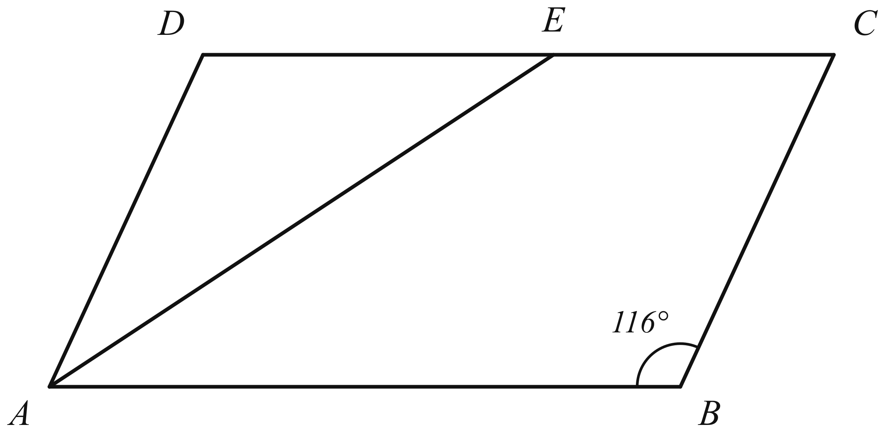
(a) Find angle $DAE$. [1]

(b) Find angle $AEC$. [2]

- Two solid trophies are geometrically similar and are made of the same metal.
The smaller trophy has height $6$ cm and the larger trophy has height $15$ cm.
(a) The surface area of the smaller trophy is $72$ cm$​^{2}$.
Calculate the surface area of the larger trophy. [1]

(b) The mass of the larger trophy is $875$ g.
Calculate the mass of the smaller trophy. [2]

- $E=\{x:x\text{ is an integer and }1≤x≤15\}$
$A=\{x:x\text{ is a multiple of }3\}$
$B=\{x:x\text{ is a factor of }30\}$
(a) List the elements of $A∩B$. [1]

(b) Find $n(A^{′}∩B^{′})$. [1]

- The mass of one helium atom is $6.64×{10}^{−27}$ kg.
A balloon contains $2.5×{10}^{23}$ helium atoms.
(a) Calculate the mass of the helium in the balloon.
Give your answer in kilograms in standard form. [2]

(b) A second balloon contains $4.15×{10}^{−3}$ kg of helium.
Calculate the total number of helium atoms in the two balloons.
Give your answer in standard form. [2]

- A teacher has 216 pens and 288 erasers. She puts them into gift bags so that each bag has the same number of pens and the same number of erasers, with none left over.
(a) Find the greatest number of gift bags she can make. [2]

(b) She also puts stickers into each of the gift bags, with the same number in each bag and none left over. Stickers are sold in packets of 10.
Find the smallest number of packets of stickers she must buy. [1]

- Simplify $\frac{6x^{2}−7x−20}{4x^{2}−25}$. [3]

- Two shops, Shop A and Shop B, sell bags of rice, trays of eggs and bottles of cooking oil. The matrix $P$ shows the price, in dollars, of each item at each shop. The rows represent Shop A and Shop B, and the columns represent rice, eggs and cooking oil, in that order.
$P=\left(\begin{matrix}12 & 4 & 7 \\ 13 & 3 & 6\end{matrix}\right)$
Mrs Tan needs to buy 2 bags of rice, 5 trays of eggs and 3 bottles of cooking oil.
(a) Represent the numbers of items Mrs Tan needs to buy in a $3×1$ matrix $Q$. [1]

(b) Find the matrix $C=PQ$. [2]

(c) Find the matrix $\left(\begin{matrix}1 & −1\end{matrix}\right)C$ and explain what the element of this matrix represents. [1]

- A square tile has sides of length $(3x+2)$ cm. A square hole with sides of length $(x−1)$ cm is cut from the tile, where $x>1$. The remaining part of the tile is called the frame.
(a) Show that the area of the frame is $(8x^{2}+14x+3)$ cm$​^{2}$. [2]

(b) The area of the frame is $63$ cm$​^{2}$. Find the length of a side of the tile. [2]

- The diagram shows a triangular plot of land $LMN$ on horizontal ground.
The side $MN$ runs along a straight road.
$LM=120$ m, $LN=85$ m and angle $MLN={104}^{∘}$.
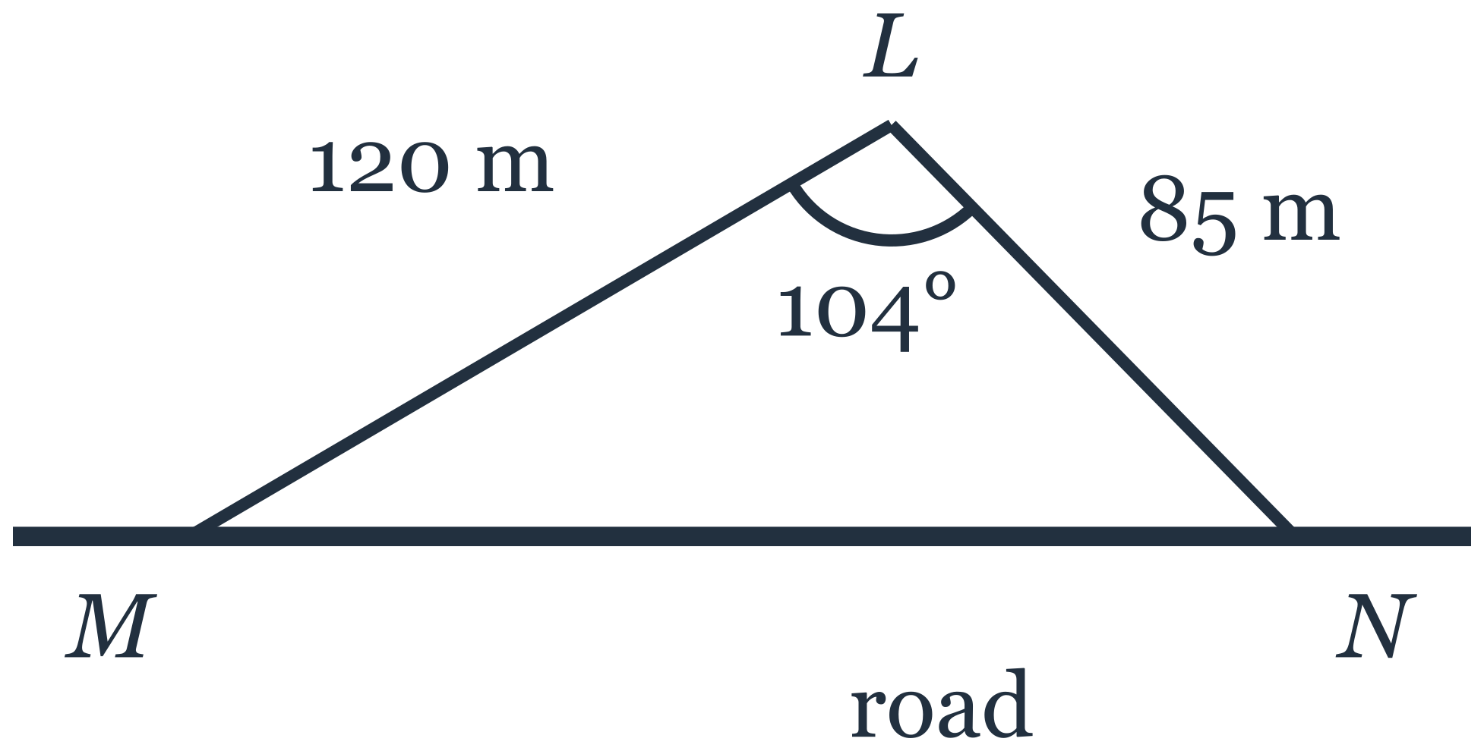
(a) Show that $MN=163$ m, correct to 3 significant figures. [2]

(b) Calculate angle $LMN$. [2]

(c) A straight path is to be built from $L$ to the road so that the path is as short as possible.
Calculate the length of this path. [2]

- The time, $T$ seconds, taken by a pendulum to complete one swing is directly proportional to the square root of its length, $L$ cm.
A pendulum of length $64$ cm takes $1.6$ seconds to complete one swing.
(a) Find an expression for $T$ in terms of $L$. [2]

(b) Find the length of a pendulum that takes $2.5$ seconds to complete one swing. [1]

- The box-and-whisker plot shows the distribution of the times, in minutes, taken by 80 runners to complete a race.
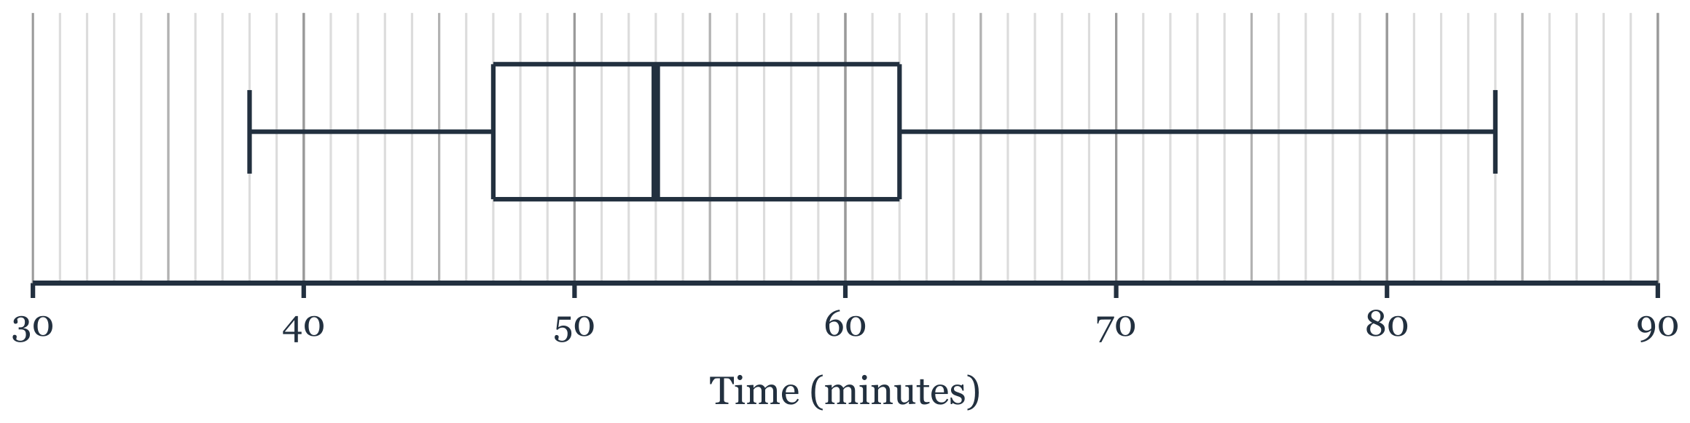
(a)
(i) Find the interquartile range of the times. [1]

(ii) Find how many of the runners took more than 62 minutes to complete the race. [1]

(b) The times taken by 80 runners in a second race had a median of 58 minutes and an interquartile range of 9 minutes.
Make two comments comparing the times taken in the two races. [2]

- The diagram shows a solid wooden ornament.
It is made from a cylinder of radius 6 cm and height 10 cm.
A hemisphere of radius 4 cm is removed from the top face of the cylinder, as shown.
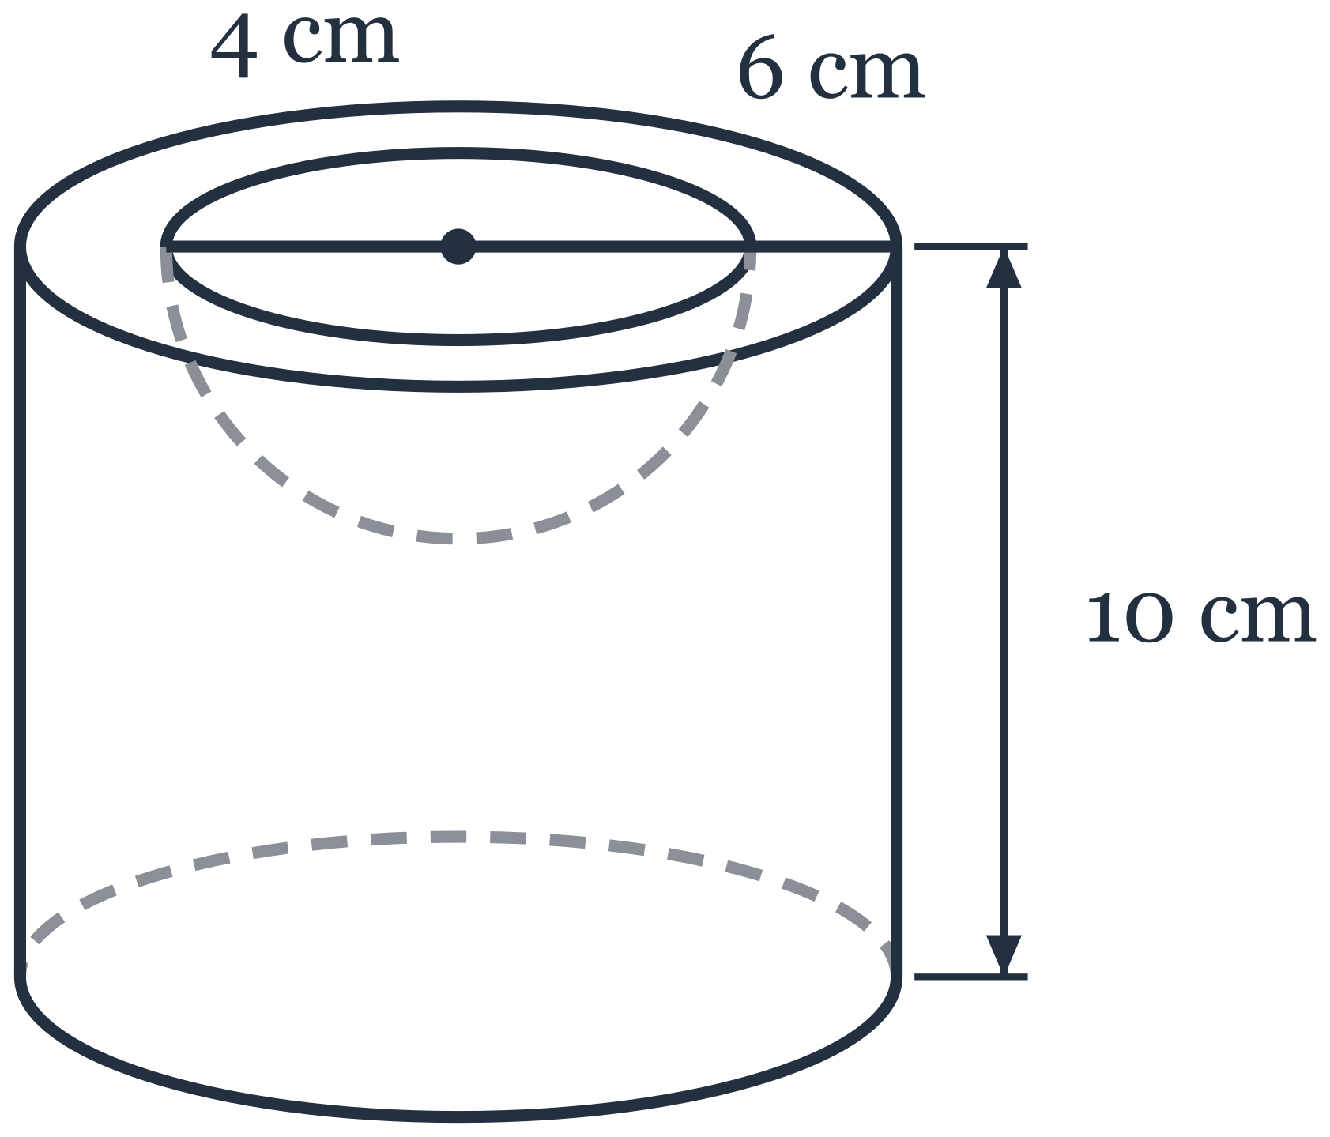
(a) Calculate the volume of the ornament. [2]

(b) Calculate the total surface area of the ornament.
Give your answer in terms of $π$. [3]

- The first five terms of a sequence are $5$, $12$, $21$, $32$, $45$.
(a) Write down the next term of the sequence. [1]

(b) Find an expression, in terms of $n$, for the $n$th term of the sequence. [2]

(c)
(i) Show that every term of the sequence is 4 less than a square number. [1]

(ii) Hence explain why 500 is not a term of the sequence. [1]

(iii) Hence find the value of $n$ for which the $n$th term of the sequence is 1152. [1]

