MATHEMATICS 4052/02 · WORKED SOLUTIONS
Paper 2 · set 1 · 90 marks
(a) Solve the inequality $5−3(x−2)>2x+1$. [2]
(b) Simplify ${\left(9p^{4}q^{−2}\right)}^{\frac{1}{2}}×2p^{−3}q^{5}$, giving your answer in positive index form. [2]
(c) Make $t$ the subject of the formula $v=\sqrt{\frac{k−3t}{t}}$. [3]
(d) Solve the equation $\frac{4}{x−1}+\frac{3}{x+2}=2$. Give your solutions correct to two decimal places. [4]

Solution:
(a) | $5−3(x−2)>2x+1$\n$5−3x+6>2x+1$\n$11−3x>2x+1$\n$10>5x$\n$x<2$\n\n(b) ${\left(9p^{4}q^{−2}\right)}^{\frac{1}{2}}=9^{\frac{1}{2}}p^{4×\frac{1}{2}}q^{−2×\frac{1}{2}}=3p^{2}q^{−1}$\n$3p^{2}q^{−1}×2p^{−3}q^{5}=6p^{2+(−3)}q^{−1+5}=6p^{−1}q^{4}=\frac{6q^{4}}{p}$\n\n(c) $v=\sqrt{\frac{k−3t}{t}}$\nSquare both sides: $v^{2}=\frac{k−3t}{t}$\n$v^{2}t=k−3t$\n$v^{2}t+3t=k$\n$t(v^{2}+3)=k$\n$t=\frac{k}{v^{2}+3}$\n\n(d) $\frac{4}{x−1}+\frac{3}{x+2}=2$\nMultiply throughout by $(x−1)(x+2)$:\n$4(x+2)+3(x−1)=2(x−1)(x+2)$\n$4x+8+3x−3=2(x^{2}+x−2)$\n$7x+5=2x^{2}+2x−4$\n$2x^{2}−5x−9=0$\nUsing the quadratic formula with $a=2$, $b=−5$, $c=−9$:\n$x=\frac{−(−5)±\sqrt{(−5)^{2}−4(2)(−9)}}{2(2)}=\frac{5±\sqrt{25+72}}{4}=\frac{5±\sqrt{97}}{4}$\n$\sqrt{97}=9.84886…$\n$x=\frac{5+9.84886}{4}=3.71221…$ or $x=\frac{5−9.84886}{4}=−1.21221…$\n$x=3.71$ or $x=−1.21$ (correct to 2 decimal places)\nCheck: $x=3.71221$: $\frac{4}{2.71221}+\frac{3}{5.71221}=1.47481+0.52519=2.0000$; $x=−1.21221$: $\frac{4}{−2.21221}+\frac{3}{0.78779}=−1.80815+3.80815=2.0000$.

- Mei runs a small café.
(a) Mei buys a coffee machine from Italy for €2 450. The exchange rate is €1 = S$1.48.
Goods and Services Tax (GST) of 9% is charged on the price in Singapore dollars.
Calculate the total amount, in Singapore dollars, that Mei pays for the machine. [2]
(b) Mei increased the selling price of a cup of latte by 8%. The new selling price is \5.94$.
Calculate the selling price of a cup of latte before the increase. [2]
(c) The cost of making a cup of latte is made up of the cost of coffee beans, the cost of milk and other costs in the ratio $5:4:3$. The coffee beans for one cup cost \1.25$.
Calculate the percentage profit Mei makes on a cup of latte sold at \5.94$. [2]
(d) Mei spends \180$onGradeAcoffeebeans,whichcost$\$x$ per kilogram.
Grade B coffee beans cost \5$ per kilogram more than Grade A coffee beans.
For \180$, Mei would get 3 kg less of Grade B coffee beans than of Grade A coffee beans.
(i) Form an equation in $x$ and show that it simplifies to $x^{2}+5x−300=0$. [3]
(ii) Solve the equation $x^{2}+5x−300=0$. [1]
(iii) Hence find the cost of 1 kilogram of Grade B coffee beans. [1]

Solution:
(a) | Price in Singapore dollars = 2450 \times 1.48 = \3626$.  With GST, total paid = 3626 \times 1.09 = \3952.34$.
(b) | The new price is $108\%$ of the old price.  108\% \to \5.94$,so$100\% \to \frac{5.94}{1.08} = \$5.50$.
(c) | Beans are 5 parts of the ratio $5:4:3$, which has 12 parts in all.  5 parts = \1.25$,so12parts$= \frac{1.25}{5} \times 12 = \$3.00$ (the cost of making a cup).  Profit per cup = 5.94 - 3.00 = \2.94$.  Percentage profit $=\frac{2.94}{3.00}×100\%=98\%$.
(d)(i) | Mass of Grade A beans bought for \180= \frac{180}{x}$ kg.  Grade B beans cost \(x+5)$perkilogram,sothemassofGradeBbeansboughtfor$\$180$ $=\frac{180}{x+5}$ kg.  The Grade B mass is 3 kg less: $\frac{180}{x}−\frac{180}{x+5}=3$.  Multiply through by $x(x+5)$: $180(x+5)−180x=3x(x+5)$  $$180x+900−180x=3x^{2}+15x$$  $$900=3x^{2}+15x$$  Divide by 3: $300=x^{2}+5x$, so $x^{2}+5x−300=0$ (shown).
(d)(ii) | $$x^{2}+5x−300=0$$  $$(x−15)(x+20)=0$$  $x=15$ or $x=−20$.
(d)(iii) | $x$ is a price per kilogram, so $x=−20$ is rejected and $x=15$.  Cost of 1 kg of Grade B beans = 15 + 5 = \20$.  ✓ Check: \180$buys$\frac{180}{15} = 12$kgofGradeAand$\frac{180}{20} = 9$kgofGradeB;$12 - 9 = 3$ kg.

- The diagram shows a sketch of the curve $y=ax^{2}+bx+c$.
The curve crosses the $x$-axis at the points $(−1,0)$ and $(3,0)$ and crosses the $y$-axis at the point $(0,3)$.
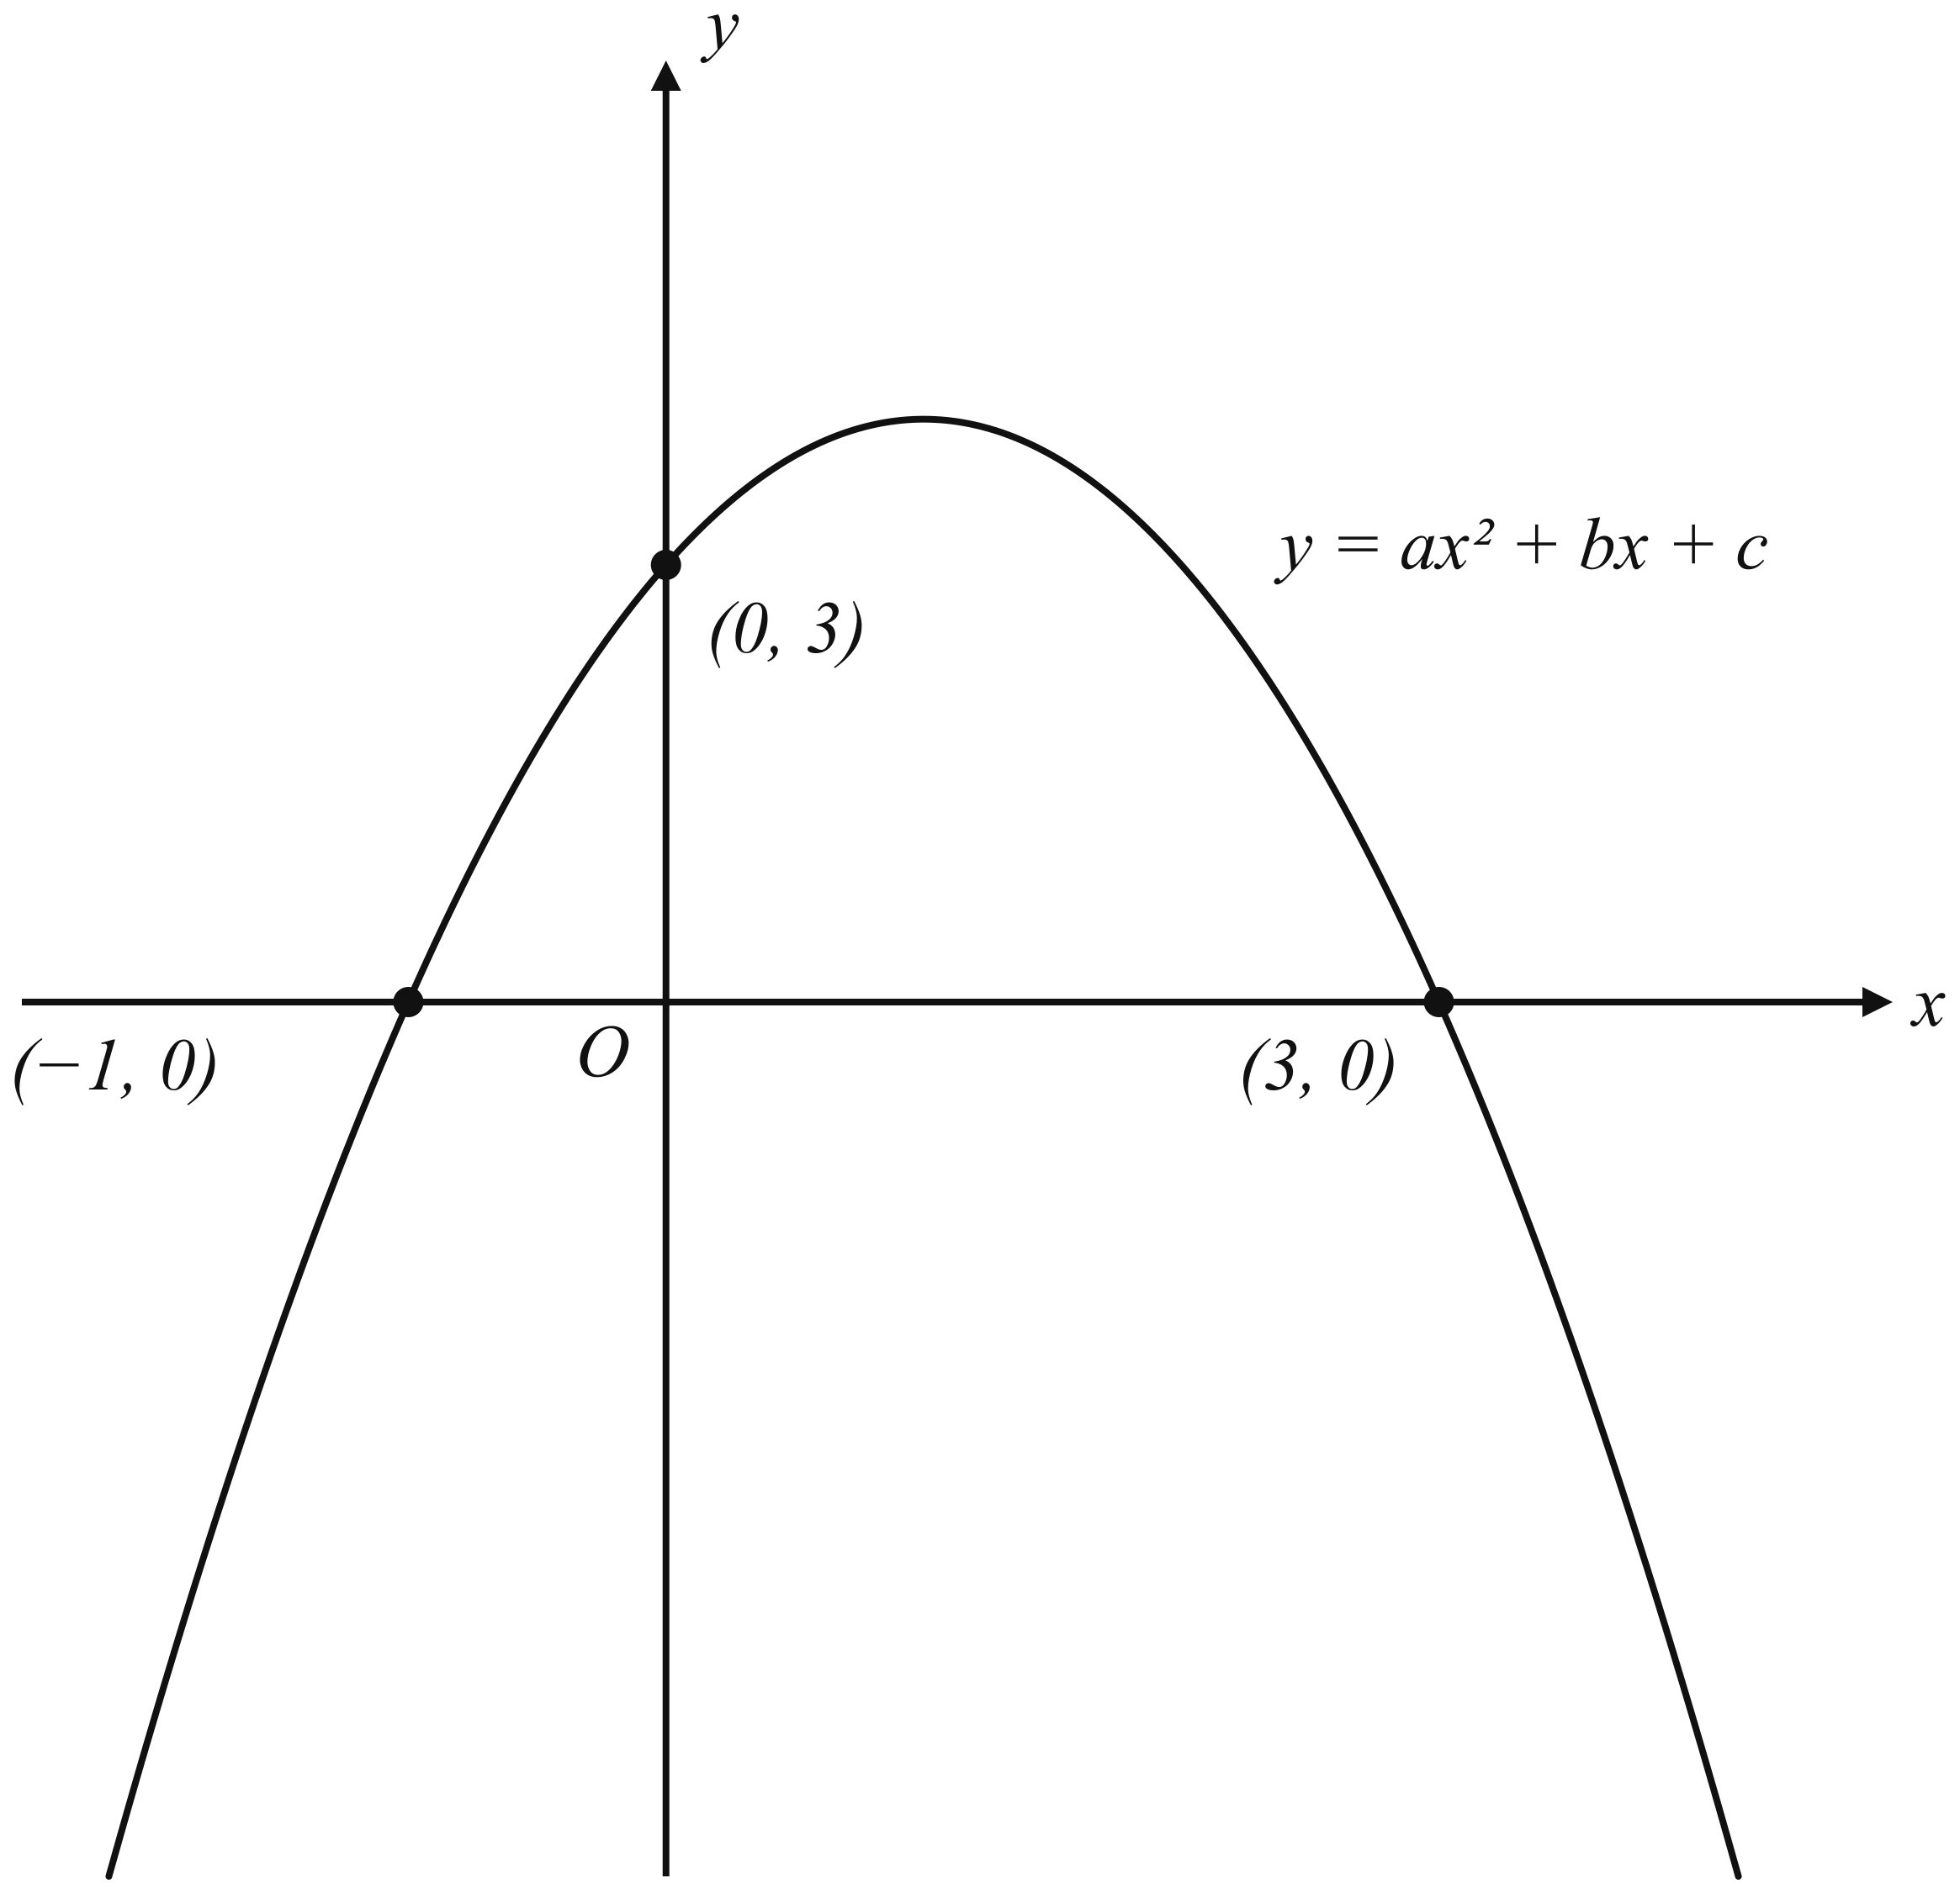
(a) Find the value of $a$, of $b$ and of $c$. [3]
(b)
(i) Write the equation of the curve in the form $y=k−(x−h)^{2}$, where $h$ and $k$ are integers. [2]
(ii) Hence write down the coordinates of the maximum point of the curve. [1]
(c) The point $P$ lies on the curve and has $x$-coordinate 4.
Find the equation of the straight line that passes through $P$ and the maximum point of the curve. [3]

Solution:
(a) | Since the curve crosses the $x$-axis at $x=−1$ and $x=3$, its equation can be written as $y=a(x+1)(x−3)$.  The curve passes through $(0,3)$: $3=a(0+1)(0−3)=−3a$, so $a=−1$.  Expanding, $y=−(x+1)(x−3)=−(x^{2}−2x−3)=−x^{2}+2x+3$.  Hence $a=−1$, $b=2$, $c=3$.
(b)(i) | $$\begin{aligned}−x^{2}+2x+3&=−(x^{2}−2x)+3 \\ &=−\left[(x−1)^{2}−1\right]+3 \\ &=−(x−1)^{2}+1+3 \\ &=4−(x−1)^{2}\end{aligned}$$  So $k=4$ and $h=1$.
(b)(ii) | Since $(x−1)^{2}≥0$, the greatest value of $y$ is $4$, occurring when $x=1$.  The maximum point is $(1,4)$.
(c) | When $x=4$: $y=−(4)^{2}+2(4)+3=−16+8+3=−5$, so $P$ is $(4,−5)$.  Gradient of the line through $P(4,−5)$ and the maximum point $(1,4)$: $\frac{4−(−5)}{1−4}=\frac{9}{−3}=−3$.  Using the point $(1,4)$: $y−4=−3(x−1)$, so $y=−3x+7$.  Check at $P$: $−3(4)+7=−5$. Correct.  The equation of the line is $y=−3x+7$.

- The table shows some values of $x$ and the corresponding values of $y$ for $y=x^{2}+\frac{3}{x}$.
$$\begin{matrix}x & −3 & −2.5 & −2 & −1.5 & −1 & −0.5 & 0.5 & 1 & 1.5 & 2 & 2.5 & 3 \\ y & 8 & 5.05 & 2.5 & & −2 & −5.75 & 6.25 & 4 & 4.25 & 5.5 & & 10 \\ \end{matrix}$$
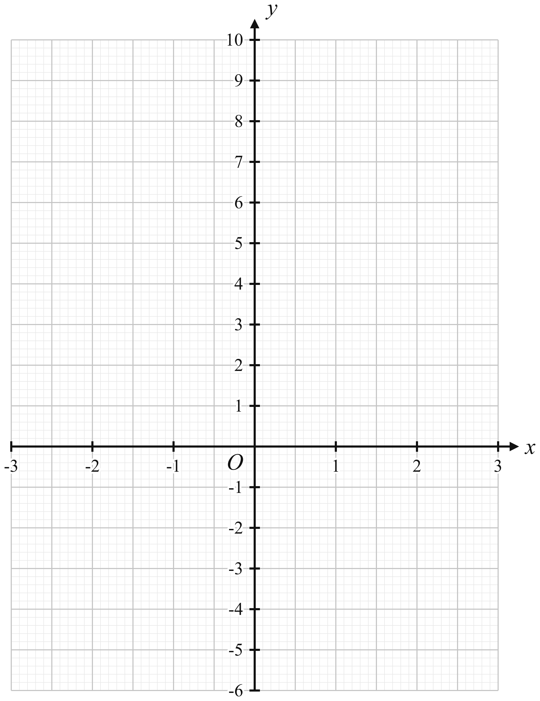
(a) Complete the table of values. [2]
(b) On the grid, draw the graph of $y=x^{2}+\frac{3}{x}$ for $−3≤x≤3$. [3]
(c)
(i) By drawing a tangent, use your graph to find the gradient of the curve at the point where $x=2$. [2]
(ii) Use your graph to explain why the equation $x^{2}+\frac{3}{x}=3$ has only one solution. [1]
(iii) By drawing a suitable straight line on the grid, solve the equation $x^{3}−2x^{2}−3x+3=0$. [3]

Solution:
(a) | $y=x^{2}+\frac{3}{x}$\nWhen $x=−1.5$: $y=(−1.5)^{2}+\frac{3}{−1.5}=2.25−2=0.25$\nWhen $x=2.5$: $y={2.5}^{2}+\frac{3}{2.5}=6.25+1.2=7.45$\nFull table: $x=−3,−2.5,−2,−1.5,−1,−0.5,0.5,1,1.5,2,2.5,3$ gives $y=8,5.05,2.5,0.25,−2,−5.75,6.25,4,4.25,5.5,7.45,10$.\n\n(b) Plot the twelve points on the grid (2 cm to 1 unit on the $x$-axis, 1 cm to 1 unit on the $y$-axis, $−3≤x≤3$, $−6≤y≤10$) and join them with two smooth curves: the left branch from $(−3,8)$ down to $(−0.5,−5.75)$, and the right branch from $(0.5,6.25)$ down to a minimum near $(1.1,3.9)$ and up to $(3,10)$. No curve is drawn between $x=−0.5$ and $x=0.5$ because $y$ is undefined at $x=0$.\n\n(c)(i) Draw the tangent to the curve at $(2,5.5)$ and take two points on it far apart, e.g. $(1,2.25)$ and $(3,8.75)$.\nGradient $=\frac{8.75−2.25}{3−1}=\frac{6.5}{2}=3.25$\n(Exact value: $\frac{dy}{dx}=2x−\frac{3}{x^{2}}=4−0.75=3.25$; accept $2.9$ to $3.6$ from a drawn tangent.)\n\n(c)(ii) The solutions of $x^{2}+\frac{3}{x}=3$ are the $x$-coordinates of the points where the curve meets the line $y=3$. The line $y=3$ cuts the left-hand branch once, at $x≈−2.1$, but the right-hand branch has its lowest point at $y≈3.9$ (exactly $y=3.93$ at $x=1.14$), which is above $y=3$, so the line does not meet the right-hand branch. Hence there is only one solution.\n\n(c)(iii) $x^{3}−2x^{2}−3x+3=0$\nDivide throughout by $x$ ($x≠0$): $x^{2}−2x−3+\frac{3}{x}=0$\n$x^{2}+\frac{3}{x}=2x+3$\nSo the required line is $y=2x+3$, which passes through $(−3,−3)$, $(0,3)$ and $(3,9)$.\nDraw the line on the grid and read the $x$-coordinates of the three points where it cuts the curve:\n$x=−1.45$, $x=0.75$, $x=2.7$\n(Exact values $−1.4605…$, $0.7609…$, $2.6996…$; check: at $x=2.7$, $x^{2}+\frac{3}{x}=7.29+1.111=8.40$ and $2x+3=8.40$. Accept $−1.55≤x≤−1.4$, $0.7≤x≤0.85$, $2.6≤x≤2.8$.)

- The diagram shows a sector $OAB$ of a circle, centre $O$ and radius $9$ cm.
Angle $AOB=1.2$ radians.
$C$ is the point on $OB$ such that $OC=5$ cm.
The region bounded by $AC$, $CB$ and the arc $AB$ is shaded.
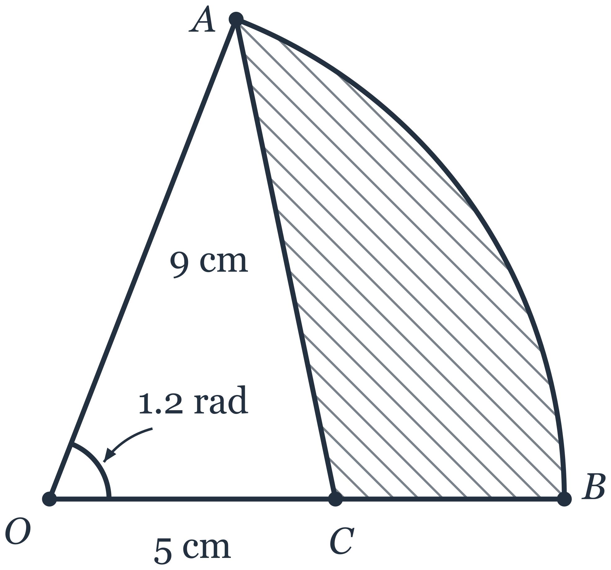
(a) Calculate $AC$. [2]
(b) Calculate angle $OAC$.
Give your answer in degrees. [2]
(c) Calculate
(i) the perimeter of the shaded region, [2]
(ii) the area of the shaded region. [3]

Solution:
 | The calculator is set to radians for every step that uses the sector angle.
(a) | In triangle $OAC$, $OA=9$ cm, $OC=5$ cm and the included angle $AOC=1.2$ radians.  By the cosine rule,  $$AC^{2}=9^{2}+5^{2}−2(9)(5)cos1.2$$  $$=106−90(0.362357…)$$  $$=106−32.6121…$$  $$=73.3878…$$  $AC=\sqrt{73.3878…}=8.56666…=8.57$ cm (3 s.f.)
(b) | In triangle $OAC$, by the sine rule,  $$\frac{sinOAC}{OC}=\frac{sinAOC}{AC}$$  $$\begin{aligned}sinOAC&=\frac{5sin1.2}{8.56666…} \\ &=\frac{5(0.932039…)}{8.56666…} \\ &=0.543991…\end{aligned}$$  Angle $OAC$ is opposite the shortest side $OC$, so it is acute.  Angle $OAC=\sin^{−1}(0.543991…)=32.9557…^{∘}={33.0}^{∘}$ (1 d.p.)
(c)(i) | Arc $AB=rθ=9×1.2=10.8$ cm  $CB=OB−OC=9−5=4$ cm  Perimeter of shaded region $=$ arc $AB+CB+AC$  $$=10.8+4+8.56666…$$  $=23.3666…=23.4$ cm (3 s.f.)
(c)(ii) | Area of sector $OAB=\frac{1}{2}r^{2}θ=\frac{1}{2}(9^{2})(1.2)=48.6$ cm$​^{2}$  Area of triangle $OAC=\frac{1}{2}(OA)(OC)sinAOC=\frac{1}{2}(9)(5)sin1.2=20.9708…$ cm$​^{2}$  Shaded area $=48.6−20.9708…=27.6291…=27.6$ cm$​^{2}$ (3 s.f.)

- The points $A$, $B$ and $C$ have coordinates $(−4, −1)$, $(2, 7)$ and $(10, −1)$ respectively.
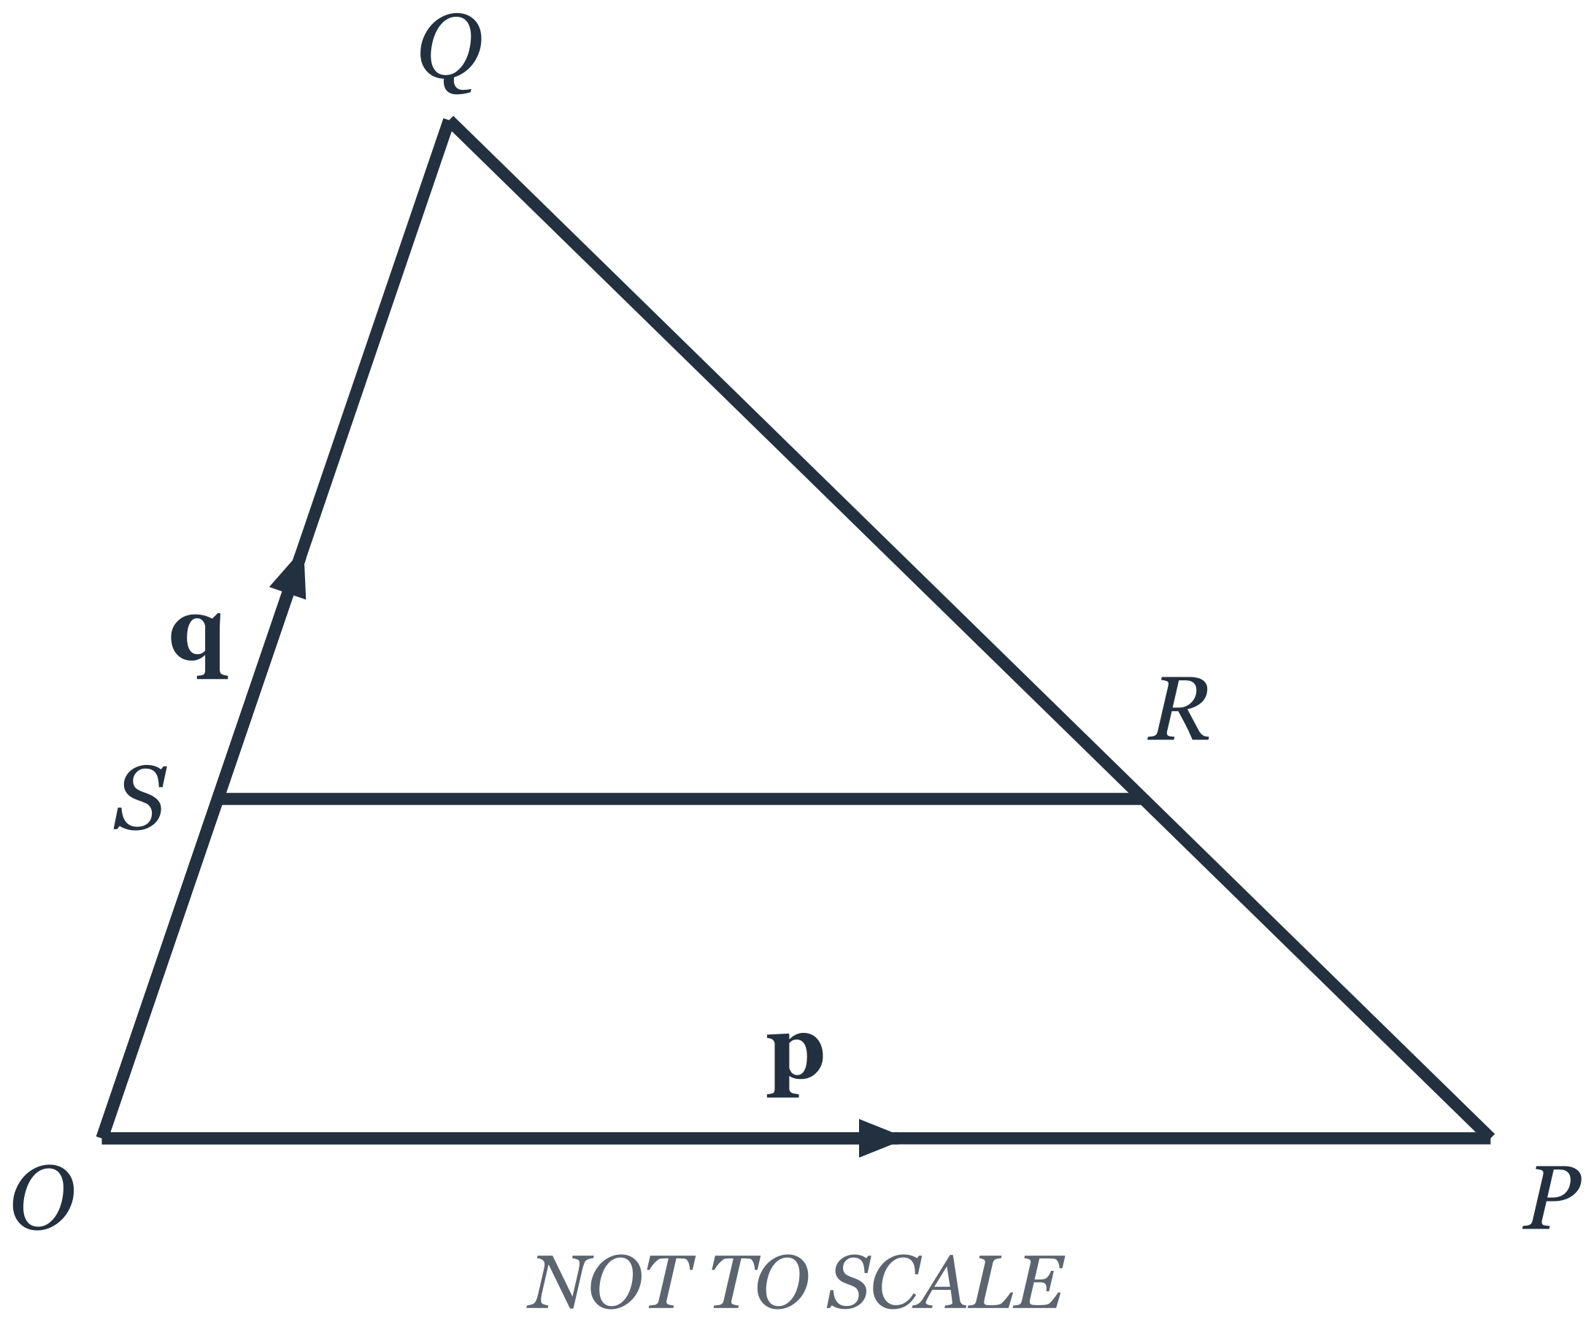
(a) Find the equation of the line which passes through $C$ and is parallel to $AB$.
Give your answer in the form $ax+by=c$, where $a$, $b$ and $c$ are integers. [3]
(b) Calculate the length of $AB$. [2]
(c) Calculate the area of triangle $ABC$. [2]
(d) $OPQ$ is a triangle.
$\vec{OP}=p$ and $\vec{OQ}=q$.
$R$ is the point on $PQ$ such that $PR:RQ=1:2$.
$S$ is the point on $OQ$ such that $OS:SQ=1:2$.
(i) Express $\vec{OR}$ in terms of $p$ and $q$, as simply as possible. [2]
(ii) Express $\vec{SR}$ in terms of $p$ and $q$, as simply as possible. [1]
(iii) Hence find $\frac{\text{area of triangle }QSR}{\text{area of triangle }QOP}$. [1]

Solution:
(a) | Gradient of $AB=\frac{7−(−1)}{2−(−4)}=\frac{8}{6}=\frac{4}{3}$  The required line is parallel to $AB$, so its gradient is also $\frac{4}{3}$, and it passes through $C(10, −1)$:  $$y−(−1)=\frac{4}{3}(x−10)$$  $$3(y+1)=4(x−10)$$  $$3y+3=4x−40$$  $$4x−3y=43$$  Check with $C$: $4(10)−3(−1)=40+3=43$.
(b) | $AB=\sqrt{(2−(−4))^{2}+(7−(−1))^{2}}=\sqrt{6^{2}+8^{2}}=\sqrt{36+64}=\sqrt{100}=10$ units
(c) | $A(−4, −1)$ and $C(10, −1)$ have the same $y$-coordinate, so $AC$ is horizontal.  Base $AC=10−(−4)=14$ units.  The perpendicular height from $B$ to $AC$ is $7−(−1)=8$ units.  Area of triangle $ABC=\frac{1}{2}×14×8=56$ units$​^{2}$
(d)(i) | $$\begin{aligned}\vec{PQ}&=\vec{OQ}−\vec{OP} \\ &=q−p\end{aligned}$$  Since $PR:RQ=1:2$, $\vec{PR}=\frac{1}{3}\vec{PQ}=\frac{1}{3}(q−p)$  $$\begin{aligned}\vec{OR}&=\vec{OP}+\vec{PR} \\ &=p+\frac{1}{3}q−\frac{1}{3}p \\ &=\frac{2}{3}p+\frac{1}{3}q\end{aligned}$$
(d)(ii) | Since $OS:SQ=1:2$, $\vec{OS}=\frac{1}{3}q$  $$\begin{aligned}\vec{SR}&=\vec{OR}−\vec{OS} \\ &=\frac{2}{3}p+\frac{1}{3}q−\frac{1}{3}q \\ &=\frac{2}{3}p\end{aligned}$$
(d)(iii) | $\vec{SR}=\frac{2}{3}\vec{OP}$, so $SR$ is parallel to $OP$ and $SR=\frac{2}{3}OP$.  Triangles $QSR$ and $QOP$ share the angle at $Q$, and angle $QSR=$ angle $QOP$ (corresponding angles, $SR∥OP$), so the triangles are similar with $\frac{SR}{OP}=\frac{2}{3}$.  $$\begin{aligned}\frac{\text{area of triangle }QSR}{\text{area of triangle }QOP}&={\left(\frac{2}{3}\right)}^{2} \\ &=\frac{4}{9}\end{aligned}$$  Check by common heights: triangles $QSR$ and $QOR$ have the common vertex $R$ with bases $QS$ and $QO$ on the same line, so $\frac{\text{area }QSR}{\text{area }QOR}=\frac{QS}{QO}=\frac{2}{3}$; triangles $QOR$ and $QOP$ have the common vertex $O$ with bases $QR$ and $QP$ on the same line, so $\frac{\text{area }QOR}{\text{area }QOP}=\frac{QR}{QP}=\frac{2}{3}$. Hence $\frac{\text{area }QSR}{\text{area }QOP}=\frac{2}{3}×\frac{2}{3}=\frac{4}{9}$, as before.

- The table shows the distribution of the distances, $d$ km, cycled by the members of a cycling club in one week.
$\begin{matrix}\text{Distance }(d\text{ km}) & 0<d≤20 & 20<d≤40 & 40<d≤60 & 60<d≤80 & 80<d≤100 \\ \text{Frequency} & 5 & x & 18 & 13 & 7 \\ \end{matrix}$
The estimated mean distance cycled is 50 km.
(a) Find the value of $x$. [2]
(b) Calculate an estimate of the standard deviation of the distances. [2]
(c)
(i) One of the members is chosen at random. Find the probability that this member cycled more than 60 km. [1]
(ii) Two of the members are chosen at random. Find the probability that exactly one of them cycled more than 60 km. Give your answer as a fraction in its lowest terms. [3]

Solution:
(a) | Mid-values 10, 30, 50, 70, 90.  $$∑f=5+x+18+13+7=43+x$$  $$\begin{aligned}∑fx&=5(10)+30x+18(50)+13(70)+7(90) \\ &=50+30x+900+910+630 \\ &=2490+30x\end{aligned}$$  Estimated mean $=\frac{2490+30x}{43+x}=50$  $$2490+30x=2150+50x$$  $$20x=340$$  $$x=17$$
(b) | Total frequency $=43+17=60$.  $$\begin{aligned}∑fx^{2}&=5(100)+17(900)+18(2500)+13(4900)+7(8100) \\ &=500+15300+45000+63700+56700 \\ &=181200\end{aligned}$$  Standard deviation $=\sqrt{\frac{181200}{60}−{50}^{2}}=\sqrt{3020−2500}=\sqrt{520}=22.803…=22.8$ km (3 s.f.).
(c)(i) | Number who cycled more than 60 km $=13+7=20$ out of 60.  $$P(\text{more than 60 km})=\frac{20}{60}=\frac{1}{3}$$
(c)(ii) | Selection is without replacement. 20 members cycled more than 60 km and 40 did not.  $$\begin{aligned}P(\text{exactly one})&=P(\text{more, not more})+P(\text{not more, more}) \\ &=\frac{20}{60}×\frac{40}{59}+\frac{40}{60}×\frac{20}{59} \\ &=2×\frac{800}{3540} \\ &=\frac{1600}{3540} \\ &=\frac{80}{177}\end{aligned}$$

- $A$, $B$, $C$ and $D$ are points on a circle, centre $O$.
$AOC$ is a diameter of the circle.
The tangent to the circle at $C$ meets $AB$ produced at $T$.
Angle $BAC={32}^{∘}$ and angle $CBD={37}^{∘}$.
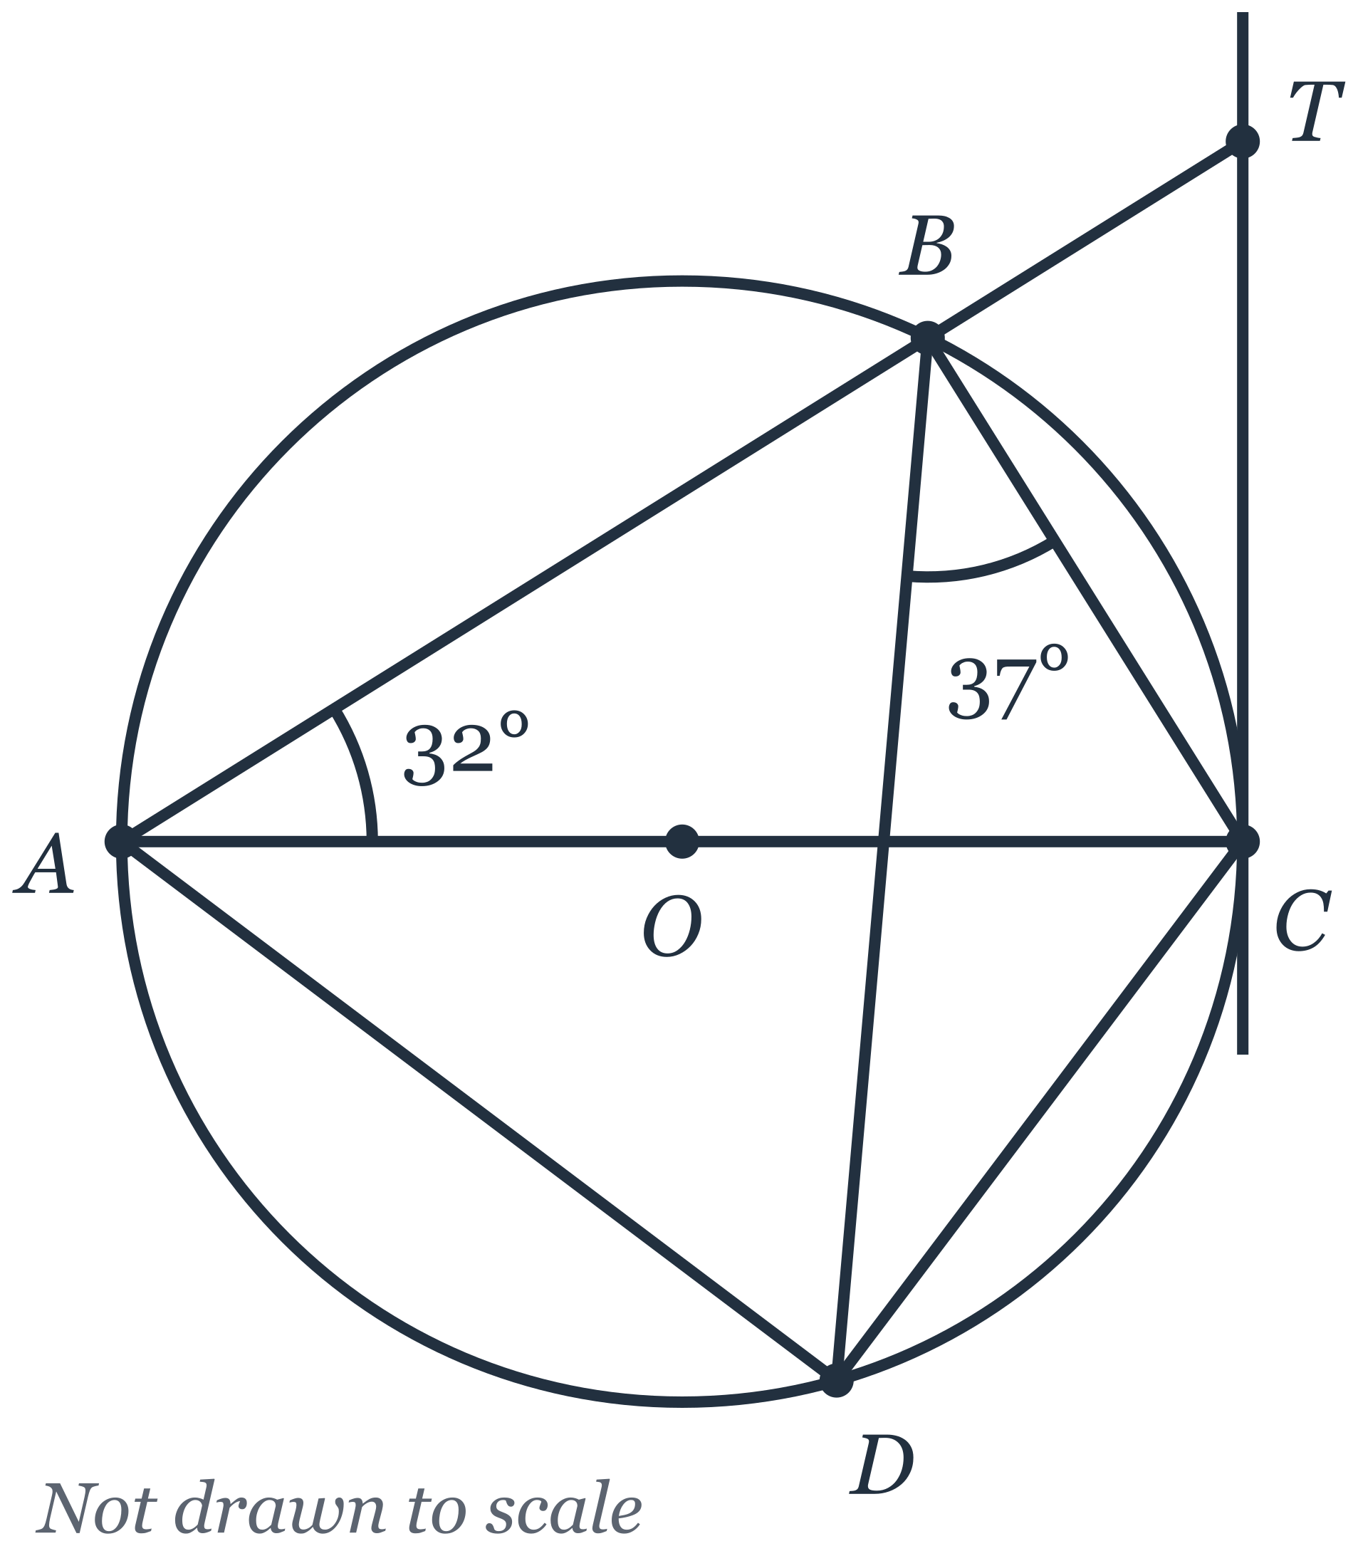
(a) Find, giving a reason for each step of your working,
(i) angle $ACB$, [2]
(ii) angle $BCT$, [2]
(iii) angle $CAD$. [1]
(b) Explain why $AD$ is not parallel to $BC$. [1]
(c) The radius of the circle is 6 cm.
(i) Show that triangle $ABC$ is similar to triangle $CBT$.
Give a reason for each statement you make. [2]
(ii) Calculate $BT$. [2]

Solution:
(a)(i) | Angle $ABC={90}^{∘}$ (angle in a semicircle, since $AC$ is a diameter).  Angle $ACB={180}^{∘}−{90}^{∘}−{32}^{∘}={58}^{∘}$ (angle sum of triangle $ABC$).
(a)(ii) | Angle $OCT={90}^{∘}$ (tangent perpendicular to radius $OC$ at the point of contact $C$), so angle $ACT={90}^{∘}$ since $AOC$ is a straight line.  Angle $BCT={90}^{∘}−{58}^{∘}={32}^{∘}$.
(a)(iii) | Angle $CAD$ = angle $CBD={37}^{∘}$ (angles in the same segment, on chord $CD$).
(b) | If $AD$ were parallel to $BC$, then angle $CAD$ would equal angle $ACB$ (alternate angles). But angle $CAD={37}^{∘}$ and angle $ACB={58}^{∘}$, and ${37}^{∘}≠{58}^{∘}$, so $AD$ is not parallel to $BC$.
(c)(i) | In triangles $ABC$ and $CBT$:  angle $ABC={90}^{∘}$ (angle in a semicircle) and angle $CBT={180}^{∘}−{90}^{∘}={90}^{∘}$ (angles on the straight line $ABT$), so angle $ABC$ = angle $CBT$;  angle $BAC={32}^{∘}$ (given) and angle $BCT={32}^{∘}$ (from (a)(ii)), so angle $BAC$ = angle $BCT$.  Two pairs of corresponding angles are equal, so triangle $ABC$ is similar to triangle $CBT$ (AA).
(c)(ii) | $AC=2×6=12$ cm.  In right-angled triangle $ABC$: $BC=12sin{32}^{∘}=6.359…$ cm and $AB=12cos{32}^{∘}=10.176…$ cm.  From the similar triangles, $\frac{BT}{BC}=\frac{CB}{AB}$, so $BT=\frac{BC^{2}}{AB}=\frac{(12sin{32}^{∘})^{2}}{12cos{32}^{∘}}=3.973…$  (Equivalently, in right-angled triangle $CBT$, $BT=BCtan{32}^{∘}=6.359…×tan{32}^{∘}=3.973…$.)  $BT=3.97$ cm (3 s.f.).  Consistency check: with $O$ at the origin and radius 6, $A(−6,0)$, $C(6,0)$, $B$ at ${64}^{∘}$ from $OC$ (angle at centre $=2×{32}^{∘}$), $D$ at $−{74}^{∘}$ (angle at centre $=2×{37}^{∘}$); line $AB$ has gradient $tan{32}^{∘}$ and meets the tangent $x=6$ at $T(6,12tan{32}^{∘})=(6,7.50)$, above $B$, so $ABT$ is a straight line with $B$ between $A$ and $T$. Every given angle is realised.

- Mr Tan is deciding whether to install a rainwater tank to water the plants in his garden.
He finds the following information.
Rainwater tank
The tank is a cylinder with internal diameter $80$ cm and internal height $120$ cm.
Price, including installation: \420$
Expected lifespan: $10$ years
Collecting rainwater
Rain falling on the roof of the garden shed drains into the tank.
The roof is a rectangle $3.6$ m by $2.5$ m.
$80\%$ of the rain that falls on the roof reaches the tank.
Average rainfall: $175$ mm per month
Watering the garden
Mr Tan waters his garden with a hose for $12$ minutes every day.
The hose delivers $9$ litres of water per minute.
Monthly water tariff
\begin{array}{|l|c|} \hline \text{First } 40 \text{ m}^3 & \2.74 \text{ per m}^3 \\ \hline \text{Each m}^3 \text{ above } 40 \text{ m}^3 & \3.69 \text{ per m}^3 \\ \hline \end{array}
$1{\text{ m}}^{3}=1000$ litres
(a) Calculate the capacity of the tank.
Give your answer in litres. [2]
(b) In a month with $30$ days, calculate
(i) the volume of water, in litres, Mr Tan uses to water his garden, [1]
(ii) the volume of rainwater, in litres, that reaches the tank. [2]
(c) Before installing the tank, Mr Tan's household uses $43{\text{ m}}^{3}$ of tap water each month.
Assume that all the rainwater that reaches the tank is used to water the garden instead of tap water.
Is it worth Mr Tan installing the rainwater tank?
Justify your answer with calculations. [5]

Solution:
(a) | Radius $=40$ cm. Capacity $=π×{40}^{2}×120=192 000π=603 185.8{\text{ cm}}^{3}$. Since $1000{\text{ cm}}^{3}=1$ litre, capacity $=603.19=603$ litres (3 s.f.). [M1 for $πr^{2}h$ with $r=40$, A1]
(b)(i) | Water used per day $=9×12=108$ litres. In $30$ days: $108×30=3240$ litres. [B1]
(b)(ii) | Roof area $=3.6×2.5=9{\text{ m}}^{2}$. Rainfall $175$ mm $=0.175$ m, so volume of rain on the roof in a month $=9×0.175=1.575{\text{ m}}^{3}=1575$ litres. Volume reaching the tank $=80\%×1575=1260$ litres. [M1 for $9×0.175$ (or $1575$), A1]
(c) | Rainwater available $=1260$ litres per month, which is less than the $3240$ litres used, so all $1.26{\text{ m}}^{3}$ replaces tap water each month. [M1 for $1.26{\text{ m}}^{3}$ replacing tap water]  Tap water used falls from $43{\text{ m}}^{3}$ to $43−1.26=41.74{\text{ m}}^{3}$, still above $40{\text{ m}}^{3}$, so the water saved is all charged at the higher rate of \3.69$perm$^3$.[M1forrecognisingthesavingisatthe$\$3.69$ tier]  Monthly saving = 1.26 \times 3.69 = \4.6494 = \$4.65$. [A1]  Saving over the $10$-year lifespan = 4.6494 \times 12 \times 10 = \557.93$(or$4.65 \times 120 = \$558.00$). [M1]  \557.93 > \$420$, so the tank saves more than it costs: net saving \approx \138$over$10$years,anditpaysforitselfafter$420 \div 4.6494 = 90.3$,i.e.$91$months(about$7.5$ years), within its lifespan. Conclusion: YES, it is worth installing. [A1 for a conclusion consistent with correct figures]  Alternative acceptable conclusion: NO — the net saving of about \138$over$10$years(about$\$14$ a year) is small, and rainfall varies so the tank may overflow in wet months and run dry in dry months; award the final A1 for this if the figures are correct and the reason is valid.  Note: using \2.74$perm$^3$gives$1.26 \times 2.74 = \$3.45$ per month and \414.29$over$10$years,whichislessthan$\$420$; this uses the wrong tier, so award M1 M0 A0 M1 A0 (max 2).

Answers
1
2
3
4
5
6
7
8
9

