MATHEMATICS 4052/02
Paper 2 · 2 hours 15 minutes · 90 marks
Practice paper in the style of the GCE O-Level, set 1. Newly written questions, not a past-year paper.

READ THESE INSTRUCTIONS FIRST
Answer all the questions.
Write your answers in the spaces provided.
If working is needed for any question it must be shown with the answer.
Omission of essential working will result in loss of marks.
The use of an approved scientific calculator is expected, where appropriate.
If the degree of accuracy is not specified in the question, and if the answer is not exact, give the answer to three significant figures. Give answers in degrees to one decimal place.
For $π$, use either your calculator value or 3.142, unless the question requires the answer in terms of $π$.
The number of marks is given in brackets [ ] at the end of each question or part question.
The total number of marks for this paper is 90.

Mathematical Formulae

Compound interest Total amount $=P{\left(1+\frac{r}{100}\right)}^{n}$
Mensuration Curved surface area of a cone $=πrl$
Surface area of a sphere $=4πr^{2}$
Volume of a cone $=\frac{1}{3}πr^{2}h$
Volume of a sphere $=\frac{4}{3}πr^{3}$
Area of triangle $ABC=\frac{1}{2}absinC$
Arc length $=rθ$, where $θ$ is in radians
Sector area $=\frac{1}{2}r^{2}θ$, where $θ$ is in radians
Trigonometry $\frac{a}{sinA}=\frac{b}{sinB}=\frac{c}{sinC}$
$a^{2}=b^{2}+c^{2}−2bccosA$
Statistics Mean $=\frac{∑fx}{∑f}$
Standard deviation $=\sqrt{\frac{∑fx^{2}}{∑f}−{\left(\frac{∑fx}{∑f}\right)}^{2}}$

(a) Solve the inequality $5−3(x−2)>2x+1$. [2]

(b) Simplify ${\left(9p^{4}q^{−2}\right)}^{\frac{1}{2}}×2p^{−3}q^{5}$, giving your answer in positive index form. [2]

(c) Make $t$ the subject of the formula $v=\sqrt{\frac{k−3t}{t}}$. [3]

(d) Solve the equation $\frac{4}{x−1}+\frac{3}{x+2}=2$. Give your solutions correct to two decimal places. [4]

- Mei runs a small café.
(a) Mei buys a coffee machine from Italy for €2 450. The exchange rate is €1 = S$1.48.
Goods and Services Tax (GST) of 9% is charged on the price in Singapore dollars.
Calculate the total amount, in Singapore dollars, that Mei pays for the machine. [2]

(b) Mei increased the selling price of a cup of latte by 8%. The new selling price is \5.94$.
Calculate the selling price of a cup of latte before the increase. [2]

(c) The cost of making a cup of latte is made up of the cost of coffee beans, the cost of milk and other costs in the ratio $5:4:3$. The coffee beans for one cup cost \1.25$.
Calculate the percentage profit Mei makes on a cup of latte sold at \5.94$. [2]

(d) Mei spends \180$onGradeAcoffeebeans,whichcost$\$x$ per kilogram.
Grade B coffee beans cost \5$ per kilogram more than Grade A coffee beans.
For \180$, Mei would get 3 kg less of Grade B coffee beans than of Grade A coffee beans.
(i) Form an equation in $x$ and show that it simplifies to $x^{2}+5x−300=0$. [3]

(ii) Solve the equation $x^{2}+5x−300=0$. [1]

(iii) Hence find the cost of 1 kilogram of Grade B coffee beans. [1]

- The diagram shows a sketch of the curve $y=ax^{2}+bx+c$.
The curve crosses the $x$-axis at the points $(−1,0)$ and $(3,0)$ and crosses the $y$-axis at the point $(0,3)$.
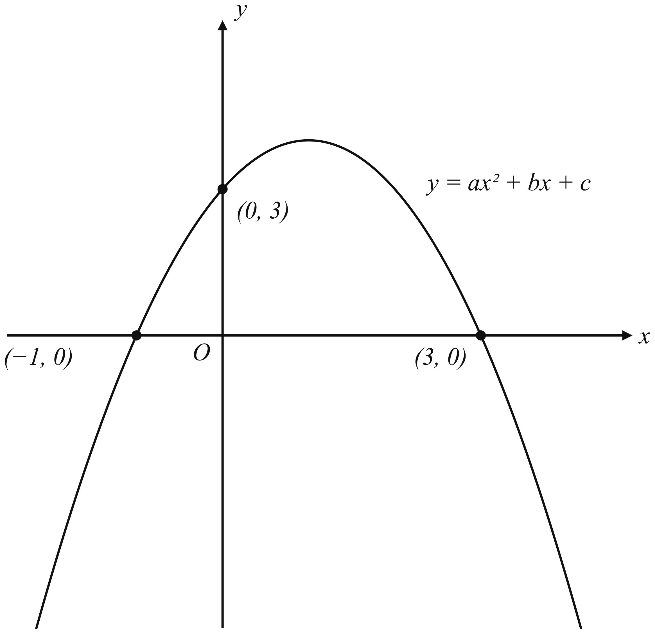
(a) Find the value of $a$, of $b$ and of $c$. [3]

(b)
(i) Write the equation of the curve in the form $y=k−(x−h)^{2}$, where $h$ and $k$ are integers. [2]

(ii) Hence write down the coordinates of the maximum point of the curve. [1]

(c) The point $P$ lies on the curve and has $x$-coordinate 4.
Find the equation of the straight line that passes through $P$ and the maximum point of the curve. [3]

- The table shows some values of $x$ and the corresponding values of $y$ for $y=x^{2}+\frac{3}{x}$.
$$\begin{matrix}x & −3 & −2.5 & −2 & −1.5 & −1 & −0.5 & 0.5 & 1 & 1.5 & 2 & 2.5 & 3 \\ y & 8 & 5.05 & 2.5 & & −2 & −5.75 & 6.25 & 4 & 4.25 & 5.5 & & 10 \\ \end{matrix}$$
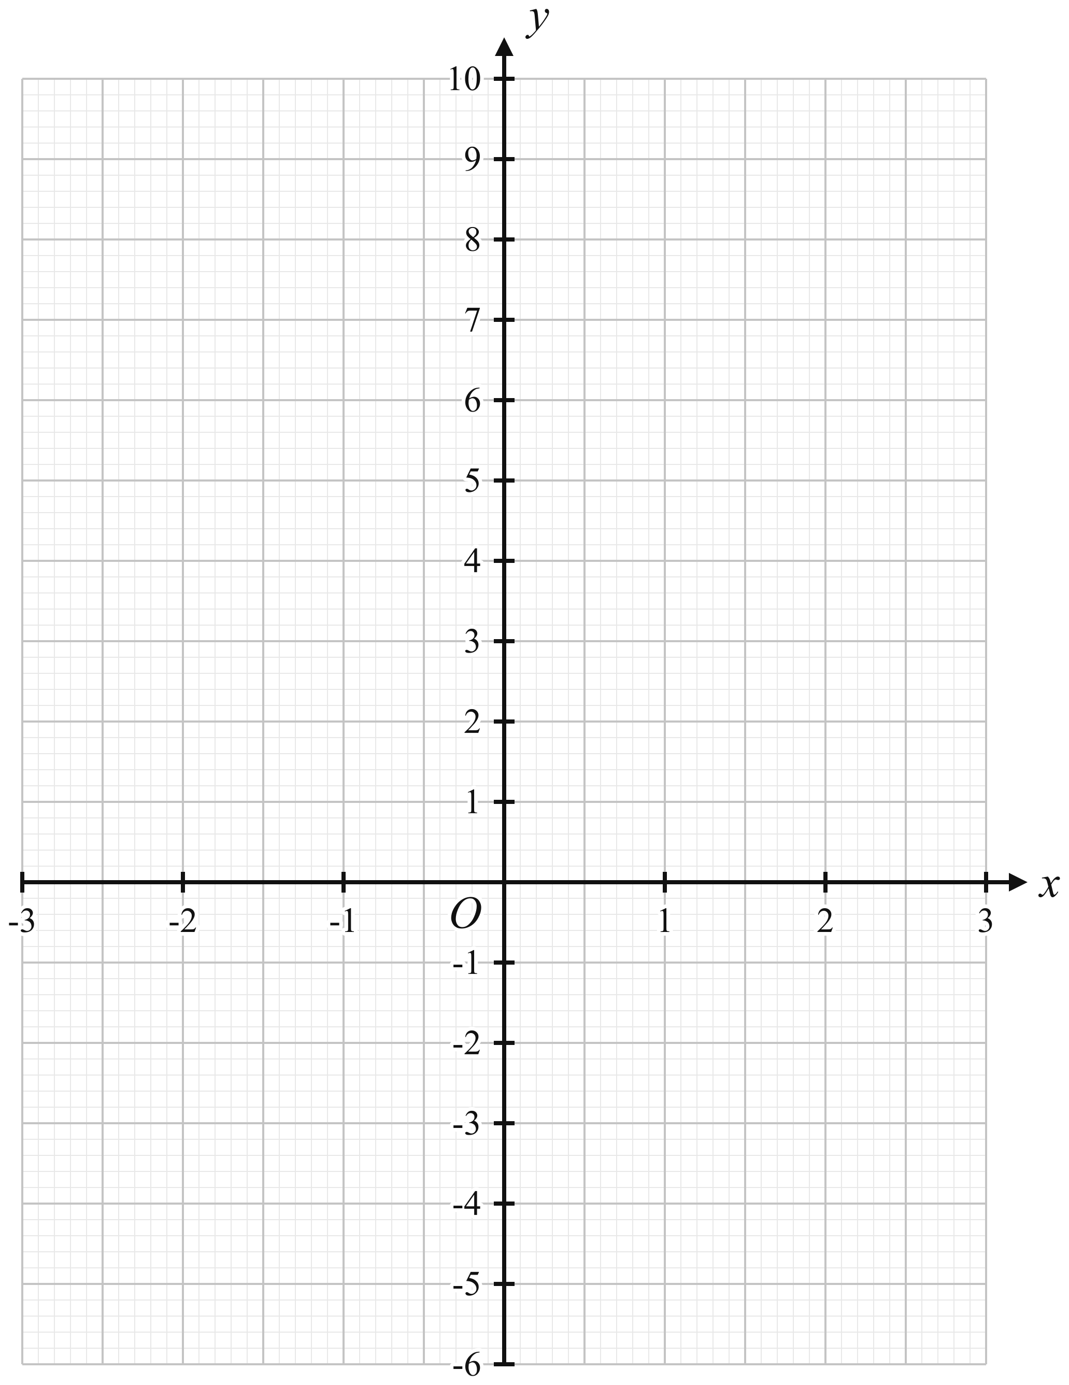
(a) Complete the table of values. [2]

(b) On the grid, draw the graph of $y=x^{2}+\frac{3}{x}$ for $−3≤x≤3$. [3]

(c)
(i) By drawing a tangent, use your graph to find the gradient of the curve at the point where $x=2$. [2]

(ii) Use your graph to explain why the equation $x^{2}+\frac{3}{x}=3$ has only one solution. [1]

(iii) By drawing a suitable straight line on the grid, solve the equation $x^{3}−2x^{2}−3x+3=0$. [3]

- The diagram shows a sector $OAB$ of a circle, centre $O$ and radius $9$ cm.
Angle $AOB=1.2$ radians.
$C$ is the point on $OB$ such that $OC=5$ cm.
The region bounded by $AC$, $CB$ and the arc $AB$ is shaded.
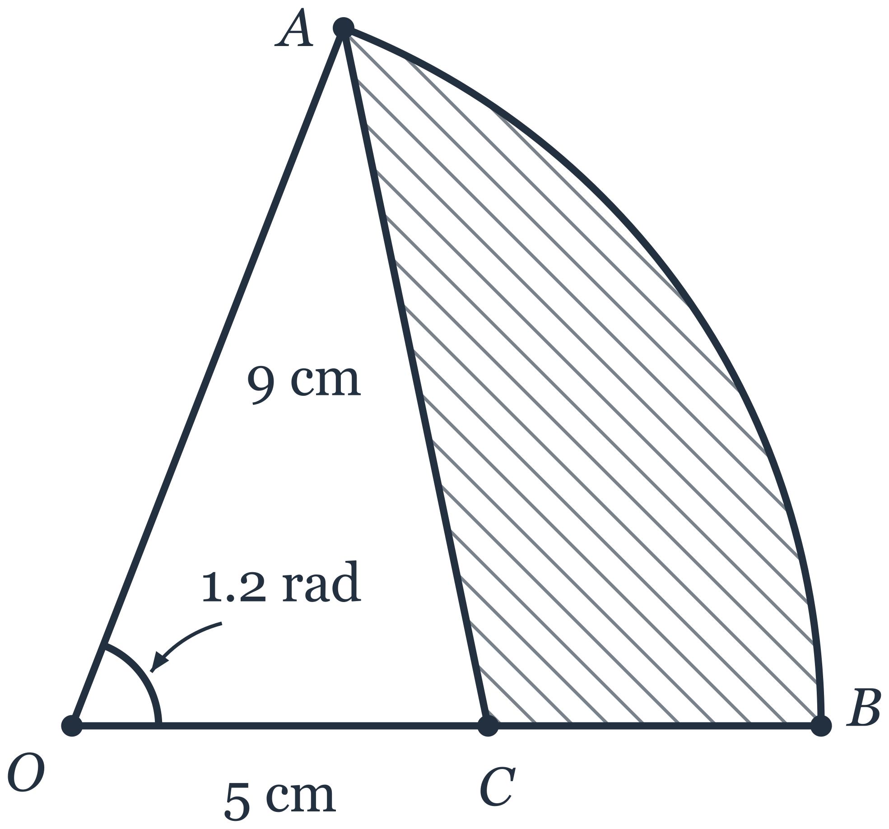
(a) Calculate $AC$. [2]

(b) Calculate angle $OAC$.
Give your answer in degrees. [2]

(c) Calculate
(i) the perimeter of the shaded region, [2]

(ii) the area of the shaded region. [3]

- The points $A$, $B$ and $C$ have coordinates $(−4, −1)$, $(2, 7)$ and $(10, −1)$ respectively.
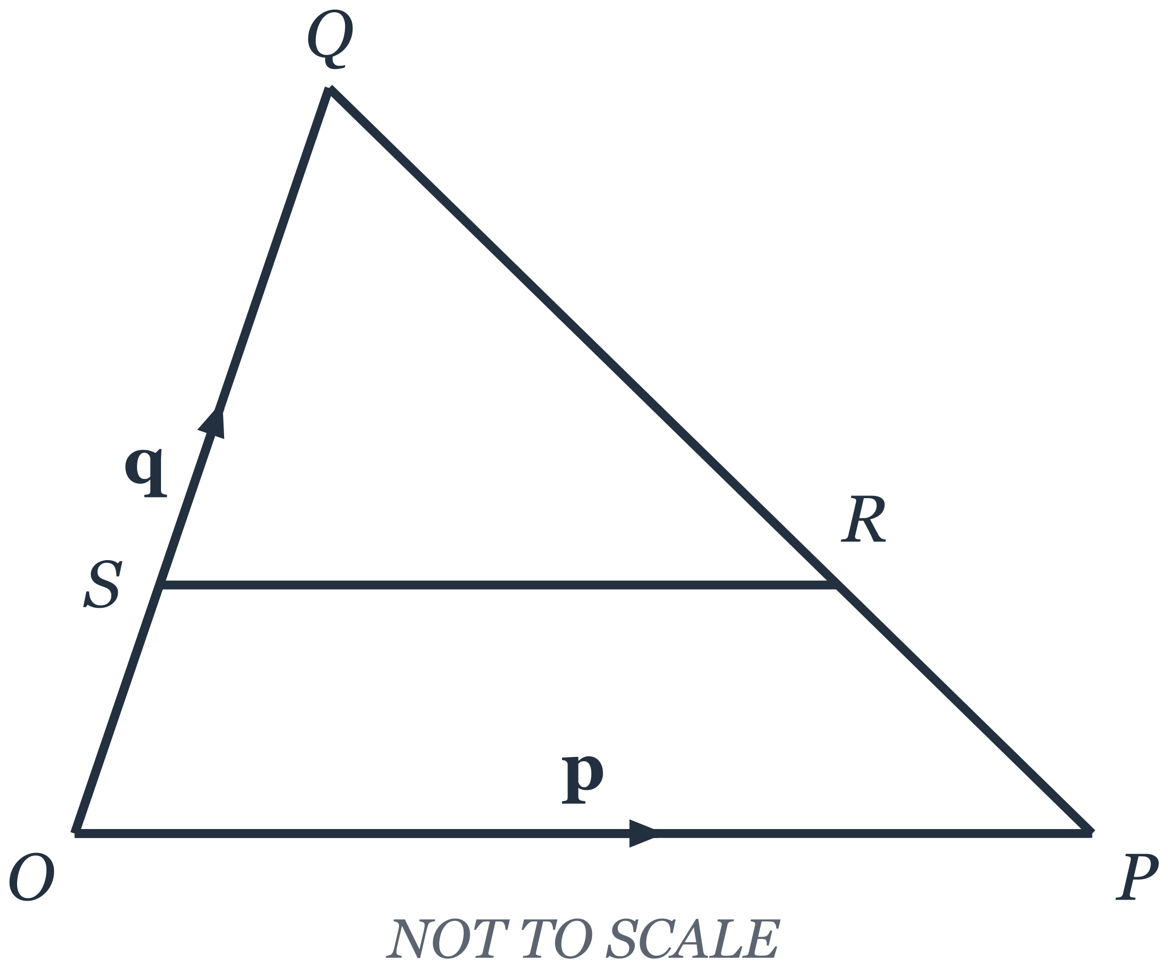
(a) Find the equation of the line which passes through $C$ and is parallel to $AB$.
Give your answer in the form $ax+by=c$, where $a$, $b$ and $c$ are integers. [3]

(b) Calculate the length of $AB$. [2]

(c) Calculate the area of triangle $ABC$. [2]

(d) $OPQ$ is a triangle.
$\vec{OP}=p$ and $\vec{OQ}=q$.
$R$ is the point on $PQ$ such that $PR:RQ=1:2$.
$S$ is the point on $OQ$ such that $OS:SQ=1:2$.
(i) Express $\vec{OR}$ in terms of $p$ and $q$, as simply as possible. [2]

(ii) Express $\vec{SR}$ in terms of $p$ and $q$, as simply as possible. [1]

(iii) Hence find $\frac{\text{area of triangle }QSR}{\text{area of triangle }QOP}$. [1]

- The table shows the distribution of the distances, $d$ km, cycled by the members of a cycling club in one week.
$\begin{matrix}\text{Distance }(d\text{ km}) & 0<d≤20 & 20<d≤40 & 40<d≤60 & 60<d≤80 & 80<d≤100 \\ \text{Frequency} & 5 & x & 18 & 13 & 7 \\ \end{matrix}$
The estimated mean distance cycled is 50 km.
(a) Find the value of $x$. [2]

(b) Calculate an estimate of the standard deviation of the distances. [2]

(c)
(i) One of the members is chosen at random. Find the probability that this member cycled more than 60 km. [1]

(ii) Two of the members are chosen at random. Find the probability that exactly one of them cycled more than 60 km. Give your answer as a fraction in its lowest terms. [3]

- $A$, $B$, $C$ and $D$ are points on a circle, centre $O$.
$AOC$ is a diameter of the circle.
The tangent to the circle at $C$ meets $AB$ produced at $T$.
Angle $BAC={32}^{∘}$ and angle $CBD={37}^{∘}$.
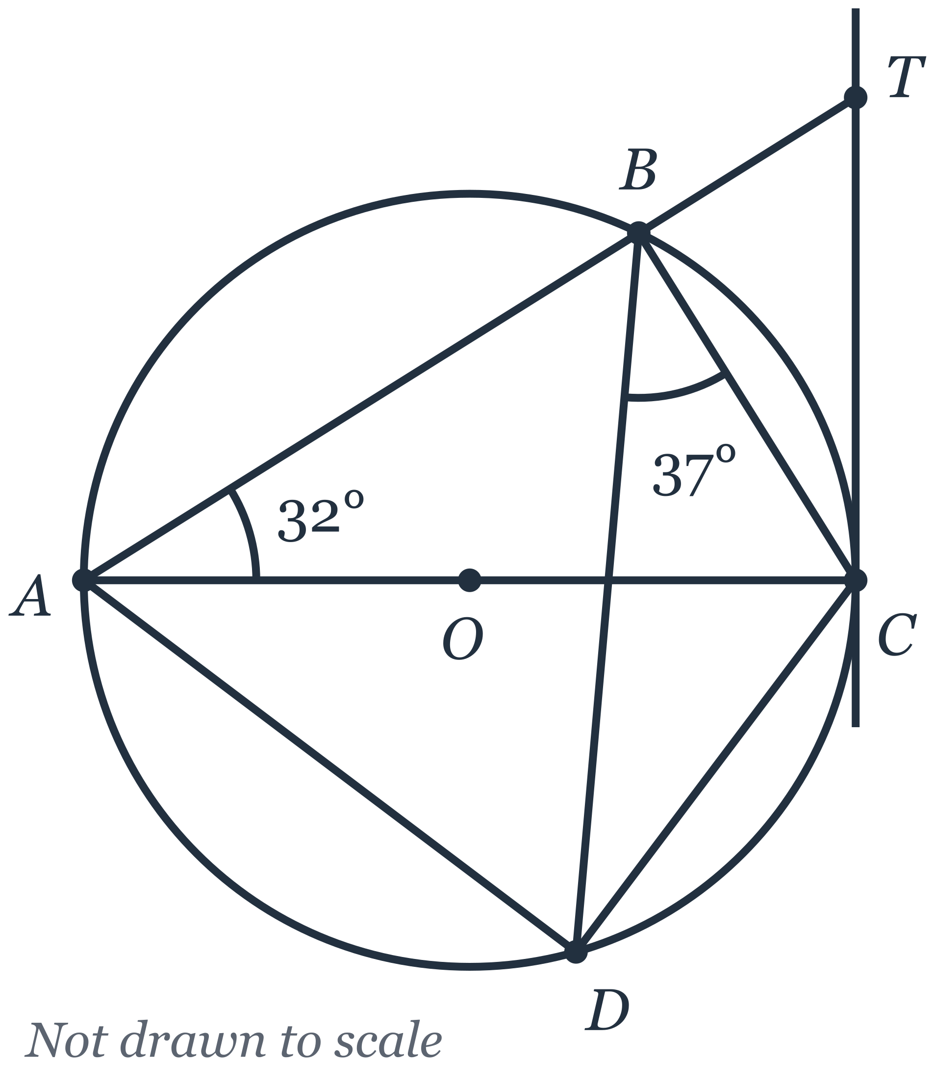
(a) Find, giving a reason for each step of your working,
(i) angle $ACB$, [2]

(ii) angle $BCT$, [2]

(iii) angle $CAD$. [1]

(b) Explain why $AD$ is not parallel to $BC$. [1]

(c) The radius of the circle is 6 cm.
(i) Show that triangle $ABC$ is similar to triangle $CBT$.
Give a reason for each statement you make. [2]

(ii) Calculate $BT$. [2]

- Mr Tan is deciding whether to install a rainwater tank to water the plants in his garden.
He finds the following information.
Rainwater tank
The tank is a cylinder with internal diameter $80$ cm and internal height $120$ cm.
Price, including installation: \420$
Expected lifespan: $10$ years
Collecting rainwater
Rain falling on the roof of the garden shed drains into the tank.
The roof is a rectangle $3.6$ m by $2.5$ m.
$80\%$ of the rain that falls on the roof reaches the tank.
Average rainfall: $175$ mm per month
Watering the garden
Mr Tan waters his garden with a hose for $12$ minutes every day.
The hose delivers $9$ litres of water per minute.
Monthly water tariff
\begin{array}{|l|c|} \hline \text{First } 40 \text{ m}^3 & \2.74 \text{ per m}^3 \\ \hline \text{Each m}^3 \text{ above } 40 \text{ m}^3 & \3.69 \text{ per m}^3 \\ \hline \end{array}
$1{\text{ m}}^{3}=1000$ litres
(a) Calculate the capacity of the tank.
Give your answer in litres. [2]

(b) In a month with $30$ days, calculate
(i) the volume of water, in litres, Mr Tan uses to water his garden, [1]

(ii) the volume of rainwater, in litres, that reaches the tank. [2]

(c) Before installing the tank, Mr Tan's household uses $43{\text{ m}}^{3}$ of tap water each month.
Assume that all the rainwater that reaches the tank is used to water the garden instead of tap water.
Is it worth Mr Tan installing the rainwater tank?
Justify your answer with calculations. [5]

