H2 Mathematics · Set 1 · Paper 1 · A-Level format
11 questions · 100 marks · 3 hours
Newly written questions in the GCE format, not a past-year paper.
Additional Materials: List of Formulae (MF26)

READ THESE INSTRUCTIONS FIRST
Answer all the questions.
Write your answers in the spaces provided.
Give non-exact numerical answers correct to 3 significant figures, or 1 decimal place in the case of angles in degrees, unless a different level of accuracy is specified in the question.
The use of an approved graphing calculator is expected, where appropriate.
Unsupported answers from a graphing calculator are allowed unless a question specifically states otherwise.
Where unsupported answers from a graphing calculator are not allowed in a question, you are required to present the mathematical steps using mathematical notations and not calculator commands.
You are reminded of the need for clear presentation in your answers.
The number of marks is given in brackets [ ] at the end of each question or part question.
The total number of marks for this paper is 100.

- A sequence $u_{1},u_{2},u_{3},…$ is defined by
$u_{1}=a$ and $u_{n+1}=u_{n}^{2}−6$ for $n≥1$,
where $a$ is a constant.
(a) It is given that $u_{3}=u_{1}$ and that the sequence is not constant. Find the possible values of $a$, giving your answers in exact form. [3]

(b) It is now given that $a>0$. Find the exact value of $\sum_{r=1}^{25}{u_{r}}$. [2]

- (a) An arithmetic series has first term $a$ and common difference $d$. The sum of the first $m$ terms of the series is equal to the sum of the first $n$ terms, where $m$ and $n$ are positive integers and $m≠n$. Show that the sum of the first $(m+n)$ terms of the series is zero. [2]

(b) A geometric series has first term 6 and its sum to infinity is 4. The sum of the first $n$ terms of this series is $S_{n}$. Find the values of $n$ for which $S_{n}$ exceeds the sum to infinity by more than $0.01$. [3]

- The function $f$ is defined by
$f:x↦ \tan^{−1}\left(\frac{x+\sqrt{3}}{1−\sqrt{3} x}\right)−\tan^{−1} x, x∈R, x≠\frac{1}{\sqrt{3}}.$
(a) Show that $f^{′}(x)=0$. [3]

(b) Hence find the range of $f$, giving your answer in exact form. [3]

- Do not use a calculator in answering this question.
On an Argand diagram, the points $A$ and $C$ represent the complex numbers $1+2i$ and $5+4i$ respectively. $A$ and $C$ are opposite vertices of a square $ABCD$, and the vertices $A$, $B$, $C$, $D$ are in anticlockwise order.
(a) Find the complex numbers represented by $B$ and $D$. [3]

(b) Show that the complex numbers represented by $A$, $B$, $C$ and $D$ are the roots of an equation of the form $(z−p)^{4}=q$, where $p$ and $q$ are complex numbers to be found. [3]

(c) Hence find the four roots of the equation $w^{4}=q$, and the square roots of $q$. [2]

- The function $f$ is defined by $f:x↦x+\frac{1}{x}$, $x∈R$, $x≠0$.
(a) Use calculus to find the range of $f$. [2]

(b) Hence find the exact values of the real roots of the equation $x^{4}−4x^{3}+5x^{2}−4x+1=0$, explaining why the equation has no other real roots. [4]

(c) Find the set of values of the constant $k$ for which the equation $x^{4}−4x^{3}+kx^{2}−4x+1=0$ has four distinct real roots. [2]

- The diagram shows the graph of $y=f^{′}(x)$ for $0≤x≤6$. The graph meets the $x$-axis only at $x=1$ and $x=4$, and the areas of the three regions between the graph and the $x$-axis are 2, 8 and 9, as shown. It is given that $f(0)=4$.
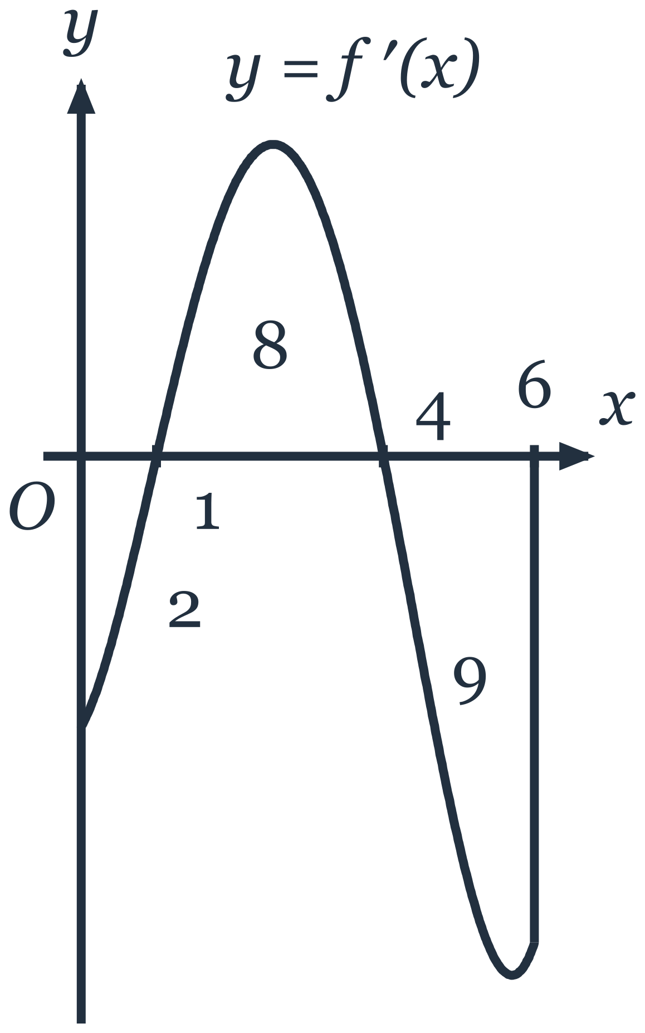
(a) State the $x$-coordinates of the stationary points of the curve $y=f(x)$ for $0≤x≤6$ and determine, with a reason, the nature of each. [2]

(b) Find the greatest and least values of $f(x)$ for $0≤x≤6$. [3]

(c) Find the coordinates of the stationary points of the curve $y=3−2f\left(\frac{1}{2}x\right)$ for $0≤x≤12$, and determine, with a reason, the nature of each. [3]

- A straight rail $AB$ of length $2a$ m is fixed at both ends. When the rail is heated, its length increases to $2a(1+k)$ m, where $k$ is a positive constant. The ends $A$ and $B$ remain $2a$ m apart, so the rail bows upwards into an arc of a circle of radius $r$ m. This arc subtends an angle of $2θ$ radians at the centre of the circle.
(a) Show that $θ=(1+k) sin θ$. [2]

(b) It is given that $k$ is small, so that $θ$ is also small. Find an approximation for $θ$ in terms of $k$. [3]

(c) Find, in terms of $a$ and $θ$, the greatest height of the arc above the line $AB$, and deduce that this height is approximately $\frac{1}{2}aθ$. [2]

(d) A rail of length 60 m, fixed at both ends, increases in length by 1 cm. Estimate the greatest height of the arc above the line joining the fixed ends, and comment on the size of this height compared with the increase in the length of the rail. [2]

- The curve $C$ has parametric equations $x=t+sin t$, $y=sin t$, for $0≤t≤π$. The curve $C$ meets the $x$-axis at the origin $O$ and at the point $F$.
(a) Show that, for $0≤t<π$, $\frac{dy}{dx}=\frac{cos t}{1+cos t}$. [2]

(b) The line $y=h$, where $h$ is a constant such that $0<h<1$, meets $C$ at the points $A$ and $B$, where the $x$-coordinate of $A$ is less than the $x$-coordinate of $B$. The tangents to $C$ at $A$ and at $B$ are perpendicular. Find the exact value of $h$ and the exact coordinates of $B$. [4]

(c) Find the exact area of the region bounded by the tangent to $C$ at $B$, the $x$-axis and the arc of $C$ between $B$ and $F$. [5]

- For $0≤k≤ln3$, the function $J$ is defined by $J(k)=\int_{1}^{3}{\left|lnx−k\right|} dx$.
(a) Find $∫lnx dx$. [2]

(b) Find $J(k)$ in terms of $k$. [4]

(c) Use calculus to find the exact value of $k$ for which $J(k)$ is least, and show that the least value of $J(k)$ is $ln\frac{27}{16}$. [4]

(d) The function $g$ is continuous and increasing for $1≤x≤3$. Without doing any detailed calculation, state, in terms of $g$, the value of $k$ for which $\int_{1}^{3}{\left|g(x)−k\right|} dx$ is least, and explain your answer. [3]

- A ball of ice is melting in a warm room and remains spherical as it melts. At time $t$ hours after it is first observed, its radius is $r$ cm and its volume is $V$ ${\text{cm}}^{3}$; the radius is $10$ cm when $t=0$ and $8$ cm when $t=1$. Two models are proposed for the melting: in model A, the rate of decrease of $V$ is proportional to the surface area of the ball, and in model B, the rate of decrease of $V$ is proportional to $V$.
[The volume of a sphere of radius $r$ is $\frac{4}{3}πr^{3}$ and its surface area is $4πr^{2}$.]
(a) Using model A, find $r$ in terms of $t$. Hence state the time at which, according to model A, the ball has melted completely. [4]

(b) Using model B, find $r$ in terms of $t$. [3]

(c) When $t=3$, the radius of the ball is measured as $4.2$ cm. Determine which model fits this measurement better. [2]

(d) Explain why model B cannot describe the whole of the melting. [1]

(e) Show that, for $0<t<1$, model B predicts a smaller radius than model A. [3]

- A solar panel $ABCD$, in the shape of a rectangle, is fixed to the flat roof of a building. Coordinates $(x,y,z)$, in metres, are measured from an origin $O$ on the roof, with the $x$-axis pointing east, the $y$-axis pointing north and the $z$-axis pointing vertically upwards, so that the roof lies in the plane $z=0$. The lower edge $AB$ of the panel rests on the roof, and the points $A$, $B$ and $D$ have coordinates $(4,1,0)$, $(8,3,0)$ and $(3,3,1)$ respectively. A vertical mast stands on the roof at the point $(4,0,0)$, and its top $T$ is $5$ m above the roof. The thicknesses of the panel and of the mast are negligible.
(a) Find a cartesian equation of the plane containing the panel. [4]

(b) Find the acute angle between the panel and the roof. [2]

(c) The sun's rays are modelled as parallel straight lines, and the power produced by the panel is proportional to $sin α$, where $α$ is the acute angle between the sun's rays and the panel. At 9 a.m. on a certain day, the sun's rays travel in the direction $\left(\begin{matrix}−1 \\ 0 \\ −1\end{matrix}\right)$. Find the power produced by the panel at this time as a percentage of the greatest power that the panel can produce. [2]

(d) At a certain time on another day, the panel produces the greatest power that it can. Find the coordinates of the point $S$ where the sun's ray through $T$ meets the plane containing the panel at this time. [4]

(e) Determine whether the shadow of $T$ falls on the panel at this time. [2]

