H2 Mathematics · Set 1 · Paper 2 · A-Level format
10 questions · 100 marks · 3 hours
Newly written questions in the GCE format, not a past-year paper.
Additional Materials: List of Formulae (MF26)

READ THESE INSTRUCTIONS FIRST
Answer all the questions.
Write your answers in the spaces provided.
Give non-exact numerical answers correct to 3 significant figures, or 1 decimal place in the case of angles in degrees, unless a different level of accuracy is specified in the question.
The use of an approved graphing calculator is expected, where appropriate.
Unsupported answers from a graphing calculator are allowed unless a question specifically states otherwise.
Where unsupported answers from a graphing calculator are not allowed in a question, you are required to present the mathematical steps using mathematical notations and not calculator commands.
You are reminded of the need for clear presentation in your answers.
The number of marks is given in brackets [ ] at the end of each question or part question.
The total number of marks for this paper is 100.

Section A: Pure Mathematics [40 marks]
- A geometric series is given by $1+\frac{x−1}{x+2}+{\left(\frac{x−1}{x+2}\right)}^{2}+{\left(\frac{x−1}{x+2}\right)}^{3}+…$, where $x$ is real and $x≠−2$.
(a) Find the set of values of $x$ for which the series converges. [2]

(b) Find the sum to infinity of the series, giving your answer as a single fraction in terms of $x$. [1]

(c) Find exactly the set of values of $x$ for which the sum to infinity of the series exceeds $\frac{2}{x}$. [4]

- The curve $C$ has equation $y=f(x)$, where $f(x)=\frac{lnx}{x}$ for $x>0$.
(a) Find the exact coordinates of the stationary point of $C$, and show that it is a maximum point. [3]

(b) Determine, with justification, which of $3^{π}$ and $π^{3}$ is greater. [3]

(c) Show that $x^{e}≤e^{x}$ for all $x>0$. [1]

(d) Find, with justification, all the positive integers $n$ for which $n^{\frac{1}{n}}≥\sqrt{2}$. [2]

- The function $f$ is defined by $f:x↦1−x^{2}, x∈R, x≥0$.
(a) Find $f^{−1}(x)$ and state the domain of $f^{−1}$. [2]

(b) Sketch, on the same diagram, the graphs of $y=f(x)$ and $y=f^{−1}(x)$, showing clearly the relationship between the two graphs and stating the coordinates of the points where each graph meets the axes. [2]

(c) Find the exact coordinates of the points at which the graphs of $y=f(x)$ and $y=f^{−1}(x)$ meet, and show that there are no other such points. [4]

(d) The function $g$ is increasing for all values of $x$ in its domain, so that $g^{−1}$ exists. Explain why every point at which the graphs of $y=g(x)$ and $y=g^{−1}(x)$ meet lies on the line $y=x$. [2]

(e) The function $h$ is defined by $h:x↦1−x^{2}, x∈R, x≤0$. Use the result of part (d) to find the exact coordinates of the point at which the graphs of $y=h(x)$ and $y=h^{−1}(x)$ meet. [1]

- The inside of a vase has a flat horizontal base and an open top at a height of $2π$ cm above the base. At height $y$ cm above the base, where $0≤y≤2π$, the horizontal cross-section of the inside of the vase is a circle of radius $(3+cos y)$ cm (see diagram). The vase is initially empty and water is poured into it at a constant rate of $12π$ ${\text{cm}}^{3}$ per second; at time $t$ seconds after pouring begins, the depth of the water is $h$ cm.
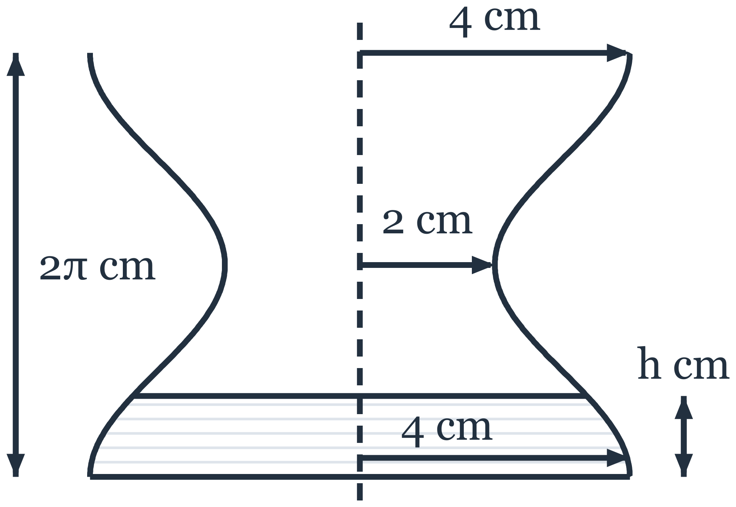
(a) Find the rate at which the depth of the water is increasing at the instant when $h=\frac{1}{2}π$. Find also the rate of change of the radius of the water surface at this instant. [5]

(b) Find the exact time taken to fill the vase. [4]

(c) Find the exact depth of the water at the instant when half of the time found in part (b) has passed. Justify your answer. [2]

(d) Without further differentiation, find the greatest and least values of the rate at which the depth of the water increases for $0≤h≤2π$, and state the depths of the water at which they occur. [2]

Section B: Probability and Statistics [60 marks]
- The integers $1$, $2$, $3$, $4$ and $5$ are arranged in a row, each integer being used exactly once. Such an arrangement is called a 'ridge' if the integers to the left of $5$ increase from left to right and the integers to the right of $5$ decrease from left to right. For example, $2 3 5 4 1$ and $5 4 3 2 1$ are ridges, but $2 5 3 4 1$ is not.
(a) Find the number of ridges in which $5$ is in the middle position. [1]

(b) Show that there are $16$ ridges. [2]

(c) Explain why, in every ridge, $1$ is at one of the two ends. [1]

(d) The integers $1,2,3,…,n$, where $n≥2$, are now arranged in a row in a random order, and a ridge is defined in the same way, with $n$ in place of $5$. Find the smallest value of $n$ for which the probability that the arrangement is a ridge is less than $0.01$. [3]

- A lamp is controlled by a worn push-button switch. Each time the switch is pressed, the lamp changes state (from on to off, or from off to on) with probability $p$, where $0<p<1$, and otherwise stays as it is, independently of what happens at any other press. The lamp is on before the switch is first pressed, and the probability that the lamp is on after the switch has been pressed $n$ times is denoted by $L_{n}$.
(a) Show that $L_{n}=\frac{1}{2}\left[1+(1−2p)^{n}\right]$. [3]

(b) Without using the result in part (a), explain why $L_{n}=\frac{1}{2}$ for every positive integer $n$ when $p=\frac{1}{2}$. [1]

(c) For a particular switch, $p=0.9$. Find $L_{10}$. [1]

(d) For a different switch, $L_{2}=0.58$. Find the possible values of $p$. [2]

(e) For any switch, explain, in context, what happens to $L_{n}$ as $n$ becomes large. [1]

- A spinner can land on any one of the scores 1, 2, 3, 4 and 5, and it is fair if these five scores are equally likely. Wei suspects that his spinner favours high scores. He spins it 50 times and records only $T$, the total of the 50 scores, and he assumes that the variance of the score on a single spin of his spinner is the same as for a fair spinner.
(a) State hypotheses for a test of Wei's suspicion, defining any parameters that you use. [1]

(b) Find the least value of $T$ that would lead Wei to conclude, at the $5\%$ level of significance, that his spinner favours high scores. [4]

(c) Explain why Wei's test is valid although the score on a single spin is not normally distributed. [1]

(d) Nadia spins a different spinner 50 times and obtains a total of 150. She says that this shows that her spinner is fair. Explain why Nadia is wrong, and give the probabilities of the five scores for a spinner that is not fair but whose score has the same mean and the same variance as the score on a fair spinner. [2]

- A student hangs loads of $x$ newtons from a spring and measures the length, $y$ cm, of the spring for each load. From her five pairs of values she calculated the equation of the least squares regression line of $y$ on $x$ as $y=1.6x+12.3$, but she later lost two of the lengths, shown as $p$ and $q$ in the table.
Load, $x$ (N) | 2 | 4 | 6 | 8 | 10
Length, $y$ (cm) | 15.7 | $p$ | 21.8 | $q$ | 28.6

(a) Find the values of $p$ and $q$. [4]

(b) Use a suitable regression line to estimate the load for which the length of the spring is $20.0$ cm, explaining your choice of line. Explain whether your estimate is reliable. [3]

(c) The student then repeats the measurement for a load of $6$ N and records a length of $21.9$ cm. Without doing any detailed calculation, explain whether including this sixth pair of values with the other five would change
(i) the equation of the regression line of $y$ on $x$, [2]

(ii) the value of the product moment correlation coefficient. [1]

- A bag contains 1 red ball and 1 blue ball. A ball is taken at random from the bag and its colour is noted; the ball is then returned to the bag together with one more ball of the same colour. This process is repeated.
(a) Find the probability that the first two balls taken are the same colour. [2]

(b) The colours of the first three balls taken are written in order; for example, RBB means that the first ball taken is red and the second and third are blue. Find the probabilities of RRB, RBR and BRR, and explain why these three probabilities are equal. [3]

(c) Given that the third ball taken is red, find the probability that the first ball taken is red. Explain why your answer is not equal to $\frac{1}{2}$, the probability that the first ball taken is red. [3]

(d) The random variable $X$ is the number of red balls among the first $n$ balls taken. Find the probability distribution of $X$. [3]

(e) Find the probability that at least $90$ of the first $99$ balls taken are the same colour. Explain why this probability is much greater than it would be if each ball taken were returned to the bag with no extra ball added. [2]

- In this question you should state the parameters of any distributions you use.
A factory uses a gauge to check metal rods that are intended to be $200$ mm long. Each rod is measured $3$ times and is rejected if its recorded length is less than $199.2$ mm or greater than $200.8$ mm; under the mean rule the recorded length is the mean of the $3$ readings, and under the median rule it is the median of the $3$ readings. In parts (a) to (d), the $3$ readings of a rod whose length is exactly $200$ mm are modelled as independent observations of a random variable with the distribution $N(200,{0.5}^{2})$.
(a) Find the probability that a rod of length exactly $200$ mm is rejected under the mean rule. [2]

(b) Find the probability that a rod of length exactly $200$ mm is rejected under the median rule, explaining your reasoning. [4]

(c) Suggest a reason why the factory might prefer the median rule, in spite of your answers to parts (a) and (b). [1]

(d) Find the value of $t$ such that, when the limits for the median rule are $(200−t)$ mm and $(200+t)$ mm, the probability that a rod of length exactly $200$ mm is rejected under the median rule is $0.01$. [3]

(e) In fact the lengths of the rods vary. In a refined model, the length, in mm, of a randomly chosen rod has the distribution $N(200,{0.3}^{2})$, and each reading of the rod is equal to its length plus an error, in mm, which has the distribution $N(0,{0.4}^{2})$; the $3$ errors are independent of one another and of the length of the rod.
(i) Explain why the $3$ readings of a randomly chosen rod are not independent. [1]

(ii) Find the probability that a randomly chosen rod is rejected under the mean rule. [3]

