WEBSITE PLANNING & DOCUMENTATION

Website Specifications

Objective
The objective of this website is to raise awareness about different smoking products and devices, educate users on their health risks, and explain how individuals especially young people are influenced into smoking. The website also aims to provide guidance for individuals who want to quit smoking, highlight the benefits of quitting, and educate users about passive smoking. Additionally, the website will include relevant statistics within the content to support the information and increase user awareness.

Goals
- To educate users about various smoking products and devices
The website will provide detailed information about different smoking products such as cigarettes, cigars, vapes (e-cigarettes), and hookah/hubbly. Each product will be explained in terms of how it works, what it contains and how it is used, helping users understand that all forms of smoking can be harmful.
- To explain how people, especially young individuals, are persuaded into smoking
The website will explore the social and psychological factors that lead people to start smoking. This includes peer pressure, curiosity, social media influence, and advertising. By understanding these factors, users—especially young people—can become more aware and resistant to such influences. Relevant statistics may be included to support these explanations.
- To highlight the dangers of both active and passive smoking
The website will explain the harmful effects of smoking on the human body, including damage to the lungs, heart, and overall health. It will also educate users about passive smoking (second-hand smoke), showing how non-smokers can also be affected by exposure to smoke in their environment. Supporting statistics will be used where appropriate.

- To provide support and recovery guidance for quitting smoking
The website will offer practical advice and step-by-step guidance for individuals who want to quit smoking. This includes strategies such as reducing intake, seeking support, avoiding triggers, and adopting healthier habits to support the recovery process.
- To explain the benefits of quitting smoking
The website will highlight the positive outcomes of quitting smoking, such as improved health, better breathing, increased energy levels, financial savings, and a longer life expectancy. These benefits may be supported by relevant data to encourage users.
- To guide parents on how to discourage their children from smoking
The website will provide parents with useful strategies to help prevent their children from starting smoking. This includes communication techniques, awareness of warning signs, and ways to create a supportive environment that discourages harmful behaviour.
- To incorporate relevant statistics to support smoking awareness
The website will include accurate and meaningful statistics within different sections (such as health risks and youth smoking trends) to reinforce the seriousness of smoking and make the content more credible and impactful.

Target Audience

The target audience for this website consists of a diverse group of individuals who are either affected by smoking directly or indirectly. The website is designed to be accessible, informative, and supportive for the following groups:

Age Group: 15–55 years
This age range includes teenagers, young adults, and middle-aged individuals. Teenagers and young adults are particularly important as they are more likely to experiment with smoking due to curiosity and peer influence. Adults within this range may already be smokers and could benefit from information and support to help them quit.

Gender: All genders
The website is designed to be inclusive and relevant to all genders. Smoking affects individuals regardless of gender, and the information provided will be applicable to everyone.

Teenagers and Young Adults
This group is one of the primary targets of the website. Many individuals begin smoking at a young age due to factors such as peer pressure, curiosity, and exposure to smoking through media and social environments. The website aims to educate this group about the risks and discourage them from starting smoking.

Adult Smokers
Adult smokers who are already using smoking products are another key audience. The website will provide them with helpful information about the harmful effects of smoking, as well as practical advice, motivation, and strategies to support them in quitting and recovering from smoking habits.

Parents and Guardians
Parents play a crucial role in preventing smoking among children. This website will provide parents and guardians with guidance on how to communicate effectively with their children about smoking, recognize early warning signs, and create a supportive environment that discourages smoking behaviour.

Technical Aptitude
The target audience is expected to have basic to intermediate technical skills.
- Basic users (e.g. parents or older users)
These users may only have simple knowledge of browsing websites. Therefore, the website will use:
  - Clear navigation menus
  - Simple language
  - Easy-to-read content
  - Minimal complexity
- Intermediate users (e.g. teenagers and young adults)
These users are more familiar with technology, smartphones, and the internet. The website will include:
  - Interactive elements (e.g. forms using JavaScript)
  - Structured layouts
  - Visual content such as images and statistics
The website will be designed to accommodate both levels by ensuring it is user-friendly, responsive, and easy to navigate on both desktop and mobile devices.

Type of Website
This website is an educational, awareness, and support website focused on smoking prevention and health education.
The website will primarily provide informational content, including explanations of smoking products, health risks, and the effects of passive smoking. It will also include support-based content, such as advice and strategies for quitting smoking and guidance for parents on how to discourage their children from smoking.
In addition, the website will include interactive elements, such as a feedback form, allowing users to engage with the content and provide input. The use of images, statistics, and structured content will enhance user understanding and improve engagement.
Overall, the website combines educational content, awareness campaigns, and user support features, making it both informative and practical for its target audience.

Information Design & Taxonomy

Sitemap

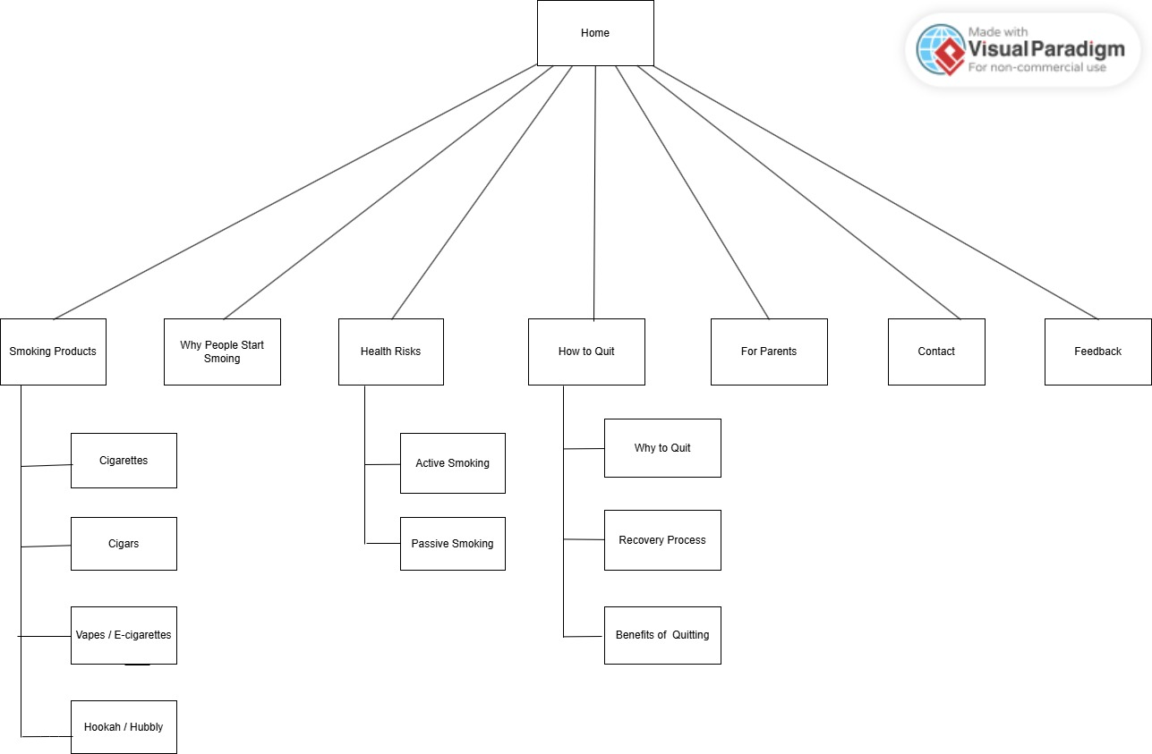

Navigation Structure
The website will use a top navigation bar that appears on all pages to ensure consistency and ease of use.
- A dropdown menu will be used under the “Smoking Products” section
- Users will be able to navigate easily between all pages
- Each page will include links back to the Home page
- The website follows the 3-click rule, allowing users to access information quickly

Page Descriptions

- Home: Provides an overview of the website and introduces smoking awareness
- Smoking Products: Displays different types of smoking products and devices with images and descriptions and their effects.
- Why People Start Smoking: Explains factors such as peer pressure, curiosity, and social influence, supported by relevant statistics
- Health Risks: Describes the effects of smoking on health, including passive smoking, supported by statistics
- How to Quit: Offers advice, recovery steps, benefits of quitting, and motivational support
- For Parents: Provides guidance on how parents can discourage children from smoking
- Contact: Contains contact information
- Feedback: Includes a form for user input

Technical Brief

The technical brief outlines the technologies, tools, and resources that will be used in the design and development of the website. These tools have been carefully selected to ensure that the website is functional, responsive, user-friendly, and compatible across different devices and browsers. The combination of these technologies will support both the structural and visual aspects of the website while allowing for interactivity and ease of maintenance.

Technologies Used
- HTML5 (HyperText Markup Language)
HTML5 will be used to create the structure of the website. It will define the layout of each page, including headings, text, images, links, and forms. It also uses semantic elements such as <header>, <nav>, and <footer> to improve structure and accessibility.

- CSS3 (Cascading Style Sheets)
CSS3 will be used to style the website by controlling colours, fonts, layout, and spacing. It ensures consistency across pages and improves the visual appearance of the website.

- Bootstrap Framework
Bootstrap will be used to create a responsive and mobile-friendly design. It provides ready-made components such as navigation bars, grids, and buttons, allowing the website to adapt to different screen sizes.

- JavaScript
JavaScript will be used to add interactivity to the website, particularly for features such as form validation on the feedback page. It enhances the user experience by making the website more dynamic and responsive.

Tools & Resources
- Visual Studio Code (VS Code)
Used as the main code editor for writing and managing HTML, CSS, and JavaScript files. It provides useful features such as syntax highlighting and extensions.

- Notepad++
Used as an additional lightweight text editor for quick editing and reviewing of code. It is simple, fast, and efficient for basic tasks.

- GitHub
Used for version control and storing project files. It helps track changes and manage the development process.

- GitHub Pages
Used to host and publish the website, making it accessible online via a URL.

- Canva / GIMP
Used to create and edit images, logos, and graphics for the website to improve visual appeal.

Browser Compatibility
The website will be tested on:
- Google Chrome
- Microsoft Edge
- Opera Web
This ensures the website works correctly across different platforms and devices.

