Junio, Toong

Machine Problem 3 (Matlab)

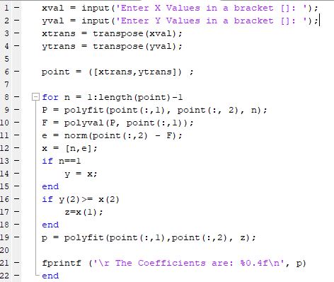

Test of Proof:

