Junio, Toong

Machine Problem 5 (Matlab)

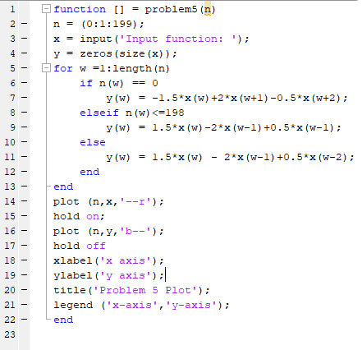

Input the function:



The resulting Graph:

