Problem 1

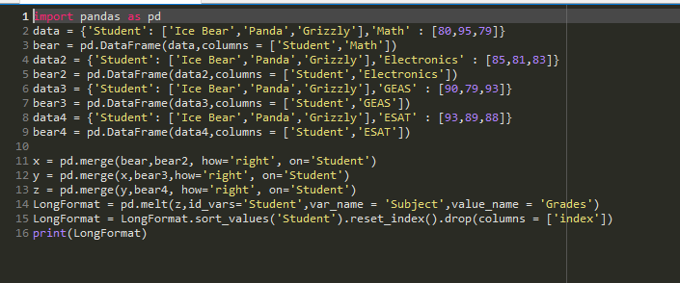

Expected Output:

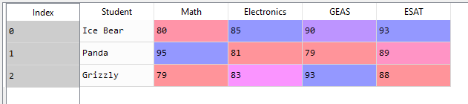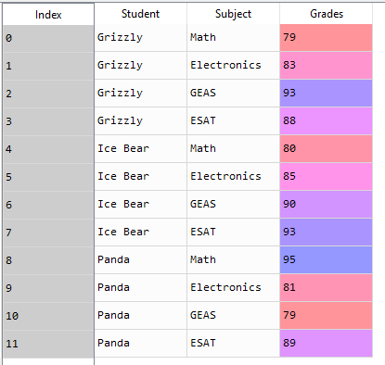

Problem 2

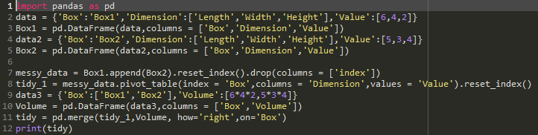

Expected Output:

Messy Data:

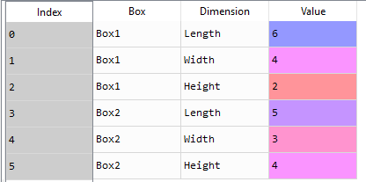

Tidy:

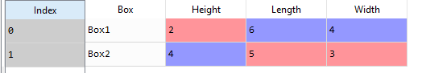

Tidy with Volume:

