**Seminar 1**

**Object-Oriented Design, IV1350**

**Adrian Kastrati,** [**kastrati@kth.se**](mailto:kastrati@kth.se)

**2022-06-05**

**Contents**

**1 Introduction 3**

**2 Method 4**

**3 Result 5**

**4 Discussion 6**

1. **Introduction**

The seminar task is to create a domain model of a retail store including a customer, cashier, different systems. As well a system sequence diagram of a basic flow for a sale process with a cashier and four systems including alternative flows at said retail store.

The task was solved in collaboration with Deni Persson, Jesper Munkeby and William Eriksson.

1. **Method**

The process for creating the domain model started with noun identification. This part was done on a whiteboard through writing down every noun. A category list was used to find other classes or/and attributes that did not make it to the first draft of the list. The nouns where then analyzed to see if they should be discarded from the list as class candidates or was better suited as attributes for other class candidates.

The domain model was then put together starting from the key classes to then add associations to the rest of the classes with names, starting with a verb describing how the classes are associated.

The outline of the sequence system diagram (SSD) was created in astah by first analyzing the basic and alternative flow to decide the actors and systems that are to be included in the SSD. The interactions between the systems and actors were then placed in the SSD by sequence order and further analyzed to see if they have a return value and of what type.

1. **Result**

The updated DM contains 16 different classes with associations that represents the process of a sale at a store. The SSD contains 5 different objects that represents the interactions between different systems and actors in sequential order.

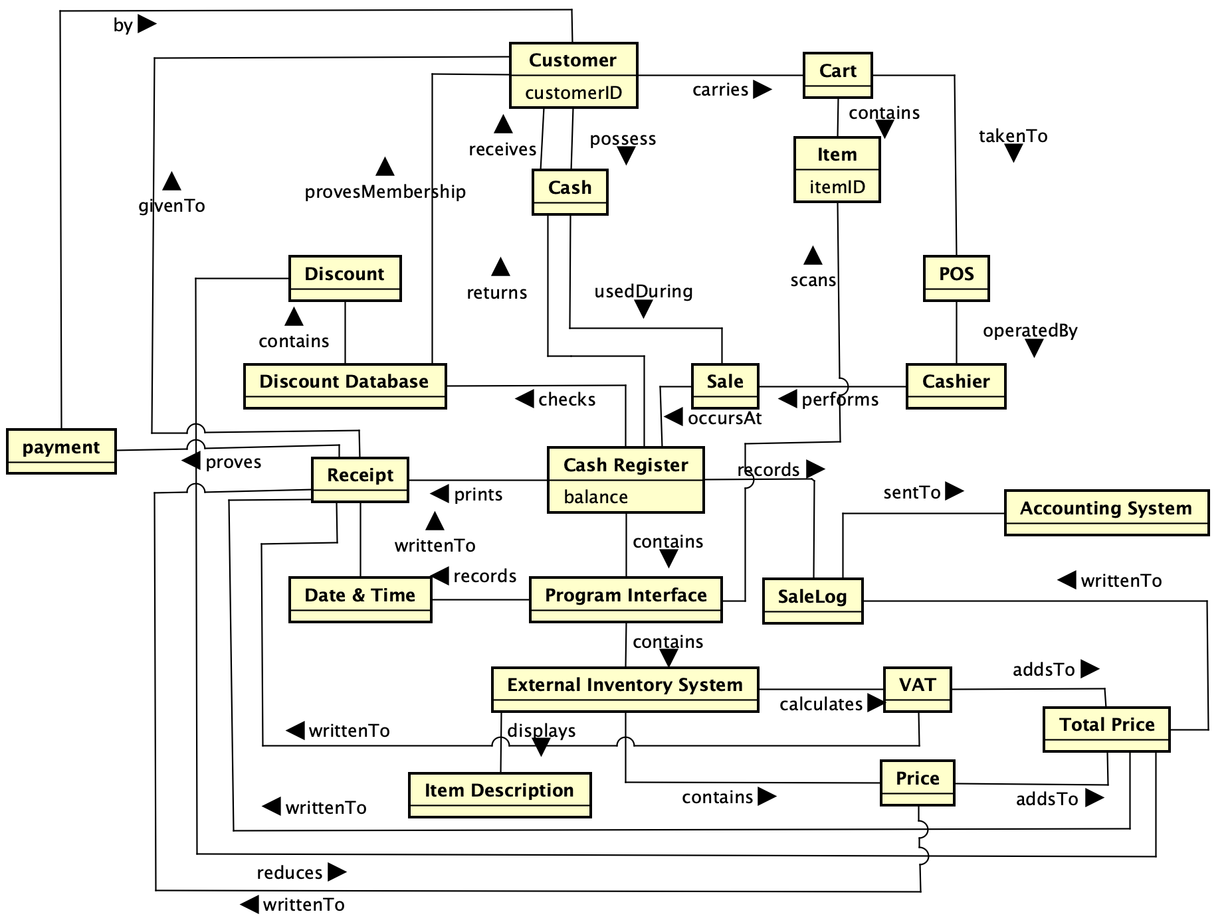

**Figure 3.1**: Domain model for retail store with different classes with classes and attributes taken from the basic flow and alternative flow in seminar 1

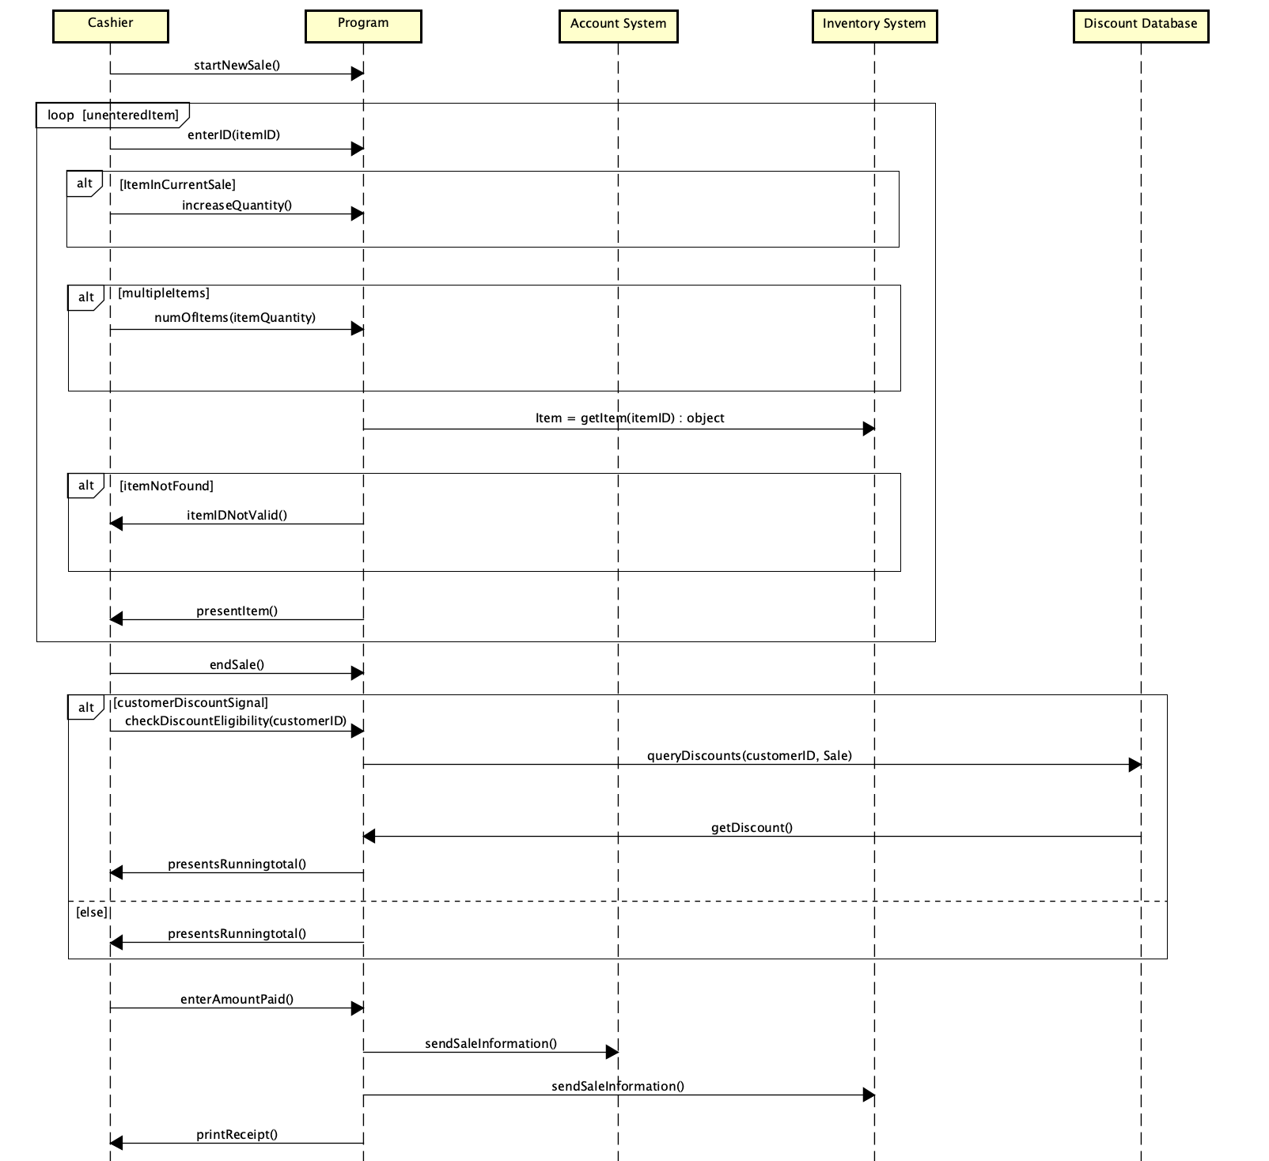

**Figure 3.2**: System sequence diagram process sale flow including basic, and alternative found in seminar 1 tasks

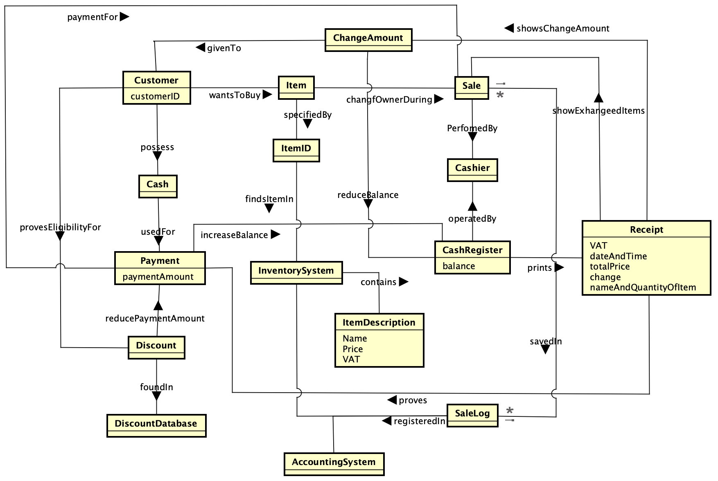

**Figure 3.3**:The updated domain model (DM) for retail store with different classes with classes and attributes taken from the basic flow and alternative flow in seminar 1

**Figure 3.4**: The updated system sequence diagram (SSD) process sale flow including basic, and alternative found in seminar 1 tasks

1. **Discussion**

Collaborating in group to analyze the relevant classes and attributes was a helpful part of starting to work with the assignment, it contributed in the way of giving different perspectives and allowing discussion of relevant nouns to include in the domain model. Setting up a category list did not lead to new classes or attributes due to our great list of nouns which derived from the whiteboard and discussions. It did help seeing the different categories and how they connect. The process of adding associations to the domain model contains relevant information that is not a flow of time but a picture of what exist during the sale process where classes do not have excessive associations and is not a “spider-in-the-web” since the nouns are split up to classes where the majority is not associated to one main class. The argument that the cashRegister is the “spider” could be made but it is a central class, and the other classes have plenty of additional associations, other than the cashRegister.

This is the updated part of the discussion concerning the domain model. The naming of the associations was updated, they now have names that show how and why they exist. Two associations that was added is between payment/sale and item/sale. There are now 5 associations to Sale, but plenty of other associations distributed to other classes, as customer and payment. Classes as DiscountSystem and itemDescription is a part of the sale process is not directly associated to sale, there are multiple reasons to why it is not a spider in the web class. The SSD was updated so that the cashier does not need to keep track of items already in sale but need to be able to count the number of items if more than one of a item is entered.

The only actor in the sequence diagram is the cashier, that is true since the customer do not interact with any system. All the customers interactions happen with the cashier which in turn interact with other system. The external systems and program are system that should be included, and the discount database could be considered as an actor or system but either way, it needs to be included since it has part in an interaction with the program and is external. The control for already scanned items is excluded from the SSD since it happens within the program without contacting another actor/system. The return value in the SSD when returning an object includes values that are needed for the diagram to be correct, it could return other values that in turn, would make the diagram to be faulty.