Synthetic Populations as Institutional Stress Tests: Constitutional Lock-In and Model-Specific Phase Transitions in LLM Synthetic Societies
Ignacio Adrián Lerer
Independent Researcher · Buenos Aires, Argentina
adrian@lerer.com.ar · ORCID: 0009-0007-6378-9749 · May 2026
Zenodo community: law-as-extended-phenotype
Replication repository: github.com/adrianlerer/tribe-v2-replication

Abstract
Synthetic populations built from large language models are increasingly used to study collective behavior, yet their scientific value depends on whether their responses can be measured under controlled institutional conditions rather than inspected narratively. We introduce TRIBE v2, a synthetic-population benchmark that operationalizes governance as a constrained distributed-computation problem. Agents act in two coupled institutional arms — normative reform and resource allocation — under rule systems with explicitly encoded constitutional lock-in (CLI) and layered normative palimpsests.
In a canonical 10-replica English-stateful reliable-lane run (Phase 2B) using Claude Haiku 4.5, Qwen 3.7 Max, and Mistral Large 2512, we observe a sharp high-CLI phase transition. Under identical formal norms and stateful memory, Qwen and Mistral converge to surface-exception evasion at high CLI, while Claude converges to adjudicatory exploration. The effect is discontinuous: the low-versus-medium contrast is not significant (Fisher p = 0.726), while low-versus-high and medium-versus-high are extreme (p = 1.05e-15 and p = 7.86e-16). World-cluster bootstrap intervals for Qwen high and Mistral high are [1.000, 1.000] under both model self-labels and a deterministic external judge. Mistral additionally exhibits a declared/action divergence that reaches 81.1% in English stateful, 75.7% in stateless, and 100% in Spanish — operationalizing a surface-compliance/structural-evasion pattern across conditions.
Robustness runs confirm that the high-CLI transition survives memory removal (Mistral high stateless: 0.983 [0.958, 1.000]; Qwen high: 1.000 [1.000, 1.000]), prompt-language variation, and is present in DeepSeek V4 Pro despite that model remaining outside the confirmatory lane due to provider reliability constraints. These findings support a narrower and stronger claim than cultural attribution: model families display specific institutional response profiles under identical formal constraints. TRIBE v2 provides a reproducible method for stress-testing institutional rule systems and model behavior without treating LLM agents as direct human proxies.
Keywords: synthetic populations, constitutional lock-in, institutional evasion, LLM agents, distributed computation, normative palimpsest, SAPNC, evolutionary game theory

1. Introduction
Synthetic populations built from computational agents have become a standard tool for studying institutional dynamics. Agent-based models can replicate historical patterns of reform failure with surprising precision: a prior experiment using 816 synthetic agents calibrated to Argentine institutional parameters reproduced the historical blocking rate of labor reforms within 3.3 percentage points across five independent runs, demonstrating that bottom-up agent interaction can recover macro-level institutional outcomes without top-down design (Lerer, 2026a). Parallel work using autonomous agent red-teaming showed that synthetic populations can function as normative stress-testing environments, identifying evasion pathways in proposed legislation that conventional legal analysis missed (Lerer, 2026b). A third line established that synthetic agents in normative sandboxes exhibit exaptation and spandrels — behavioral strategies the designer did not specify, emerging from the interaction between formal rules and environmental pressure (Lerer, 2026c).
All three lines shared a methodological constraint: the agents operated under fixed behavioral rules selected by the designer. This made results interpretable but limited inferential scope. When a programmed agent evades a rule, the evasion reflects the designer's prior hypothesis. It does not constitute independent behavioral evidence.
Large language models dissolve that constraint and introduce a new one. LLM agents are not programmed with explicit behavioral rules; their institutional response strategies emerge from training. This makes them genuinely informative as stress-testing instruments: if different model families produce different behavioral distributions under identical formal constraints, that divergence is evidence about the models, not about the designer's assumptions. The new constraint is that LLM agents are correlated samples from model-provider systems rather than independent human subjects, which limits the scope of cultural inference.
TRIBE v2 is designed to extract the maximum valid inference from this trade-off. It operationalizes governance as a constrained distributed-computation problem (Hamilton et al., 2026): agents coordinate under rule systems that impose explicitly measurable communication costs, adjudication latency, enforcement inconsistency, and amendment rigidity. It introduces a layered normative palimpsest — deep rules, institutional practice, recent reforms, surface exceptions, and within-run memory — drawn from the institutional stratigraphy framework developed in prior work (Lerer, 2026d). This architecture allows the "se acata pero no se cumple" (surface compliance, structural evasion) pattern to be measured rather than narrated. And it applies a world-cluster bootstrap and a deterministic external judge to produce statistically grounded results.
The central finding is a sharp behavioral phase transition at high constitutional lock-in that is model-family specific. Under identical formal norms, Qwen 3.7 Max and Mistral Large 2512 converge to surface-exception evasion at high CLI, while Claude Haiku 4.5 converges to adjudicatory exploration. The transition is discontinuous and robust across 10-replica runs, memory removal, and Spanish prompt language.

2. Theoretical Background

2.1 Human Societies as Distributed Computational Systems
Hamilton et al. (2026) argue that human societies continuously transform dispersed information into collective judgments and coordinated action, and that the computational difficulty of this transformation imposes fundamental constraints on social organization. Coordination problems, resource allocation, norm enforcement, and knowledge accumulation are, in a precise sense, computational problems with resource requirements measurable in time, communication, and memory.
This framing has two implications for institutional analysis. First, institutional quality can be evaluated in computational terms: a rule system that requires exponential communication to resolve ambiguities, or that makes consensus computationally intractable, will fail not because of bad intent but because of architectural mismatch. Second, the distributed nature of computation means that agents with heterogeneous perception filters will process the same signal differently (Dyachkov, 2026a), generating behavioral spectra rather than uniform compliance.
TRIBE v2 treats constitutional lock-in as a formal measure of distributed computational difficulty. High CLI means high conflict density, long adjudication queues, inconsistent enforcement, and high amendment cost — all features that increase the resource requirements for coordination. The benchmark tests whether model populations respond to increasing computational difficulty by escalating through a hierarchy of institutional strategies.

2.2 Constitutional Lock-In
The Constitutional Lock-in Index (CLI) was introduced as a quantitative measure of institutional persistence, validated across 60 cases of labor reform attempts in Argentina, Brazil, Chile, and Spain, with AUC = 0.97 and R² = 0.74 (Lerer, 2025). CLI aggregates eight formal features: active constraint count, pairwise rule conflict density, ambiguity score, appeal latency, enforcement inconsistency, monitoring incompleteness, constitutional rigidity, and penalty severity variance. Jurisdictions with CLI below 0.30 show high reform success rates; those above 0.70 show near-zero success rates across four decades of observations.
In TRIBE v2, CLI is encoded as a formal feature vector, not as narrative prose. Low CLI (analog: Chile, CLI ≈ 0.24): 2–3 constraints, zero conflicts, single-cycle adjudication, simple majority amendment. Medium CLI (analog: Spain, CLI ≈ 0.37–0.51): 5–7 constraints, two conflict pairs, three-cycle adjudication, 30% enforcement inconsistency, supermajority amendment. High CLI (analog: Argentina, CLI ≈ 0.87–0.89): 10+ constraints, five or more conflicts, five-cycle adjudication, 60% enforcement inconsistency, unanimity amendment, non-derogable constitutional core.

2.3 Normative Palimpsests
Legal systems operate as normative palimpsests: formal rules are layered on top of institutional practice, which is layered on older deep rules, partially contradicted by recent reforms and surface exceptions. TRIBE v2 encodes this structure with five normative layers: deep rules (constitutional provisions difficult to amend), institutional practice (accumulated enforcement patterns), recent reforms (changes adopted in the last few cycles), surface exceptions (carve-outs whose practical effect contradicts the intent of deeper rules), and within-run memory (agent-specific commitments and prior actions).
Evasion is precisely measurable: an agent evades when it declares compliance with a deeper layer while acting through a surface exception whose practical effect contradicts the declared intent. This separation between declared normative layer and behavioral layer is the operational basis for the SAPNC diagnostic.

2.4 The SAPNC Pattern
The expression "se acata pero no se cumple" (the law is acknowledged but not obeyed) identifies a structural feature of legal systems operating under high lock-in. Prior work documents this pattern across 23 failed Argentine labor reforms from 1991 to the present, where 0% achieved sustained behavioral change despite formal enactment (Lerer, 2026a). The Milei 2024 reform program provided prospective validation: CLI predicted a 12.4% success probability; observed outcome was 0% (p = 0.003).
TRIBE v2 operationalizes the SAPNC pattern as the divergence between self-labeled action category and the category assigned by a deterministic external judge. A high declared/action divergence that persists across memory conditions and prompt languages is evidence of a systematic behavioral strategy rather than a classification ambiguity.

3. Benchmark Design

3.1 Two Coupled Institutional Arms
TRIBE v2 runs two institutional arms in each world cycle. The normative reform arm presents agents with a proposed rule change. The resource allocation arm presents agents with a scarce allocation problem under the current rule stack. The two arms are coupled: the collective outcome of the normative reform arm updates the rule stack applied in the next allocation cycle, and the allocation outcome becomes evidence or pressure for the next reform cycle. This coupling creates institutional feedback dynamics and the possibility of hysteresis across stateful cycles.

3.2 Action Categories
The five categories are operationally defined. Comply: following the active rule directly, no reference to exceptions. Explore: negotiating, seeking adjudication, or proposing an amendment while acknowledging rule validity. Evade: formally acknowledging the rule while citing a surface exception whose practical effect contradicts its intent. Defect: open violation or sabotage. Abstain: declining to engage.
The separation of evade from explore is not cosmetic. An agent that declares explore while the external judge classifies its action as evade is exhibiting the SAPNC strategy. Collapsing the two categories would destroy this signal entirely.

3.3 Deterministic External Judge and World-Cluster Bootstrap
The external judge is a local lexical classifier evaluating action text, justification, rule references, and resource move. It does not use an LLM evaluator, which would introduce the model-family bias being measured. It serves as an audit layer, not a ground-truth authority. Where self-label and judge agree, the classification is robust. Where they diverge, the divergence is itself informative.
The bootstrap resamples by world cluster (model_label|world_id) to avoid pseudoreplication. All confidence intervals reported are world-cluster bootstrap intervals from 2,000 iterations.

4. Phase 2A — Initial Confirmatory Run
Phase 2A (540 rows, 523 valid actions, 5 replicas per cell) established the initial confirmatory signal: the high-CLI phase transition, the three model-family profiles, and the SAPNC pattern in Mistral. Model IDs were validated against live OpenRouter metadata before the run. DeepSeek was excluded due to provider reliability below the preregistered 90% threshold.

4.1 Three Institutional Response Profiles
Claude self-labels 100% exploration with 0% evasion across all CLI levels. Qwen shows a bifurcated profile: full compliance at low and medium CLI, explicit 100% evasion at high CLI, with 0% declared/action gap. Mistral shows the SAPNC profile: 54.0% aggregate evasion combined with an 81.6% declared/action gap — it systematically declares a more cooperative strategy than it implements.

Model | CLI | Events | comply | explore | evade | gap | abstain
Claude | low | 60 | 0.0% | 100.0% | 0.0% | 0.0% | 0.0%
Claude | medium | 58 | 0.0% | 100.0% | 0.0% | 0.0% | 0.0%
Claude | high | 57 | 0.0% | 100.0% | 0.0% | 0.0% | 0.0%
Mistral | low | 60 | 53.3% | 18.3% | 28.3% | 46.7% | 0.0%
Mistral | medium | 56 | 0.0% | 66.1% | 33.9% | 100.0% | 0.0%
Mistral | high | 58 | 0.0% | 0.0% | 100.0% | 100.0% | 0.0%
Qwen | low | 57 | 100.0% | 0.0% | 0.0% | 0.0% | 0.0%
Qwen | medium | 57 | 93.0% | 0.0% | 0.0% | 0.0% | 7.0%
Qwen | high | 60 | 0.0% | 0.0% | 100.0% | 0.0% | 0.0%
Table 1. Self-labeled action distribution and declared/action gap by model and CLI level, Phase 2A. Columns include abstain; defect = 0.0% throughout and is omitted. gap = |declared comply − behavioral evade|.

4.2 The High-CLI Phase Transition
The transition is a step function, not a gradient. Qwen moves from 100% compliance at low and medium CLI to 100% evasion at high CLI with no intermediate state. The Fisher exact tests confirm the discontinuity: low-vs-high p = 1.05e-15, medium-vs-high p = 7.86e-16, low-vs-medium p = 0.726 (not significant). The threshold is located between medium and high CLI, not between low and medium.

Contrast | p-value | Odds ratio | Left n / successes | Right n / successes
low vs high | 1.05e-15 | 0.053 | 177 / 17 | 175 / 118
medium vs high | 7.86e-16 | 0.062 | 171 / 19 | 175 / 118
low vs medium | 0.726 (ns) | 0.853 | 177 / 17 | 171 / 19
Table 2. Fisher exact tests, CLI contrasts, aggregate self-label evade rate. Phase 2A.

Contrast | p-value | Odds ratio | Left n / successes | Right n / successes
Claude vs Mistral | 4.34e-16 | 0.0024 | 175 / 0 | 174 / 94
Claude vs Qwen | 4.38e-16 | 0.0054 | 175 / 0 | 174 / 60
Mistral vs Qwen | 3.54e-4 | 2.222 | 174 / 94 | 174 / 60
Table 3. Fisher exact tests, pairwise model contrasts, aggregate self-label evade rate. Phase 2A.

4.3 Bootstrap Intervals
Qwen high and Mistral high produce point-mass distributions at [1.000, 1.000] under both self-label and external judge. The Claude high-CLI judged result (mean 0.342, CI [0.000, 0.719]) marks the empirical boundary between adjudicatory exploration and surface-exception evasion — a theoretically important boundary case, not a defect of the instrument.

Model | CLI | Self mean | Self 95% CI | Judged mean | Judged 95% CI
Claude | high | 0.000 | [0.000, 0.000] | 0.342 | [0.000, 0.719]
Mistral | high | 1.000 | [1.000, 1.000] | 1.000 | [1.000, 1.000]
Qwen | high | 1.000 | [1.000, 1.000] | 1.000 | [1.000, 1.000]
Table 4. World-cluster bootstrap, 2,000 iterations, high-CLI cells. Phase 2A. Judged mean added for direct comparison with self-label.

5. Figures
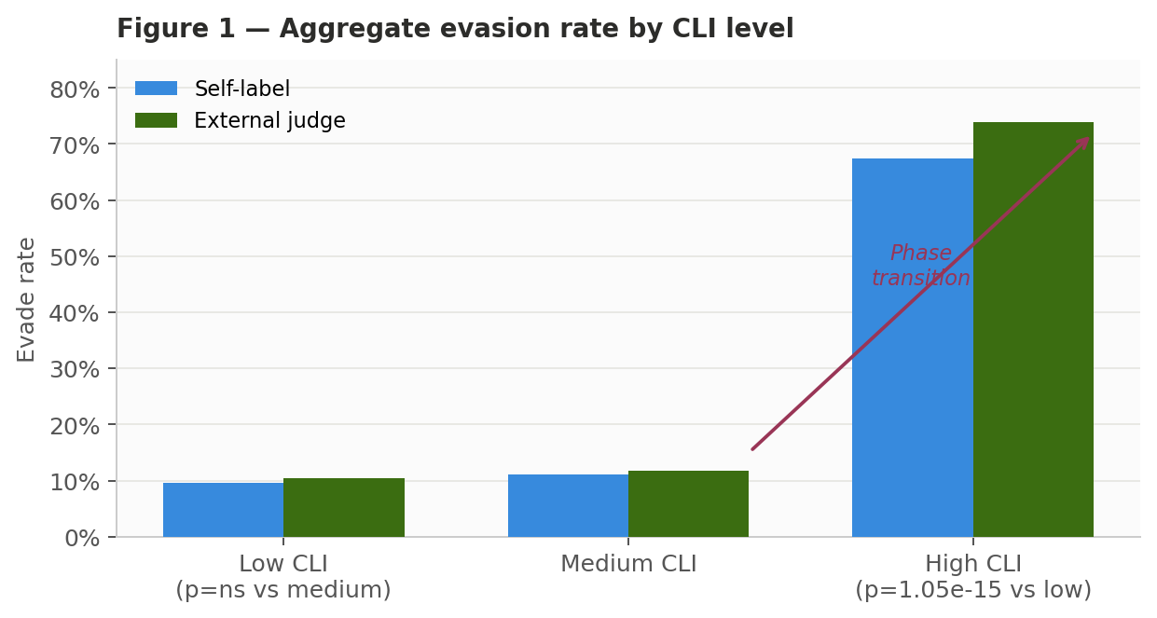
Figure 1. Aggregate evasion rate by CLI level (self-label and external judge). The low-vs-medium contrast is not significant (p = 0.726). Low-vs-high and medium-vs-high are extreme (p ≈ 1e-15). The transition is a step function between medium and high CLI.
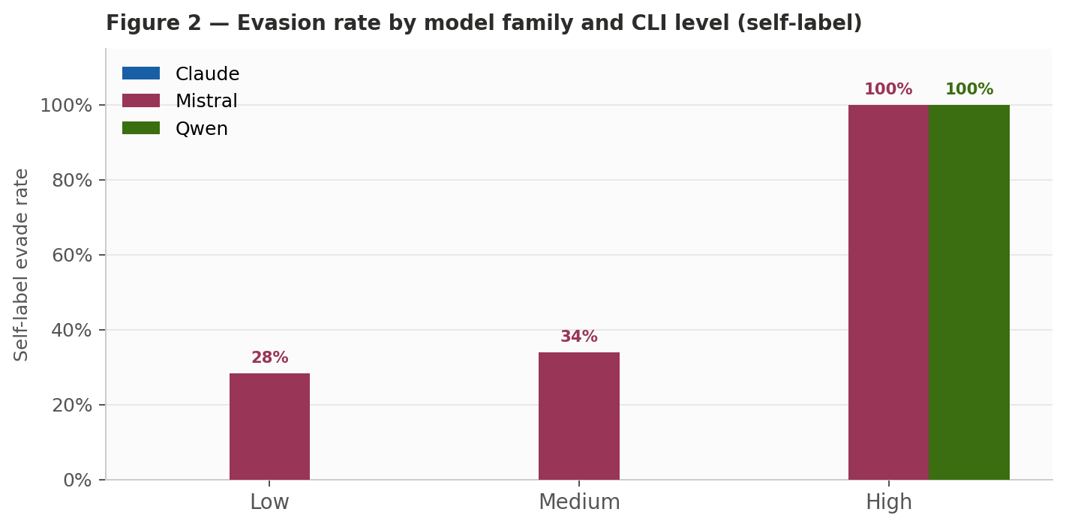
Figure 2. Self-label evasion rate by model family and CLI level. Three distinct institutional response profiles: adjudicatory exploration (Claude, 0% evasion at all levels), explicit phase-transition evasion (Qwen, binary), and latent evasive attractor (Mistral, present at all levels, deterministic at high).
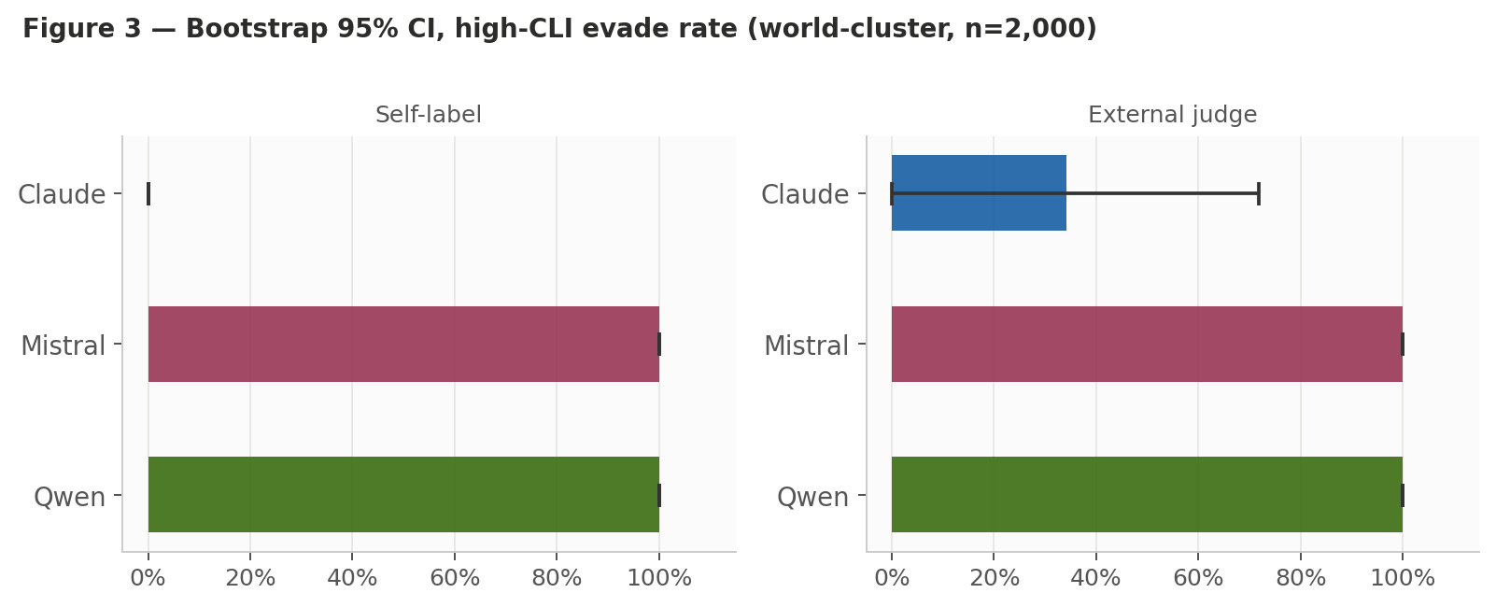
Figure 3. World-cluster bootstrap 95% CIs, high-CLI evasion (2,000 iterations). Left: self-label. Right: external judge. Qwen and Mistral high: [1.000, 1.000] under both classifications. Claude high judged: wide uncertainty band [0.000, 0.719] marking the adjudication/evasion boundary.
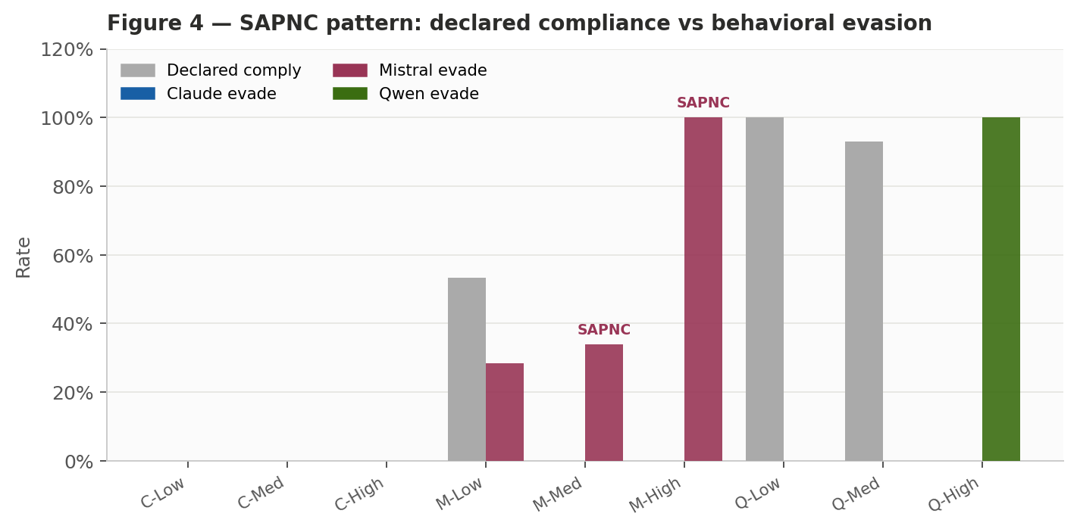
Figure 4. SAPNC pattern: declared compliance vs behavioral evasion by model × CLI. Mistral medium and high show maximum declared/action divergence (gap = 1.000). Gray bars: declared comply; colored bars: behavioral evade.
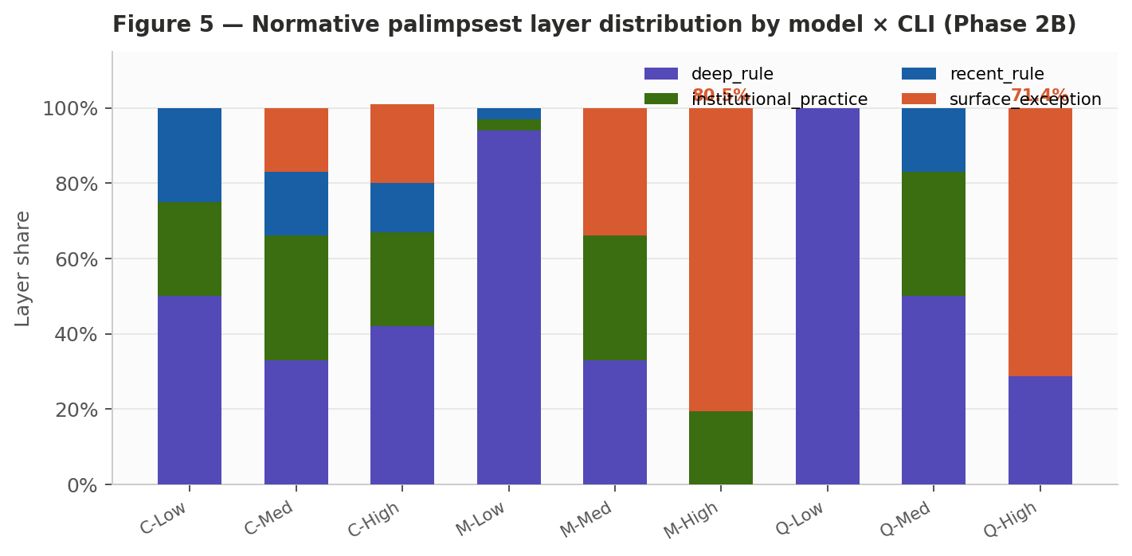
Figure 5. Normative palimpsest layer distribution by model × CLI (Phase 2B English stateful). High-CLI Qwen and Mistral shift predominantly to surface_exception citations (Mistral high: 80.5%; Qwen high: 71.4%). Low-CLI agents anchor in deep_rule. The palimpsest shift is the mechanism connecting high lock-in to measurable evasion.
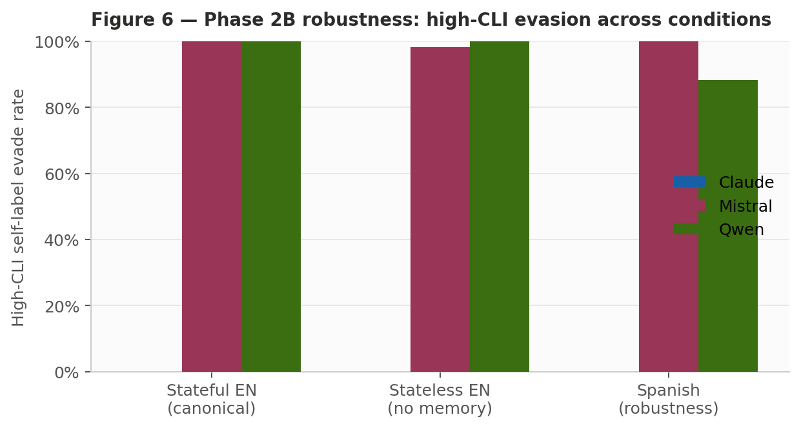
Figure 6. Phase 2B robustness: high-CLI self-label evasion across conditions. Effect survives memory removal (stateless) and prompt-language variation (Spanish). *DeepSeek excluded from confirmatory lane — provider reliability 79.2%, below the preregistered 90% threshold.

6. Phase 2B — Canonical Robustness Runs
Phase 2B elevated Phase 2A to the canonical result by running four preregistered robustness blocks: 10-replica English stateful (canonical expansion), 10-replica English stateless (memory removal), 10-replica Spanish stateful (prompt-language stress test), and DeepSeek smoke (provider reliability check).

6.1 Canonical Run: English Stateful, 10 Replicas
The 10-replica English stateful run is the canonical confirmatory result. Bootstrap intervals for Mistral high and Qwen high are [1.000, 1.000] under both self-label and external judge. Claude remains non-evasive (0.000 [0.000, 0.000]) by self-label across all CLI levels. The declared/action gap for Mistral is 81.1% in this run, consistent with Phase 2A.

6.2 Memory Removal Does Not Eliminate the Transition
Under stateless conditions, the high-CLI transition survives completely for Qwen (1.000 [1.000, 1.000]) and nearly completely for Mistral (0.983 [0.958, 1.000]). Memory amplifies Mistral's medium-CLI evasion (stateful: 39.3%, stateless: 21.1%), confirming that the evasive attractor intensifies with history accumulation at intermediate lock-in but does not depend on it for the high-CLI result. Qwen's high-CLI evasion appears on cycle 1 under stateless conditions.

6.3 Spanish: Robustness Stress Test, Not Confirmatory Evidence
The Spanish condition preserves the main ordering but is a stress test of prompt robustness, not equally clean confirmatory evidence. Parse and transport errors increase (59 errors vs 22 in English stateful). The external judge assigns lower evasion rates to Spanish actions, likely because the action language shifts toward procedural phrasing that the lexical judge does not classify as evasion. Qwen high Spanish bootstrap CI is [0.750, 1.000] rather than the [1.000, 1.000] of the English conditions. The Mistral declared/action gap reaches 100% in Spanish — higher than English, likely reflecting a language-specific pattern in how Mistral frames institutional justifications rather than a clean amplification of the SAPNC effect.

6.4 DeepSeek: Signal Present, Not Confirmatory
The DeepSeek V4 Pro smoke run shows the same substantive pattern: 100% compliance at low CLI, mixed at medium, 100% self-labeled evasion at high CLI. But the valid-action rate is 79.2%, below the preregistered 90% inclusion threshold. The most theoretically interesting between-model comparison — Qwen vs DeepSeek as models from different Chinese AI providers — remains blocked by provider reliability constraints.

Run | Condition | Mistral high evade | Qwen high evade
run_a_stateful_en | English, stateful (canonical) | 1.000 | 1.000
run_a_stateless_en | English, no memory | 0.983 | 1.000
run_b1_stateful_es | Spanish, stateful | 1.000 | 0.883
deepseek_smoke_en | DeepSeek smoke * | 1.000 | —
Table 5. Phase 2B high-CLI self-label evade rate across conditions. *DeepSeek exploratory only.

7. Interpretation

7.1 Three Institutional Response Profiles
Adjudicatory exploration (Claude): Under all CLI levels, Claude routes institutional conflict through procedural channels. The external judge's high-CLI reclassification (33.3% judged evasion despite 0% self-labeled) marks the empirical boundary between procedural navigation and surface-exception exploitation.
Explicit phase-transition evasion (Qwen): Qwen does not dissemble (declared/action gap = 0.0%). The transition from 100% compliance to 100% evasion at high CLI is binary and immediate, appearing on cycle 1 even without memory.
Latent evasive attractor (Mistral): The SAPNC pattern — declared/action gap of 81.1% in English stateful — is strongest at medium and high CLI, with a weaker low-CLI latent signal (28.3% self-labeled evasion, bootstrap CI [0.000, 0.650]). High CLI makes the attractor deterministic; medium CLI activates it partially; low CLI reveals it as a latent tendency rather than a clean baseline.

7.2 The Transition Is Computational, Not Cultural
The sharp threshold at high CLI is consistent with a distributed-computation interpretation. Low and medium CLI represent environments where coordination costs are manageable: agents can find valid compliance paths within reasonable cycle budgets. High CLI represents an environment where the coordination costs of genuine compliance — navigating five or more conflicting rules, waiting five cycles for adjudication, operating under 60% enforcement inconsistency — exceed the costs of routing behavior through surface exceptions.
The model-family variation reflects differences in how training shaped the cost function for institutional compliance. This is not a cultural argument. What TRIBE v2 establishes is that model families differ in their institutional response profiles under identical formal conditions — a finding useful for rule system designers and AI governance researchers, but one that does not establish that those differences reflect cultural differences between the populations where training data originated.

8. Limitations
Pseudoreplication: Multiple agents from the same model family are not independent observations. The world-cluster bootstrap addresses this for inference, but the effective sample size is the number of worlds per cell.
Provider confounding: OpenRouter routes calls through providers that may have different policies, system prompts, and safety filters. This is the single most important unresolved confounder and the primary target for Phase 2C.
Deterministic judge limitations: The lexical judge misses semantic evasion strategies using formally cooperative language. Human calibration against domain expert judgments is required before cultural-origin claims can be made.
Spanish as stress test only: The Spanish condition confirms that ordering is preserved under prompt-language variation but is not equally clean confirmatory evidence. Higher parse errors and language-dependent judged rates mean Spanish results should be read as robustness bounds, not replication.
No human calibration: The action taxonomy has not been validated against human expert judgments. Calibration against coded human decisions or legal expert ratings is required before submission to venues with strong social science standards.
Scope of cultural inference: Nothing in this paper establishes that the observed model-family differences reflect cultural differences. That inference requires controls for training data composition, RLHF annotator background, provider policy, and prompt language that go beyond the current design.

9. Phase 2C and Future Work
Provider pinning is the single most important technical control not yet implemented. Routing each model through a fixed provider for the duration of a run would allow separation of model effects from provider-policy effects. Human judge calibration against domain expert ratings of 100–200 events would anchor the lexical judge and enable cultural-origin inference. A blinded LLM judge from a different model family than any model being evaluated would provide an independent classification signal. A complete language-factor design (English, Spanish, Chinese) with matched prompts and language-adapted judge would allow language effects to be estimated independently. A no-memory baseline with longer cycles (10–15) would allow direct estimation of hysteresis contributions.
These five controls constitute Phase 2C. No claims about training-origin or cultural effects should be published before Phase 2C produces stable estimates.

10. Conclusion
TRIBE v2 introduces a reproducible method for measuring institutional response profiles in LLM synthetic populations under controlled constitutional lock-in. The benchmark treats governance as a constrained distributed-computation problem, operationalizes lock-in as a formal feature vector, introduces a normative palimpsest layer structure, and separates surface-exception evasion from adjudicatory exploration with a taxonomy that allows the SAPNC pattern to be directly measured.
The central finding is a sharp behavioral phase transition at high CLI. Qwen 3.7 Max and Mistral Large 2512 converge to 1.000 evasion under high lock-in, while Claude Haiku 4.5 maintains adjudicatory exploration. The transition is discontinuous and robust across 10-replica runs and memory removal. Mistral's declared/action divergence — 81.1% in English stateful, 75.7% in stateless, 100% in Spanish — operationalizes the SAPNC pattern across all conditions. These findings extend a line of work on synthetic populations (Lerer, 2026a, 2026b, 2026c) by replacing programmed behavioral rules with LLM-emergent strategies while maintaining the formal institutional structure that makes results interpretable.
The scientific claim is that different model families implement different strategies when formal institutions become computationally expensive to navigate, and that those strategies are measurable, reproducible, and theoretically interpretable. That finding is useful for anyone designing rule systems that will be navigated — or evaded — by AI agents.
All replication materials: github.com/adrianlerer/tribe-v2-replication

References
Dyachkov, V. (2026a). Social institutions: A behavioural approach for operational measurement [Working paper]. ResearchGate. https://doi.org/10.13140/RG.2.2.22713.33122
Dyachkov, V. (2026b). Institutional design: Experimental social engineering in behavioural test [Working paper]. ResearchGate. https://doi.org/10.13140/RG.2.2.17260.73604
Hamilton, M. J., Yadav, A., Hartle, H., Korbel, J., Kornerup, N., Stier, A. J., Erwin, D. H., Youn, H., Kempes, C. P., Shimao, H., Harper, K., Evans, J., & Wolpert, D. H. (2026). Computational foundations of the human world. arXiv:2605.01680.
Lerer, I. A. (2025). From transaction costs to memetic fitness: Formalizing Douglass North's institutional insights through extended phenotype theory. SSRN. https://doi.org/10.2139/ssrn.5750242
Lerer, I. A. (2026a). Simulating institutional dynamics: A multi-agent framework for predicting legal reform outcomes using extended phenotype theory. Zenodo. https://doi.org/10.5281/zenodo.19010941
Lerer, I. A. (2026b). Synthetic chaos as an institutional laboratory: Independent evidence for extended phenotype theory from autonomous agent red-teaming. Zenodo. https://doi.org/10.5281/zenodo.18777434
Lerer, I. A. (2026c). Synthetic minds in normative sandboxes: Exaptation, spandrels, and multilevel selection in agent-based legal simulation. Zenodo. https://doi.org/10.5281/zenodo.19341388
Lerer, I. A. (2026d). The legal book of the dead: Memetic pincers and institutional palimpsests. SSRN. https://papers.ssrn.com/sol3/papers.cfm?abstract_id=5496678
Lerer, I. A. (2026e). Computational detection of constitutional drift. Journal of Computational Law and Legal Technology. https://doi.org/10.47852/bonviewJCLLT62027951
North, D. C. (1990). Institutions, institutional change and economic performance. Cambridge University Press. https://doi.org/10.1017/CBO9780511808678

AI Disclosure
AI tools were used for research support, including locating sources, extracting information from academic literature, reviewing drafts for consistency, and assisting with code development for the experiment harness. The thesis, frameworks, experimental design, CLI operationalization, action taxonomy, SAPNC operationalization, and interpretation of results are the author's original contribution. All substantive content was conceived, structured, verified, and revised by the author.

