**Letter of Intent**

Quito, June 23,2020

Sirs.

Java Master

Dear:

Their project is about an online store for video games, consoles among other things, what they are doing due to current circumstances seems perfect to me, the health emergency in which we are forced to stay at home, is at this point that the project becomes attractive since it allows us to make purchases without leaving home, this practice strengthens the trade of large, medium and small companies this tool also provides convenience to people, the project seems feasible to me due to the possibility of linking with entities banks with credit card service and similar companies such as Pay pal, the project has the advantage that they contain a very modern market such as video games, in conclusion, their project adopts the digital market methodologies being very useful in the current situation and providing a reliable service.

Cordially

Jose Antonio Roman Vasco

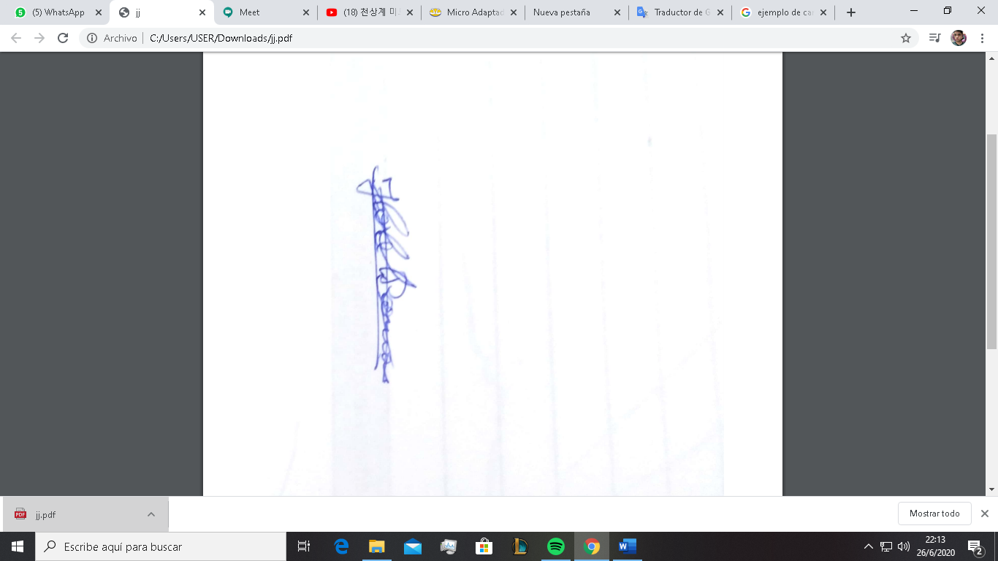

____________________

# **Summary**

This document consists of 5 sections. In the first section of the document an introduction is made about what the software product will cover, where it will provide an overview of the functional and non-functional requirements specifications, its objectives, and the scope of the software product, in addition to a description of the personnel involved in the development of the system with the roles that each one fulfills.

In the second section of the document, a general description of the system is made, in order to have a perspective and know the main functions that a software product must perform, characteristics, restrictions, dependencies that affect the operation of the software product, but without entering so many details.

The third section of the document is the one that defines in detail the functional and non-functional requirements that the software product system must meet.

In the fourth and fifth section of the document, the use cases where the multiple possible routes that the user can follow to carry out the process are detailed, calling each of these possible routes the scenario.

1. Introducción

This document is a Software Requirements Specification (SRS), for the allocation system, location of commercial services, this software does not belong to any specific company.

This specification has a structure established in the guidelines given by the IEEE Recommended Practice Standard for ANSI / IEEE 830 Software Requirements Specifications.

* 1. **Purpose**
* The main objective is to fully and concretely define the functional and non-functional requirements necessary for the development of a new commercial services allocation and location software through the validation of this document.
* The developed software belongs to the same developers, and project managers in such a way that there is no express request from an entity for the development of this software.
  1. **Scope**

# The software product due to its main characteristics and in relation to the environment to which it is focused will be called “VirtualGameStore”.

Consider the following points in more detail

* Aplication of user
  + Enter to the system.
  + User Register.
  + Data gestión of toys.
  + Data gestión of consoles.
  + Data gestión of accsesory
  + Data gestión of games
  + See the products
  + Accept or reject the purchase
  + End de purchase.
  + Exit the system
  1. **Involver Staff**

|  |  |
| --- | --- |
| Name | Josué Moreno |
| Role | Project Manager, analyst, desarrollador, tester DBA. |
| Professional category | Student of Software Engineer |
| Responsibilities | Code review, help in documentation tasks |
| Contact information | [jamoreno15@espe.espe.edu.ec](mailto:jamoreno15@espe.espe.edu.ec) |
| Approval | Yes |

|  |  |
| --- | --- |
| Name | Fernando Noguera |
| Role | Developer, reviewer, tester DBA |
| Professional category | Student of Software Engineer |
| Responsibilities | Code review, help in documentation tasks |
| Contact information | [lfnoguera@espe.espe.edu.ec](mailto:lfnoguera@espe.espe.edu.ec) |
| Approval | Yes |

|  |  |
| --- | --- |
| Name | Samuel Roman |
| Role | Developer, reviewer, tester DBA |
| Professional category | Student of Software Engineer |
| Responsibilities | Code review, help in documentation tasks |
| Contact information | [siroman@espe.espe.edu.ec](mailto:siroman@espe.espe.edu.ec) |
| Approval | Yes |

|  |  |
| --- | --- |
| Name | Christian Pacheco |
| Role | Developer, reviewer, tester DBA |
| Professional category | Student of Software Engineer |
| Responsibilities | Code review, help in documentation tasks |
| Contact information | [cjpacheco@espe.espe.edu.ec](mailto:cjpacheco@espe.espe.edu.ec) |
| Approval | Yes |

|  |  |
| --- | --- |
| Name | Adrian Ramos |
| Role | Developer, reviewer, tester DBA |
| Professional category | Student of Software Engineer |
| Responsibilities | Code review, help in documentation tasks |
| Contact information | [aeramos2@espe.espe.edu.ec](mailto:aeramos2@espe.espe.edu.ec) |
| Approval | Yes |

* 1. **Definitions, acronyms and abbreviations**

|  |  |
| --- | --- |
| Concept | Definition |
|  |  |
| On-line Shop | A type of business that you use as your primary means of making your connections to a website or application connected to the Internet. |

* 1. **References**

|  |  |  |  |  |
| --- | --- | --- | --- | --- |
| Reference | Title | Route | Date | Author |
| 1 | Standard IEEE  830 | PDF | 22/10/2008 | IEEE |
| 2 | Especificación de requisitos de software | [http://www.qualitatis.org](http://www.qualitatis.org/) | 12/04/2010 | Qualitatis.org |

1. Overview
   1. **Product Perspective**

The "VirtualGameStore" system is a standalone software product, which will allow access to people who will be able to view and buy all the products offered by the system; on the part of the program, the user can create an account where he will see the different types of product with their respective price.

* 1. **Product functionality**

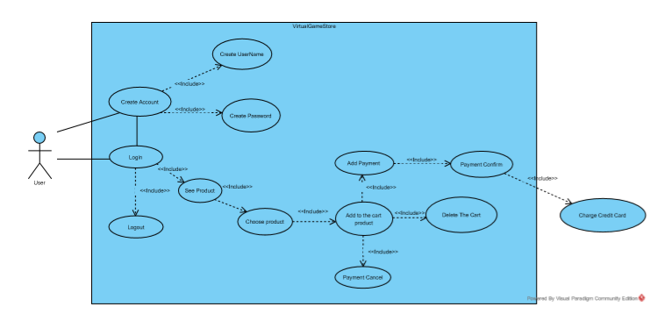

1. **User features**

|  |  |  |  |
| --- | --- | --- | --- |
| Type of User | | User | |
| Academic training | Basic Education. | |
| Abilities | Ease of operation of programs on computers or mobile in any operating system. | |
| Activities | Register in the system, view the different types of products, and add products to the cart for the buy. | |

1. **Restrictions**

* The system must be developed in Java programming language for the existing Computer Operating Systems.
* The information about users, characteristics of all the products of the shop, Information of the product in the cart. It should be stored in format .csv .database of .csv files.
* The system will be compatible with computer operating systems and mobile devices.

1. **Assumptions and Dependencies**

* The program to be delivered will for on devices whit Operating Systems of basic features.this will have enough power to be able to get the results in an appropriate time.
* The computer's internet signal either wired or WIFI must be acceptable enough for the program to perform the system's functionalities in an appropriate manner.

1. **Predictable evolution of the system**

It is planned that after implementing the module within the system and with its proper functioning and handling, add new tools within the same module to yield detailed reports for periods in general and individually for each of the users, payments, history, and problems that may arise.

**3. Specific Requirements.**

**3.1. Functional Requirements**

Virtual game store

RF1: Create an account

•   The program registers the user for the first time.

•   The log asks for information about the user being stored.

RF2: Verify account

•   The user, once created your account has the option to verify the information you enter.

•   You can edit the account information.

RF3: Acceded to the menu.

•   After logged in, the user accesses an interactive menu.

•   The user can access several opinions within the menu.

RF4: View products

•   The user can see a list of the products.

•   The list of products varies according to the option: game, toy, accessory, console.

RF5: Search for products.

•   The user using a menu option has the option to search for a specific product.

•   The searched is performed by entering a key attribute of the product.

RF6: Select product.

•   The user, after searching for a product has the option to select it.

•   The selection of a product opens other functionalities that can be done with it such as buying, adding etc.

RF7: Add product to cart.

•    There is the option to add one or more products to the sales cart.

•    There is no limit to products that can be added to the cart.

RF8: Delete products.

•   You can delete products that you have previously added to the sales cart.

•   The user may request that the list that is accumulated in the sales cart be canceled.

•

RF9: Buy products.

•   The user can request to purchase the products that he has previously added to the sales cart.

•   When selecting the purchase option, they must move the different payment methods that the user can make.

RF10: Enter credit target.

•   The user has the option to pay for their product with credit target, entering their data.

**3.2. Non-functional requirements.**

* The application must be ordered so that the user is not lost.
* The application must be repeated and the data lost again if the user misunderstands any process.
* The application must have an option to exit.
* The application must be scheduled in Java
* The user can edit their account at any time.
* The program will not allow access to unidentified persons without an account.

**5.**

**5.1._Virtual Game Store**

|  |  |
| --- | --- |
| Identifier | RF1 |
| Name | Create account |
| Description | The user creates an account, entering the name the password the address the email and the date of birth |
| Actors | User |
| Preconditions |  |
| Postconditions | The user is registered and the application will ask him to log in when entering |
|  |  |

|  |
| --- |
| Normal flow of events |
| 1. The user creates an account, entering the name the password the address the email and the date of birth  2. Validate Name.  3. Validate password  4. Validate address  5. Validate the email  6. Validate the date of birth |
| Alternate flows and exceptions |
| A. Lack of information  1. The system prints that no data has been entered.  2. The system allows you to put the data back in (return) |
| B. Wrong user  1. The program prints "Incorrect username or password" |

|  |  |
| --- | --- |
| Identifier | RF2 |
| Name | Verify Account |
| Description | The user checks their account to check if their username and password is ok. |
| Actors | User |
| Preconditions | Have created an account and access the menu. |
| Postconditions |  |
| Normal flow of events | |
| A. Correct use  1. The user can verify their account. | |
| Alternate flows and exceptions | |
| B. Execution failure.  1. The program is repeated.  2. The program prints "User is not valid" | |
| C. Lack of information.  1. The program prints "error in read the file"  2. The program prints "cannot verify account" | |

|  |  |
| --- | --- |
| Identifier | RF3 |
| Name | Access the menu |
| Description | The user enters the menu to choose from the options: 1 for see the consoles, 2 for see the Games, 3 for see the Toys, 4for see the Accessories, 5 for buy the product. |
| Actors | User |
| Preconditions | Have entered the correct username and password. |
| Postconditions |  |
| Normal flow of events | |
| A. Correct use  1. The user can see the list of products. | |
| Alternate flows and exceptions | |
| B. Execution failure.  1. The program is repeated. | |
| C. Lack of information  2. The program prints "error in read the file" | |

|  |  |
| --- | --- |
| Identifier | RF4 |
| Name | See products |
| Description | The user through the menu sees the products entering their: id, name, Price. |
| Actors | User |
| Preconditions | Have entered the correct username and password and access the option from the menu. |
| Postconditions |  |
| Normal flow of events | |
| A. Correct use  1. The user can see a specific product. | |
| Alternate flows and exceptions | |
| B. Execution failure.  2. The program is repeated. | |
| C. Lack of information.  3. The program prints "error in read the file"  4. The program prints "the product was not found" | |

|  |  |
| --- | --- |
| Identifier | RF5 |
| Name | Search object |
| Description | The user will type the option 1-5 and the program will search for the file regarding the option |
| Actors | User |
| Preconditions | Start section |
| Postconditions | The program will receive the option, open it and ask you to enter another option. |

|  |
| --- |
| Normal flow of events |
| 1. The user enters an option and the program will open the file with respect to the entered option. 2. Validate Console. 3. Validate Toy 4. Validate Accesory 5. Validate Game |
| Alternate flows and exceptions |
| 1. Error reading the file 2. The system prints that the file could not be read |

|  |  |
| --- | --- |
| Identifier | RF6 |
| Name | Select products |
| Description | The user through the menu selects the products that I am looking for individually. |
| Actors | User |
| Preconditions | Have entered the correct username and password and accessed the option from the menu, and have completed the option to search for product. |
| Postconditions |  |
| Normal flow of events | |
| A. Correct use  1. The user can select a specific product to open other functionalities. | |
| Alternate flows and exceptions | |
| B. Execution failure.  1. The program is repeated. | |
| C. Lack of information.  1. The program prints "error in read the file"  2. The program prints "the product cannot be selected" | |

|  |  |
| --- | --- |
| Identifier | RF7 |
| Name | Add product |
| Description | The user will be able to see the products and add them to the shopping cart |
| Actors | User |
| Preconditions | Start section  See the product |
| Postconditions | The user will add the product and the program will allow him to continue adding more products |

|  |
| --- |
| Normal flow of events |
| 1. The user will choose the product, typing an option 2. Validate Console. 3. Validate Toy 4. Validate Accesory 5. Validate Game |
| Alternate flows and exceptions |
| 1. Error in choosing the product 2. The system prints that the product does not exist 3. The system prints that there is no longer the product |

|  |  |
| --- | --- |
| Identifier | RF9 |
| Name | Sell ​​product |
| Description | The user will enter the option of the object to buy and the program will ask you to enter your username and password and enter your card details |
| Actors | User |
| Preconditions | Start section  See the product  Choose the product |
| Postconditions | The user will enter the data and confirm the purchase. |

|  |
| --- |
| Normal flow of events |
| * 1. The user buys the product by entering the username and password of your card   2. Validate user   3. Validate password   4. Validate card type   5. Validate card number   6. Validate expiration date   7. Validate name of card owner   8. Validate the security code |
| Alternate flows and exceptions |
| 1. Lack of information 2. The system prints that no data has been recorded. 3. The system allows you to put the data back (return) |
| 1. incorrect data 2. incorrect user data 3. incorrect card details |

|  |  |
| --- | --- |
| Identifier | RF10 |
| Name | Insert credit card |
| Description | The user will enter all the data corresponding to the credit card |
| Actors | User |
| Preconditions | Have a user account |
| Postconditions | The user will be able to enter the card details in order to make the purchase |

|  |
| --- |
| Normal flow of events |
| * 1. The user enters the credit card information   2. Validate card number   3. Validate date of expiry   4. Validate name of card owner   5. Validate security code   6. Validate confirm |
| Alternate flows and exceptions |
| 1. Lack of information 2. The system prints missing a field on the card 3. The system allows you to put the data back (return) |
| 1. incorrect data   1. incorrect card details |