05.03.2025
VS Code 2022
Contents
Project Plan 1
Structure 2
Required references 2
Sample calls 2
Invalid response 4
db browser for Sqlite 4
Time storage (hourly format) 6
Text file logging 7
Unit tests 8
Test summary 9
Swagger documentation 9

Project Plan
- Setup .NET 6 Minimal API
- Define API Endpoints
  - Fetch and aggregate Bitcoin prices from Bitstamp & Bitfinex.
  - Return cached/persisted prices if available.
  - Retrieve persisted prices in a time range.
- Implement Data Persistence
  - Use SQLite with Entity Framework Core.
  - Use MemoryCache for quick access.
- Fetch External Data
  - Call Bitstamp & Bitfinex APIs.
  - Handle errors & retries.
- Aggregate Price Data
  - Calculate the average close price.
- Expose the API
  - Use REST API.
  - Implement Swagger for documentation.
- Implement Logging & Testing
  - Add proper logging.
  - Write unit and integration tests.
- Deploy & Push to GitHub
  - Push the code to GitHub.
  - Add nextupdev1 as a collaborator.
Structure
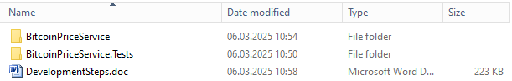
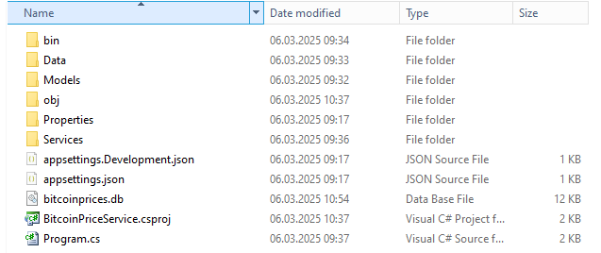
Required references
dotnet add package Microsoft.AspNetCore.Diagnostics.HealthChecks
dotnet add package Microsoft.EntityFrameworkCore
dotnet add package Microsoft.EntityFrameworkCore.Sqlite
dotnet add package Microsoft.Extensions.Caching.Memory
dotnet add package Swashbuckle.AspNetCore
dotnet add package System.Text.Json
dotnet add package RestSharp
Added models
Added services
Added db context
Sample calls
Valid response
http://localhost:5046/api/price/2020-03-02T00:00:00Z
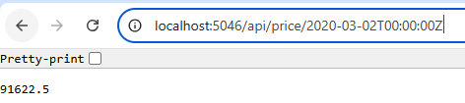
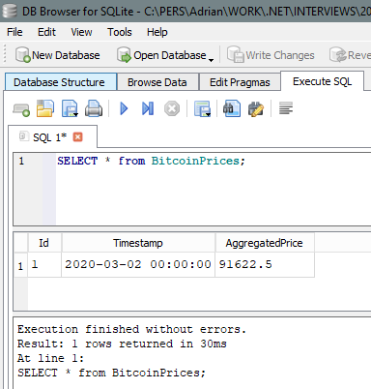
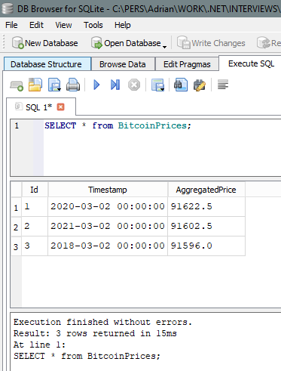

Invalid response
http://localhost:5046/api/price/2021-03-05T12:00:00Z
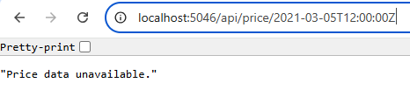
db browser for Sqlite
https://sqlitebrowser.org/dl/
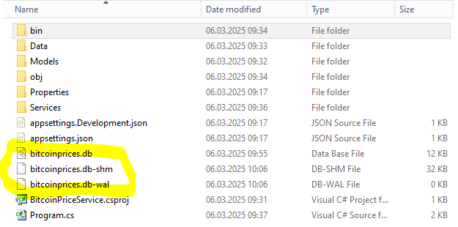
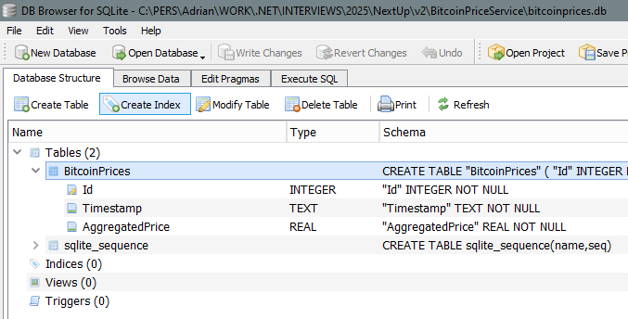
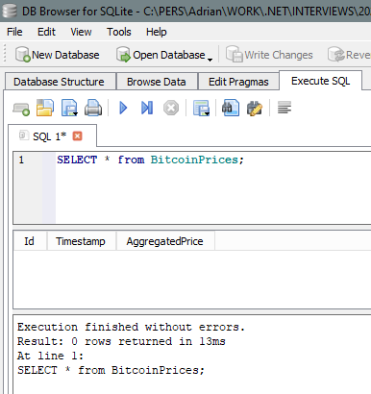

Time storage (hourly format)
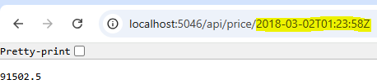
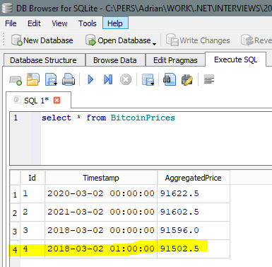

Text file logging
dotnet add package Serilog
dotnet add package Serilog.AspNetCore
dotnet add package Serilog.Sinks.File
Sample call to check the logs
http://localhost:5046/api/price/2018-03-02T01:23:58Z
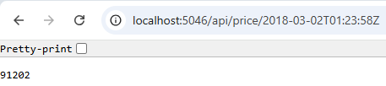
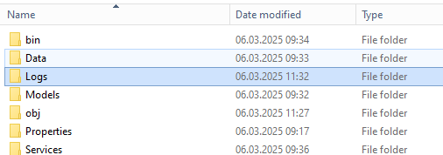
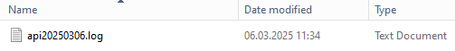
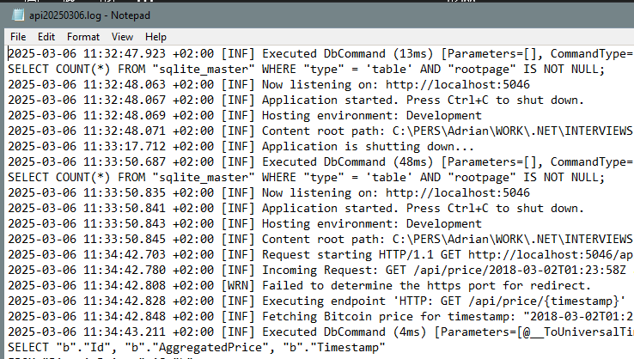

Unit tests
Created a Test project with xUnit
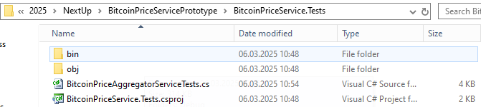
dotnet add package xunit
dotnet add package Moq
dotnet add package Microsoft.EntityFrameworkCore.InMemory
dotnet add package Newtonsoft.Json
dotnet add package Microsoft.TestPlatform.CommunicationUtilities

Test summary
Test summary: total: 3; failed: 0; succeeded: 3; skipped: 0; duration: 5.0s
Build succeeded with 3 warning(s) in 16.7s

Swagger documentation
http://localhost:5046/api/price/2018-03-02T01:23:58Z
http://localhost:5046/swagger/index.html
dotnet add package Swashbuckle.AspNetCore
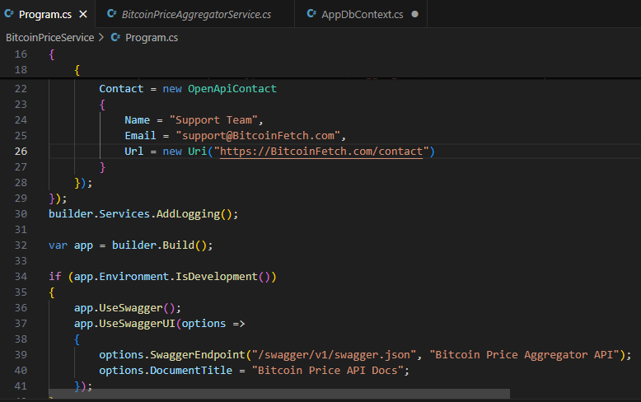
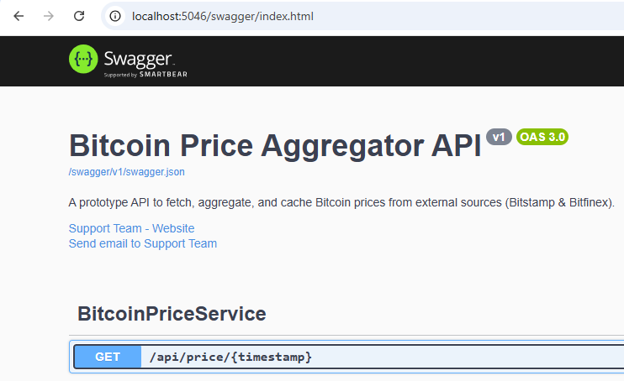
Publish to GitHub
https://github.com/adrianmihailescu/BitcoinPriceServicePrototype

