Contents

Documentation & Submission 1

Provide the hosted link and repository URL 1

Deploy to Vercel 2

Used software 2

Project Setup 3

Create basic react app 3

Test react basic app 3

Project structure 4

Desired functionality 4

Implement the GroupNode Component 4

Enable Node Grouping 5

Implement Dragging for Nodes and Groups 5

Enable Node Connectivity 5

Support Dynamic Node Addition 5

Testing & Validation 5

Installed dependencies 5

Unit tests for useFlowState.ts 5

Functionalities 5

Initial state 6

Added nodes and groups 7

Add new node 8

Connect nodes 11

Drag nodes 12

Add groups 13

Deployed the Application 13

# Documentation & Submission

Provide the hosted link and repository URL

<https://github.com/adrianmihailescu/ReactFlowDynamicNodes.git>

Deploy to Vercel  
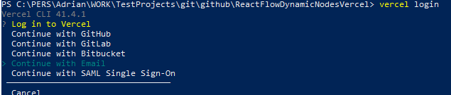

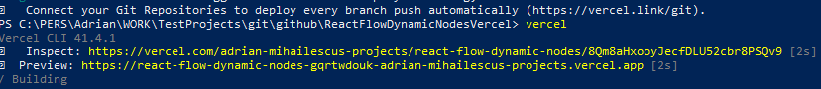

<https://react-flow-dynamic-nodes-gqrtwdouk-adrian-mihailescus-projects.vercel.app>

Before running the solution, perform a:

del package-lock.json  
npm install  
to install the required dependencies

# Used software

VS Code 2022

.net framework



node .js



npm



React v19

npm list react

**Expected Outcome:** A ReactFlow-based application with a functional GroupNode component that supports grouping, dragging, dynamic node addition, and connectivity between nodes, deployed on a hosting platform.

# Project Setup

* Initialize a new React project using Create React App.
* Install dependencies:

npm install reactflow

## Create basic react app

npx create-react-app reactflowgraphcomponent

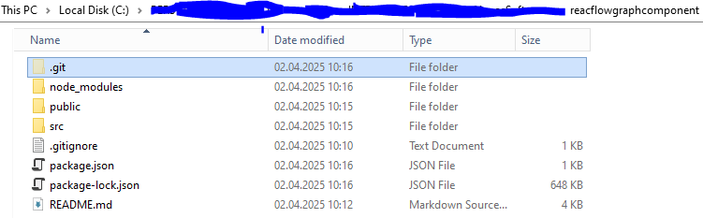Install additional packages

npm install reactflow

**Fix potential warnings**

rmdir /s /q node_modules

del package-lock.json

npm cache clean --force

npm install

## Test react basic app

npm start

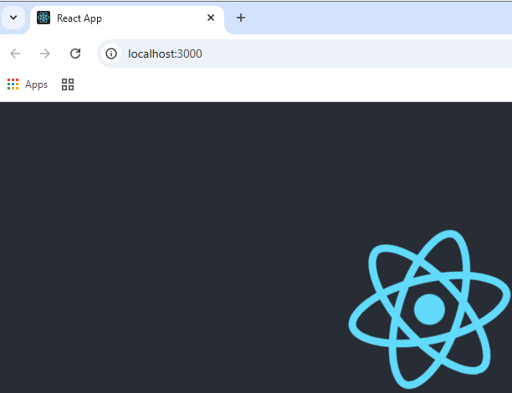

# Project structure

* Configure the project structure:
* /src
  + /components
  + /hooks
  + /interfaces
* App.tsx

# Desired functionality

## Implement the GroupNode Component

* Create GroupNode.tsx that:
  + Allows grouping multiple nodes.
  + Displays a bounding box around the contained nodes.
  + Enables resizing and positioning.
  + Handles state management for contained nodes.

## Enable Node Grouping

* Implement functionality to:
  + Drag and drop nodes into a GroupNode.
  + Identify a node’s parent group.
  + Manage nested nodes within a group.

## Implement Dragging for Nodes and Groups

* Ensure individual nodes are draggable.
* Allow dragging the entire GroupNode along with its contained nodes.

## Enable Node Connectivity

* Implement edge connections between nodes using ReactFlow’s connection feature.
* Ensure edges update dynamically when nodes are moved or grouped.

## Support Dynamic Node Addition

* Implement UI to add new nodes dynamically.
* Allow inserting a node between two connected nodes inside or outside a group.

# Testing & Validation

## Installed dependencies

npm install @testing-library/react-hooks

npm install --save-dev @types/jest

## Unit tests for useFlowState.ts

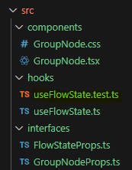

# Functionalities

* + Grouping and ungrouping nodes.
  + Dragging nodes and groups.
  + Connecting nodes and updating edges.
  + Adding nodes dynamically.
* Fix any UI/UX or functionality issues.

Initial state  
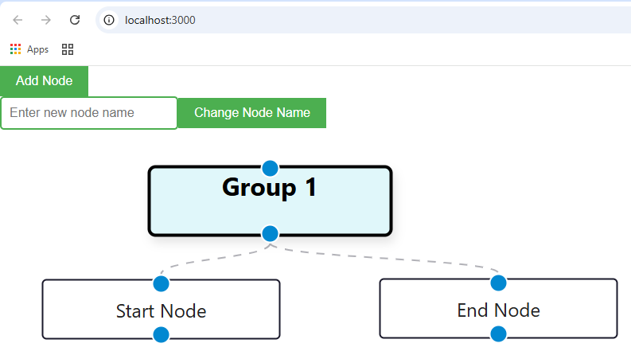

## Added nodes and groups

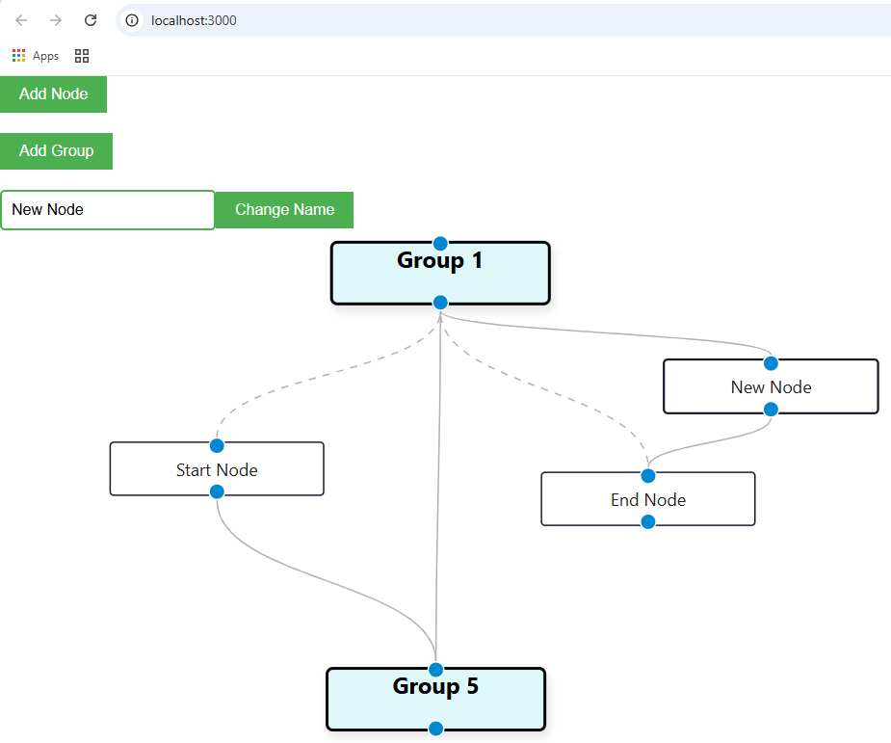

Add new node  
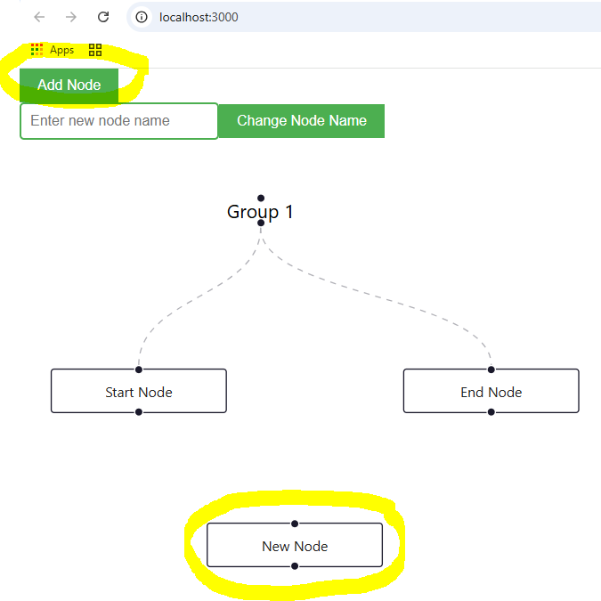  
Change node name

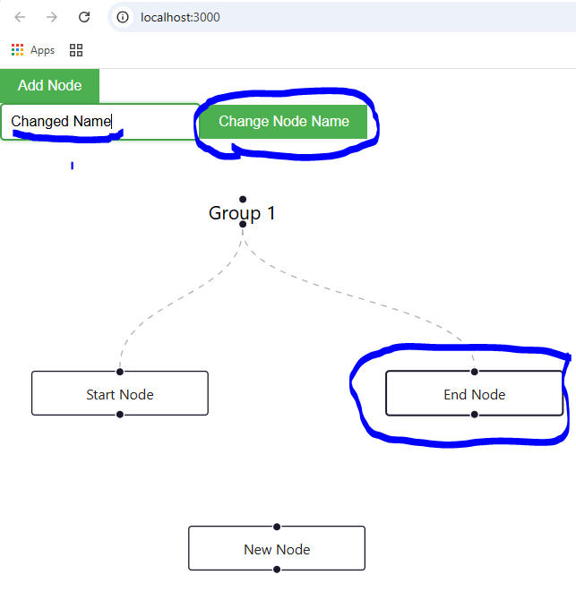

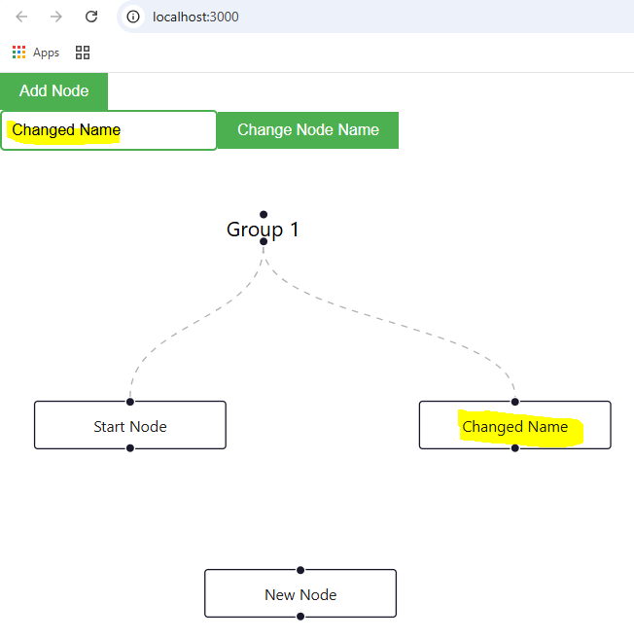

Connect nodes  
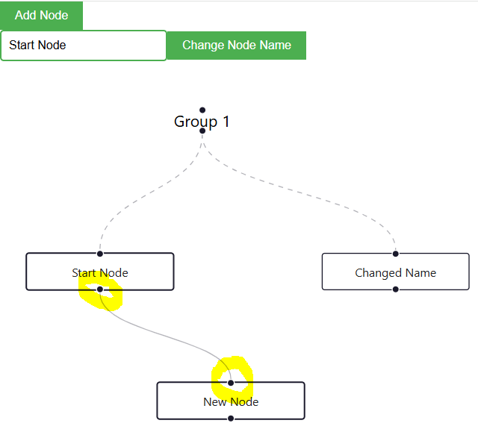

Drag nodes  
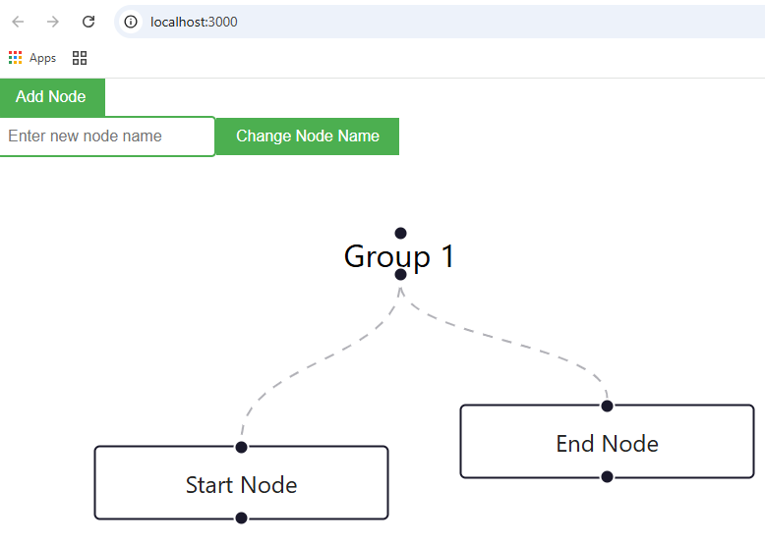

## Add groups

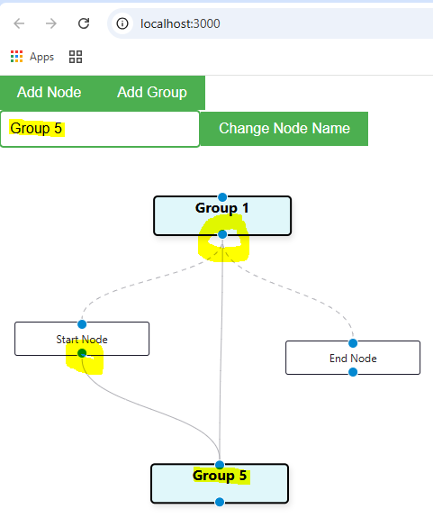

# Deployed the Application

* Deploy using an available platform for hosting
* Generate a live link for testing.