Backend

MongoDb

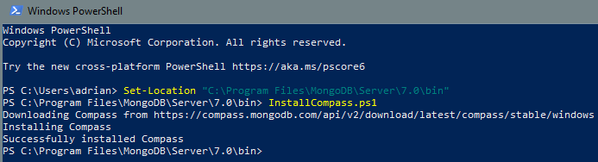

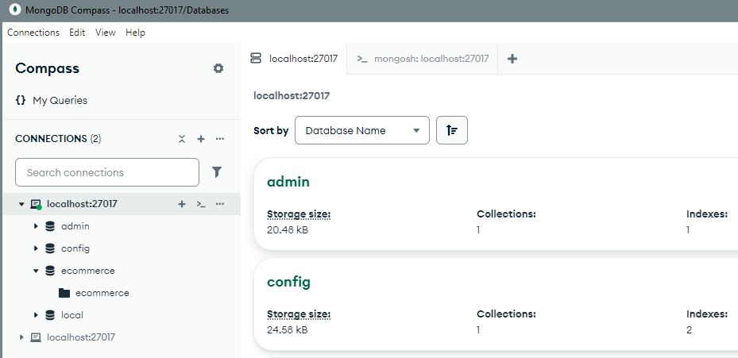

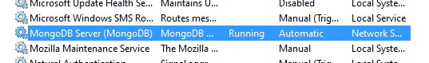

npm run dev

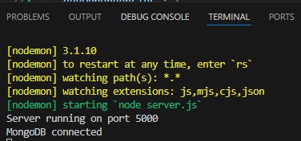

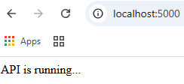

Paypal account

https://developer.paypal.com/dashboard/applications/sandbox

Afv6GxR1eTt5B1xU7HXVETLlhJUbiRFRypHDCyD2oy9rdk931ePbcy32cMfSCc8S9bEu6I9grHpO9zc7

Frontend

|  |  |
| --- | --- |
| **Purpose** | **Library** |
| UI | React.js (with hooks) |
| State Management | Redux Toolkit |
| Routing | React Router DOM |
| HTTP Client | Axios |
| Styling | Basic CSS |

Product cards  
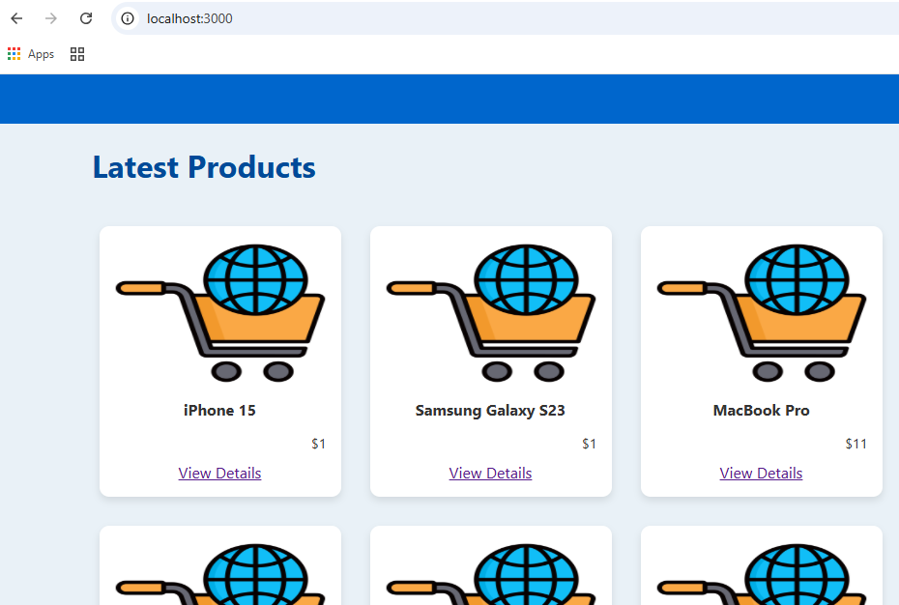

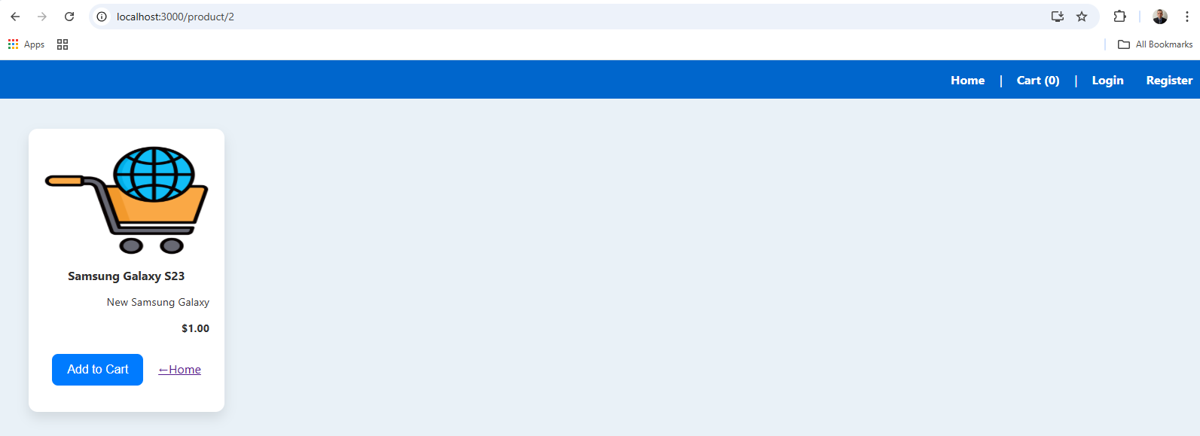

Checkout

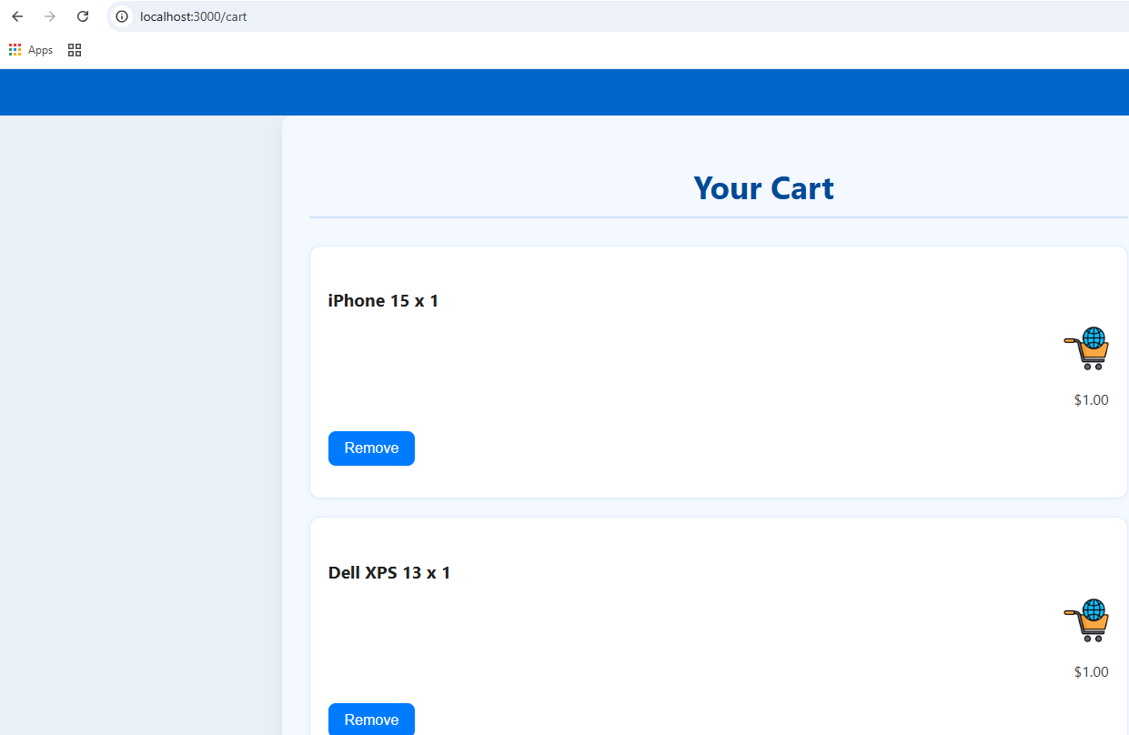

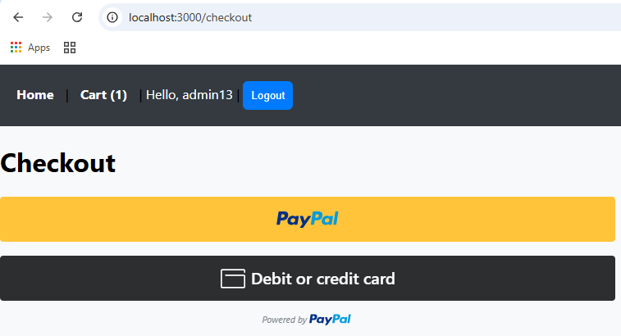

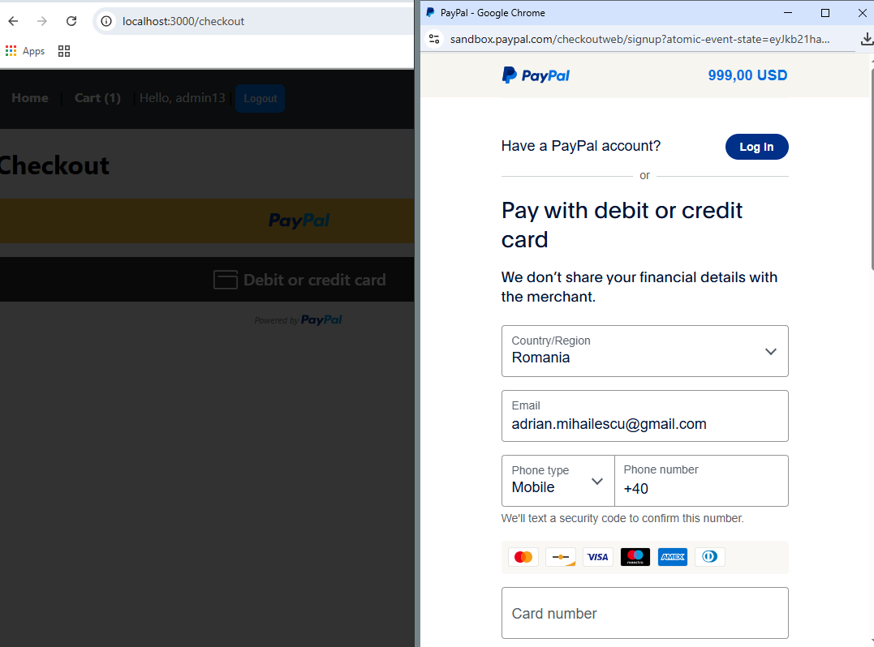

**Visa Test Card (Sandbox Only)**

* **Card number:** 4111 1111 1111 1111
* **Expiration date:** Any future date (e.g., 12/2027)
* **CVV:** 123
* **Name:** Any name (e.g., Test User)
* **Billing address:** Any valid address (can be fake)

**Name**: John Doe

**Address**:  
1234 Oak Street  
Springfield, IL 62704  
United States

**Phone Number**:  
+1 (555) 555-5555 (or any other dummy phone number in the format of (555) xxx-xxxx)

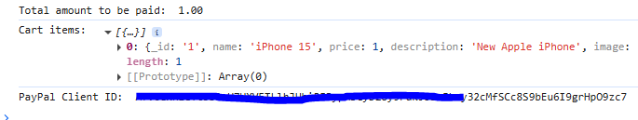

Saved products  
