Contents
Install steps 1
Part 1 2
1.a infinite loop bug 2
1.b key prop warning 2
1.c show content as well 3
1.d add status sorting 5
1.e add status update functionality 6
1.f Add date sorting 7
Part 2 9

Install steps
npm install
PS C:\PERS\Adrian\WORK\TestProjects\git\github\TheLotter_AdrianMihailescu> npm install
npm error Conflicting peer dependency: react@16.14.0
npm error node_modules/react
npm error peer react@"^15.3.0 || ^16.0.0" from material-ui-icons@1.0.0-beta.36
npm error node_modules/material-ui-icons
npm error material-ui-icons@"^1.0.0-beta.36" from the root project
Fixed
npm uninstall material-ui-icons
npm install
npm run dev failed. Runned:
npm install concurrently –save-dev
npm install react-scripts –save
changed target to .net8
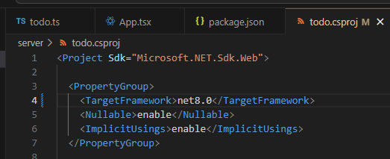
Fixes

Part 1

1.a infinite loop bug
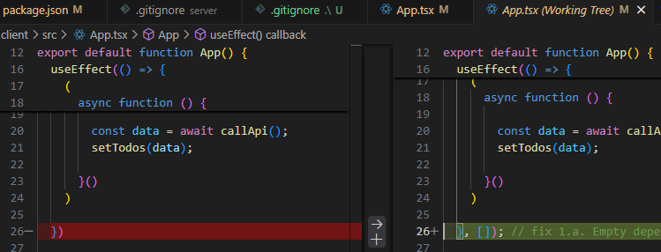
- useEffect with an empty dependency array ([]) will only run once when the component mounts, instead of re-running on every render.
- Without the dependency array, the effect runs on every render, causing an infinite loop because setTodos triggers a re-render, which calls the effect again.
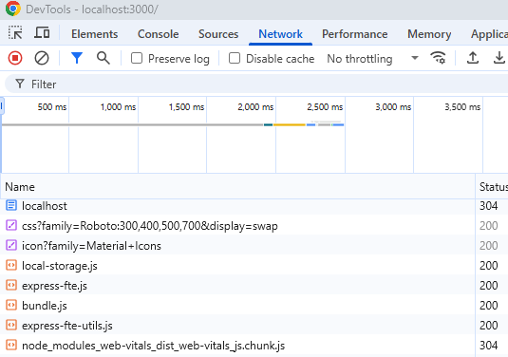

1.b key prop warning
Added a key to each grid item.
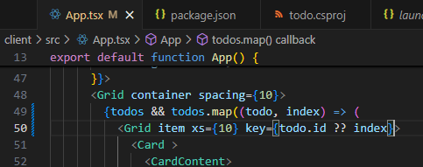
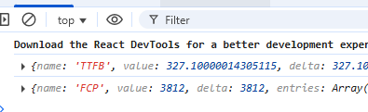

1.c show content as well
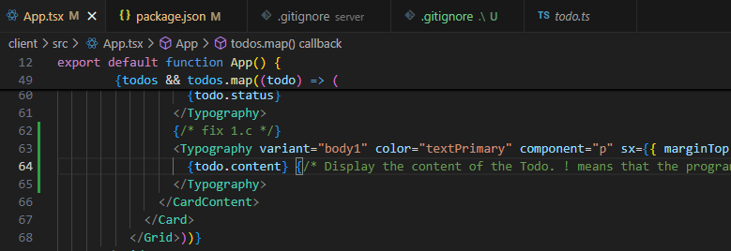
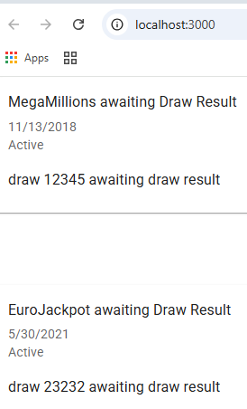
Taken from
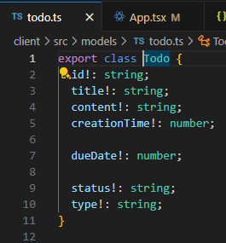

1.d add status sorting
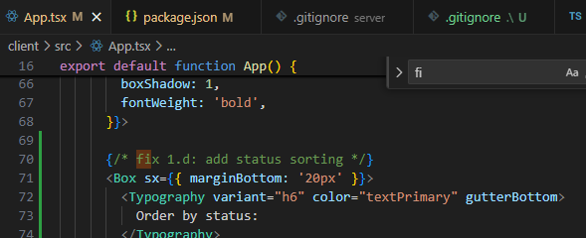

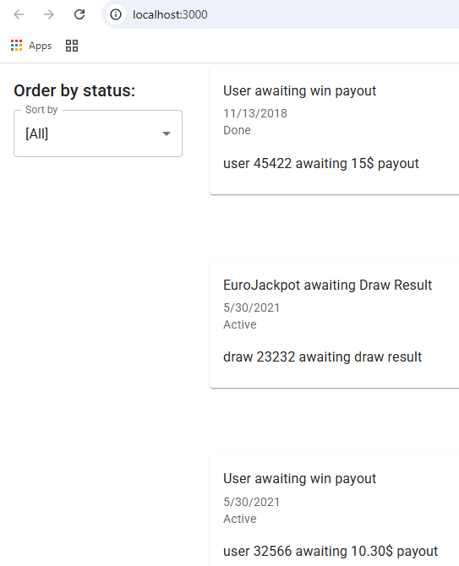

1.e add status update functionality
Add a "Mark as Done" button for TODOs that are still "Active".
Create a handleStatusUpdate function to call the API and update status.
Re-fetch or locally update the todos state to reflect the change and re-sort.
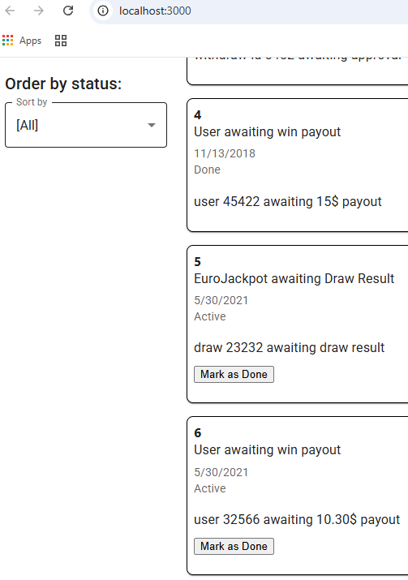

1.f Add date sorting
• Add a "Sort by date" button.
Toggle between ascending and descending order.
Reflect the sort in the list of TODOs.
Before
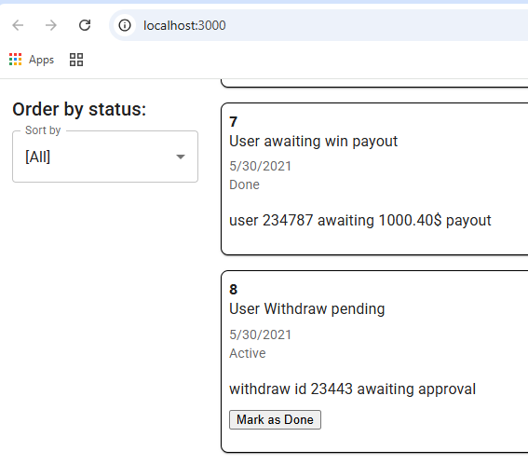
After
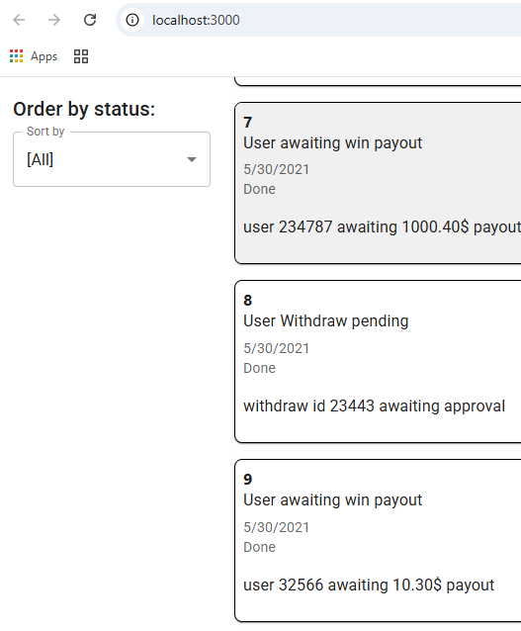

Part 2

2.a. Pagination
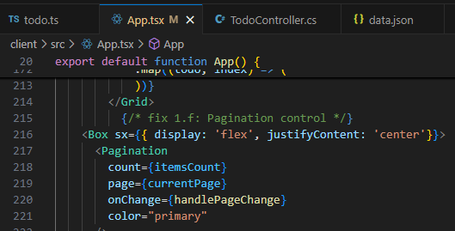

2.c Type filter
Backend changes
Frontend changes
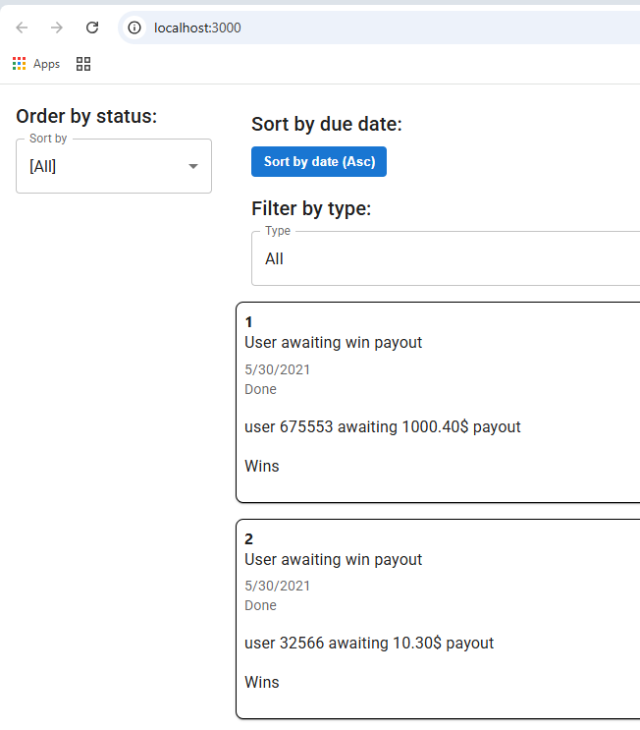
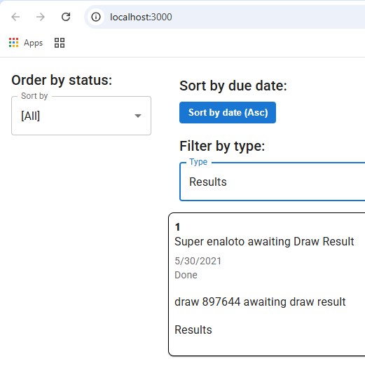

2.d Local storage
