Contents
Setup 1
Back-end (.net web api) 1
Entity Framework 1
Initial migration 2
Sqlite 3
Validations (Back-end) 3
Unit tests (Back-end) 3
Front-end (React .js) 4
Vite 4
Axios 4
Certificates 4
Main screen 6
Login page 6
Register page 7
Drag & drop 8
Persist task order in a storage 9
Validations (Front-end) 9
Unit tests (Front-end) 10

Setup
Vs code 2026
https://github.com/adrianmihailescu/WebApoi_React_Sql.git
.net Framework 10

Back-end (.net web api)
- dotnet new webapi -n TaskManager.Api

Entity Framework
- dotnet add package Microsoft.EntityFrameworkCore.Sqlite
- dotnet add package Microsoft.EntityFrameworkCore.Tools
dotnet tool install --global dotnet-ef You can invoke the tool using the following command: dotnet-ef Tool 'dotnet-ef' (version '10.0.2') was successfully installed.
dotnet ef --version
Entity Framework Core .NET Command-line Tools
10.0.2

Initial migration
dotnet ef migrations add InitialCreate
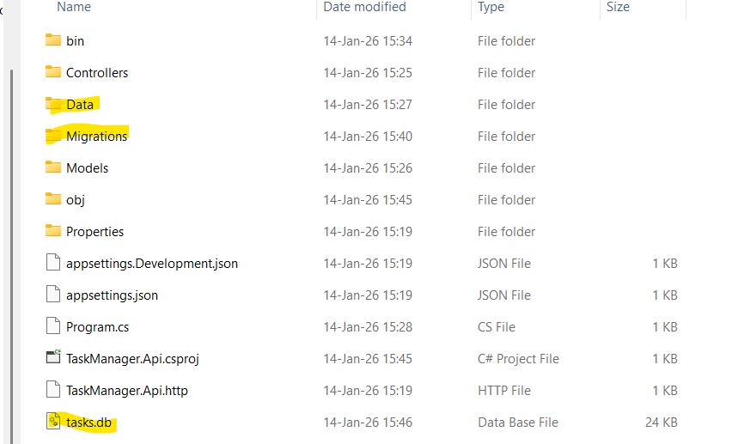

Sqlite
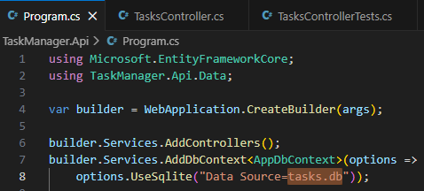
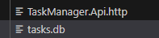

Validations (Back-end)
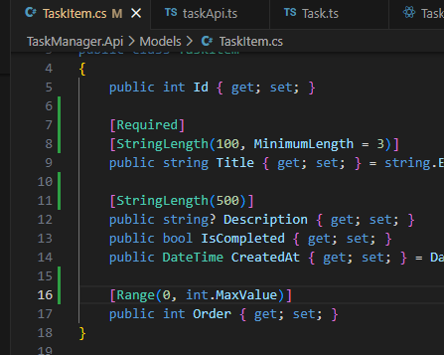

Unit tests (Back-end)
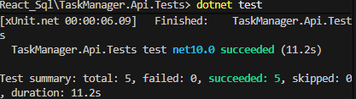

Front-end (React .js)

Vite
- npm create vite@latest task-manager-ui -- --template react-ts

Axios
- npm install axios

Certificates
- dotnet dev-certs https --clean
- dotnet dev-certs https –trust
Swagger
- dotnet add package Swashbuckle.AspNetCore
http://localhost:5020/swagger/index.html
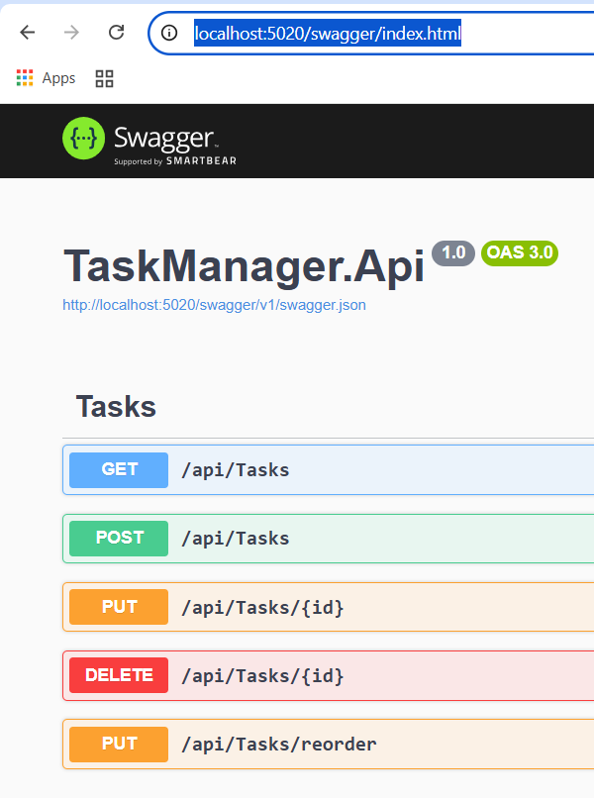

Main screen
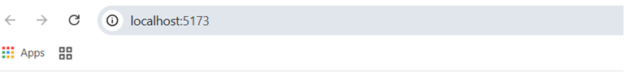
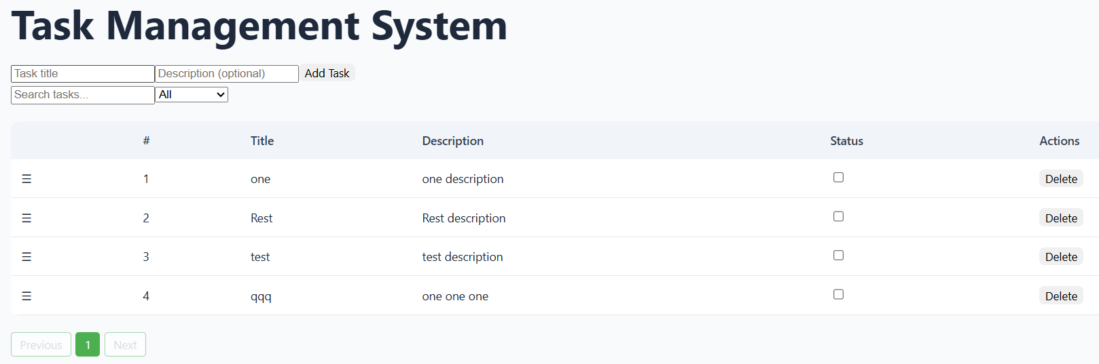

Login page
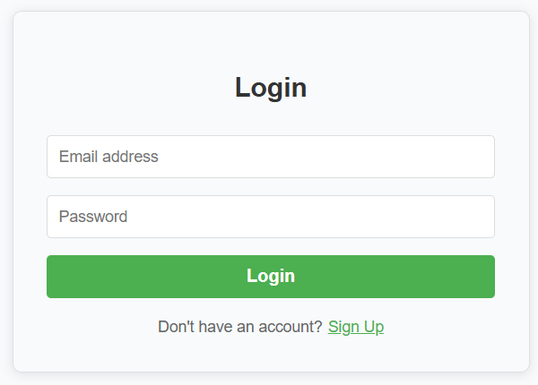

Register page
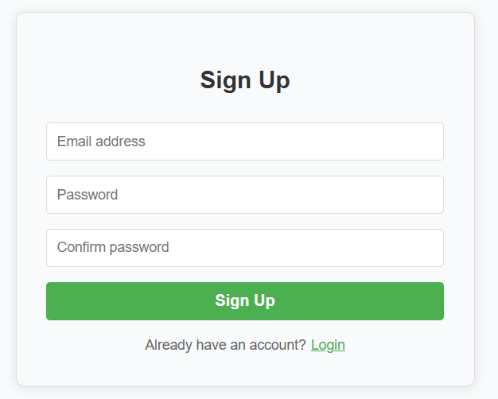

Drag & drop
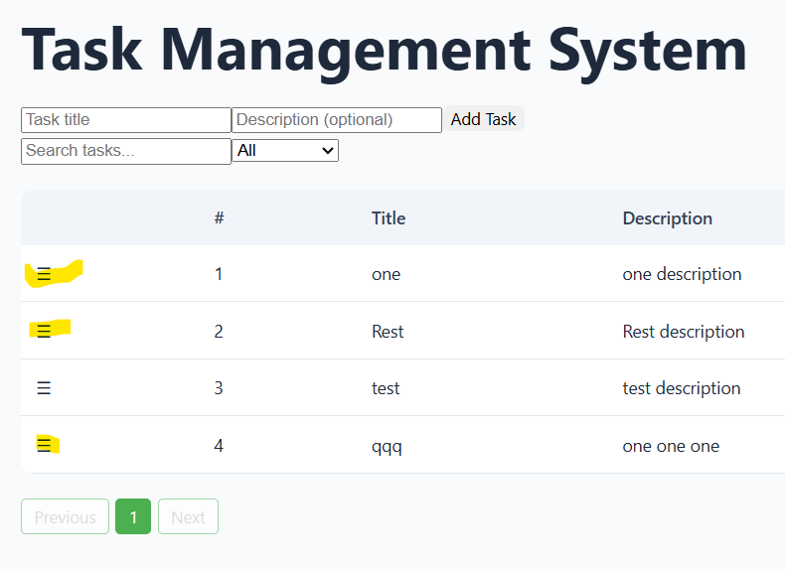

Persist task order in a storage
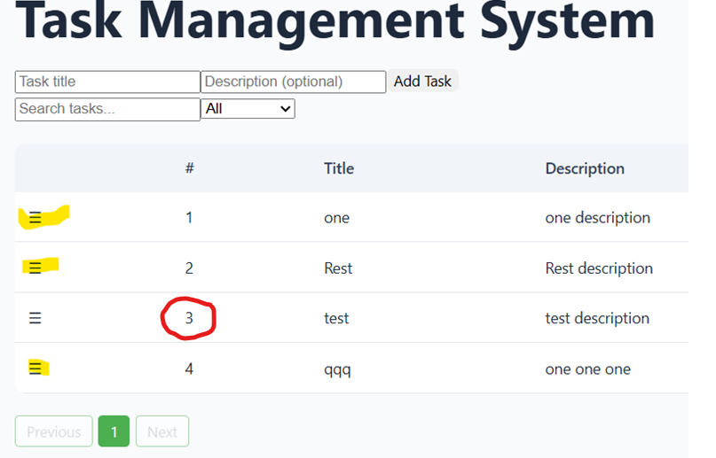

Validations (Front-end)
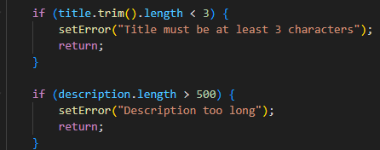
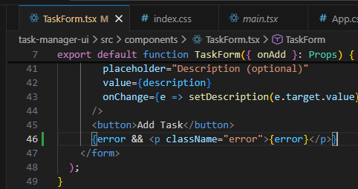
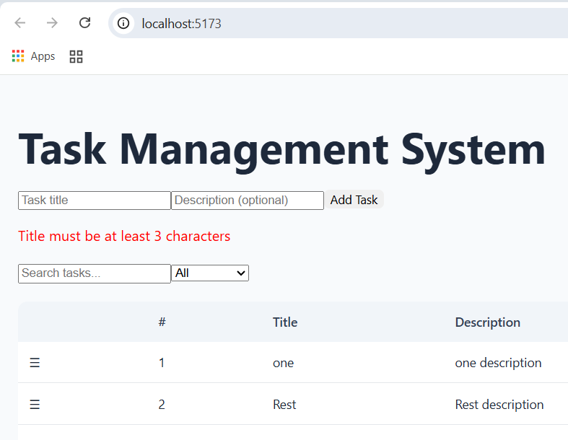

Unit tests (Front-end)
Playwright
npm install -D @playwright/test
