Rolling Lights

Custom Project Final Report

Winter 2018

Adrian Tran

Table of Contents

**Introduction** **2**

[**Hardware**](https://docs.google.com/document/d/1NvPVm5a7Isv4_d26X6CvUHIxGvPaGoooEj0PC1eMaFs/edit#heading=h.vqmbsuo5p330)[**2**](https://docs.google.com/document/d/1NvPVm5a7Isv4_d26X6CvUHIxGvPaGoooEj0PC1eMaFs/edit#heading=h.vqmbsuo5p330)

[Parts List](https://docs.google.com/document/d/1NvPVm5a7Isv4_d26X6CvUHIxGvPaGoooEj0PC1eMaFs/edit#heading=h.xtqh2tzibtrr) [2](https://docs.google.com/document/d/1NvPVm5a7Isv4_d26X6CvUHIxGvPaGoooEj0PC1eMaFs/edit#heading=h.xtqh2tzibtrr)

[Pinout](https://docs.google.com/document/d/1NvPVm5a7Isv4_d26X6CvUHIxGvPaGoooEj0PC1eMaFs/edit#heading=h.8yptvhjzojq8) [3](https://docs.google.com/document/d/1NvPVm5a7Isv4_d26X6CvUHIxGvPaGoooEj0PC1eMaFs/edit#heading=h.8yptvhjzojq8)

[**Software**](https://docs.google.com/document/d/1NvPVm5a7Isv4_d26X6CvUHIxGvPaGoooEj0PC1eMaFs/edit#heading=h.w9543qe124on) **4**

**User Guide 5**

[**Complexities**](https://docs.google.com/document/d/1NvPVm5a7Isv4_d26X6CvUHIxGvPaGoooEj0PC1eMaFs/edit#heading=h.sn48u4uktu3c) **5**

[**Youtube Link**](https://docs.google.com/document/d/1NvPVm5a7Isv4_d26X6CvUHIxGvPaGoooEj0PC1eMaFs/edit#heading=h.u9cxbem9510r) **6**

[**Known Bugs and Shortcomings**](https://docs.google.com/document/d/1NvPVm5a7Isv4_d26X6CvUHIxGvPaGoooEj0PC1eMaFs/edit#heading=h.grlzpb6vy2cq) **6**

[**Future work**](https://docs.google.com/document/d/1NvPVm5a7Isv4_d26X6CvUHIxGvPaGoooEj0PC1eMaFs/edit#heading=h.qbv6f31drpex) **6**

# 

# Introduction

My game uses three buttons as input for the game, which is displayed on an 8x8 LED matrix. There are two possible levels of increasing difficulty that the user can choose to start from. Once the user selects a level the LED matrix displays one LED that the user needs to stop on. Then, the LEDs light up in a trail of varying patterns. One button stops the trail of LEDs. If the user stops the trail on the correct LED, a congratulatory message is displayed. Otherwise, a death message is displayed. Also, one of the buttons can be used to reset the level. The other button can be used to change the level being played. If the user stops the trail of LEDs too early or too late, the time the user was too early or too late by is displayed on a LCD.



## Parts List

The hardware that was used in this design is listed below. The equipment that was not taught in this course has been bolded.

* ATMega1284p microcontroller
* **8x8 LED Matrix**
* Buttons (3)
* LCD Screen

## Pinout

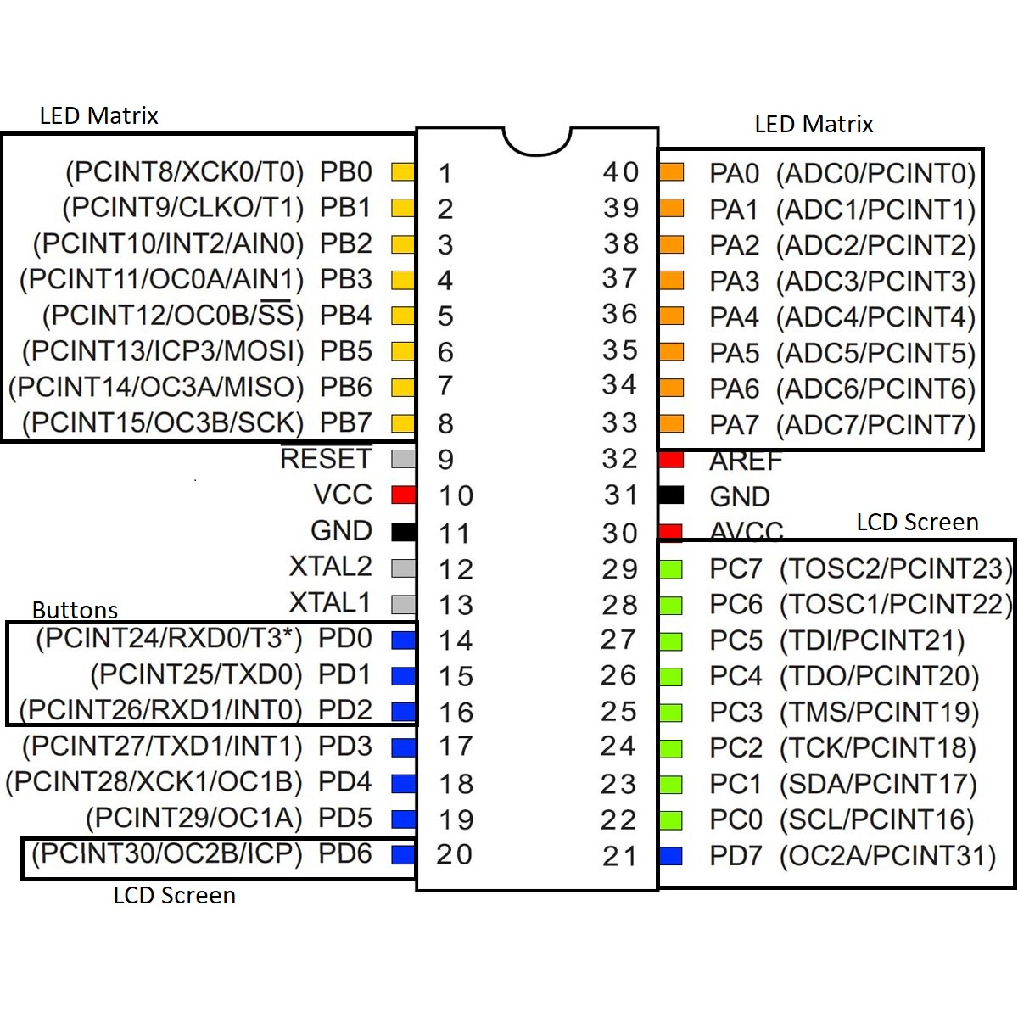

# 

# 

# Software

The following is an image of the state machines I followed to design the project.



# 

# 

# 

# User Guide

Initialization:

D0 Button: Increase level

D1 Button: Decrease level

D2 Button: Select level

Level selected:

D0 Button: Stop LED trail

D1 Button: Reset Level

D2 Button: Change level (after D0 pressed)

# Complexities

## Completed Complexities:

* Integrating and calibrating the 8x8 LED Matrix
* Using buttons as input for the LED Matrix
* Displaying time (early / late) on the LCD Screen
* Implementing rand() into the LED Matrix levels

## Incomplete complexities:

* Second microcontroller for two player mode

# 

# Youtube Link

https://youtu.be/yyFAv6wyrdE

# Known Bugs and Shortcomings

* The victory and death messages, which is an exclamation point and a skull displayed on the LED Matrix, respectively, do not display correctly. However, I added this feature mostly for fun. To check if the user wins or loses, I just displayed LEDs in differing locations in the end. I believe that this is due to a logic error in my code.
* If the user completes a level (wins or loses) and eventually changes the level, the LED that the user stopped on will be displayed for one timer period. I believe that this is due to incorrect state machine transitions in my code.
* There is no transition upon victory to the second level if the user completes the first level. In addition, there is no transition from the second level to an end display if the user completes the second level.

# Future work

If I were to continue the project, I would add an additional level and experiment with continually decrementing timer periods. In addition, I would experiment with the trail of LEDs moving in different, unique patterns. Finally, I would finish implementing the victory and death screens and complete an end screen if the user completes all three levels.