- Não tem escalabilidade

Tipo de instância
i4i.2xlarge.search
Número de nós de dados
12

Número de nós principais
Ativado
Sim
Tipo de instância
m7i.large.search
Número de nós principais
3

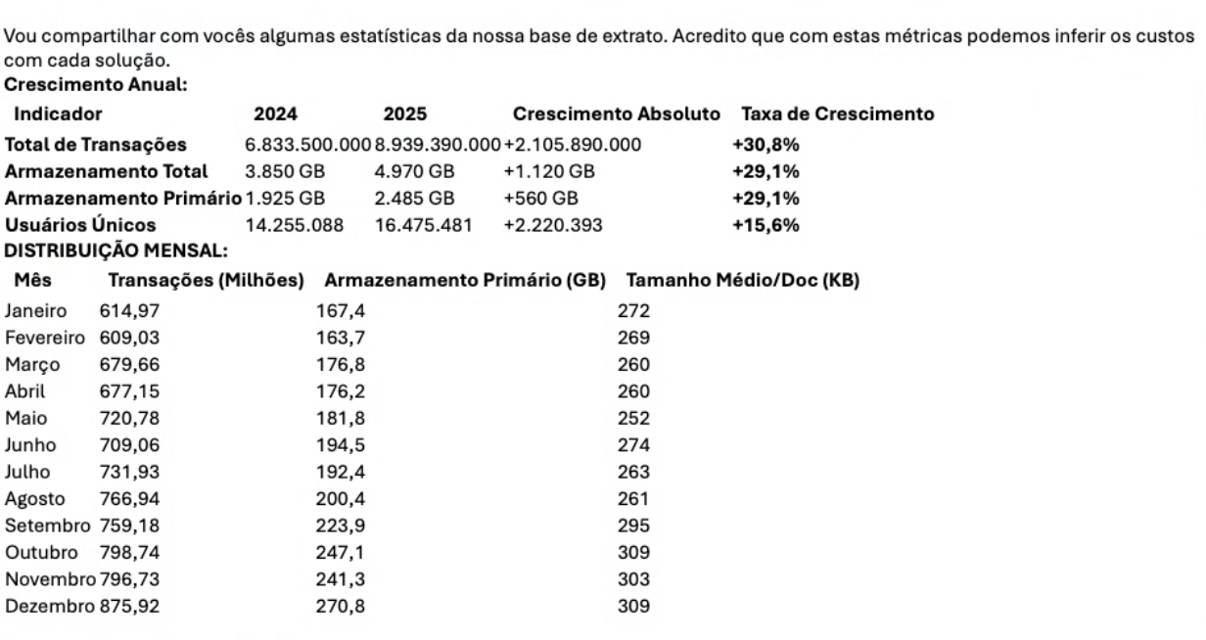

Custo:

8 mil dolares por mes

Estrutura do Json:
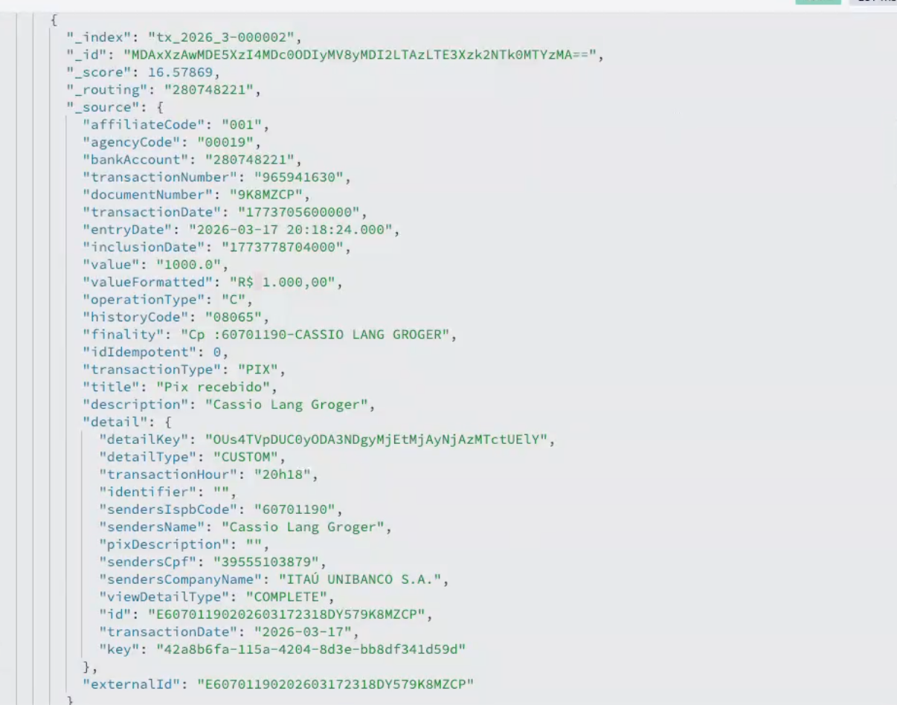

Quando eu coloco categoria eu faço:

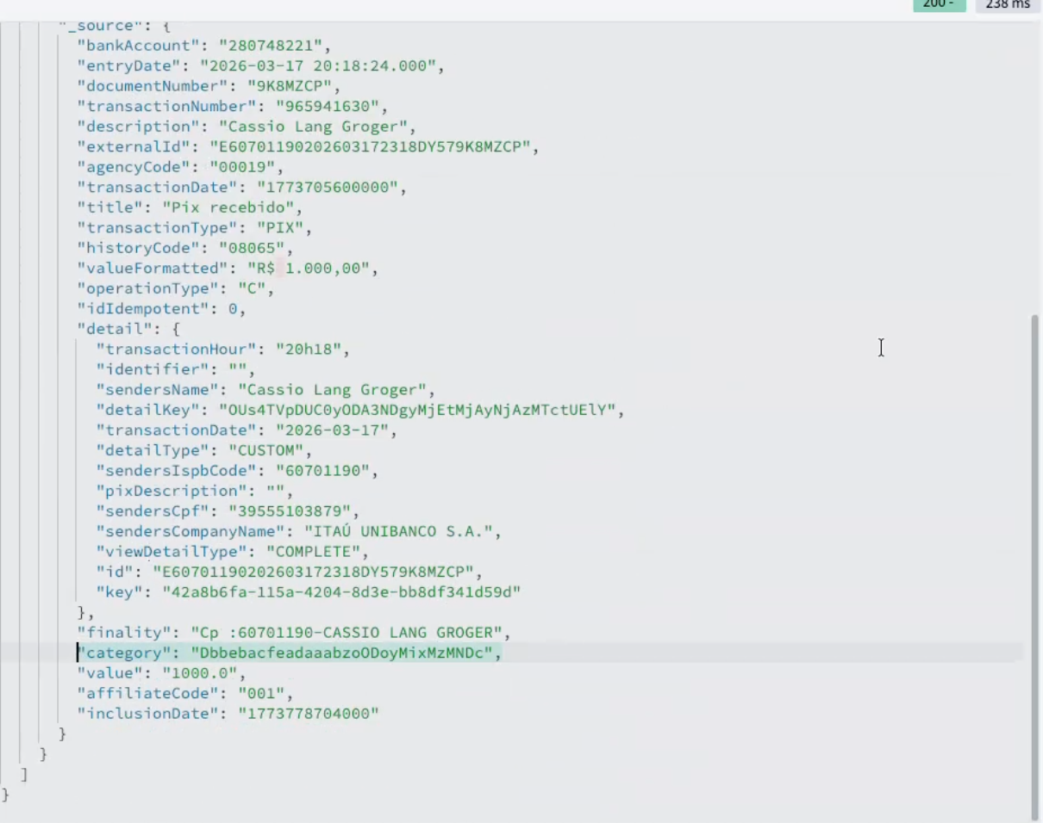

Ele já fizeram melhoras na indexacao em FInOps, eles tiraram indices.

Estrutura do Indice:

{
"tx_2026_1-000001": {
"mappings": {
"dynamic": "false",
"_routing": {
"required": true
},
"properties": {
"accountType": {
"type": "object",
"enabled": false
},
"affiliateCode": {
"type": "object",
"enabled": false
},
"agencyCode": {
"type": "object",
"enabled": false
},
"bankAccount": {
"type": "keyword",
"meta": {
"routing": "true"
}
},
"category": {
"type": "keyword",
"ignore_above": 100
},
"description": {
"type": "text",
"index": false,
"copy_to": [
"search_content"
]
},
"detail": {
"properties": {
"added": {
"type": "object",
"enabled": false
},
"affiliateCode": {
"type": "object",
"enabled": false
},
"affiliated": {
"type": "object",
"enabled": false
},
"agency": {
"type": "object",
"enabled": false
},
"agencyCode": {
"type": "object",
"enabled": false
},
"agencySent": {
"type": "object",
"enabled": false
},
"agreementCompanyCode": {
"type": "object",
"enabled": false
},
"agreementSegment": {
"type": "object",
"enabled": false
},
"agreementType": {
"type": "object",
"enabled": false
},
"assesmentPeriod": {
"type": "object",
"enabled": false
},
"assessmentPeriod": {
"type": "object",
"enabled": false
},
"authentication": {
"type": "object",
"enabled": false
},
"automatic": {
"type": "object",
"enabled": false
},
"bankAccount": {
"type": "object",
"enabled": false
},
"bankAccountSent": {
"type": "object",
"enabled": false
},
"bankCheckNumber": {
"type": "object",
"enabled": false
},
"barCode": {
"type": "object",
"enabled": false
},
"beneficiaryInstitution": {
"type": "object",
"enabled": false
},
"billetValue": {
"type": "object",
"enabled": false
},
"boletoType": {
"type": "object",
"enabled": false
},
"cashValue": {
"type": "object",
"enabled": false
},
"cashbackValue": {
"type": "object",
"enabled": false
},
"cellCompany": {
"type": "text",
"index": false,
"copy_to": [
"search_content"
]
},
"checkNumber": {
"type": "object",
"enabled": false
},
"cmc7": {
"type": "object",
"enabled": false
},
"comment": {
"type": "text",
"index": false,
"copy_to": [
"search_content"
]
},
"companyName": {
"type": "object",
"enabled": false
},
"companyNameSent": {
"type": "object",
"enabled": false
},
"cpfCnpj": {
"type": "keyword",
"doc_values": false,
"ignore_above": 100
},
"cpfCnpjSent": {
"type": "keyword",
"doc_values": false,
"ignore_above": 100
},
"data": {
"type": "object",
"enabled": false
},
"date": {
"type": "object",
"enabled": false
},
"description": {
"type": "text",
"index": false,
"copy_to": [
"search_content"
]
},
"descriptionBankCheck": {
"type": "text",
"index": false,
"copy_to": [
"search_content"
]
},
"destinyCpfCnpj": {
"type": "keyword",
"doc_values": false,
"ignore_above": 100
},
"destinyName": {
"type": "object",
"enabled": false
},
"detailDescription": {
"type": "text",
"index": false,
"copy_to": [
"search_content"
]
},
"detailKey": {
"type": "keyword",
"doc_values": false,
"ignore_above": 100
},
"detailType": {
"type": "keyword",
"doc_values": false,
"ignore_above": 100
},
"devolutionId": {
"type": "object",
"enabled": false
},
"digitableLine": {
"type": "object",
"enabled": false
},
"discount": {
"type": "object",
"enabled": false
},
"discount1": {
"type": "object",
"enabled": false
},
"discount2": {
"type": "object",
"enabled": false
},
"discount3": {
"type": "object",
"enabled": false
},
"dkNsu": {
"type": "object",
"enabled": false
},
"dkOperationId": {
"type": "object",
"enabled": false
},
"dueDate": {
"type": "object",
"enabled": false
},
"effectiveDate": {
"type": "object",
"enabled": false
},
"endToEnd": {
"type": "object",
"enabled": false
},
"establishment": {
"type": "object",
"enabled": false
},
"fine": {
"type": "object",
"enabled": false
},
"forumNickname": {
"type": "text",
"index": false,
"copy_to": [
"search_content"
]
},
"fullNumber": {
"type": "text",
"index": false,
"copy_to": [
"search_content"
]
},
"holderCpfCnpj": {
"type": "object",
"enabled": false
},
"holderName": {
"type": "object",
"enabled": false
},
"hour": {
"type": "object",
"enabled": false
},
"id": {
"type": "keyword",
"doc_values": false,
"ignore_above": 100
},
"identifier": {
"type": "keyword",
"doc_values": false,
"ignore_above": 100
},
"increasedValue": {
"type": "object",
"enabled": false
},
"initiatingInstitution": {
"type": "object",
"enabled": false
},
"interest": {
"type": "object",
"enabled": false
},
"issueDate": {
"type": "object",
"enabled": false
},
"issuerCompanyName": {
"type": "object",
"enabled": false
},
"itauAuthenticationCode": {
"type": "object",
"enabled": false
},
"itauDocumentNumber": {
"type": "object",
"enabled": false
},
"itauPaymentCode": {
"type": "object",
"enabled": false
},
"key": {
"type": "object",
"enabled": false
},
"limitDate": {
"type": "object",
"enabled": false
},
"liquidation": {
"type": "object",
"enabled": false
},
"mcc": {
"type": "keyword",
"doc_values": false,
"ignore_above": 100
},
"movementOrigin": {
"type": "object",
"enabled": false
},
"name": {
"type": "text",
"index": false,
"copy_to": [
"search_content"
]
},
"nameSent": {
"type": "object",
"enabled": false
},
"operationDate": {
"type": "object",
"enabled": false
},
"operationHour": {
"type": "object",
"enabled": false
},
"operationType": {
"type": "object",
"enabled": false
},
"orders": {
"type": "object",
"enabled": false
},
"originalTransactionId": {
"type": "object",
"enabled": false
},
"originalValue": {
"type": "object",
"enabled": false
},
"ourNumber": {
"type": "object",
"enabled": false
},
"paidVia": {
"type": "object",
"enabled": false
},
"partialValue": {
"type": "object",
"enabled": false
},
"payerSocialId": {
"type": "object",
"enabled": false
},
"paymentDate": {
"type": "object",
"enabled": false
},
"pinCode": {
"type": "object",
"enabled": false
},
"pixDescription": {
"type": "text",
"index": false,
"copy_to": [
"search_content"
]
},
"principalAmount": {
"type": "object",
"enabled": false
},
"product": {
"type": "text",
"index": false,
"copy_to": [
"search_content"
]
},
"productName": {
"type": "keyword",
"doc_values": false,
"ignore_above": 100
},
"purchaseId": {
"type": "object",
"enabled": false
},
"purchaseValue": {
"type": "object",
"enabled": false
},
"purpose": {
"type": "object",
"enabled": false
},
"receivedAccountType": {
"type": "object",
"enabled": false
},
"receivedAgency": {
"type": "object",
"enabled": false
},
"receivedBankAccount": {
"type": "object",
"enabled": false
},
"receivedBankCode": {
"type": "object",
"enabled": false
},
"receivedCompanyName": {
"type": "object",
"enabled": false
},
"receivedCpf": {
"type": "keyword",
"doc_values": false,
"ignore_above": 100
},
"receivedName": {
"type": "keyword",
"doc_values": false,
"ignore_above": 100
},
"recipientAgency": {
"type": "object",
"enabled": false
},
"recipientBankAccount": {
"type": "object",
"enabled": false
},
"recipientBankName": {
"type": "object",
"enabled": false
},
"recipientCpfCnpj": {
"type": "keyword",
"doc_values": false,
"ignore_above": 100
},
"recipientName": {
"type": "object",
"enabled": false
},
"recurrence": {
"type": "object",
"enabled": false
},
"redeemCode": {
"type": "object",
"enabled": false
},
"reduction": {
"type": "object",
"enabled": false
},
"reference": {
"type": "object",
"enabled": false
},
"registrationDate": {
"type": "object",
"enabled": false
},
"registrationTime": {
"type": "object",
"enabled": false
},
"requestDate": {
"type": "object",
"enabled": false
},
"requestNumber": {
"type": "object",
"enabled": false
},
"returnCode": {
"type": "object",
"enabled": false
},
"returnDate": {
"type": "object",
"enabled": false
},
"returnReason": {
"type": "object",
"enabled": false
},
"returns": {
"properties": {
"id": {
"type": "keyword",
"doc_values": false,
"ignore_above": 100
}
}
},
"revenueCode": {
"type": "object",
"enabled": false
},
"sendersCompanyName": {
"type": "object",
"enabled": false
},
"sendersCpf": {
"type": "keyword",
"doc_values": false,
"ignore_above": 100
},
"sendersName": {
"type": "text",
"index": false,
"copy_to": [
"search_content"
]
},
"sourceCompanyName": {
"type": "object",
"enabled": false
},
"sourceCpfCnpj": {
"type": "object",
"enabled": false
},
"sourceName": {
"type": "object",
"enabled": false
},
"tax": {
"type": "object",
"enabled": false
},
"telephone": {
"type": "object",
"enabled": false
},
"terminalId": {
"type": "object",
"enabled": false
},
"totalValue": {
"type": "object",
"enabled": false
},
"transactionCanBeRepeated": {
"type": "object",
"enabled": false
},
"transactionHour": {
"type": "object",
"enabled": false
},
"transactionId": {
"type": "object",
"enabled": false
},
"transactionOrigin": {
"type": "object",
"enabled": false
},
"transferDescription": {
"type": "object",
"enabled": false
},
"vendorControlNumber": {
"type": "object",
"enabled": false
},
"vendorNsu": {
"type": "object",
"enabled": false
},
"viewDetailType": {
"type": "keyword",
"ignore_above": 100
},
"whoPaidCompanyName": {
"type": "object",
"enabled": false
},
"whoPaidCpf": {
"type": "object",
"enabled": false
},
"whoPaidName": {
"type": "object",
"enabled": false
},
"yourNumber": {
"type": "object",
"enabled": false
}
}
},
"documentNumber": {
"type": "keyword",
"doc_values": false,
"ignore_above": 100
},
"entryDate": {
"type": "date",
"format": "yyyy-MM-dd HH:mm:ss.SSS"
},
"externalId": {
"type": "keyword"
},
"finality": {
"type": "object",
"enabled": false
},
"historyCode": {
"type": "keyword",
"ignore_above": 100
},
"idIdempotent": {
"type": "object",
"enabled": false
},
"inclusionDate": {
"type": "object",
"enabled": false
},
"isDeleted": {
"type": "boolean"
},
"operationType": {
"type": "keyword",
"ignore_above": 100
},
"search_content": {
"type": "text",
"index_options": "docs",
"norms": false,
"analyzer": "brazilian"
},
"title": {
"type": "text",
"index": false,
"copy_to": [
"search_content"
]
},
"transactionDate": {
"type": "object",
"enabled": false
},
"transactionNumber": {
"type": "keyword",
"doc_values": false,
"ignore_above": 100
},
"transactionType": {
"type": "keyword",
"ignore_above": 100
},
"value": {
"type": "scaled_float",
"scaling_factor": 100
},
"valueFormatted": {
"type": "text",
"index": false,
"copy_to": [
"search_content"
]
}
}
}
}
}

Tem um desejo de mais facilmente mandar o dado para o datalake.

Esfriar é importante

50%

Iago: Elder esta no time do Zord

