**SAM output format:**

\t-delimited format for alignments,

optional header (denoted by @) + alignment body (11 mandatory fields), one SAM alignment line for one linear alignment

uses 1..n coordinate system

**minimal header, containing @HD and @SN lines:**

\t-delimited TAG:VALUE pairs

@HD: first in file, must contain VN-version tag, should contain @SO XOR @GO tag

SN: subfield of @SQ reference sequence dictionary field, denoting reference sequence name

LN: also required when using @SQ field, denoting reference sequence length

**Alignment section, containing mandatory fields:**

1. QNAME (string): query template name, paired reads have identical QNAMES
2. FLAG (int): bitwise representation of different properties; reverse = 0x10, secondary = 0x100
3. RNAME (string): name of the reference sequence, must be identical to @SQ-SN-header
4. POS (int): 1-based leftmost mapping position of first CIGAR operation, POS=0 if unmapped
5. MAPQ (int): mapping quality, default = 0
6. CIGAR (string): concatenation of different letters, encoding sequence alignment

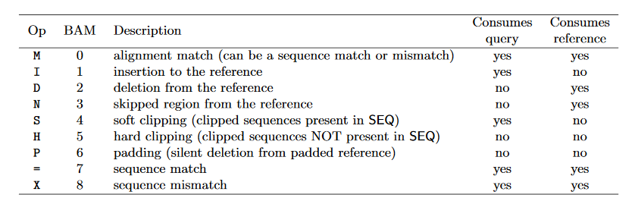

1. RNEXT (string): reference name of next read, default = *
2. PNEXT (string): position of next read, default = 0
3. TLEN (int): observed template length, default = 0
4. SEQ (string): segment sequence, default = *
5. QUAL (string): Phred-alginment quality, default = *