

jOBDER uSER mANUAL



By Adrian Rabbitt

Contents

1. Installation 3

2. Choose Options 4

3. Login. 5

4. Sign Up. 6

5. Employee’s Home Page. 7

6. Employee’s Profile. 8

7. Messages. 9

8. Contacts. 10

9. Files: 11

10. Employee Settings: 12

11. Employers Home : 13

12.Profile : 14

13. Employer Settings: 15

14. Web Application: 17

# **Installation**

At the current moment to hold a current version of the mobile application Jobder, the User must have an android device that has:

* Location
* Internet Access
* Useable Version of Android

The application can be installed on the phone manually via USB from the Android Studio Platform. It is not currently available on the Google Play Store but will be from the 15th of June 2018.

However, the web application is available to any one that is a member of the application and has Internet access.

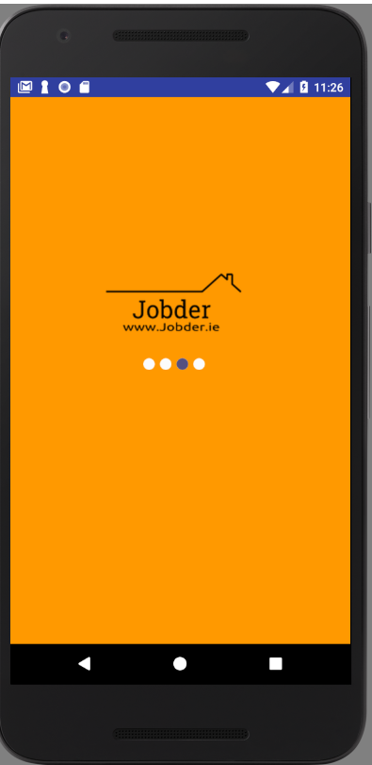

# **Choose Options**

When the Application is installed, the User has the choice between two modes based on their context which are Employer and Employee.

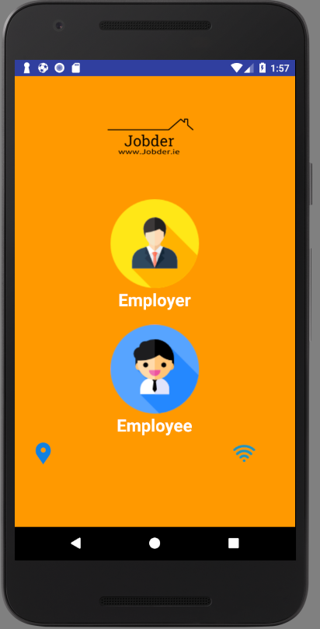

1. **Login**

If the User has signed up, he/ she can login in with their unique credentials. If the User has forgotten their password, they can opt for “Forgot Password” which allows them to enter a valid email where reset password instructions will be sent to the user via email.

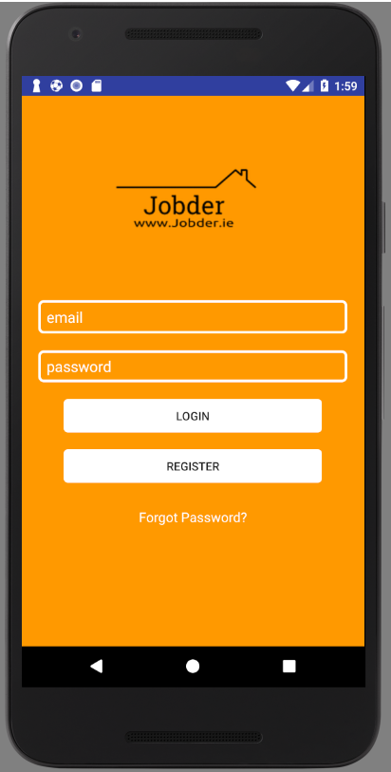 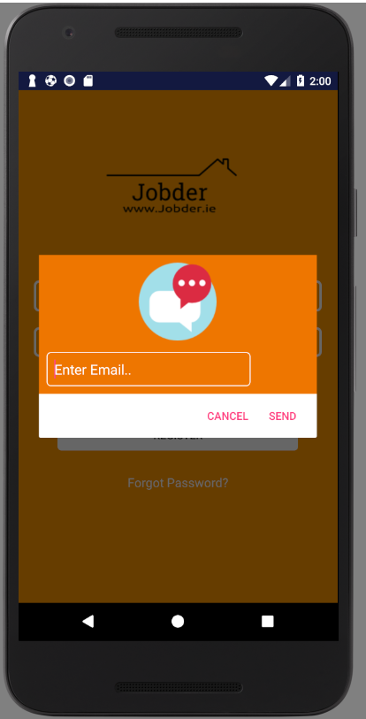

1. **Sign Up**

If the User is new to the Jobder platform, he/ she has the chance to sign up to the application. The user must have a valid email address and create a unique password. The User then must conform that he/she is an Employer or an Employee.

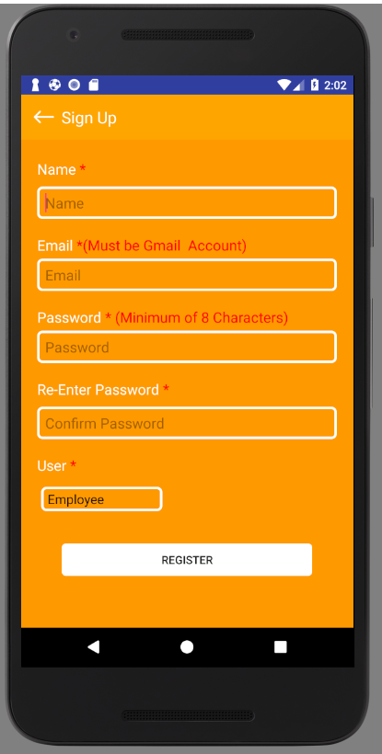

**4) Employee’s Home Page**

The Employee’sHome page consist of four functionalities that theEmployee can choose from which are:

* Profile (Edit/ Create Profile)
* Contacts (View Contacts of Employers)
* Messages (View Conversations with Employers)
* Files (Upload relevant documents/files)

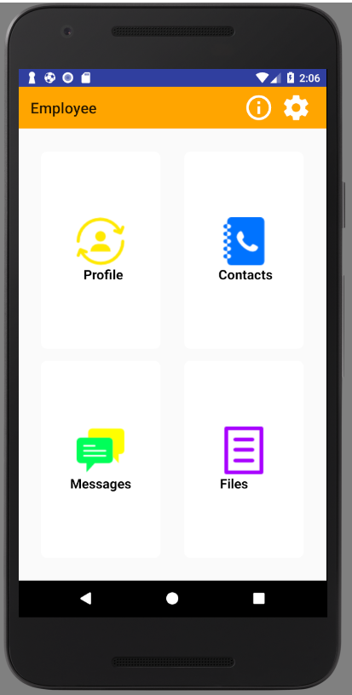 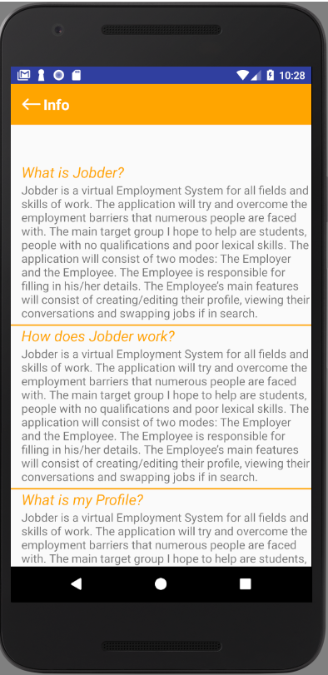

1. **Employees Profile**

The Employees Profile allows them to create/ edit a profile, fill in all mandatory fields e.g. Name, Age, Previous work employment, and skills, allows them to save their Profile according to their location.

,  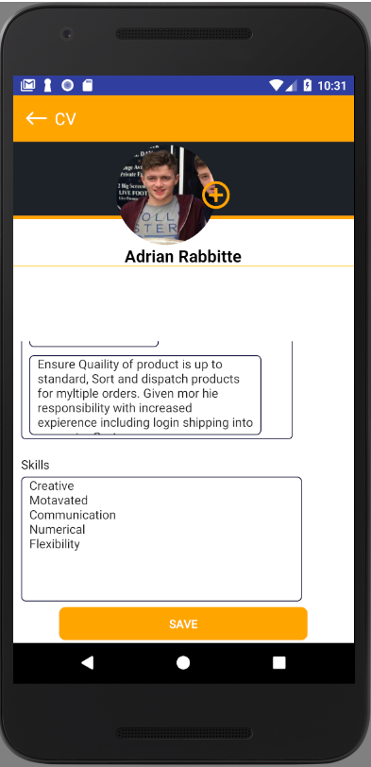

**7) Messages**

When the Employee clicks on messages they are brought to a conversation activity where he/she can view their different conversation threads with Employers. Where they can instant message Employers when a conversation is clicked.

 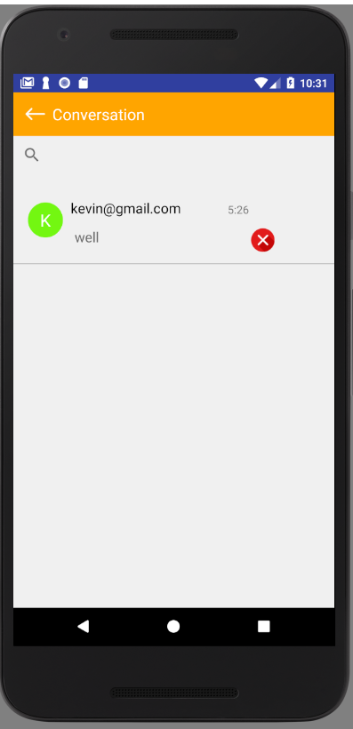

 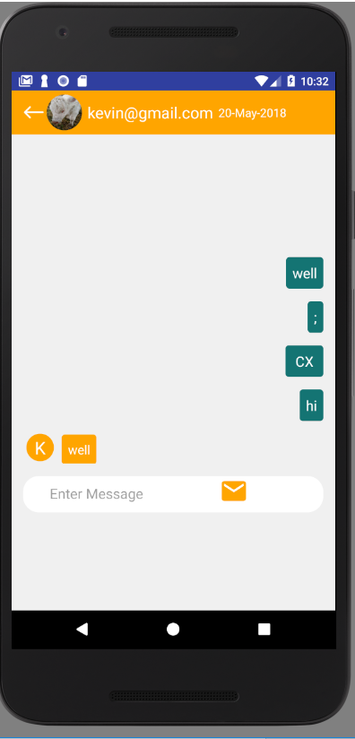

**8)Contacts**

Here the Employees can view their contacts with Employers, A contact is only created on that users account if the Employer messages that Employee first. When a contact is created, the Employee has the chance to message the Employer.

 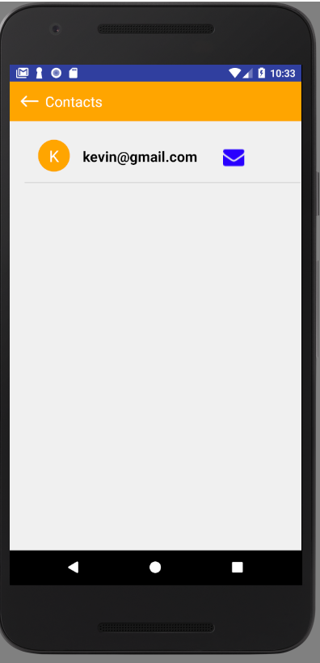

 

1. **Files:**

Here the Employee can upload relevant files showing their achievements and possible qualifications. The Employee can upload files by clicking on the upload button.

 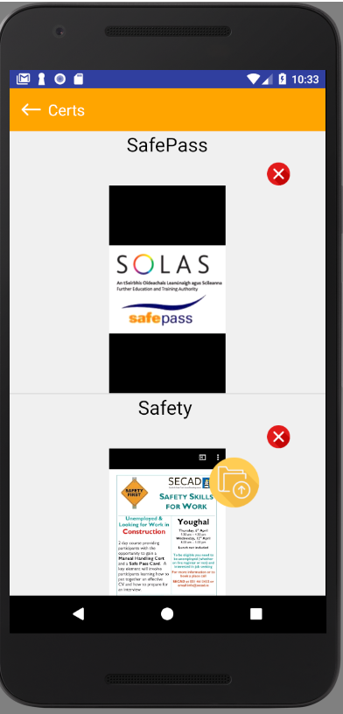 . 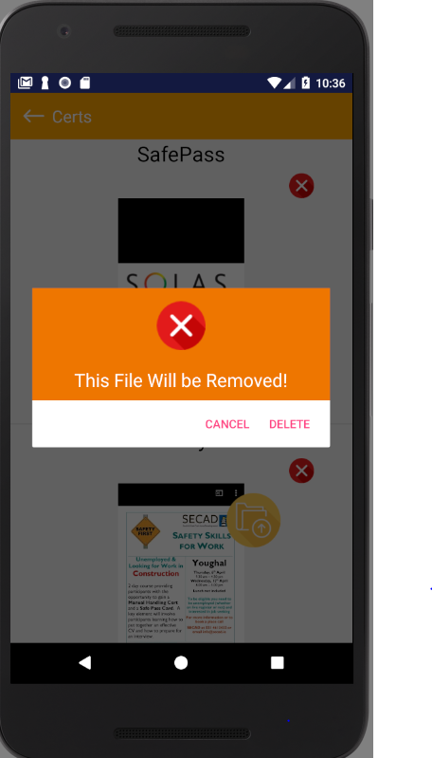 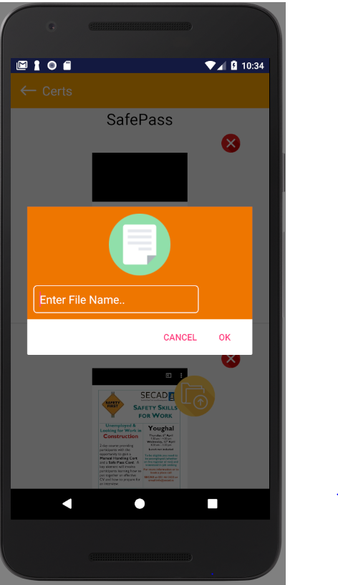

**10) Employee Settings:**

The Employee settings allow the Employee to establish the range that they are available for employment, Show Notifications, and the choice to make their Profile visible on google Maps corresponding to their location.

 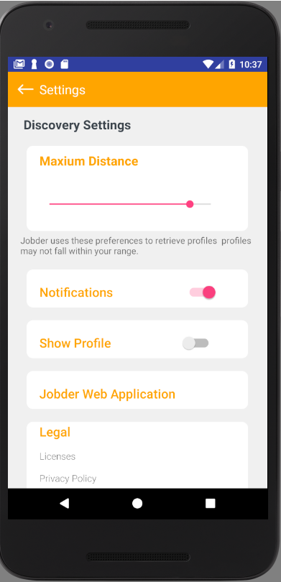

**11) Employer Home Page.**

The Employer homepage allows the Employer to choose the field of employment that which they are search for e.g. Plumbing, view conversations and view settings.

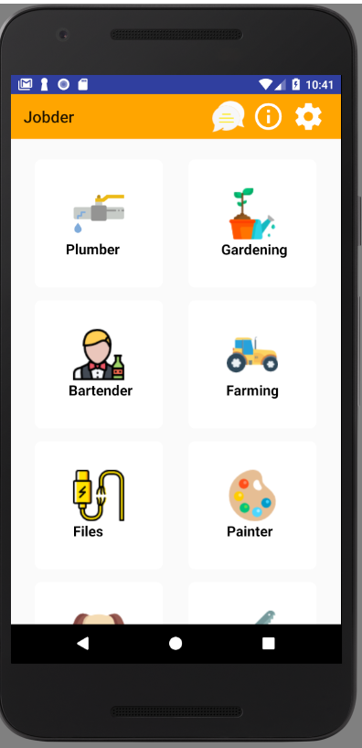 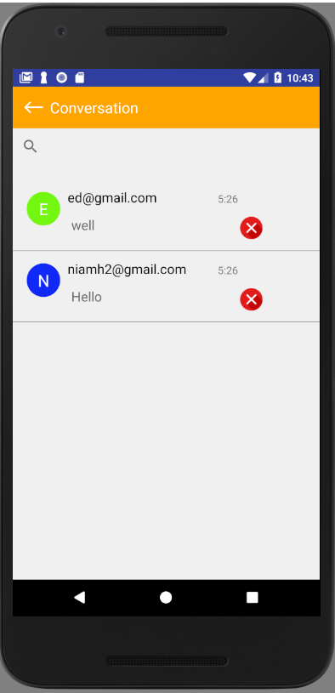

**12) Maps**

When an Employer clicks on a field in search of Employment, they will be able to view all the Employees available in a fixed range. When the Employee clicks on the emoji which represents an Employee they will be brought to the Employees profile where he/ she can start a message thread.

 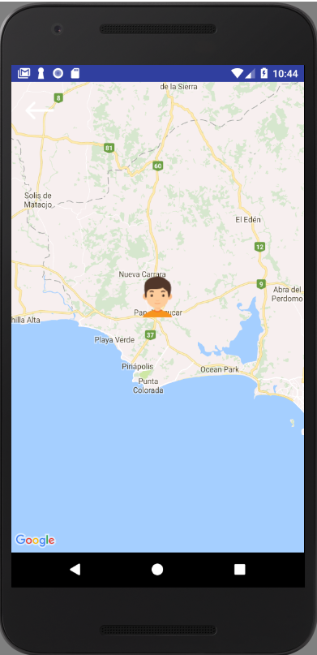

 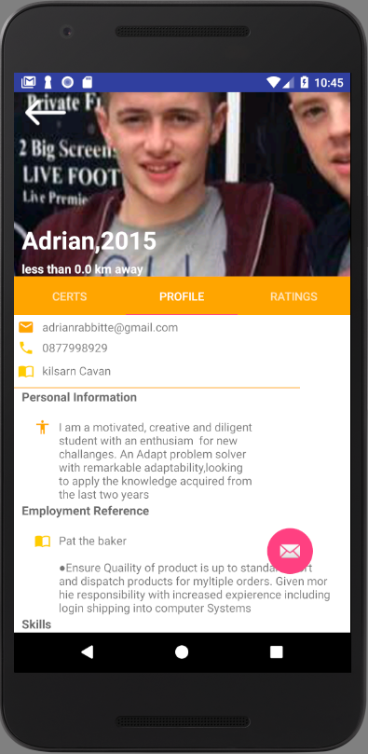

**12) Profile**

The Profile allows the Employers to view the Employees profile, view achievements, view and create ratings.

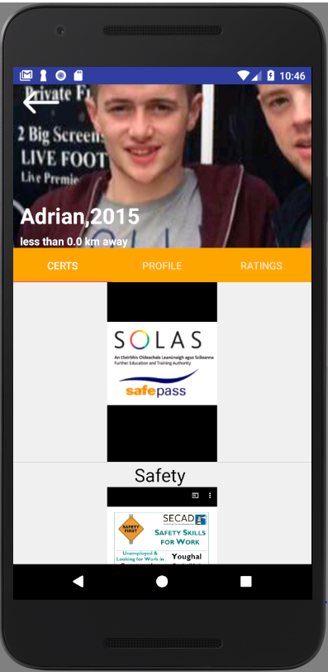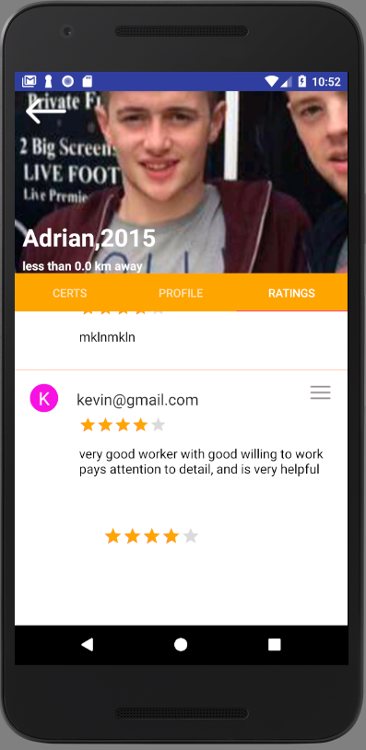

 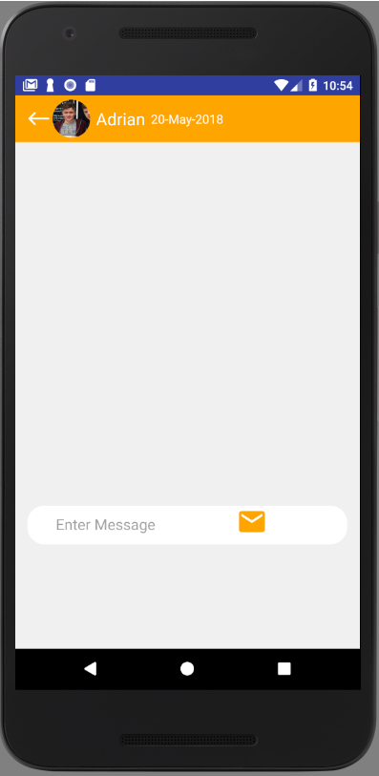

**13) Settings:**

The Employer settings allow the Employer to establish the range to view Employee profiles, show notifications, filter employees, and change the location of search in google maps.

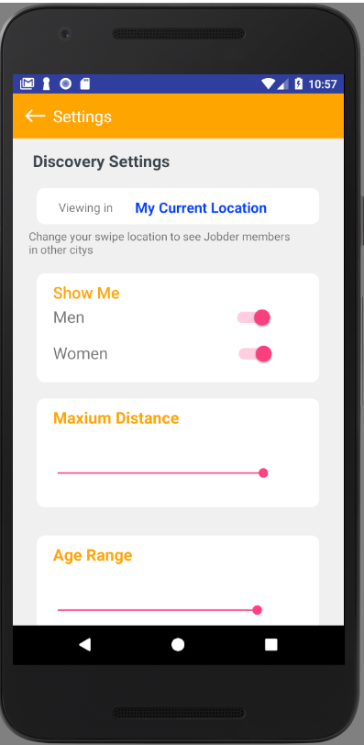 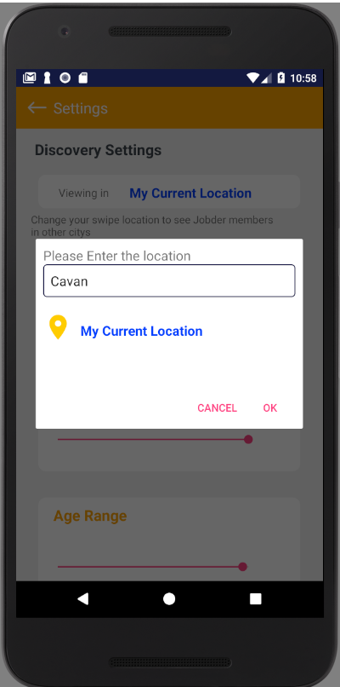

**14) Web Application:**

The web application Jobber is solely based on statistical purposes. Only members of the application can login via their email and password.

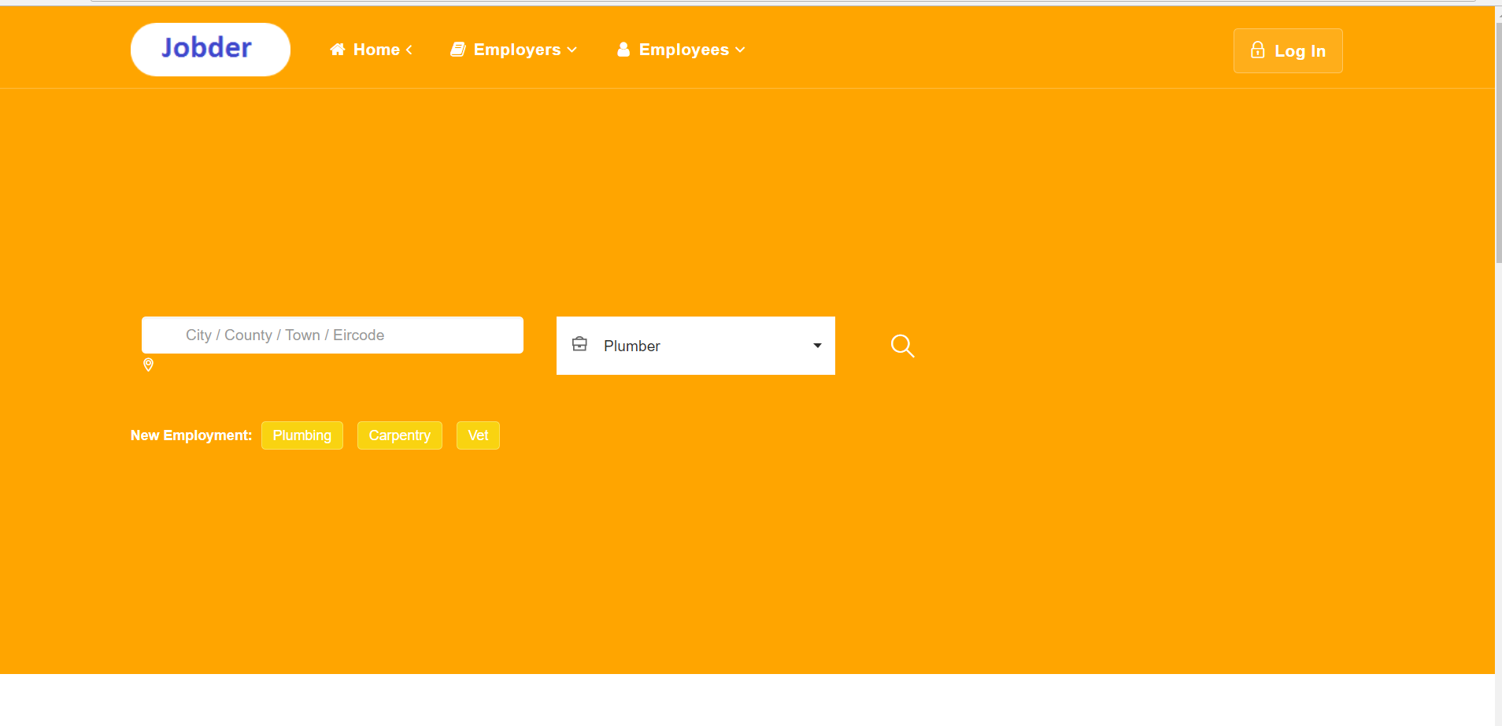

Login to the application via Email and Password.

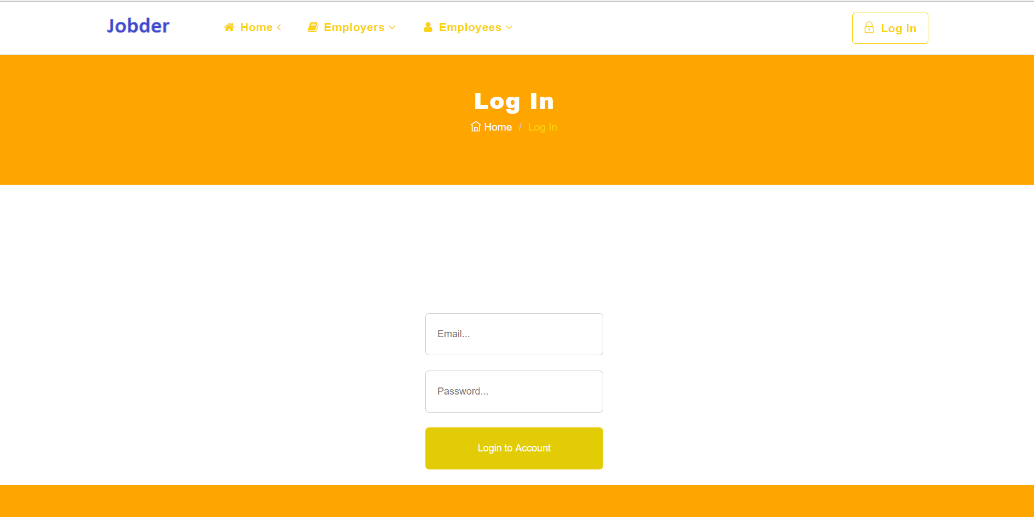

When the User Logs in to the web he/she can view different real time statistics of Employment trends of the application.

