Node.js Image Processing Service and Elastic Beanstalk Deployment Report
  - Screenshot Evidence Submission
Prepared by | Adrian Russo
Date | 03/09/2026
Version | 1.0
Status | Completed V1

Table of Contents
Contents
Table of Contents 1
1. Executive Summary 1
2. Purpose and Scope 1
3. Environment and Prerequisites 1
4. Screenshot Evidence 2
4.1 Local Node.js Service Starts Without Errors 2
4.2 Valid Local RESTful GET Request 2
4.3 Invalid Request and Error Status Code 3
4.4 Elastic Beanstalk CLI Deployment 4
4.5 Elastic Beanstalk Console Dashboard 4
4.6 Functional Cloud Endpoint 5
5. Testing and Results 6
6. Requirements and Evidence Mapping 6
7. Issues and Resolutions 7
8. Conclusion and Next Steps 7

1. Executive Summary
This report provides screenshot evidence that the Node.js image-filtering service runs locally, follows RESTful design principles, returns appropriate HTTP status codes, and is deployed as a functional AWS Elastic Beanstalk application.

2. Purpose and Scope
The scope covers local execution with npm run dev, the completed /filteredimage GET endpoint, successful and error response codes, Elastic Beanstalk CLI deployment commands, the Elastic Beanstalk console dashboard, the required deployment screenshot directory, and a working cloud endpoint URL.

3. Environment and Prerequisites
Item | Details
Platform or service | Local Machine & AWS Udacity Environment
Region or environment | us-east-1
Tools and versions | VS Code 1.136.0  EB CLI 3.27.3 (Python 3.14.1 (tags/v3.14.1:57e0d17, Dec 2 2025, 14:05:07) [MSC v.1944 64 bit (AMD64)])  NPM 11.17.0
Prerequisites | - Node.js(opens in a new tab)  - Node Package Manager(opens in a new tab)  - Elastic Beanstalk Command Line Interface(opens in a new tab)  - AWS CLI

4. Screenshot Evidence

4.1 Local Node.js Service Starts Without Errors
Run npm run dev. Capture the terminal showing the command, the server start message, the local port, and no startup errors.
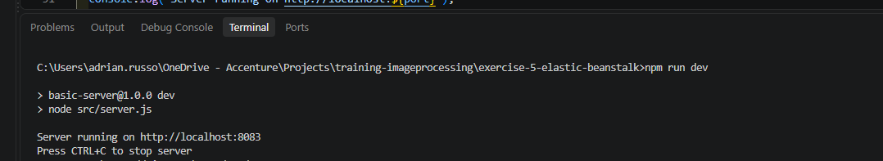
Show the service starting successfully and listening on the configured local port.
Figure 1. Local Node.js service starts with npm run dev without errors.
Evidence shown: The project launches a working local Node.js server and reports no startup errors.

4.2 Valid Local RESTful GET Request
Send a valid GET request to http://localhost:[PORT]/filteredimage?image_url=https://upload.wikimedia.org/wikipedia/commons/b/bd/Golden_tabby_and_white_kitten_n01.jpg. Capture the request, the HTTP 200 response, and the returned filtered image or saved output.
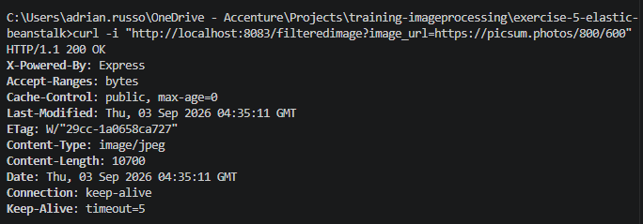
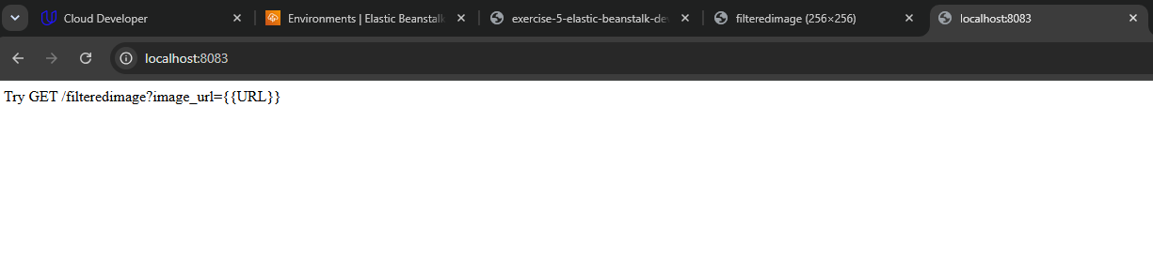
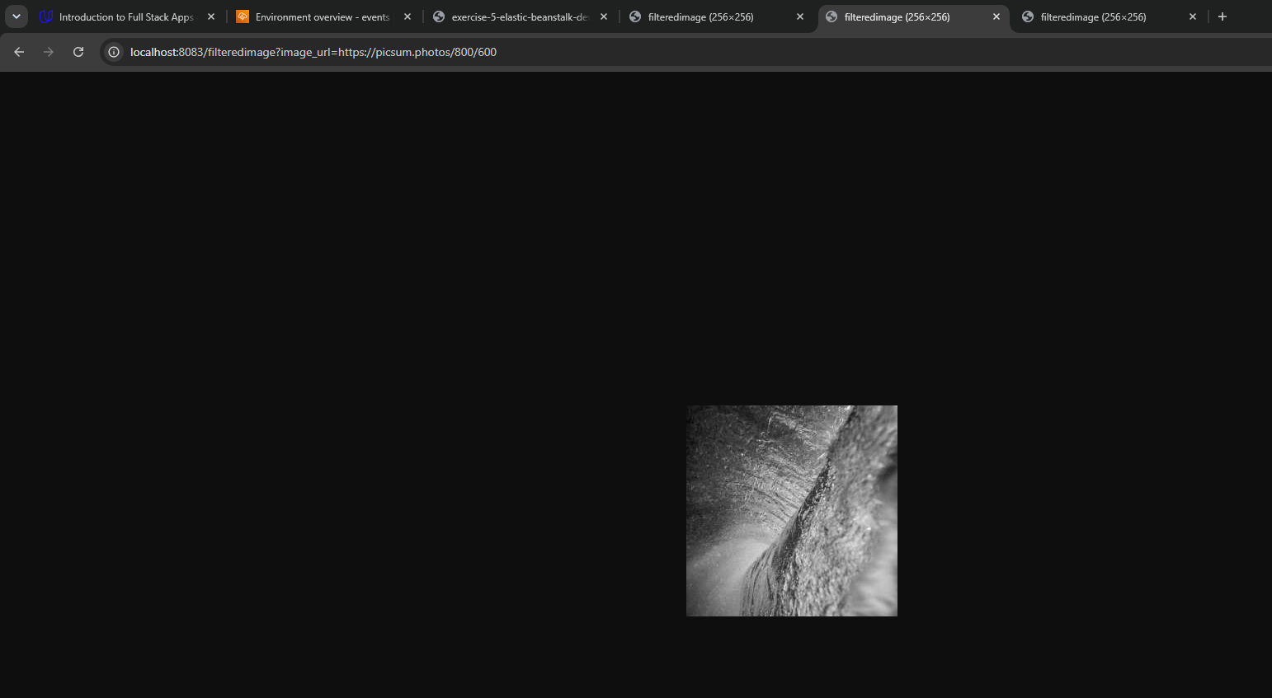
Show the complete request, returned output, and HTTP 200 status.
Figure 2. Valid local GET request to the completed /filteredimage endpoint.
Evidence shown: The endpoint accepts the image_url query parameter, follows a resource-oriented GET pattern, and returns a successful response.

4.3 Invalid Request and Error Status Code
Send an invalid request, such as omitting the image_url parameter or supplying an unusable value. Capture the response body and an appropriate caught-error status such as HTTP 422.
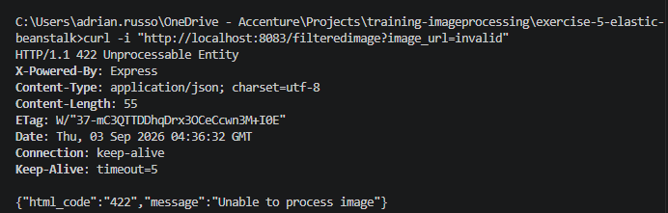
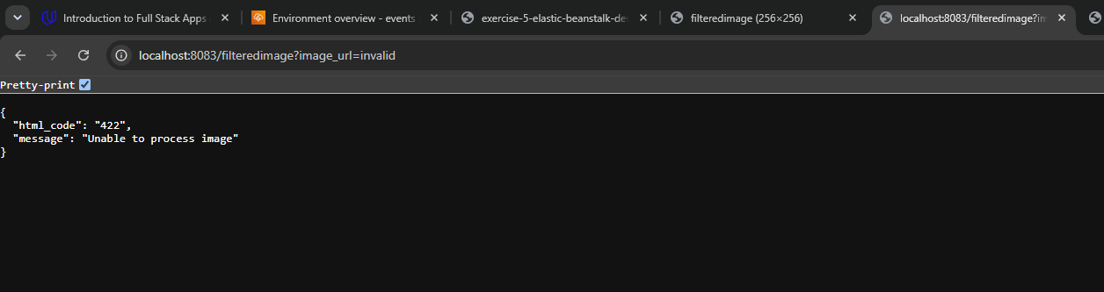
Show the invalid request, error message, and HTTP 422 or other appropriate caught-error status.
Figure 3. Invalid request returns an appropriate HTTP error code.
Evidence shown: The service validates input and uses HTTP status codes to distinguish successful and unsuccessful requests.

4.4 Elastic Beanstalk CLI Deployment
Capture terminal evidence that the project was configured and deployed using the AWS Elastic Beanstalk CLI commands eb init, eb create, and eb deploy. The output should show successful completion or the resulting environment details.
eb init
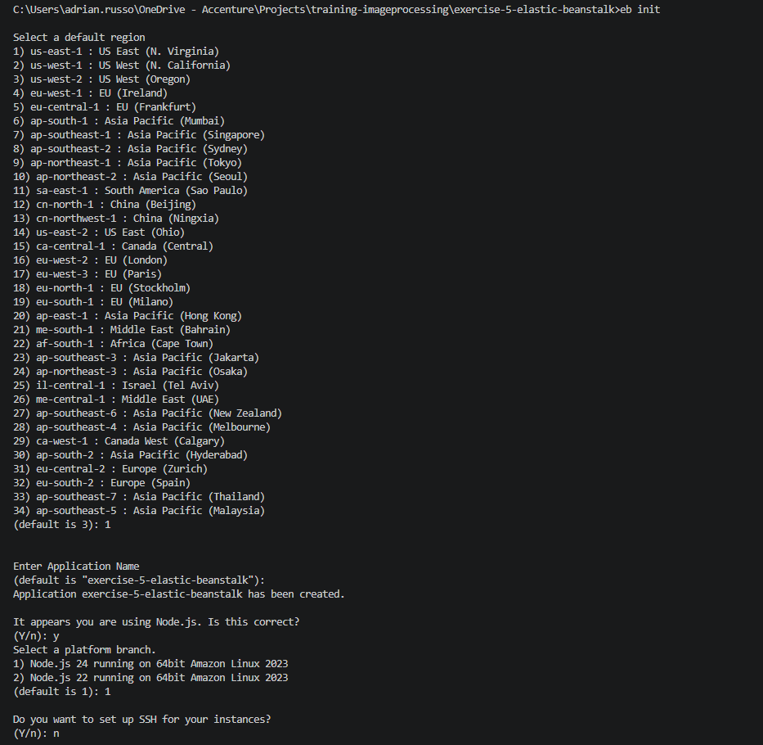
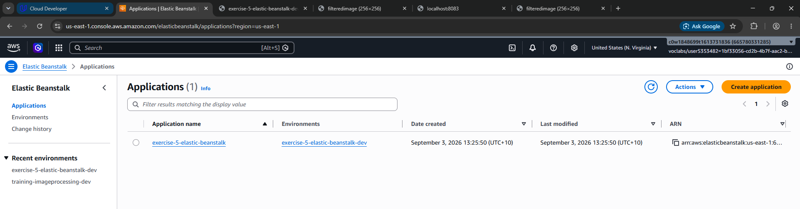
eb create
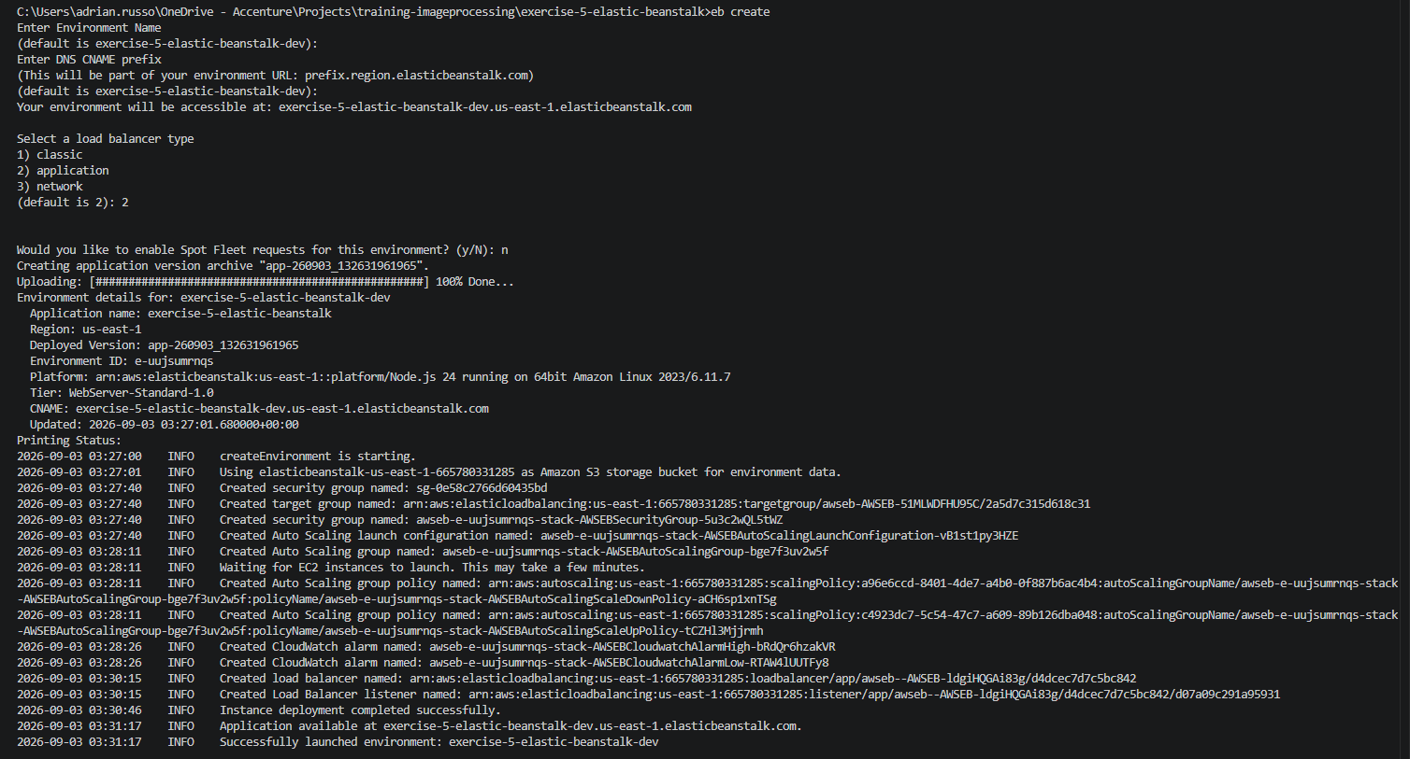
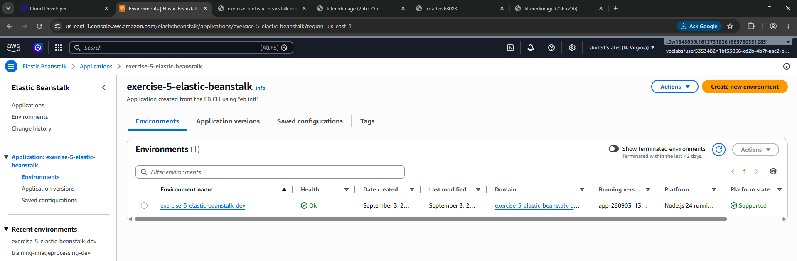
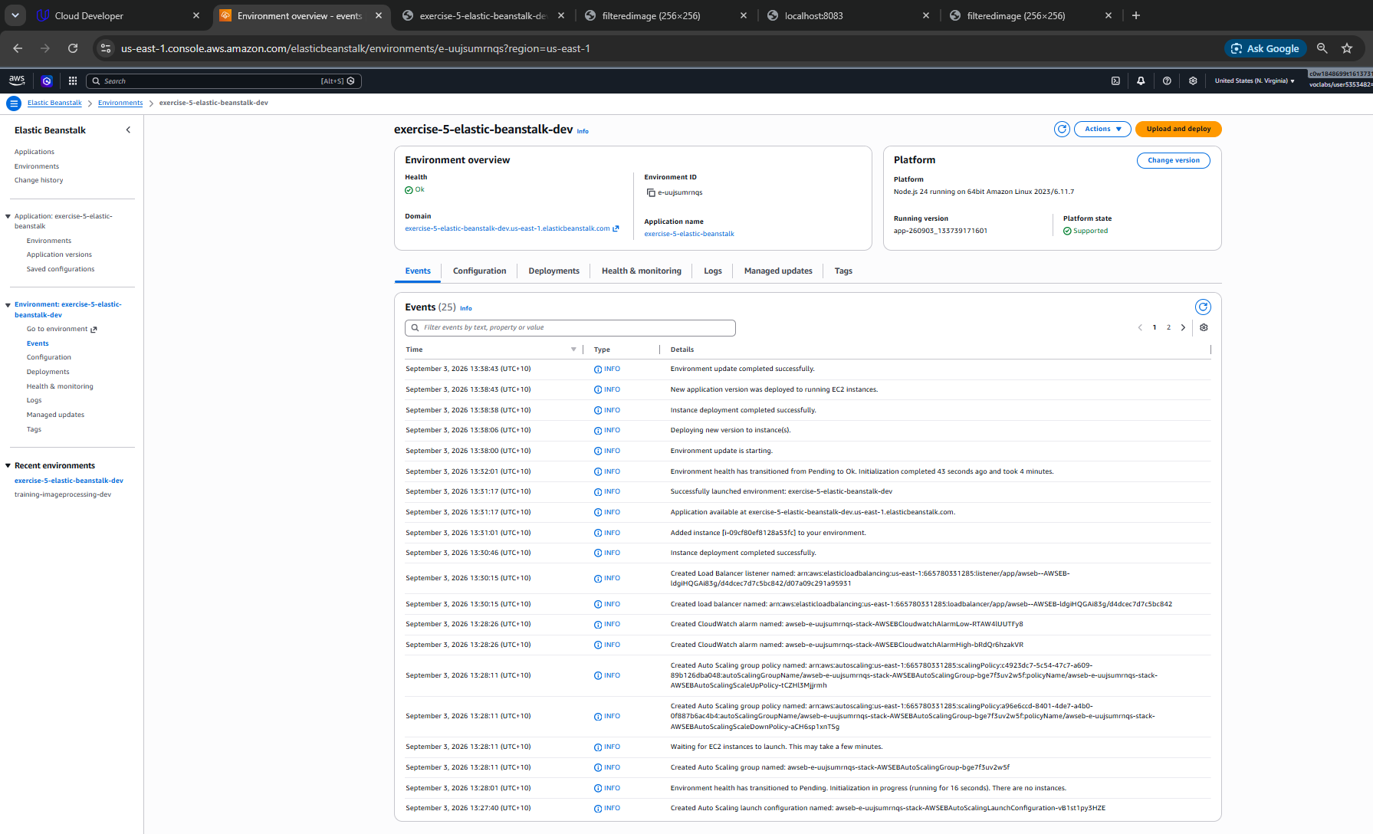
eb deploy
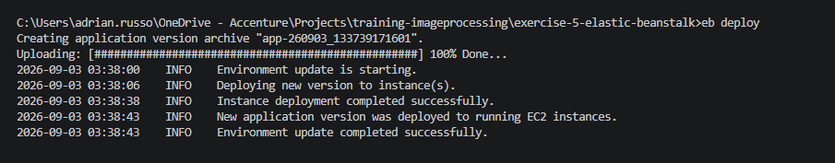
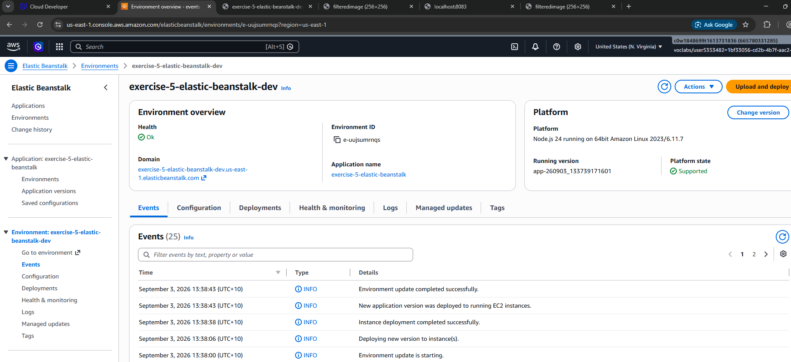
Use one clear composite screenshot or separate captures that show all three commands and their successful results.
Figure 4. Elastic Beanstalk CLI configuration, environment creation, and deployment.
Evidence shown: The application was deployed using the required Elastic Beanstalk CLI workflow.

4.5 Elastic Beanstalk Console Dashboard
Capture the Elastic Beanstalk application dashboard showing the application and environment name, environment health, platform, and domain. Save a copy of this screenshot in the project’s deployment_screenshot directory.
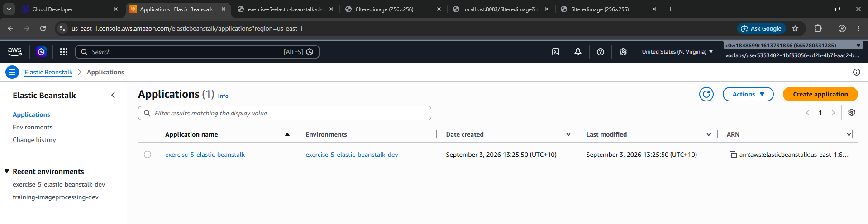
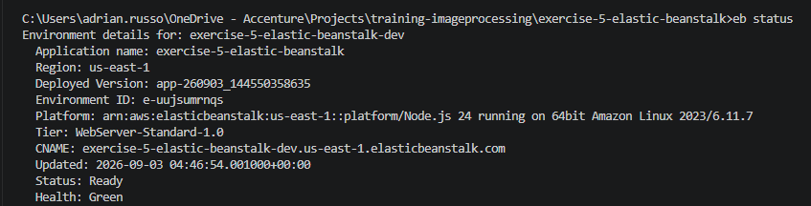
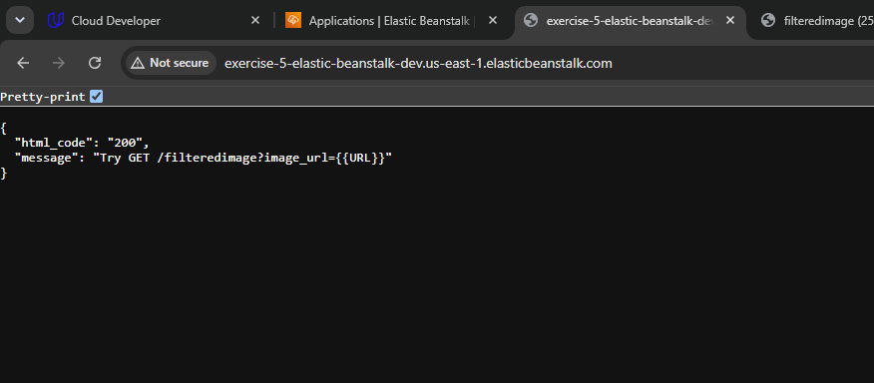
Show the deployed environment and healthy status. Confirm the same image is stored in deployment_screenshot.
Figure 5. Elastic Beanstalk application dashboard for the deployed environment.
Evidence shown: The Elastic Beanstalk console contains the application and its running environment.

4.6 Functional Cloud Endpoint
Submit the deployed environment URL and send a valid GET request to http://[EB_URL]/filteredimage?image_url=https://upload.wikimedia.org/wikipedia/commons/b/bd/Golden_tabby_and_white_kitten_n01.jpg. Capture the full endpoint, HTTP 200 response, and returned or downloaded filtered image.
Show the full EB_URL, valid image_url query, HTTP 200 status, and successful output
http://exercise-5-elastic-beanstalk-dev.us-east-1.elasticbeanstalk.com/filteredimage?image_url=https://picsum.photos/800/600
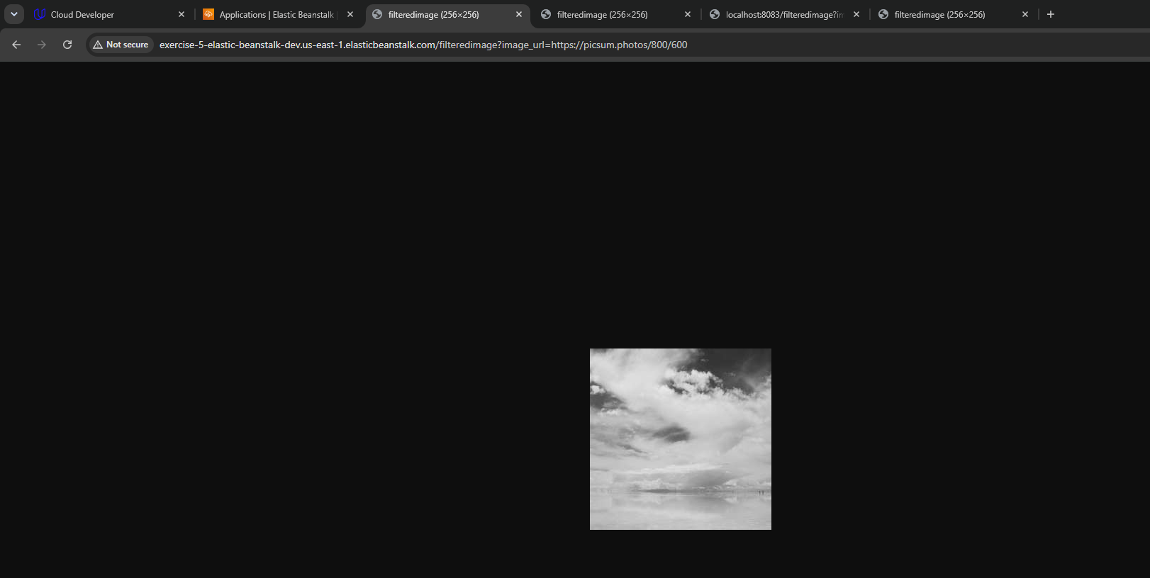
Show the full EB_URL, invalid image_url query, HTTP 422 status, and successful output
http://exercise-5-elastic-beanstalk-dev.us-east-1.elasticbeanstalk.com/filteredimage?image_url=invalid
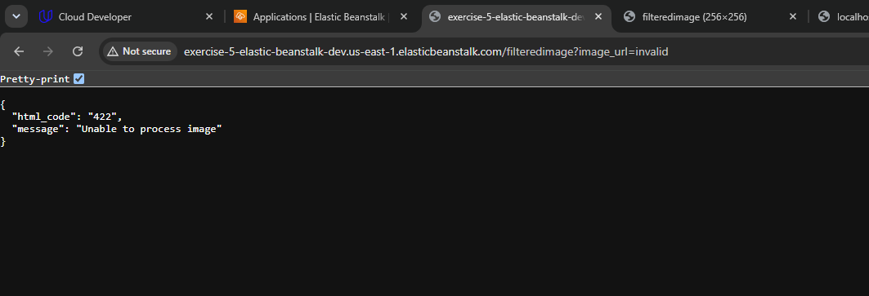
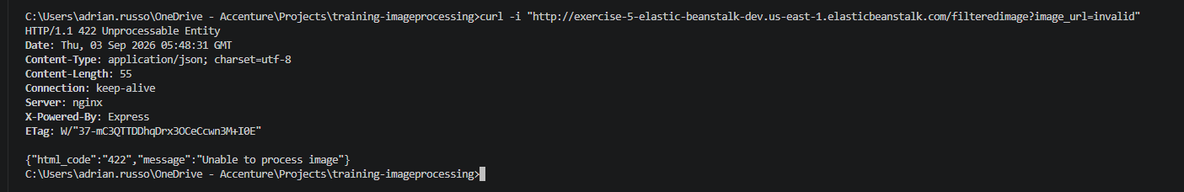
.
Figure 6. Functional cloud deployment responds to a valid GET request.
Evidence shown: The submitted Elastic Beanstalk URL is publicly reachable and the deployed service performs the required image-filtering operation.
Submitted EB_URL: [Insert the running Elastic Beanstalk endpoint URL]

5. Testing and Results
Test | Expected result | Actual result | Status
Local service startup | npm run dev starts the server with no errors. | [Record observed port and startup result] | Pass
Valid local GET request | /filteredimage accepts the required image_url and returns HTTP 200 with a filtered image. | [Record response and output] | Pass
Invalid local request | The service returns a clear error response with an appropriate status such as HTTP 422. | [Record response code and message] | Pass
Valid cloud GET request | The EB_URL endpoint returns HTTP 200 and a filtered image. | [Record response and output] | Pass

6. Requirements and Evidence Mapping
Criterion | Required screenshot evidence | Report location | Status
Working Node.js service | Terminal showing npm run dev starts the server without errors. | Section 4.1, Figure 1 | Completed
RESTful design and completed endpoint | Valid local GET request using the required /filteredimage path and image_url parameter. | Section 4.2, Figure 2 | Completed
Appropriate HTTP status codes | HTTP 200 for a successful request and HTTP 422 or another appropriate caught-error code for an invalid request. | Sections 4.2–4.3, Figures 2–3 | Completed
Elastic Beanstalk CLI and Console Dashboard | Evidence of eb init, eb create, and eb deploy, plus the application dashboard and a copy saved under deployment_screenshot. | Sections 4.4–4.5, Figures 4–5 | Completed
Functional cloud deployment | Submitted EB_URL and a valid cloud GET request returning HTTP 200 and a filtered image. | Section 4.6, Figure 6 | Completed

