***# 1. Install Node.js (includes npm)* *# Download from:*** [***https://nodejs.org/***](https://nodejs.org/) 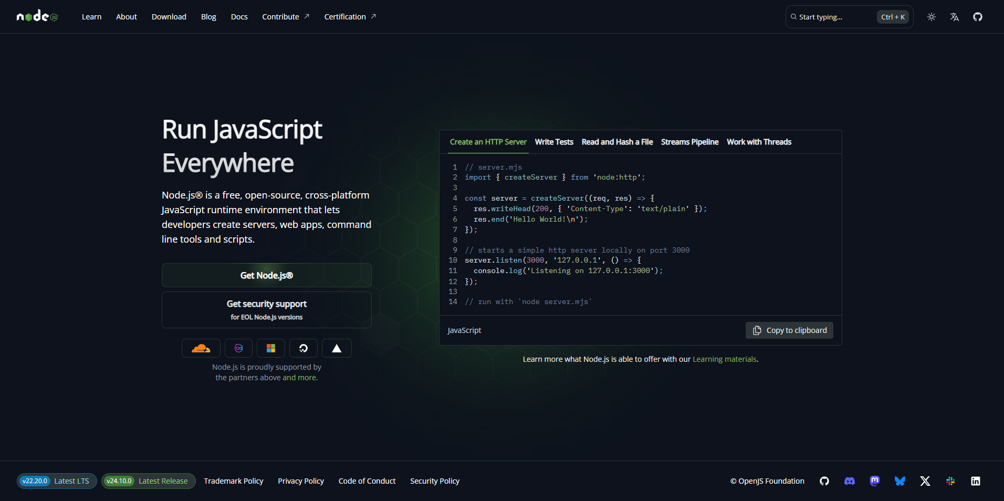

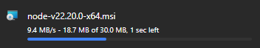

***# 2. Step 1: Open Command Prompt or Terminal and Verify installation***

***node --version # Should show v18+ or v20+***



***npm --version # Should show v8+ or v10+***



***# 3. Install Vue CLI globally***

***npm install -g @vue/cli***



***# 4. Verify Vue CLI installation***

***vue --version # Should show @vue/cli 5.x.x***



***# 5. Navigate to where you want to save the project***

***cd Desktop # or cd Documents***

***git clone https://github.com/adriansarmiento-code/6WCSERVER-Final-Project.git***

  
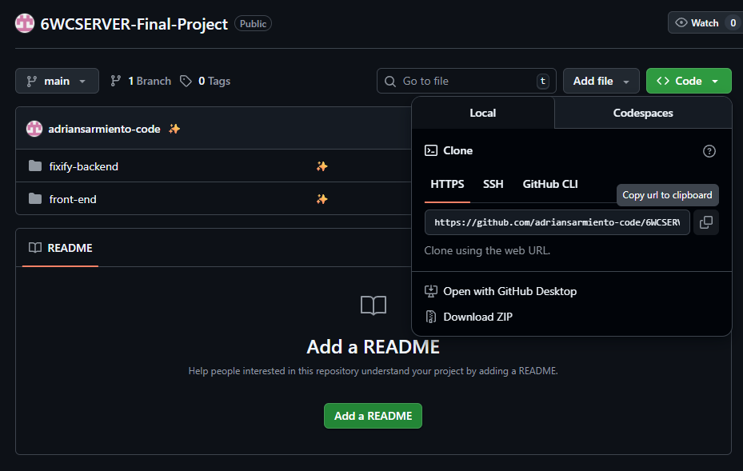

***# 6. Navigate to the Project Folder***

cd 6WCSERVER-Final-Project

**Part 2: Setup Frontend**

### **Step 1: Navigate to Frontend Folder**

cd front-end

### **Step 2: Install Frontend Dependencies**

npm install

**Expected output:**

added XXX packages in XXs

**Step 3: Fix Any Vulnerabilities**

npm run lint -- --fix

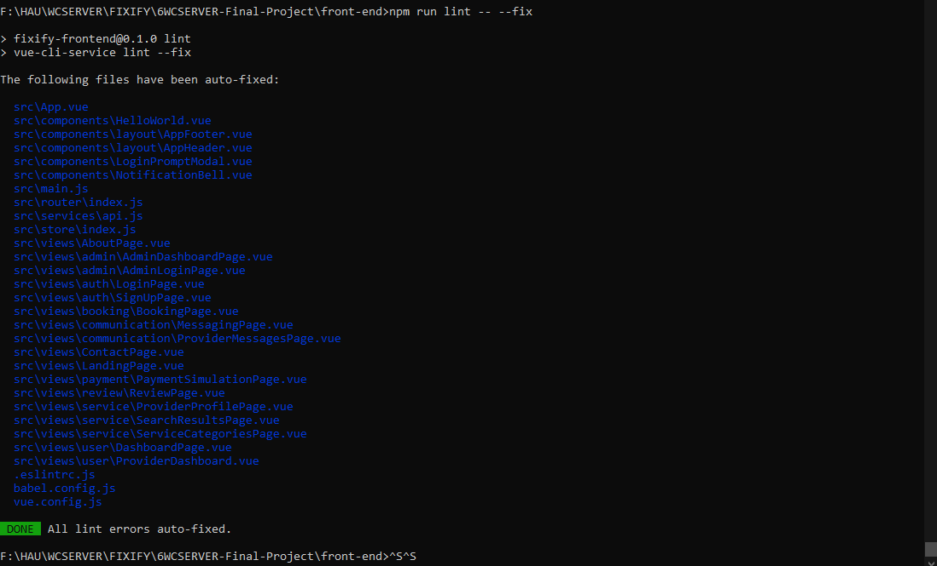

**PART 3: Setup BackEnd**

**Set Up MongoDB: Preferably New MongoDB account**

**Step 1 Create Account:**

* Go to<https://www.mongodb.com/cloud/atlas>
* Click "Try Free"
* Sign up with email or Google

**Step 2 Create Cluster:**

* Choose "M0 FREE" tier. If “Free” isn’t available, login with another email or google.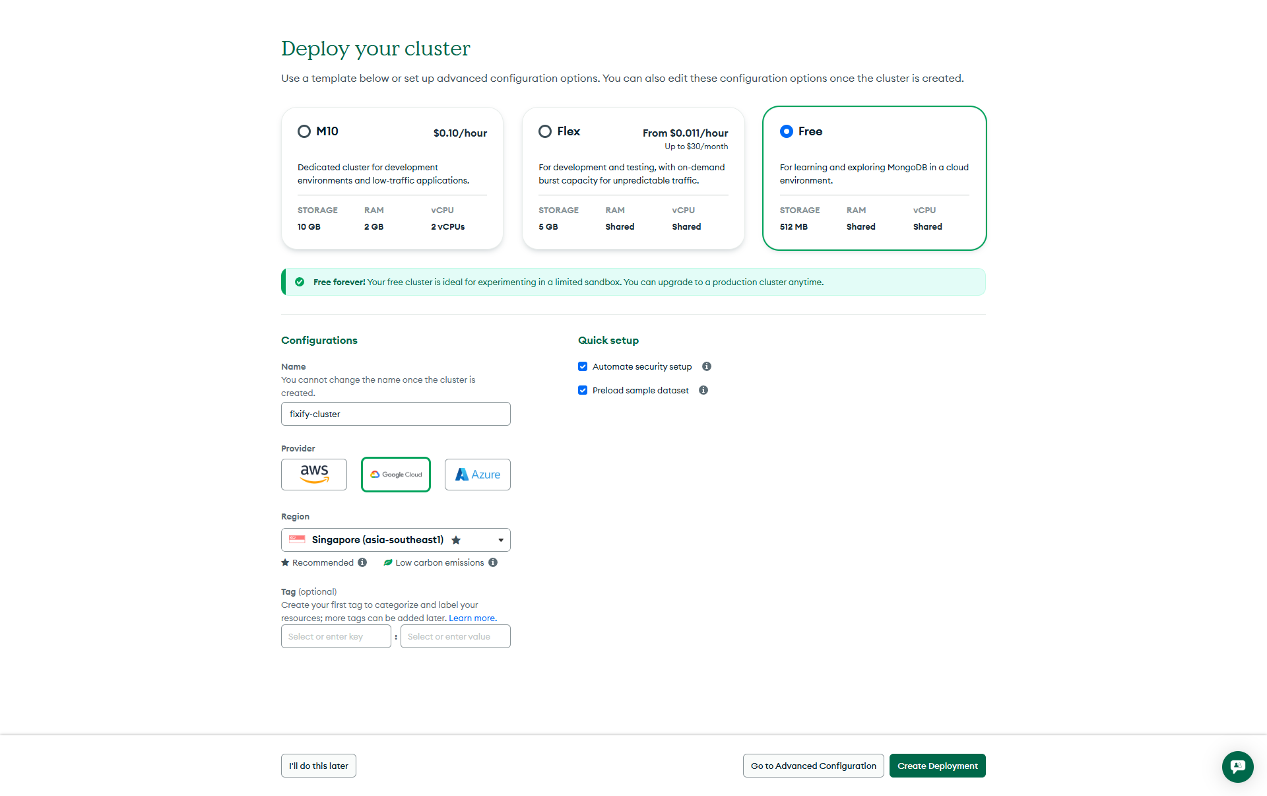
* Select a cloud provider (AWS, Google Cloud, or Azure)
* Choose region closest to you (e.g., Singapore for Philippines)
* Cluster name: fixify-cluster
* Click "Create Cluster" 



**Step 3 Get Connection String:**

* This should automatically pop up. If it doesn’t, click **“Cluster”** on the left sidebar and click “Connect” button

Create Database User:

Username: fixify_admin

Password: Auto generated -> Copy the password

Click “Create Database User”

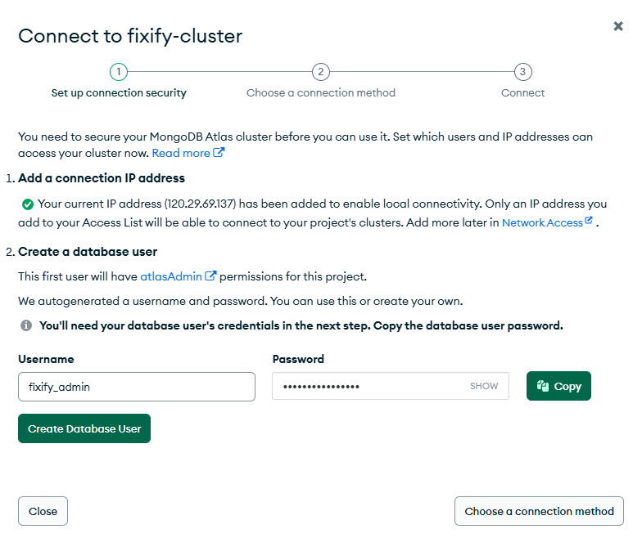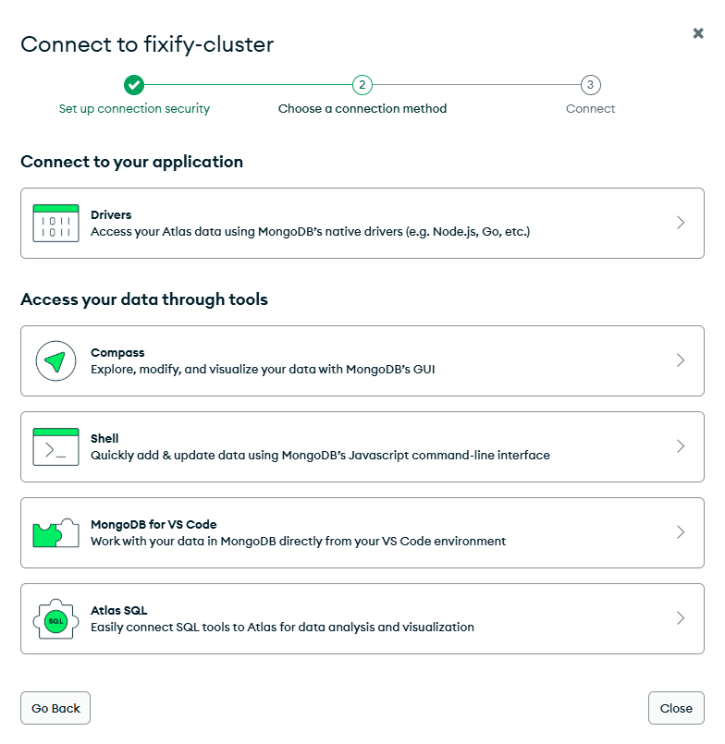

Click “Drivers”

* + Driver: Node.js, Version: 6.7 or later
  + Copy the connection string (looks like):

mongodb+srv://fixify_admin:<password>@fixify-cluster.xxxxx.mongodb.net/?retryWrites=true&w=majority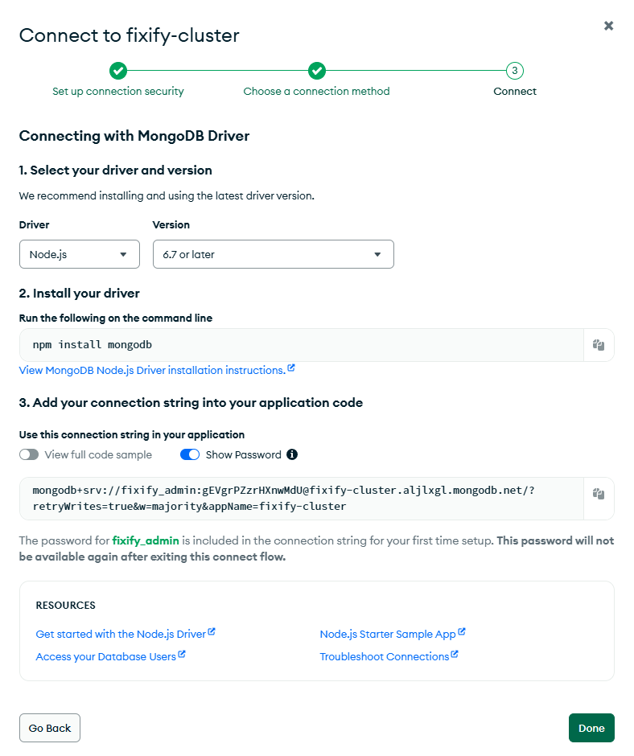

**Replace <password>** with the password you copied earlier

**Step 4 Configure Database Access:**

* Left sidebar: Click "Database Access"
* Click "Add New Database User"
* Username: fixify-user
* Password: Click "Autogenerate Secure Password" → **COPY THIS PASSWORD**
* Database User Privileges: "Read and write to any database"
* Click "Add User"

Note: save this for the JWT_SECRET password later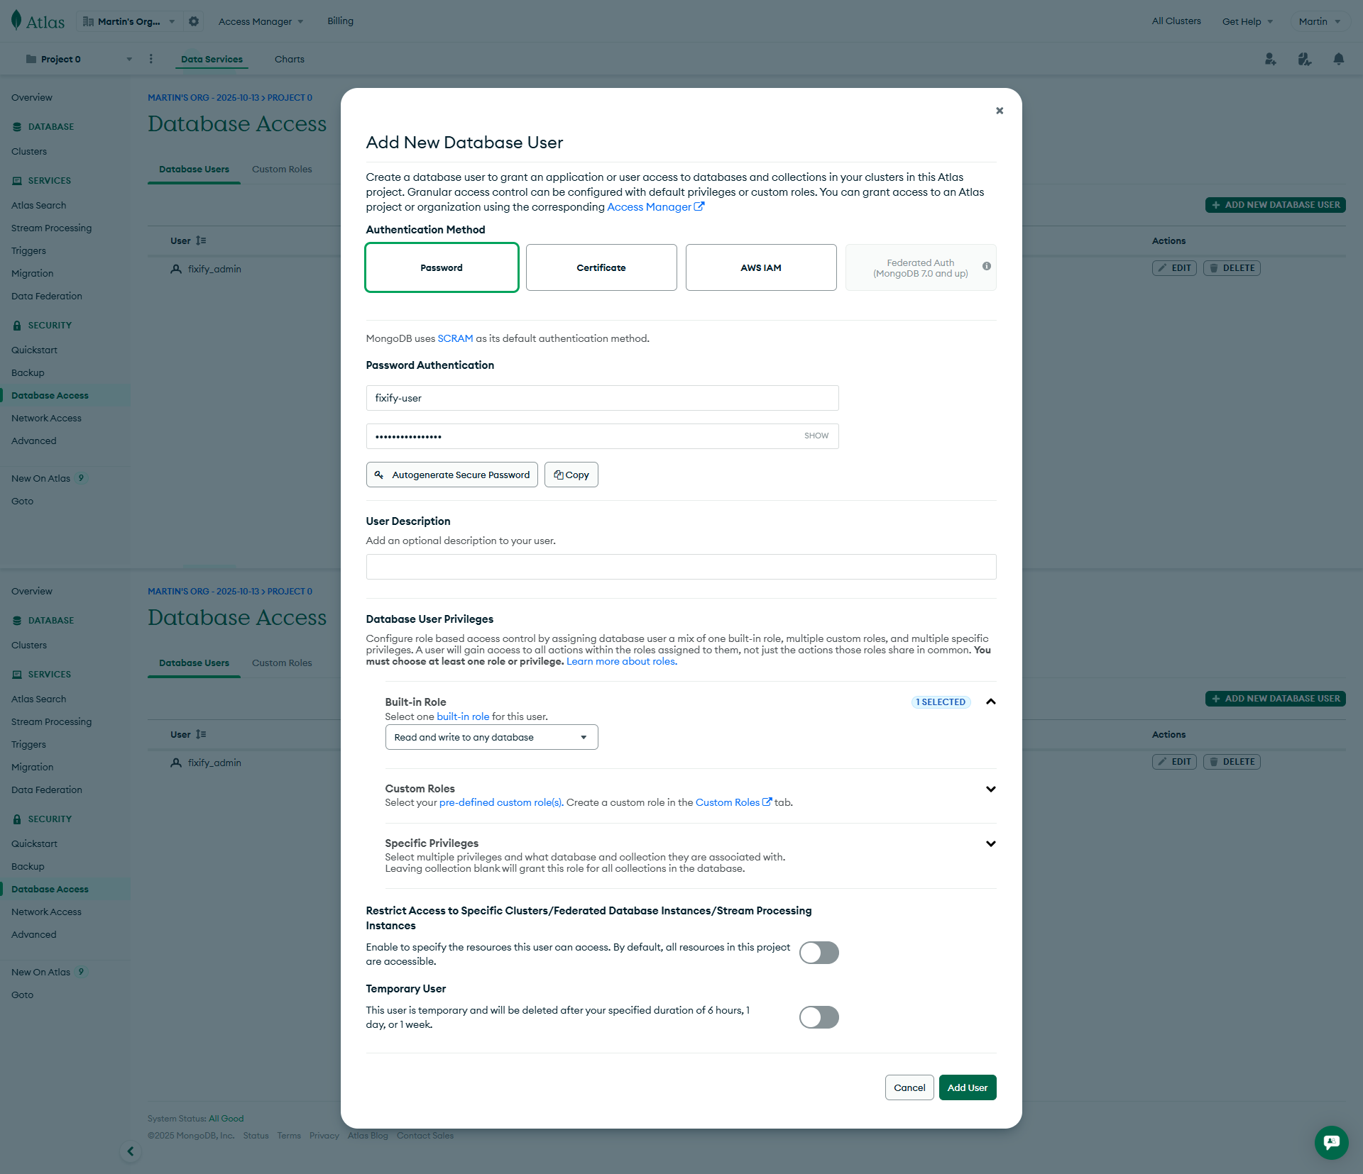

**Configure Network Access:**

* Left sidebar: Click "Network Access"
* Click "Add IP Address"
* Click "Allow Access from Anywhere" (for development)
* Click "Confirm"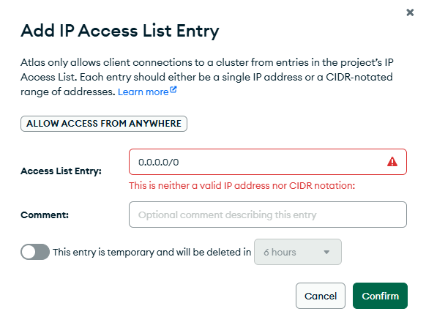

**RUN THE BACKEND (open another command prompt)**

**Step 1:** Open Command Prompt

**Step 2:** Navigate to where you saved/cloned the project (e.g documents)

cd document

cd fixify

cd fixify-backend

npm install

**Step 3:** Create the .env file (make sure it's in the fixify-backend folder)

paste:

PORT=5000 MONGO_URI=mongodb+srv://fixify_admin:<your-password>@fixify-cluster.xxxxx.mongodb.net/fixifyDB?retryWrites=true&w=majority&appName=fixify-cluster JWT_SECRET=<your-JWT-password>

NODE_ENV=development

**Step 4: Back to back-end terminal:** Create the admin user

node src/utils/createAdmin.js

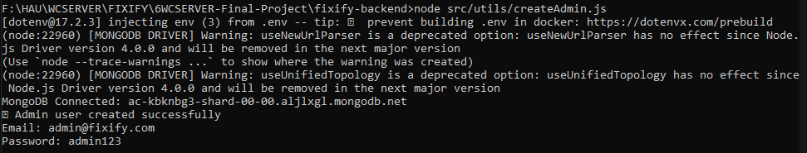

**Step 5: Start the frontend development server**

npm run serve  
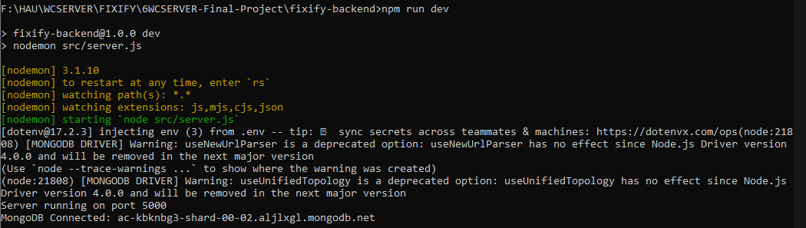

**Step 6: Open Front-end command prompt**

npm run serve

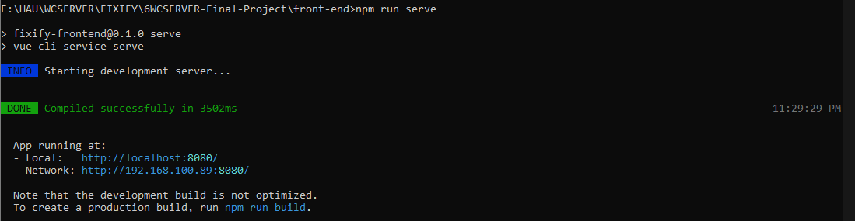

**Open Browser:**

* Go to<http://localhost:8080>

That's it! The app is running.