How I construct the Program:

DoOnePing: I search online to open a socket with icmp and found the code

ReceiveOnePing:

1. I extract the ICMP header. ICMP is piggyback with IP packet therefore ICMP header starts at 20th bytes (length of IP header) and ends at 28th bytes (length of ICMP header given on assignment pdf).

2. In sendOnePing, it is known about the format of the struct, bbHHh, and time is attach after the header (data section) in a d format. Thus, from the following information, we can unpack the structure easily and retrieve the header and data (time).

3. Finally can compute rtt_min by using python min function on rtt_min and rtt, rtt_max by using python max function on rtt_max and rtt, and rtt_sum by adding rtt_sum + rtt. Also increment rtt_count to compute the number of packet received

A. Test your client by sending packets to localhost, that is, 127.0.0.1.

B. Test your client by sending packets to stonybrook.edu or cs.stonybrook.edu

Stonybrook.edu

C. Select and ping 4 servers; each in a different continent.

Server 1: University of Oxford (United Kingdom, Europe) ox.ac.uk

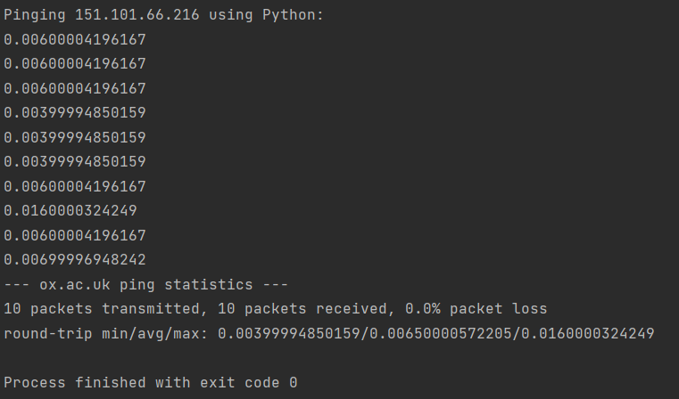

Server 2: Pohang University of Science and Technology (South Korea, Asia) postech.ac.kr

Server 3: University of Melbourne (Australia) unimelb.edu.au

Server 4: Universidade de Sao Paulo (Brazil, South America) usp.br

D. Explain the differences in minimum round trip time to each of these servers in parts A, B, and C.

In part A, I ping my own machine, this is fast and done almost in an instance (0 second) since packets doesn’t need to travel outside my machine.

In part B, I ping the Stonybrook University server from my dorm, in which the server lives on the same network. This has low RTT because packets doesn’t need to travel through the Internet.

In part C, the distance affect the RTT the farther the packet needs to travel the higher the RTT will be. In Postech & Universidade de Sao Paulo server, both of them doesn’t use CDN, so packets travel to their respective continent (Asia and South America). We can confirm this through the traceroute and a sudden spike in one of the server which indicates travel to a different continent.

University of Oxford server is hosted in Fastly CDN which is hosted in Manhattan, NY. So packet hops a few times.

Finally, University of Melbourne server is not hosted in CDN, yet utilize Cloudflare along the route so doesn’t need to travel through different router. Packet can travel through the Cloudflare router which means fewer and closer hops.

4. Currently, the program calculates the round-trip time for each packet and prints it out individually. Modify this to correspond to the way the standard ping program works. You will need to report the minimum, maximum, and average RTTs at the end of all pings from the client.

F. In addition, calculate the packet loss rate (in percentage).

