Can human values explain one’s interest in cryptocurrencies? A correlational study in Germany

27. Mai, 2022

Write abstract here

# Introduction

Cryptocurrencies are digital money, and much more. The idea of cryptocurrency has developed recently, in 2009, when a person or a group of people known as Satoshi Nakamoto have launched a novel currency that was entirely digital and based on a chain of mathematical algorithms. Their vision was one in which the centralized financial system as we know it can one day be de-centralized in that financial transactions will be possible directly between involved parties. The idea was a simple one: by eliminating the role of banks and governmental bodies that secure trust in financial transactions, unnecessary taxes can be eliminated, people can have more control of their finances, as well as global barriers due to currency conversion might as well be abolished. This has since entered the public knowledge domain and is now known as Bitcoin. Several variations of it and a number of alternative cryptocurrencies later, and it is becoming increasingly clear that the topic is no longer in the under-ground of our society, but quite the contrary, it is here to stay.

This research sets to explore reasons why some people are interested in this new form of finance whereas other are against it, or they are skeptical. We focus on the role of human values as possible explanators and seek to understand associations with an interest in and motivation to invest in cryptocurrencies among the general German population. We look at the associations between human values in the Theory of Basic Human Values (TBHV, Schwartz, 2012) and varying cryptocurrency items as formulated in a recent survey by the OECD (OECD, 2019). Data for the study stems from a quota sample in line with the demographics of the German general population and was collected in April 2022.

## Cryptocurrencies

[input from Mariana]

## Human values

TBHV is currently the most complete theory of human values (Schwartz, 2012; Schwartz et al., 2012; Schwartz & Boehnke, 2004). This theory states that values represent socially desirable goals that individuals pursue in coping with existential needs. There are ten (or nineteen according to the refined theory, Schwartz et al., 2012) value types that transcend specific actions and situations and serve as standards (see Figure 1). These value types are universal in the sense that individuals, regardless of age, gender, country of birth or any other attributes, endorse them to some degree. Therefore, people differ not in the endorsement of one value over another, but they do because they prioritize one value more than the other.

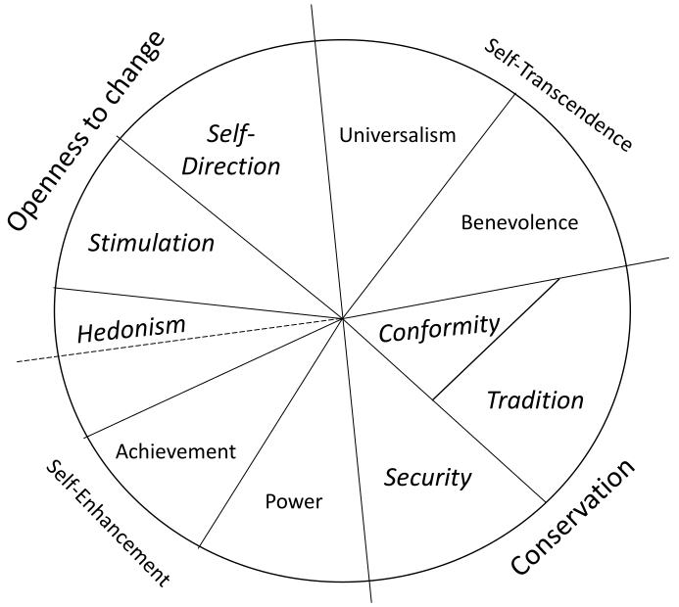

Value typologies specified in the non-refined TBHV. This is portrayed here and not the refined TBHV because the values described in the latter are collapsable onto the original ten

The theory organizes value types according to incompatibilities between underlying goal motivation in a circular fashion. For instance, universalism opposes power since the motivational goal of the former is protection for the welfare of all people and of the latter is dominance over people and resources. Or, conformity conflicts with self-direction since the motivational of the former is restraint of impulses likely to violate social expectations or norms and of the latter is independent thought. These examples were not given randomly; due to shared motivational contents, specific values pertain to a higher ordering of values in fact. Self-enhancement, conformity, and tradition all share the goal of maintaining the status quo which is incompatible with the goal of being open to change shared by hedonism, self-transcendence, and self-direction. On the other hand, universalism and benevolence share the goal of transcending the self which contrasts the goal of enhancing the self-shared by achievement and power. It is because of these relations of goal incompatibility that values drive and motivate human behavior (also see Bardi & Schwartz, 2003).

## The present research

Why should it matter if values inform people’s interst in cryptocurrencies? What makes values ultimately relevant is that they are culture-informed, have a developmental trajectory that is lifelong [refer here manuscript by Smallenbroek, Stanciu et al], while they can change due to specific life events such as entering parenthood (Lönnqvist et al., 2018), but also due to drastic changes in society such as due to the Covid-19 Pandemic (Daniel et al., 2022). Cryptocurrencies hold several similarities with other technological advancements such as the Internet and mobile phones. Compared to previous advancements however, the notion of cryptocurrencies is also in a way an economic and political statement [Mariana = do you have a citation for this?]. Though this technology is still in its onset stage, there are reasons to expect that it will impact people’s financial independence and potentially people’s dependencies on established monetary and governmental institutions [Mariana = do you have a citation for this?].

In other words, the concept of cryptocurrency is potentially going to shape in the future in currently unknown ways people’s motivational goals. We speak of the future because we want to raise awareness that a new technology is now being adopted, in spite of groups of people being against it or disbelieving its mission. This is happening. Therefore, to begin understanding how this will shape our beliefs in the future, we reason that the pertinent first step is to explore what makes this technology possible from a social perspective. That is, why some people are interested, engaged with, and open for this form of finance, while others are not.

We study the link between human values and an interest in cryptocurrencies in a general sense. We draw on the Theory of Planned Behavior (TPB, Ajzen, 1991; Conner & Armitage, 1998) and seek to identify a “gradient” describing the influence of human values at varying stages in the formation of actual behavior of holding cryptocurrencies. TPB suggests that behavior takes shape after an intention was formed, which in turn has been informed by attitudes, subjective norms and perceived behavioral control. Thus, we explore the role of values in (a) creating an intention to (b) presently or in the future holding cryptocurrencies. *Intention creation* is here defined as possessing knowledge of/having awareness of what cryptocurrencies are and what they stand for. *Holding of cryptocurrencies* is here understood as possession/intention on possessing them in the future.

We can think of two approaches to how human values contribute to a person’s interest in cryptocurrencies. Please note that this is here meant in a general sense; it addresses both awareness and holding of cryptocurrencies as well as overall beliefs about the topic. First, we acknowledge the fact that cryptocurrencies are a new form of finance thus it is potentially linked with people’s motivational goals of accepting or rejecting novelty in their life. The first hypothesis is that values of openness to change will associate with a stronger interest in crypto-currencies (Hypothesis 1).

Second, we acknowledge the primary goal of cryptocurrencies-that of creating a decentralized financial system-thus facilitating financial independence in people who otherwise are dependent on monetary institutions such as banks. We reason that this might be linked with people’s motivational goal of self-enhancing themselves, striving for own financial wellbeing that is. The second hypothesis is that values of self-enhancement will associate with a stronger interest in cryptocurrencies (Hypothesis 2).

Please note that this study does not test for causal mechanisms and therefore the present hypotheses have the role of guiding our interpretations of findings, rather than informing claims about theory.

# Method

## Participants

Data from *N* = 794 participants (age: *M* = 42.74, *SD* = 13.64; Min = 18, Max = 65) were collected by respondi in April 2022 in Germany. The sampling strategy used predefined quotas of gender, education, and employment in line with the German general population. Of the present sample there were 51.13% women, 61.59% employed, and 35.01% had finished at least ten classes in the local education system (i.e., *Mittlerer Schulabschluss*).

## Measurement

Unless otherwise stated, all measurements were translated from English into German by a bilingual author, and then the German translation was checked by a second bilingual author. Measurement on cryptocurrencies was taken from the OECD report covering the topic in Asia (OECD, 2019).

### Values

Human values were measured in the refined TBHV (Schwartz, 2012; Schwartz et al., 2012) with the available German version of the PVQ-RR instrument (Schwartz & Cieciuch, 2021). Fifty-seven brief value descriptions of a fictitious character were presented to the study participants. Men and women received their gender specific questionnaire. Study participants were asked to indicate how much they saw themselves similar to these fictitious characters on an asymetric 6-points scale: 1 *not at all like to me*, 2 *not like to me*, 3 *a little like me*, 4 *moderately like me*, 5 *like me*, 6 *very much like me me*. These items were then used to create ten value typologies and 4 higher order values. An example item that measures universalism is: “It is important to him/her that the weak and vulnerable in society be protected.”

### Cryptocurrency theme

Six questions addressed the gradient of involvement with digital currencies and cryptocurrencies. **Awareness** was self-reported as either *has heard of* or *never heard of* digital currencies and cryptocurrencies. **Current holding** was self-reported as either possessing digital currencies and cryptocurrencies *currently*, *in the past*, or *never*. **Intention for holding** was measured as either *wanting* to hold digital currencies and cryptocurrencies in the future, as *not wanting* to do so, or as *not being sure* about it.

## Aanalytical approach

# Results

## Descriptives

# Discussion

## Limitations and future research

# Conclusion

# References

Ajzen, I. (1991). The theory of planned behavior. *Organizational Behavior and Human Decision Processes*, *50*(2), 179–211. https://doi.org/<https://doi.org/10.1016/0749-5978(91)90020-T>

Bardi, A., & Schwartz, S. H. (2003). Values and behavior: Strength and structure of relations. *Personality and Social Psychology Bulletin*, *29*(10), 1207–1220. <https://doi.org/10.1177/0146167203254602>

Conner, M., & Armitage, C. J. (1998). Extending the theory of planned behavior: A review and avenues for further research. *Journal of Applied Social Psychology*, *28*(15), 1429–1464. https://doi.org/<https://doi.org/10.1111/j.1559-1816.1998.tb01685.x>

Daniel, E., Bardi, A., Fischer, R., Benish-Weisman, M., & Lee, J. A. (2022). Changes in personal values in pandemic times. *Social Psychological and Personality Science*, *13*(2), 572–582. <https://doi.org/10.1177/19485506211024026>

Lönnqvist, J.-E., Sointu, L., & Verkasalo, M. (2018). Value change in men and women entering parenthood: New mothers’ value priorities shift towards conservation values. *Personality and Individual Differences*, *120*, 47–51. https://doi.org/<https://doi.org/10.1016/j.paid.2017.08.019>

OECD. (2019). *Cryptoassets in Asia. Consumer attitudes, behaviours and experiences*. <https://www.google.com/url?client=internal-element-cse&cx=012432601748511391518:xzeadub0b0a&q=https://www.oecd.org/financial/education/consumer-insights-survey-on-cryptoassets.pdf&sa=U&ved=2ahUKEwiqirGGhu73AhUV_7sIHSIYC784ChAWegQIAxAB&usg=AOvVaw3cDPEcPWSlVpH_RQSrWyUX>

Schwartz, S. H. (2012). An overview of the schwartz theory of basic values. *Online Readings in Culture and Psychology*, *2*, 1. <https://doi.org/10.9707/2307-0919.1116>

Schwartz, S. H., & Boehnke, K. (2004). Evaluating the structure of human values with confirmatory factor analysis. *Journal of Research in Personality*, *38*(3), 230–255. https://doi.org/<https://doi.org/10.1016/S0092-6566(03)00069-2>

Schwartz, S. H., & Cieciuch, J. (2021). Measuring the refined theory of individual values in 49 cultural groups: Psychometrics of the revised portrait value questionnaire. *Assessment*, *(online first)*, 1073191121998760. <https://doi.org/10.1177/1073191121998760>

Schwartz, S. H., Cieciuch, J., Vecchione, M., Davidov, E., Fischer, R., C., C. B., Ramos, A., Verkasalo, M., Lönnqvist, J., Demirutku, J.-E., Dirilen-Gumus, O., & Konty, M. (2012). Refining the theory of basic individual values. *Journal of Personality and Social Psychology*, *103*(4), 663–688. <https://doi.org/10.1037/a0029393>