A psychological network approach to depression and sleep deprivation among people who experienced loss during COVID-19

04. Juli, 2022

Write abstrct here

# Introduction

Text here.

# The present research

[Text here…]

Psychological networks are increasingly popular in the field of clinical psychology [—here literature—]. Their use contributes to re-shaping the way psychopathology and clinical aspects are being looked at. This is mainly due to a shift towards treating the co-occurance of symptoms as part of a dynamic process which contrasts the paradigm in which they are seen as manifest states of latent constructs, a logic that is implemented in statistical procedures such as factor analysis and multidimensional scaling. The approach facilitates the examination of symptom-interrelation and therefore can extract information on which symptom is central to a specific illness, disease and mental state that deviates from normatively considered healthy parameters. One major benefit is that targeted-interventions can be developed, and it is generally expected that such strategies can outperform other ways toward research-based intervention.

# Method

## Participants

Data was collected as part of a larger multinational study in Latin America on testing an online intervention for people with a loss during the COVID-19 pandemic. For the purpose of the present study we focused on participants from Mexico. The sample had *N* = 8604 (age: *M* = 33.59, *SD* = 10.85) participants. Of the sample 85.59% were women, 59.19% had a Bachelor degree, and 60.48% were employed. Considering clinical information, of the total sample 28.27% suffered a loss less than a month before the study, 6.01% followed a form of psychological treatment and 7.55% used medication. For a detailed sample decomposition see the Appendix.

## Measurement

Unless otherwise specified, all measures were adapted to the Spanish language spoken in Mexico. The translation procedure was one in which [—briefly describe the procedure—].

### Demographics

Participants’ *gender* was self-reported as male, female or other. Education, employment status, use of sleep medication, use of psychological treatment were self-reported likewise. The time since a participant lost someone was measured in months and was likewise self-reported.

#### Heading 4.

# Results

Node IDs and corresponding symptom names of CESDR and PSQI symptoms

| ID | Symptom | Variable | Construct |
| --- | --- | --- | --- |
| 1 | CESDR1 | Poor appetite | Appetite |
| 2 | CESDR2 | Cannot shake off the blues | Sadness |
| 3 | CESDR3 | Trouble focusing | Thinking |
| 4 | CESDR4 | Felt depressed | Sadness |
| 5 | CESDR5 | Restless sleep | Sleep |
| 6 | CESDR6 | Felt sad | Sadness |
| 7 | CESDR7 | Could not get going | Tired |
| 8 | CESDR8 | Nothing makes me happy | Loss of interest |
| 9 | CESDR9 | Felt like a bad person | Guilt |
| 10 | CESDR10 | Lost interest in usual activities | Loss of interest |
| 11 | CESDR11 | Slept much more than usual | Sleep |
| 12 | CESDR12 | Felt like moving too slowly | Movement |
| 13 | CESDR13 | Felt fidgety | Movement |
| 14 | CESDR14 | Wished was dead | Suicidal ideation |
| 15 | CESDR15 | Wanted to self-hurt | Suicidal ideation |
| 16 | CESDR16 | Tired all the time | Tired |
| 17 | CESDR17 | Not like self | Guilt |
| 18 | CESDR18 | Lost weight without trying to | Appetite |
| 19 | CESDR19 | Trouble getting to sleep | Sleep |
| 20 | CESDR20 | Could not focus on important things | Thinking |
| 21 | PSQI5a | No sleep in 30 minutes | Sleep latency |
| 22 | PSQI5b | Wake up in the middle of the night | Sleep disturbance |
| 23 | PSQI5c | Have to get up to use bathroom | Sleep disturbance |
| 24 | PSQI5d | Cannot breathe comfortably | Sleep disturbance |
| 25 | PSQI5e | Cough or snore loudly | Sleep disturbance |
| 26 | PSQI5f | Feel too cold | Sleep disturbance |
| 27 | PSQI5g | Feel too hot | Sleep disturbance |
| 28 | PSQI5h | Had bad dreams | Sleep disturbance |
| 29 | PSQI5i | Has pain | Sleep disturbance |
| 30 | PSQI7 | Frequency sleep medicine | Sleep medication |
| 31 | PSQI8 | Trouble staying awake | Daytime disfunction |

Table @ref(tab:nodes) provides an overview of node IDs and corresponding symptoms names of the CESDR and PSQI instruments.

# References

Borkulo, C. D. van, Bork, R. van, Boschloo, L., Kossakowski, J. J., Tio, P., Schoevers, R. A., Borsboom, D., & Waldorp, L. J. (2022). Comparing network structures on three aspects: A permutation test. Psychological Methods, Advance online publication. <https://doi.org/doi/10.1037/met0000476>

# Appendix

## Sample description

Sample description

| Variable | Level | N | Proportion | Cummulative |
| --- | --- | --- | --- | --- |
| Gender | Male | 1220 | 14.18 | 14.18 |
| Gender | Female | 7364 | 85.59 | 99.77 |
| Gender | Other | 20 | 0.23 | 100.00 |
| Education | Studies not finalized | 9 | 0.10 | 0.10 |
| Education | Preparatory school | 1700 | 19.76 | 19.86 |
| Education | Primary school | 59 | 0.69 | 20.55 |
| Education | Secondary school | 381 | 4.43 | 24.98 |
| Education | Bachelor | 5093 | 59.19 | 84.17 |
| Education | Master | 1048 | 12.18 | 96.35 |
| Education | Doctorate | 140 | 1.63 | 97.98 |
| Education | Other | 174 | 2.02 | 100.00 |
| Employment status | Not working | 3400 | 39.52 | 39.52 |
| Employment status | Working | 5204 | 60.48 | 100.00 |
| Uses medication | No | 5704 | 66.29 | 66.29 |
| Uses medication | Yes | 650 | 7.55 | 73.85 |
| Uses medication | No data available | 2250 | 26.15 | 100.00 |
| Follows psychological treatment | No | 5837 | 67.84 | 67.84 |
| Follows psychological treatment | Yes | 517 | 6.01 | 73.85 |
| Follows psychological treatment | No data available | 2250 | 26.15 | 100.00 |
| Time since loss | Less than one month | 2432 | 28.27 | 28.27 |
| Time since loss | One month | 1052 | 12.23 | 40.49 |
| Time since loss | Two months | 681 | 7.91 | 48.41 |
| Time since loss | Three months | 432 | 5.02 | 53.43 |
| Time since loss | Four months | 297 | 3.45 | 56.88 |
| Time since loss | Five months | 359 | 4.17 | 61.05 |
| Time since loss | Six months | 394 | 4.58 | 65.63 |
| Time since loss | More than six months | 707 | 8.22 | 73.85 |
| Time since loss | No data available | 2250 | 26.15 | 100.00 |

## Association network

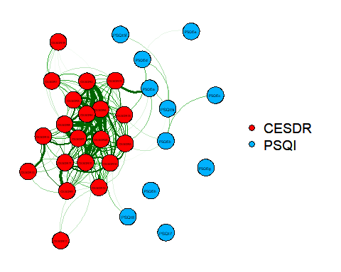

Association network

### Network accuracy and stability

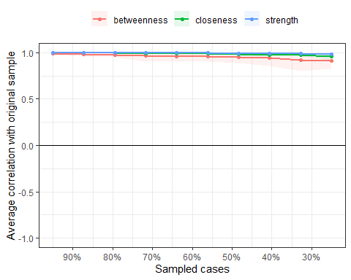

Correlation stability coefficients at varying levels of data dropping