操作预先要准备的工作：

  - 运行rabbitmq-server
  - 运行mysql数据库, 导入数据库，并配置连接信息
  - run worker_meta_direct.py 来接收rabbitmq的消息
  - run proxy server

使用手册
- 用户相关
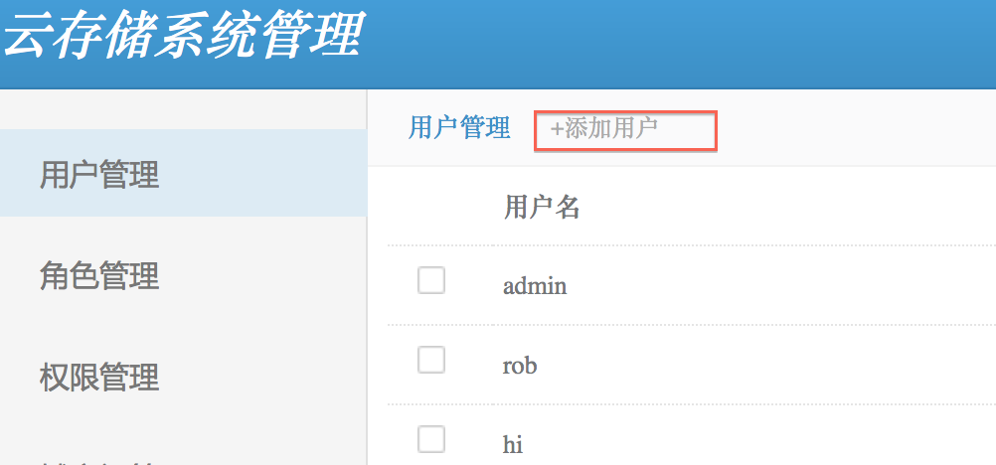
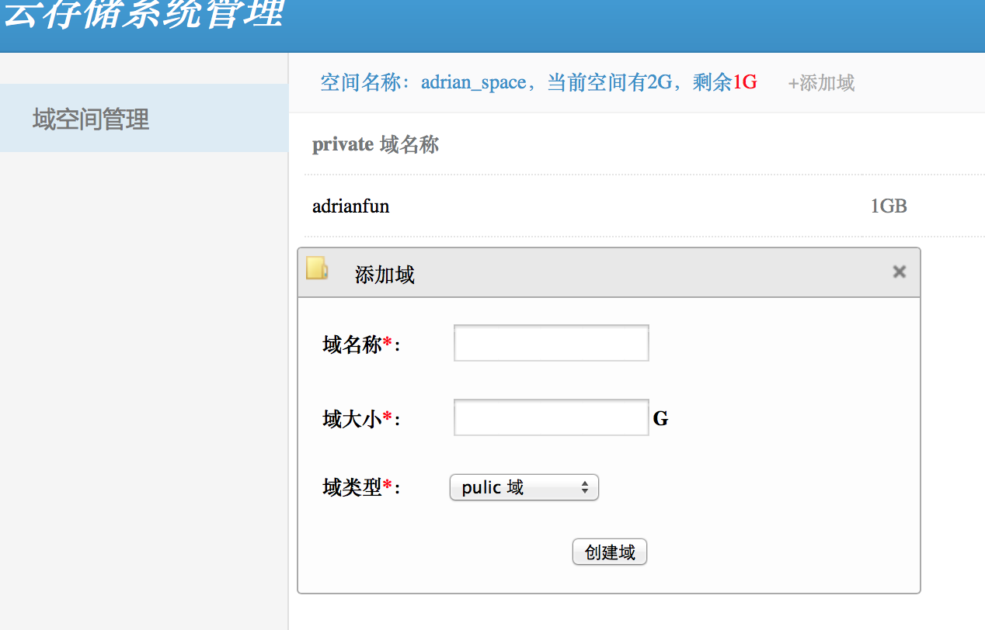
使用GUI创建用户后，如果用户不在user_space中建立域空间，则认为此用户不可用。

用户创建步骤：
  - 管理员在GUI见面上点击[添加用户]，默认添加用户的space空间为2G
  - 指定用户名和用户密码
  - 使用该用户名和密码登陆GUI
  - 选择创建域【可选类型：private, public, protected】

- 操作命令

使用curl完成rest操作，分为POST, PUT, GET, DELETE, HEAD 5个部分

curl命令：

格式 | 意义
-i | 回显response头信息
-H | 指定文件头， 多个头需要多个-H
--data-binary | 以二进制方式上传本地文件
-X | 指定curl方式，可以指定POST, PUT, GET, DELETE, HEAD等

- 操作

操作 | 格式
domain操作 | http://[host_url]/scloud_domain/[domain_name]
container操作 | http://[host_url]/scloud_container/[domain_name]/[container_name]/[container...]
object操作 | http://[host_url]/scloud_object/[domain_name]/[container_name]/[container...]/[object_name]
capability操作
queue操作

- 举例

curl -i -H "X-Auth-Key: ADMIN" -H "X-Auth-User: admin" http://localhost:8080/scloud_object/admin/haha/helloadrian.html --data-binary "@love.html" -X PUT

'''
@important
the server listen on port :8080
server port can be changed if any conflict occurs
---------------------------

目前支持的几大对象：
domain, container, object, capability
---------
domain: 逻辑域，用户权限管理单元，孩子节点为container
container: 文件夹， 孩子节点为container 和 object【底层云存储实现应该是flat结构，这里做了扩展】
object：文件， 最终存储在文件系统上
capability： 功能对象， 标明domain， container， object几大对象针对当前用户开放的功能
----------

具体操作：
0.查看 domain[public, protected, private]
1.创建、查看、罗列、删除 container
2.修改、获取container的访问权限[public_read, public_read_write, private]
3.上传、查看、罗列、删除 Object
4.查看 capability

----------not finished yet
5.对于大文件支持分片上传(Multi-Part Upload)
6.访问时支持If-Modified-Since和If-Match等HTTP参数

公共请求头（5个）：
Content-Type, host, X-CDMI-Specification-Version, Authorization, date
通过如下代码获得：
self.content_type = req.headers.get('Content-Type', '')
self.host = req.headers.get('host', '')
self.cdmi_version = req.headers.get('X-CDMI-Specification-Version', '')
self.authorization = req.headers.get('Authorization', '')
self.date = req.headers.get('date', '')
公共响应体(8个):
objectType, objectID, objectName, parentURI, parentID, domainURI, capabilitiesURI, metadata

例子：
Api Url Pattern:
Domain:
PUT: http://[localhost:8080]/scloud_domain/MyDomain HTTP/1.1
[header]
Host: scloud.ecust.com
Accept: application/scloud-domain
Content-Type: application/scloud-domain-public[private, protected]
X-CDMI-Specification-Version: 1.0.2
Date: Fri, 24 Feb 2012 07:18:48 GMT
Authorization: scloud x-user-name: x-user-key
GET: http://[localhost:8080]/scloud_domain/MyDomain HTTP/1.1
[header]
Host: scloud.ecust.com
Accept: application/scloud-domain
Content-Type: application/scloud-domain-public[private, protected]
X-CDMI-Specification-Version: 1.0.2
Date: Fri, 24 Feb 2012 07:18:48 GMT
Authorization: scloud x-user-name: x-user-key
DELETE: http://[localhost:8080]/scloud_domain/MyDomain HTTP/1.1
[header]
Host: scloud.ecust.com
Accept: application/scloud-domain
Content-Type: application/scloud-domain-public[private, protected]
X-CDMI-Specification-Version: 1.0.2
Date: Fri, 24 Feb 2012 07:18:48 GMT
Authorization: scloud x-user-name: x-user-key
HEAD: http://[localhost:8080]/scloud_domain/MyDomain HTTP/1.1
[header]
Host: scloud.ecust.com
Accept: application/scloud-domain
Content-Type: application/scloud-domain-public[private, protected]
X-CDMI-Specification-Version: 1.0.2
Date: Fri, 24 Feb 2012 07:18:48 GMT
Authorization: scloud x-user-name: x-user-key

Container:
PUT: http://[localhost:8080]/[container]/[the-container]/ HTTP/1.1
[params]
:param container: could be an existing container or zero or many
:param the-contianer: the container u want to create
[header]
Host: domain.scloud.ecust.com
Accept: application/scloud-container
Content-Type: application/scloud-container-pr[prw, pri]
X-CDMI-Specification-Version: 1.0.2
Date: Fri, 24 Feb 2012 07:18:48 GMT
Authorization: scloud x-user-name: x-user-key
DELETE: http://[localhost:8080]/[container]/[the-container]/ HTTP/1.1
[params]
:param container: could be an existing container or zero or many
:param the-contianer: the container u want to delete
[header]
Host: domain.scloud.ecust.com
Accept: application/scloud-container
Content-Type: application/scloud-container-pr[prw, pri]
X-CDMI-Specification-Version: 1.0.2
Date: Fri, 24 Feb 2012 07:18:48 GMT
Authorization: scloud x-user-name: x-user-key
GET: http://[localhost:8080]/[container]/[the-container]/ HTTP/1.1
[params]
:param container: could be an existing container or zero or many
:param the-contianer: the container u want to get
[header]
Host: domain.scloud.ecust.com
Accept: application/scloud-container
Content-Type: application/scloud-container-pr[prw, pri]
X-CDMI-Specification-Version: 1.0.2
Date: Fri, 24 Feb 2012 07:18:48 GMT
Authorization: scloud x-user-name: x-user-key
HEAD: http://[localhost:8080]/[container]/[the-container]/ HTTP/1.1
[params]
:param container: could be an existing container or zero or many
:param the-contianer: the container u want to head
[header]
Host: domain.scloud.ecust.com
Accept: application/scloud-container
Content-Type: application/scloud-container-pr[prw, pri]
X-CDMI-Specification-Version: 1.0.2
Date: Fri, 24 Feb 2012 07:18:48 GMT
Authorization: scloud x-user-name: x-user-key
POST: http://[localhost:8080]/[container]/[the-container]/ HTTP/1.1
[params]
:param container: could be an existing container or zero
:param the-contianer: the container u want to change the container name
[header]
Host: domain.scloud.ecust.com
Accept: application/scloud-container
Content-Type: application/scloud-container-pr[prw, pri]
X-CDMI-Specification-Version: 1.0.2
X-Current-Name: current-name
Date: Fri, 24 Feb 2012 07:18:48 GMT
Authorization: scloud x-user-name: x-user-key
Object:
PUT: http://[localhost:8080]/[container]/[MyObject] HTTP/1.1
[params]
:param container: could be an existing container or many
:param MyObject: the object u want to create
[header]
Host: domain.scloud.ecust.com
Accept: application/scloud-container
Content-Type: application/scloud-object
X-CDMI-Specification-Version: 1.0.2
Date: Fri, 24 Feb 2012 07:18:48 GMT
Authorization: scloud x-user-name: x-user-key
[request body]
{
"mimetype" : "text/plain",
"metadata" : { },
"valuetransferencoding" : "base64"
"value" : "VGhpcyBpcyB0aGUgVmFsdWUgb2YgdGhpcyBEYXRhIE9iamVjdA=="
}
GET: http://[localhost:8080]/[container]/[MyObject] HTTP/1.1
[params]
:param container: could be an existing container or many
:param MyObject: the object u want to get
[header]
Host: domain.scloud.ecust.com
Accept: application/scloud-container
Content-Type: application/scloud-object
X-CDMI-Specification-Version: 1.0.2
Date: Fri, 24 Feb 2012 07:18:48 GMT
Authorization: scloud x-user-name: x-user-key
DELETE: http://[localhost:8080]/[container]/[MyObject] HTTP/1.1
[params]
:param container: could be an existing container or many
:param MyObject: the object u want to delete
[header]
Host: domain.scloud.ecust.com
Accept: application/scloud-container
Content-Type: application/scloud-object
X-CDMI-Specification-Version: 1.0.2
Date: Fri, 24 Feb 2012 07:18:48 GMT
Authorization: scloud x-user-name: x-user-key
POST: http://[localhost:8080]/[container]/[MyObject] HTTP/1.1
[params]
:param container: could be an existing container or many
:param MyObject: the object u want to create
[header]
Host: domain.scloud.ecust.com
Accept: application/scloud-container
Content-Type: application/scloud-object
X-CDMI-Specification-Version: 1.0.2
X-Current-Name: current-name
Date: Fri, 24 Feb 2012 07:18:48 GMT
Authorization: scloud x-user-name: x-user-key

HEAD: http://[localhost:8080]/[container]/[MyObject] HTTP/1.1
[params]
:param container: could be an existing container or many
:param MyObject: the object u want to create
[header]
Host: domain.scloud.ecust.com
Accept: application/scloud-container
Content-Type: application/scloud-object
X-CDMI-Specification-Version: 1.0.2
Date: Fri, 24 Feb 2012 07:18:48 GMT
Authorization: scloud x-user-name: x-user-key
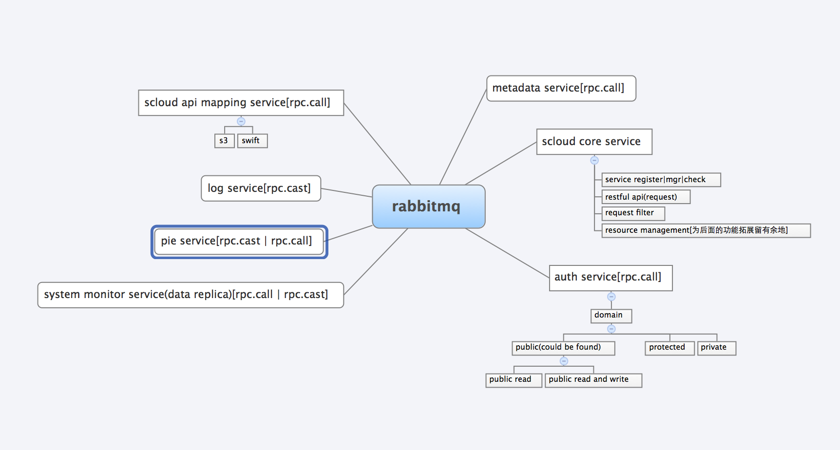

服务组合理念：

- 我们引入了paste.deploy 模块
通过该模块的config file 中的pipeline来进行服务间的工作流组合
组合出来的服务定义为扩展服务
2、 扩展服务之间通过RPC.CALL()和RPC.CAST()给rabbitmq发送消息进行交互， 这里的Rabbitmq相当于消息总线【中间件】， 进行扩展服务与扩展服务之间的消息转发和协作。

TODO

- 修改object的parent_id不能是0，因为会有不同的domain存在
- 实现用户注册GUI和restful互通
- 一个domain内同名文件夹检验
- 文件夹命名规范约定
- 一个container内同名文件检验
- object类型检测（container or object）
- 如果文件夹内有文件，不允许删除文件夹
- 文件夹或者文件重命名【通过post改变metadata】
- 监测模块实现
- 写php, java的的sdk

