**Mesoscale simulation of biomembranes with FreeDTS**

Weria Pezeshkian1* and John H. Ipsen2

1Niels Bohr International Academy, Niels Bohr Institute, University of Copenhagen.

2 MEMPHYS/PhyLife, Department of Physics, Chemistry and Pharmacy (FKF), University of Southern Denmark,

Campusvej 55, 5230 Odense M, Denmark.

*corresponding author: weria.pezeshkian@nbi.ku.dk

**Abstract**

We present OpenDTS software to perform computational research on biomembranes at messocpic length-scale. In this mode a membrane is represented by a dynamically triangulated surface equipped with vertex-based inclusions to integrate the effects of integral and peripheral membrane proteins. The model parameters of these inclusions can be calibrated using finer scale simulation techniques e.g., all atom and coarse grain molecular dynamics or through a top down approach through experimental data. Several algorithms are included into the software that allow for simulation of framed membrane with constant tension, vesicles with various fixed volume or constant pressure difference, confined membranes into the fixed region of the space, constant fixed global curvature and application for external forces on regions of the membrane. In addition, the software allows one to turn off the shape evolution of the membrane and only explore inclusions organization. This allows to take realistic membrane shapes obtained from Cryo-ET and obtain heterogeneous organization of biomolecules which can be backmapped to finer simulations models. In addition to many biomembrane exploration. this software brings us a step closer to simulate realistic biomembranes with molecular resolution. Here we show several interesting show cases of the power of the software and the detail information of how to use the software is included in the associated documents.

**Introduction**

Many biological processes involve large scale changes in lateral chemical organization and geometrical shapes of biological membranes. The modeling of this processes with molecular based simulations is very expensive, not feasible or at least many interesting features would be lost. Therefore, macroscopic modes in which the molecular details are ignored altogether and the membrane is typically represented by a continuous surface and the proteins, as one or few interacting particles, are better suited and a pragmatic choice.

Here, we present OpenDTS for computational investigation of biomembranes at messocpic length-scale. In OpenDTS a membrane is represented by a dynamically triangulated surface equipped with vertex-based inclusions to integrate the effects of integral and peripheral membrane proteins. The model parameters of these inclusions can be calibrated using finer scale simulation techniques e.g., all atom and coarse grain molecular dynamics or through a top down approach through experimental data.

Several algorithms are implemented into OpenDTS to performed complex membrane simulations in conditions mimicking biophysical exploration of complex membranes in wet labs. For instance, it is possible to simulate framed membrane with constant tension and pull a nanotube (membrane tethers). Also, closed membranes, e.g., vesicles, simulations can be performed with various fixed volume, constant pressure difference or/and constant fixed global curvature. Membranes also can be confined into the fixed region of the space to explore the effect of the environment on the membrane shape and fluctuations. In addition, OpenDTS allows one to turn off the shape evolution of the membrane and only explore inclusions organization. This allows to take realistic membrane shapes obtained for instance from cryo-electron tomography and obtain heterogeneous organization of biomolecules which can be backmapped to finer simulations models. This feature with a help of backmapping software e.g., TS2CG, brings us a step closer to simulate realistic biomembranes with molecular resolution. Here we show several interesting show cases of the power of the software and the detail information of how to use the software is included in the associated documents.

**Mesoscopic Membranes**

At mesoscale the molecular detail and interaction can be ignored all together and the system can be described by an energy function that captures membrane bending and the energy associated with mesoscale lateral organization of its chemical constituents. For the membrane deformation the energy of the bending can be well described by Helfrich Hamiltonia that is quadratic in the extrinsic curvature of the surface.

The validity of this for large scale membrane conformation changes has been tested well even some md shows it is good up to ….

However, with a simple argument this could be obtained.… since area is an extensive variable …

For numerical integration, a continuous membrane is discretized by a dynamical triangulated surface (DTS) containing vertices, NT triangles, NL links which together form an irregular planer triangulated network (Figure 1A).

To mimic this model to a realistic system, a vertex should be seen as a segment of a bilayer containing hundreds of lipids, this means that the resolution of the model is limited to the length-scales above few nanometers.

Using a set of discretized geometrical operations, each vertex is furthermore assigned with a normal vector Nˆυ, surface area Aυ (one third of the area of its neighboring triangles), principal curvatures (c1υ, c2υ) and principal directions (X1(υ), X2(υ)) (Ramakrishnan et al., 2010) (Figure 1A). This suffices to construct an elastic energy function associated with membrane bending that allows us to obtain the surface equilibrium configurations using numerical update algorithms.

Length scale definition:

Although this are suggested length scale definition, the code does not care about it and ….

**System evolution**

The difference between dynamical and static triangulation is that the mutual link between two neighboring triangles can flip (Alexander moves). This allows to sample through all possible triangulations for a given . Link flipping and positional updates of the vertices gives the fluid character with full translational invariance in the plane of the surface. To ensure self-avoidance of the surface each vertex is equipped with a spherical bead. In this work, we have employed the Metropolis Monte Carlo algorithm

(Ramakrishnan et al., 2010; Bahrami et al., 2012; van der Wel et al., 2016), but many other updating schemes are possible (Noguchi and Takasu, 2001; Cooke et al., 2005; Noguchi and Gompper, 2006; Peng et al., 2013; Mauer et al., 2018).

**About the code**

**Software**

To run the software, you need a triangulated mesh in q or tsi file format.

Restart with the res file format. Is a binary file

Trajectory is in both tsi and bts file format.

*Visualization*

DTS produces a set of file names as conf(i).vtu that can all be loaded to Paraview for visualization and evaluation of the system. Tsi file format can be visualized using vmd.

*Performance*

Moves and Step

Time for one accepted step

**Results**

1. **Framed membranes**

Flat membranes are very common model of segments of biological membranes as the curvature of typical cellular or model membranes are very large and can be locally considered flat. OPENDTS allows for simulations of flat membranes within a periodic box.

**Framed membrane under tension and tensionless**

Such membrane shows a specific undulation mode that follows

Figure 1 shows the results for such spectrum obtained from the DTS simulations for two situations in which one is tensionless membrane and the other is under tension. For more details on how to perform such a simulation, see SI-section XX.

**Sandwiching tensionless membranes**

Confining a tension less membrane between two rigid walls change the fluctuation spectrum. Such effect can also be investigated using FreeDTS.

Figure XX shows

How area and projected area changes as function of wall thickness

How fluctuation spectrum changes



Figure 1: Membrane undulation spectrum obtained from DTS simulation, (A) tension less membrane (B) membrane under tension of …

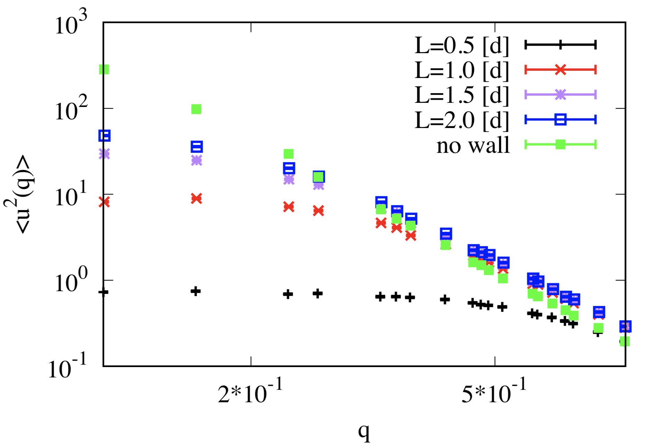

*Figure 2:* Membrane undulation spectrum obtained from DTS simulation for surfaces confined between to rigid wall.

***Proteins, membrane shape deformation***

In the current version, proteins are modelling as in-plane inclusions. These inclusions are vertex based, meaning each protein is mapped into one point. Therefore, only limited choice of this proteins is possible.

180 degree-symmetric inclusions can locally bend the membrane differently in different directions. Such inclusions can thus be given an orientation in the plane of the vertex. Since at each point of a smooth surface only two independent direction could exist, these proteins also can induce different curvature in different direction one parallel to their in-plane orientation and one perpendicular to their inplane direction .

The membrane curvature in these directions can easily be obtained by Eulers curvature formula

And

where is the angle between the orientation of the inclusion and the direction of the main principal curvature of the membrane. Such inclusion will give rise to an additional local contribution to the total elastic energy in Equation (1),

where  and  are the directional bending rigidities imposed by the inclusion on the membrane.

**Lipid and protein domains**

**Protein sorting on mitochondrial membranes**

**Dynamics lipid domains**