1. Creating and Renaming Files/Directories

Create a directory named test_dir using mkdir.

Inside test_dir, create an empty file called example.txt.

Rename example.txt to renamed_example.txt using mv

**Answer :-**

mkdir test_dir    //Create a directory named test_dir

touch test_dir/example.txt    //Create an empty file example.txt inside test_dir

mv test_dir/example.txt test_dir/renamed_example.txt   //rename the file example.txt to renamed_example.txt inside test_dir

**Screenshot -**

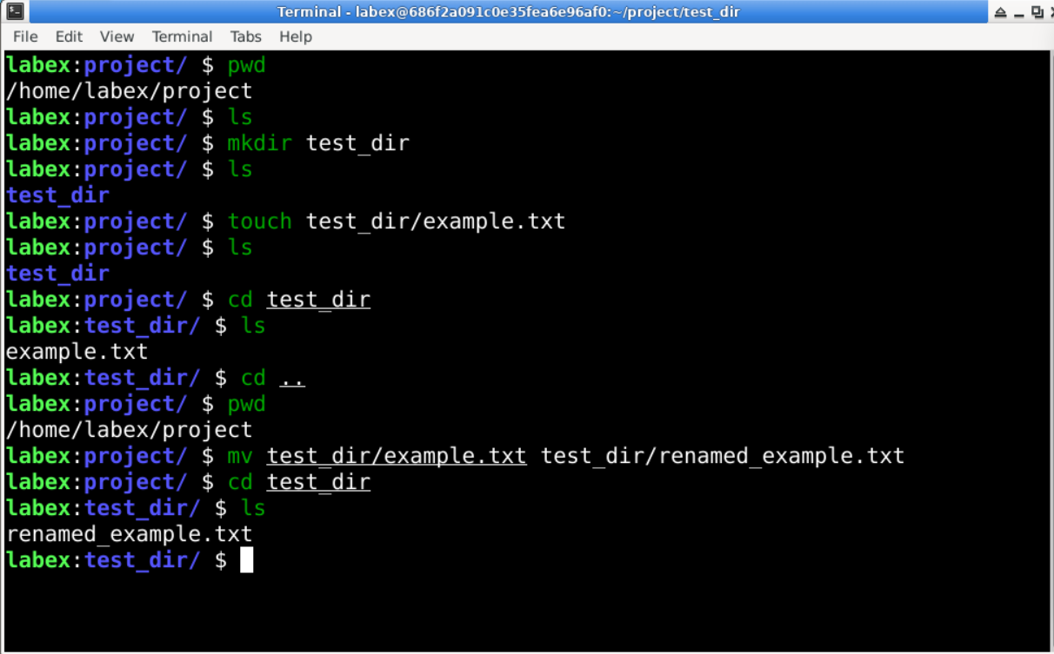

2. Viewing File Contents

Use cat to display the contents of /etc/passwd.

Display only the first 5 lines of /etc/passwd using head.

Display only the last 5 lines of /etc/passwd using tail.

**Answer:-**

cat /etc/passwd    //Display the entire contents of /etc/passwd

head -n 5 /etc/passwd    //Display only the first 5 lines

tail -n 5 /etc/passwd       //Display only the last 5 lines

**Screenshot:-**

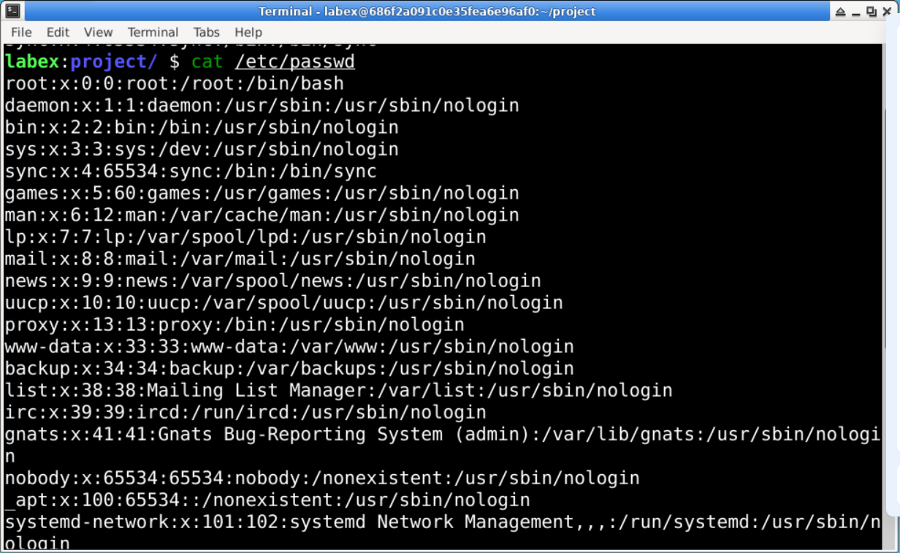

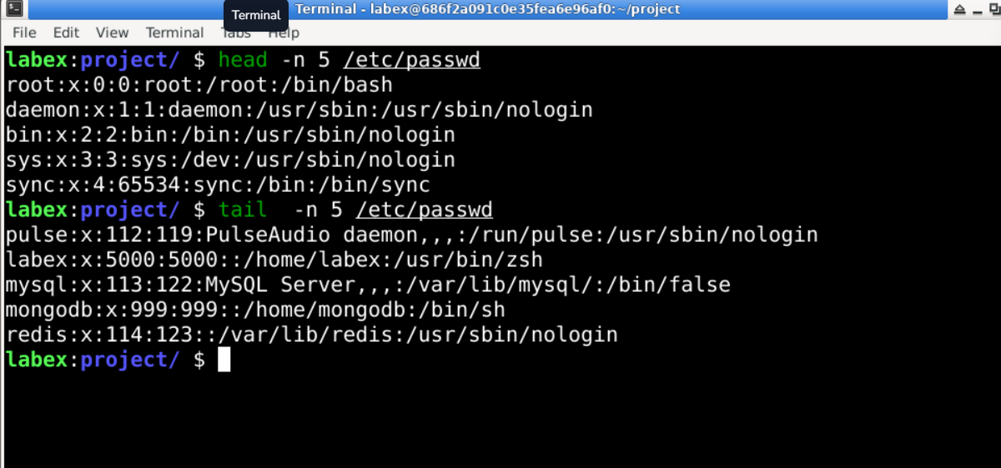

—-----------------------------------------------------------------------------------------------------------------

3.Searching for Patterns

Use grep to find all lines containing the word "root" in /etc/passwd.

**Answer:-**

grep ‘root’ /etc/passwd

**Explanation:-**

grep is used to search for patterns in files.

'root' is the string pattern we are searching for.

/etc/passwd is the file we are searching in.

**Screenshot:-**

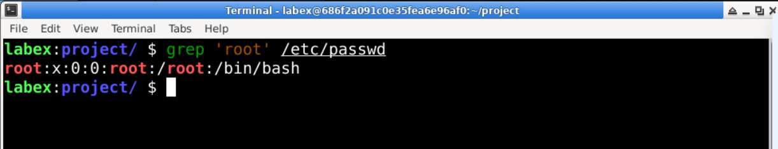

4. Zipping and Unzipping

Compress the test_dir directory into a file named test_dir.zip using zip.

Unzip test_dir.zip into a new directory named unzipped_dir.

**Answer:-**

zip -r test_dir.zip test_dir       //Compress test_dir to test_dir.zip

* -r means recursive, so it includes all files and subdirectories.
* This creates test_dir.zip in the current directory.

unzip test_dir.zip -d unzipped_dir     //unzip test_dir.zip into new dir called unzipped_dir

* -d specifies the target directory for extraction

**Screenshot:-**

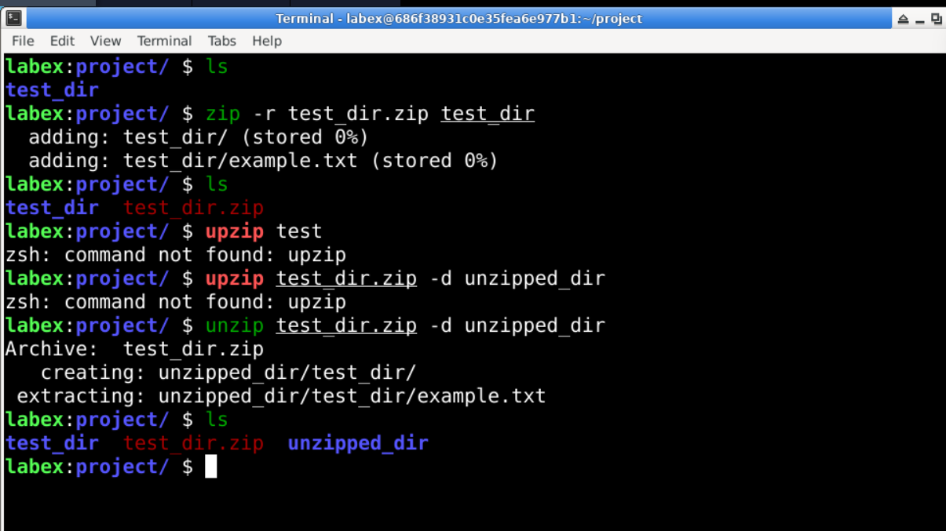

5. Downloading Files

Use wget to download a file from a URL (e.g., <https://example.com/sample.txt>).

Answer:-

wget <https://example.com/sample.txt>

**Explanation:**

wget is a command-line utility to download files from the web.

https://example.com/sample.txt is the URL of the file you want to download.

**Screenshot:**

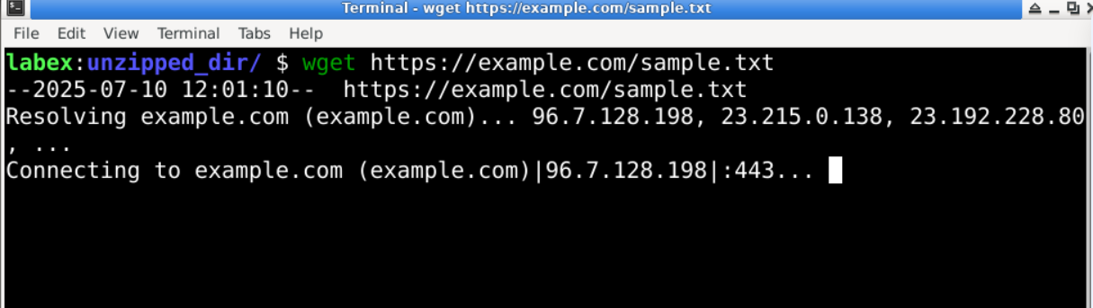

6. Changing Permissions

Create a file named secure.txt and change its permissions to read-only for everyone using chmod.

**Answer:**

touch secure.txt       //create a empty file named secure.txt

chmod 444 secure.txt       //change the permission of the file to ready-only for everyone.

**Screenshot:**

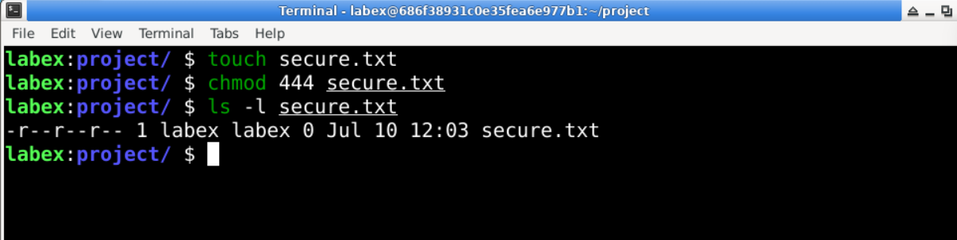

7. Working with Environment Variables

Use export to set a new environment variable called MY_VAR with the value "Hello, Linux!".

**Answer:**

export MY_VAR=”Hello, Linux!”        //Create an env variable called MY_VAR and set it’s value to “Hello, Linux!”

**Screenshot:**



GITHUB REPO Link -