##### Cluster Engagement

**Description:** Cluster an engagement to let the user split a bigger engagement into more specific ones.

To allow an Engagement to be clustered, it must be granted explicit permission to do so by the engagement partner or manager. The user who granted this permission and the hour of this action are then saved on the engagement record. After this, when a user wants to cluster the Engagement, a button on the Engagement Hierarchy component at the right side, named Cluster, is displayed.

This button starts process of clustering and validates that all the criteria conditions are met, then the related lists specified in the custom metadata are cloned to the new Engagement. Also a deifned set of fields are set as null, like the primary product. Setting those values as null is one of the main differences with the cloning process.

**User Stories**: US-4933, US-4514

**Triggers:** Pressing the *Cluster* button; automatically creates the new record.

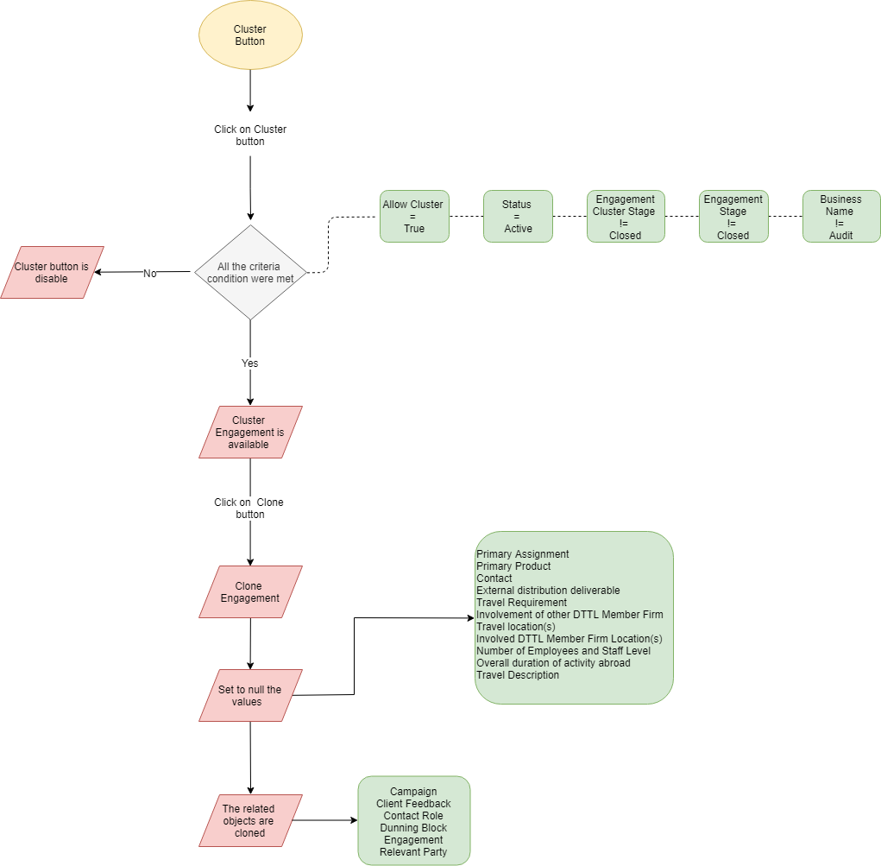

Figure 4. Cluster Technical Flow

**Metadata**

|  |  |
| --- | --- |
| Type | Name |
| Objects and Fields | Engagement (DEAL_AllowCluster__c , DEAL_AllowClusterDate__c ,DEAL_PrimaryAssignment__c, DEAL_AllowClusterEmployee__c, DEAL_Status__c, DEAL_EngagementStage__c, DEAL_PrimaryProduct__c, DEAL_Contact__c, DEAL_ExternalDistributionDeliverable__c, DEAL_DeliverableDistributionLocation__c, DEAL_TravelRequirement__c, DEAL_InvolvementOfOtherDTTLMemberFirm__c, DEAL_TravelLocations__c, DEAL_InvolvedDTTLMemberFirmLocations__c, DEAL_NumberOfEmployeesAndStaffLevel__c, DEAL_EngagementCluster__c, DEAL_ParentId__c, DEAL_OverallDurationOfActivityAbroad__c, DEAL_TravelDescription__c) |
| Lightning Component | DEAL_EngagementHierarchy.cmp |
| Apex Class | DEAL_EngagementHierarchyController (methods: getEngagementParent, getEngagementBusiness, doCloneEngagement, doClone, cloneChildren, prepareSubqueries) |
| Custom Setting | DEAL_AuditProducts |
| Custom Metadata | Clone_Engagements__mdt(Campaign, DEAL_ClientFeedback_c, DEAL_ContactRole_c, DEAL_DunningBlock_c, DEAL_Engagement_c, DEAL_RelevantParty_c) |