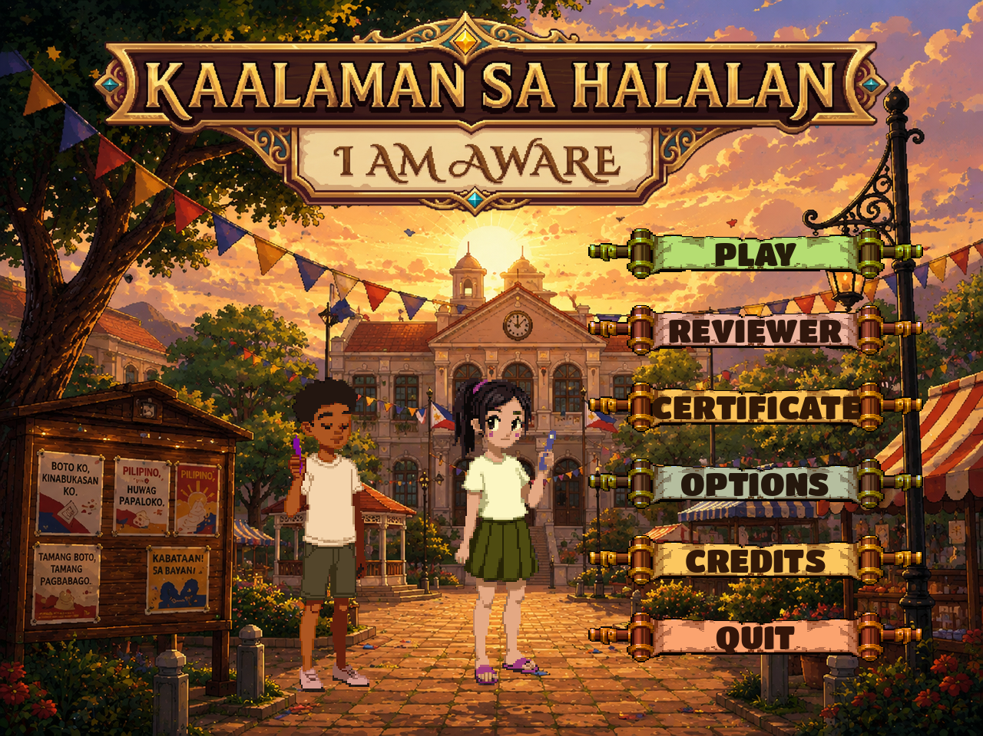
KAALAMAN SA HALALAN
I Am Aware

A Complete Project Write-Up
Design, Implementation, Testing, and Deployment of a
Browser-Based Voter-Education Game
Game Developer
Adriel Jose Villas
Election Officer IV
Atty. Keinth L. Horario
Godot Engine 4.7.1 · GDScript · HTML5
https://kaalamansahalalan.vercel.app
August 2026

Table of Contents
Abstract 5
1. Introduction and Project Background 6
1.1. Overview 6
1.2. Project Origin and Evolution 6
1.3. Development Context 6
2. Statement of the Problem 8
2.1. Passive delivery produces weak retention 8
2.2. Recognition is mistaken for recall 8
2.3. Terminology is the practical barrier 8
2.4. Access and cost constrain distribution 8
3. Objectives 9
3.1. General Objective 9
3.2. Specific Objectives 9
4. Significance of the Project 10
4.1. For students and first-time voters 10
4.2. For teachers and civic educators 10
4.3. For election-education programmes 10
4.4. For the software development discipline 10
5. Scope and Limitations 11
5.1. Scope 11
5.2. Limitations 11
6. Review of the Game Concept 13
6.1. Design Premise 13
6.2. Influences and Departures 13
7. Target Users 14
8. Unique Features 15
9. Gameplay and Game Flow 16
9.1. Flow from launch to certificate 16
9.2. The battle loop 16
9.3. Win, loss, and continuation 17
10. Game Rules and Mechanics 18
10.1. Core parameters 18
10.2. Damage calculation 18
10.3. Board behaviour 19
10.4. Special tiles 19
10.5. Potions 20
11. Characters, Opponents, and Moves 21
11.1. Playable characters 21
11.2. Opponents 21
11.3. Opponent moves 22
12. User Interface and Scenes 24
12.1. Scene inventory 24
12.2. Screens 24
12.3. Responsive layout system 26
12.4. Touch interaction 28
13. System Architecture 29
13.1. Architectural overview 29
13.2. Data flow 29
13.3. Data layer 30
14. Data Storage and Progress 31
14.1. What is stored 31
14.2. What is deliberately not stored 31
14.3. Save format migration 31
15. Educational Content 32
15.1. Provenance and scope 32
15.2. Bank composition 32
15.3. Content categories 32
15.4. Question structure 32
15.5. How difficulty is implemented 33
16. Implementation 34
16.1. Technologies 34
16.2. Principal scripts 34
16.3. Animation system 35
16.4. Audio 35
16.5. Asset inventory 36
17. Certificate and Reviewer Systems 37
17.1. The Reviewer 37
17.2. The Certificate 37
18. Testing and Validation 39
18.1. Approach 39
18.2. Verified results 39
18.3. Content validation 39
19. Deployment 41
19.1. Build and deployment process 41
19.2. Deployment configuration 41
19.3. Delivered artefact 41
20. Challenges and Solutions 42
20.1. Concept: the word game that was not about elections 42
20.2. Multiple choice permitted answering by elimination 42
20.3. Melee attacks visibly failed to connect 42
20.4. Attacks all looked identical 42
20.5. Shared mutable state corrupted animation, twice 42
20.6. The interface was unusable on a phone 43
20.7. Interface panels measured before they had a width 43
20.8. Controls silently refused the size they were given 43
20.9. Deployments succeeded while players saw the old build 43
21. Security, Privacy, Accessibility, and Ethics 45
21.1. Security and privacy 45
21.2. Accessibility 45
21.3. Ethical considerations 45
22. Current Limitations 47
23. Future Enhancements 48
24. Conclusion 49
References 50
Appendix A — Repository Structure 51
Appendix B — Autoload Configuration 51
Appendix C — Display Configuration 51
Appendix D — Scrabble Letter Values Used for Damage 51
Appendix E — Verification Commands 52

Figures and Tables
This document contains 9 figures and 28 tables. Figures are screenshots captured from the running build; tables summarise data read directly from the project source.

Abstract
Kaalaman sa Halalan ("Knowledge in the Election") is a browser-based, single-player educational video game that teaches Philippine electoral literacy through a turn-based word-spelling battle. The player is presented with a fill-in-the-blank civics question and must spell its answer from a six-by-six grid of letter tiles before a difficulty-scaled countdown expires. A correct answer becomes an attack against an opposing character; letting the clock run out surrenders the turn to the opponent. Chapter 1, "Barangay Beginnings," is fully implemented and consists of five sequential encounters against fictional archetypes of electoral misconduct, culminating in a boss fight.
The game is built in the Godot Engine 4.7.1 using GDScript, comprises approximately 7,900 lines of hand-written code across twenty scripts, and is exported to HTML5 for deployment on Vercel. It carries a curated bank of 390 questions, of which 150 belong to Chapter 1, each paired with an explanatory fact drawn from Philippine election law and Commission on Elections (COMELEC) procedure. A Reviewer screen exposes the entire question bank for study outside of play, and a Certificate of Completion is awarded to players who defeat the chapter on Easy, Medium, and Hard difficulty within a single continuous session.
This document records the project in full: its rationale and objectives, its gameplay and rule set, its educational content and alignment with voter-education themes, its software architecture and implementation, the testing and deployment process followed, the technical obstacles encountered and how they were resolved, and an assessment of the system's present limitations alongside recommended future work. Every technical claim herein was verified against the project source at the time of writing.
Keywords: voter education, electoral literacy, educational game, serious games, Godot Engine, GDScript, HTML5, Philippine elections, COMELEC, gamified learning.

1. Introduction and Project Background

1.1. Overview
Voter education in the Philippines is delivered largely through printed material, seminars, and broadcast announcements. These formats reach a wide audience but share a common weakness: they are passive. The recipient reads or listens, and retention depends entirely on attention and motivation that the medium itself does little to create. For younger voters in particular — including first-time voters in the Sangguniang Kabataan (SK) elections, who may be as young as fifteen — the gap between "having been told" and "actually remembering on election day" is wide.
Kaalaman sa Halalan was developed to close part of that gap by turning voter-education content into something a learner must actively produce rather than merely receive. Rather than presenting a fact and asking the player to agree that they have read it, the game withholds a key term, gives a partial hint, and requires the player to reconstruct and physically spell that term from scattered letters under time pressure. Recall is the mechanic, not a side effect of it.

1.2. Project Origin and Evolution
The project passed through two discarded concepts before arriving at its present form. Both are preserved in the repository rather than deleted, so the design reasoning remains auditable.
Iteration | Concept | Outcome
Boto Showdown | A Pokemon-style turn-based trivia battle with multiple-choice answers. | Built and playtested; set aside. Multiple choice permitted correct answers by elimination rather than knowledge. Archived under archive/.
Boto Wyrm / Halalan Wyrm | A Bookworm-style word game: spell any valid dictionary word from adjacent tiles to deal damage equal to word length. | Built; set aside. The word game was engaging but had no necessary connection to election content — any English word served equally well.
Kaalaman sa Halalan (current) | Civics question with a fill-in-the-blank answer that must be spelled on the letter board. The answer is the attack. | Adopted and completed for Chapter 1. Combat progress and learning are the same action.
Table 1.1 — Concept evolution
The decisive insight came from the second iteration. A word game about elections in which any dictionary word works is a word game with an election-themed skin. Making the question's answer the only submittable word — enforced in BoardController.is_submittable() — fused the educational content to the game mechanic so that neither can be bypassed in favour of the other.
A trace of this history remains visible in the codebase: the file halalan-wyrm-overview.md at the repository root still describes the abandoned Bookworm concept and does not reflect the shipped game. It is retained as a historical artefact. The authoritative description of current behaviour is the source code, and it is the source code that this document describes.

1.3. Development Context
The project was developed by a single developer, with electoral subject-matter guidance credited in-game to an Election Officer IV. Development on the current codebase spans commits dated 21 August 2026 through 26 August 2026, with earlier prototype work preserved in the archive directory. The working repository is a Git repository on the master branch.

2. Statement of the Problem
The project addresses four specific, observable problems in the delivery of Philippine voter education.

2.1. Passive delivery produces weak retention
Conventional voter-education material asks nothing of the learner beyond attention. A reader who has skimmed a leaflet on the barangay election process has no way to discover whether the terminology actually stayed with them, and no prompt to try. The material offers no point of failure and therefore no signal of learning.

2.2. Recognition is mistaken for recall
Multiple-choice assessment — the standard interactive format for civics quizzes — measures recognition. A learner can identify the correct option among four without being able to produce the term unaided. This was directly observed during the project's own first iteration, Boto Showdown, and was the reason that concept was abandoned. On election day and in civic conversation, unaided recall is the ability that matters.

2.3. Terminology is the practical barrier
Much of the confusion surrounding elections is vocabulary rather than principle. Terms such as canvassing, proclamation, precinct, certificate of canvass, reactivation, and disenfranchisement carry precise procedural meanings. A citizen who does not hold these terms cannot follow an official announcement, a news report, or a COMELEC advisory, however motivated they may be.

2.4. Access and cost constrain distribution
Educational software distributed as an installable application requires device storage, an installation step, and platform-specific builds. For a public-good tool intended to reach students and first-time voters on whatever device they already own — frequently a mid-range Android phone — an installation barrier meaningfully reduces reach.

3. Objectives

3.1. General Objective
To design, develop, and deploy an accessible, browser-based educational game that improves Philippine electoral literacy by requiring players to actively recall and produce key election terminology within an engaging turn-based game structure.

3.2. Specific Objectives
- To implement a game mechanic in which the answer to a civics question is the only valid game action, so that learning and gameplay progress cannot be separated.
- To develop and validate a question bank of election-related terms, each paired with a short explanatory fact grounded in Philippine election law and COMELEC procedure.
- To implement three difficulty tiers that vary the question pool, the answering time limit, and the proportion of the answer revealed as a hint, so that the same content serves a range of prior knowledge.
- To design a progression structure of sequential encounters that introduces recognisable archetypes of electoral misconduct without depicting any real person, party, or organisation.
- To provide a study mode (the Reviewer) that exposes the complete question bank with answers and explanatory facts for revision outside of gameplay.
- To implement a Certificate of Completion that recognises demonstrated mastery across all three difficulty tiers within one continuous session.
- To deliver the game as an HTML5 web application requiring no installation, playable on desktop, tablet, and mobile browsers.
- To implement a responsive user interface that adapts its layout to phone, tablet, and desktop viewports rather than uniformly scaling a single fixed design.

4. Significance of the Project

4.1. For students and first-time voters
The primary beneficiaries acquire working command of election vocabulary through repeated active production rather than passive reading. The Reviewer screen additionally serves as a structured revision resource covering 390 question-and-answer pairs with explanatory notes.

4.2. For teachers and civic educators
The game provides a self-contained classroom or workshop activity requiring no installation, no user accounts, and no network configuration beyond a browser and a link. Its difficulty tiers allow one activity to serve mixed-ability groups, and the Certificate of Completion supplies a concrete completion artefact.

4.3. For election-education programmes
The system demonstrates a reusable pattern for delivering electoral information: content is stored as plain data (a JSON file) entirely separate from game logic, so subject-matter experts can revise, correct, or extend the question bank without modifying program code or opening the game engine.

4.4. For the software development discipline
The project documents a complete small-scale game development cycle — concept iteration, engine selection, responsive interface engineering, asset production, testing, and web deployment — including two abandoned concepts and the reasoning that led away from them. The responsive-layout subsystem described in Section 12 addresses a problem common to pixel-art games on mobile devices and is generalisable beyond this project.

5. Scope and Limitations

5.1. Scope
The following are implemented, verified in the shipped build, and described in this document.
- Chapter 1, "Barangay Beginnings" — five sequential encounters ending in a boss fight.
- Three difficulty tiers (Easy, Medium, Hard) with sequential unlocking within a session.
- A question bank of 390 entries, 150 of which are scoped to Chapter 1, each with an explanatory fact.
- Two playable characters, Juan and Maria, mechanically identical and differing only in appearance.
- Five opponent characters, each with three telegraphed special moves (fifteen moves in total).
- A six-by-six letter board with four tile types: Normal, Spark, Gold, and Mudslinging.
- Two consumable potions (Health and Power Up), usable as free actions.
- A Reviewer screen with filtering by chapter, difficulty tier, and content category.
- A Certificate of Completion, personalised with the player's name and rendered as a PNG image.
- A responsive interface supporting phone portrait, phone landscape, tablet, and desktop layouts.
- HTML5 export and public web deployment.

5.2. Limitations
The following are explicitly outside the delivered system. They are recorded here so that the scope is not overstated.
Limitation | Detail
Only Chapter 1 is playable | Chapters 2 through 5 appear on the chapter map but are locked and display an "Available Soon" notice. Their question data (240 entries) already exists in the bank, but no encounters, opponents, or artwork have been authored for them.
Single-player only | There is no multiplayer, no leaderboard, and no networked component of any kind.
No user accounts | The game stores no personal data on any server. It has no login, no registration, and no back-end database.
Session-scoped progress | Difficulty progress is deliberately not persisted (see Section 14). Only the fact that a certificate was earned, and the name typed onto it, survive a browser restart.
English-language interface | The interface, prompts, and facts are in English. Answers include Filipino terms (KAGAWAD, PUNONGBARANGAY, SANGGUNIAN), but the game is not translated into Filipino.
No audio narration | All text is read visually. There is no voice-over, screen-reader integration, or text-to-speech.
No formal learning-outcome study | Testing verified that the software functions correctly (Section 17). No controlled study of knowledge gain among learners was conducted, and no claim of measured educational effectiveness is made.
Table 5.1 — Delivered scope boundaries

6. Review of the Game Concept

6.1. Design Premise
The central design decision is that the answer to the civics question is the only word the board will accept. This is enforced in a single method:
func is_submittable(word: String) -> bool:
if word.length() < 3:
return false
if not _required_answer.is_empty():
return word.to_upper() == _required_answer
return WordValidator.is_valid_word(word)
# scripts/board_controller.gd
While a question is on screen, _required_answer holds that question's answer and no other word — however long, however valid in English or Filipino — can be submitted. The dictionary fallback on the final line applies only when the battle scene is launched directly for testing with no question loaded. The consequence is that a player cannot make progress in the game without producing the correct election term, and cannot produce the correct election term without making progress in the game. The two are the same act.

6.2. Influences and Departures
The battle structure borrows recognisably from Bookworm Adventures: a letter grid, word-based attacks, consumable potions, special tiles that reward or punish, and a sequence of opponents with telegraphed attacks. The departures are what make it an educational instrument rather than a word game.
Aspect | Conventional word game | Kaalaman sa Halalan
Valid input | Any dictionary word | Only the current question's answer
Tile selection | Adjacent tiles only (path-based) | Any tile in any order — the constraint is knowledge, not dexterity
Source of challenge | Vocabulary breadth and spatial search | Civics recall under time pressure
Turn loss | Poor word choice | Clock expiry — the opponent acts only when the player fails to answer in time
Reward for success | Score | Damage, plus an explanatory fact displayed for two seconds
Table 6.1 — Departures from the word-game model
The removal of the adjacency requirement is a deliberate accessibility decision. In a conventional word game, adjacency is the puzzle. Here the puzzle is knowing the term; requiring the player to also trace a legal path would add a dexterity barrier unrelated to the learning objective, and would penalise players on small touchscreens.

7. Target Users
User group | Relevance | How the design serves them
Senior high school and college students | Approaching or at voting age; civics is part of the curriculum. | Difficulty tiers accommodate mixed prior knowledge; the Reviewer supports revision; the certificate provides a completion artefact.
First-time and SK voters (15+) | Eligible to vote in Sangguniang Kabataan elections but with little procedural exposure. | Chapter 1 is scoped entirely to barangay and SK elections, the first election most will participate in.
Teachers and civic educators | Deliver voter education in classrooms and workshops. | No installation, no accounts, one shareable link; runs on school desktops and student phones alike.
Election-education programmes and NGOs | Conduct community voter-education drives. | Content is editable plain JSON; the game runs offline-capable in any modern browser once loaded.
General adult voters | May be unfamiliar with procedural terminology despite voting experience. | Easy tier and generous hint reveal provide a low-barrier entry point.
Table 7.1 — Intended user groups
The interface language and reading level assume functional English literacy. The colour palette, font sizes, and touch targets were tuned for readability on small screens, as described in Section 12.

8. Unique Features
The following features distinguish the system. Each has been verified present in the shipped build.
# | Feature | Description
1 | Answer-locked board | The question's answer is the only submittable word, fusing learning to progression.
2 | Guaranteed-solvable board | Every reseed scatters the answer's letters across the grid first, then fills the remainder randomly, so a question can never become unanswerable.
3 | Difficulty-scaled hints | The blank in the prompt is partly pre-filled — 50% of letters on Easy, 34% on Medium, 25% on Hard — with revealed positions spread evenly across the word rather than clustered at the start.
4 | Scrabble-weighted damage | Damage derives from summed Scrabble letter values rather than raw word length, so rarer letters contribute more.
5 | Speed bonus per letter | Answering quickly multiplies damage up to 1.30x, measured in seconds per letter so that long answers are not unfairly judged.
6 | Explanatory fact on success | Each correct answer displays a short sourced fact for two seconds, converting a win into a teaching moment.
7 | Telegraphed opponent moves | The opponent's next special move is always visible before it lands, making the encounter readable rather than random.
8 | Fifteen distinct move animations | Each of the fifteen opponent moves has its own choreography, projectile pattern, colour, and paired cast/impact sound effects.
9 | Twenty player attack styles | Ten per playable character, split between melee and ranged, each with its own sprite clip.
10 | Four tile types | Normal, Spark (bonus damage), Gold (damage multiplier), and Mudslinging (a timed threat that detonates if ignored).
11 | Potions as free actions | Using a potion never consumes the turn, and a potion that would have no effect refuses to be spent.
12 | Continuous-session certificate | The certificate requires Easy, then Medium, then Hard within one unbroken session; leaving resets the climb.
13 | Personalised certificate render | The player's name is composited onto the certificate template at runtime and delivered as a PNG image.
14 | Full-bank Reviewer | All 390 questions, answers, and facts are browsable and filterable outside of play.
15 | Per-device responsive layout | The interface selects one of three authored layouts by device class rather than scaling one fixed design.
16 | Effect density scaling | Visual effect counts scale to the device class, preserving each move's identity while reducing load on phones.
17 | Fictional archetypes only | Opponents represent categories of electoral misconduct; no real person, party, or organisation is depicted.
Table 8.1 — Feature inventory

9. Gameplay and Game Flow

9.1. Flow from launch to certificate
The complete player journey proceeds as follows. Screens named here correspond to the interface elements described in Section 11.
- Title screen. The player chooses Play, Reviewer, Certificate, Options, Credits, or Quit.
- Chapter map. Five chapters are shown. Chapter 1 is unlocked; Chapters 2 to 5 display an "Available Soon" notice when tapped.
- Character select. The player chooses Juan or Maria. The choice is cosmetic; both have identical statistics and clip counts.
- Difficulty select. Easy is available at the start of a session. Medium unlocks only after Easy has been completed in the same session, and Hard only after Medium.
- Encounter banner. A card announces the encounter number and the opponent's name.
- Battle. The core loop described in Section 9.2, repeated until one side reaches zero health.
- Transition. On victory, the player character walks to the right, the screen veils over, and the next encounter begins. Health is partially restored between encounters.
- Chapter completion. Defeating the fifth encounter, the boss Ate Ayuda, completes the chapter at that difficulty tier.
- Certificate. Once Easy, Medium, and Hard have all been completed within one continuous session, the Certificate panel unlocks. The player types a name and receives a personalised PNG.

9.2. The battle loop
One turn of battle proceeds as follows.
- A question is drawn from the bank, filtered to the current chapter and difficulty. Its prompt appears with a partially revealed blank in place of the answer.
- The board reseeds. The answer's letters are scattered to random cells; remaining cells are filled from a weighted letter pool.
- The countdown begins — 30 seconds on Easy, 45 on Medium, 60 on Hard.
- The player taps letter tiles in any order. Each tap lifts the letter into a word tray above the board. Tapping a tile in the tray returns it.
- The player presses Attack. If the assembled word matches the answer, the attack resolves; otherwise the word is rejected and the tiles return.
- On success: damage is calculated (Section 10.2), the player character performs one of ten attack animations, the opponent flinches and loses health, and the question's explanatory fact is displayed for two seconds.
- On clock expiry: the correct answer is revealed and the opponent takes its turn, performing its next telegraphed move and dealing damage.
- The next question is presented and the loop repeats until one side reaches zero health.

The design consequence of step 7 is significant: the opponent acts only when the player fails to answer in time. A player who answers every question correctly and promptly will never be attacked. Damage taken is therefore a direct measure of questions missed, not of chance.
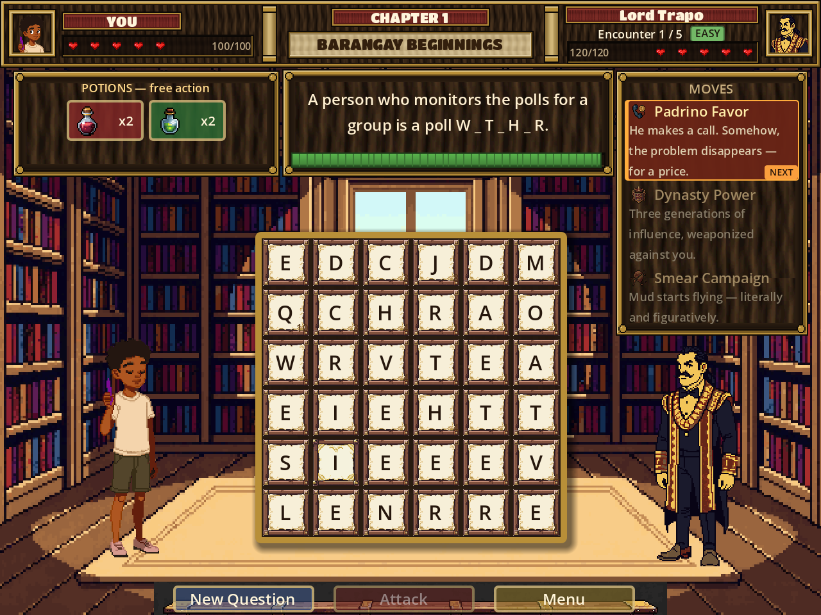
Figure 9.1 — The battle screen on a desktop viewport. The head-up display carries player and opponent health; the question panel shows a partially revealed blank and the countdown bar; the opponent's three moves are listed at right with the next one highlighted; the six-by-six letter board occupies the centre.

9.3. Win, loss, and continuation
Reducing the opponent to zero health wins the encounter. Reaching zero health as the player ends the run and offers Try Again, which restarts the chapter from the first encounter with potion stock reset. There is no permanent failure state and no penalty beyond repeating the chapter.
Between encounters the player recovers 35 percent of maximum health. This is a deliberate softening of the source model, in which health carries over untouched; a full five-encounter chapter with no relief was judged too punishing for the intended age group, while a full heal would render potions pointless.

10. Game Rules and Mechanics

10.1. Core parameters
Parameter | Value | Source constant
Board size | 6 x 6 = 36 tiles | BoardController.COLS, ROWS
Player maximum health | 100 | GameState.player_max_hp
Minimum word length | 3 letters | MIN_WORD_LENGTH
Answering time (Easy / Medium / Hard) | 30 / 45 / 60 seconds | GameState.QUESTION_TIME_BY_DIFFICULTY
Hint reveal (Easy / Medium / Hard) | 50% / 34% / 25% of letters | HINT_REVEAL_BY_DIFFICULTY
Minimum hidden letters | 2 | MIN_HIDDEN_LETTERS
Correct-answer damage multiplier | x2.5 | ANSWER_BONUS_MULTIPLIER
Spark tile bonus | +10 damage | SPARK_BONUS_DAMAGE
Gold tile multiplier | x2 | GOLD_MULTIPLIER
Power Up potion multiplier | x2 (one attack only) | POWER_UP_MULTIPLIER
Health potion restoration | 40 health | HEALTH_POTION_HEAL
Starting potion stock | 2 of each | GameState.STARTING_POTION_COUNT
Between-encounter healing | 35% of maximum | BETWEEN_ENCOUNTER_HEAL_FRACTION
Mudslinging tile spawn interval | every 4 turns | MUD_SPAWN_INTERVAL
Mudslinging tile fuse | 2 ignored turns | MUD_DETONATE_TURNS
Mudslinging detonation bonus | +8 damage to the opponent's hit | MUD_DAMAGE_BONUS
Fact display duration | 2.0 seconds | FACT_PAUSE
Table 10.1 — Core game parameters

10.2. Damage calculation
Damage is computed in WordBattleController._on_word_accepted() by applying a chain of multipliers to a base value. The order is significant and is reproduced here exactly.
- Base. Sum the Scrabble letter values of the submitted word. Common letters (A, E, I, O, U, L, N, S, T, R) are worth 1; D and G are 2; B, C, M, P are 3; F, H, V, W, Y are 4; K is 5; J and X are 8; Q and Z are 10.
- Gold tile. If a Gold tile was used, multiply by 2.
- Spark tile. If a Spark tile was used, add 10.
- Correct answer. If the word is the question's answer, multiply by 2.5 and round.
- Length tier. Multiply by the attack tier factor: 1.00 for words up to 5 letters, 1.25 for 6 to 8 letters, 1.60 for 9 or more.
- Speed tier. Multiply by the speed factor: 1.30 if faster than 0.35 seconds per letter, 1.15 if faster than 0.60, 1.05 if faster than 1.00, otherwise 1.00.
- Power Up. If a Power Up potion is active, multiply by 2 and consume the effect.

Two design decisions are embedded in this chain. First, the base uses Scrabble values rather than word length because letter values track length only loosely — BOTO scores 6 across four letters while BALLOT scores only 8 across six — and a speed bonus could otherwise erase a genuine length advantage. The explicit length-tier multiplier restores a strict ordering, so the fastest possible short word still lands below the slowest long one. Second, speed is measured per letter rather than as elapsed time, because a fourteen-letter answer legitimately takes longer to locate than a four-letter one and judging both against the same stopwatch would make long answers unrewardable.
The speed multiplier never falls below 1.00. Slowness costs the bonus but does not reduce the hit; the countdown clock is already the penalty for taking too long.

10.3. Board behaviour
When a question is presented, BoardController.set_required_answer() reseeds the entire grid. The answer's letters are placed first at randomly chosen cells, and the remaining cells are filled from a weighted pool in which common English letters appear more often. This guarantees that the answer is always spellable. On submission the used tiles clear, the columns above them drop, and fresh letters refill from the top.
Selection has no adjacency constraint. Any tile may be selected in any order, and selection is tracked as an ordered list of grid coordinates; hit-testing derives the cell from the tap position and the current tile pitch, so placement and hit-testing cannot drift apart when tile size changes between device layouts.

10.4. Special tiles
Tile | Behaviour | Player consequence
Normal | Ordinary letter tile. | None.
Spark | One is designated on the board at a time. | Including it in the submitted answer adds 10 flat damage.
Gold | Spawned on a random normal tile after any word of 5 or more letters resolves. | Including it doubles the base damage of the next word that uses it.
Mudslinging | Spawns on a random normal tile every 4 turns while none is present. | If not cleared within 2 turns it detonates, adding 8 damage to the opponent's next hit. Clearing it requires spelling an answer that uses that tile.
Table 10.2 — Tile types
The Mudslinging tile is thematically the opponent's smear campaign made mechanical: ignoring misinformation lets it spread and hurt you. Note that following the removal of the Purify potion (Section 10.5) the tile can only be cleared by spelling through it.

10.5. Potions
Potions are free actions: consuming one never spends the turn, so a player can heal and still attack in the same breath. Each refuses to spend stock when it would have no effect, so a mis-tap at full health does not waste a bottle. Each begins a run with two units and stock resets when a run restarts.
Potion | Effect | Status
Health | Restores 40 health, capped at maximum. | Active
Power Up | Doubles the damage of the next successful attack, then expires. | Active
Purify | Removed contamination (the Mudslinging tile) from the board without costing a turn. | Withdrawn. Starting stock set to zero and the button hidden; the underlying mechanic is intact and can be restored by changing one line in GameState.reset_potions().
Table 10.3 — Potions
The Purify potion was withdrawn at the request of the project owner during mobile testing, on the grounds that its purpose was not legible from its button. Its removal is a deliberate design decision with a known consequence: the Mudslinging tile now has no item counter and must be cleared by spelling through it.

11. Characters, Opponents, and Moves

11.1. Playable characters
Two playable characters are offered. They are mechanically identical — the same clip counts, the same statistics, the same attack pool — so the choice is one of representation rather than strategy. Maria's sprites were generated facing the opposite direction and are mirrored horizontally at display time by a flag rather than being redrawn.
Character | Sprite clips | Attack styles
Juan (male) | idle (5), attack (7), hit (5), walk (9) | 10 — punch, uppercut, kick, throw and variants, split between melee and ranged
Maria (female) | idle (5), attack (7), hit (5), walk (9), mirrored | 10 — kick, punch, throw and variants, split between melee and ranged
Table 11.1 — Playable characters
Each character has ten distinct attack styles rather than one. Melee styles carry the character across the battlefield to strike at close range; ranged styles keep the character in place and send a projectile across the gap. The distances involved are computed at runtime from the two characters' live on-screen rectangles rather than from fixed constants, which is what allows the same combat choreography to work correctly at every screen size (Section 12.3).
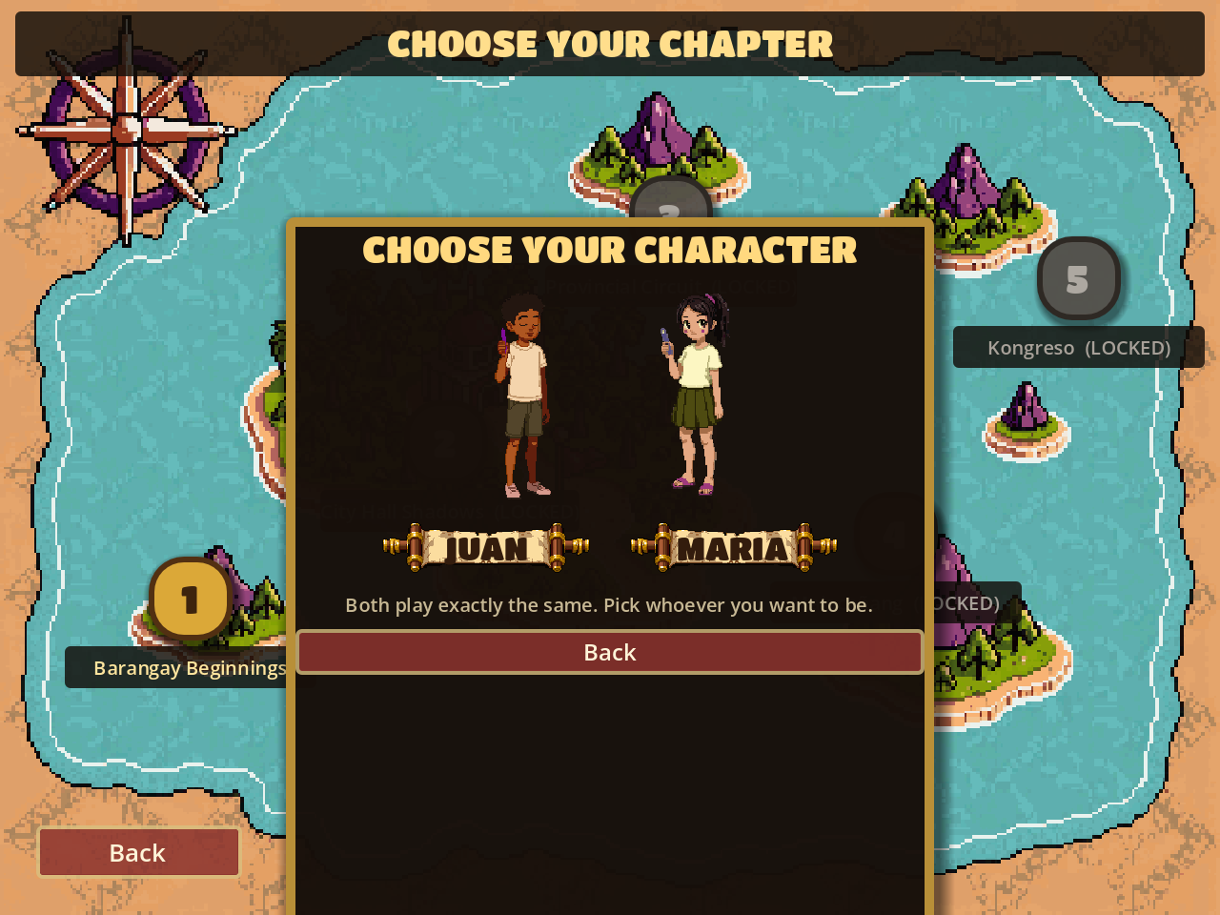
Figure 11.1 — Character selection. Both characters are mechanically identical; the hint text states this explicitly so that the choice is not mistaken for a difficulty decision.

11.2. Opponents
The five opponents of Chapter 1 are fictional archetypes of electoral misconduct. Each represents a category of behaviour rather than an individual. No real person, party, or organisation is depicted, and this constraint was applied throughout development.
# | Name | Title | Health | Archetype represented
1 | Lord Trapo | The Dynasty Heir | 120 | Political dynasty and inherited office
2 | Vote Vandal | The Ballot Defacer | 140 | Ballot tampering and defacement
3 | Senator Sabaw | The Empty Chair | 160 | Empty rhetoric and legislative absenteeism
4 | Kapitan Komisyon | The Ten Percent | 180 | Kickbacks and procurement corruption
5 | Ate Ayuda | The Patroness | 300 | Patronage politics and vote-buying through relief goods (boss)
Table 11.2 — Chapter 1 opponents, in encounter order
Health rises across the chapter from 120 to 180, with the boss at 300 — a deliberate step up rather than a smooth curve, so the final encounter reads as a climax. Opponent lore text, shown in the moves panel, expands each archetype in a sentence or two.

11.3. Opponent moves
Each opponent cycles three special moves in a fixed round-robin order. The next move is always displayed before it is used, so an encounter is readable rather than random. A move's damage lands when the player fails to answer in time.
Opponent | Move | Damage | Animation style
Lord Trapo | Padrino Favor | 6 | curse
Lord Trapo | Smear Campaign | 8 | spray
Lord Trapo | Dynasty Power | 10 | slam
Vote Vandal | Poster Paste | 7 | slam
Vote Vandal | Ballot Defacer | 9 | spray
Vote Vandal | Spray and Run | 11 | lunge
Senator Sabaw | Filibuster | 8 | curse
Senator Sabaw | Word Salad | 10 | volley
Senator Sabaw | Sabaw Splash | 12 | spray
Kapitan Komisyon | Tong Collection | 10 | volley
Kapitan Komisyon | Under the Table | 11 | lunge
Kapitan Komisyon | Ghost Payroll | 13 | curse
Ate Ayuda | Tarpaulin Wall | 12 | slam
Ate Ayuda | Relief Goods Blitz | 14 | volley
Ate Ayuda | Medical Mission | 16 | spray
Table 11.3 — All fifteen opponent moves
The five animation styles describe how a move reads on screen: lunge is one fast bolt with the opponent driving forward behind it; volley is three staggered shots with the opponent recoiling at each; slam has no projectile at all — the opponent looms and the screen takes the impact; spray is a wide fan of small motes; curse is one slow drifting mote that creeps across. Each move additionally carries its own tint colour and its own pair of sound effects (a cast sound and an impact sound), keyed by a stable move identifier so that a move can never end up with one move's picture and another's sound.
The moves system is built from independent components — direct damage, self-healing, status effects on the player, status effects on the opponent, and board-state effects — although only direct damage is exercised by the current move set. The remaining fields exist so that later moves can add persistent effects without changing the data structure.

12. User Interface and Scenes

12.1. Scene inventory
The game comprises two principal scenes and three reusable component scenes.
Scene file | Role
scenes/main_menu.tscn | Title screen and every menu overlay: chapter map, character select, difficulty select, Options, Credits, Reviewer, and Certificate. Overlays rather than separate scenes, so the background and music never restart.
scenes/word_battle.tscn | The battle screen: head-up display, question panel, letter board, character stage, moves panel, control bar, pause overlay, and result overlay.
scenes/ui/letter_tile.tscn | One letter tile, with its four visual types.
scenes/ui/heart_row.tscn | A row of hearts representing a proportion of maximum health.
scenes/ui/hp_bar.tscn | A numeric health bar.
Table 12.1 — Scenes
A notable architectural decision is that several substantial interface panels — the Reviewer, the Certificate, the Options panel, and the entire battle head-up display — are constructed in code rather than authored in the scene file. The reason is practical: the Godot editor rewrites a scene file whenever it saves, silently discarding edits made to that file on disk. Building these panels in code places them beyond the reach of that behaviour.

12.2. Screens
Figure 12.1 — Title screen (desktop). Juan and Maria stand on the plaza; the menu occupies the right.
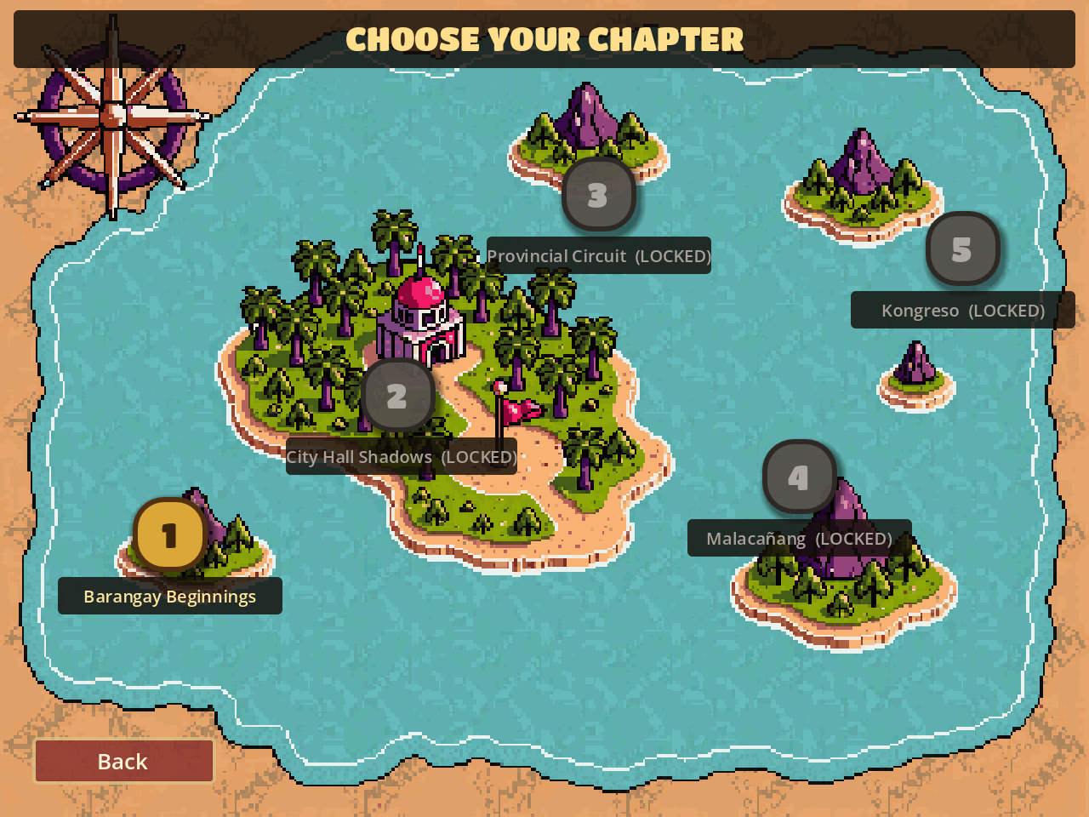
Figure 12.2 — Chapter map (desktop). Chapter 1 is unlocked; the remaining four display an "Available Soon" notice when selected.
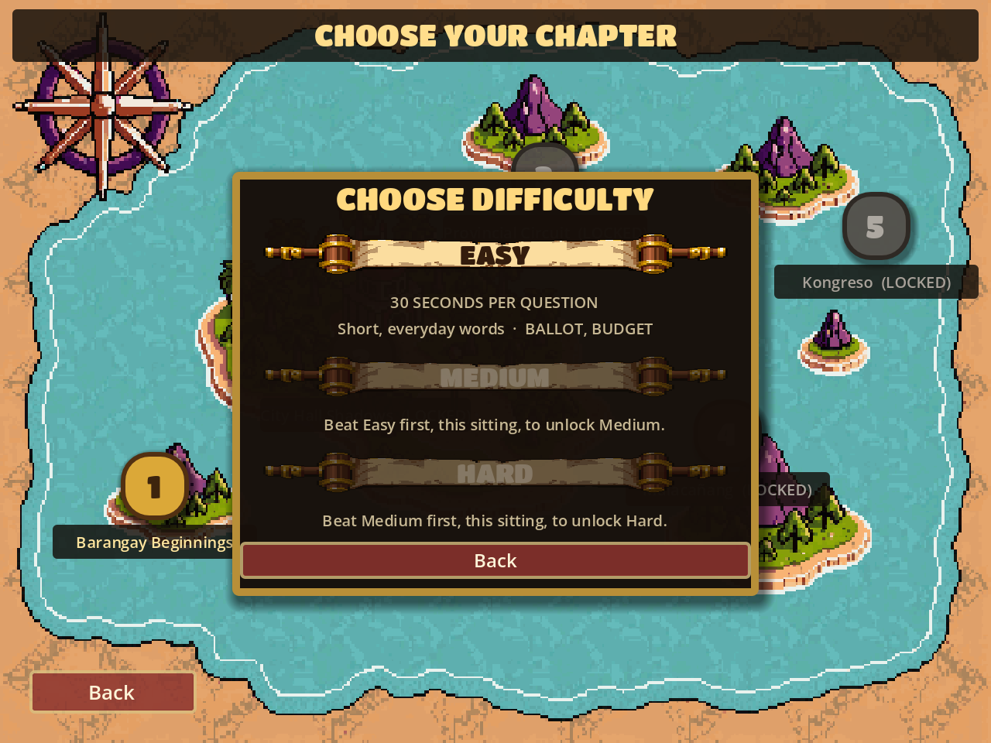
Figure 12.3 — Difficulty selection, showing sequential unlocking. Medium and Hard are dimmed and state the prerequisite explicitly.
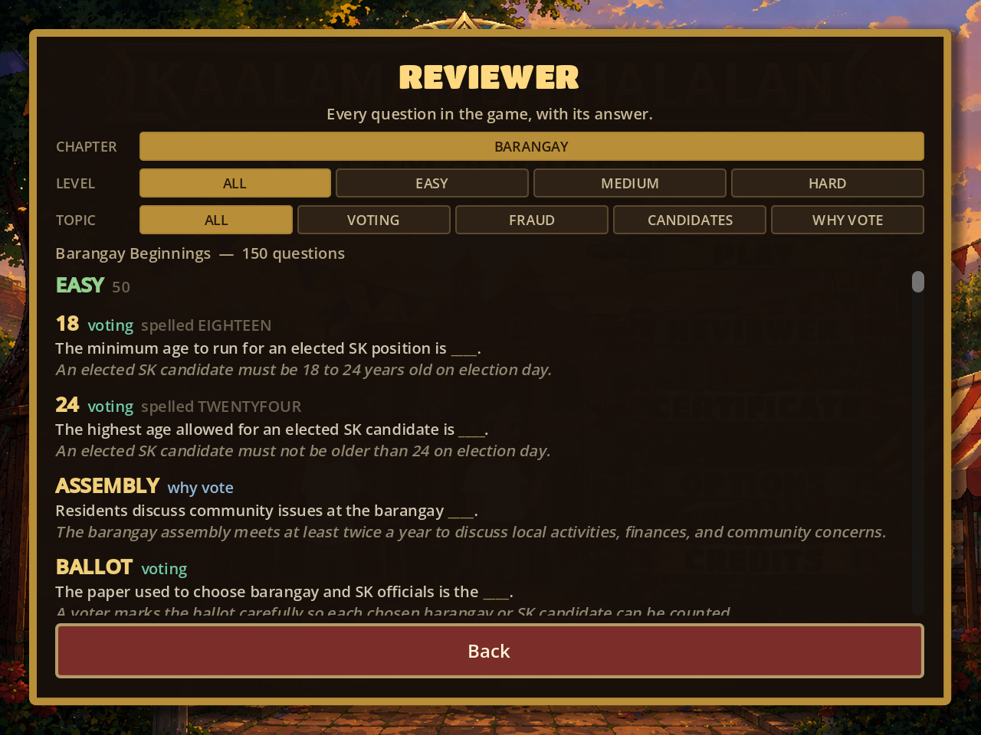
Figure 12.4 — The Reviewer, filtered by chapter, difficulty tier, and content category. Every question, answer, and explanatory fact in the bank is browsable here.

12.3. Responsive layout system
The game was originally authored at a fixed 640 by 480 canvas that was scaled whole into whatever window it was given. On a phone this produced a complete but unusable interface: 36-pixel letter tiles arrived at roughly 22 CSS pixels, half the 44-pixel minimum a fingertip can reliably hit, and 10-pixel hint text fell below reading size.
The solution was a layout director that selects a design canvas per device class and re-places both scenes against it. The key insight is that choosing a *smaller* canvas on a phone is what solves the problem: fewer design units span the same glass, so tiles, buttons, and text all grow by the same factor with no artwork rescaled relative to anything else. One number controls the entire interface's physical size.
Device class | Trigger (CSS pixels) | Base canvas | Layout
Phone portrait | short edge < 600, portrait | 320 x 560 | Stacked
Phone landscape | short edge < 600, landscape | 480 x 270 | Two-column
Tablet portrait | short edge 600-1023, portrait | 480 x 640 | Stacked
Tablet landscape | short edge >= 600, landscape | 640 x 480 | Wide
Desktop | long edge >= 1200 | 640 x 480 | Wide
Table 12.2 — Device classification and layouts
Five device classes collapse to three authored layouts. At a 4:3 aspect ratio every offset in the responsive code evaluates to the original authored value, so the desktop presentation is unchanged by construction rather than by inspection.
Two layout decisions were driven by the artwork rather than by convention. On the title screen, the menu sits *above* the characters in portrait: only the bottom five percent of the plaza background is ground, so a bottom-anchored menu covered all of it and left the characters standing on the town hall roof. On the chapter map, the illustrated map is replaced entirely on compact screens by a list of full-width chapter buttons, because its five pins are placed against landmarks in a 640-pixel-wide picture that can only be shown whole — and shown whole on a phone, its captions fall to about six pixels.
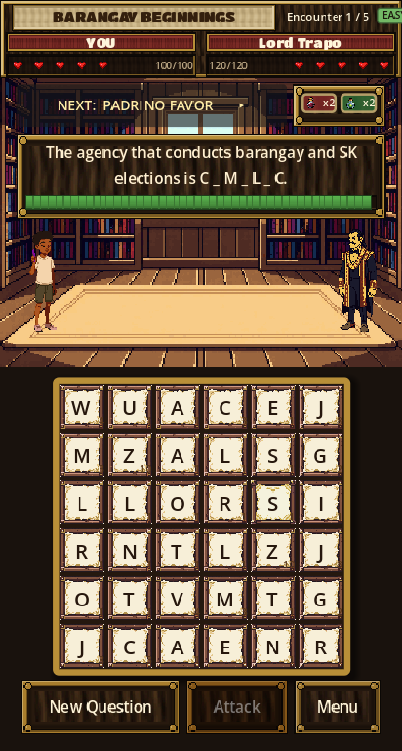
Figure 12.5 — The battle screen in phone portrait. The head-up display is a compact two-deck band; the opponent's move is a tappable strip that expands the full move list; the potions sit beside it; the control bar carries New Question, Attack, and Menu.
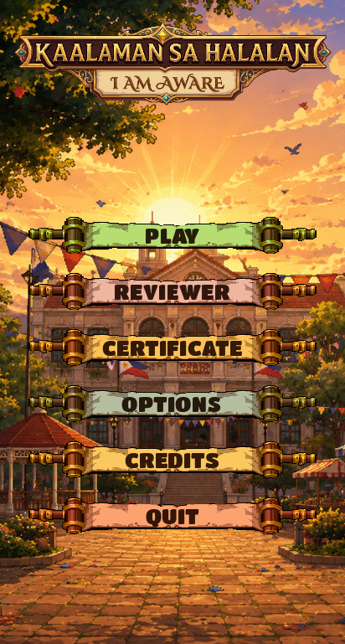
Figure 12.6 — The title screen in phone portrait, with the menu occupying the sky and the characters removed to give the buttons the full width.

12.4. Touch interaction
Every button in the original build assigned a single visual style to all four of its states, so no control changed appearance when held. With a mouse this is merely flat, since the cursor is its own feedback; on a touchscreen it means a tap returns nothing at all, which is precisely when users tap a second time. A shared utility now derives pressed, hover, and disabled appearances from whatever style each button already carries, re-tinting copies of it so that each control keeps its own artwork and only its brightness changes. Controls that deliberately define their own distinct states are detected and left untouched.

13. System Architecture

13.1. Architectural overview
The system follows the scene-and-node architecture of the Godot Engine, with a layer of always-loaded singleton services (Godot terms these autoloads) providing shared state and data access to whichever scene is active.
Singleton | Script | Responsibility
WordValidator | scripts/word_validator.gd | Loads the English and Filipino word lists at startup and answers validity queries.
GameState | scripts/game_state.gd | Holds run-scoped state: chapter, encounter index, chosen character, difficulty, potion stock, certificate status. Owns the save file.
Audio | scripts/audio_manager.gd | Central audio service: one music player plus a pool of eight interchangeable one-shot players.
QuestionBank | scripts/question_bank.gd | Loads and parses the question JSON once at startup; serves questions filtered by chapter and difficulty.
Layout | scripts/ui/layout_director.gd | Classifies the device, sets the window content scale, and notifies subscribed scenes when the layout changes.
Table 13.1 — Autoloaded singleton services

13.2. Data flow
The following describes the path of a single turn through the system.
- The battle controller requests a question from QuestionBank, which returns the next entry from a shuffled lap filtered to the active chapter and difficulty.
- The controller formats the prompt, replacing the blank marker with a partially revealed answer shape, and passes the answer to BoardController.
- BoardController reseeds the grid, guaranteeing the answer's letters are present, and instantiates LetterTile nodes.
- Player taps are received by BoardController, which converts screen position to grid coordinates, updates the ordered selection, and emits signals describing the change.
- The battle controller listens to those signals and updates the word tray and preview text.
- On submission, BoardController validates the word against the required answer and emits either word_accepted (with flags indicating whether Spark or Gold tiles were used) or word_rejected.
- On acceptance the battle controller computes damage, plays the attack sequence, applies the result to the opponent's health, and displays the explanatory fact.
- On chapter completion the battle controller informs GameState, which records the difficulty tier as beaten for this session and, if all three tiers are complete, writes the certificate flag to disk.

Communication between the board and the battle controller is by Godot signals rather than direct calls, which keeps the board ignorant of combat: BoardController knows about words and tiles, and nothing about health, damage, or opponents. This separation is what allowed the board to be resized for mobile without touching combat logic.

13.3. Data layer
Game content is stored as data files separate from code, in two forms.
Path | Format | Contents
data/questions/questions.json | JSON | 390 question entries.
data/chapters/chapter_01.tres | Godot resource | Chapter number, name, and the ordered list of encounters.
data/enemies/*.tres | Godot resource | Five opponent definitions: name, title, health, portrait, background, lore, moves, sprite clip paths and frame counts.
data/moves/*.tres | Godot resource | Fifteen move definitions: identifier, name, description, icon, damage, animation style, effect colour, and optional per-move sprite clip.
data/wordlists/en.txt, fil.txt | Plain text | English and Filipino word lists, 466,978 entries combined, used only in the unfiltered testing mode.
Table 13.2 — Content data files
The question bank is deliberately JSON rather than one Godot resource per question, so that adding or correcting a question does not require opening the game engine. This is what makes the content editable by a subject-matter expert rather than only by a programmer.

14. Data Storage and Progress

14.1. What is stored
The game maintains no server-side storage, no user account, and no database. The only persisted data is a single small JSON file written to the browser's per-origin storage (or, in a desktop build, the user data directory), containing exactly two items: whether a certificate has ever been earned, and the name the player last typed onto a certificate.
{"certificate_earned": {"1": true}, "player_name": "..."}
# user://progress.save

14.2. What is deliberately not stored
Progress *toward* the certificate is intentionally never written to disk. Which difficulty tiers have been beaten is held only in memory, so a fresh process — a page reload, a browser restart — begins that climb again from Easy.
This is a design requirement rather than an oversight. The certificate is meant to attest that a player completed Easy, Medium, and Hard in one continuous sitting; persisting partial progress would let the three tiers be accumulated across weeks, which the certificate would then misrepresent. Making the state run-scoped enforces the rule structurally, so it cannot be circumvented, rather than merely stating it.
A secondary benefit is that this sidesteps a genuine limitation of Godot's HTML5 export, in which writes to persistent storage are synchronised to the browser's IndexedDB asynchronously and are not guaranteed to complete before a page is closed. Because the climb is never written, there is nothing to lose.

14.3. Save format migration
Two earlier save formats existed during development: an initial "completed_chapters" list and an intermediate "completed_difficulties" map. Neither is migrated forward. Both recorded progress in ways that could not distinguish a continuous-session climb from tiers accumulated separately, so crediting them would produce certificates that assert something never demonstrated. A save from before the change begins with the certificate un-earned.

15. Educational Content

15.1. Provenance and scope
A clear distinction must be drawn here. No external voter-education syllabus document exists within this project's repository, and none was supplied to the author of this write-up. The educational content described below is therefore documented as what it demonstrably is: a question bank authored for this project, whose explanatory facts cite Philippine election law and COMELEC procedure. Where this document refers to alignment with voter-education themes, it means thematic correspondence observable in the content itself, not certification against an official curriculum. Any claim of formal syllabus alignment would require review against that syllabus by a competent authority and has not been made here.

15.2. Bank composition
Chapter | Topic scope | Easy | Medium | Hard | Total
1 — Barangay Beginnings | Barangay and SK elections | 50 | 50 | 50 | 150
2 — City Hall Shadows | City and municipal elections | 20 | 20 | 20 | 60
3 — Provincial Circuit | Provincial elections | 20 | 20 | 20 | 60
4 — Malacanang | National executive | 20 | 20 | 20 | 60
5 — Kongreso | Legislature | 20 | 20 | 20 | 60
All chapters |  | 130 | 130 | 130 | 390
Table 15.1 — Question bank composition
Only Chapter 1's 150 questions are reachable in play, since Chapters 2 to 5 are locked. The remaining 240 entries are nonetheless browsable in the Reviewer and are ready for use when those chapters are authored.

15.3. Content categories
Every question carries one of four content-area tags. These are surfaced as filters in the Reviewer.
Category | Focus | Count
voting | The mechanics of registering and casting a ballot | 117
why | Civic rationale — why participation matters | 114
candidate | Offices, qualifications, and candidacy | 91
fraud | Electoral offences and safeguards | 68
Table 15.2 — Content categories (whole bank)

15.4. Question structure
Each entry carries six fields. A seventh, display, is present on 29 entries where the human-readable form of a term differs from how it must be spelled on the board — for instance "PUNONG BARANGAY" against PUNONGBARANGAY.
{
"chapter": 1,
"difficulty": "easy",
"category": "voting",
"prompt": "The choice a barangay resident marks for a local candidate is a ___.",
"answer": "VOTE",
"fact": "In the BSKE, voters choose the Punong Barangay, seven Barangay
Kagawad, and the SK officials they are eligible to vote for."
}
All 390 entries carry a non-empty fact. This is the payload of the exercise: the answer is what the player produces, and the fact is what the game gives back. Facts across the bank reference the Commission on Elections 39 times, the 1987 Constitution 20 times, the Omnibus Election Code 6 times, Republic Act 7166 four times, and Republic Act 12232 twice.

15.5. How difficulty is implemented
Difficulty is not a single multiplier. It varies three independent things at once.
Axis | Easy | Medium | Hard
Question pool | 50 shortest, most fundamental terms | 50 procedural terms | 50 longest and most technical terms
Answering time | 30 seconds | 45 seconds | 60 seconds
Hint reveal | 50% of letters shown | 34% shown | 25% shown
Mean answer length (Chapter 1) | 5.9 letters | 8.9 letters | 12.3 letters
Answer length range | 3-11 letters | 5-14 letters | 4-20 letters
Representative answers | VOTE, BALLOT, KAGAWAD, COMELEC | SUFFRAGE, CANVASSING, BIOMETRICS | DISENFRANCHISED, CERTIFICATEOFCANVASS
Table 15.3 — Difficulty implementation
Note that the answering time *increases* with difficulty. This is deliberate and may appear counter-intuitive: harder tiers pose longer answers — up to twenty letters — which genuinely take more time to locate and assemble on a thirty-six tile board. Holding the clock constant would have made the hardest questions a test of manual speed rather than knowledge. The difficulty menu quotes these same figures to the player before a run begins, reading from the same table the battle uses, so the promise cannot drift from the clock.
The hint reveal is spread evenly across the word rather than clustered at the start, so that the shape of the answer comes through instead of just its opening. At least two letters always remain hidden, so a short answer such as INK is never spelled out in its own prompt.

16. Implementation

16.1. Technologies
Component | Technology | Role
Game engine | Godot Engine 4.7.1 (standard build) | Rendering, scene graph, input, audio, export. The .NET build cannot export to Web and is not used.
Language | GDScript | All game logic. Approximately 7,900 lines across 20 scripts.
Renderer | Forward Plus / OpenGL ES 3.0 via WebGL 2.0 in the browser | Two-dimensional rendering with nearest-neighbour texture filtering to preserve pixel art.
Export target | HTML5 / WebAssembly, single-threaded | Browser delivery without installation.
Hosting | Vercel static hosting | Public deployment with configurable response headers.
Version control | Git | 25 commits on the master branch.
Art production | PixelLab (AI pixel-art generation) | Character sprites, animation clips, portraits, icons, and interface panels.
Fonts | Titan One; Playfair Display | Interface display font; certificate name rendering.
Table 16.1 — Technology stack

16.2. Principal scripts
Script | Lines | Responsibility
word_battle_controller.gd | 3,704 | The battle scene: turn resolution, damage calculation, all attack and move choreography, head-up display construction, the three responsive battle layouts, pause and result overlays.
main_menu.gd | 1,645 | Title screen and all menu overlays: chapter map, character and difficulty selection, Reviewer, Certificate, Options, Credits, and the three responsive menu layouts.
board_controller.gd | 449 | The letter board: grid construction, answer-guaranteed reseeding, selection and hit-testing, clear and refill, and the four tile types.
animated_character.gd | 330 | Sprite clip playback, per-move clip selection, visible-body measurement for melee spacing, and the cut-out rig used for walk cycles.
game_state.gd | 279 | Run-scoped state, potion stock, difficulty unlocking, certificate status, and save file input/output.
settings_panel.gd | 267 | The shared Options panel used by both the title screen and the in-battle pause menu.
audio_manager.gd | 215 | Music and effect playback, volume control, and the one-shot player pool.
layout_director.gd | 201 | Device classification, window content scale, and layout change notification.
question_bank.gd | 199 | Question loading, validation, filtering, and shuffled serving.
touch_feedback.gd | 105 | Derives pressed, hover, and disabled button appearances from each control's existing style.
letter_tile.gd | 103 | One tile's appearance and its four types.
heart_row.gd, hp_bar.gd | 114 | Health display components.
layout_profile.gd | 79 | The immutable per-device layout description passed to every scene.
enemy_move.gd, enemy_data.gd, chapter_data.gd | 133 | Content data class definitions.
word_validator.gd | 31 | Word list loading and validity queries.
status_effect.gd, tile_effect.gd | 28 | Effect data definitions, reserved for future moves.
Table 16.2 — Scripts by responsibility

16.3. Animation system
Character animation uses frame sequences loaded from directories at runtime rather than pre-built sprite sheets. A clip is identified by a directory path and a frame count, because the loader walks frame_0 through frame_N-1 and has no way to count a directory's contents at runtime. Clips are cached on first use.
A significant constraint shaped the combat presentation: each character sheet has only one generic attack clip. Rather than accept fifteen opponent moves that all look alike, each move's identity is carried by its *motion* — how the character moves, how many projectiles cross the screen and in what pattern, what colour they are, and how hard the impact lands. Some moves additionally carry their own generated clip, named on the move itself so that the mapping lives with the move rather than in a lookup table.
For melee attacks the system measures each character's *visible body* rather than its node rectangle. Sprite artwork includes transparent padding, so spacing measured node-to-node left the fighters visibly failing to connect. Measuring the opaque pixel bounds instead, and computing approach distance from those live measurements, produces correct contact at every screen size — melee closes to exactly 22 design units from the opponent's body whether the canvas is 320 units wide or 868.

16.4. Audio
Audio is served by a single autoloaded manager exposing one music player and a pool of eight interchangeable one-shot players, so overlapping sounds — a tile tap during an impact — take separate players rather than cutting each other off. Music sits 11 decibels below effects so that hits and clicks remain legible.
Hurt reactions are stored as arrays and selected at random, so a long encounter does not repeat the same sound on every exchange; the player's reactions are human and the opponents' are distinct, which keeps who was just hit audible without looking at the screen. Each of the fifteen moves carries a paired cast and impact sound, keyed by the same identifier that selects its animation.
One browser-specific accommodation is required: browsers refuse to play audio on a page until the user has interacted with it. Music playback is therefore deferred until the first genuine tap, click, or key press anywhere on the page, rather than being started from the title screen's initialisation, where the browser would silently block it.

16.5. Asset inventory
Category | Count | Notes
Image assets | 283 files | Character animation frames, portraits, backgrounds, interface panels, tiles, move icons, and the certificate template.
Audio assets | 47 files | 3 music tracks, 14 general effects, and 30 move-specific cast/impact effects.
Fonts | 2 families | Titan One (interface display); Playfair Display (certificate name).
Word lists | 466,978 entries | 358,612 English and 108,366 Filipino words.
Table 16.3 — Assets

17. Certificate and Reviewer Systems

17.1. The Reviewer
The Reviewer is a study mode that exposes the entire question bank outside of gameplay. It presents every question with its answer and explanatory fact, filterable by chapter, by difficulty tier, and by content category. Its data access is deliberately separated from the battle's: reading the bank for display touches neither the shuffled lap nor the position within it, so opening the Reviewer cannot disturb a run in progress, and the array it receives is a copy so that sorting or filtering it cannot reorder the bank itself.

17.2. The Certificate
The Certificate of Completion is awarded for defeating Chapter 1 on Easy, then Medium, then Hard, all within one continuous session. The panel displays the player's progress toward this and states the requirement plainly while locked.
On claiming, the player types a name. The system renders that name onto a prepared certificate template at runtime. Because the engine cannot draw text directly onto an image — text is a draw operation and draw operations require a render target — an off-screen viewport is used as a canvas: the template is placed as a background, a label carrying the name is positioned over it, and the result is read back as an image. The name is positioned as a fraction of the template's dimensions rather than in absolute pixels, so the layout holds if the template is ever re-exported at a different resolution.
Delivery differs by platform. In a browser the finished image is opened in a new tab, from which the player saves it by the ordinary means; there is no file written to disk. In a desktop build it is written to the user data directory and opened with the system image viewer.
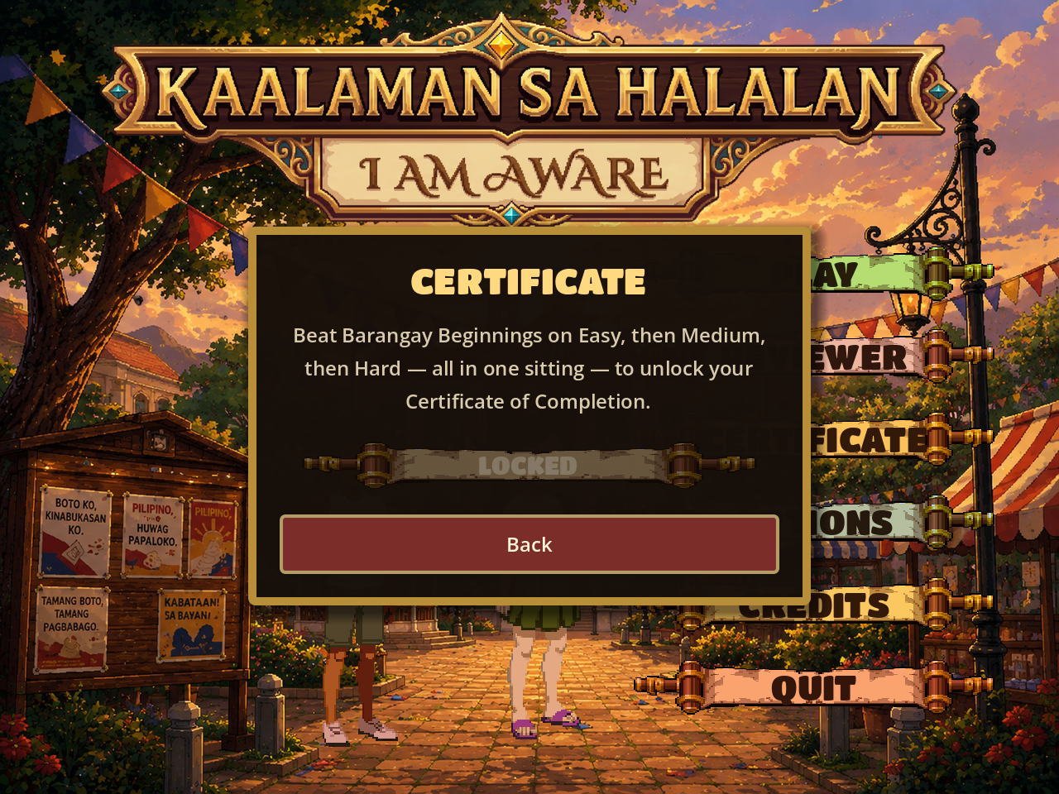
Figure 17.1 — The Certificate panel in its locked state, stating the requirement explicitly.
The unlock condition is checked in one place, consulted by both the panel's appearance and the claim handler, so the two can never disagree. This matters more than it appears: pressing Enter in the name field submits directly to the handler whether or not the claim button is reachable, so a lock enforced only by disabling the button would still hand out certificates.

18. Testing and Validation

18.1. Approach
Testing was conducted by the developer against the running application rather than through an automated unit-test suite. Three complementary methods were used.
Method | Purpose | Coverage
Automated render sweep | Boot each scene at a specified viewport, drive it to a given screen, capture a screenshot and any engine errors or warnings. | Up to 8 viewport sizes x 12 screens = 96 combinations per run.
Geometric assertion | Read back actual on-screen rectangles at runtime and assert properties that cannot be judged reliably by eye — control overlap, melee reach, effect counts. | Control bar overlap at 10 widths; melee reach at 5 sizes; effect density at 3 device classes.
Real-device testing | Play the deployed build on an actual Android phone in a mobile browser. | Six defects found that the render sweep had not caught.
Table 18.1 — Testing methods

18.2. Verified results
Property verified | Method | Result
Zero script errors or warnings | Render sweep, 8 sizes x 12 screens | Clean across all 96 combinations.
Desktop presentation unchanged by the responsive work | Screenshot comparison at 1280x960 | Identical; background rectangle computes to (0,0,640,480) by construction at 4:3.
Melee attacks reach their target at every size | Runtime measurement of body rectangles | Melee closes to exactly 22 design units from the opponent's body at all 5 tested sizes.
No control overlap in the action bar | Pairwise rectangle intersection test | Zero overlaps at 10 widths from 320 to 1920 pixels.
Effect density scales with device class | Peak node and animation counts during the heaviest move | Desktop 14 nodes / 31 animations; tablet 11 / 25; phone 8 / 19.
Save file integrity during testing | Byte-level backup and restore with equality assertion | Player save preserved byte-for-byte across all persistence tests.
Deployed build matches local build | HTTP header and content-length comparison | Byte-identical package size on every deployment.
Table 18.2 — Selected verification results

18.3. Content validation
The question bank is validated at load time. An entry lacking a prompt or an answer is skipped. An answer is rejected as unspellable if it is shorter than three letters, longer than twenty-four, or contains any character outside A to Z — a sanity bound ensuring no malformed entry can produce an answer the thirty-six cell board could never hold. An unrecognised difficulty value defaults to medium rather than failing. All 390 current entries pass.
Question content was reviewed against COMELEC procedure and Philippine election law during development, including a revision to reflect Republic Act 12232 and a later pass narrowing Chapter 1's wording to barangay-and-SK scope specifically. The author of this write-up verified the bank's structure, counts, and internal consistency but is not positioned to certify its legal accuracy; that remains the responsibility of the subject-matter reviewer credited in the game.

19. Deployment

19.1. Build and deployment process
- Export. The standard (non-.NET) Godot 4.7.1 build exports the Web preset to build/web/. The .NET build cannot export to Web at all; the project is pure GDScript, so nothing is lost by using the standard build.
- Configuration copy. vercel.json is copied into build/web/. This step is not optional: build/web is uploaded as the site root, so a configuration file left at the repository root falls outside the upload and is silently ignored.
- Deploy. The Vercel command-line tool uploads build/web as a production deployment.
- Alias. The custom domain alias is repointed at the new deployment. Vercel updates only its own generated alias automatically.
- Verify. An HTTP request confirms a 200 response and that the served package size matches the local build byte for byte.

19.2. Deployment configuration
The export is single-threaded by deliberate choice. A multi-threaded Godot web build requires SharedArrayBuffer, which browsers grant only to pages served with cross-origin isolation headers; hosts unable to set response headers cannot run such a build, and the failure presents as a blank canvas rather than a clear error. A two-dimensional word game has no threaded workload to lose. The isolation headers are nonetheless set in the deployment configuration, so that re-enabling threads would require no other change.
A second configuration point concerns non-resource data files. Godot's "all resources" export filter omits anything the engine does not treat as a resource. The two word lists are plain text and were silently dropped from the first build — the game ran, but the validator was empty, visible only as a browser console warning. An explicit include filter for *.txt corrects this and must be extended for any future non-resource data file.

19.3. Delivered artefact
Property | Value
Public URL | https://kaalamansahalalan.vercel.app
Package size | Approximately 16.3 MB game data plus 39.5 MB engine (WebAssembly)
Transfer size | Approximately 14 MB compressed
Installation required | None — runs in any modern browser
Accounts required | None
Table 19.1 — Deployment characteristics

20. Challenges and Solutions
This section records substantive technical problems encountered during development and how each was resolved. They are included because the reasoning is more instructive than the outcome.

20.1. Concept: the word game that was not about elections
Problem. The second iteration was an engaging word game in which any valid dictionary word dealt damage. Election content was decoration; a player could complete it without learning anything.
Solution. Make the question's answer the only submittable word. Progression and learning became the same act, and the concept became an educational instrument rather than a themed word game.

20.2. Multiple choice permitted answering by elimination
Problem. The first iteration used multiple-choice answers and was playtested. Players reached correct answers by eliminating implausible options rather than by knowing the term.
Solution. Abandon selection entirely in favour of production. Requiring the player to spell the answer removes elimination as a strategy.

20.3. Melee attacks visibly failed to connect
Problem. Characters measured node-to-node were left 85 to 97 pixels apart when the intended gap was 22, because sprite artwork carries transparent padding around the visible figure.
Solution. Measure the opaque pixel bounds of each sprite and compute approach distance from those, cached per texture. As an unplanned benefit, this made combat spacing resolution-independent, which is why the later responsive work required no changes to combat code at all.

20.4. Attacks all looked identical
Problem. All twenty player attack styles appeared the same on screen. Considerable effort was spent adjusting choreography and timing without effect.
Solution. The root cause was not the choreography layer at all: each character had exactly one attack sprite clip, in which only the arm extended. No amount of motion tuning can make a kick look different from a punch when the artwork is identical. Real per-style animation clips were generated and wired so that each style plays its own frames. The episode is a reminder that repeated failed fixes at one layer are evidence that the fault lies at another.

20.5. Shared mutable state corrupted animation, twice
Problem. A single shared dictionary held choreography rest-pose data for both the player and the opponent. Whichever character acted most recently overwrote the other's entry, stranding the player at contact range so that every subsequent attack *appeared* melee regardless of its actual type.
Solution. Key the storage by node identity rather than using one shared slot. The same fault class had occurred earlier with a rendering-order slot; the same fix applied. Shared single-slot state between two symmetric actors is a recurring hazard worth naming.

20.6. The interface was unusable on a phone
Problem. The fixed 640 by 480 canvas scaled whole onto a phone produced 22-pixel letter tiles — half the reliable touch minimum — and sub-legible hint text.
Solution. A layout director selecting a smaller design canvas per device class, so that every element grows by the same factor with no artwork rescaled relative to anything else, combined with three authored layouts rather than one scaled design.

20.7. Interface panels measured before they had a width
Problem. Four separate panels — the Reviewer, the Credits, the moves overlay, and the "Available Soon" notice — each collapsed or overflowed. The shared cause is that Godot computes a container's minimum size from its children's *current* width. A hidden auto-wrapping label asked how tall it needs to be answers as though it had no width at all, reporting every word as its own line; a scrolling container reports almost no minimum height and collapses to nothing.
Solution. Give the element a width, wait one frame, then measure. In the Reviewer's case the constraint was additionally circular — the panel is as wide as its entries and the entries wrap to the panel's width — which was broken by deciding the width from the screen first, rebuilding the entries at that width, and only then sizing the panel.

20.8. Controls silently refused the size they were given
Problem. Buttons in the mobile action bar overlapped. Setting a button's label and font *after* placing it meant that a button whose text needed more room than its allotted slot quietly grew past it, displacing everything downstream.
Solution. Godot clamps a control's size up to its minimum at the moment of assignment. The bar now sets everything affecting a minimum first, measures what each control genuinely needs, then shares out the remaining space — so no control can be squeezed below its minimum and spring back over its neighbour. A two-row fallback engages automatically when one row cannot hold everything comfortably.

20.9. Deployments succeeded while players saw the old build
Problem. Every deployment verified correctly — a 200 response, matching package size — yet the deployed game continued to show a previous build on the project owner's device.
Solution. The game package and engine were served with a cache directive marking them immutable for one year. That directive is only safe when filenames carry a content hash; Godot writes the same filename on every export, so the first visit pinned a player to that build indefinitely. Both are now served with a revalidation directive: an unchanged file answers with a 304 status and a zero-byte body, costing one round trip rather than 16 MB, while a changed file is genuinely fetched. The episode illustrates a verification blind spot worth recording: every check performed was accurate and measured the wrong end of the pipeline. Nothing being tested could have detected a client that had been instructed not to ask.

21. Security, Privacy, Accessibility, and Ethics

21.1. Security and privacy
The system's privacy posture follows from its architecture rather than from policy. It has no server-side component, no user accounts, no authentication, no analytics, and no telemetry. It collects no personal information and transmits none. The only data retained is a single local file holding a certificate flag and a name the player chose to type; that file never leaves the device and is readable only by the game's own browser origin.
The attack surface is correspondingly small: the deployed artefact is a static bundle with no server-side execution and no database. The one input the player supplies — the certificate name — is drawn onto an image rather than being stored in or interpreted by any query, and is capped in length.

21.2. Accessibility
Area | Status
Touch target size | Addressed. Interactive elements are sized to meet the 44 CSS pixel guideline on phones; letter tiles reach 44-56 CSS pixels on a standard phone.
Text legibility | Addressed. Font sizes were raised for compact layouts; text clips with an ellipsis rather than overflowing.
Touch feedback | Addressed. Every control now has a distinct pressed appearance, previously absent throughout.
Hover independence | Addressed. No functionality requires hovering, which touch devices cannot produce.
Time pressure | Partially addressed. Longer answers receive proportionally more time, and the Reviewer offers the same content with no timer at all. There is no option to disable the timer during play.
Colour reliance | Partially addressed. State is generally conveyed by more than colour — the countdown bar also shortens, locked buttons also carry explanatory text — but this was not systematically audited against colour-vision deficiency.
Screen reader support | Not addressed. The game renders to a canvas element; its contents are not exposed to assistive technology.
Keyboard-only play | Not addressed. Play requires pointing at tiles.
Language | Not addressed. The interface is English only.
Table 21.1 — Accessibility measures and gaps

21.3. Ethical considerations
The most consequential ethical decision in the project concerns the depiction of its opponents. Every opponent is a fictional archetype of a *category* of electoral misconduct — dynastic succession, ballot tampering, patronage — and no real person, party, or organisation is depicted, named, or caricatured. This constraint was applied consistently throughout development, including the explicit rejection of a proposal to model an opponent on a real public figure. The Credits panel states the position in the game itself.
This matters for a voter-education tool in a way it would not for entertainment. A game distributed during or near an election period that resembled real candidates would function as campaign material regardless of intent. Keeping the archetypes fictional allows the game to teach how misconduct works without telling anyone whom to vote against.
A second consideration concerns the certificate. It attests to a specific, verifiable achievement — completing all three difficulty tiers in one continuous session — and the rule is enforced structurally rather than by honour. It is a record of engagement with the material and is not represented as an official qualification of any kind.

22. Current Limitations
# | Limitation | Impact and status
1 | Only Chapter 1 is playable | Four fifths of the intended progression is unavailable. Question data exists; encounters, opponents, and artwork do not.
2 | No measured learning outcomes | Educational effectiveness is designed for and argued from mechanism, but has not been demonstrated by study.
3 | Mudslinging tile has no item counter | Following the withdrawal of the Purify potion, the tile can only be cleared by spelling through it. Playability is unaffected; difficulty rose slightly.
4 | Progress cannot be resumed | A player interrupted midway through the three-tier climb must begin again. This is intentional (Section 14.2) but is a genuine usability cost.
5 | No accessibility support for assistive technology | The game is unusable with a screen reader and cannot be played by keyboard alone.
6 | English only | A voter-education tool for a Filipino audience is not available in Filipino.
7 | Large initial download | Approximately 14 MB compressed must be transferred before play begins — a real barrier on a metered or slow connection.
8 | Landscape phone layout is cramped | Playable but tight; portrait is the better experience on a phone and the board is smaller in landscape.
9 | Stale documentation in repository | halalan-wyrm-overview.md describes an abandoned concept and does not reflect the shipped game.
10 | Status and tile effect systems unused | The move data structure supports persistent status effects and board-state effects; no current move uses them.
Table 22.1 — Known limitations

23. Future Enhancements
Recommendations are ordered by the ratio of educational value to implementation cost.
Priority | Enhancement | Rationale
High | Complete Chapters 2 to 5 | The 240 questions already exist. Each chapter needs five opponents, artwork, and a backdrop. This is the single largest gain in educational coverage available.
High | Filipino-language interface | The intended audience is Filipino. Translating prompts, facts, and interface text would substantially widen reach, particularly outside urban centres.
High | Optional untimed practice mode | Removing time pressure would serve anxious learners, slower readers, and classroom settings where discussion is wanted between questions.
Medium | Learning-outcome study | A pre-test and post-test with a student cohort would convert a designed-for educational claim into a measured one, and would be a natural extension for academic work.
Medium | Progress resumption | Allowing a climb to be resumed after interruption while still requiring genuine continuity — for example a time-limited resumption window — would reduce the usability cost of the current rule.
Medium | Reduce initial download | Texture compression and audio re-encoding could meaningfully lower the 14 MB transfer. A progressive loading screen would also improve the perceived wait.
Medium | Wrong-answer review | Recording which questions a player failed and offering them for targeted revision would close the loop between play and study.
Low | Exercise the status effect system | Moves that weaken, slow, or lock tiles are already supported by the data structures and would add tactical variety.
Low | Accessibility pass | Screen-reader support is difficult for canvas-rendered games, but a colour-vision audit and a high-contrast option are achievable.
Low | Teacher dashboard | Aggregate, anonymous class-level results would help educators identify which concepts a group finds hardest. This would require a back-end and a careful revisit of the current no-data-collection position.
Table 23.1 — Recommended future work

24. Conclusion
Kaalaman sa Halalan delivers a complete, publicly accessible educational game that teaches Philippine electoral terminology by requiring players to recall and produce it rather than merely recognise it. Chapter 1 is fully implemented across five encounters and three difficulty tiers, backed by a validated bank of 390 questions each paired with a sourced explanatory fact, and is playable without installation on phone, tablet, or desktop.
The project's central contribution is structural rather than presentational. By making the answer to a civics question the only valid game action, the design removes the gap that ordinarily opens between an educational game's teaching and its playing — the gap through which a player can enjoy the game while learning nothing. That decision was not arrived at by theory but by discarding two working prototypes that each demonstrated the failure in a different form: one that permitted answering by elimination, and one whose subject matter was decorative.
The engineering work is likewise honest about its own history. The responsive layout system, the animation architecture, and the deployment configuration each arrived at their current form through identified faults, several of which are recorded in Section 20 precisely because the reasoning that resolved them is more valuable than the code that resulted. Two of those faults — repeated fixes applied at the wrong layer, and verification that measured the wrong end of a pipeline — are general lessons rather than project-specific ones.
What the project does not claim is equally important. Its educational effectiveness is designed for and argued from mechanism; it has not been measured. Four of its five intended chapters remain unbuilt. It is not accessible to users of assistive technology, and it is not yet available in the language of most of its intended audience. These are stated plainly in Sections 5, 22, and 23 rather than deferred, because a project write-up that overstates its scope is of less use to whoever continues the work than one that marks the boundaries accurately.
Within those boundaries, the system is complete, verified, deployed, and in use.

References
The following sources are cited in the game's own credits or were used in its construction. Legal instruments listed are those referenced within the question bank's explanatory facts.
Republic Act No. 7166 — An Act Providing for Synchronized National and Local Elections and for Electoral Reforms. Referenced in four question-bank facts.
Republic Act No. 12232 — Referenced in two question-bank facts, concerning barangay and SK electoral provisions.
Batas Pambansa Blg. 881 — Omnibus Election Code of the Philippines. Referenced in six question-bank facts.
Constitution of the Republic of the Philippines (1987), Article V (Suffrage). Referenced in twenty question-bank facts.
Commission on Elections (COMELEC) procedural guidance on registration, canvassing, and proclamation. Referenced in thirty-nine question-bank facts.
Godot Engine 4.7.1. Open-source game engine, MIT License. https://godotengine.org
Kerr, T. ("Wolfgang_"). Battle Theme. OpenGameArt.org, Creative Commons Zero (CC0).
Kenney. Music Jingles, Interface Sounds, and Impact Sounds. kenney.nl, Creative Commons Zero (CC0).
Fuenzalida, R. Titan One typeface. SIL Open Font License 1.1.
Playfair Display typeface. SIL Open Font License 1.1.
dwyl/english-words. English word list, Unlicense.
AustinZuniga/Filipino-wordlist. Filipino word list, MIT License.
PixelLab. AI pixel-art generation service, used for character sprites, animation clips, portraits, icons, and interface panels.
Vercel. Static site hosting platform. https://vercel.com

Full licensing detail for all third-party assets is maintained in CREDITS.md at the repository root.

Appendix A — Repository Structure
klhgamefinal/
assets/
audio/ music (3), sfx (14), sfx/moves (30)
images/ 283 files: characters, portraits, backgrounds,
ui, tiles, moves
fonts/ TitanOne-Regular.ttf, PlayfairDisplay-Variable.ttf
certificate/ certificate_template.png
data/
questions/ questions.json (390 entries)
chapters/ chapter_01.tres
enemies/ 5 opponent definitions
moves/ 15 move definitions
wordlists/ en.txt, fil.txt (466,978 words)
scenes/
main_menu.tscn, word_battle.tscn
ui/ letter_tile, heart_row, hp_bar
scripts/ 20 GDScript files (~7,900 lines)
ui/ 9 interface component scripts
build/web/ HTML5 export output (not in version control)
archive/ Superseded concept documents
project.godot, export_presets.cfg, vercel.json
CREDITS.md, DEPLOY.md

Appendix B — Autoload Configuration
Autoloads are registered in project.godot and are instantiated before any scene loads, in the order listed.
[autoload]
WordValidator = "*res://scripts/word_validator.gd"
GameState = "*res://scripts/game_state.gd"
Audio = "*res://scripts/audio_manager.gd"
QuestionBank = "*res://scripts/question_bank.gd"
Layout = "*res://scripts/ui/layout_director.gd"

Appendix C — Display Configuration
[display]
window/size/viewport_width = 640
window/size/viewport_height = 480
window/stretch/mode = "canvas_items"
window/stretch/aspect = "expand"
[rendering]
textures/canvas_textures/default_texture_filter = 0 # nearest neighbour
The stretch mode and aspect settings are what permit the layout director to vary the design canvas at runtime. Nearest-neighbour filtering preserves the pixel-art aesthetic; the scale factor is deliberately not snapped to whole numbers, because doing so would discard exactly the enlargement that makes the phone layout usable.

Appendix D — Scrabble Letter Values Used for Damage
Value | Letters
1 | A, E, I, O, U, L, N, S, T, R
2 | D, G
3 | B, C, M, P
4 | F, H, V, W, Y
5 | K
8 | J, X
10 | Q, Z
Table D.1 — Letter values

Appendix E — Verification Commands
The following commands reproduce the build and deployment described in Section 19, on Windows PowerShell. They are recorded in DEPLOY.md at the repository root.
# 1. Export the web build
& "D:\GODOT\standard\Godot_v4.7.1-stable_win64_console.exe" `
--headless --path . --export-release "Web" `
"D:\klhgamefinal\build\web\index.html"
# 2. Copy the deployment configuration into the build
Copy-Item vercel.json build\web\ -Force
# 3. Deploy
npx vercel deploy build\web --prod --yes
# 4. Verify (expect 200)
(Invoke-WebRequest -Uri "https://kaalamansahalalan.vercel.app" `
-Method Head -UseBasicParsing).StatusCode

