**Computer Science 2**   **Lab # 05**



**Dr. Hanh Pham**

**Student Last Name: Martinez Student First Name: Adriel**

**CS2 Section # 01**

**Due:** Problem A by the **end of the lab** and Problems B by the end of **Saturday** of the same week.

**TOPIC: Review of complete Java programs, standard I/O, If-Else**

**Problem B:**

**Problem Description:**

Write a program that prompts the user to enter the number of students, the students’ names, and their scores, and prints student names in **decreasing order** of their scores.

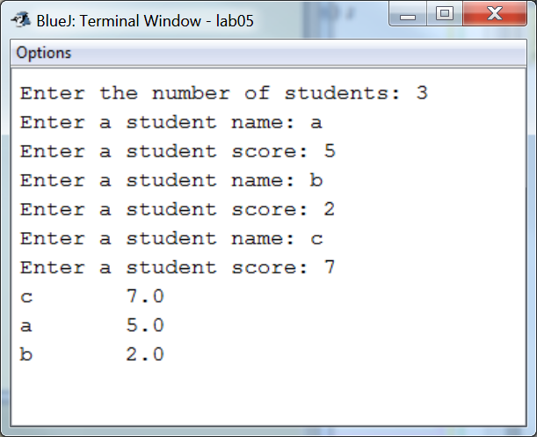

**Analysis:**

(Describe the problem including input and output in your own words. Type your answer in the following with **BLUE font color**)

|  |
| --- |
| **…**  **INPUT: The user will first input the number of students; this number will determine the size for both the name and score arrays. After inputting the number of students, the user will enter a name for the first student, followed by a integer score associated with that student, this is complete once the array is filled (based on number of students).**  **OUTPUT: The output will be a formatted output consisting of the student’s names on the left and their corresponding score on their right. If the array of scores is not in descending order already, then the array of scores will be sorted from greatest to least and swapped, along with their corresponding name.** |

**Design:**

(Describe the major steps for solving the problem. Type your answer in the following with **BLUE font color**)

|  |
| --- |
| **The major steps for solving this problem included how to use selection sort in a way that it will sort the scores array from largest to smallest, as opposed to vice versa. To accomplish this, in the third nested for loop I put if the current element score in the array is larger than the current max score, then the two scores will be swapped around, as well as their corresponding names in names array. Another major step was inputting both the name and their score in two of the same corresponding array elements (names[1] with scores[1]), so it would not be random when sorting.** |

**Coding:** (Copy and Paste Source Code here. Type your answer in the following with **BLUE font color**)

|  |
| --- |
| **import java.util.Scanner;**  **public class StudentScore{**  **public static void main(String[] args){**  **Scanner input= new Scanner(System.in);**  **System.out.print("Enter the number of students: ");**  **int size= input.nextInt();**  **int[] scores= new int[size];**  **String[] names= new String[size];**  **for (int i=0; i<size; i++) {**  **System.out.print("Enter a student name: ");**  **names[i]= input.next();**  **System.out.print("Enter a student score: ");**  **scores[i]= input.nextInt();**  **}**  **for (int i=0; i<size; i++) {**  **for (int j=i; j<size; j++) {**  **int maxIndex= j;**  **int max= scores[j];**  **//**  **for (int k=j+1; k<size; k++) {**  **if (scores[k] > max) {**  **max= scores[k];**  **maxIndex= k;**  **}**  **}**  **if (max != j) {**  **//swap scores**  **int temp= scores[j];**  **scores[j]= scores[maxIndex];**  **scores[maxIndex]= temp;**  **// swap string**  **String temps= names[j];**  **names[j]= names[maxIndex];**  **names[maxIndex]= temps;**  **}**    **}**  **System.out.printf("%-6s %4d\n",names[i],scores[i]);**  **}**  **}**  **}** |

**Testing:** (Describe how you test this program. Type your answer in the following with **BLUE font color**)

|  |
| --- |
| **RUN three times, using the same input as in the sample runs:**  **Test 1:**  **Enter the number of students: 2**  **Enter a student name: Adriel**  **Enter a student score: 84**  **Enter a student name: Alex**  **Enter a student score: 93**  **Alex 93**  **Adriel 84**  **Test 2:**  **Enter the number of students: 3**  **Enter a student name: John**  **Enter a student score: 6**  **Enter a student name: Isabella**  **Enter a student score: 11**  **Enter a student name: Maria**  **Enter a student score: 9**  **Isabella 11**  **Maria 9**  **John 6**  **Test 3:**  **Enter the number of students: 4**  **Enter a student name: John**  **Enter a student score: 85**  **Enter a student name: Jackie**  **Enter a student score: 90**  **Enter a student name: Kevin**  **Enter a student score: 95**  **Enter a student name: Kate**  **Enter a student score: 100**  **Kate 100**  **Kevin 95**  **Jackie 90**  **John 85** |