**Computer Science 2 Lab # 08**



**Dr. Hanh Pham**

**Student Last Name: Martinez Student First Name: Adriel**

**CS2 Section # 01**

**Due:**Problem A by the **end of the lab**and ProblemsBby the end of **Saturday** of the same week.

**TOPIC: File IO & Exceptions (+ String)**

**Project A:**

**Problem Description:** (Occurrences of each letter)

Write a program that prompts the user to enter a file name and display the occurrences of each letter in the file. Must use exceptions. Letters are not case-sensitive. Here is a sample run:

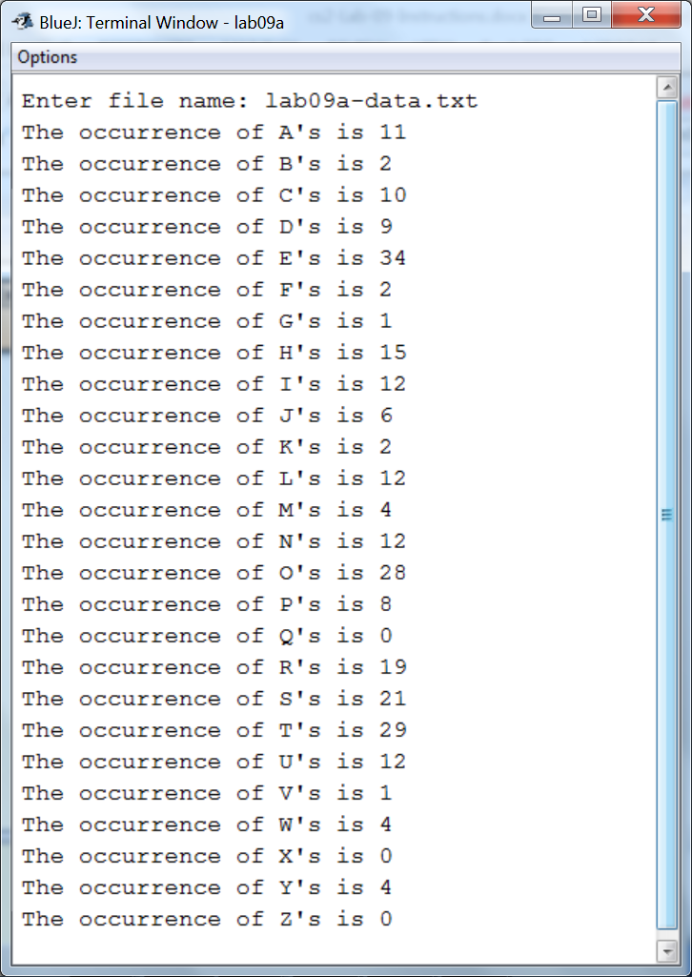

**Analysis:**

(Describe the problem including input and output in your own words. Type your answer in the following with **BLUE font color**)

|  |
| --- |
| **…**  **INPUT: The program will ask the user for a file name (.txt), if that particular file exists in the project folder, the program will run.**  **OUTPUT: The output of this program will be if the file exists in the project folder, the program will run through the entire text file and once it has gone through the entire file, it will display the number of occurrences for each individual character of the alphabet. If the file is not found in the folder, the program will display a FileNotFoundException, displaying that the inputted file name cannot be found.** |

**Design:**

(Describe the major steps for solving the problem. Type your answer in the following with **BLUE font color**)

|  |
| --- |
| **The major steps for solving this problem was to figure out how the scanner will take the file input from the user. In order to achieve this, I created a string called fileLocation, which held the user’s file input, afterwards, in my try statement, I created a new scanner which took in a new file of fileLocation, creating a file object in the process. In order to go through the text file and found out how many times a particular character occurs, I made a new string called text and assigned it to the scanner input’s next line, so the entire line would be made a string and ran the string through a for loop, along with another for loop that goes through a char array of the entire alphabet. Simultaneously, in a nested for loop, a particular character from the text is checking to see if it matches with a particular element of the char array. Eventually when the character from the text equals to the character of the array, a separate array, an integer array of letterIndex is incremented by 1 each time an instance of a particular character is found.** |

**Coding:** (Copy and Paste Source Code here. Type your answer in the following with **BLUE font color**)

|  |
| --- |
| **import java.io.File;**  **import java.io.FileNotFoundException;**  **import java.util.Scanner;**  **public class lab08 {**  **public static void main(String[] args){**  **Scanner input= new Scanner(System.in);**  **File file;**  **char[] x={'A','B','C','D','E','F','G','H','I','J','K','L','M','N','O','P','Q','R','S','T','U','V','W','X','Y','Z'};**  **int[] letterIndex= new int[26];**  **System.out.print("Enter file name: ");**  **String fileLocation= input.next();**  **try(Scanner sc= new Scanner(new File(fileLocation))){**  **do{**  **String text= sc.nextLine();**  **for (int i=0; i<x.length; i++) {**  **for(int j=0; j<text.length(); j++){**  **if (Character.toUpperCase(text.charAt(j))==x[i]) {**  **letterIndex[i]= letterIndex[i]+1;**  **}**  **}**  **}**  **}while(sc.hasNextLine());**  **}**  **catch(FileNotFoundException e){**  **System.out.print(e);**  **System.exit(-1);**  **}**  **for(int k=0; k<letterIndex.length; k++){**  **System.out.println("The occurance of "+ x[k]+"'s is "+ letterIndex[k]);**  **}**  **}**  **}** |

**Testing:** (Describe how you test this program.Type your answer in the following with **BLUE font color**)

|  |
| --- |
| **RUN three times, using the same input as in the sample runs:**  **Test 1:**  **Enter file name: cs2-lec08.txt**  **The occurrence of A's is 78**  **The occurrence of B's is 21**  **The occurrence of C's is 42**  **The occurrence of D's is 21**  **The occurrence of E's is 81**  **The occurrence of F's is 11**  **The occurrence of G's is 9**  **The occurrence of H's is 22**  **The occurrence of I's is 39**  **The occurrence of J's is 12**  **The occurrence of K's is 3**  **The occurrence of L's is 31**  **The occurrence of M's is 26**  **The occurrence of N's is 42**  **The occurrence of O's is 53**  **The occurrence of P's is 10**  **The occurrence of Q's is 1**  **The occurrence of R's is 46**  **The occurrence of S's is 50**  **The occurrence of T's is 65**  **The occurrence of U's is 15**  **The occurrence of V's is 12**  **The occurrence of W's is 7**  **The occurrence of X's is 1**  **The occurrence of Y's is 9**  **The occurrence of Z's is 1**  **Test 2:**  **Enter file name: cs2-lec09.txt**  **The occurrence of A's is 24**  **The occurrence of B's is 6**  **The occurrence of C's is 14**  **The occurrence of D's is 13**  **The occurrence of E's is 36**  **The occurrence of F's is 4**  **The occurrence of G's is 12**  **The occurrence of H's is 14**  **The occurrence of I's is 15**  **The occurrence of J's is 1**  **The occurrence of K's is 0**  **The occurrence of L's is 13**  **The occurrence of M's is 18**  **The occurrence of N's is 13**  **The occurrence of O's is 17**  **The occurrence of P's is 12**  **The occurrence of Q's is 1**  **The occurrence of R's is 27**  **The occurrence of S's is 18**  **The occurrence of T's is 18**  **The occurrence of U's is 8**  **The occurrence of V's is 2**  **The occurrence of W's is 2**  **The occurrence of X's is 1**  **The occurrence of Y's is 5**  **The occurrence of Z's is 1**  **Test 3:**  **Enter file name: t.txt**  **java.io.FileNotFoundException: t.txt (No such file or directory)** |