**Computer Science 2 Lab # 08**



**Dr. Hanh Pham**

**Student Last Name: Martinez Student First Name: Adriel**

**CS2 Section # 01**

**Due:**Problem A by the **end of the lab**and ProblemsBby the end of **Saturday** of the same week.

**TOPIC: File IO & Exceptions (+ String)**

**ProblemB:**

**Problem Description:** (*Baby name popularity ranking*)

The popularity ranking of baby names from years 2010 to 2015 can be found at www.ssa.gov/oact/babynames. Copy only the data and store them in files named**babynameranking2010.txt**, **babynameranking2011.txt**, . . . , **babynameranking2015.txt**. Each file contains one thousand lines. Each line contains a ranking, a boy’s name, and a girl’s name. For example, the first two lines in the file **babynameranking2015.txt** are as follows:

|  |
| --- |
| 1 Noah Emma  2 Liam Olivia |

So, the boy’s name Noah and girl’s name Emma are ranked #1 and the boy’s name Liam and girl’s name Olivia are ranked #2. Write a program that prompts the user to enter the year, gender, and followed by a name, and displays the ranking of the name for the year. Must use exceptions. Here is a sample run:

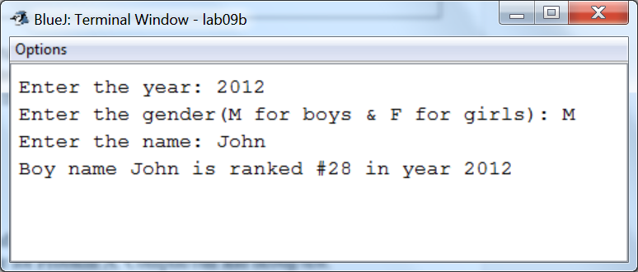

Try to get and create the data files above by yourself so that you learn how to collect and obtain data. If you have problems (you shouldn’t) then you can use the files I’ve got in the lab folder. You must put those files inside your BlueJ working folder.

**Analysis:**

(Describe the problem including input and output in your own words. Type your answer in the following with **BLUE font color**)

|  |
| --- |
| **INPUT: The user will type in year that they want to search names within, then type in a gender (either male or female) and enter in a name that will be searched for within a particular array (based on the two previous inputs).**  **OUTPUT: The output will display the name along with its appropriate rank (if it has a ranking) of that particular year.** |

**Design:**

(Describe the major steps for solving the problem. Type your answer in the following with **BLUE font color**)

|  |
| --- |
| **The major steps to solving this problem started with taking the baby name ranking files and storing it in a way where they will be the most accessible to search through. Since the text files are all names, I made two 2D arrays (Of string type), one for all the boy names and the other for all the girls names, along with 1000 rows each for all the names. Followed by this is the creation of a file object, which allow all the text files to be taken in by the scanner. In my try statement, I filed both boys and girls’ name arrays simultaneously for each year (based on the i of the for loop, i signified the year’s last digit). For the catch, if an error is detected, an exception is thrown, and the printStackTrace method will print out error and on what line it occurred. In order to check whether the user’s name input is present in the ranking list, I created a method that took in the parameters of an array (Depends on the input’s gender), the year (also dependent on the user’s input year), and the name the user inputted. In this method, a for loop goes through all names (whether boy or girl) of a certain year and checks whether the user input’s name matches any name in the ranking list. If the names do match, then the method will return the index value of the name, if the name does not exists in the ranking list, the method will return -1.** |

**Coding:** (Copy and Paste Source Code here. Type your answer in the following with **BLUE font color**)

|  |
| --- |
| **import java.util.Scanner;**  **import java.io.*;**  **public class lab08B{**  **public static void main(String[] args) {**  **Scanner input= new Scanner(System.in);**  **//Created arrays for both boys and girls names**  **String[][] boyNames= new String[6][1000];**  **String[][] girlNames= new String[6][1000];**  **//Created file object**  **File file;**  **try{**  **//Files taken in and names put its them in the appropriate array**  **for (int i=0;i<6;i++) {**  **//Scanner takes in text file(s)**  **Scanner kb= new Scanner(new File("Babynamesranking201"+i+".txt"));**  **//In the loop, for each iteration of j, it will fill both arrays with the appropriate name from the scanner**  **int j=0;**  **while (kb.hasNext()) {**  **kb.nextInt();**  **boyNames[i][j]= kb.next();**  **girlNames[i][j]= kb.next();**  **j++;**  **}**  **}**  **}**  **catch(Exception e){**  **//Directs you to where error occured**  **e.printStackTrace();**  **}**  **//User inputs year**  **System.out.print("Enter the year: ");**  **int year= input.nextInt();**  **//User enters gender**  **System.out.print("Enter the gender(M for boys & F for girls): ");**  **char gender= input.next().charAt(0);**  **//User enters name, whether male or female**  **System.out.print("Enter the name: ");**  **String name= input.next();**  **/\*\***  **\* If gender is male:**  **\* SearchName method will use boyNames array along with the user input's year and name**  **\* If returns a number greater than or equal to 1, it displays boy's names with appropriate ranking and year**  **\*/**  **if (gender=='M') {**  **//Displays boy's names with appropriate ranking and year**  **System.out.print("Boy name "+name+" is ranked #"+SearchName(boyNames,year,name)+" in year "+year);**  **}**  **/\*\***  **\* If gender is female:**  **\* SearchName method will use girlsNames array along with the user input's year and name**  **\* If returns a number greater than or equal to 1, it displays girl's names with appropriate ranking and year**  **\*/**  **if(gender=='F'){**  **System.out.print("Girl name "+name+" is ranked #"+SearchName(girlNames,year,name)+" in year "+year);**  **}**  **}**  **/\*\***  **\* This method will return the index value if the name exists within the string array, if not it will return -1**  **\*/**  **public static int SearchName(String[][] names,int year, String name){**  **for(int i=0; i<1000; i++){**  **if(names[year-2010][i].equals(name)){**  **return i+1;**  **}**  **}**  **return -1;**  **}**  **}** |

**Testing:** (Describe how you test this program. Type your answer in the following with **BLUE font color**)

|  |
| --- |
| **RUN three times, using the same input as in the sample runs:**  **Test 1:**  **Enter the year: 2015**  **Enter the gender (M for boys & F for girls): M**  **Enter the name: Adriel**  **Boy name Adriel is ranked #286 in year 2015**  **Test 2:**  **Enter the year: 2010**  **Enter the gender (M for boys & F for girls): F**  **Enter the name: Melissa**  **Girl name Melissa is ranked #157 in year 2010**  **Test 3:**  **Enter the year: 2013**  **Enter the gender (M for boys & F for girls): M**  **Enter the name: Malcolm**  **Boy name Malcolm is ranked #444 in year 2013** |