Introduction - JB

CHAPTER 1
Intro - JB
SOP- Louis
Objectives - Louis
Significance - Adriel
Time and Place - Aby
Scope - Aby
DOT - JB
Conceptual - Josh

CHAPTER 2
RRL 1 - Louis
RRL 2- Louis
RRL 3 - Aby
RRL 4 - Jb
RRL 5 - Josh
RRL 6 - Adriel
RRL 7 - Adriel

CHAPTER 3
Project Design - JB
FDD - Josh
Project and Dev. - Adriel
Operation - Aby
Evaluation - Louis

GUI
Login - Josh
Dashboard - Josh
Members - Aby
Declaration - Aby
Inventory - Louis
Manage Claims - Louis
Budget Vs. Expenses - Adriel
Target vs. Actual - Adriel
Per District - Adriel
Audit Trail -JB
Accounts - JB
Settings - JB

Objectives of the Study - Louis

{ ------------------------------------------ }

Significance of the Study - Me
The development of this study will be essential for both the Philippine Red Cross Cavite Chapter’s Fund Generations Department and the members of the Membership Accident Assistance Benefits (MAAB) Program. Through establishing an effective system to manage member data, and process insurance claims, the system will simplify the overall management of these operations. This will enable the PRC Cavite Chapter to offer improved service to its members and ensure the proper allocation of resources. Additionally, the system will minimize manual errors contributing to the smooth functioning of the organization. With the implementation of this system, the PRC Cavite Chapter will be better equipped to meet the needs of its expanding membership and strengthen its ability to provide prompt and accurate assistance to those in need.
This will also be significant to the researchers and future researchers as they will gain knowledge from the process of creating a system that enhances efficiency in managing membership and claims data. The study will contribute to the field of system development in non-profit organizations. Future researchers can build upon this work to develop similar systems or improve upon the techniques used, exploring new methods to improve service delivery, data accuracy, and operational transparency in such organizations.

Time and Place of the Study - Aby

{ ------------------------------------------ }

REVIEW OF RELATED LITERATURE AND STUDIES

Web designing using HTML, CSS and JavaScript - Josh

Security and Data Privacy in Web-Based Systems - Me
The rapid growth of web applications has increased the risk of cyber threats, making security a top priority. As stated by Gandikota et al. (2023), conducting comprehensive vulnerability assessments and penetration testing is essential in identifying and addressing security flaws that may compromise user data. As web application vulnerabilities, particularly those outlined by Open Worldwide Application Security Project (OWASP) pose significant risks, implementing proactive security measures helps prevent breaches and protect sensitive information. Integrating security practices into the software development life cycle strengthens application integrity and enhances defense against evolving cyber threats.
The Philippines faces increasing cybersecurity threats, ranking second globally in web threat incidents in 2023. A survey revealed that ransomware attacks doubled, significantly impacting businesses and government sectors. The rise in cyber threats highlights the need for stronger cybersecurity measures, improved infrastructure, and stricter compliance with data protection regulations to safeguard sensitive information and prevent unauthorized access (International Trade Administration, 2023). Addressing the growing demand for strong cybersecurity measures, the Republic Act No. 10173 or Data Privacy Act of 2012 establishes a legal framework for safeguarding personal information in both government and private sectors. It mandates the protection of fundamental privacy rights while allowing the free flow of information necessary for innovation and economic growth. Organizations handling personal data must comply with security standards to prevent unauthorized access, disclosure, or misuse (Congress of the Philippines, 2012).
Web-based systems face increasing cybersecurity risks, making strong security measures essential. As stated by Gandikota et al. (2023), vulnerability assessments and penetration testing help prevent data breaches and strengthen system integrity. The Data Privacy Act of 2012 enforces strict data protection policies, aligning with ISO 27001:2022, which promotes a risk-based approach to cybersecurity. Ensuring data security and compliance with privacy regulations is necessary for the web-based application. Implementing security measures during development helps protect user data, reduce vulnerabilities, and maintain user trust. ISO 25010
ISO/IEC 25010 provides a framework for evaluating and ensuring software quality by defining eight key characteristics: functional suitability, reliability, performance efficiency, usability, security, compatibility, maintainability, and portability. These characteristics help assess a software product's overall effectiveness and its ability to meet user and system requirements (ISO/IEC 25010, 2023).
Functional suitability measures how well a system or product performs its intended functions. It includes sub-characteristics such as functional correctness, functional completeness, and appropriateness.
Performance efficiency evaluates the system’s performance relative to the resources it consumes under specified conditions. This characteristic includes time behavior, resource utilization, and capacity.
Compatibility refers to the ability of a product, system, or component to exchange information and perform required functions within a shared hardware or software environment. It consists of co-existence and interoperability.
Usability assesses the extent to which a system can be used effectively, efficiently, and satisfactorily by specified users in a particular context. Its sub-characteristics include appropriateness recognizability, learnability, operability, user error protection, user interface aesthetics, and accessibility.
Reliability determines a system's ability to perform its intended functions under specific conditions for a defined period. It consists of maturity, availability, fault tolerance, and recoverability.
Security focuses on protecting information and data, ensuring only authorized access while maintaining confidentiality and integrity. Its sub-characteristics include confidentiality, integrity, non-repudiation, accountability, and authenticity.
Maintainability is the ease with which a system can be modified to improve functionality, adapt to environmental changes, or correct faults. It includes modularity, reusability, analyzability, modifiability, and testability.

Portability measures the ease with which a system, product, or component can be transferred to different environments, including hardware or software platforms. This characteristic includes adaptability, installability, and replaceability.
Developers utilize ISO/IEC 25010 as a standard evaluation framework to ensure the completeness and quality of a system in all these aspects to improve software reliability and user satisfaction.

METHODOLOGY

Functional Decomposition Diagram (FDD) - Josh

Project Development
This shows the system's design through a flowchart that presents various levels of detail. It ranges from a broad overview to a detailed representation of specific processes within the system.
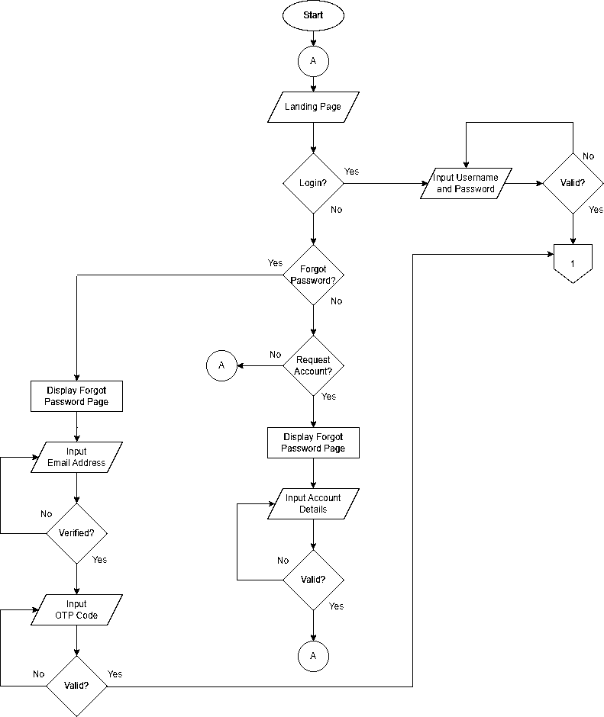
Figure 4: Context Diagram of the MIS of Fund Generations’ MAAB Membership for the Philippine Red Cross Cavite Chapter.

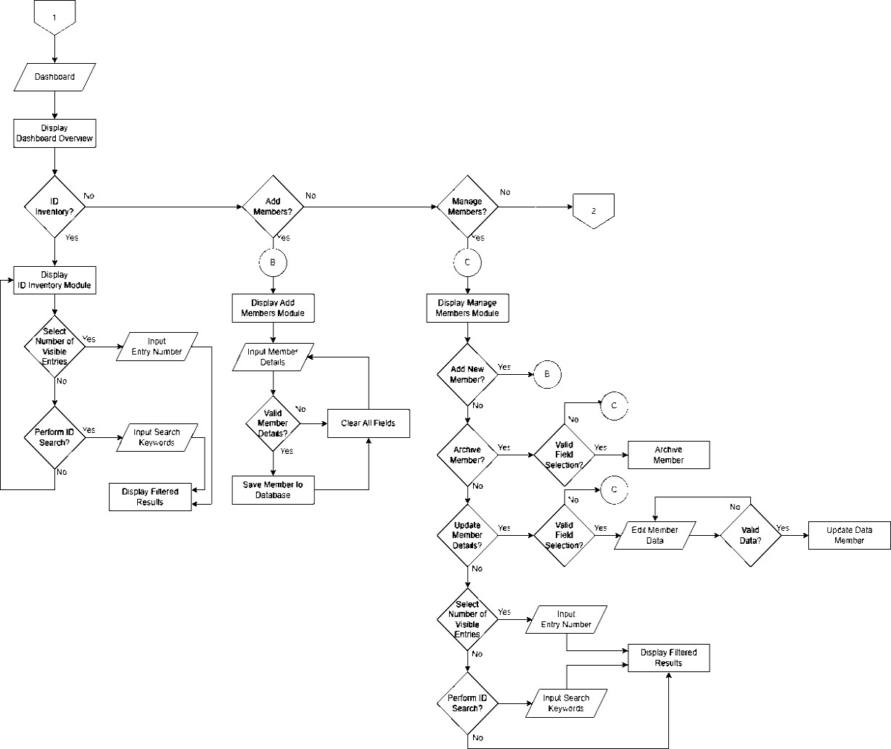

Figure 4. Continued.

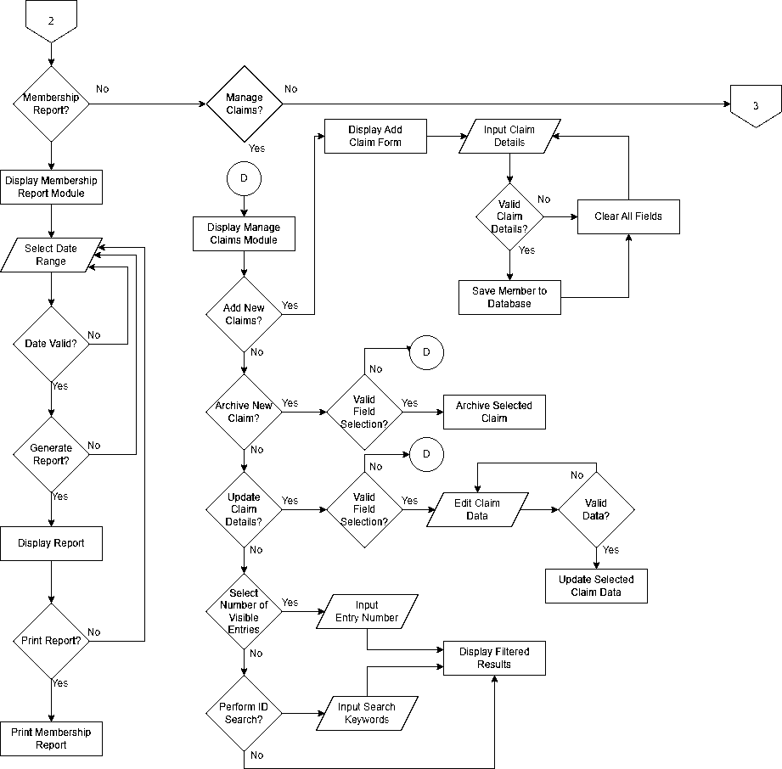

Figure 4. Continued

Operation and Testing Procedure - Aby

