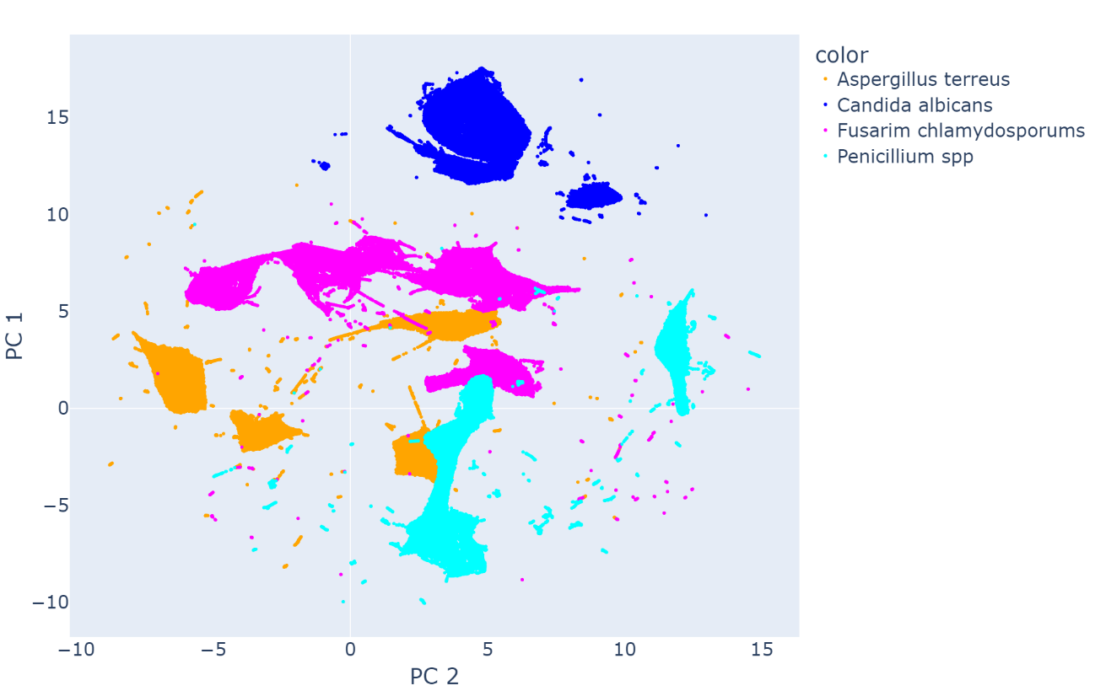*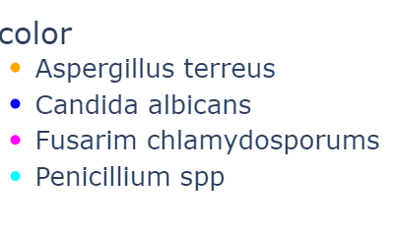*

PC 1

PC 2

*Aspergillus terreus*

*Candida albicans*

*Fusarium chlamydosporums*

*Penicillium spp*