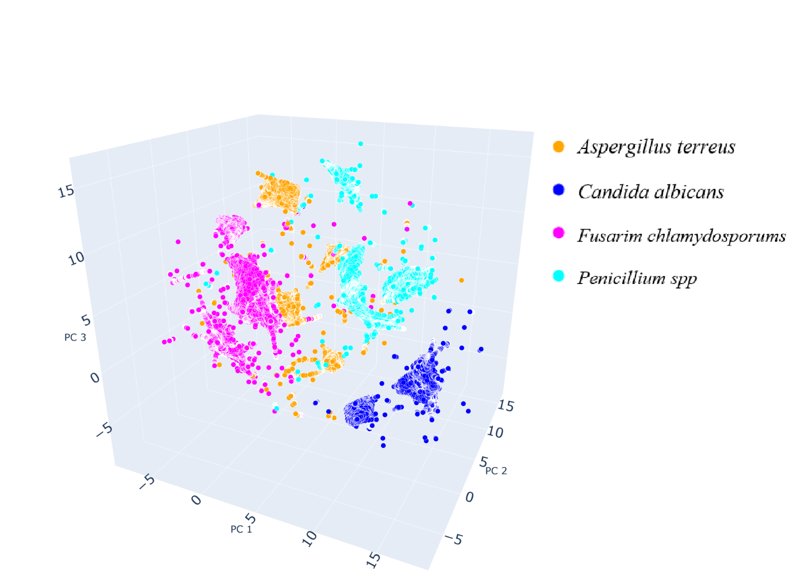

*Aspergillus terreus*

*Candida albicans*

*Fusarim chlamydosporums*

*Penicillium spp*