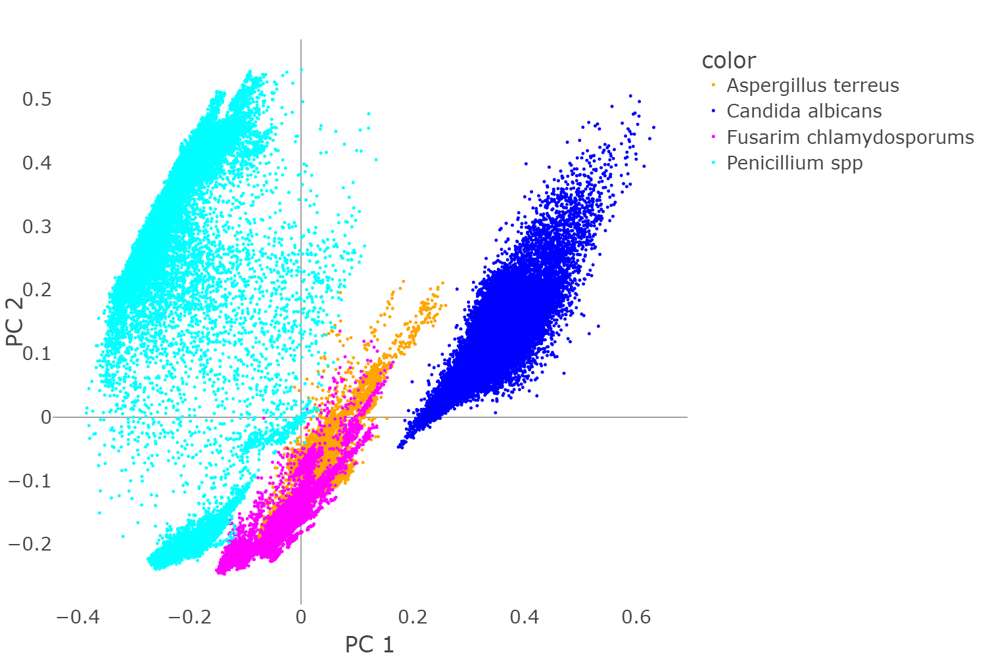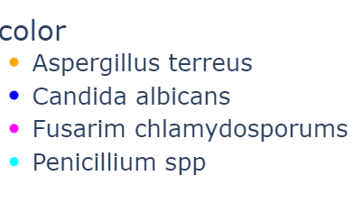

*Aspergillus terreus*

*Candida albicans*

*Fusarium chlamydosporums*

*Penicillum spp*