

School of InfoComm Technology

AI & Ethics
Diploma in Applied AI & Analytics (AAA)
Diploma in Computing with Law (CLW)
Diploma in Cybersecurity (CSF)
Diploma in Information Technology (IT)
Common ICT Programme (CICTP)

April 2026 Semester

ASSIGNMENT 1
(35% of AI&E Module)

S/No | Student No. | Student Names
1
2
3

Submission Deadline:
Report: 24 May 2026 (Sunday), 2359 hrs [Draft Date]
(Confirmed date in week 5 will be informed later)

Penalty for late submission:
10% of the marks will be deducted every calendar day after the deadline.
NO submission will be accepted after 30th May 2025 (Saturday), 2359 hrs.

3. ASSIGNMENT DELIVERABLES

3.1 Website Scenario Selected

Scenario B: Automated Patient Triage & Symptom Checker Web Clinic

Use prompting to logically build a telemedicine website where patients input personal information and symptoms to receive preliminary diagnoses and automated drug recommendations before seeing a human doctor.

Initial Requirements from Group Research

Research Method
To understand the human needs behind Scenario B, our group conducted a Google Form survey as our requirement-gathering method. The survey focused on how users search for symptoms online, what challenges they face, and what would make a healthcare guidance website feel clearer, safer, and more trustworthy. We collected 22 responses, mainly from students and young adults.

Target Users
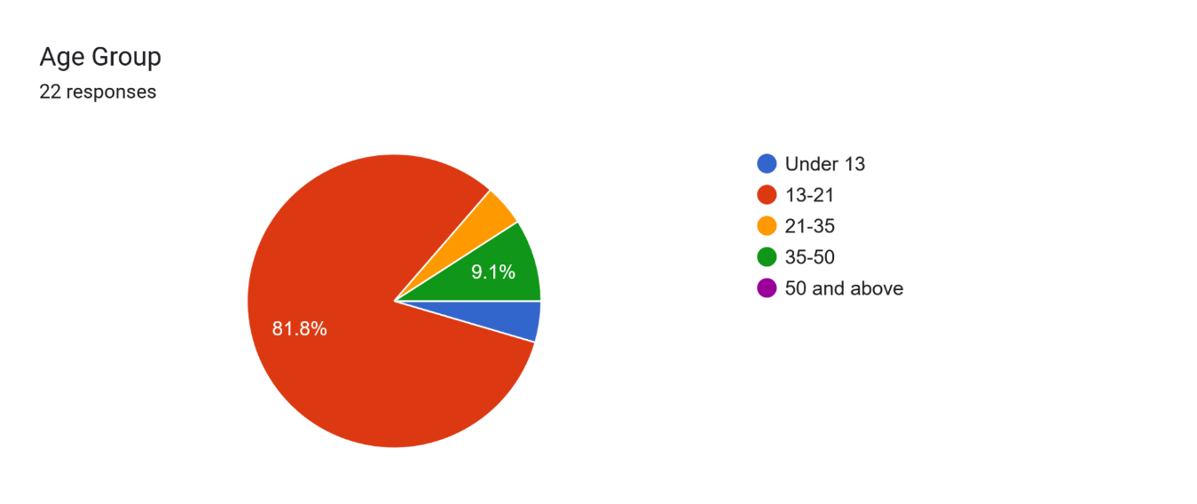
Based on the survey, most respondents were from the 13–21 age group, making students and young adults the main target users for the prototype. This shaped the website direction: it needed to be simple, fast to understand, and reassuring for users who may not have strong medical knowledge.

Key Survey Findings
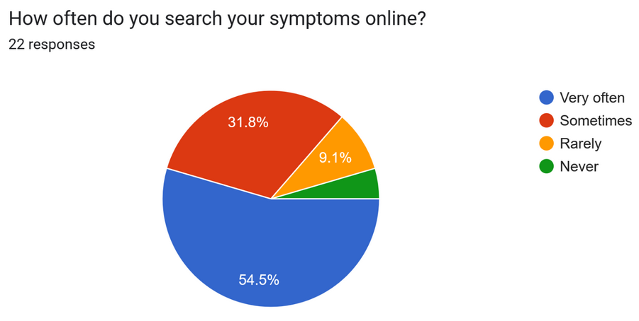 | 54.5% of respondents said they search symptoms online very often. This shows that users already rely on online symptom searching, so a healthcare guidance website is relevant to their behaviour.
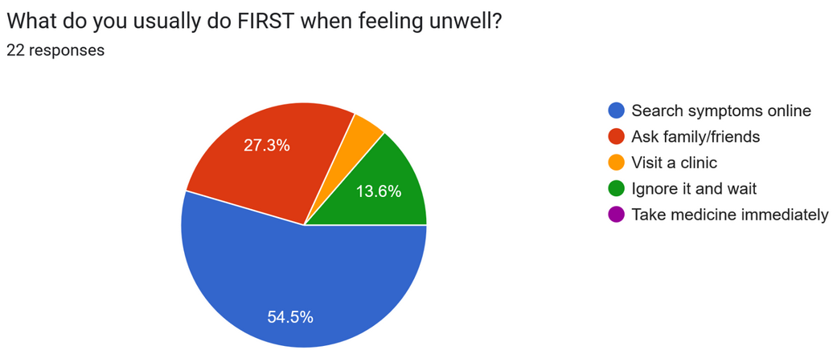 | 54.5% said their first action when feeling unwell is to search symptoms online. This shows that the website should be easy to use as a first point of guidance.
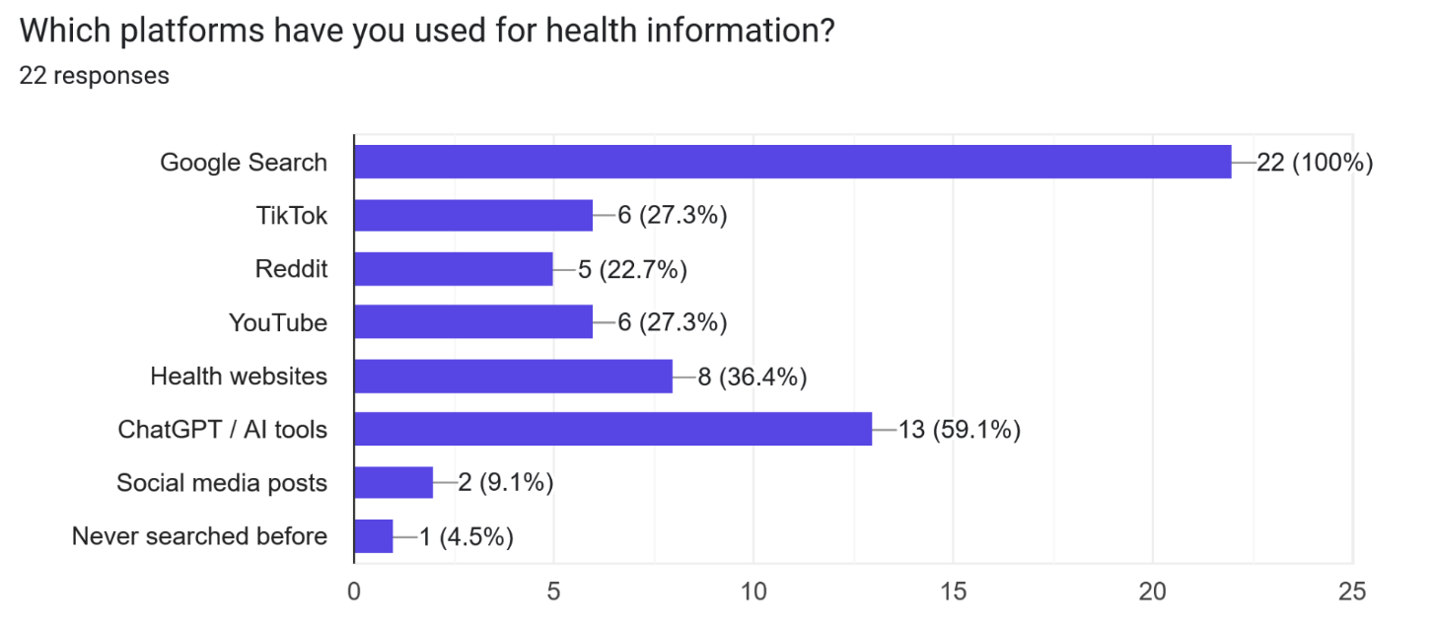 | All respondents, 100%, have used Google Search for health information. A significant number, 59.1%, have also used ChatGPT / AI tools, while 36.4% used health websites. This shows that users are already exposed to AI-generated or online health information. Therefore, the website should be transparent about AI limitations and should avoid presenting AI-generated advice as final medical truth. It should also include trusted sources to reduce overreliance on random search results or unverified AI responses.
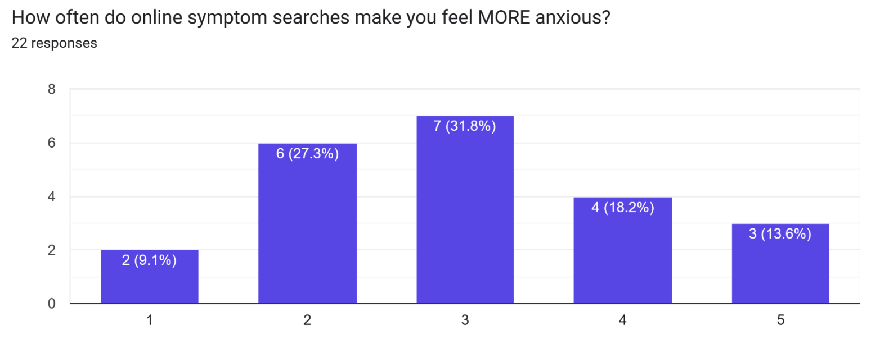 | The responses were spread across the scale, but a noticeable number selected higher anxiety levels. 31.8% selected level 3, 18.2% selected level 4, and 13.6% selected level 5. This suggests that online symptom searching can increase anxiety for many users, especially when results are unclear or frightening. Therefore, the website should use calm, balanced, and non-alarmist language. It should avoid exaggerating worst-case outcomes and should guide users toward practical next steps.
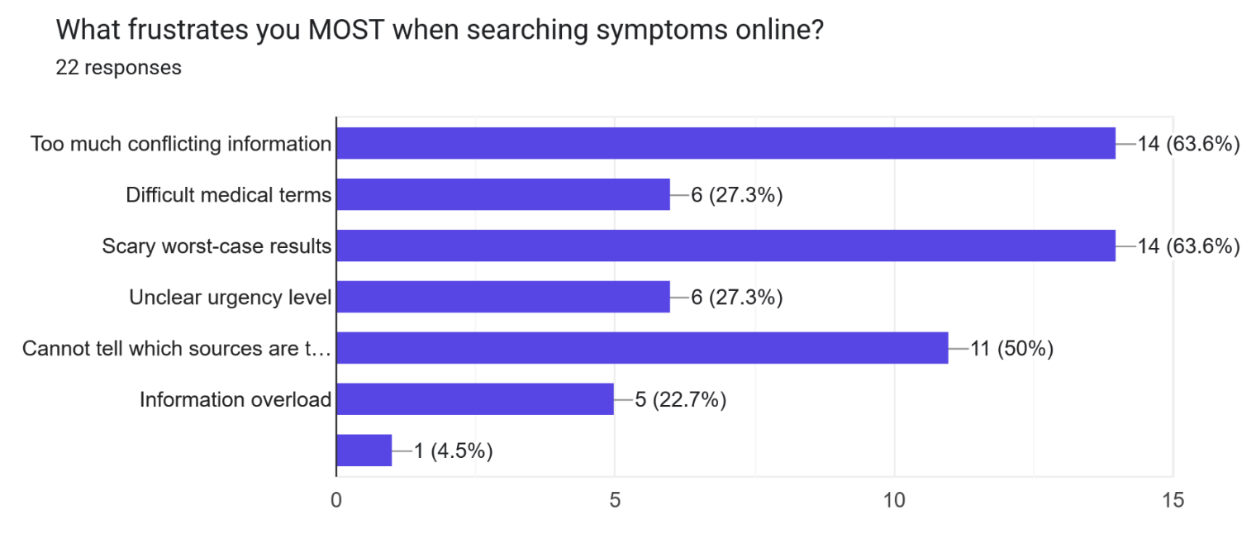 | The top frustrations were too much conflicting information and scary worst-case results, both selected by 63.6% of respondents. Another 50% said they cannot tell which sources are trustworthy. This is one of the strongest findings because it shows the main problem is not simply lack of information, but lack of clear, trustworthy, and reassuring information. Therefore, the website should organise information clearly, avoid overwhelming users, and include trusted references or source labels.
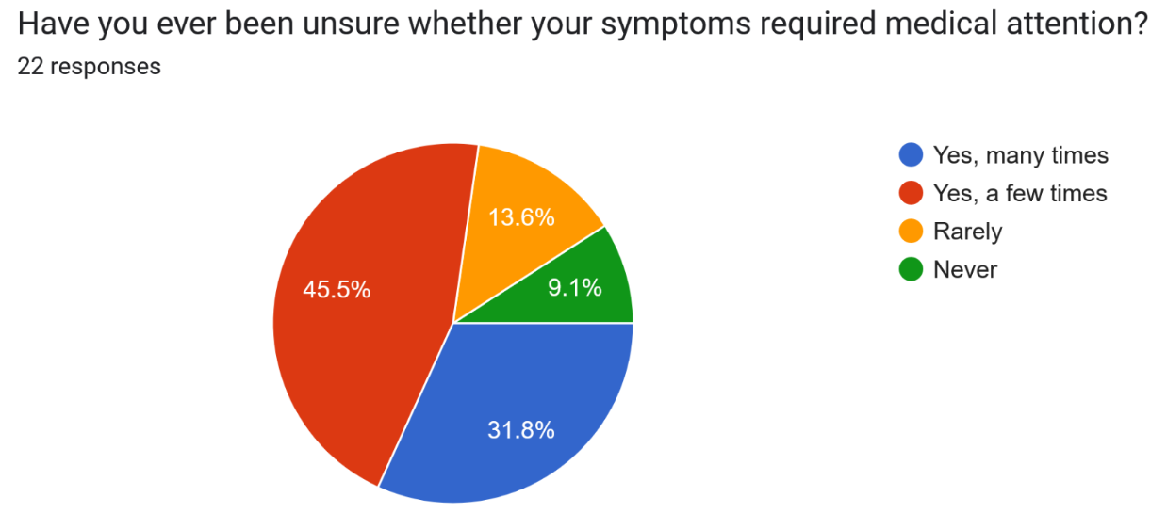 | 31.8% of respondents said they have been unsure many times, and 45.5% said they have been unsure a few times. Combined, 77.3% have experienced uncertainty about whether their symptoms required medical attention. This directly supports the need for the website. The prototype should focus on helping users understand urgency levels and when to seek professional help, rather than simply listing possible conditions.
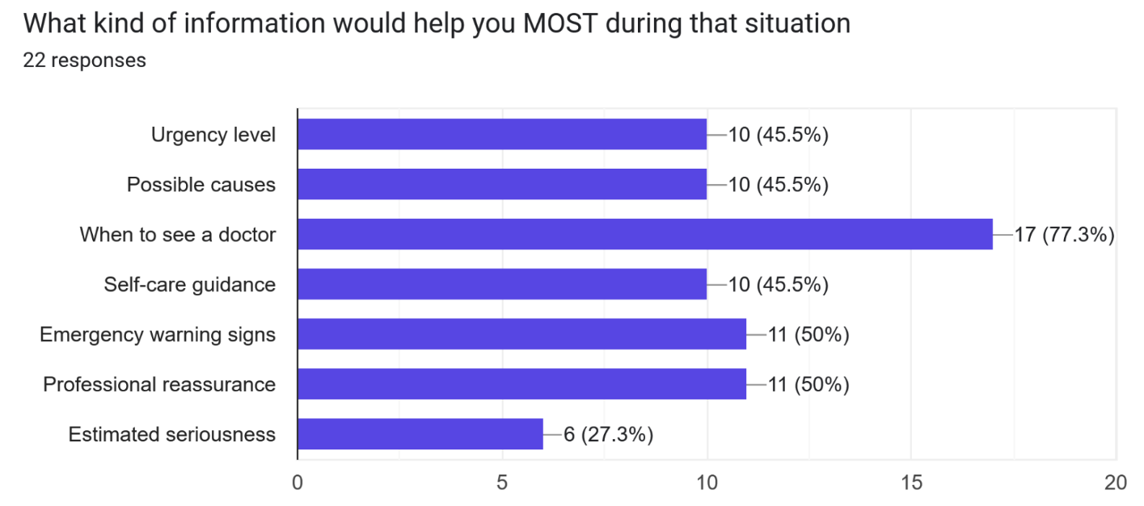 | The most selected response was “When to see a doctor”, chosen by 77.3% of respondents. Emergency warning signs and professional reassurance were each selected by 50%. This shows that users want decision support, not just medical facts. Therefore, the website should include clear “when to see a doctor” guidance, emergency red-flag warnings, and reassurance that encourages users to consult a human doctor when necessary.
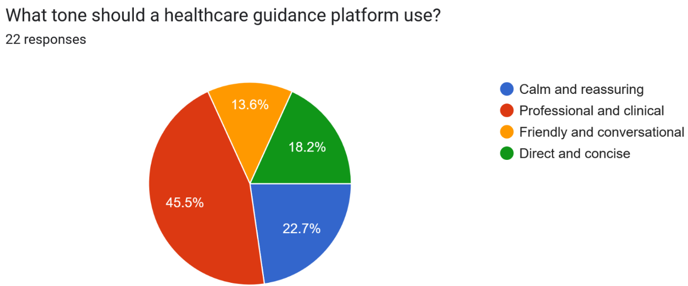 | The most preferred tone was professional and clinical, selected by 45.5% of respondents. 22.7% preferred calm and reassuring, while 18.2% preferred direct and concise. This suggests that users want the platform to feel credible and medically serious, but still understandable. Therefore, the website tone should be professional, calm, and clear. It should not sound too casual, playful, or overly dramatic.
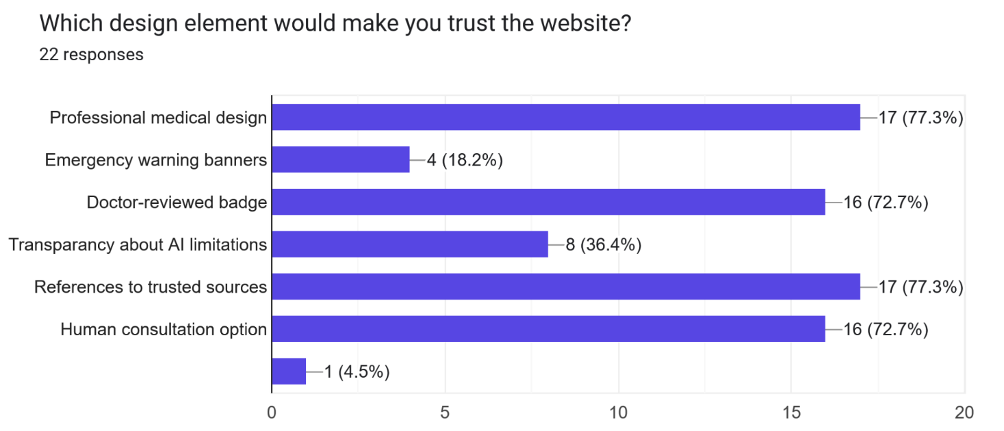 | The strongest trust-building features were professional medical design and references to trusted sources, both selected by 77.3% of respondents. Doctor-reviewed badge and human consultation option were also highly selected at 72.7% each. This shows that trust depends not only on the AI feature, but also on credibility, source transparency, and human involvement. Therefore, the website should include a professional healthcare-style interface, trusted source references, a doctor-reviewed indicator as a prototype feature, and clear options to consult a human medical professional.

Overall, the survey findings show that users already rely heavily on online symptom searching, but they often experience confusion, anxiety, and uncertainty because of conflicting information, scary worst-case results, and difficulty judging whether medical attention is needed. The findings suggest that the website should not be designed as an “AI doctor” that replaces professional care. Instead, it should function as an AI-assisted healthcare guidance platform that provides clear urgency guidance, emergency warning signs, trusted references, and human consultation options. With that, we formed our POV statement.

POV Statement:
Young adults who experience uncertain symptoms need an accessible and reassuring healthcare guidance platform because current online symptom searches can feel overwhelming, inconsistent, and anxiety-inducing.

Initial Website Requirements
Requirement Area | Initial Website Requirement
Target users | The website should be designed mainly for students and young adults.
Main purpose | The website should help users understand symptom urgency and possible next steps.
Tone | The website should use a professional, calm, and clear tone.
Information design | Health information should be organised and easy to understand.
Anxiety reduction | The website should avoid scary, alarmist, or overly certain wording.
Medical safety | The website should avoid definitive diagnosis and direct drug recommendations.
Emergency support | The website should include red-flag symptoms and emergency warning guidance.
Human oversight | The website should include doctor review or human consultation options.
Trust | The website should include references to trusted sources and transparent AI limitations.
Visual design | The website should use a clean, professional medical design to build credibility.

Explaining my Prompting Approach

For my individual prototype, I used a structured prompting approach that combined the “PTCF framework” that we learned from AI&E lesson 2 with a separate vibecoding documentation framework.
The vibecoding framework did not replace PTCF. Instead, I used it as a context pack inside my engineered PTCF prompt. The vibecoding guide explains that AI coding agents perform better when they are given clear project documents before coding, because these documents reduce ambiguity and stop the AI from guessing product scope, technical stack, screen flow, data handling, and implementation sequence. Here is the link for the vibecoding guide.
I created six planning documents before using Codex.

Table

These documents strengthened by PTCF prompt by giving each part more detail.

Table

This approach also connects to the lesson 2 slides, which state that prompt engineering is the process of designing inputs to guide AI models, and that the quality of AI output reflects the clarity of the input. The slides also say that AI can hallucinate and therefore requires human verification and critical oversight. Since my scenario involves healthcare guidance, I added strict constraints to prevent Codex from generating unsafe medical claims, such as definitive diagnoses, direct medication recommendations, fake doctor approval, or real data storage.

3.2 Individual Report Requirements

Explaining my Prompting Approach

For my individual prototype, I used a structured prompting approach that combined the “PTCF framework” that we learned from AI&E lesson 2 with a separate vibecoding documentation framework.
The vibecoding framework did not replace PTCF. Instead, I used it as a context pack inside my engineered PTCF prompt. The vibecoding guide explains that AI coding agents perform better when they are given clear project documents before coding, because these documents reduce ambiguity and stop the AI from guessing product scope, technical stack, screen flow, data handling, and implementation sequence. Here is the link for the vibecoding guide.

I created six planning documents before using Codex. The documents can be found in the GitHub Repository.

Vibecoding Document | Purpose in My Prompting
Product Requirements Document | Defined what I was building, who it was for, the problem, user needs, features, and ethical boundaries.
Technical Requirements Document | Defined the technical stack, frontend-only scope, privacy constraints, and what Codex must not build.
App Flow | Mapped the user journey from homepage to symptom checker, urgency result, red flags, and human consultation.
UI/UX Design Brief | Defined the professional healthcare design style, tone, colour palette, accessibility, and trust-building elements.
Backend / Data Handling Plan | Clarified that no real health data should be stored, uploaded, or sent to a backend.
Implementation Plan | Defined the step-by-step build sequence so Codex would build the website in a controlled and coherent way.

These documents strengthened by PTCF prompt by giving each part more detail.

P.T.C.F. Element | How the Vibecoding Documents Supported It
Persona | I instructed Codex to act as a frontend developer, healthcare UX designer, and ethical AI safety reviewer.
Task | The PRD and Implementation Plan clearly defined the website Codex needed to build.
Context | The PRD, App Flow, and Data Handling Plan gave Codex the user research background, ethical concerns, privacy limits, and project purpose.
Format | The TRD, App Flow, UI/UX Brief, and Implementation Plan specified the required pages, file structure, design style, simulated logic, and output format.

This approach also connects to the lesson 2 slides, which state that prompt engineering is the process of designing inputs to guide AI models, and that the quality of AI output reflects the clarity of the input. The slides also say that AI can hallucinate and therefore requires human verification and critical oversight. Since my scenario involves healthcare guidance, I added strict constraints to prevent Codex from generating unsafe medical claims, such as definitive diagnoses, direct medication recommendations, fake doctor approval, or real data storage.

- The Diagnostic Log:

- The Synthesis Protocol:

- The Mindful Creator Audit:

