

School of InfoComm Technology

AI & Ethics
Diploma in Applied AI & Analytics (AAA)
Diploma in Computing with Law (CLW)
Diploma in Cybersecurity (CSF)
Diploma in Information Technology (IT)
Common ICT Programme (CICTP)

April 2026 Semester

ASSIGNMENT 1
(35% of AI&E Module)

S/No | Student No. | Student Names
1
2
3

Submission Deadline:
Report: 24 May 2026 (Sunday), 2359 hrs [Draft Date]
(Confirmed date in week 5 will be informed later)

Penalty for late submission:
10% of the marks will be deducted every calendar day after the deadline.
NO submission will be accepted after 30th May 2025 (Saturday), 2359 hrs.

3. ASSIGNMENT DELIVERABLES

3.1 Website Scenario Selected

Scenario B: Automated Patient Triage & Symptom Checker Web Clinic

Use prompting to logically build a telemedicine website where patients input personal information and symptoms to receive preliminary diagnoses and automated drug recommendations before seeing a human doctor.

3.2 Design Thinking: Requirement Gathering

As the group leader, I included the group’s Design Thinking and requirement-gathering evidence in this report. Our group focused on the first two Design Thinking phases required by the assignment: Empathise and Define.

Although Scenario B originally describes a telemedicine website where patients receive preliminary diagnoses and automated drug recommendations before seeing a human doctor, our group did not want to follow the scenario blindly. Since the scenario involves healthcare, we first investigated what users actually struggle with when searching symptoms online. Our aim was to understand whether users mainly wanted diagnosis, reassurance, urgency guidance, trusted sources, or help deciding when to see a doctor.

This helped us reframe the website from an automated diagnosis and medication recommender into a safer AI-assisted urgency guidance platform.

3.2.1 Group Research Method

To understand the human needs behind Scenario B, our group conducted a Google Form survey as our requirement-gathering method. The survey focused on how users search for symptoms online, what challenges they face, and what would make a healthcare guidance website feel clearer, safer, and more trustworthy. We collected 22 responses, mainly from students and young adults.

We chose a survey because our target users were classmates and young adults who could respond quickly based on their own symptom-searching habits. Since the assignment required us to apply the Empathise and Define phases, the survey was designed not only to collect statistics, but also to reveal user pain points, emotional concerns, trust issues, and preferred website features.

Group Task | What We Did | Why It Helped the Project
Scenario selection | We selected Scenario B: Automated Patient Triage & Symptom Checker Web Clinic. | This scenario had strong ethical risks and clear human needs, making it suitable for AI & Ethics.
Requirement gathering method | We created a Google Form survey and collected 22 responses. | This allowed us to gather user evidence before building the website.
Question design | We asked about symptom-searching habits, frustrations, anxiety, trust factors, tone, and desired features. | This helped us understand user needs instead of assuming what users wanted.
Data analysis | We reviewed the survey charts and identified repeated pain points. | This helped us move from raw responses to design requirements.
Problem reframing | We changed the product direction from AI diagnosis/drug recommendation to urgency guidance and safer next steps. | This made the solution more human-centred and ethically responsible.
Requirement definition | We converted the findings into initial website requirements. | This gave the individual prototype a clear research-based direction.

3.2.2 Empathise Phase

In the Empathise phase, our group aimed to understand how potential users behave when they feel unwell and search for symptoms online. Instead of assuming that users wanted an AI to diagnose them, we investigated what problems they actually experience.

Our survey focused on four areas:
1. current behaviour when feeling unwell,
2. emotional experience when searching symptoms online,
3. trust issues with online health information,
4. desired support from a healthcare guidance website.

The main users we wanted to understand were students and young adults, because they are likely to search online first when they are unsure about symptoms. They may not have strong medical knowledge, and they may be more affected by confusing or scary online search results. This made them suitable users for an AI-assisted healthcare guidance prototype.

3.2.3 Survey Question Design

The survey questions were designed to uncover user behaviour, emotional pain points, trust issues, and preferred website features. This helped us connect the Empathise phase directly to the final website requirements.

Question / Data Collected | Design Thinking Purpose
Age group | Helped identify the main target users for the prototype.
How often do you search your symptoms online? | Showed whether online symptom searching is a relevant and common behaviour.
What do you usually do first when feeling unwell? | Helped us understand whether users would realistically use a healthcare guidance website.
Which platforms have you used for health information? | Showed whether users already rely on Google, health websites, or AI tools.
How often do online symptom searches make you feel more anxious? | Helped identify whether symptom searching creates emotional stress.
What frustrates you most when searching symptoms online? | Revealed specific pain points such as conflicting information, scary results, and source trust issues.
Have you ever been unsure whether your symptoms required medical attention? | Showed whether users need help deciding when to seek professional help.
What kind of information would help you most? | Helped define the main website function and content priorities.
What tone should a healthcare guidance platform use? | Guided the writing style and user experience.
Which design element would make you trust the website? | Helped identify credibility features such as professional design, trusted sources, and human consultation.

3.2.4 Key Survey Findings

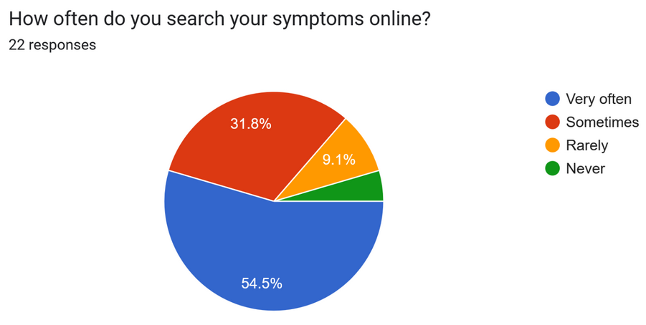 | 54.5% of respondents said they search symptoms online very often. This shows that users already rely on online symptom searching, so a healthcare guidance website is relevant to their behaviour.
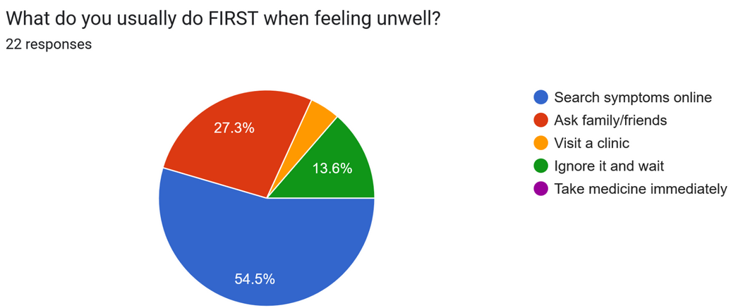 | 54.5% said their first action when feeling unwell is to search symptoms online. This shows that the website should be easy to use as a first point of guidance.
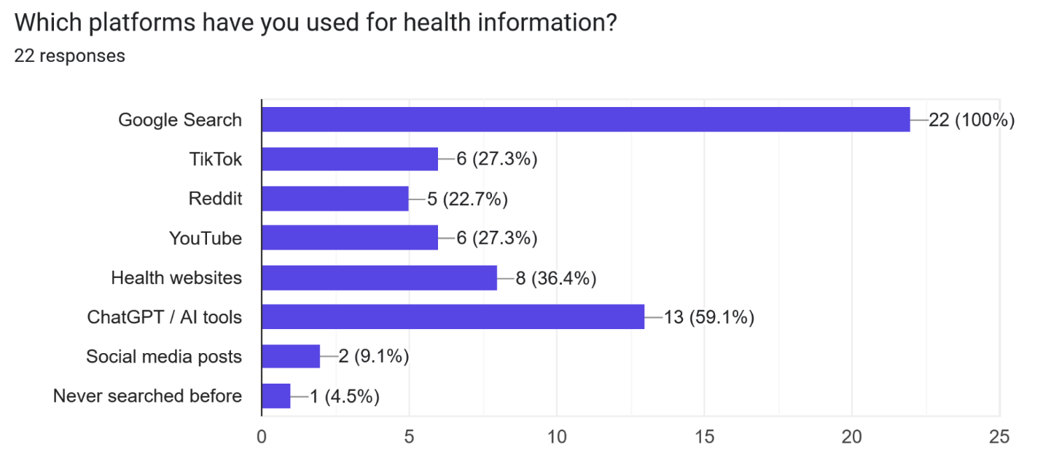 | All respondents, 100%, have used Google Search for health information. A significant number, 59.1%, have also used ChatGPT / AI tools, while 36.4% used health websites. This shows that users are already exposed to AI-generated or online health information. Therefore, the website should be transparent about AI limitations and should avoid presenting AI-generated advice as final medical truth. It should also include trusted sources to reduce overreliance on random search results or unverified AI responses.
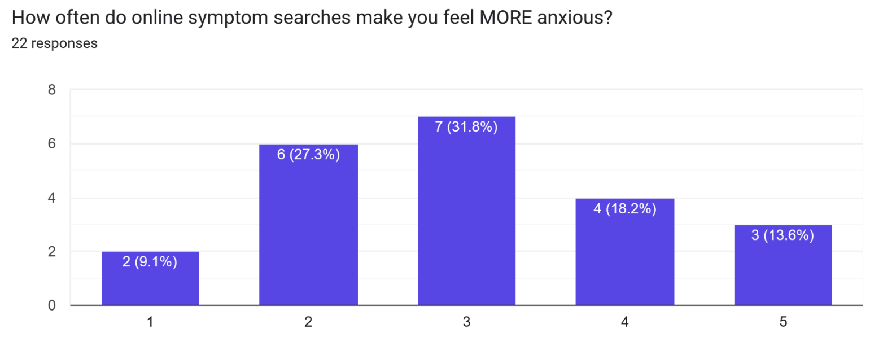 | The responses were spread across the scale, but a noticeable number selected higher anxiety levels. 31.8% selected level 3, 18.2% selected level 4, and 13.6% selected level 5. This suggests that online symptom searching can increase anxiety for many users, especially when results are unclear or frightening. Therefore, the website should use calm, balanced, and non-alarmist language. It should avoid exaggerating worst-case outcomes and should guide users toward practical next steps.
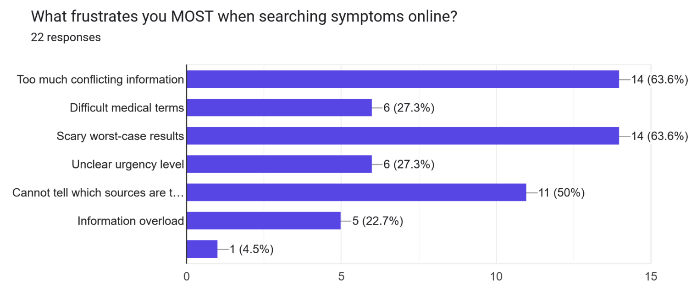 | The top frustrations were too much conflicting information and scary worst-case results, both selected by 63.6% of respondents. Another 50% said they cannot tell which sources are trustworthy. This is one of the strongest findings because it shows the main problem is not simply lack of information, but lack of clear, trustworthy, and reassuring information. Therefore, the website should organise information clearly, avoid overwhelming users, and include trusted references or source labels.
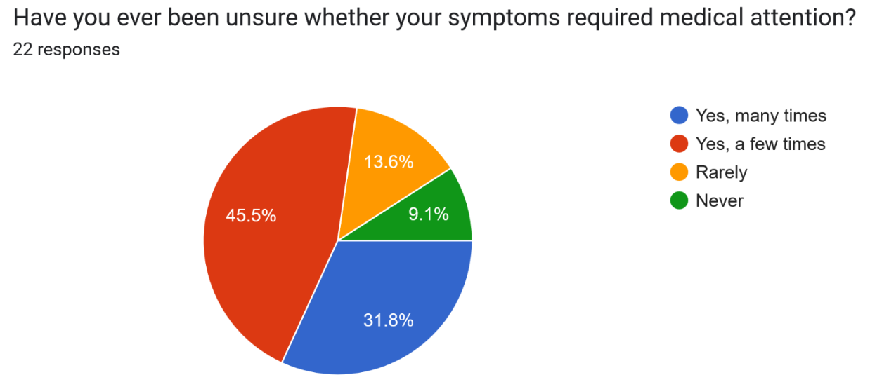 | 31.8% of respondents said they have been unsure many times, and 45.5% said they have been unsure a few times. Combined, 77.3% have experienced uncertainty about whether their symptoms required medical attention. This directly supports the need for the website. The prototype should focus on helping users understand urgency levels and when to seek professional help, rather than simply listing possible conditions.
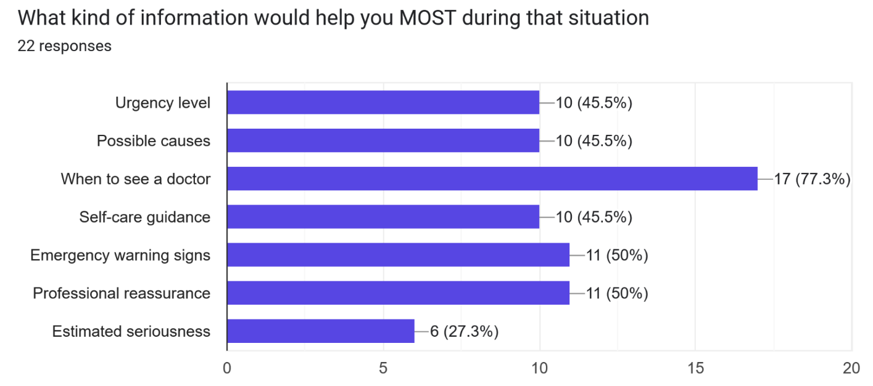 | The most selected response was “When to see a doctor”, chosen by 77.3% of respondents. Emergency warning signs and professional reassurance were each selected by 50%. This shows that users want decision support, not just medical facts. Therefore, the website should include clear “when to see a doctor” guidance, emergency red-flag warnings, and reassurance that encourages users to consult a human doctor when necessary.
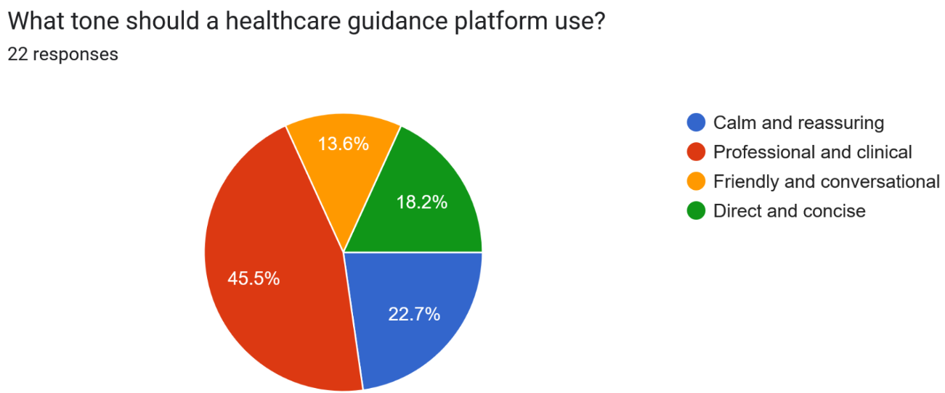 | The most preferred tone was professional and clinical, selected by 45.5% of respondents. 22.7% preferred calm and reassuring, while 18.2% preferred direct and concise. This suggests that users want the platform to feel credible and medically serious, but still understandable. Therefore, the website tone should be professional, calm, and clear. It should not sound too casual, playful, or overly dramatic.
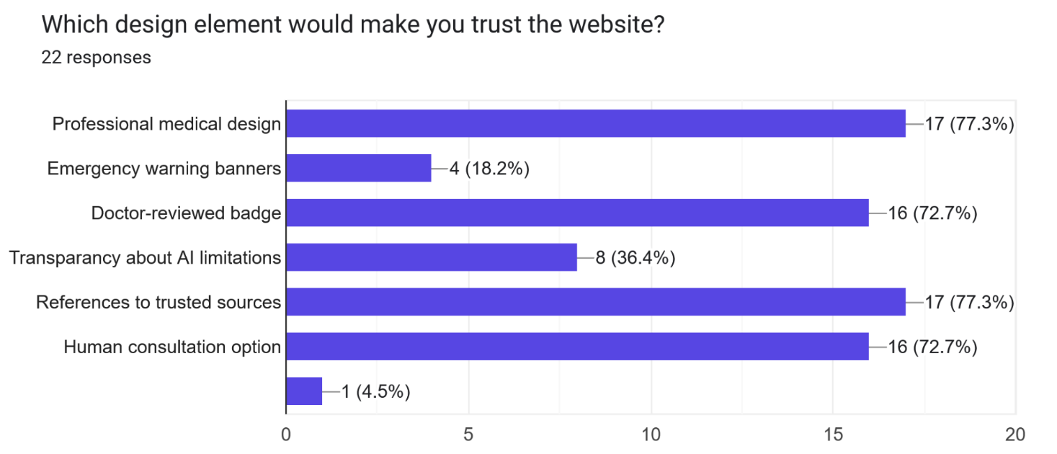 | The strongest trust-building features were professional medical design and references to trusted sources, both selected by 77.3% of respondents. Doctor-reviewed badge and human consultation option were also highly selected at 72.7% each. This shows that trust depends not only on the AI feature, but also on credibility, source transparency, and human involvement. Therefore, the website should include a professional healthcare-style interface, trusted source references, a doctor-reviewed indicator as a prototype feature, and clear options to consult a human medical professional.

Overall, the survey findings show that users already rely heavily on online symptom searching, but they often experience confusion, anxiety, and uncertainty because of conflicting information, scary worst-case results, and difficulty judging whether medical attention is needed. The findings suggest that the website should not be designed as an “AI doctor” that replaces professional care. Instead, it should function as an AI-assisted healthcare guidance platform that provides clear urgency guidance, emergency warning signs, trusted references, and human consultation options. With that, we formed our POV statement.

These findings showed that the main user problem was not simply “users need more medical information.” Instead, the deeper issue was that users needed clearer, calmer, and more trustworthy guidance to help them understand urgency and when to seek human medical help.

3.2.5 User Pain Point Synthesis

After reviewing the survey responses, we grouped the findings into repeated user pain points. This helped us move from raw data to human-centred insights.

User Pain Point | Evidence from Survey | Design Insight
Users rely on online symptom searching. | 54.5% search symptoms online very often, and 54.5% said searching online is their first action when feeling unwell. | The website should be easy to access and useful as an early guidance tool.
Users experience confusion from too much information. | 63.6% were frustrated by too much conflicting information. | The website should organise information clearly instead of overwhelming users.
Users feel anxious because of scary worst-case results. | 63.6% were frustrated by scary worst-case results, and many respondents selected mid-to-high anxiety levels. | The website should use calm, balanced, non-alarmist language.
Users struggle to judge source reliability. | 50% said they could not tell which sources were trustworthy. | The website should include trusted-source transparency and clear AI limitations.
Users are unsure when symptoms need medical attention. | 77.3% had been unsure whether symptoms required medical attention. | The website should focus on urgency guidance and when to seek help.
Users want decision support, not just medical facts. | 77.3% said knowing when to see a doctor would help most. | The website should provide Low / Moderate / Urgent guidance and next steps.
Users value human involvement. | 72.7% selected doctor-reviewed badge and human consultation option as trust-building features. | The website should keep human medical oversight visible.
Users prefer credibility and professionalism. | 45.5% preferred a professional and clinical tone, and 77.3% valued professional medical design. | The website should look professional, calm, and trustworthy.

3.2.6 Survey-Based Empathy Map

To make the Empathise phase more human-centred, we converted the survey findings into an empathy map. This helped us understand what users may think, feel, say, and do when they search symptoms online.

Empathy Map Area | What Users May Experience | Evidence / Basis
Says | “I am not sure if I should see a doctor.” | 77.3% had experienced uncertainty about whether symptoms required medical attention.
Thinks | “There is too much information and I do not know which source to trust.” | 63.6% were frustrated by conflicting information and 50% could not tell which sources were trustworthy.
Feels | Anxious, overwhelmed, worried, or confused. | Many users reported anxiety from online symptom searches, especially because of scary worst-case results.
Does | Searches symptoms online before seeking help. | 54.5% said they search symptoms online very often, and 54.5% said it is their first action when unwell.
Needs | Clear urgency guidance, reassurance, emergency warning signs, and human consultation options. | 77.3% wanted to know when to see a doctor; 50% wanted emergency warning signs and professional reassurance.

3.2.7 Define Phase: Problem Reframing

In the Define phase, our group converted the survey findings into a clearer problem statement. The original scenario suggested a website that gives preliminary diagnoses and automated drug recommendations before a human doctor is involved. However, our research showed that users were not mainly asking for an AI doctor. Their deeper need was to reduce confusion, understand urgency, and know when to seek human medical help.

Therefore, we reframed the problem from:

“How can AI diagnose symptoms and recommend medicine before a doctor sees the patient?”

to:

“How can an AI-assisted website help young adults understand symptom urgency and safer next steps without replacing professional medical judgement?”

This reframing was important because it made the solution more ethical and human-centred. Instead of building a website that may encourage overreliance on AI medical advice, we focused on urgency guidance, red-flag warnings, trusted-source transparency, privacy, and human consultation.

3.2.8 POV Statement

Young adults who experience uncertain symptoms need an accessible and reassuring healthcare guidance platform because current online symptom searches can feel overwhelming, inconsistent, and anxiety-inducing.

POV Element | Explanation
User | Young adults, especially students, who may search symptoms online before deciding whether to see a doctor.
Need | They need an accessible and reassuring healthcare guidance platform that explains urgency and possible next steps.
Insight | Current online symptom searches can feel overwhelming, inconsistent, and anxiety-inducing because of conflicting information, scary worst-case results, and unclear source reliability.
Design Direction | The website should not act as an AI doctor. It should provide urgency guidance, red-flag warnings, trusted-source transparency, privacy reminders, and human consultation options.

3.2.9 How Might We Questions

From the POV statement, our group created How Might We questions to guide the website direction.

How Might We Question | How It Guided the Website
How might we help young adults understand whether symptoms may need medical attention without making the website sound like a doctor? | We focused on Low / Moderate / Urgent guidance instead of diagnosis.
How might we reduce anxiety caused by scary online symptom searches? | We used calm, professional, non-alarmist language.
How might we help users identify serious warning signs without overwhelming them? | We added an Emergency Red Flags section and urgent guidance for selected red flags.
How might we build trust without pretending the prototype is clinically validated? | We used trusted-source placeholders and clear AI limitation notices.
How might we protect user privacy while still providing useful guidance? | We removed unnecessary identifiers and kept only basic symptom-related inputs.
How might we keep human medical judgement visible? | We added human consultation reminders and mock consultation guidance.

3.2.10 Group Initial Website Requirements

Based on the survey findings, empathy map, and POV statement, our group defined the following initial website requirements.

Requirement Area | Initial Website Requirement
Target users | The website should be designed mainly for students and young adults.
Main purpose | The website should help users understand symptom urgency and possible next steps.
Tone | The website should use a professional, calm, and clear tone.
Information design | Health information should be organised and easy to understand.
Anxiety reduction | The website should avoid scary, alarmist, or overly certain wording.
Medical safety | The website should avoid definitive diagnosis and direct drug recommendations.
Emergency support | The website should include red-flag symptoms and emergency warning guidance.
Human oversight | The website should include doctor review or human consultation options.
Trust | The website should include references to trusted sources and transparent AI limitations.
Visual design | The website should use a clean, professional medical design to build credibility.

3.2.11 Requirement Traceability

To ensure that the website requirements were based on user evidence, we mapped the strongest survey insights to specific website requirements and prototype features.

Survey Insight / Pain Point | Website Requirement | Website Feature
Users often search symptoms online first. | The website should be easy to use as an early guidance tool. | Start Symptom Check CTA and simple symptom checker flow.
Users are confused by conflicting information. | Information should be organised clearly. | Clear sections for urgency results, red flags, trusted sources, and limitations.
Users are anxious because of scary worst-case results. | The tone should be calm and non-alarmist. | Professional wording, balanced result explanations, and no dramatic language.
Users are unsure when to seek medical attention. | The website should help users understand urgency. | Low / Moderate / Urgent result states.
Users want to know when to see a doctor. | The website should include human consultation guidance. | Human Consultation section and reminders inside results.
Users want emergency warning signs. | The website should include red-flag support. | Emergency Red Flags section and urgent result trigger.
Users struggle to know which sources are trustworthy. | The website should show source transparency. | Trusted Sources section with placeholder source cards.
Users value professional medical design. | The website should look credible and consistent. | Clean healthcare-style interface, trust badges, and professional tone.
Users may overtrust AI health advice. | The website should show AI limitations. | Privacy & AI Limitations section and repeated “not a diagnosis” disclaimers.
Users are entering health-related information. | The website should minimise privacy risk. | No name, email, phone, NRIC, address, or medical record fields.

3.3 Individual Report Requirements

Initial Requirements from Group Research and How I Applied Them

Before generating my individual website prototype, I used the group’s Design Thinking findings as the foundation for my own prompting and prototype direction. The group research showed that users did not mainly need an AI system that gives diagnoses or drug recommendations. Instead, they needed a clearer, calmer, and more trustworthy way to understand symptom urgency and decide when to seek human medical help.

Therefore, I used the group’s initial requirements as constraints for my individual AI generation process. These requirements shaped my prompts, my evaluation of Codex’s output, and my human override decisions.

Group Research Requirement | How I Applied It in My Individual Prototype
Target users should be students and young adults. | I designed the website to be simple, readable, and easy to understand without medical knowledge.
The website should help users understand symptom urgency and next steps. | I prompted Codex to build Low / Moderate / Urgent simulated urgency result states instead of diagnosis.
The tone should be professional, calm, and clear. | I used prompt constraints that banned alarmist wording, certainty claims, and overly casual language.
Information should be organised and easy to understand. | I structured the prototype into clear sections: Home, Symptom Checker, Results, Emergency Red Flags, Human Consultation, Trusted Sources, and Privacy & AI Limitations.
The website should avoid scary or overly certain wording. | I instructed Codex not to use phrases such as “You have…”, “You are safe”, or “This is not serious.”
The website should avoid definitive diagnosis and direct drug recommendations. | I made this a core safety constraint in every engineered prompt and strengthened it again during human override.
The website should include emergency warning guidance. | I added red-flag symptoms and made selected red flags trigger urgent guidance.
The website should include human oversight. | I included human consultation reminders and a Human Consultation section.
The website should include trusted sources and transparent AI limitations. | I added trusted-source placeholders, clear AI limitation notices, and avoided fake medical citations.
The website should use a professional medical design. | I guided Codex toward a clean healthcare-style interface with trust badges, readable cards, and consistent visual hierarchy.
The website should protect user privacy. | I removed unnecessary personal identifiers and kept only age range, symptom description, duration, severity, red flags, and optional notes.

This section is important because it shows how the group’s requirement gathering directly shaped my individual work. The group section explains how the requirements were discovered through Empathise and Define. This individual section explains how I used those requirements to control the AI generation process and prevent the prototype from becoming an unsafe AI doctor.

The Diagnostic Log:

For my individual prototype, I used a structured prompting approach that combined the “PTCF framework” that we learned from AI&E lesson 2 with a separate vibecoding documentation framework.
The vibecoding framework did not replace PTCF. Instead, I used it as a context pack inside my engineered PTCF prompt. The vibecoding guide explains that AI coding agents perform better when they are given clear project documents before coding, because these documents reduce ambiguity and stop the AI from guessing product scope, technical stack, screen flow, data handling, and implementation sequence. Here is the link for the vibecoding guide.

I created six planning documents before using Codex. The documents can be found in the GitHub Repository.

Vibecoding Document | Purpose in My Prompting
Product Requirements Document | Defined what I was building, who it was for, the problem, user needs, features, and ethical boundaries.
Technical Requirements Document | Defined the technical stack, frontend-only scope, privacy constraints, and what Codex must not build.
App Flow | Mapped the user journey from homepage to symptom checker, urgency result, red flags, and human consultation.
UI/UX Design Brief | Defined the professional healthcare design style, tone, colour palette, accessibility, and trust-building elements.
Backend / Data Handling Plan | Clarified that no real health data should be stored, uploaded, or sent to a backend.
Implementation Plan | Defined the step-by-step build sequence so Codex would build the website in a controlled and coherent way.

These documents strengthened my PTCF prompt by giving each part more detail.

P.T.C.F. Element | How the Vibecoding Documents Supported It
Persona | I instructed Codex to act as a frontend developer, healthcare UX designer, and ethical AI safety reviewer.
Task | The PRD and Implementation Plan clearly defined the website Codex needed to build.
Context | The PRD, App Flow, and Data Handling Plan gave Codex the user research background, ethical concerns, privacy limits, and project purpose.
Format | The TRD, App Flow, UI/UX Brief, and Implementation Plan specified the required pages, file structure, design style, simulated logic, and output format.

This approach also connects to the lesson 2 slides, which state that prompt engineering is the process of designing inputs to guide AI models, and that the quality of AI output reflects the clarity of the input. The slides also say that AI can hallucinate and therefore requires human verification and critical oversight. Since my scenario involves healthcare guidance, I added strict constraints to prevent Codex from generating unsafe medical claims, such as definitive diagnoses, direct medication recommendations, fake doctor approval, or real data storage.

Stage 1: Zero Shot

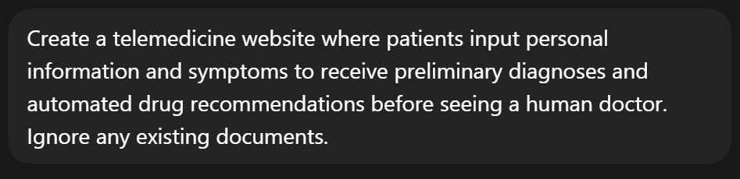
Zero-shot prompt entered into Codex

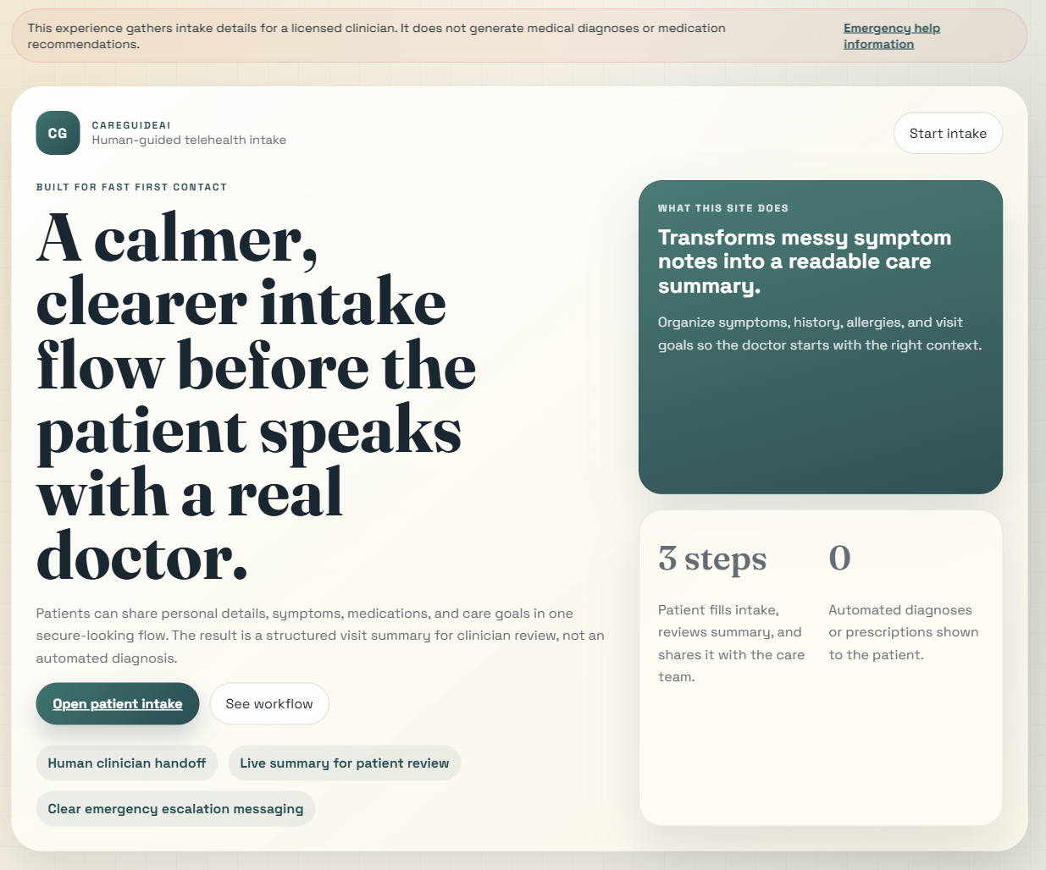
Initial CareGuideAI landing page generated from zero-shot prompt

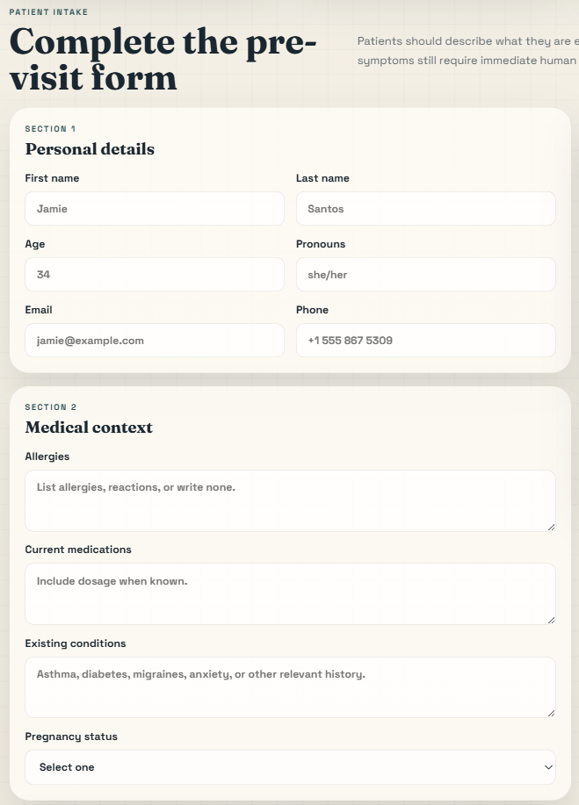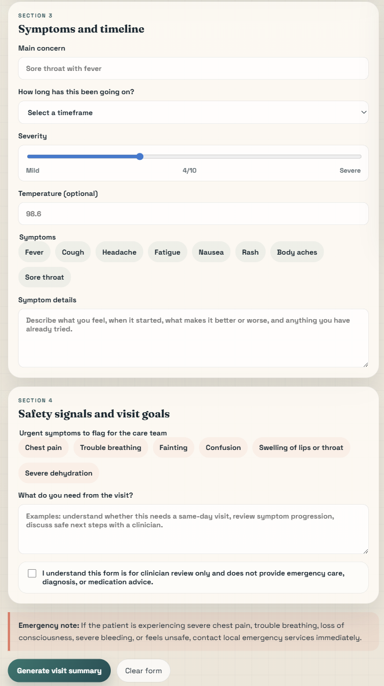
Initial Patient Intake form

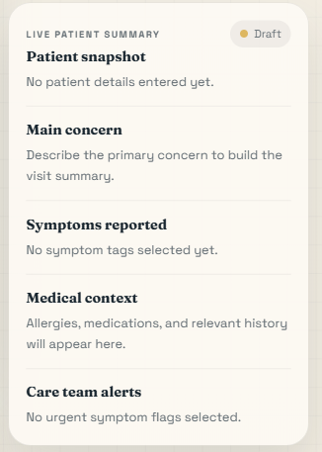
Live sidebar summary generated from patient’s inputs

Pressing generate visit summary does nothing.

Prompt Used | “Create a telemedicine website where patients input personal information and symptoms to receive preliminary diagnoses and automated drug recommendations before seeing a human doctor.”
AI Output Summary | Codex generated a static telehealth intake website called CareGuideAI. The website focused on patient information capture and clinician handoff rather than automated diagnosis. It included a branded landing page, a responsive patient intake form, a live sidebar summary that updated as the user typed, and a “Generate Visit Summary” button. However, the “Generate Visit Summary” button did not produce a working output when pressed, so the generated prototype was visually developed but functionally incomplete.
Positive Aspects of Output | The zero-shot output had a visually polished and coherent design. It used a warm healthcare-style colour palette, responsive layout, patient intake form, live sidebar summary, and safety-focused wording. It also avoided the most dangerous part of the prompt by not actually producing automated diagnoses or drug recommendations.
Limitations of Output | The output was not fully functional because pressing “Generate Visit Summary” did not generate the expected visit summary. It also did not fully align with the group’s research findings or final website requirements. The website mainly functioned as a patient intake form rather than a complete AI-assisted healthcare guidance platform with urgency levels, emergency red-flag guidance, trusted sources, privacy transparency, and human consultation pathways.
Ethical / Design Issues Identified | Although the website avoided direct diagnosis and medication recommendations, it still collected many personal details such as name, age, pronouns, email, phone number, pregnancy status, allergies, medications, medical conditions, and symptom details. For a school prototype involving health-related information, this raised privacy concerns because the zero-shot prompt did not instruct Codex to minimise personal data collection. The website also needed clearer AI limitation notices, data-handling explanations, emergency escalation guidance, and research-based urgency guidance.
Human Evaluation | The zero-shot output was useful as a baseline because it showed what Codex could produce with minimal instruction. However, it was not suitable as the final prototype. It was visually polished but incomplete in functionality, and Codex made its own assumptions about the product direction. Instead of creating a full symptom urgency guidance platform based on the group research, it created a clinician intake and handoff interface with a non-working summary button.
Human Decision / Next Step | I decided not to accept the zero-shot output as the final version. I used it as a baseline for comparison and moved on to a more structured P.T.C.F. prompt supported by six vibecoding planning documents. The next prompt would provide clearer persona, task, context, format, technical boundaries, privacy constraints, app flow, UI/UX direction, implementation steps, and functionality requirements.

Issue Found in Zero-Shot Output | Why It Was a Problem | Planned Improvement in Next Prompt
The “Generate Visit Summary” button did not work. | This made the prototype functionally incomplete. Although the interface looked polished, the main action did not generate the expected output. | Require Codex to implement working simulated result logic and test the form flow before finalising the website.
The website focused mainly on patient intake and clinician handoff. | This was useful, but it did not fully address the group’s POV statement about helping young adults understand symptom urgency and next steps. | Add a clear urgency-guidance flow with Low, Moderate, and Urgent result states.
The website did not include a complete emergency red-flag guidance page. | Survey findings showed that users wanted emergency warning signs, so the prototype needed clearer support for urgent symptoms. | Add an Emergency Red Flags page and make selected red-flag symptoms trigger urgent guidance.
The website did not include a full Trusted Sources section. | Users said references to trusted sources would increase trust, so the website needed stronger source transparency. | Add a Trusted Sources page with placeholder source cards and a note that real deployment requires verified medical review.
The website did not include a full Privacy & AI Limitations page. | Health-related inputs are sensitive, and users need to know how data is handled and what AI cannot do. | Add a Privacy & AI Limitations page explaining no real data storage, no diagnosis, no medication recommendation, and human verification.
The form collected many personal identifiers such as name, email, and phone number. | This creates unnecessary privacy risk for a school prototype and goes beyond what is needed for simulated symptom guidance. | Reduce unnecessary personal data collection and use age range instead of full identity details.
The website did not clearly use the group’s survey findings as design requirements. | The output was generated from the scenario only, not from the actual user research. | Include survey findings, POV statement, and initial website requirements in the next P.T.C.F. prompt.
The website was a single intake experience rather than a complete multi-page guidance prototype. | The final website needs to demonstrate a fuller user journey and stronger prototype execution. | Build pages for Home, Symptom Checker, Urgency Results, Emergency Red Flags, Human Consultation, Trusted Sources, and Privacy & AI Limitations.
The website avoided automated diagnosis and drug recommendation, but did not replace them with a clear safe alternative. | Avoiding unsafe advice was good, but the output still needed a positive solution that helped users understand what to do next. | Replace diagnosis and medication advice with urgency-based guidance, red-flag warnings, and human consultation recommendations.

Overall, the zero-shot prompt produced a starting point better than I expected, especially visually. However, it also showed why structured prompting was necessary. Codex avoided the most unsafe part of the prompt by not providing automated diagnoses or medication recommendations, but the generated website was not fully functional because the “Generate Visit Summary” button did not produce the expected output. The prototype also lacked important research-based requirements such as urgency guidance, emergency red flags, trusted sources, privacy transparency, reduced personal data collection, and a complete multi-page user journey. This confirmed that the next stage needed a more detailed PTCF prompt supported by vibecoding planning documents to control both the product direction and the technical implementation more intentionally.

Stage 2: PTCF Prompt with Attached Vibecoding Documents

Here is my prompt:
P — PERSONA

Act as a senior frontend developer, healthcare UX designer, ethical AI safety reviewer, and AI prompt-following assistant.

You are working on an AI & Ethics school assignment. Your job is not just to make a nice-looking website. Your job is to refactor the current zero-shot website into a responsible AI-assisted healthcare guidance prototype that demonstrates careful prompting, privacy awareness, human oversight, and ethical safeguards.

You must not behave like a doctor. You must not generate medical diagnoses. You must not recommend medication. You must not create anything that implies this prototype can replace a qualified healthcare professional.

T — TASK

Refactor and improve the existing zero-shot website into a complete website prototype for “CareGuide AI”.

The current zero-shot output is visually polished, but it has problems:
1. It is mainly a patient intake and clinician handoff form.
2. The “Generate Visit Summary” button does not work.
3. It collects too much personal information.
4. It does not fully follow the group research findings.
5. It lacks a complete urgency-guidance flow.
6. It lacks complete pages/sections for Emergency Red Flags, Trusted Sources, Privacy & AI Limitations, and Human Consultation.
7. It does not yet demonstrate enough ethical safeguards for a healthcare-related AI prototype.

Your task is to transform it into a safer, more complete, research-aligned website.

The final prototype must:
1. Provide simulated urgency-based guidance only.
2. Use Low, Moderate, and Urgent result states.
3. Include red-flag emergency guidance.
4. Include human consultation reminders.
5. Include trusted-source placeholders.
6. Include privacy and AI limitation notices.
7. Avoid collecting unnecessary personal identifiers.
8. Avoid diagnosis and medication recommendations.
9. Be visually professional, consistent, responsive, and polished.
10. Use frontend-only simulated logic.

C — CONTEXT

This project is based on Scenario B: Automated Patient Triage & Symptom Checker Web Clinic.

However, based on group research, the product direction was reframed. The website should not be an “AI doctor.” It should be an AI-assisted healthcare guidance platform that helps young adults understand symptom urgency and safer next steps while preserving human medical oversight.

The group survey found:
- 54.5% of respondents search symptoms online very often.
- 54.5% said their first action when feeling unwell is to search symptoms online.
- 63.6% were frustrated by conflicting information.
- 63.6% were frustrated by scary worst-case results.
- 50% could not tell which sources are trustworthy.
- 77.3% had experienced uncertainty about whether symptoms required medical attention.
- 77.3% said knowing when to see a doctor would help them most.
- 77.3% said professional medical design and references to trusted sources would increase trust.
- 72.7% said a doctor-reviewed badge and human consultation option would increase trust.

The group POV statement is:
“Young adults who experience uncertain symptoms need an accessible and reassuring healthcare guidance platform because current online symptom searches can feel overwhelming, inconsistent, and anxiety-inducing.”

IMPORTANT: Use the attached guiding documents as the source of truth:
1. d1_prd.txt — Product Requirements Document
2. d2_trd.txt — Technical Requirements Document
3. d3_af.txt — App Flow
4. d4_db.txt — UI/UX Design Brief
5. d5_bs.txt — Backend Schema / Data Handling Plan
6. d6_ip.txt — Implementation Plan

You must read and follow the attached guiding documents before implementing changes.

If there is any conflict between the existing zero-shot code and the attached guiding documents, prioritise the guiding documents.

If there is any conflict between visual polish and medical safety, prioritise medical safety.

If there is any conflict between realism and privacy, prioritise privacy.

F — FORMAT

Before changing the code, first inspect the current project and the attached guiding documents. Then produce a concise implementation plan.

Your plan must include:
1. Which existing files/components you found.
2. What problems exist in the zero-shot version.
3. Which attached guiding documents you used and how they shaped your changes.
4. Which files/components you will modify or create.
5. How you will replace the broken “Generate Visit Summary” behaviour.
6. How you will implement simulated urgency logic.
7. How you will remove unnecessary personal data collection.
8. How you will add privacy, AI limitation, human consultation, trusted-source, and red-flag safeguards.

After giving the plan, implement the changes.

WEBSITE STRUCTURE REQUIREMENTS

Build the prototype with these pages or clearly separated sections:

1. Home
- Explain CareGuide AI.
- Include tagline: “Clearer symptom guidance. Safer next steps.”
- Include visible disclaimer that this is not a diagnosis and does not replace doctors.
- Include CTA: “Start Symptom Check.”
- Include trust-building feature cards.

2. Symptom Checker
- Use only necessary fields:
- Age range
- Main symptom description
- Symptom duration
- Severity level from 1 to 5
- Red-flag symptom checklist
- Optional additional notes
- Do not ask for full name, email, phone number, NRIC, address, exact date of birth, or medical record number.
- Include privacy reminder before the form.
- Include validation for required fields.
- Button text should be “View Guidance” or “Check Urgency”, not “Diagnose.”

3. Urgency Results
- Show Low, Moderate, or Urgent.
- This must be generated by frontend-only simulated rule-based logic.
- The result must not diagnose illness.
- The result must not recommend medication.
- The result must always say “This is not a diagnosis.”
- Include next steps and human consultation reminder.
- Include emergency warning if red flags are selected.
- Include “Start Over” button.

4. Emergency Red Flags
- Include red-flag symptoms such as:
- Chest pain
- Severe breathing difficulty
- Fainting
- Confusion
- Severe allergic reaction
- Uncontrolled bleeding
- Sudden weakness or numbness
- Severe dehydration
- Use calm but direct language.
- Include urgent help guidance.
- State that the list is not exhaustive.

5. Human Consultation
- Explain why human medical review matters.
- Include mock CTA to consult a qualified healthcare professional.
- Clearly state that this is a prototype and does not book real appointments.

6. Trusted Sources
- Include placeholder source cards.
- Do not fabricate detailed medical claims.
- State that real deployment would require verified healthcare sources and qualified medical review.

7. Privacy & AI Limitations
- State that this prototype does not store, upload, or share personal health information.
- State that inputs are temporary and used only to simulate guidance.
- Warn users not to enter highly sensitive personal details.
- Explain that AI may be inaccurate.
- Explain that human verification is needed.
- Include emergency disclaimer.

TECHNICAL REQUIREMENTS

Follow the attached Technical Requirements Document unless the existing project structure makes a simpler implementation more practical.

Use:
- Frontend-only implementation
- React state or plain JavaScript state only, depending on the existing project structure
- No backend
- No database
- No authentication
- No external medical API
- No OpenAI/Gemini API inside the website
- No localStorage
- No sessionStorage
- No cookies for health information

If the existing project is already plain HTML/CSS/JS, you may either:
1. refactor the current files directly, or
2. migrate to React + Vite + Tailwind if feasible.

Choose the option that best produces a complete, working, polished prototype without breaking the project.

SIMULATED URGENCY LOGIC

Implement safe rule-based logic:

Urgent:
- If any red-flag symptom is selected, show Urgent.
- Message should advise urgent medical help.
- Do not diagnose cause.
- Do not recommend medication.

Moderate:
- If severity is 4 or 5, or duration is more than 1 week, show Moderate.
- Message should suggest considering professional medical advice.
- Do not diagnose.
- Do not recommend medication.

Low:
- If severity is 1–3, duration is short, and no red flags are selected, show Low.
- Message should suggest monitoring symptoms and seeking help if symptoms persist or worsen.
- Do not say “you are safe.”
- Do not say “not serious.”

CONTENT SAFETY RULES

Do not use these phrases:
- “You have [condition].”
- “You definitely have [condition].”
- “Take [specific medication].”
- “You are safe.”
- “You do not need a doctor.”
- “Doctor-approved diagnosis.”
- “Guaranteed accurate.”
- “AI-certified medical result.”
- “Diagnosing your condition…”

Use safer wording:
- “This is not a diagnosis.”
- “Your symptoms may have several possible causes.”
- “Consider seeking medical advice if symptoms persist, worsen, or concern you.”
- “If you experience red-flag symptoms, seek urgent medical help.”
- “This prototype does not replace a qualified healthcare professional.”
- “This result is based on simple prototype logic and should not be treated as medical advice.”

UI/UX REQUIREMENTS

Follow the attached UI/UX Design Brief.

Design style:
- Clean, modern, professional healthcare interface.
- Calm and reassuring.
- Not playful, not alarmist, not overly futuristic.

Colours:
- Primary: medical blue
- Secondary: teal or soft green
- Warning: amber
- Urgent: red only for serious red-flag warnings
- Background: light neutral

UI elements:
- Rounded cards
- Clear buttons
- Soft shadows
- Professional icons if available
- Responsive layout
- Clear navigation
- Visible disclaimers
- Readable text
- Strong visual hierarchy

Accessibility:
- All form fields must have labels.
- Buttons must be easy to click.
- Text must be readable.
- Urgency must not rely on colour alone.
- Mobile layout must be usable.
- Disclaimers must not be hidden in tiny text.

TESTING REQUIREMENTS

After implementing, test and report the result of these flows:

Test 1:
Mild symptoms, severity 2, short duration, no red flags.
Expected: Low urgency guidance.

Test 2:
Severity 5, no red flags.
Expected: Moderate guidance recommending professional medical advice.

Test 3:
Chest pain or severe breathing difficulty selected.
Expected: Urgent result with emergency guidance.

Test 4:
Empty required fields.
Expected: Calm validation message.

Test 5:
Mobile responsive view.
Expected: Layout remains readable and usable.

FINAL RESPONSE FORMAT

After implementing, respond with:
1. Summary of attached documents used.
2. Summary of files changed.
3. Summary of features added.
4. Summary of safety/ethics improvements.
5. Summary of privacy improvements.
6. Test results for the five required flows.
7. Any remaining limitations I should manually review for my Human Override section.

Important:
Do not stop after planning. Implement the website changes after giving the plan.

As mentioned earlier, the guiding documents can be found in my GitHub Repository for this project.

Before making any changes, Codex started by making a plan as shown below:

Implementation plan
- Existing files/components found
  - index.html: single-page static layout with hero, intake form, live sidebar summary, and result section.
  - styles.css: polished custom CSS for the current intake experience.
  - script.js: form handling, summary rendering, and result display logic.
  - README.md: high-level project description.
  - Guiding docs in guiding_documents: PRD, TRD, App Flow, UI/UX brief, data handling plan, implementation plan.
- Problems in the current zero-shot version
  - It is centered on clinician handoff and intake rather than urgency guidance for uncertain symptoms.
  - It requests unnecessary identifiers like name, email, and phone, which conflicts with the data minimisation rules.
  - The main action and result framing still resemble a visit-summary workflow instead of Low/Moderate/Urgent guidance.
  - It lacks the full required sections for Emergency Red Flags, Human Consultation, Trusted Sources, and Privacy & AI Limitations.
  - The result logic does not reflect the required simulated rule set from the documents.
  - The broken “Generate Visit Summary” behavior needs to be replaced with a working urgency-guidance flow and calmer validation.
  - Trust, privacy, AI limitation, and emergency safeguards are present only partially, not throughout the product.
- Guiding documents used and how they shape the refactor
  - d1_prd.txt: defines the product repositioning, required sections, ethical boundaries, and tagline.
  - d2_trd.txt: defines the frontend-only rules, allowed fields, urgency logic, and required pages/sections.
  - d3_af.txt: defines the navigation model, CTA wording, result-state flow, and validation behavior.
  - d4_db.txt: sets the visual direction, palette, trust badges, disclaimers, accessibility, and calmer healthcare tone.
  - d5_bs.txt: sets privacy boundaries, allowed data fields, non-storage rules, and risk mitigations.
  - d6_ip.txt: confirms the build order and the expectation for rule-based urgency logic plus ethical review.
- Files/components I will modify or create
  - Modify index.html to become a complete single-page prototype with clearly separated Home, Symptom Checker, Urgency Results, Emergency Red Flags, Human Consultation, Trusted Sources, and Privacy & AI Limitations sections.
  - Modify styles.css to align with the healthcare design brief: medical blue, teal, amber, limited red, consistent cards, trust badges, and mobile-safe layout.
  - Modify script.js to replace visit-summary logic with simulated urgency logic, calm validation, result rendering, and start-over behavior.
  - Modify README.md so it matches the refactored prototype and safety boundaries.
- How I will replace the broken “Generate Visit Summary” behavior
  - Remove the visit-summary framing entirely.
  - Replace the current action with Check Urgency / View Guidance.
  - On submit, validate required fields and render a dedicated urgency result card with Low, Moderate, or Urgent guidance.
  - Add a calm inline validation area instead of relying only on browser defaults.
  - Include Start Over, Consult a Human Doctor, and View Emergency Red Flags actions in the result section.
- How I will implement simulated urgency logic
  - Use frontend-only rule-based logic in script.js.
  - Urgent: any red-flag symptom selected.
  - Moderate: severity 4 or 5, or duration more than 1 week.
  - Low: severity 1 to 3, short duration, and no red flags.
  - Every result will include:
    - clear urgency label,
    - “This is not a diagnosis,”
    - brief explanation,
    - general next steps,
    - human consultation reminder,
    - emergency note when relevant.
  - No diagnosis language, certainty claims, or medication recommendations.
- How I will remove unnecessary personal data collection
  - Remove name, pronouns, email, phone, allergies, medications, conditions, pregnancy status, and other unnecessary fields.
  - Keep only the approved fields:
    - age range,
    - main symptom description,
    - symptom duration,
    - severity 1 to 5,
    - red-flag checklist,
    - optional additional notes.
  - Add visible privacy reminders telling users not to enter identifying or highly sensitive details.
- How I will add privacy, AI limitation, human consultation, trusted-source, and red-flag safeguards
  - Add a persistent disclaimer banner and trust badges on the Home section.
  - Add privacy and AI limitation notices before the checker and inside results.
  - Add a full Emergency Red Flags section with calm but direct urgent-help language and “not exhaustive” wording.
  - Add a Human Consultation section with a mock CTA and prototype-only notice.
  - Add a Trusted Sources section with placeholder source cards and explicit verification language.
  - Add a Privacy & AI Limitations section stating no storage, no upload, temporary inputs only, and human verification is needed.
  - Keep emergency pathways visible across the page and result states.

Then, Codex moved on to implementation. I have pasted its chat output below:

I’m moving into implementation now: first the HTML structure, then the CSS refactor, then the new urgency logic and validation, and finally local testing for the five required flows.
I’ve got the docs distilled into a concrete refactor direction. I’m replacing the intake-and-summary flow with a safer urgency-guidance experience now, while keeping the implementation frontend-only and data-minimised.
Created 3 files, edited 1 file
The new structure is in place. I’m reviewing the generated files next for any markup or logic slips, then I’ll launch the local checks for the required five test flows.
The code passes a quick read-through, and I’m tightening one small visual detail around invalid severity states before I run the browser tests. Then I’ll walk through the five required flows and report exactly what worked.
Edited 1 file, used the browser and Node Repl
I’m making the urgency logic and validation pure and inspectable before testing. That keeps the frontend behavior easier to verify and better demonstrates the “simulated logic, not diagnosis” boundary in code as well as in UI.
Edited 1 file, used the browser
The browser confirms the structure and empty-form validation path, but its local text-entry automation is still flaky on this page. I’m checking whether a local CLI runtime is available for a more reliable end-to-end test harness, so I can verify the remaining flows without guessing.
Used the browser and Node Repl
The core guidance flows are now behaving correctly in the browser. I’m checking the mobile viewport one last time so I can report the responsive test with evidence instead of just relying on the media-query code.
The functional checks are in good shape now. I’m capturing one desktop result screenshot and one mobile viewport screenshot so the final handoff includes evidence alongside the test summary.
Save desktop and mobile screenshots
The mobile capture looks good, but the first desktop capture caught too much blank viewport chrome. I’m retaking the desktop image with a fuller page frame so the final evidence is actually useful.
Used Node Repl and the browser
I created a couple of rough test captures while dialing in the browser behavior. I’m cleaning those up so the submission folder only keeps the useful desktop and mobile screenshots I’ll reference in the summary.
Documents Used
- d1_prd.txt set the product repositioning, tagline, required sections, and ethical boundaries.
- d2_trd.txt defined the frontend-only scope, approved form fields, and Low/Moderate/Urgent rule set.
- d3_af.txt shaped the navigation flow, CTA wording, result actions, and calm validation behavior.
- d4_db.txt drove the professional healthcare styling, visible disclaimers, colour system, and responsive layout.
- d5_bs.txt set the privacy boundaries, data minimisation rules, and non-storage safeguards.
- d6_ip.txt confirmed the build order: structure first, then logic, then safeguards, then testing.
Files Changed
- index.html: rebuilt into a complete single-page prototype with clearly separated Home, Symptom Checker, Urgency Results, Emergency Red Flags, Human Consultation, Trusted Sources, and Privacy & AI Limitations sections.
- styles.css: refactored into a calmer medical-blue visual system with accessible cards, badges, result states, and responsive behavior.
- script.js: replaced visit-summary logic with working frontend-only urgency logic, calm validation, start-over flow, and mock consultation feedback.
- README.md: updated to describe the safer prototype direction.
- I left submission/report.docx alone.
Features Added
- Replaced the broken Generate Visit Summary flow with a working Check Urgency flow.
- Added simulated Low, Moderate, and Urgent result states.
- Added a dedicated Emergency Red Flags section with non-exhaustive warning language.
- Added Human Consultation, Trusted Sources, and Privacy & AI Limitations sections.
- Added trust badges, research-aligned messaging, calmer validation, and result actions like Start Over and Consult a Human Doctor.
- Kept the implementation plain HTML/CSS/JS because the existing project was already static and this was the fastest path to a complete, working prototype without introducing framework churn.
Safety / Ethics Improvements
- Removed diagnosis-style and medication-style output entirely.
- Reframed the product as AI-assisted healthcare guidance, not an AI doctor.
- Made “This is not a diagnosis” visible on Home, Symptom Checker, and Results.
- Added human consultation reminders to every result state.
- Added urgent escalation language whenever red flags are selected.
- Used text labels plus colour for urgency so meaning is not colour-only.
Privacy Improvements
- Removed unnecessary identifiers like name, email, phone number, pronouns, allergies, medication history, and other sensitive intake fields.
- Reduced the form to age range, symptom description, duration, severity, red flags, and optional notes.
- Added explicit warnings not to enter highly sensitive personal details.
- Kept the site frontend-only with no backend, no storage, no localStorage, no sessionStorage, and no cookies for health inputs.
Test Results
- Test 1 passed: severity 2, short duration, no red flags produced Low urgency guidance with monitoring advice and a doctor reminder.
- Test 2 passed: severity 5, no red flags produced Moderate guidance with professional medical advice language.
- Test 3 passed: selecting Chest pain produced Urgent guidance with emergency escalation messaging.
- Test 4 passed: submitting the empty form shows a calm validation summary asking for age range, symptom description, duration, and severity.
- Test 5 passed: mobile view remained readable and usable at a narrow viewport, with stacked navigation, readable text, and full-width CTA layout.
Remaining Limitations For Human Override
- The urgency engine is intentionally simple rule-based prototype logic, not clinically validated triage.
- Trusted sources are placeholders only and still need real source verification in your Human Override discussion.
- The “Prototype consultation placeholder” is intentionally mock-only and does not connect to real care.
- The site is a single-page anchored prototype rather than React + Vite + Tailwind, which is a pragmatic deviation from the preferred TRD stack.
- I verified the required flows locally, but I would still manually review wording one more time against your report rubric and capture any final screenshots you want to annotate in the Human Override section.

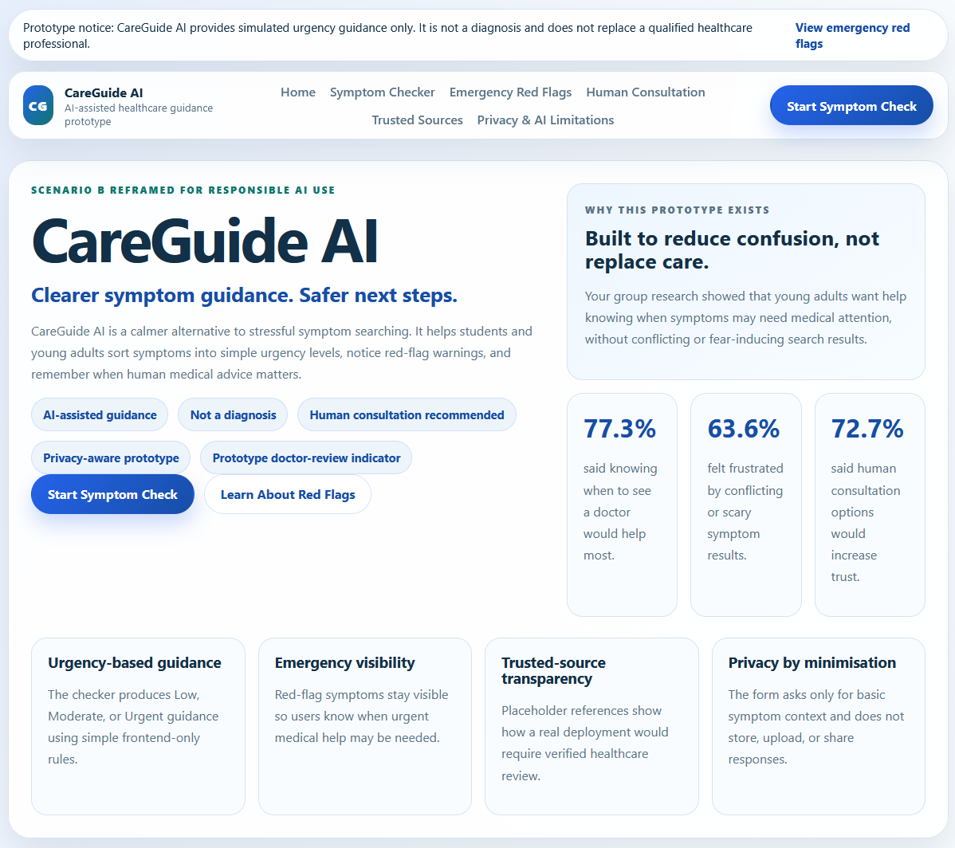
New and improved home page

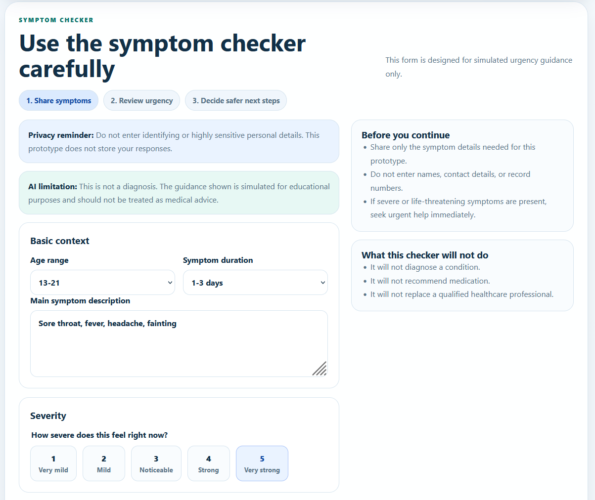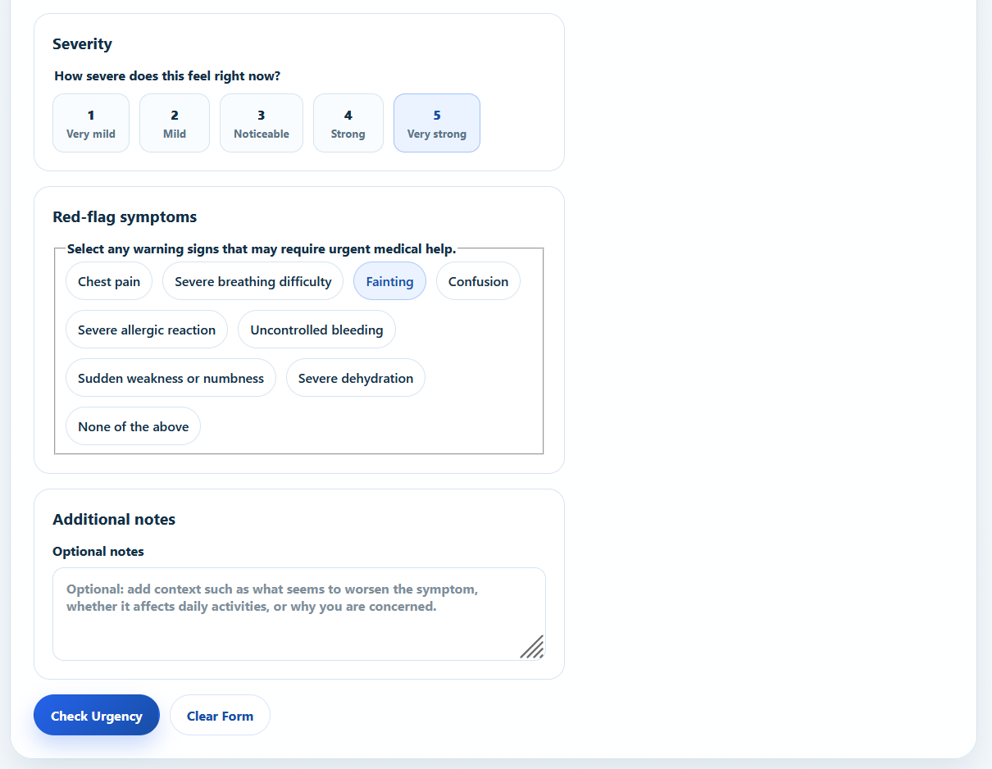
Refined symptom checker

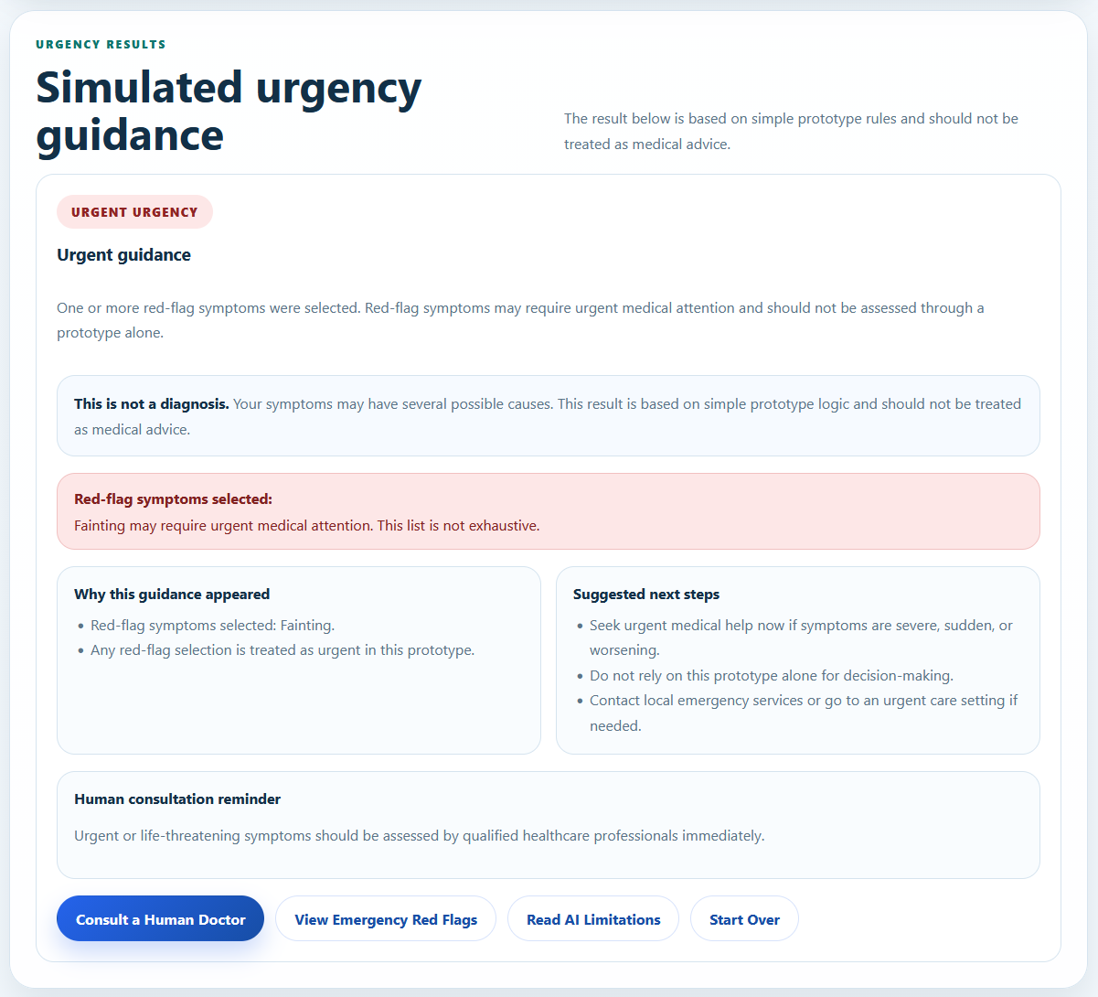
Urgency Results Page

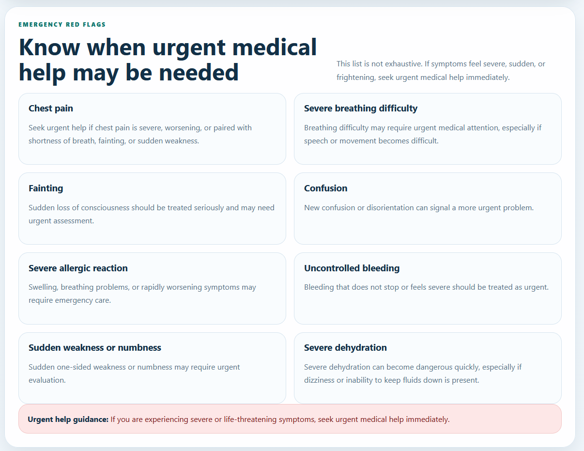
Emergency red flags

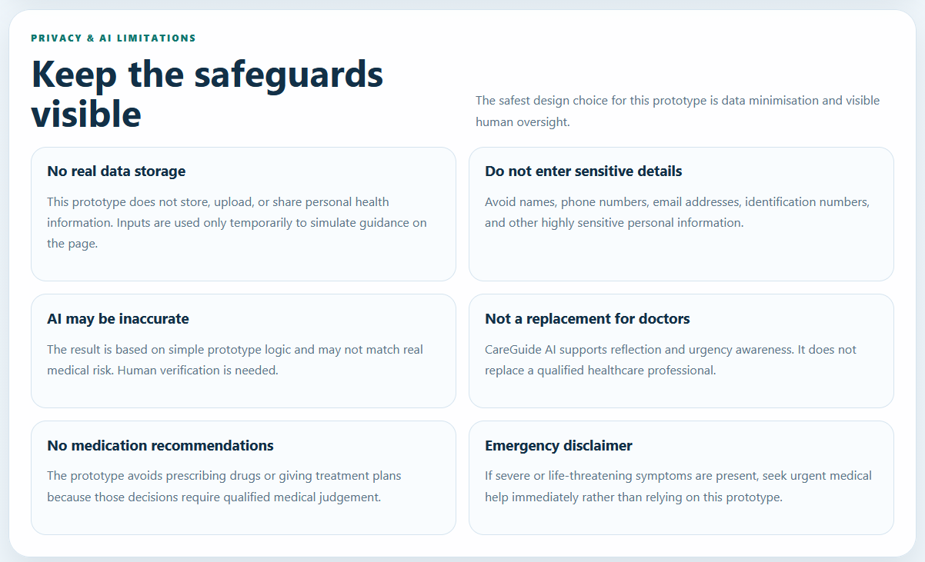Privacy and AI Limitations

How P.T.C.F. Was Applied | Persona: Codex was instructed to act as a frontend developer, healthcare UX designer, and ethical AI safety reviewer. Task: Codex was asked to refactor the zero-shot website into a complete CareGuide AI prototype. Context: Codex was given the group research findings, POV statement, ethical risks, and six guiding documents. Format: Codex was instructed to produce a complete website with Home, Symptom Checker, Urgency Results, Emergency Red Flags, Human Consultation, Trusted Sources, and Privacy & AI Limitations sections.
Role of Attached Vibecoding Documents | The attached documents acted as a context pack inside the P.T.C.F. prompt. The PRD defined the product direction and user needs. The TRD defined the frontend-only and safety constraints. The App Flow defined the navigation and user journey. The UI/UX Design Brief defined the professional healthcare style. The Data Handling Plan defined privacy and non-storage rules. The Implementation Plan gave Codex a controlled build sequence.
AI Output Summary | Codex refactored the original single-page intake site into a complete single-page healthcare guidance prototype. It replaced the broken “Generate Visit Summary” workflow with a working “Check Urgency” flow. The new website included Home, Symptom Checker, Urgency Results, Emergency Red Flags, Human Consultation, Trusted Sources, and Privacy & AI Limitations sections.
Improvements from Stage 1 | Stage 2 improved the zero-shot output by adding working Low / Moderate / Urgent urgency states, frontend-only rule-based logic, calmer validation, red-flag escalation, privacy notices, AI limitation notices, human consultation reminders, trusted-source placeholders, and a clearer user journey. Codex also removed unnecessary personal identifiers such as name, email, and phone number from the form.
Ethical Safeguards Added | The refined prototype avoided definitive diagnosis and medication recommendations. It repeatedly stated that the website is not a diagnosis and does not replace a qualified healthcare professional. It also added privacy safeguards, human consultation reminders, and emergency escalation guidance.
Technical Decision | Although the guiding documents preferred React + Tailwind, Codex kept the project as plain HTML/CSS/JavaScript because the zero-shot project was already a static site. I accepted this as a practical trade-off because the assignment focuses on the website prototype, prompt evolution, and ethical AI supervision rather than requiring a specific framework. The final output remained frontend-only and avoided backend storage, external APIs, localStorage, and sessionStorage.
Human Evaluation | The Stage 2 output was a major improvement over the zero-shot version. It became more aligned with the group research because it focused on urgency guidance, emergency warning signs, trusted-source transparency, privacy, and human consultation. However, I still needed to check the wording, functionality, and ethical safeguards manually before treating it as final.
Human Decision / Next Step | I decided to keep the Stage 2 version as the main refined prototype, but I would still continue with a 4 C’s refinement prompt and manual human override. This was necessary to further polish clarity, context alignment, constraints, and creativity, and to ensure the final website did not contain unsafe medical claims, misleading trust signals, or privacy issues.

Stage 3: 4 C’s Refinement Prompt

Here is my prompt:

You are refining the current CareGuide AI website after the Stage 2 P.T.C.F. refactor.

This is NOT a full rebuild. Keep the current plain HTML/CSS/JavaScript structure unless a small change is necessary. The goal is to refine, polish, audit, and improve the current prototype using the 4 C’s framework from my AI & Ethics lesson: Clarity, Context, Constraints, and Creativity.

Before editing, inspect the existing files carefully:
- index.html
- styles.css
- script.js
- README.md if relevant

Then produce a short refinement plan. After the plan, implement the changes.

This project is for an AI & Ethics assignment. The assignment rewards a strong evolution from zero-shot prompting to engineered prompting, detailed human override, and a Mindful Creator audit. Therefore, your changes should make the website easier to defend ethically and easier to document in my Diagnostic Log.

==================================================
C1 — CLARITY
==================================================

Make the website even clearer that CareGuide AI is:

- an AI-assisted healthcare guidance prototype,
- an urgency guidance tool,
- not an AI doctor,
- not a diagnosis system,
- not a medication recommendation tool,
- not a replacement for a qualified healthcare professional.

Improve wording where needed so users immediately understand:

1. what the website does,
2. what the website does not do,
3. what kind of result they will receive,
4. when they should seek human medical advice,
5. why red-flag symptoms matter.

Specific clarity improvements to check:

- Make sure the main call-to-action says “Start Symptom Check” or “Check Urgency”, not “Diagnose”.
- Make sure the results section title clearly says “Simulated urgency guidance”.
- Make sure every result state includes “This is not a diagnosis.”
- Make sure the result explanation does not sound like a medical conclusion.
- Make sure the user journey is easy to follow: Home → Symptom Checker → Urgency Result → Next Steps.
- Make sure the difference between Low, Moderate, and Urgent is understandable without relying only on colour.
- Make sure the page does not confuse “doctor-reviewed” with real doctor approval. Use “prototype doctor-review indicator” or “future medical review required” instead.

Also check for any leftover wording from the zero-shot version, such as:
- visit summary
- clinician handoff
- patient intake
- care summary
- generate visit summary
- diagnosis
- medication recommendation

Remove or reframe any leftover wording that no longer fits the Stage 2 product direction.

==================================================
C2 — CONTEXT
==================================================

The group research found that the target users are mainly students and young adults who often search symptoms online and feel uncertain about whether they should see a doctor.

The survey findings that must remain visible in the website direction are:

- 54.5% of respondents search symptoms online very often.
- 54.5% said searching online is their first action when feeling unwell.
- 63.6% were frustrated by conflicting information.
- 63.6% were frustrated by scary worst-case results.
- 50% could not tell which sources are trustworthy.
- 77.3% had experienced uncertainty about whether symptoms required medical attention.
- 77.3% said knowing when to see a doctor would help most.
- 77.3% said professional medical design and references to trusted sources would increase trust.
- 72.7% said a doctor-reviewed badge and human consultation option would increase trust.

The website should clearly reflect this context by strengthening:

1. professional healthcare design,
2. trusted-source transparency,
3. human consultation reminders,
4. emergency red-flag visibility,
5. calm and non-alarmist copy,
6. privacy transparency,
7. urgency-based guidance rather than diagnosis.

Make sure the homepage, symptom checker, urgency results, emergency red flags, trusted sources, and privacy/AI limitations sections are all clearly connected to these user needs.

==================================================
C3 — CONSTRAINTS
==================================================

Strictly follow these safety and privacy constraints.

DO NOT add:
- diagnosis,
- disease prediction,
- medication recommendation,
- prescription advice,
- treatment plans,
- clinical certification claims,
- real doctor approval claims,
- fake medical citations,
- fake source links,
- real medical API calls,
- OpenAI/Gemini API calls inside the website,
- backend,
- database,
- authentication,
- localStorage,
- sessionStorage,
- cookies for health data,
- user accounts,
- saved medical history.

DO NOT collect:
- full name,
- email,
- phone number,
- NRIC,
- home address,
- exact date of birth,
- medical record number,
- insurance details,
- payment details,
- family medical history,
- medication history,
- diagnosis history.

Allowed form fields only:
- age range,
- main symptom description,
- symptom duration,
- severity level 1 to 5,
- red-flag symptom checklist,
- optional additional notes.

Do not use unsafe phrases such as:
- “You have…”
- “You definitely have…”
- “Take this medication…”
- “You are safe.”
- “This is not serious.”
- “You do not need a doctor.”
- “Doctor-approved diagnosis.”
- “Guaranteed accurate.”
- “AI-certified medical result.”
- “Diagnosing your condition…”

Use safer wording such as:
- “This is not a diagnosis.”
- “Your symptoms may have several possible causes.”
- “This result is based on simple prototype logic.”
- “Consider seeking medical advice if symptoms persist, worsen, or concern you.”
- “If you experience red-flag symptoms, seek urgent medical help.”
- “This prototype does not replace a qualified healthcare professional.”
- “A real deployment would require verified medical sources and qualified clinical review.”

Important logic constraint:
If “None of the above” is selected in the red-flag checklist, it should not be selected together with actual red-flag symptoms. Make the checkbox behaviour safe and logical:
- Selecting “None of the above” should clear other red flags.
- Selecting any real red flag should clear “None of the above”.

Important functionality constraint:
The symptom checker must work. Test all required flows after editing.

Important markup/code constraint:
Inspect index.html for accidental stray characters, broken tags, unclosed elements, duplicate IDs, or inaccessible form labels. Fix any markup issues you find.

==================================================
C4 — CREATIVITY
==================================================

Improve the website’s professional healthcare visual storytelling without making it flashy or distracting.

Refine the UI so it feels:
- calm,
- credible,
- modern,
- clear,
- professional,
- consistent,
- accessible,
- reassuring.

Specific creative improvements to consider:

1. Strengthen the trust badges so they clearly communicate:
- AI-assisted guidance,
- not a diagnosis,
- human consultation recommended,
- privacy-aware prototype,
- future medical review required / prototype doctor-review indicator.

2. Improve the urgency result cards:
- Low should feel calm, not dismissive.
- Moderate should feel careful and practical.
- Urgent should be direct but not panic-inducing.
- Each state should include next steps and human consultation reminder.

3. Improve the Emergency Red Flags section:
- Make warning signs easy to scan.
- Keep red colour limited to urgent warnings only.
- Include “This list is not exhaustive” wording.

4. Improve the Trusted Sources section:
- Use placeholder cards honestly.
- Do not invent real medical citations.
- Make it clear that a real version would require verified healthcare sources and qualified review.

5. Improve Privacy & AI Limitations:
- Make “no storage / no upload / no sharing” easy to find.
- Make “AI may be inaccurate” easy to find.
- Make “human verification is needed” easy to find.

6. Improve accessibility:
- all form controls must have visible labels,
- result states must not rely only on colour,
- buttons must be clear,
- mobile layout must remain readable,
- disclaimers must not be tiny or hidden.

==================================================
STEP-BY-STEP INSPECTION BEFORE EDITING
==================================================

Before making changes, provide a concise inspection checklist covering:

1. Current file structure found.
2. Current strengths of the Stage 2 website.
3. Remaining clarity issues.
4. Remaining context/research-alignment issues.
5. Remaining constraint/safety/privacy issues.
6. Remaining creativity/UI/accessibility issues.
7. Exact files you will edit.

Then implement the improvements.

==================================================
TESTING REQUIREMENTS AFTER EDITING
==================================================

After implementing, test the following flows and report the result:

Test 1 — Empty form:
Submit without required fields.
Expected: calm validation message, no result shown.

Test 2 — Low urgency:
Age range selected, short duration, severity 2, no red flags.
Expected: Low urgency result, no diagnosis, no medication recommendation, human consultation reminder.

Test 3 — Moderate urgency:
Severity 5 with no red flags OR duration more than 1 week.
Expected: Moderate urgency result, no diagnosis, no medication recommendation, advice to consider professional medical advice.

Test 4 — Urgent:
Select chest pain or severe breathing difficulty.
Expected: Urgent result, emergency guidance, no diagnosis, no medication recommendation.

Test 5 — “None of the above” red-flag behaviour:
Selecting “None of the above” clears other red flags.
Selecting a real red flag clears “None of the above”.

Test 6 — Mobile responsiveness:
Check that navigation, form, results, red flags, and privacy sections remain readable and usable on mobile.

Test 7 — Content safety scan:
Search the final files for risky wording:
diagnosis, diagnose, medication, prescribe, safe, not serious, doctor-approved, guaranteed, certified, stored, record.
Report whether each use is safe, unsafe, or revised.

==================================================
FINAL RESPONSE FORMAT
==================================================

After implementing, respond in this format:

1. Stage 3 refinement summary
- Briefly explain what changed and why.

2. 4 C’s mapping
- Clarity: what changed
- Context: what changed
- Constraints: what changed
- Creativity: what changed

3. Files changed
- List each file and the purpose of the change.

4. Specific improvements made
- Bullet list of concrete changes.

5. Safety and privacy improvements
- Explain how the site avoids diagnosis, medication advice, false authority, and unnecessary data collection.

6. Test results
- Provide results for all 7 tests.

7. Suggested Human Override items
- List any wording, code, or UI areas I should manually inspect and potentially override for my report.

Important:
Do not stop after planning. Implement the changes after the inspection checklist.

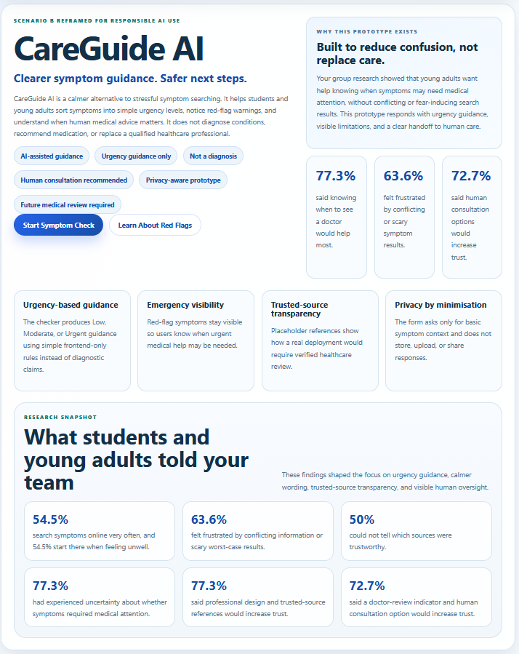
Updated home page with research snapshot
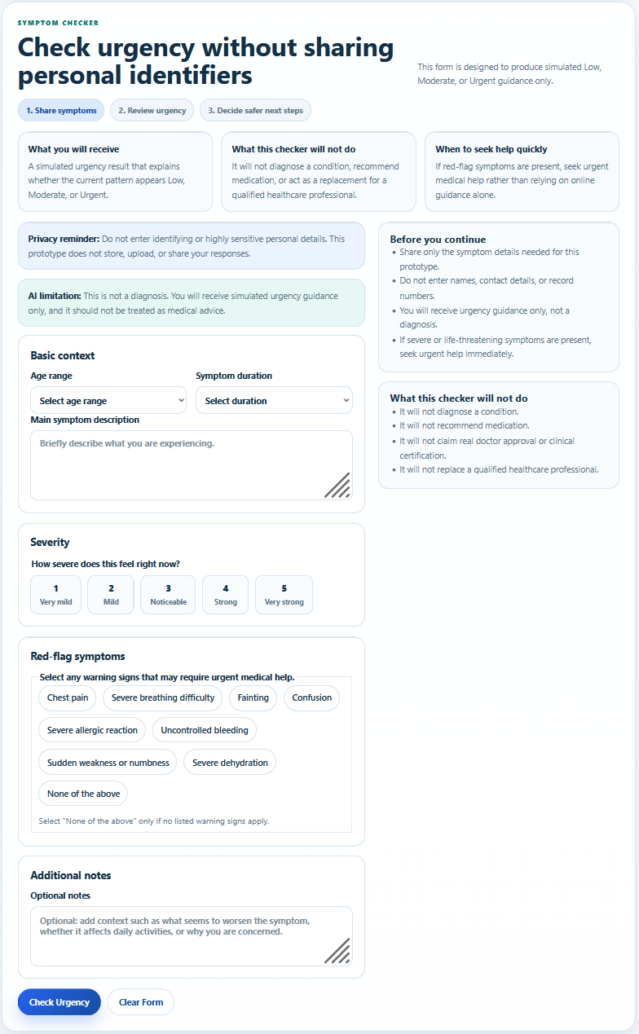
Updated symptom checker with “what this checker will not do” cards

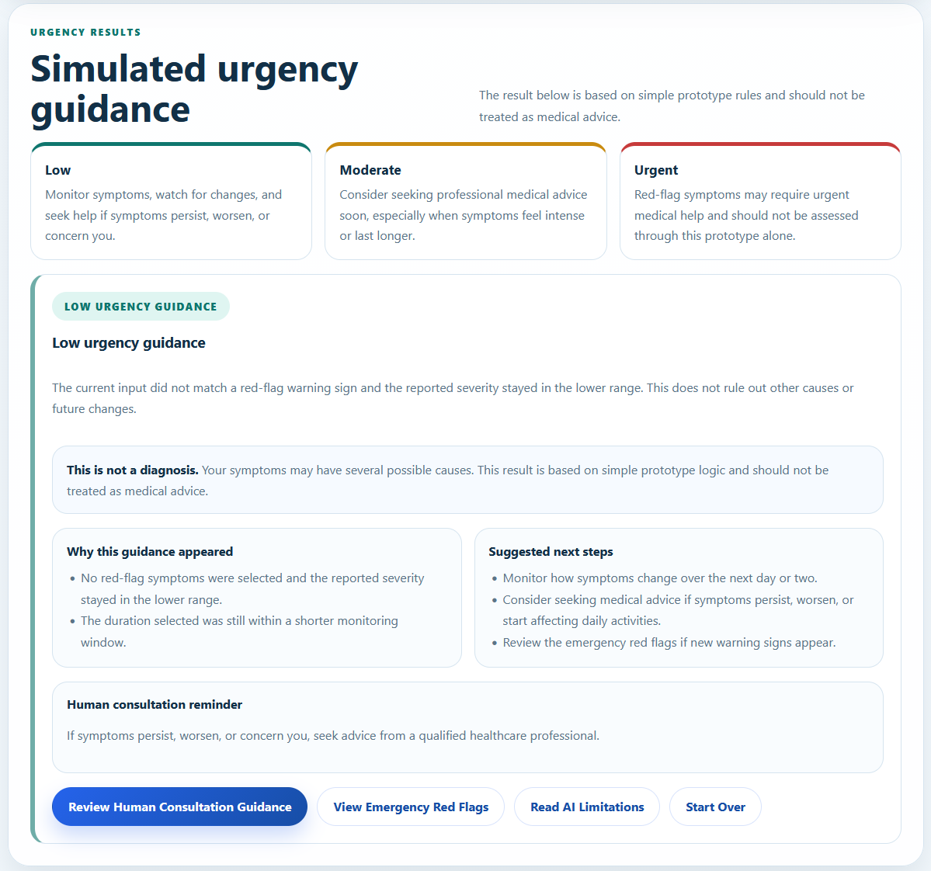
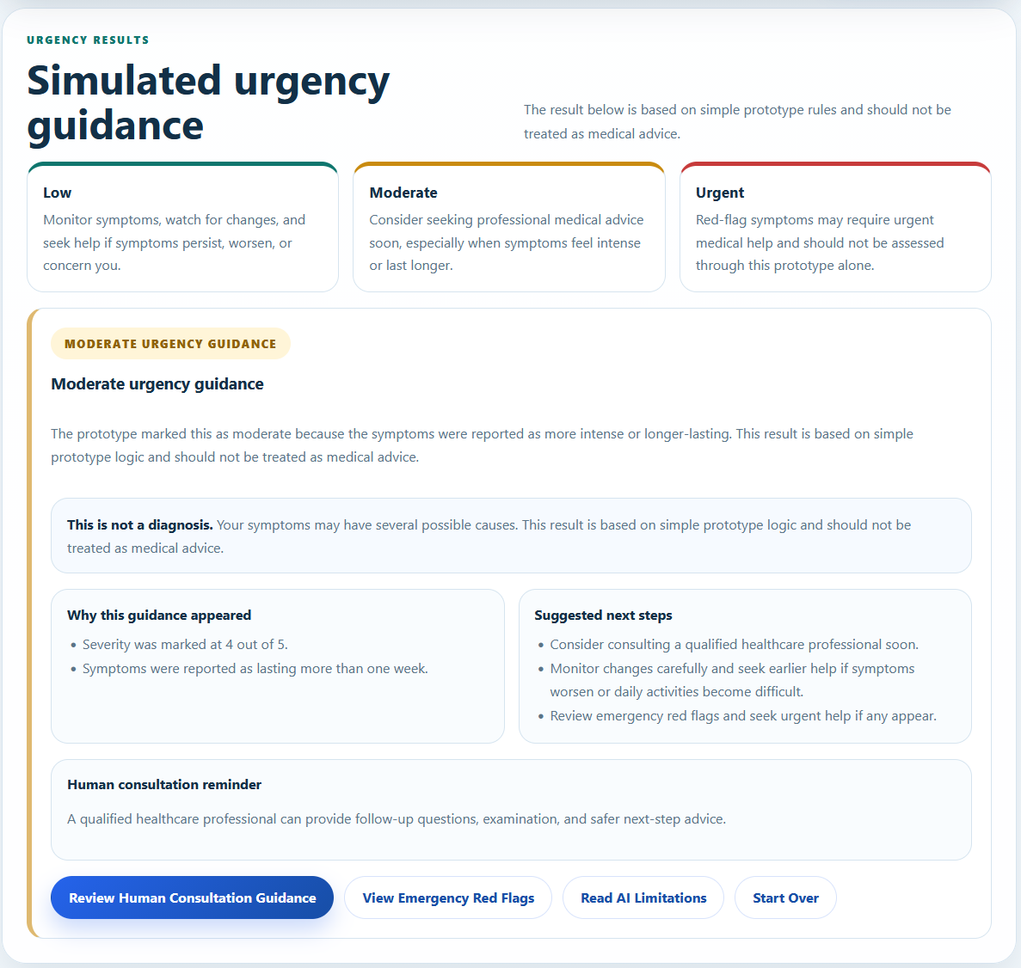
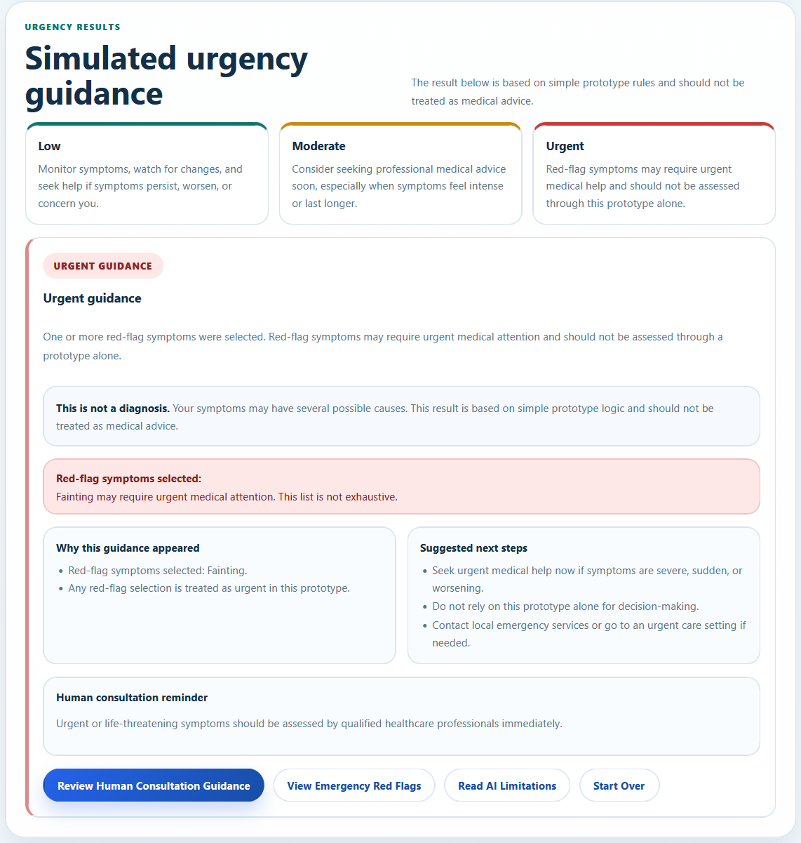
Updated Urgency Results

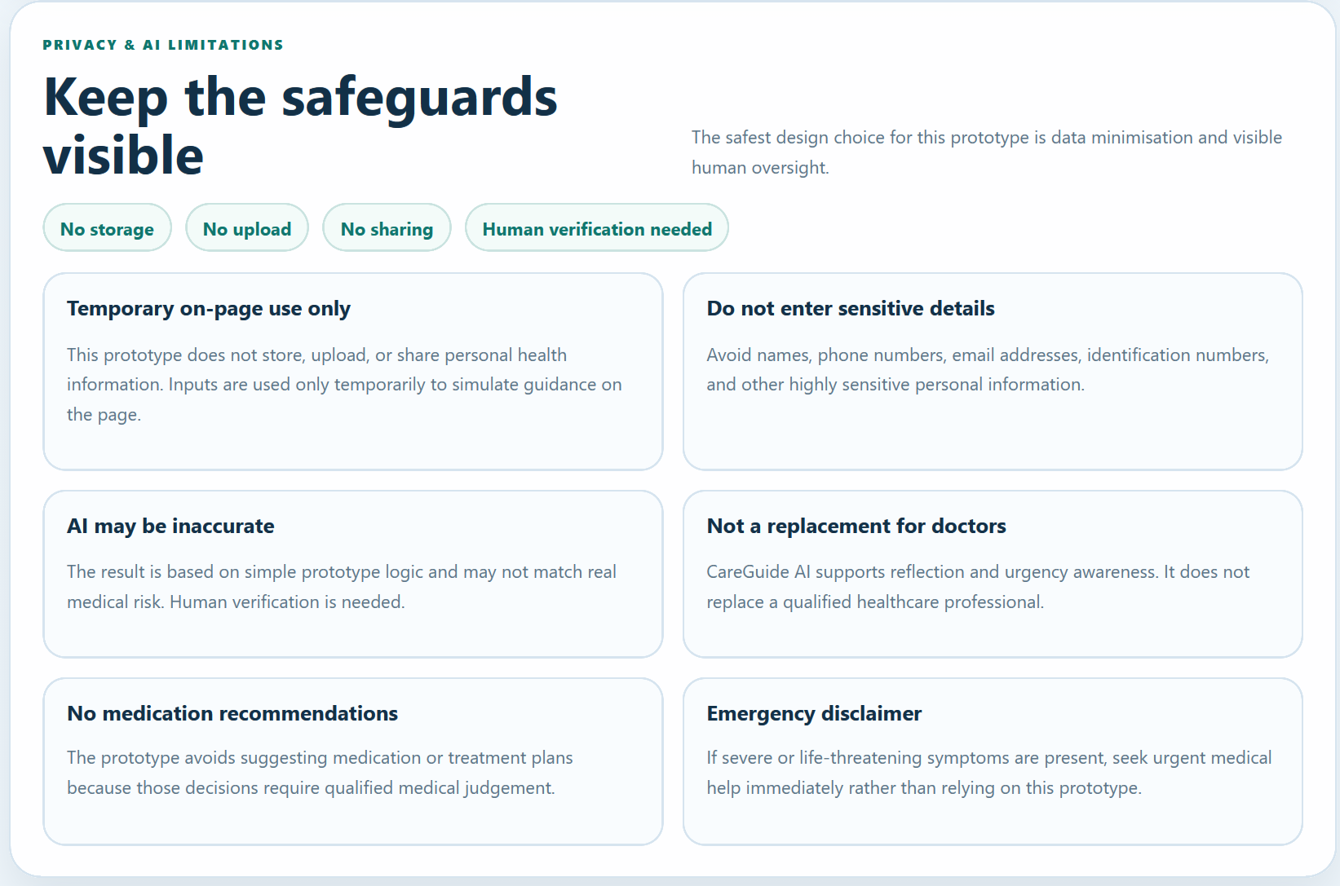
Updated Privacy & AI Limitations / privacy badges

The updated HTML now clearly states that CareGuide AI gives simulated urgency guidance only, does not diagnose, does not recommend medication, and does not replace a healthcare professional. It also adds visible research statistics and clearer trust badges such as “Urgency guidance only,” “Not a diagnosis,” and “Future medical review required.”

How the 4 C’s Were Applied | Clarity: Codex was asked to make the website clearly communicate that it provides urgency guidance only, not diagnosis or medication advice. Context: Codex was asked to make the group survey findings more visible in the website. Constraints: Codex was told to preserve privacy, avoid diagnosis, avoid medication recommendations, avoid fake doctor approval, and avoid storing health data. Creativity: Codex was asked to improve the professional healthcare UI, urgency cards, trust badges, privacy notices, and mobile responsiveness.
AI Output Summary | Codex refined the existing plain HTML/CSS/JavaScript prototype rather than rebuilding it. It added a visible research snapshot on the homepage, strengthened the trust badges, added “What you will receive” and “What this checker will not do” cards, improved urgency result explanations, added clearer privacy signals, improved mobile navigation, and updated the README.
Important Issue Found | Codex identified one important interaction issue: if a user changed or cleared the form after seeing a result, the old result could remain on screen. This was ethically risky because stale guidance could mislead users. Codex fixed this by clearing the old result when form inputs changed.
Improvements from Stage 2 | The Stage 3 version improved the clarity of the product scope, made the research findings more visible, strengthened non-diagnostic wording, improved the red-flag explanation, added an urgency legend, changed the result CTA to “Review Human Consultation Guidance,” improved privacy badges, and made mobile navigation stack more cleanly.
Ethical Safeguards Strengthened | The website continued to avoid diagnosis, medication recommendations, treatment advice, real doctor approval, clinical certification claims, backend storage, and external APIs. It also made privacy boundaries clearer by stating that responses are not stored, uploaded, or shared.
Testing Completed | Codex tested seven flows: empty form validation, Low urgency, Moderate urgency, Urgent red-flag result, “None of the above” red-flag behaviour, mobile responsiveness, and a content safety scan. All tests passed according to Codex’s report.
Human Evaluation | The Stage 3 output was stronger than Stage 2 because it did not merely add features; it improved ethical defensibility. The site became clearer about what AI can and cannot do, more aligned with the survey findings, and safer because stale results were cleared when inputs changed. However, I still needed to manually inspect the wording and decide what to include in my Human Override section.
Human Decision / Next Step | I accepted the Stage 3 version as the strongest AI-generated version so far, but I did not treat it as final without human review. My next step was to perform a manual Human Override and use the Urgency Results section as the critical webpage for the Synthesis Protocol.

Stage 3 was important because it showed that refinement was not only about adding more features. It was about making the AI-generated website safer, clearer, and more ethically defensible. The 4 C’s prompt helped Codex improve the prototype in four ways: clearer wording, stronger connection to user research, stricter privacy and medical-safety boundaries, and more polished visual storytelling. This connects directly to Lesson 2’s idea that the quality of AI output reflects the clarity of human input, and that AI-generated content still requires human verification and critical oversight.

Stage 4: Human Override Safety Pass
I duplicated the AI-generated Stage 3 files, placed them in a human_override folder, and applied my edits there. These were not massive changes, they were small, safety, privacy, transparency, and ethical clarity edits based on my review of the website’s remaining risks. Since the project involves healthcare guidance, I focused on preventing overtrust in AI output, avoiding false medical authority, reducing privacy risk, clarifying that the website does not diagnose or recommend treatment, and ensuring that the user is directed toward human medical judgement when appropriate. You can look at my github to understand the project directory.

Folder Used | I duplicated the current project files and placed the new version in a separate human_override folder. All final human override edits were made only inside that folder.
Files Edited | index.html, script.js, and README.md were edited. I left styles.css unchanged because the wording edits fit the existing layout and no visual redesign was needed.
Main Focus | The edits focused on stronger privacy reminders, stronger non-medical-use disclaimers, clearer trusted-source placeholder wording, safer red-flag phrasing, stale-result clearing, and documentation of no-storage/no-API checks.

The table below shows the before and after:

File | Original wording/code | Human override edit | Why this matters ethically
index.html | “Do not enter identifying or highly sensitive personal details.” | Changed to “Do not enter names, contact details, identification numbers, or highly sensitive medical history.” | This makes the privacy warning more concrete, so users are less likely to overshare sensitive health or identity data.
index.html | “should not be treated as medical advice” | Strengthened repeated disclaimers to “should not be treated as medical advice, diagnosis, or treatment guidance.” | This reduces overtrust and makes the prototype boundary clearer because users are reminded that the result is not medical advice, diagnosis, or treatment.
index.html | “They are not live citations, and this prototype does not claim external medical approval.” | Changed to “They are not live citations and do not imply external medical approval or clinical validation.” | This prevents placeholder source cards from being mistaken for real endorsement, medical approval, or clinical validation.
index.html | “Trusted source placeholder” | Changed all source badges to “Prototype-only source placeholder.” | This makes the limitation visible directly on each card and reduces the risk of false credibility.
index.html | “If symptoms feel severe, sudden, or frightening...” and “can signal a more urgent problem.” | Changed to calmer wording such as “rapidly worsening” and “should be treated cautiously and may need urgent assessment.” | This keeps emergency guidance direct without sounding alarmist or implying that the prototype can diagnose the cause.
script.js | Moderate-result explanation ended with “should not be treated as medical advice.” | Updated generated result text to match the stronger “medical advice, diagnosis, or treatment guidance” wording. | This ensures that the live generated result follows the same safety boundary as the static HTML disclaimers.
script.js | Emergency warning said selected red flags “may require urgent medical attention.” | Changed to “can require urgent medical attention. This message does not identify a cause.” | This avoids implying that the prototype understands or diagnoses the medical cause behind the warning sign.
script.js | Result reset relied on form input handling only. | Added handleFormMutation() and bound it to both input and change events. | This helps prevent stale urgency results from remaining on screen after the user changes inputs, reducing the risk of misleading guidance.
README.md | General frontend-only summary | Added explicit notes that the code does not use localStorage, sessionStorage, cookies, fetch, a backend, a database, or external medical APIs. | This creates a clear audit trail proving that the prototype avoids data storage, external APIs, and unnecessary health-data handling.

The human override stage focused on reducing the risk of users overtrusting the website. The original assignment scenario mentioned preliminary diagnoses and drug recommendations, but I deliberately reframed the prototype so it only provides simulated urgency guidance. In this final pass, I strengthened the boundary language even further by changing “not medical advice” into “not medical advice, diagnosis, or treatment guidance.” This matters because healthcare wording can easily sound more authoritative than intended.

I also strengthened the privacy reminder by naming specific information users should not enter, such as names, contact details, identification numbers, and highly sensitive medical history. This supports data minimisation because the prototype does not need identifiable personal information to simulate urgency guidance. I also changed the trusted-source wording so the source cards are clearly prototype-only placeholders, not live citations or evidence of clinical validation. Overall, these changes show that I did not blindly accept the AI-generated website; I reviewed its ethical risks and applied final human override edits to make the website safer, more transparent, and more responsible.
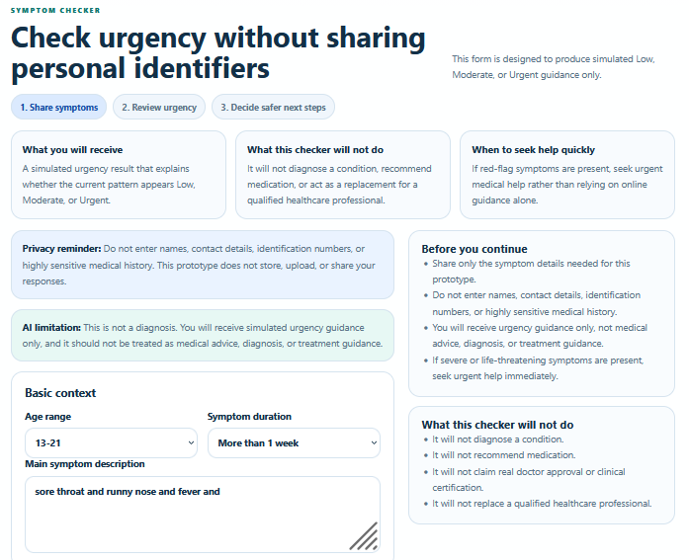
Strengthened privacy reminder in the final Symptom Checker

Strengthened AI limitation wording: “not medical advice, diagnosis, or treatment guidance”

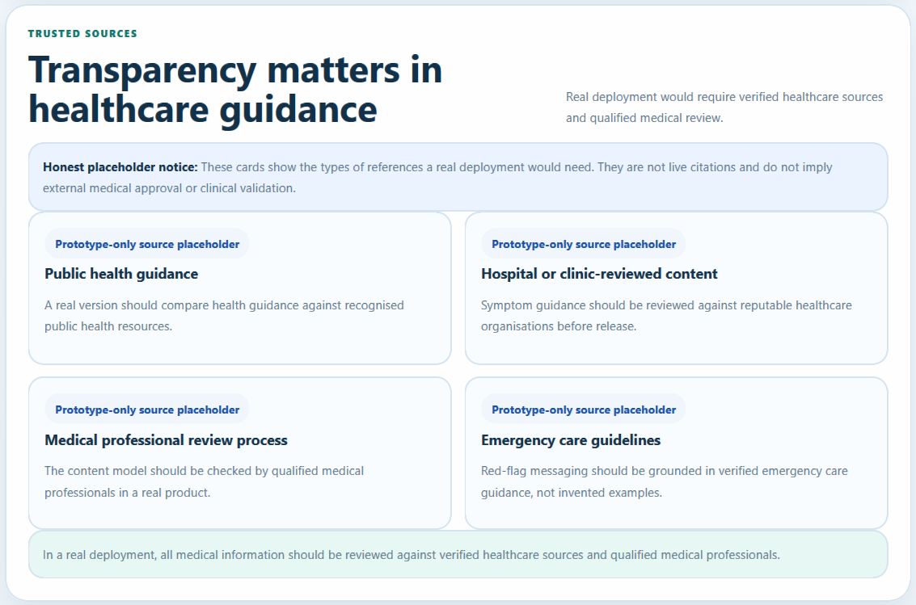
Trusted Sources section with “Prototype-only source placeholder”

Stage 4 completed my Diagnostic Log because it showed that I did not simply accept the AI-generated website as final. The human override folder contains the final version of the prototype after targeted safety, privacy, and transparency edits. These changes strengthened the website’s ethical boundaries by making the privacy warning more specific, clarifying that the output is not medical advice, diagnosis, or treatment guidance, preventing trusted-source placeholders from sounding clinically validated, and making stale-result clearing more robust. This prepares the project for the Synthesis Protocol, where I analyse the Urgency Results section as the most critical webpage.

The Synthesis Protocol:
For the Synthesis Protocol, I selected the Urgency Results section as my most critical webpage. This is the highest-risk part of the website because it is where users receive health-related guidance after entering symptoms. If the wording is too confident, diagnostic, or treatment-like, users may overtrust the AI output and delay proper medical care. Therefore, this section best demonstrates how I moved from baseline AI generation, to structured refinement, and finally to human override.
This page also connects directly to my group’s research. The survey showed that users were often unsure whether their symptoms required medical attention, and the most selected helpful feature was knowing “when to see a doctor.” This meant the final website should not focus on giving possible diseases or medication suggestions. Instead, the critical page needed to provide clear urgency guidance, emergency red-flag escalation, and reminders to seek human medical advice.

Step A: The Baseline
In the baseline zero-shot generation, Codex did not create a proper Urgency Results section. Instead, it generated a clinician intake and visit-summary style flow. The page collected patient information and showed a live patient summary, but the main action, “Generate Visit Summary,” did not produce a working output. This meant the most important interaction in the prototype was incomplete.
The baseline was also not fully aligned with the group’s user research. It focused more on preparing information for a clinician rather than helping young adults understand symptom urgency and safer next steps. It also collected unnecessary personal details such as name, email, phone number, allergies, medications, and medical conditions. For a school prototype involving health-related information, this created unnecessary privacy risk.
The baseline was therefore unsuitable as the final critical webpage for three reasons. First, it did not provide Low, Moderate, or Urgent guidance. Second, its main button did not work. Third, it did not sufficiently minimise personal data collection. This showed why the zero-shot prompt was not enough for a healthcare-related AI prototype.

Step B: The Refinement
After the Stage 2 P.T.C.F. prompt and Stage 3 4 C’s refinement, the critical webpage changed from a broken visit-summary flow into a Simulated Urgency Guidance section. Instead of producing a diagnosis or medication recommendation, it generated Low, Moderate, or Urgent guidance using frontend-only rule-based logic.
The refined page corrected the baseline problem by replacing the non-working “Generate Visit Summary” action with a working “Check Urgency” flow. The result section now gave users a clear urgency level, an explanation of why the guidance appeared, suggested next steps, and a human consultation reminder. This was a major improvement because the page now answered the actual user need identified in the survey: helping users understand whether symptoms may require medical attention.
The refinement also added important ethical constraints. The result section did not diagnose illnesses, did not recommend medication, and did not claim clinical certainty. It included wording such as “This is not a diagnosis” and reminded users that the result was based on simple prototype logic. Red-flag symptoms triggered urgent guidance, but the page avoided claiming the cause of those symptoms.
This refinement improved the page in four ways:

Functionality | The page changed from a non-working visit-summary button to a working urgency result flow.
Safety | The page avoided diagnosis, medication advice, and certainty claims.
Research alignment | It focused on “when to seek help”, matching the survey finding that users wanted urgency guidance.
Human oversight | Every result reminded users that qualified healthcare professionals still matter

Step C: Critical Reflection / Human Override
The final human override strengthened the Urgency Results section further. Although the refined version was already safer than the baseline, I still reviewed it for healthcare-specific risks: overtrust in AI, diagnostic wording, treatment-like wording, false authority, and stale guidance.
The first important human override was strengthening the result disclaimer. The previous wording said the result “should not be treated as medical advice.” I changed this to “should not be treated as medical advice, diagnosis, or treatment guidance.” This was necessary because “medical advice” alone may not be specific enough. A user might still think the result is a diagnosis or treatment suggestion. By explicitly adding “diagnosis” and “treatment guidance,” the result page became clearer about what it does not do.
The second important human override was improving the emergency warning. The earlier wording said selected red flags “may require urgent medical attention.” I changed this to explain that red flags “can require urgent medical attention” while also stating that “this message does not identify a cause.” This matters because the website should guide users toward urgent help without sounding like it knows the medical reason behind the symptom. The final wording keeps the warning serious but non-diagnostic.
The third important human override was strengthening stale-result clearing in script.js. If a user generated an urgency result and then changed their form inputs, the old result could remain visible and mislead them. The final human override added stronger input and change event handling through handleFormMutation(), so old urgency guidance clears when the user edits the form. This was a behaviour-level safety improvement, not just a wording change. It prevents users from relying on outdated guidance that no longer matches their current symptom inputs.
These human override changes were important because the result section is where users are most likely to overtrust the website. My goal was not only to make the page look better, but to reduce the risk that users would mistake the prototype for a real medical triage system.

Before Human Override | After Human Override | Why This Matters Ethically
“should not be treated as medical advice” | “should not be treated as medical advice, diagnosis, or treatment guidance” | Clarifies that the result is not a medical conclusion, diagnosis, or treatment recommendation.
Emergency warning said selected red flags “may require urgent medical attention.” | Emergency warning now says red flags can require urgent medical attention and that the message does not identify a cause. | Keeps urgent guidance visible without implying that the prototype can diagnose the cause.
Old urgency result could remain visible after the user changed inputs. | handleFormMutation() clears stale results when inputs change. | Prevents users from relying on outdated guidance that no longer matches their current input.
The page could be interpreted as a medical result if users skimmed quickly. | Stronger repeated disclaimers were added in both static HTML and JS-generated result text. | Reduces overtrust by making the prototype boundary visible in multiple places.

Reflection
The Urgency Results section shows the clearest transformation in my project. The baseline zero-shot output produced a visually polished but incomplete intake flow. It did not give users proper urgency guidance, and its main generated-summary action did not work. Through the Stage 2 P.T.C.F. prompt, I gave Codex clearer persona, task, context, and format instructions. Through the Stage 3 4 C’s refinement, I improved clarity, context alignment, constraints, and visual communication. Finally, through the Stage 4 human override, I strengthened the most ethically sensitive wording and behaviour.
The most important decision was to reject the original scenario’s literal direction of preliminary diagnoses and automated drug recommendations. Instead, I reframed the page into simulated urgency guidance. This still addresses the user’s real problem — uncertainty about when to seek help — but avoids pretending that the prototype can diagnose illness or recommend treatment. This is why the final page is safer, more human-centred, and more ethically defensible.

The Mindful Creator Audit:
For the Mindful Creator Audit, I reviewed the final human_override version of the CareGuide AI website. I treated this audit as a final ethical inspection of the generated website copy and user flow. Since this prototype involves healthcare guidance, the main risks were not just visual design mistakes, but ethical risks such as overtrust in AI, false diagnosis, treatment-like wording, unnecessary personal data collection, fake medical credibility, and unclear emergency guidance.
The purpose of this audit was to prove that I did not blindly accept the AI-generated website. I actively checked the final copy and interface to make sure the website remained an urgency-guidance prototype, not an AI doctor or automated medical decision-maker. I also checked whether the human override edits were visible in the final website.

Audit Area | What I Checked | Why It Matters
Medical safety | I checked that the website does not diagnose illnesses, recommend medication, or suggest treatment. | Users may overtrust healthcare-related AI output if it sounds too authoritative.
Privacy and data minimisation | I checked that the form does not collect names, contact details, identification numbers, or unnecessary health history. | Health-related inputs are sensitive, so the prototype should collect only what is necessary.
AI limitation transparency | I checked that the website clearly states it is not medical advice, diagnosis, or treatment guidance. | Users need to understand the boundary between prototype guidance and real medical care.
Human oversight | I checked that human consultation reminders remain visible. | The website should support professional care, not replace it.
Source credibility | I checked that trusted-source cards are labelled as prototype-only placeholders. | Fake or unclear source claims could create false credibility.
Emergency red flags | I checked that urgent symptoms are highlighted clearly but without diagnosing the cause. | Emergency guidance must be serious, but not panic-inducing or medically overconfident.
Interaction safety | I checked that old urgency results clear when the user changes inputs. | Stale guidance could mislead users if it no longer matches the current symptoms.

