Deep Learning
Homework 1 Report
Student ID: 115550818 | Name: Toh Cheng Hee Adriel

Part 1 (b): Image regression with an INR

Network architecture and training setup
Setting | Configuration
Raw-coordinate model | 2 → 128 → 128 → 3
Fourier-feature model | 26 → 128 → 128 → 3
Hidden / output activations | tanh / linear RGB output
Optimizer | Mini-batch SGD; learning rate 0.01
Training | 800 epochs; batch size 512
Objective | Mean-squared error over all three RGB channels

Learning curve and reconstruction
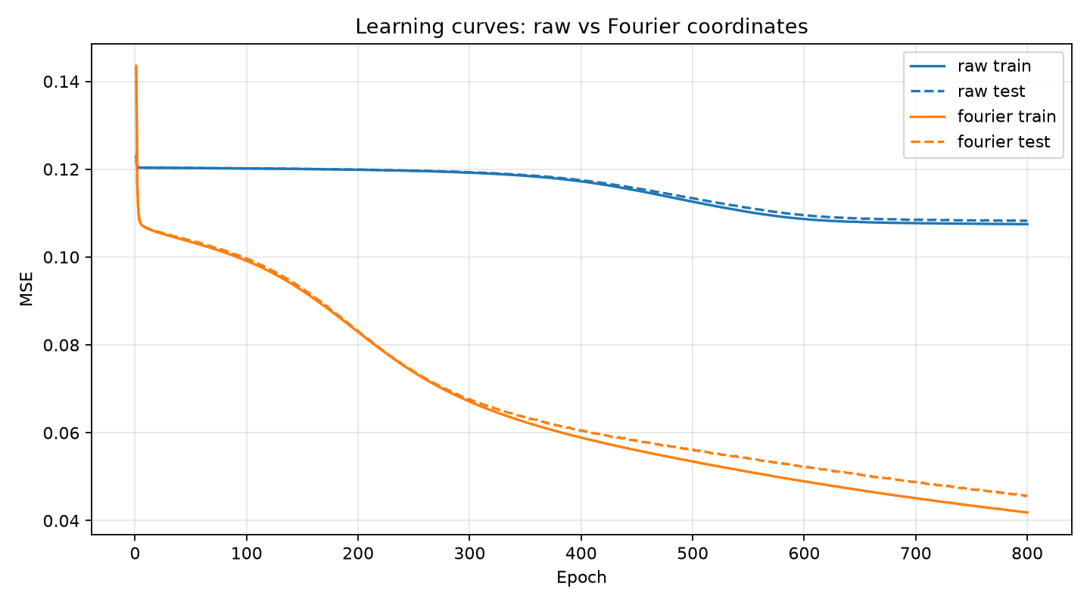
Figure 1. Training and test MSE for raw and Fourier coordinates over 800 epochs.

Training RMS error and test RMS error
Input representation | Training RMS | Test RMS
Raw coordinates | 0.327837 | 0.329030
Fourier features | 0.204593 | 0.213886

Reconstructed images at different stages
 | Epoch 100 | Epoch 200 | Epoch 400 | Final: 800
Raw |  |  |  | 
Fourier | 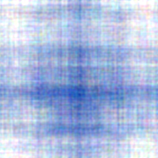 | 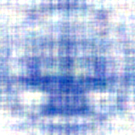 | 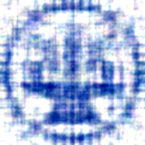 | 
Figure 2. Full-image predictions at epochs 100, 200, 400, and 800. Every panel includes both training and test pixels.

Part 1 (c): Raw coordinates vs Fourier mapping

Input representation
The raw model receives only (x, y). The encoded model receives these coordinates together with sine and cosine features at six frequency bands. For each coordinate, the frequencies are π × 2ᵏ for k = 0, …, 5. Each band adds four values: sin(π2ᵏx), sin(π2ᵏy), cos(π2ᵏx), and cos(π2ᵏy). The total input size is therefore 2 + 6 × 4 = 26 features.
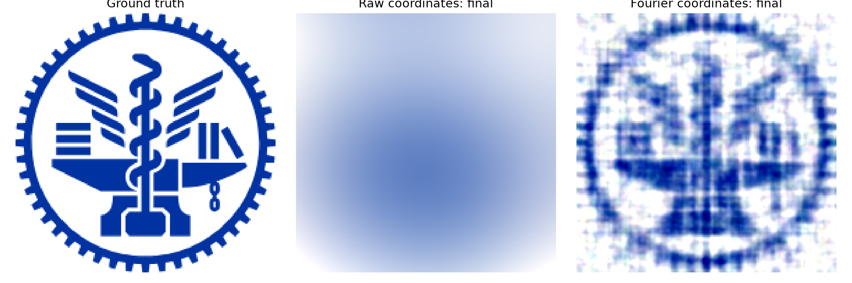
Figure 3. Ground truth, raw-coordinate reconstruction, and Fourier-feature reconstruction at epoch 800.

Observed results
The raw-coordinate network produces a smooth blue region and does not recover the logo’s internal structure. The Fourier model recovers the circular outline and several internal shapes, although fine edges remain blurred and a grid-like texture is visible. Test RMS decreases from 0.329030 to 0.213886.
The learning curves support this visual comparison. The raw model improves slowly and approaches a plateau, while the Fourier model continues reducing both training and test error through epoch 800. The small raw-model train/test gap, together with its large errors, is consistent with underfitting under this training setup.

Why encoding helps
An MLP trained on raw coordinates tends to learn slowly varying patterns more readily than sharp spatial changes. The logo contains narrow lines, abrupt color changes, and repeated teeth around its boundary. Fourier encoding supplies rapidly varying functions of position, making these spatial details easier for the network to represent and learn.
Encoding improves reconstruction but does not guarantee a perfect fit. Both networks have two 128-node hidden layers, but the encoded model has more first-layer parameters because it receives 26 inputs instead of 2.

Part 2 (b): Ionosphere binary classification

Network architecture and preprocessing
The selected model is a one-hidden-layer ReLU network: 34 input features → 16 ReLU neurons → 2 softmax outputs. The outputs represent the probabilities of bad (b) and good (g) radar returns.
Setting | Configuration
Loss | Mean two-class softmax cross-entropy
Optimizer | Mini-batch SGD with momentum 0.9
Learning rate / batch size / epochs | 0.001 / 32 / 1,000

Learning curve
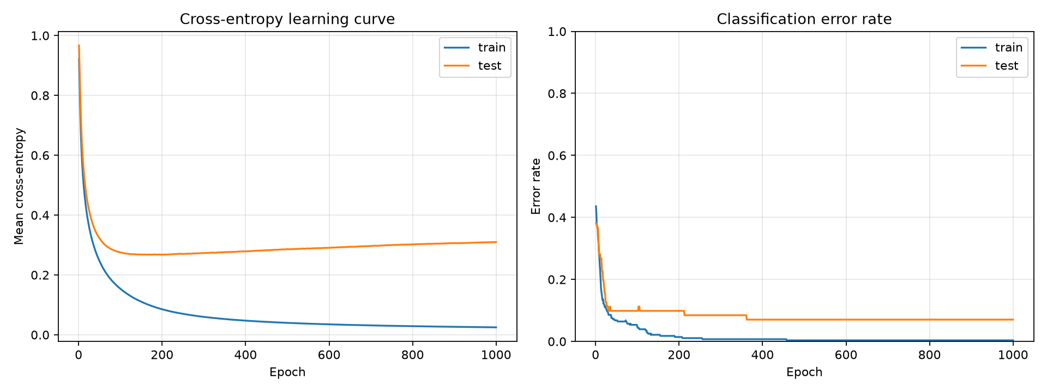
Figure 4. Cross-entropy and classification error for the main 16-node ReLU model.

Training error rate and test error rate
Split | Cross-entropy | Error rate | Incorrect / total
Training | 0.024888 | 0.36% | 1 / 280
Test | 0.309796 | 7.04% | 5 / 71

Part 2 (c): Comparing latent-layer widths

Experimental setup
The layer immediately before the output is the latent layer. Its activations form a learned representation of each sample. Four networks are compared: 34 → 2 → 2, 34 → 8 → 2, 34 → 16 → 2 and 34 → 32 → 2. All use ReLU hidden activations, the same data split, learning rate 0.001, momentum 0.9, batch size 32, and 1,000 epochs.
Latent features are recorded at epochs 10, 100, 500, and 1,000 and displayed using a two-dimensional principal component analysis (PCA) projection. Each dot represents one sample; blue denotes b and orange denotes g. The plots include all 351 samples, although only training samples influence the network updates.

Final results of the width comparison
Latent nodes | Training error | Test error | Test cross-entropy
2 | 2.86% | 19.72% | 0.599595
8 | 0.71% | 7.04% | 0.265736
16 | 0.36% | 7.04% | 0.262906
32 | 0.36% | 8.45% | 0.254770

At early epochs, the projected representations show substantial class overlap. By epochs 500 and 1,000, the 8, 16 and 32-node networks show clearer separation between the blue and orange distributions, although some overlap remains. The 2-node network retains a restricted representation with points concentrated along narrow branches and has the highest final test error, 19.72%.
The 2-node model appears to have insufficient capacity under the selected training settings, as indicated by its higher training and test errors. Increasing the width to 8 nodes improves performance substantially. The 16-node model further reduces training error but provides no additional improvement in test accuracy, suggesting diminishing returns from increased capacity. Finally, the 32-node model did not reduce training error, test error increased from 16-node, indicating possible overfitting.
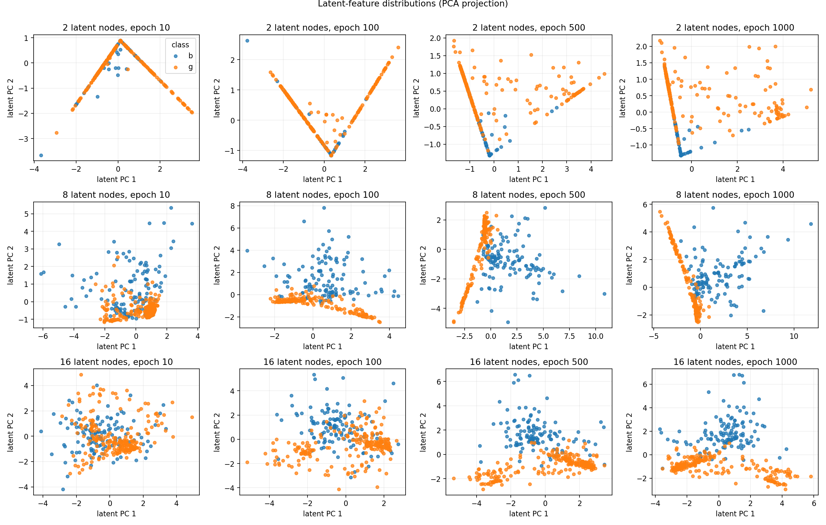
Figure 5. Rows: 2, 8, and 16 latent nodes. Columns: epochs 10, 100, 500, and 1,000. Blue = bad (b); orange = good (g). Each panel is a separate PCA projection of all samples.

