Material Flow Analysis II, April 2024

Questions? [t.fishman@cml.leidenuniv.nl](mailto:t.fishman@cml.leidenuniv.nl)

# Hands-on with a dynamic MFA model in Excel

## Objective and pointers

The objective of this exercise is to understand the “behind the scenes” of the flow-driven dynamic MFA model, and how changes in the input data propagate to the results of the model.

* Use the Excel file “flow_driven_model.xlsx” found in Brightspace for this exercise.

If the Model_Output sheet is full of errors, your Excel version is really old! Use “flow_driven_model_old - use only if you have older Excel that doesnt have the xlookup function.xlsx” instead. It only affects question 5.

* It’s useful to have the Data_Input and Model_Output sheets in two separate windows to view both simultaneously and immediately see how changes in Data_Input affect Model_Output. (in Excel: view > New Window)
* There are several graphs in the Data_Input and Model_Output sheets. Before you start, check which cells they visualize.
* Use the *Trace Precedents* and *Trace Dependents* feature to keep track of data connections across the model:

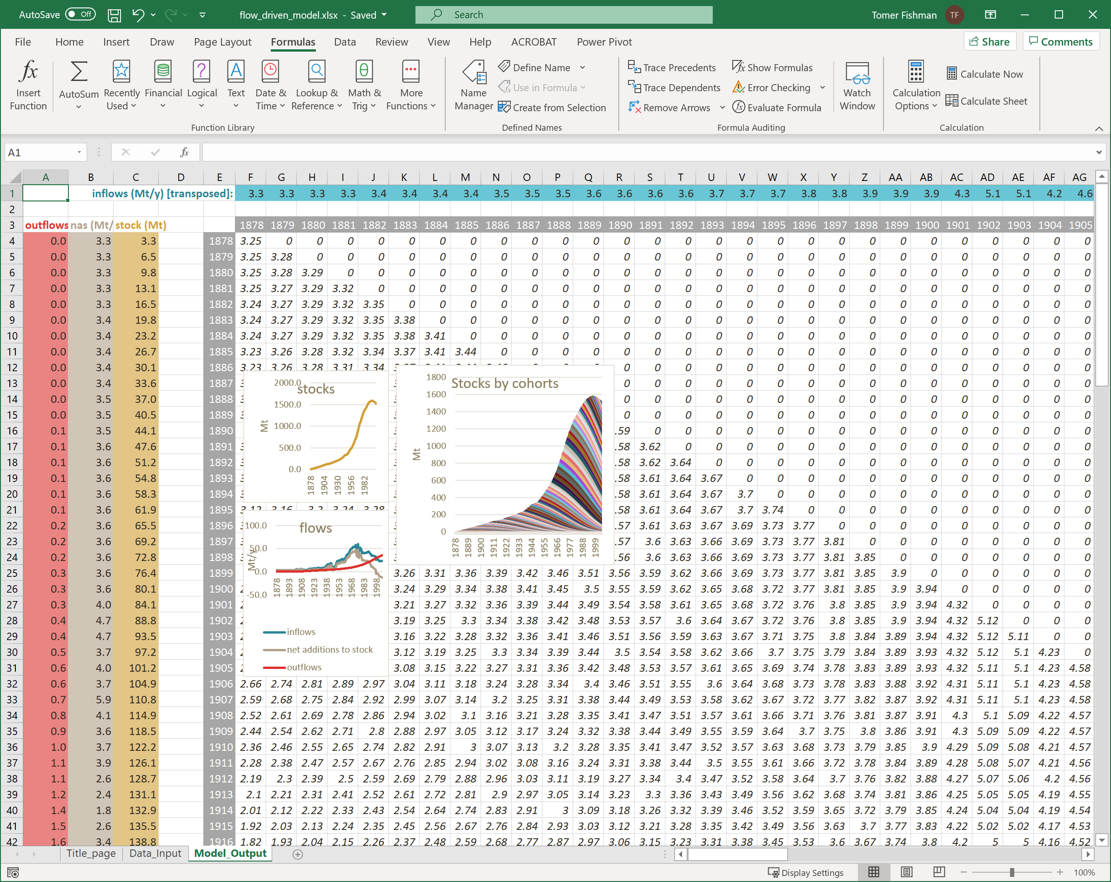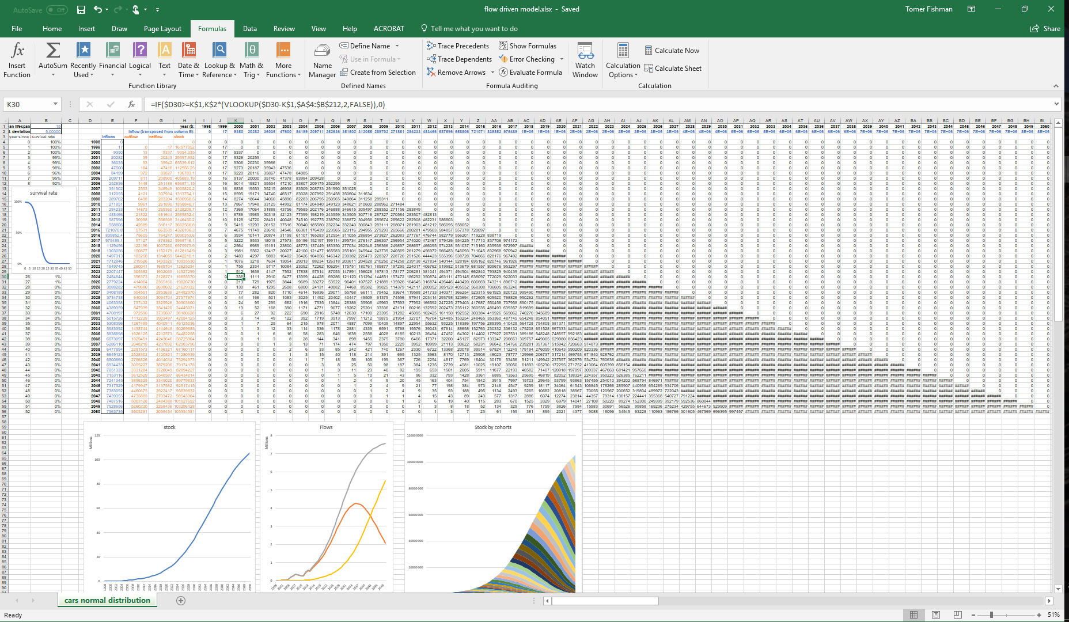

## Part 1: Understanding the dynamic model

1. In the Model_Output sheet, select cells F4:F131 and plot a line graph. What is the relation of this to the survival rate graph in Data_Input? What is similar and what is different between them?
2. Select cells K4:K131 in Model_Output and plot a line graph. Do the same for cells BA4:BA131. Do the same for any other column in the cohort matrix (any column in the range F3:EC131). What are the differences with the previous graph?
3. Which data is the diagonal of the matrix in Model_Output equal to?
4. What does each column in the cohort matrix (F3:EC131) stand for in normal human language?
5. Describe the code in cell F4 (or any other cell in the range F3:EC131) in normal human language.
6. How do the cells in column C calculate the time series of the stock?
7. How does column B calculate the time series of the net addition to stock?
8. How does column A calculate the time series of the outflows? Which principle does it use?
9. Explain in normal human words what the Stocks by cohorts figure shows.
10. Why would it be wrong to plot stocks on the same figure as the flows?
11. How is it possible that net additions to stocks are negative in some years like 1998? What does it mean? How does it manifest in the stocks?
12. Now open the file “flow_driven_model_with_surv_matrix.xlsx”. The Data_Inputs and the results are identical to the previous file, but there’s a new sheet called “Survival_curve_matrix”. We also set conditional formatting to color the cells of the matrices by their values – green for zero, through yellow, to red for the highest values.   
    What is the difference between sheet “Survival_curve_matrix” and sheet “Cohort_survival_matrix_&Outputs”? What does Excel calculate in the cells of each of these matrices?

## Part 2: Understanding the data

* After each question, undo the changes to return the input cells to their original values.
* The original input data is also available in the sheet Data_Backup so you can copy it back from there.

What happens to the stocks and outflows…

1. If you change the inflows in 1970 (or any other year) to 0 Mt? To 100 Mt?
2. If you change the inflows 1970-1980 to 0 Mt? To 100 Mt?
3. If you change the inflows for all years (1878-2005) to 10 Mt?
4. If you change the mean lifespan to 60 years? 20 years? 5 years?
5. If you change the standard deviation to 10? To 20?
6. Let’s try changing the survival curve altogether. Go to Data_Backup and plot line graphs of I4:K131. We have our original normal distribution survival curve and two alternative curves. Describe in normal human words the two alternative curves.

Again, What happens to the stocks and outflows…

1. If you replace the normal distribution survival curve in Data_Input with alternative survival curve 1 from Data_Backup? (i.e. copy Data_Backup J4:J131 to Data_Input I4:I131)
2. If you replace the normal distribution survival curve in Data_Input with alternative survival curve 2 from Data_Backup? (i.e. copy Data_Backup K4:K131 to Data_Input I4:I131)

Extra bonus optional practice challenge if you finished everything else:

By only changing the inputs in Input_Data:

1. Can you reach a stable-state zero-waste circular economy for at least 10 years? That means: stabilize the stocks to remain constant (and above zero), and minimize outflows to 0?
2. Can you “break the model” and cause it to calculate unrealistic negative stocks or negative outflows?

Good luck!