CARRIE – The Game

Technical document

* Targeted screen ratio: 16:9
* Targeted screen resolution: 1920x1080
* Full pixel art, no smoothing effect, only lights effects are accepted
* Make sure pixel art style is respected, like references listed bellow
* You have time, there is no hurry so don’t bother your mind with this

# Game objects scaling

All the sprites must fit in the 1920x1080 canvas. Knowing this, we can define the sprites default size. We have chosen to work on a 480x270 area, rescaled in the code by multiplying the sprites per 4.

* Canvas: 480x270
* UI Items: 16x16
* Game items: Depending on items, the spawner in 16x16 is enough
* Monster size: Depending on the monster
* Projectile size: 16x16
* Carrie size:

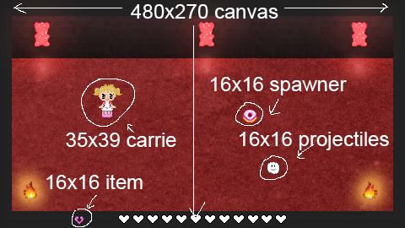

For enemies, I currently manually multiply the scale of the sprite you gave me by x. X change for every enemy as follow:

|  |  |  |  |  |
| --- | --- | --- | --- | --- |
| Enemy | Default size | Rescale coeff. | 1080p scale | Required size |
| Jelly | 50x50 | 1.2 | 60x60 | 15x15 |
| Lollipop | 54x105 | 1.0 | 54x105 | 13x26 |
| Jellybear | 54x83 | 1.5 | 81x124 | 20x31 |
| Crocodile | 120x26 | 1.5 | 180x39 | 45x9 |
| CakeMonster | 104x104 | 1.0 | 104x104 | 26x26 |
| CakeKing | 160x146 | 1.8 | 288x262 | 72x65 |
| JellyQueen | 136x143 | 1.8 | 244x257 | 61x64 |

(Approximated scales are rounded to lower unit)

Be careful, some sprites are not well cropped, so their in-game size should be inferior to the sizes written bellow.

# Sprites to work on:

* Map1 (Including door and edges)
  + Rescale
  + Maybe adding some details on the scene, like an equivalent to cake lights
* Map2 (Including door and edges)
  + Rescale
* Shop map (Including door and edges)
  + Creating the map
* Projectiles (Needs to be in 16x16)
  + New Cream (No smooth effect, full pixel art)
  + Rescale (Or recreate) sugar and improving his outline visibility (Some feedbacks on Carrie were about sugar in-game visibility)
  + Cupcake projectile for the second boss (You already created a cupcake, but it can be improved)
* Enemies
  + Rescale or recreate every enemy (Front only, except for crocodile which must be looking on the right)
* Spawner
  + Rescale or recreate the donut-shape spawner to 16x16 (Or recreate)
* Carrie
  + Rescale every Carrie direction to 35x39 (Approximatively +- 2 pixels)
* NPC
  + Adapt the NPC to Carrie scale (Can be a little bit taller cause Carrie is a child)
* Curses icons
  + Rescale to 16x16 (Or recreate)
* Toothpaste icon
  + Rescale to 16x16 (Or recreate)
* Heart icon
  + Rescale to 16x16 (Or recreate)
* Potion icon (Clean curses)
  + Rescale to 16x16 (Or recreate)
* Generic entity shadow (I will rescale it for every entity depending on her size)
  + Rescale to 16x16 (Or recreate in pixel art style, like the following picture)

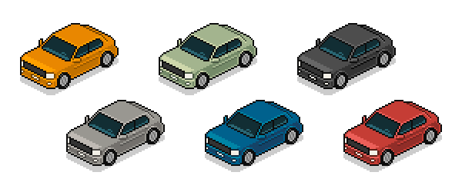

# References

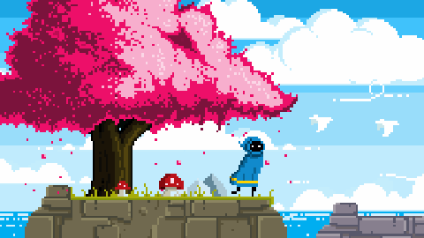

Global style (Unknown game source)

Global style (From CRAWL game)

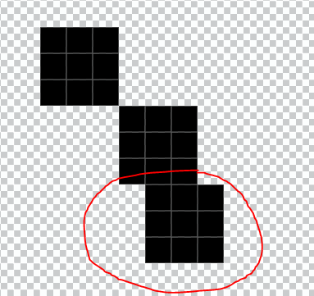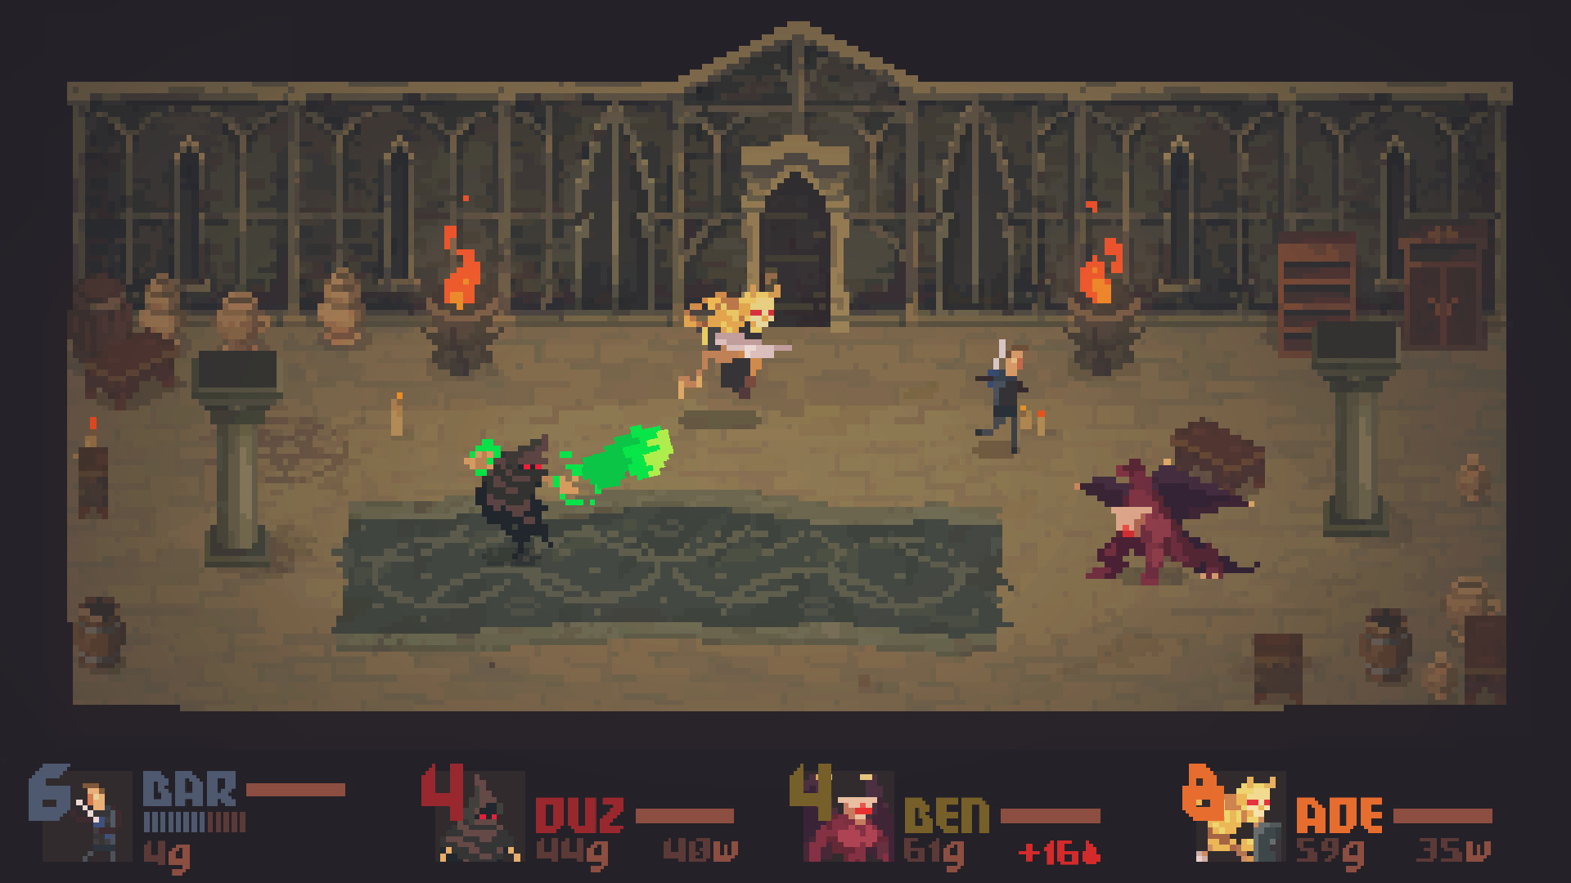

It is allowed, cause our smallest unit is 1 pixel (un-cuttable), so don’t worry, use it 😊

Game items 16x16 style (With x4 rescale for 1080p)

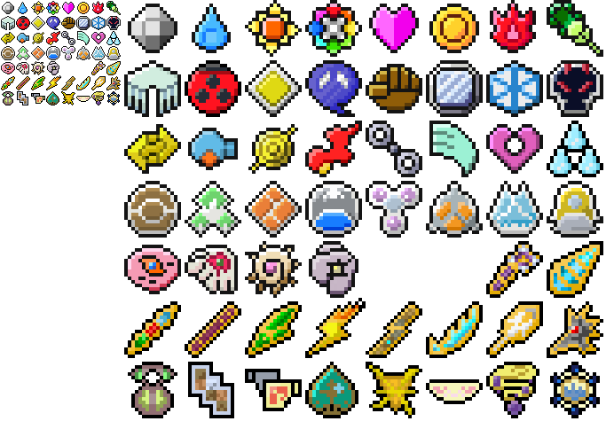

You can refer to it to make your items (Outline are great on those ones)



Same sprite, made in 16x16 then rescaled in 64x64 (1080p)